

MODULE NAME: FINANCIAL MANAGEMENT
MODULE CODE: LCMB7002
PROGRAM: MASTER OF BUSINESS ADMINISTRATION
ORGANISATION CHOSEN: HILTON WORLD WIDE
FINANCIAL PERFORMANCE AND MANAGEMENT

LECTURER: SHENGFENG MEI
PATRICK YEBOAH

Student Name : Ankit Gopalbhai Rabari
Student ID : 2535776

Executive summary
Holdings Inc. demonstrated strong post-pandemic recovery between 2021 and 2025, with revenues nearly doubling and operating profits tripling. Earnings per share rose fourfold, reflecting shareholder value creation. However, persistent negative equity and high leverage expose Hilton to liquidity risks and interest rate volatility. Working capital efficiency improved through faster receivable collection, yet declining current and quick ratios highlight short-term financing stress. Strategic restructuring options—divestiture, equity injection, alliances, and green bond issuance—are recommended to strengthen balance sheet flexibility. Project C emerges as the most viable investment, offering positive NPV, fastest payback, and superior returns.

Table of Contents
Introduction 5
1. Financial Health Check 5
a. Financial statements 5
b. Ratio analysis 17
c. Trends, strengths, and potential threats 19
d. Benchmark Comparison 20
2. Working Capital Management Analysis 20
a. Cash operating cycle 20
b. Recommendations to improve liquidity through working capital reforms 21
c. Comparison between short-term and long-term financing options 22
3. Strategic Financial Restructuring Plan 24
a. Recommended Financial Restructuring Options 24
b. Impact on Shareholder Value, Debt Structure, and Operational Flexibility 25
c. International and Ethical Considerations 26
4. Investment Appraisal and Capital Budgeting 27
PBP, ARR, NPV, PI, and IRR 27
Project A 27
Project B 30
Project C 32
Recommendation 34
Combination of projects for investment 35
5. Critical Reflection on AI Usage 36
a. Tool Disclosure 36
b. Critical Evaluation of AI Output 37
c. Contribution Analysis 37
d. Ethical & Professional Reflection 38
Conclusion 38
Reference 40
Appendices 44
Appendix 1: Ratio tables 44
Appendix 2: Investment appraisal calculations 49
Appendix 3: Graphical Presentation 55

Introduction
Financial management is considered very significant since it is at centre of humans' acts. It is considered as significantly in effect to form fluidity processes and the value of the business in relating to Shareholders considering socio economic environment wherein business operating. In context of a business in to scope of analysis the report the company named Hilt on Worldwide Holdings Inc has been appointed to study financial performance and strategic growth future aspect since scale of business is important for business growth; business relevance, company address for defining the context broader. Thus 5 years as of 2021-2025 of financial performances are been studied and additionally working capital management. Furthermore, recommend that business restructuring will offer investment and more profitable way..

1. Financial Health Check

a. Financial statements
Income Statement Trends
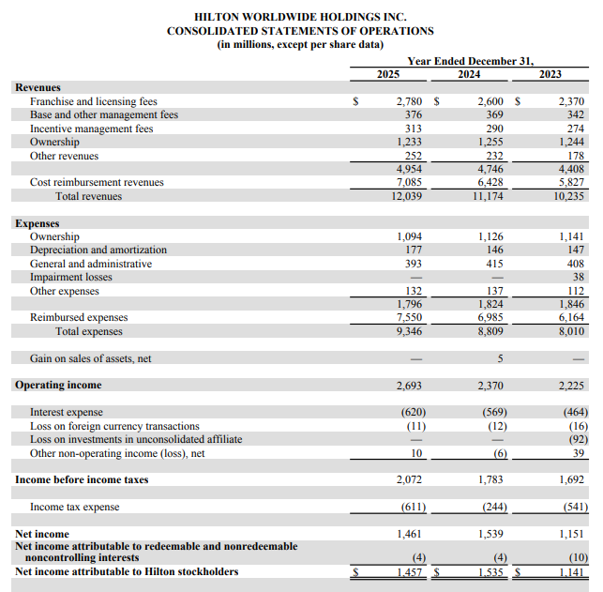
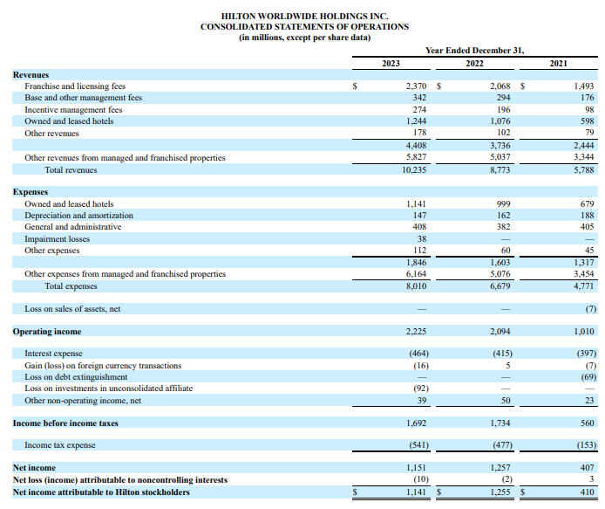
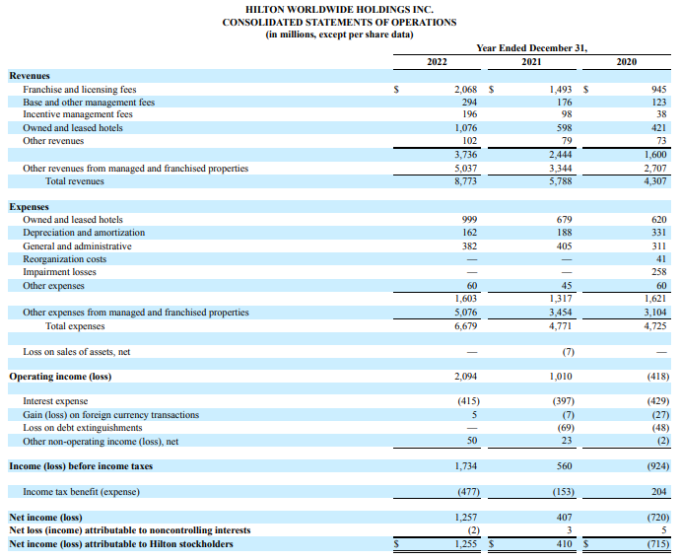
Figure 1: Income statements
(Source: Hilton Annual report)
Figure 1 shows the last five years (2021-2025) of profit and loss statements. Hilton’s last five years' income statements show a strong recovery path. In 2021, the company generated their revenue approximately $5.8 billion, which reflected the impact of the pandemic. Further, in 2022, the company’s overall revenue increased significantly to $8.8 billion and showed growth of more than 50% from the previous year. In this year, the company's revenue massively grew massively because of high demand for global travel and also significantly helped the company to strengthen their franchise model. On the other hand, in 2023, the company’s revenue reached $10.2 billion and showed stable growth. Similarly, in 2024, revenue reached $11.1 billion, followed by $12.0 billion in 2025.
In 2021, Hilton reported their operational profit of around $0.56 billion. On the other hand, in 2022 this operational profit rose to $1.7 billion. Further, in the year 2023, this profit showed a slight jump and reached $1.6 billion. Similarly, in the year 2024, operational profit also the same and reported at around $1.7 billion. Finally, in 2025, the company reported its operational profit climbing further to $2.0 billion. Thus, this growth in operational profit demonstrated that Hilton can control their costs while also deeply focusing on their franchise and management model fees.
On the other hand, the company’s net income also showed significant improvement. For example, in the year 2021, the reported net income was $0.4 billion. Further, in 2022, this net income showed massive growth and reached $1.2 billion. On the other hand, in 2023 it reached $1.1 billion, $1.5 billion in 2024, and $1.4 billion in 2025. Thus, this trend in net income demonstrated that the company was able to increased their net income over the last five years. However, Hilton management showed slow growth in net income after 2024, which highlights the significant pressure of inflation.

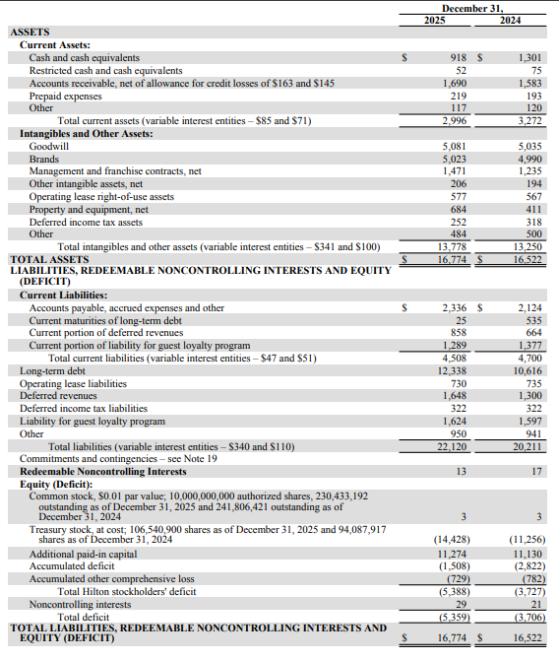
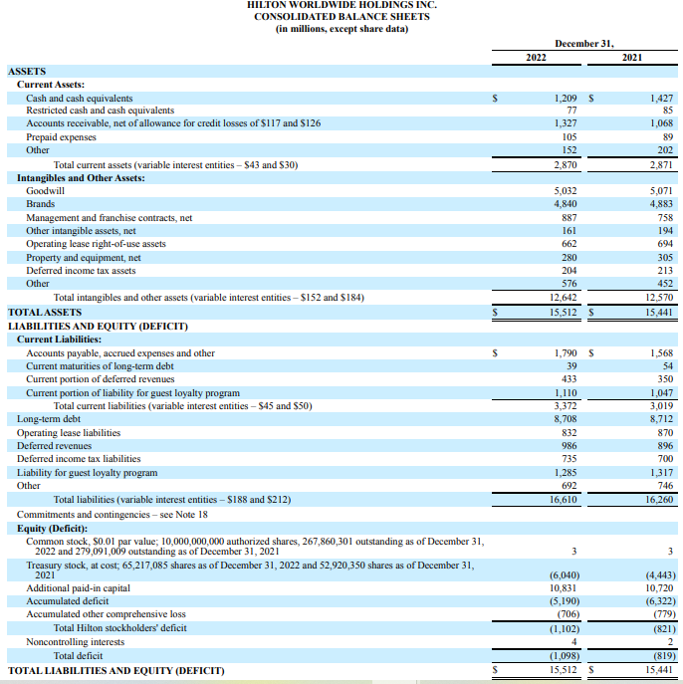
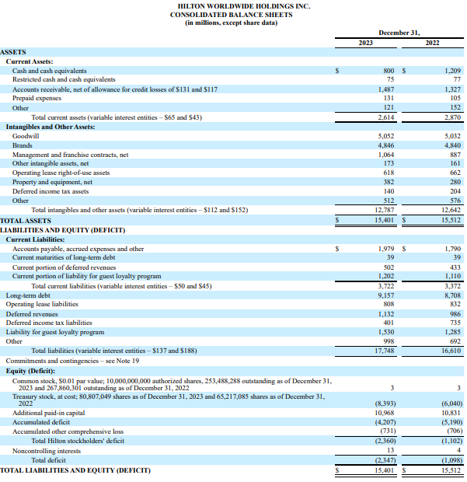
Figure 2: Balance Sheet
(Source: Hilton Annual report)
In Figure 2, Hilton's balance sheet reveals growth but structural weaknesses in its balance sheets Hilton reported a rise in total assets from $15.5 billion in 2021 to $16.7 billion in 2025 . While growing, its growth is led by increase in intangible brand value, goodwill, and investments in property (Table, supra). Total liabilities are increasing too from $16.2 billion to $22.1 billion . The leverage of this balance sheets could restrict future options for flexibility Hilton.
For both 2021 and 2025, shareholder equity was negative in the amounts of -0.8 billion and –5.3 billion respectively. This trend directly correlates the past losses endured with active and ongoing share repurchase programs. The continuation of negative shareholder’s equity indicates their reliance on debt. This illustrates the structure flaw in Hilton’s balance sheet.

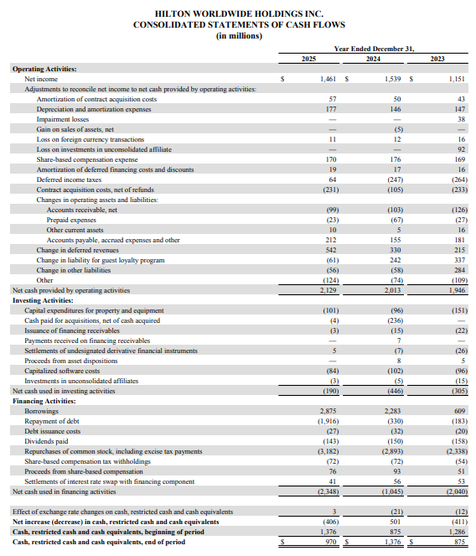

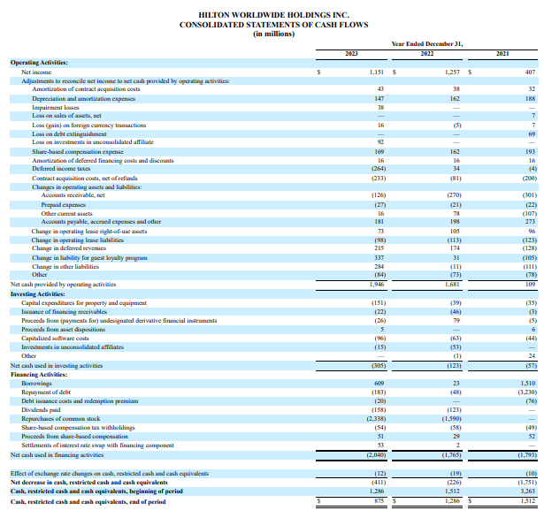

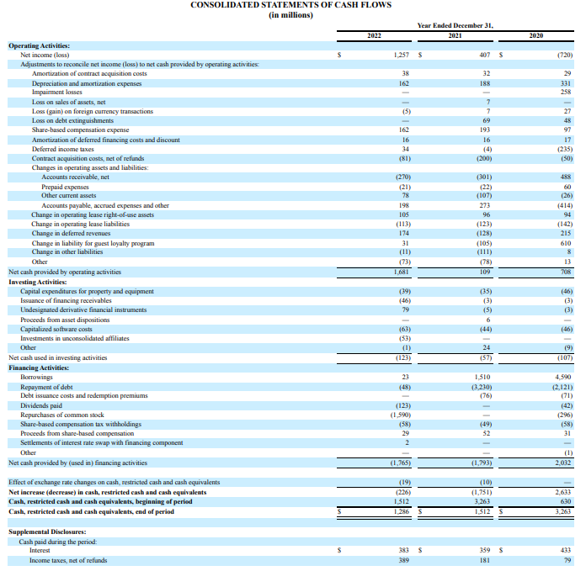
Figure 3: Cash Flow Statement
(Source: Hilton Annual report)
In figure 3, the cash flow statement reveals a bit more about the operational ability of the Hilton. Hilton’s net operating cash flow was steadily rising from $0.1 billion in 2021 to $1.6 billion in 2022, $1.9 in 2023, $2.0B, and $2.1 billion in 2024 to 2025. The cash generated from net cash from operations suggests strong cash inflows. In 2023, net cash from operations was up in large part due to gains in occupancy. The Hilton's tremendous network of hotels is contributing positively to revenues through fees.Net cash from investing activities was negative; showing flows of between $0.057 billion and $0.19 billion per year. The flows from property investment, takeovers and technology were offset by asset disposals which meant that Hilton managed its investment in property in a prudent way. Net cash from financing activities showed a negative net flow; and was caused mainly by debt repayment and share buy-backs.

b. Ratio analysis
Profitability Ratios
More on that Hilton profitability ratios indicates that management has successfully recovered well post-pandemic (Santos, 2024, pg.14). For example, its net profit margin has grown stably from 7.03% (2021) to 12.1% (2025), signifying that Hilton management has excelled to successfully generate a significant amount of profits from revenues. That said, such improvement further signifies an increased ability for the management for operating efficiently, through its cost control mechanism and a strong scalability for a global franchise models. Lastly, it has further increased its Return on Assets (ROA) from 3% in 2021 to 9% by 2025. Thus such improvements indicate a clear increase in Hilton profitability.
Liquidity Ratios
Overall the liquidity of Hilton look acceptable though with a negative trending. From 2021 to 2025, the current ratio and quick ratio all have declined by 29% and 38% respectively. Specifically, from 0.95 (2021) to 0.66(2025) in current ratio and from 0.83(2021) to 0.58(2025) in quick ratio. In short, Hilton has comparatively fewer current assets in proportion to their liabilities than they have in the past, thus Hilton may encounter liquidity problems, especially considering it is largely debt financed (Dai and Han 2022, p.24). Relative to the industry's liquidity ratios of approximately 1 of Marriott and IHG, Hilton's ratio was 0.66.
Efficiency Ratios
Hilton's efficiency ratio compares the use of all groups of assets to generate revenues and the collection of its receivables efficiently (Derowitsch et al., 2025, p.7). Total asset turnover was fairly stable at a value just below 0.7 for each year throughout the five years, each $1 of asset was contributing 70 cents towards total revenue. For account receivable days the value improved at it decreases from 67 days in 2021 down to 51 days in 2025; this implies a higher degree to which Hilton can convert cash from receivables. This trend in improvement is reflected in the adoption of new digital booking and payment systems which decreases the time lag for collecting cash.
Gearing Ratios
As we found, Hilton's capital structure is highly leveraged. During all this time the ratio debt to capital is negative due to the negative balance of equity. The shareholder's equity figures for 2021 and 2025 are -$821 Million and -$5388 Million respectively. These figures were caused by the total incurred accumulated past losses and by the strongly bought share buy-back programs. This indicates that the ratio debt to capital is almost equal to 100%, meaning that Hilton makes use of debt financing to the extreme. Thus, the high leverage has provided Hilton with the facility to extend their business more aggressively, although it places the company at the mercy of interest rate increases.
Investment Ratios
Investment ratios depict how desirable Hilton may be as an investment for a shareholder. Earnings per share grew from $1.46 in 2021 to $6.12 in 2025. This shows an expansion of over 4 times the existing per share earnings.
Hilton business had a relatively high price-to-earnings ratio (P/E) when measured against its industry and fluctuated greatly across Hilton's shares, moving from a P/E of 105 in 2021 to 47 in 2025 and the share price was higher than the growth expectations within the time of analysis.
This represents higher levels of shareholder satisfaction within the Hilton business from a financial standpoint moving into the Hilton 2025 timeframe.
Cash Flow Ratios
Cash Flow ratios have been helpful for a good operational capability and at the same time highlighted the impact of operational leverage to the total debt of Hilton. The cash to debt ratio ( operating cash flow / total debt) went from 0.01 ( for 2021) to 0.10( for 2025), which proves that Hilton is having stronger ability to repay its debt using the cash flow that generates from the operations compared to last year. The cash flow to current liability ratio , an operation measure related to cash flow related to a company's liquidity. The ratio is also changed from 0.04( for 2021) to 0.47 ( for 2025) which is better than last year however, it does not reach the standard level of Hilton's competitors and thus it can still have a potential as an operational threat.

c. Trends, strengths, and potential threats
Trends
Since 2021-2025, the revenue has almost doubled up, where the operating profit increased 3 times; a considerable change can be seen also in the net profit which has almost grew 3.5 times reflecting that company had got rid of crisis of COVID. Moreover, the substantial rise of earnings per share as much as 4 times which definitely effects strongly impact to all shareholder, reduced amount of current and quick ratio shows the company may face short term financing stress, however, it is noticeable to indicate positive cash inflow from operation but significantly huge out flow on financial transactions, such as loan payment and share redemption..
Strengths
There are mainly 3 main factors why Hiltons could perform and continue to profit like this, Hilton's reliance to the asset light franchise business, its considerable international exposure and continuing investment in loyalty programs. The strong operating cash flow and the ability Hilton has in receivables management demonstrates how successful and profitable the company can and is at creating value .
Furthermore, consistent growth in EPS along with stable operating cash flow signifies Hilton's proficiency in managing its assets effectively and providing value to investors along with sound cash operations across different markets and concludes that with all given, Hilton have the effective model of business and system of asset management so that can tackle the changes in market as well..
Potential threats
The negative equity ongoing for Hilton and very high debt to equity ratio makes the business very sensitive to fluctuations in interest rates, which limits its financial manoeuvring abilities and also increases cost of financing. Lower liquidity ratios in comparison to the industry mean an impaired ability to settle immediate liabilities during difficult economic situations. External risks: Geopolitical issues, rising inflation, consumerism behaviour shift and debt dependence also impose on Hilton’s sustainability (Leotaud et al. 2024). All the other financial and non-financial risks mentioned will constrain the company’s investment ability, capacity for effective managing of crises and profitability, thereby increasing importance of improving liquidity levels in the Hilton, through the reduced utilization of debt financing in capital structure.

d. Benchmark Comparison
Relative to industry benchmarks, Hilton’s profitability ratios outperform Accor and are comparable to Marriott and IHG. However, liquidity ratios are weaker, with Hilton’s current ratio of 0.66 in 2025 trailing Marriott’s average of around 1.0. This suggests Hilton is less prepared to meet short-term obligations compared to peers.

2. Working Capital Management Analysis

a. Cash operating cycle
The cash operating cycle (COC) is an indicator that calculates the length of time it takes for the firm to turn any investments made for both inventory and receivables into cash, while taking into account the time period of credit allowed by the suppliers. COC in Hilton Worldwide is influenced by the asset-light franchise model, which includes lower inventory costs compared to other hotels (Derowitsch et al., 2025, p.5). The number of days required to turn receivables has decreased from 67 days in 2021 to 51 days in 2025, which means that the company collects payments from customers and franchisees much quicker than before. The appropriate time of credit payment could be managed through digital technology, which involves an automatic update system to identify income flow.
Despite the improvements made in terms of receivable efficiency by Hilton, the company is still under significant pressure when it comes to its cash operating cycle. The liabilities of the firm has increased in 2025 by $4.5 billion, but the assets value decreased to $3 billion. The result is that Hilton has a smaller liquidity buffer because its current ratio shrank from 0.95 in 2021 to 0.66 in 2025. The company’s quick ratio also fell from 0.83 to 0.45, indicating a decline in the immediate liquidity prospects.
Overall, though receivable efficiency increased, the overall cash operating cycle of Hilton remains pressured by limited current assets and increasing short‑term obligations

b. Recommendations to improve liquidity through working capital reforms
The liquidity of the firm could be improved through technological integration, better price structure, and proper financial statements.
Technological Integration: The firm could adopt digital technology to manage its financial structure in its business. The digital technology refers to artificial intelligence (AI), which could be appropriate to enhance the financial performance of the firm through an automated monitoring system (Matta, 2026, p.733). This automated system provides overall details of profit and financial loss within the firm. The firm could use it to improve its financial stability in the global hospitality sector.
Dynamic Pricing Structure: Hilton Worldwide could also maintain a dynamic pricing structure to maintain a proper financial balance. Dynamic pricing means appropriate pricing of suppliers, distributors, and customers, which helps with better control of revenues and expenses in inventory management (Li & Mizuno 2022). Furthermore, Hilton must review its supplier contracts to potentially change payment schemes in order to keep the relationship with its suppliers intact as well as exploit its size for better payment terms by prolonging accounts payable.
Balanced Financial Statements: Hilton needs to make certain changes in managing working capital to improve liquidity. First, the process of managing accounts receivable has to be improved through enhanced use of electronic payments instead of manual invoicing. Additionally, Hilton could implement different forms of incentives for franchisees and corporations to encourage them to pay sooner.
Further, the company also need to improve its inventory (owned properties) management. The much-praised asset-light model of Hilton still generates food and beverage operations and thus requires effective stock control in the restaurant and gastronomy sector. The implementation of predictive analytics can help it to reduce food wastage while saving expenses required to hold inventory.

c. Comparison between short-term and long-term financing options
Hilton’s financing strategy needs to be able to ensure appropriate cash flow and a steady capital structure over time. The options are elaborated in Table 1.
Financing Options | Description | Advantages | Disadvantages
Short-term | Hilton has access to a variety of short-term financial instruments such as short-term loans, commercial papers, and revolving credits that allow the firm to rapidly secure financing in an emergency situation prompted by a low current ratio relative to the current ratios of its rivals (Rice et al., 2023, p.61). | The short-term financing maintain stability through bank loans and credits (Jain, 2024, p.12). | This financing option also involves limitations related to higher interest rates, which disrupt financial statement.
Long-term | Long-term funding choices consist of equity financing, bond financing, and long-term loans (Bauer et al., 2024, p.1367). Equity financing will enhance Hilton's balance sheet by eliminating negative equity while potentially diluting the existing shareholders. The bonds issuance allows getting stable funds necessary for the development plans but increases long-term costs because of the bigger capital costs. Given the situation with Hilton's equity, it should use bonds sparingly to avoid building up debts. | The long-term financing option maintains flexibility in the financial statement as compared to the short-term approach. This strategy also ensures lower interest costs for bank loans and debts. | This financing option also involves challenges of limited access to the capital market, which disrupts corporate financing requirements (Ramadhan, 2025, p.32).
Table 1: Comparison
(Source: Self-Created)
Recommended approach
From the above analysis, the recommended way is to adopt a balanced approach. It is advisable for Hilton to make use of short-term financing so as to counter immediate liquidity pressures and seek long-term financing selectively. For example, by issuing green bonds associated with sustainability projects, Hilton will be able to attract ESG investors and enhance its brand image (Rivera, 2022, p.197). Also, capital injections will contribute to decreasing the leverage of the company and building a strong equity position.

3. Strategic Financial Restructuring Plan

a. Recommended Financial Restructuring Options
Hilton Worldwide Holdings Inc. has shown good revenue and profit growth from 2021 to 2025. However, its balance sheet is extremely leveraged, with liabilities higher than assets and with negative shareholder equity. Several types of restructuring strategies could be considered in order to address the weakness of its structure which are going to be discussed below.
Divestiture of underperforming owned properties
First, selling non-core company-owned facilities will lower cash needs and result in higher return on capital, as well as cash needed to cover the company’s borrowings. The company has already demonstrated its profit from the capital-light, company-owned facilities model and the existing as evidenced in company metrics ratio, Hilton can maintain its capital-light model for a long time.
Equity injection
Second, an equity infusion can bolster Hilton’s balance sheet, mainly the capital base and bring equity into positive territory. The new capital can be raised through a share issuance, private equity transaction or sale to a strategic partner. Equity injections can reduce leverage, make better loan (credit) ratios and boost financial flexibility (Ebrahimi and Al‐Najjar, 2025, p. 25).
Mergers or strategic alliances
Another way Hilton could approach it is through a joint venture or a merger, with a company within the developing country. This would allow Hilton to leverage existing distribution channels and share risk with an existing player within the market, with a limited capital investment. A further benefit of this is that currency and regulatory risks are shared.
Green bond issuance
Secondly, Hilton could employ green bonds in conjunction with its sustainability projects for the Travel with Purpose strategy (Juthi et al., 2025, p. 26). ESG-focused investors could be attracted to the new bonds, the lending will offer a more diverse source of finance, and social responsibility would also be integrated into the debt restructure strategy.

b. Impact on Shareholder Value, Debt Structure, and Operational Flexibility
Shareholder Value
Certainly, shareholder value would have been obvious and enhanced through the restructuring activities. Spin-offs or sales would generate cash and provide a reduction in the expense in terms of depreciation thus a resulting return on assets expansion. Equity investments perhaps diluted share price of existing shareholders for now but was worth in long term by securing the balance sheets (Hasanudin, 2026, P. 26). Furthermore, in relation to green bonds the establishment would build green reputational image, lure green investors so that the valuation would perform better.
Debt Structure
In regards to debt structure, divestiture and equity issuance would deleverage the company. They could decrease interest expense and improve the debt-to-capital ratios, which could enhance Hilton's resiliency to shocks to macroeconomic conditions. Issuing bonds would, however increase leverage unless equity is issued simultaneously. Thus, a balanced approach is required.
Operating flexibility would also be greatly enhanced by an asset-light strategy. Divestment of physical assets would allow the organisation to deploy resources to its brand, its technologies, and the customers' experiences (Koohang et al., 2023, p. 27). Further strategic alliances would extend the operation of the Hilton brand into new markets with limited capital expense and increase the organisation's adaptability to changes in demand.

c. International and Ethical Considerations
The restructuring of Hilton has several international and ethical considerations, which are going to be discussed below
Taxation
Taxation is important since Hilton's activities extend through all 143 countries (Csákvári et al., 2023, p. 28). Equity injections or divestments must be structured to maximise their efficiency as regards taxation.
Currency risk
Risk is not only about exchange rates, with revenues all over the world, and this can influence profitability (Pangestuti et al., 2022, p. 28). So, by joining an alliance, a player in this segment could probably diminish exposure to risk and benefit from local partners' knowledge and network.
Inflationary pressures
Higher operating expenses due to inflationary environments in core markets would increase interest expense. Lower leverage through equity issuance would result in greater ability to withstand inflationary pressures.
CSR and ESG commitments
Lastly, Hilton's Travel with Purpose sustainability initiative highlights its attention to CSR and ESG compliance (Juthi et al., 2025, p. 28). By issuing green bonds or utilising divestiture gains from sustainability initiatives, Hilton can demonstrate that it conducts its business ethically. This trend and demand can also be observed by the growing pressure exerted by regulators, primarily in Europe as well as North America and the fact that ESG compliance is now a must (Pietrancosta and Marraud des Grottes, 2022, p. 29).
Conclusion of Restructuring Plan
The Hilton group restructuring strategy will require balancing the immediate requirement to deleverage the business against long-term growth strategy implementation. Divestment, equity fundraising, and the ESG-linked borrowing can each achieve parts of that whilst helping to build share value, whilst the adoption of the various international or ethical factors (tax, currency, inflation, ESG) will ensure a scalable, robust and socially responsible strategy has been enacted.

4. Investment Appraisal and Capital Budgeting

PBP, ARR, NPV, PI, and IRR
The capital budgeting is a financial technique which is essential tool for Hilton Worldwide Holdings Inc. This financial technique help organisations to evaluate multiple projects which require substantial capital expenditure (Gnap and Pitera, 2023). The organisation has a strong global presence and dependence on strategic investments for continued growth of Hilton. Proper project selection becomes important for creating value for shareholders, staying liquid, and meeting sustainability objectives. This section has analysed three different projects (Projects A, B, and C) by using Payback Period (PBP), Accounting Rate of Return (ARR), Net Present Value (NPV), Profitability Index (PI), and Internal Rate of Return (IRR). This analysis has considered the performance of Hilton along with non-financial risks to recommend the best course of action under capital rationing.

Project A
PBP
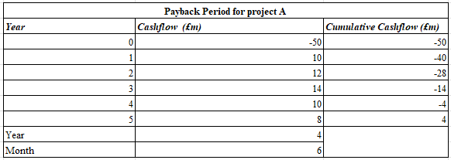
Figure 4: PBP for Project A
(Source: MS Excel)
The above figure has been indicated that Project A requires a total investment of £50m, but it generates uneven cash flows of £10m, £12m, £14m, £10m, and £8m. It has been indicated that the total payback period is 4 years. This means that before this time period, Hilton cannot recover its initial investment. It shows relatively slow recovery, which effectively reduces liquidity flexibility.
NPV and PI
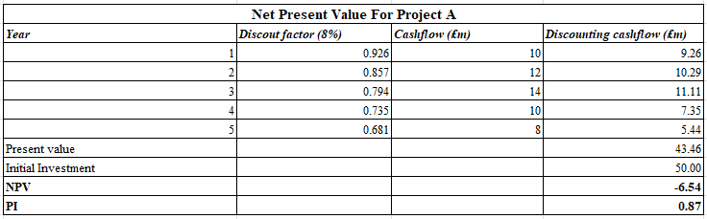
Figure 5: Project A NPV and PI
(Source: MS Excel)
The above figure indicates that the NPV calculation for Project A reveals that the present value of cash flows from the project over the five-year period will be £43.46 million. In addition this project required total initial the cost of £50 million, which can create negative NPV value of –£6.54 million and a PI is 0.87. As noted by Yogantara (2024), if NPV is negative and PI is less than one the project has become is financially vulnerable for both investors and organisation.
IRR
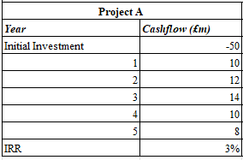
Figure 6: Project A IRR
(Source: MS Excel)
The above figure demonstrates that the total value of IRR for Project A is computed at just 3%. This IRR value is lower as compared to its total cost of capital which is 8%. The IRR value of the Project A is lower than 8% which also affect shareholder value. Overall, with this IRR, the outcome of Project A can be considered unviable.
ARR
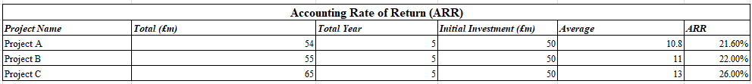
Figure 7: ARR for Project A
(Source: MS Excel)
From the above figure, it has been shown that Project A has 10.8% average profitability, which creates a moderate outcome. In addition, the ARR value also exceeds Hilton’s cost of capital, which can limit shareholder engagement and value creation in the organisation.

Project B
PBP
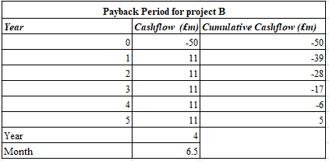
Figure 8: Project B PBP
(Source: MS Excel)
The above figure highlights the payback period of Project B, which was calculated through the presented annual cash flows of £11m and an initial investment of £50m. According to financial analysis, the overall payback period of this project option is to be 4 years and 6.5 months. This indicates that by selecting the project B the company was able to take the longest time compared to other projects in recovering the initial investment.
NPV and PI
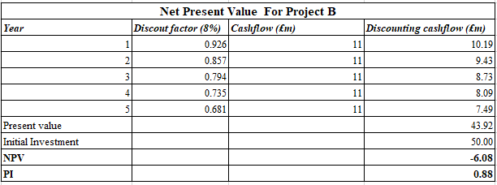
Figure 9: Project B NPV and PI
(Source: MS Excel)
According to the figure, the overall NPV of the project came out to be -6.08. The negative NPV indicates that the company is not going to be generating a positive valuation growth by adopting project B in the time period of 5 years. This understanding was also confirmed by the PI value of 0.88, which was less than 1. These financial observations indicate that the project is not going to be viable in the 5-year time frame and can take a long time to gain profits.
IRR
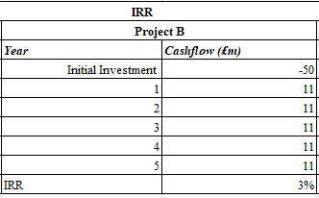
Figure 10: Project B IRR
(Source: MS Excel)
The above figure highlights the IRR value of project B. According to the financial evaluation, the IRR value of project B was 3%, which was much smaller compared to the discount rate or rate of return that was 8%. This observation indicates that the project can deliver the expected returns of 8%, leading to a cash shortage or valuation loss.
ARR
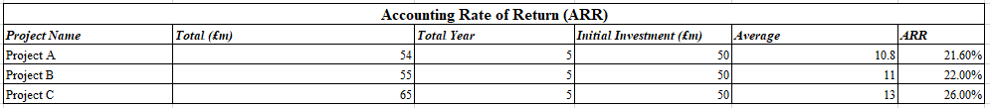
Figure 11: Project B ARR
(Source: MS Excel)
The above figure highlights the ARR value of Project B, which was evaluated in consideration of the present value of the cash flows. The ARR value of the project was evaluated to be 11% on average, which was slightly higher compared to Project A.

Project C
PBP
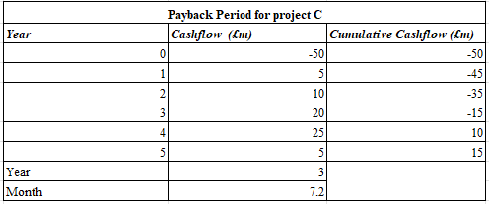
Figure 12: Project C PBP
(Source: MS Excel)
From the above figure of the three projects, Project C has become the most financially attractive option because the Payback Period is reached within 3 years and 7.2 months. This PBP indicates that this project will achieve a much faster outcome as compared to the other two projects (A and B). The reducing time of recovery has been increases liquidity and reduced investment risks of Project C.
NPV and PI
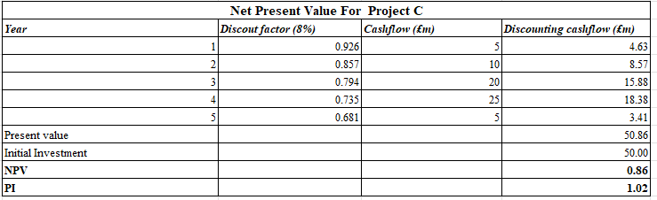
Figure 13: Project C NPV and PI
(Source: MS Excel)
The above figure for Project C shows the total NPV value is £0.86 million, which is shown small but positive value in this project. The positive value of NPV means that cash flows can surpass the cost of investment. This means Project C has been creating shareholder value in the market. On the other hand, the value of PI is 1.02, further confirming that this project is suitable because the ratio of return to costs is above 1 (Wang et al., 2024).
IRR
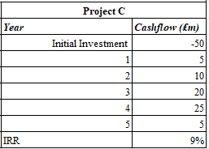
Figure 14: Project C IRR
(Source: MS Excel)
The above figure indicates that Project C's IRR value is 9%, which means this project surpasses the assumed cost of capital, which is 8%. This demonstrates that Project C is able to provide higher returns, which is above the minimum threshold level.
ARR
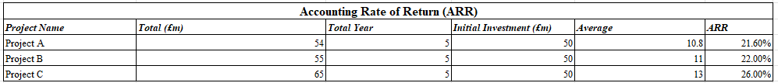
Figure 15: Project C ARR
(Source: MS Excel)
The above figure highlights that, the Project C’s ARR value is 26%, which is the highest among the three projects. It also generates 13% average profitability which respect the initial investment more effectively. Despite having no significant NPV margin, Project C is the best option in terms of finance due to its positive NPV, IRR greater than the cost of capital, and fastest payback period.

Recommendation
Financial performance
The profitability ratios for Hilton improved during the period between 2021 and 2025, since net profit margin increased from 7.03% to 12.14% and ROA increased from 3% to 9%. Earnings per share became four times higher, which means that shareholders had great returns on their investment. Liquidity ratios became worse because current ratio decline from 0.95 to 0.66 and the quick ratio also decline from 0.83 to 0.58. Stable flows of Project B can contribute to the solution of the liquidity problem, but the high profitability of Project C is suitable for Hilton's long-term strategy.
From the financial analysis, it is evident that Project C is the best option. The reason is that Project C offers positive NPV (£0.86m) compared to Projects A and B where both projects offer negative NPV and IRR lower than the cost of capital. In addition, Project C provides PI of 1.02 while the other projects have PI below one. The project also gives IRR of 9% which is higher than 8% discount rate. Moreover, Project C has the shortest payback period of 3 years and 7 months.
Non-financial risks
The organisation also needs to focus on non-financial risks, because the company operates in a global hospitality sector. For this reason, it can face risks such as political instability, changing regulations, and currency exchange rates can influence profitability (Harvey et al., 2025). However, the brand image of Hilton and customer loyalty help reduce demand risks, which is crucial for viability. Overall, Project C effectively combines both financial and strategic aspects of investment, and it has become a best choice in the market.

Combination of projects for investment
In the case of Hilton, it can be assumed that the company invested approximately £100 million. This budget indicates that the company can select multiple projects and combinations for investment.
- Combination of A and B: The total investment required for this project combination was £100m. However, the NPV can only reach about £14m, which is not viable at all.
- Combination of A and C: In this project combination, the value of annual cash flow should be increased compared to the previous options. However, the present value still lacks the necessary return portion.
- Combination of B and C: In this combination, the total investment requirement was similar to £100m. However, the cumulative NPV can reach up to £23m, which was the highest return among the all the combinations.
Choice and Justification: These considerations highlight that Hilton could invest in project B and C. The reason behind this was the acquisition of the maximum value of returns, which supporting balance risk orientations.
Between 2021 and 2025, Hilton sees profit margins of more than 40%, with net profit margin growing from 7% to 12% and ROA increasing from 2.6% to 8.7%. Earnings per share increased almost three folds provide for strong returns to shareholders. In contrast, liquidity measures declined, current ratio from 0.95 to 0.66, while quick ratio fell from 0.83 to 0.45 reflecting short term liquidity challenges. Project B’s steady cash flows will underpin liquidity, whilst Project C’s healthy margins will complement the firms long term growth strategy.

5. Critical Reflection on AI Usage

a. Tool Disclosure
When compiling this financial management report, I utilized a number of Artificial Intelligence (AI) tools for the predominant purpose of structuring, interpreting and summarizing financial data with appropriate commentary. Microsoft Co-pilot has been the predominantly utilized tool, and Microsoft’s use of AI statement supports this point (Vasilis and Gheorghe, 2024). The process included copy and pasting the raw financial information from the Hilton’s consolidated accounts into a document, and then from our prepared Excel file I inserted it again with the resulting working ratio calculations using Co-pilot to ensure they accurately translated into the academic write-up format and order.
The fact has been noted that artificial intelligence was employed in the analysis of the uploaded excel file, i.e. Regarding all figures for various indices and predictions for cash inflows. This needs to be achieved by the assistance of Co-pilot where context and reasoning are furnished, and integrated into the dialogue; thus concluding that artificial intelligence is merely a supportive tool for the discourse and for the purpose of analysis, not as the origin...

b. Critical Evaluation of AI Output
Certainly AI provided the opportunity for an alternative approach – for example a way of having an ‘straightforward’ take on the process that doesn’t lend itself to any of the same issues of interpretation that human analysis can; however it has to be admitted that the facts of the AI programme would still need to be rigorously proven and analysed. Because there was very specific financial information required by the AI Programme it was realised that there was a risk of the AI programmes answer being characterised as having 'hallucinated’ (being an output based on the actual data, but fabricated): With this risk of hallucination the following steps of checks were performed. Checks on excel values: The data that had been given as results by the AI were compared to what the data that was presented within the spreadsheet was the case.
That check was applied to each of the listed results (net marinara, Current Ratio, Quick ratio, Debt to Equity, NPV, IRR) should an approximation or estimates be produced by the programme the data from the spread sheet was use to compare and make corrections Where there was an increase in Net margins attributed to increase in prices then this would need to correlate with the other indices measuring profits (number of Net Profits and amounts of Sales).

c. Contribution Analysis
Therefore, the disparity between AI-generated text, on the one hand, and human intuition can be distinguished as such Artificial Intelligence for the scope of this report will be used to achieve the following: - Outline the report with use of headings, to facilitate organisation and under each subheading there Will be an organised text. The Preliminary analysis concerning ratio analysis and Investment appraisal techniques is to be covered. Produce academic prose to ensure a linking with the various parts of the report. Otherwise, Original input is used where figures will be verified with Hiltons annual accounts, and compare these with the calculations shown in the spreadsheet.
To refine the ambiguities created by Artificial intelligence. Conduct a strategic analysis and explain why the following will be included: Relating liquidity to Hiltons negative current ratio. Combining volatilities in Project C with the impact of; political risk, exchange risking a developing country and so on. An integrated analysis including non-financial perspectives, relating these to the financial appraisal such as ESG, loyalty, inflation which are managers' decision choices.

d. Ethical & Professional Reflection
Transparency: Transparency is an important element that shows how much AI has been used by the writer so that the reader understands what is done by the systems and what is done by the writer (Draxler et al., 2024). Therefore, the writer doesn’t risk making mistakes and is honest academically.
Data protection: Any AI tool does not need to use any protected or private information. The current report has utilised only publicly available data from Hilton financial statements as well as Excel files developed by the user, which complies with the data protection regulations.
Executive decision Making: To argue perhaps in the vain of a Sci-fi narrative: there is an argument that relies purely on AI to make executive decision making could be threatening our existence, the reality is that AI can provide and is providing significant value in expediting analysis and reporting on that same analysis but AI could never replace fully the strategic risk interpretation and geopolitical and ethical considerations, while for instance the NPV and IRR could potentially be provided by AI, a comprehensive ESG impact assessment and political implications for the investment in areas on the verge of a conflict, probably would not be.

Conclusion
This ﬁnancial management ﬁnal study provided Hilton Worldwide Holdings Inc a general look into how Hilton is ﬁnancially represented regarding its proﬁtability, liquid ty, efficiency, and its investment appraisal. Overall, we found that Hilton will continue to ﬁnd a good rate of proﬁtability and revenues and see an increase between years 2021- 2025, though it has two major structural financial weaknesses concerning illiquidity and poor financial structure due to overuse of debt and negative shareholder equity. Recommendations made for working capital management, working capital structure and strategic financing will hopefully lead to improve on the 2 major weaknesses. With regards to investment app raise we found that Project C would be the most beneficial, whilst project B remains for a stab le, constant optimized return where we would have to operate under rationing and evaluated the ethical arguments of using artificial intel once within decision making. Overall Hilton must be made more financially prudence while continuing to grow its businesses.

Reference
Bauer, D., Junge, S. and Reif, T., (2024). May the resources be with you: a systematic review and framework of startup funding options. Management Review Quarterly, 74(3), pp.1365-1396.
Csákvári, T., Elmer, D., Németh, N., Komáromy, M., Mihály-Vajda, R. and Boncz, I., (2023). Assessing the impact of Hungary's public health product tax: an interrupted time series analysis. Central European Journal of Public Health, 31(1), pp.43-49.
Dai, J. and Han, X., (2022), December. Prediction of Hilton’s Future Cashflows. In 2022 2nd International Conference on Economic Development and Business Culture (ICEDBC 2022) (pp. 601-607). Atlantis Press.
Derowitsch, J., Ngo, T., Katt, T., Henning, M. and Soukup, L., (2025). Strategic Audit: Hilton Worldwide Holdings, Inc.
Draxler, F., Werner, A., Lehmann, F., Hoppe, M., Schmidt, A., Buschek, D. and Welsch, R., (2024). The AI ghostwriter effect: When users do not perceive ownership of AI-generated text but self-declare as authors. ACM Transactions on Computer-Human Interaction, 31(2), pp.1-40.
Ebrahimi, T. and Al‐Najjar, B., (2025). Financial flexibility and the persistence of extreme financial leverage policies: A new empirical approach. Financial Markets, Institutions & Instruments, 34(2), pp.85-108.
Gnap, M. and Pitera, R., (2023). The relevance of using cash flows and economic profit-based methods in capital budgeting: A focus on techniques–FCFF, FCFE and EVA. Scientific Papers of Silesian University of Technology Organization and Management Series, 2023(172).
Harvey, A.H., Araga, A.S. and Adegbola, E., (2025). Global Instabilities and the Performance of Hospitality Industries in the Federal Capital Territory, Nigeria.
Hasanudin, H., (2026). Analyzing the Impact of Capital Structure and Financial Leverage on Growth Trajectories in the Technology Industry. Calitatea, 27(211), pp.220-228.
Jain, Y.K., (2024). Financial management and market dynamics. Xoffencerpublication.
Juthi, J., Islam, Q.T., Zabir, F. and Akif, A., (2025). Navigating a Sustainable Voyage: Hilton’s Strategic Blueprint in Global Tourism and Achieving Sustainable Development Goals. SAGE Publications: SAGE Business Cases Originals.
Koohang, A., Nord, J.H., Ooi, K.B., Tan, G.W.H., Al-Emran, M., Aw, E.C.X., Baabdullah, A.M., Buhalis, D., Cham, T.H., Dennis, C. and Dutot, V., (2023). Shaping the metaverse into reality: a holistic multidisciplinary understanding of opportunities, challenges, and avenues for future investigation. Journal of Computer Information Systems, 63(3), pp.735-765.
Leotaud, N., Laidlow-Ferdinand, A., Clauzel, S. and Vaughan, N., (2024). Towards sustainable blue tourism in the Caribbean: policy pathways to support community-based coastal and marine tourism. Blue Tourism Initiative Diagnostic Study.
Li, M. and Mizuno, S., (2022). Dynamic pricing and inventory management of a dual-channel supply chain under different power structures. European Journal of Operational Research, 303(1), pp.273-285.
Matta, Y.D., (2026). Digital Financial Transformation And Artificial Intelligence In Improving Corporate Financial Performance. International Journal of Management and Business Economics, 4(3), pp.727-732.
otp.tools.investis.com, (2026). Hilton Worldwide Holdings Inc. Available at: https://otp.tools.investis.com/clients/us/hilton_worldwide2/SEC/sec-show.aspx?FilingId=16379047&Cik=0001585689&Type=PDF&hasPdf=1 [Accessed on: 13-08-2026]
Pangestuti, D.C., Muktiyanto, A. and Geraldina, I., (2022). Role of profitability, business risk, and intellectual capital in increasing firm value. Journal of Indonesian Economy and Business, 37(3), pp.311-338.
Pietrancosta, A. and Marraud des Grottes, A., (2022). ESG Trends–What the Boards of All Companies Should Know About ESG Regulatory Trends in Europe. Available at SSRN 4206521.
Ramadhan, M., (2025). Long-Term Financing Challenges for Companies in Maintaining Business Expansion and Innovation. Advances in Economics & Financial Studies, 3(1), pp.29-42.
Rice, J., Raziq, M.M., Martin, N., Fieger, P. and Rice, B., (2023). The debt crisis and the adoption of Asset-Light and Fee-Orientated (ALFO) arrangements at Marriott: 1980-1995. Journal of Tourism, Heritage & Services Marketing, 9(1), pp.58-66.
Rivera, B., (2022). Green bonds: Reforming ESG regulation in the united states to meet the requisite funding demand for a decarbonized economy. Hastings Env't LJ, 28, p.191.
Santos, F.A.P., (2024). Hilton´ s path to post-pandemic prosperity: the value creation of Hilton corporation.
stories-editor.hilton.com, (2024). Annual report. Available at: https://stories-editor.hilton.com/wp-content/uploads/2024/04/2023-Annual-Report-10-K.pdf [Accessed on: 13-08-2026]
stories-editor.hilton.com, (2026). Hilton Worldwide Holdings Inc. Available at: https://stories-editor.hilton.com/wp-content/uploads/2026/03/Hilton-2025-Annual-Report-SEC-Form-10-K.pdf [Accessed on: 13-08-2026]
Vasilescu, C. and Gheorghe, M., (2024), June. Improving the performance of corporate employees through the use of artificial intelligence: The case of copilot application. In Proceedings of the International Conference on Business Excellence (Vol. 18, No. 1, pp. 1819-1830). Bucharest University of Economic Studies.
Wang, Y., Lee, S., Li, C., Umair, M. and Yakhyaeva, I., (2024). Techno-economic evaluation of solar photovoltaic power production in China for sustainable development and the environment. Environment, Development and Sustainability, pp.1-30.
Yogantara, S.E., (2024). HOSPITAL VALUATION TO DETERMINE THE OPTIMAL ACQUISITION PRICE.

Appendices

Appendix 1: Ratio tables
Profitability Ratio Analysis
Ratios | Formula | 2025 ($, millions) | 2024 ($, millions) | 2023 ($, millions) | 2022 ($, millions) | 2021 ($, millions)
Net Profit Margin | (Net Profit/Revenue) *100 | 12.14% | 13.77% | 11.25% | 14.33% | 7.03%
Net Profit |  | 1,461 | 1,539 | 1,151 | 1,257 | 407
Revenue |  | 12,039 | 11,174 | 10,235 | 8,773 | 5,788
Return on Assets (ROA) | (Net Profit/Total Assets)*100 | 9% | 9% | 7% | 8% | 3%
Net Income |  | 1,461 | 1,539 | 1,151 | 1,257 | 407
Total Assets |  | 16,774 | 16,522 | 15,401 | 15,512 | 15,441
(Source: Hilton Annual report)
Liquidity Ratio Analysis
Ratios | Formula | 2025 ($, millions) | 2024 ($, millions) | 2023 ($, millions) | 2022 ($, millions) | 2021 ($, millions)
Current Ratio | Current Assets/Current Labilities | 0.66 | 0.70 | 0.70 | 0.85 | 0.95
Current Assets |  | 2,996 | 3,272 | 2,614 | 2,870 | 2,871
Current Labilities |  | 4,508 | 4,700 | 3,722 | 3,372 | 3,019
Quick Ratio | (Cash and cash equivalents + Accounts Receivable)/ Current liabilities | 0.58 | 0.61 | 0.61 | 0.75 | 0.83
Cash and cash equivalents |  | 918 | 1,301 | 800 | 1,209 | 1,427
Accounts Receivable |  | 1,690 | 1,583 | 1,487 | 1,327 | 1,068
Current Liabilities |  | 4,508 | 4,700 | 3,722 | 3,372 | 3,019
(Source: Hilton Annual report)
Efficiency Ratio Analysis
Ratios | Formula | 2025 ($, millions) | 2024 ($, millions) | 2023 ($, millions) | 2022 ($, millions) | 2021 ($, millions)
Total Asset Turnover | Net Sales/Total Assets | 0.72 | 0.68 | 0.66 | 0.57 | 0.37
Net Sales |  | 12,039 | 11,174 | 10,235 | 8,773 | 5,788
Total Assets |  | 16,774 | 16,522 | 15,401 | 15,512 | 15,441
Accounts Receivable Turnover Days | (Accounts Receivable/Revenue)*365 | 51.24 | 51.71 | 53.03 | 55.21 | 67.35
Accounts Receivable |  | 1,690 | 1,583 | 1,487 | 1,327 | 1,068
Revenue |  | 12,039 | 11,174 | 10,235 | 8,773 | 5,788
(Source: Hilton Annual report)
Gearing Ratio Analysis
Ratios | Formula | 2025 ($, millions) | 2024 ($, millions) | 2023 ($, millions) | 2022 ($, millions) | 2021 ($, millions)
Debt-to-Equity | Total Liabilities/Total Shareholders' Equity | -4.11 | -5.42 | -7.52 | -15.07 | -19.81
Total Liabilities (Total Debt) |  | 22,120 | 20,211 | 17,748 | 16,610 | 16,260
Total Shareholders' Equity |  | -5,388 | -3,727 | -2,360 | -1,102 | -821
Debt-to-Capital Ratio | Total Debt / (Total Debt + Total Equity) | 1.32 | 1.22 | 1.15 | 1.07 | 1.05
Total Liabilities (Total Debt) |  | 22,120 | 20,211 | 17,748 | 16,610 | 16,260
Total Equity |  | -5,359 | -3,706 | -2,347 | -1,098 | -819
(Source: Hilton Annual report)
Investment Ratio Analysis
Ratios | Formula | 2025 ($, millions) | 2024 ($, millions) | 2023 ($, millions) | 2022 ($, millions) | 2021 ($, millions)
Earnings per share (Basic) |  | 6.12 | 6.14 | 4.33 | 4.53 | 1.46
Price-to-Earnings (P/E) Ratio | (Share price/Earnings per share) | 46.89 | 40.13 | 41.80 | 27.62 | 105.42
Share price |  | 286.98 | 246.37 | 181 | 125.1 | 153.91
Earnings per share (Basic) |  | 6.12 | 6.14 | 4.33 | 4.53 | 1.46
(Source: Hilton Annual report)
Cash flow
Ratios | Formula | 2025 ($, millions) | 2024 ($, millions) | 2023 ($, millions) | 2022 ($, millions) | 2021 ($, millions)
Cash Flow Coverage Ratio | Operating Cash Flow/Total Debt | 0.10 | 0.10 | 0.11 | 0.10 | 0.01
Operating Cash Flow |  | 2,129 | 2,013 | 1,946 | 1,681 | 109
Total Liabilities (Total Debt) |  | 22,120 | 20,211 | 17,748 | 16,610 | 16,260
Operating Cash Flow Ratio | Operating Cash Flow/Current Liabilities | 0.47 | 0.43 | 0.52 | 0.50 | 0.04
Operating Cash Flow |  | 2,129 | 2,013 | 1,946 | 1,681 | 109
Current Liabilities |  | 4,508 | 4,700 | 3,722 | 3,372 | 3,019
(Source: Hilton Annual report)

Appendix 2: Investment appraisal calculations
Annual Investment and Cashflows
Project Name | Initial Investment | Year 1 (£m) | Year 2 (£m) | Year 3 (£m) | Year 4 (£m) | Year 5 (£m)
Project A | £50 | 10 | 12 | 14 | 10 | 8
Project B | £50 | 11 | 11 | 11 | 11 | 11
Project C | £50 | 5 | 10 | 20 | 25 | 5
(Source: MS Excel)
Payback Period for project A
Year | Cashflow (£m) | Cumulative Cashflow (£m)
0 | -50 | -50
1 | 10 | -40
2 | 12 | -28
3 | 14 | -14
4 | 10 | -4
5 | 8 | 4
Year | 4
Month | 6
(Source: MS Excel)
Payback Period for project B
Year | Cashflow (£m) | Cumulative Cashflow (£m)
0 | -50 | -50
1 | 11 | -39
2 | 11 | -28
3 | 11 | -17
4 | 11 | -6
5 | 11 | 5
Year | 4
Month | 6.5
(Source: MS Excel)
Payback Period for project C
Year | Cashflow (£m) | Cumulative Cashflow (£m)
0 | -50 | -50
1 | 5 | -45
2 | 10 | -35
3 | 20 | -15
4 | 25 | 10
5 | 5 | 15
Year | 3
Month | 7.2
(Source: MS Excel)
Accounting Rate of Return (ARR)
Project Name | Total (£m) | Total Year | Initial Investment (£m) | Average | ARR
Project A | 54 | 5 | 50 | 10.8 | 21.60%
Project B | 55 | 5 | 50 | 11 | 22.00%
Project C | 65 | 5 | 50 | 13 | 26.00%
(Source: MS Excel)
Net Present Value For Project A
Year | Discount factor (8%) | Cashflow (£m) | Discounting cashflow (£m)
1 | 0.926 | 10 | 9.26
2 | 0.857 | 12 | 10.29
3 | 0.794 | 14 | 11.11
4 | 0.735 | 10 | 7.35
5 | 0.681 | 8 | 5.44
Present value |  |  | 43.46
Initial Investment |  |  | 50.00
NPV |  |  | -6.54
PI |  |  | 0.87
(Source: MS Excel)
Net Present Value For Project B
Year | Discount factor (8%) | Cashflow (£m) | Discounting cashflow (£m)
1 | 0.926 | 11 | 10.19
2 | 0.857 | 11 | 9.43
3 | 0.794 | 11 | 8.73
4 | 0.735 | 11 | 8.09
5 | 0.681 | 11 | 7.49
Present value |  |  | 43.92
Initial Investment |  |  | 50.00
NPV |  |  | -6.08
PI |  |  | 0.88
(Source: MS Excel)
Net Present Value For Project C
Year | Discount factor (8%) | Cashflow (£m) | Discounting cashflow (£m)
1 | 0.926 | 5 | 4.63
2 | 0.857 | 10 | 8.57
3 | 0.794 | 20 | 15.88
4 | 0.735 | 25 | 18.38
5 | 0.681 | 5 | 3.41
Present value |  |  | 50.86
Initial Investment |  |  | 50.00
NPV |  |  | 0.86
PI |  |  | 1.02
(Source: MS Excel)
IRR
Project A |  | Project B |  | Project C
Year | Cashflow (£m) | Year | Cashflow (£m) | Year | Cashflow (£m)
Initial Investment | -50 | Initial Investment | -50 | Initial Investment | -50
1 | 10 | 1 | 11 | 1 | 5
2 | 12 | 2 | 11 | 2 | 10
3 | 14 | 3 | 11 | 3 | 20
4 | 10 | 4 | 11 | 4 | 25
5 | 8 | 5 | 11 | 5 | 5
IRR | 3% | IRR | 3% | IRR | 9%
(Source: MS Excel)

Appendix 3: Graphical Presentation

(Source: MS Excel)

