BA(HONS) Leadership and Management Skills in the Workplace Level 5

Managing Project in the Organization

Module code : BMSW5104
Assessment : Task 2 Development Report
Module Coordinator : Dr Rexon Nting
Lecturer Name : Charles Nwaogwugwu
Student Name : Iosif Tcaciu
Student Id No : 2022775

Table of Contents

Task 2 : Project Development Report.................................................10
Introduction.........................................................................................10
Project Details....................................................................................10
Goals and Objectives.........................................................................10
Methodology.......................................................................................11
Project Task and Subtasks ................................................................11
Phases of Project Management.........................................................11
Analysis of the Project’s Stakeholders...............................................13
Project Work Breakdown....................................................................15
Project cost Estimation.......................................................................16
Project Gantt chart..............................................................................17
Analyzing Risk Involved in the Project................................................18
Quality, Results , and Preventative measures....................................18
Conclusion..........................................................................................20
References..........................................................................................21

Task 2: Project Development Report

Introduction
When first introduced, the concept of remote work lacked clarity (Johansson, 2017). Due to the global nature of the CoV-19 pandemic, however, the business environment and scope have shifted. Changes in work style and attitude have also occurred throughout this time. Companies today use a variety of online and offline tools to do business and have mostly automated their processes. In order to survive in the current economic climate, businesses must invest in their employees by providing them with the training and development they need to become more flexible and efficient while cutting costs.
Organizations of various sizes and types need to implement suitable action projects to accomplish this goal. In this study, we'll assess WysePower's proposed training program, which aims to increase employees' technological versatility and foundational building skills in preparation for future project development. Working as an apprentice associate officer at WysePower, where I was primarily responsible for assisting with a variety of projects and helping to manage them, has given me valuable experience in both of these areas.

Project Details
WysePower provides temporary electrical, hoist, crane, cabin, and general plant services since 1958. It has become the industry standard for temporary site services, employing over 200 people directly from its 8 regional depots located from Glasgow to Bristol. They have been in business for almost 60 years, and during that time we have earned and kept the confidence and loyalty of customers who value the variety of services we offer, the excellence of our designs and installations, and the commitment of our staff.

Throughout the Covid-19 outbreak, it had to stop working offline and started working from home instead. Meanwhile, this firm discovered a possible skill gap in the use of direction, communication, and teamwork among some employees (i.e. the main strength of a construction company). The business has intended to keep doing some work from home even once the covid-19 crisis has been resolved. As a result, it became crucial to educate managers and employees on how to make the most of their team's communication and collaboration efforts. Therefore, WysePower has instituted an initiative to educate its staff.

Goals and Objectives
The WysePower-initiated project aims to improve the communication and teamwork skills of 45 internal employees and workers. The project's goal is to raise workers' expertise, skills, and technological flexibility levels (Gatti, 2019). An outside training organization will help facilitate the training. A project manager will be in charge of leading the team through the project's execution. The project manager's duties will include coordinating the efforts of all involved parties to develop, refine, and carry out the project's strategy. When this project is done, the staff will be able to use collaboration and communication tools efficiently.

Methodology
The manager in charge of the project must choose a suitable approach to managing it. Methodologies refer to the theories and practices that guide how projects should be handled. Today's project managers can choose from a wide variety of methodologies depending on the specifics of each individual project (Campbell, 2022). There are a variety of different approaches to project management, including waterfall, agile, Scrum, Kanban, and others. As the project calls for work decomposition, constant improvement throughout the building process, and careful management of fulfilling all of the wishes of all stakeholders, an agile approach is ideal. Management of the project's stakeholders is also essential for success in the employee training project, as is the identification of the many phases of the project, such as the phases of development and improvement in each step. Thus, the agile technique will be the most suitable choice for the project.

Project Tasks and Subtasks
The following tasks make up the employee training project:
Serial | Particulars | Start Date | Duration (Days) | Predecessor
1 | Planning phase | 29-Oct | 1 | -
2 | Showcase managers | 30-Oct | 4 | 1
3 | Budgetary decision | 3-Nov | 6 | 2
4 | Teambuilding | 9-Nov | 9 | 3
5 | Project team grooming | 18-Nov | 7 | 4
6 | Identify Attendee | 25-Nov | 4 | 3
7 | Find the skills that need to be developed | 29-Nov | 7 | 6
8 | Assessment of skill gaps | 6-Dec | 17 | 7
9 | Locating a training facility | 23-Dec | 3 | 5
10 | Discussions and correspondence with the training facility | 26-Dec | 4 | 9
11 | Contract with a Learning Center | 30-Dec | 1 | 9,10
12 | Persons involved listed | 4-Jan-23 | 5 | 8
13 | Setting aside seats | 7-Jan-23 | 3 | 12
14 | Instructional Meeting | 24-Jan-23 | 17 | 9, 10, 12,13
15 | Regulation and Supervision | 10-Feb-23 | 12 | 14
16 | End | 11-Feb-23 | 1 | 15
Table 1: Project Tasks and Subtasks (Source: Authgor).

Phases of Project Management
Regardless of the size or scope of the project, successful management is a challenging endeavor (Johansson, 2017). There are many potential pitfalls, from failing to plan for the smallest of details to failing to meet clients' ever-evolving demands to failing to timely distribute products. It's easier to keep the project under control and ensure high-quality results if it's broken down into discrete phases with their own objectives and outputs.

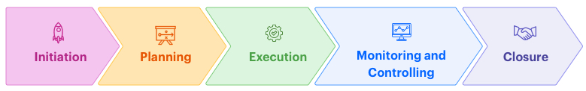
Figure 1: Phases of Project Management (Lennon, 2021).

Initiation: Launching a project turns a concept into a goal. The manager should now be creating a strategic plan and project outline. First, determine the project's scope and draft a charter. The project scope statement details the project's scope, objectives, goals, management, money, timeline, and more. After setting project goals and scope, identify key stakeholders. Gather stakeholder information, including titles, contact information, influence, and project benefits. The scope of the project does not include technical details from the planning phase, only the project's end goal.
Planning: The project's roadmap must be meticulously planned. Unless you're employing agile project management, phase 2 of managing projects will take almost half the project's time. Technical requirements, project schedules, communication plans, and goals/deliverables are the main duties in this phase.

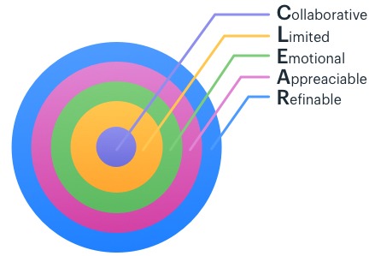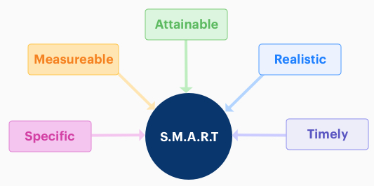
Figure 2: Types of Goals (Gatti, 2019).

S.M.A.R.T. and C.L.E.A.R. are the two most popular project goal-setting methodologies. The "SMART" criteria critically evaluate your project goals (Campbell, 2022). It decreases risk and helps project managers set realistic targets. Modern workplaces require a flexible goal-setting system like "CLEAR." CLEAR can assist citizen developers to adapt to fast-paced businesses. Project scope is defined during planning. Project managers must approve scope changes. Planning includes creating a project timeline with deliverables. The project manager extrapolates prior data to identify program management risks and devise a mitigation plan.
Execution: The whole team works during project execution. Project managers create effective workflows and regularly monitor team progress (Lennon, 2021). The managers involved in this project must also ensure stakeholder collaboration during this time. This keeps everyone in sync and the project running well. Best project collaboration tools are accessible.
Monitoring and Controlling: The third and fourth project management phases are not sequential. Project objectives and deliverables are realized through simultaneous project monitoring and control. By setting CSF (Critical Success Factors) and KPIs (Key Performance Indicators), project managers can prevent deviation from the plan (KPI). Project managers quantify effort and expense during monitoring. This tracking keeps the project within budget and helps future projects. For instance, the project leader will think about how well the training is helping the employees improve their skills at a certain level. If the project isn't going as planned, he can also use the right plans or change the plans.
Closing: Project management ends here. Project closure occurs after delivery. Sometimes project-specific contract talent is hired. The project manager must also terminate and file these contracts. Most teams have a post-project reflection meeting to discuss their triumphs and mistakes (Lennon, 2021). This helps the organization improve continuously to boost team efficiency. The manager will conclude with a comprehensive project assessment and report. The higher authority of WysePower can obtain all relevant data in a secure location.

Analysis of the Project's Stakeholders
To successfully manage a project, it is essential to do a thorough analysis of the many stakeholders involved (Verzuh, 2019). Potential parties with an involvement in the project's outcomes are referred to as "stakeholders".
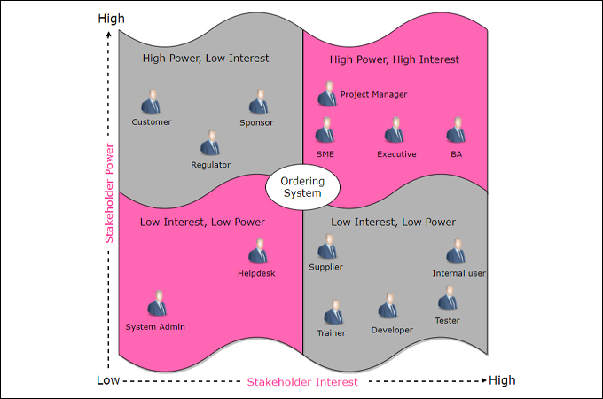
Figure 3: Stakeholder matrix (Smith, 2014).

Multiple internal and external parties are involved in the staff training effort. It is the responsibility of the project manager to identify these issues and deal with them efficiently (Crosby, 2022). See below for an explanation of the various stakeholders and the corresponding stakeholder matrix.

Stakeholder | Internal / External | The measure of the stakeholder's influence or interest | In what ways might this stakeholder influence or be influenced by the project? | Techniques of Exchange of Information
Project manager | Internal | High power/ high interest | The project coordinator will plan, implement and oversee the project. | Personal meeting
Customers | External | Low power/ low interest | The customers will obtain great services. | Social media
Sponsor | Internal | High power/ low interest | The project's financial plan and timeline will be green-lit by the sponsor. | Conversations over the phone and in person
Trainer | External | High power/ low interest | They promise to supply instructions. | Communicate via phone and electronic mail.
Developers | External | Low power/ low interest | Violations will be tracked | Phone and electronic mail.
Internal user | Internal | High power/ high interest | They'll have the ability to develop and strengthen their skills. | Phone and electronic mail.
Tester | Internal | Low power/ high interest | They will act as project managers. | Conversations over the phone, email, and in person
System Admin | External | Low power/ low interest | They'll lend a hand to the project manager as work gets done. | Conversations over the phone and in person
Table 2: Analysis of the Stakeholder Matrix (Source: Author).
These are some of the ways through which the impacts of the stakeholders can affect the project development.

Project Work Breakdown
The WBS is the method by which project tasks are decomposed into more manageable chunks (Maylor, 2021). Different duties and semi should be defined and assessed in the worker training program. We have included the project's WBS for perusal below:
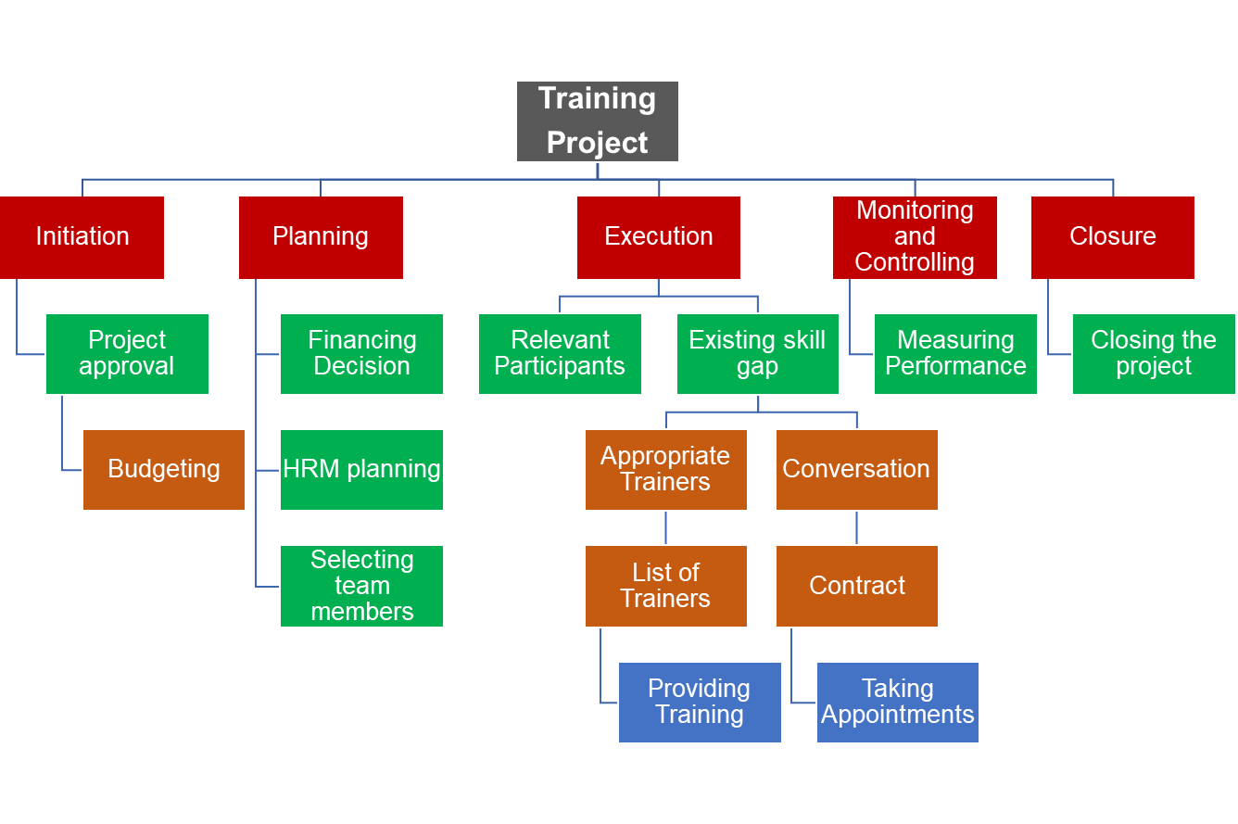
Figure 4: Project work Breakdown (Source: Author).
The Work Breakdown Structure (WBS) for the Training Project is depicted in Figure 4 with expanded Level 1, Level 2, and Level 3 Elements. Work Packages are the most granular level of the WBS's Legs and Branches. Information about the deliverable (its owner, achievements, durations, resources, risks, etc.) is captured in the work package.

Project Cost Estimation
Identifying the amount of money that will be needed to complete a project is the definition of project cost estimation (Joslin, 2020). There are a variety of expenses involved with this endeavor. Items included in the projected price range are:
Particulars | Estimated cost (£)
Payment for Advice During Project Planning | 2,500
Project Manager's Salary | 4,900
Project staff compensation | 8,200
The price tag of scientific investigation | 1,250
Booking of Communication Space | 2,250
Inbound and Outbound Transport Logistics | 4,700
Cost of Training | 18,000
Total | 41,800
Table 3: Cost estimation table (source: Author).

Consultation fees are listed in the table as one of the many expenditures associated with the training project. Payment for the project manager and team members, the price of research, the price of training, the price of communication, price of logistics supplies, and the price of transportation. That puts the grand total of the project at £41,800.

Project Gantt chart
When planning a project, a Gantt chart can be a helpful tool for visualizing the tasks that will be completed on certain days. It's a straightforward stacked bar chart that shows the beginning, middle, and finish dates of a project alongside its major milestones. Microsoft Project is a great tool for making a Gantt chart. The data, however, has been entered correctly into Ms. Excel. Below is a depiction of WysePOower's employee training initiative.

Figure 5: Gantt Chart for Employee Training (Source: Author).
The aforementioned Gantt chart was constructed in Microsoft Excel with the project's tasks included. According to the Gantt chart, work on the project will begin on October 29, 2022, and wrap up on February 11, 2023.

Analyzing Risks Involved in the Project
There are many potential threats to the staff training project. Potential threats that the project coordinator needs to be aware of are known as risks.
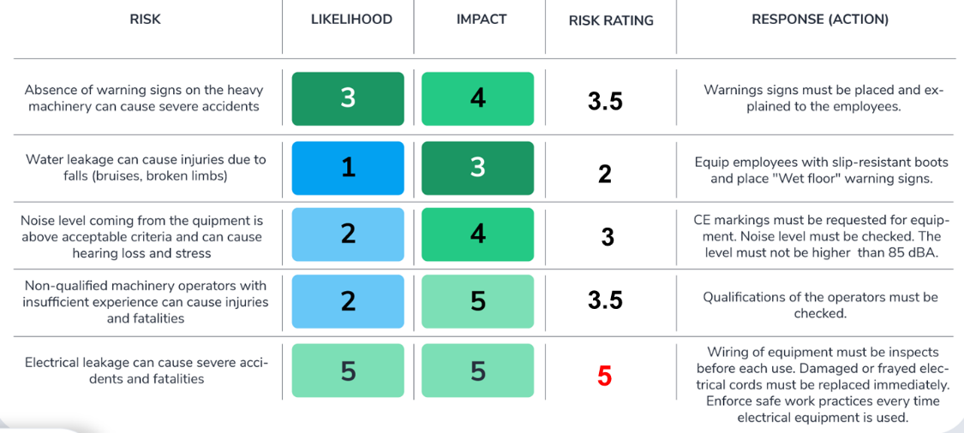
Table 4: Risk Measurement (Source: Author).
As a vital aspect of the project management process, risk management enables the manager to take corrective action to lessen the impact of risk (Smith, 2014). In addition, there are numerous dangers of various kinds associated with the aforementioned endeavor that could reduce its likelihood of success. Indicated in the risk matrix are the probabilities and consequences of various threats to the project. The state project's risk matrix is displayed in the following table:

Quality, Results, and Preventative measures
Before beginning a project, keep in mind the quality expectation, quality specifications, and procedures to control the event (Joslin, 2020). The following performance expectation, specifications, and procedures to regulate the event should be taken into account by the project manager in the aforementioned project of worker training to develop their skill using effective tools for communication and collaboration.

Specifications and expectations for quality:
- Training workers to become more efficient.
- Capacity to make use of means of interaction and cooperation.
- Timeliness in completing the assignment is essential (Maylor, 2021).
- Ideally, the project's final price tag would end up being exactly what was predicted.
- Training should be of sufficient quality.

Methods of Supervision and Regulation:
For successful project completion, there must be reliable methods of monitoring and controlling the project's progress. The event can be monitored and evaluated in a number of ways; for example, the project manager could put in place a controlling and monitoring team to keep tabs on how things are going (Verzuh, 2019). To evaluate success, one must first establish a standard against which actual results can be measured. Project managers should also use Complete Quality Management (TQM) techniques when carrying out their duties. Thus, it will be able to involve people at every level of the organization in the transition.

Conclusion
A methodical approach is required for implementing the WysePower-approved project. The project plan that was created nearly encompasses all the fundamentals of a successful endeavor like the implementation of the project activities along with the life-cycle, stakeholder analysis, WBS, cost estimation, Gantt chart, risk matrix analysis, and lastly, recommendation. All project stakeholders and risks have been evaluated and cataloged. Accordingly, the success and achievement of the project's aims and objectives are anticipated.

References
Campbell, K. (2022) Project development. Sports Council.
Crosby, B. (2022) Stakeholder analysis: A vital tool for strategic managers. Washington, D.C.: USAID's Implementing Policy Change Project.
Gatti, S. (2019) “Project Characteristics, risk analysis, and Risk Management,” Project Finance in Theory and Practice, pp. 43–75. Available at: https://doi.org/10.1016/b978-0-12-391946-5.00003-7.
Johansson, P.-O. (2017) Cost-benefit analysis of environmental change. Cambridge: Cambridge University Press.
Joslin, R. (2020) “Project Management Methodologies, project SUCCESS, Project Governance, contingency theory, agency theory, and stewardship theory,” Project Management Methodologies, Governance and Success, pp. 17–30. Available at: https://doi.org/10.1201/9780429071416-3.
Lennon, C. (2021) “The project lifecycle,” The Silver Bullets of Project Management, pp. 14–35. Available at: https://doi.org/10.4324/9781003188964-4.
Maylor, H. (2021) Project Management. Harlow, England: Pearson.
Smith, D. (2014) “Informal Project Management,” Project Management Best Practices, pp. 441–453. Available at: https://doi.org/10.1002/9781118835531.ch9.
Verzuh, E. (2019) The fast forward MBA in Project Management. New York: J. Wiley.

