APPLIED QUANTITATIVE BUSINESS RESEARCH

Student Name: Xuya Li

Student ID Number: 1651110

Lecturer: Dr Abdullah Promise Opute and Dr Caroline Jawad

Submission Date : 29th Nov 2021

Assignment 2

Content
Abstract 2
Introduction 3
Rationale for choice of articles 5
Discussion of methodology and research design 7
Parametric and Non-Parametric Discussion 7
First picked articles Parametric or Non-parametric discussion (Pandey and Charoensukmongko, 2019) 8
Second picked articlesParametric or Non-parametric discussion((Kaur et al, 2009) 9
Quantitative research discussion 10
Methodology or research method discussion in the first picked article (Pandey and Charoensukmongko, 2019) 11
Methodology or research method discussion in the second picked article (Kaur et al, 2009) 13
Conclusion and recommendations 14
Bibliography 15
Appendix: 21
Appendix1: Link to the first picked article: 21
Appendix2: Link to the second picked article: 22
Appendix3: Parametric or Non-parametric procedures 23
Appendix4: Quantitative vs Qualitative 24

Abstract
There is not a completely perfect article, and according to the analysis of different articles, it will bring new thinking for the researcher. This reportfinding out two articles from twodifferent1start journals in2021Academic Journal Guide (AJG), Both of these two articles will have related topics and focus on the area between cross-culture to international business: the one is focused on the cross-culture and negotiation which conclude that Textile and Clothing exporters have a low level of awareness of cross-cultural negotiations in international business. And the other one is focused on cultural intelligence, which concludes thathigh cultural intelligence (CQ) willbring a good improvement forthe to behave ofinternational sellers. Then,base on the content of two journal artifices. the researcher will have a series analysis on different parts: including having a critically thinking on methodology, research method and design thinking, include discussion of alternative methods and predicting the changing of the result. And the relevant recommendation to shortcomings or potential limitations will be provided at last.

Introduction
In recent years, culture and its related areas such as cultural differences and cultural diversity started to play an important role in international business areas, such as Sebenius (2002) proposed that not only the culture will influence the negotiation in international business, but also different cultures will influence the expectation into the international negotiation. And Lu (2012) also conclude that, because of the influence of cultural difference, MNEs’ sellers have to face cross-culture challenges when they communicate with local customers. Therefore, with the research areas between the cross-culture and international business, the research will find two articles that base on the 2021 Academic Journal Guide (AJG), which is a guide in business and management journals and adopted by most UK business schools (Walker et al, 2019). Based on the platform of AJG, and focus on the International Business and Areas Studies, the research pick up two journals, the one in the Journal of Asia Business Studies, which provide the researcher with a related article called Contribution of cultural intelligence to adaptive selling and customer-oriented selling of salespeople at international trade shows: does cultural similarity matter (Pandey and Charoensukmongko, 2019)? another one is the journal of Foreign Trade Review, which provide research on one article called: An Analysis of Cross-Cultural Negotiations in Textile and Clothing Exporting Units (Kaur et al, 2009). From the topics of two articles, it seems like two articles are narrowing their research into two different areas, what Pandey and Charoensukmongko (2019) did is find out whether and how cultural intelligence contributes to the sellers’ customer-oriented and adaptive selling behaviour. And what Kaur and her partner authors (2009) did is doing research on the roles of textile and clothing export negotiation in foreign trade. However, both of these two articles have the same background in cross-culture and international business. Pandey and Charoensukmongko (2019) did research on CQ is going to find out whether culture and cultural factors such as cultural intelligence will enhance a good improvement for sellers to have a good behave in different countries selling. And Kaur and her partner authors (2009) did research in the area of cross-culture negotiation in foreign trade companies. Therefore, both of these two picked articles will show how culture and cross-culture play in the international business areas. This fit into the researcher request in this report. Therefore, the researcher firstly will provide a Rationale for the choice of articles to provide the reason why the researcher would like to pick up these two related topics articles. Secondly, this report will analyze these two different articles’ analytical approaches to identify whether these two articles use parametric or Non-parametric, and provide a reason why this analysis approach is appropriate or not to be used in these two articles. Thirdly, this report will have critically discuss and compare two different articles’ research design, methodology and findings, including discussions on whether using an alternative method will bring a different result at last. Finally, this report will conclude two articles’ shortcomings and then base on their shortcomings, discuss whether and how to change research design, research method or methodology will improve the result.

Rationale for choice of articles
The first reason for picking these two articles is about the research interested area: culture influence in international business. International business plays a role in trading goods, technology, capital and knowledge on a global scale, which increase the service between different countries and increase the co-operation between different countries (Joshi, 2009). For the roles of culture play in international business, this is a debated item in different people (Yeganeh, 2011), because in the traditional international business area, people may be more concerned about the factors such as economic, market, local legal and local policies (Leung et al., 2005) but culture. However, culture and its related research area have been found that it will have effect in business even international business area, for instance, different national cultures will bring different influences in business activity such as the influence in group performance and capital structure (Gibson, 1999; Chui et al., 2002). Moreover, other related cultural areas such as cultural distance also been proved that it has built one internal focus, institutional and widely used framework in the areas of international business, which will bring influence to strategy decisions making in different organizations or MNEs, such as entry mode choice, investment in the foreign countries and Foreign branch performance policy. (Srivastava et al., 2020; Shenkar, 2012). Therefore, base on the interest of cultural influence on international business. Although two picked articles did their research in different areas: one is focused on the CQ influence in international selling and the other one is focused on the importance of cross-culture international negotiation, they still show how culturally related areas influence the relevant international business areas, which is fit into the researchers request in this report.

The second reason is for the definition of culture itself and methodology selected by the two articles’ authors. For the definition of culture, different people will have different descriptions on it, such as Spencer-Oatey (2012) conclude that, due to face that different people are living in different organizations in this world, different people may have different thinking on culture and there will be difficult to have a common admitted definition (Schein 1990). Therefore, because of this different descriptive with different performance, the definition of culture still needs to be rethought because of different influence factors (Hofstede, 1991; Popescu, 2019). Furthermore, base on the discussion of the definition of culture and characteristics of quantitative and qualitative research: the qualitative is focused on the rich descriptions and the quantitative research is focused on the numerical summaries (Polit and Beck, 2010). it seems that using the qualitative research methods in More subjective research areas such as culture will be more suitable than using numbers to analyze it. However, both of the two picked articles did their research based on quantitative research. Analyze these two articles not only will make the researcher enhance the understanding of the research method, advantages and limitations of using quantitative research, but also will make research know more about the basics of using quantitative research in the area of cross-culture and international business, which will bring a improve for the researcher to know how to use quantitative research into relevant research areas in the future.

Discussion of methodology and research design

Parametric and Non-Parametric Discussion
Before discussing the analysis approach in the two picked articles, it is necessary to have an introduction to Parametric and Non-Parametric. For the definition Parametric, according to Cox (2006) proposed that Parametric statistic can be imagined as one well-known statistic method, Parametric statistic belongs to one part of the statistic and it assumes that data of sample all come from one population and this population can be fully modelled by a fixed group of parameters probability distribution (Geisser and Johnson, 2006). For the definition of Non-parametric, Non-parametric also belongs to one part of the statistic, the difference between Non-parametric to Parametric definition is when data is modelled, the Non-parametric will not need to assume the data structure, but it still can do some hypotheses to the distribution, such as assume whether the distribution is symmetry or continuity, and Non-parametric also always has been used for the situation that the hypotheses of parametric tests are not right (Cox, 2006; Pearce and Charoensukmongko, 2019). In detail, to analyze whether one article uses a Parametric or Non-parametric analysis approach, the first method is analyzing that whether this article uses the relevant procedures, such as Hoskin (2012) conclude a table about Parametric or Non-parametric procedures (Appendix3), In that table, when comparing the means between two different or independent groups, the Parametric will use the two-sample t-test and Non-parametric will use the method of Wilcoxon rank-sum test. When comparing two different quantitative measurements from one individual, the Parametric will use Paired t-test and the Non-parametric will use Wilcoxon signed-rank test. When comparing means between equal or over three different or independent groups, the parametric will use the analysis of variance (ANOVA), and Non-parametric will use the Kruskal-Wallis test. And when calculating the connection between two quantitative variables, the parametric will use Pearson coefficient or correlation and Non-parametric will use Spearman’s Rank Correlation. Furthermore, there are some simple characteristics that will show whether this article use Parametric or Non-parametric analysis approaches: the types of SEMs. Such as for the PLS-SEM and CB-SEM, if one article claims that it uses the PLS-SEM as its statistic analysis approach, it means that this article is using the Non-parametric because the approaches such as PLS-SEM or VB-SEM belong to the Non-parametric but one Parametric method like CB-SEM (Mohamad et al., 2019).

First picked articles Parametric or Non-parametric discussion (Pandey and Charoensukmongko, 2019)
According to the Pandey and Charoensukmongko (2019) proposed in the statistical analysis technique, what whey used in this article is Partial Least Squares Structural Equation Modeling (PLS-SEM), because as they think, PLS-SEM will provide different statistical methods to choose, for instance, structural equation modelling, multiple regression analysis and path analysis (Hammer et al., 1978), and moreover, PLS-SEM will not require the data structure shows the normaldistribution and will not require large sample such as SEM (Chin, 1988). Therefore, the characteristics of PLS-SEM fit into their situation. Because they think they have a small sample and they propose they find out most of their data does not show a normal distribution. Overall, from what the researcher found from this article, data not showing a normal distribution and using PLS-SEM as their statistic analysis approach will prove that they are used Non-parametric in their research such as this report introduced before (Cox, 2006;Mohamad et al., 2019). From the researcher opinion, considering the advantages of Non-parametric, such as Non-parametric will not ask the people to have a normal distribution data structure(Frost, 2017), good for using in the small simple and can be used for solving the problems that result may outlying observation or unexpected in the research (Whitley et al., 2002). the researcher thinks that the Non-parametric is appropriate in this research due to the fact the authors in the first article meet the situations that data do not show the normal distribution and they think they use small simple in their research. However, the authors also need to consider some limitations from Non-parametric such as small simple questions and P-value may not obvious (Whitley et al., 2002).

Second picked articlesParametric or Non-parametric discussion((Kaur et al, 2009)
From the second picked article (Kaur et al., 2009), there is obvious evidence to prove that this article uses the Parametric approach, this evidence comes fromresearch methodology that the authorswould like to use the statistic tool such as percentage, mean scores and t-testto do data analysis, in detail, they used these tools to analyze different section such as factors that influence cross-cultural negotiation preparation, the resultpreparation, and different information that participants may obtain from other places before the negotiation and other over 30 tables. Therefore According to what authors did in their research, using t-test and analysis the group means can be thought of as evidence as using Parametric, such asKim (2015) proposed that t-test belongs to a Parametric analysis approach, and Parametric also focus on the analysis of the group means (Frost, 2017). From the researcher opinion, what makes researchers worried to use Parametric in this article is the size of simple. From the articles, what sample that used by the authors of this research is 40 exporters, which include 5 large scale exporters and 35 small exporters. 40 samples seem a little small to use the t-test in parametric. Such as De Winter (2013) proposed that some meteorologists suggest that do not use a t-test when the sample is small. Of course, the sample in this article is not small as what the meteorologist said. Otherwise, if the authors can use more samples, it will avoid the potential risk such as being less precise (Frost, 2018) and make it more appropriate in this article.

Quantitative research discussion
Before analyzing the research method or methodology of two picked quantitative research articles, it is necessary to have a discussion about quantitative research itself. Generally, quantitative research is one research or research strategy that focus on the collection and analysis of numerical data (Bryman, 2016). Most quantitative research is completed by using quantitative research methods and technology such as numerical analysis, mathematical even using big data (Tominc, 2018). With several years of academic articles published, quantitative research has been proved that have good use in different types of the research areas, such as social science, natural science, formal science and applied science (Given, 2008; Muijs, 2004; Babbie, 2020). For quantitative research, to find out how it works in one quantitative research study, it is important to know its strength and weakness, and comparing it to qualitative research will be a good method to know the characteristics of quantitative research. According to the conclusion from Apuke (2017), there is one table (Appendix4) that compare both quantitative research and qualitative research (Johnson and Christensen, 2008; Lichtman, 2012). From the table, there are some advantages of using the quantitative, for instance: firstly, sample size, comparing lower sample in qualitative research, large sample will bring more validity and reliability to convince the readers that what researcher done is more likely to represent a population. Secondly, using the statistical analysis approach also improves the ability for quantitative research to hand huge different types of data and find out what is inside of it. Thirdly, the objective is critical in quantitative research, which means compared to qualitative research that more expect subjectivity, data and result from good quantitative research will have less bias and more close to the real situation. However, there is also something that may bring limitation for quantitative research, because there are always planning and execution in every methodology and during the process of two steps, there is something that may not be controlled by researchers themselves (Younus, 2014; Simon and Goes, 2011). in quantitative research, firstly, the limitation such as choosing an improper target population will bring a wrong calculation on probability distribution even lead to a failure of the whole research, despite the author choosing a suitable sampling method (Chetty, 2016). Secondly, lacking resources also could be one limitation to having good and completely quantitative research (St-Pierre, 2001) due to fact that quantitative research usually needs a large sample in its research. Thirdly, research in an uncontrollable environment is also one weakness of less deep research. Because if there are some special and emergency events that happened in the researcher’s research environment, this also may bring an unexpected influence to the results from participants (Baxter and Jack, 2008), and it will be difficult to normal quantitative research method such as questionnaire to change this situation. Fourthly, quantitative research methods such as questionnaires cannot avoid facing the question of not accurate or not real data, because limited options supported by researchers may not show a real answer from participants (Chetty, 2016; Neuman, 2006).

Methodology or research method discussion in the first picked article (Pandey and Charoensukmongko, 2019)
Pandey and Charoensukmongko (2019) proposed that they wish to analyze whether CQ will bring a positivist influence to sellers in cross-culture international business selling. The first advantage is the authors used questionnaires to collect information from Thai sellers who did their selling work in two different trade exhibitions: Japan and Vietnam. Both Japan and Vietnam trade exhibition has been sent 120 questionnaires and the Japan trade exhibition receive 110 feedback, which means 92% response rate, and Vietnam also receive 100 feedback, which is an 83% response rate. These response rates are high response rates because usually the response rate will change around 33% (Lindemann, 2019), and the two response rates are much higher than 33%, which means the two authors have good control for their data collection process. Although two authors think their data is a small sample, a higher response rate such as over 80% is better than a low response rate in a large sample (SJ, 1991). the second obviously advantage in this article is two authors using Jarque-Bera test to confirm and find out that most of their research’s variables are not normally distributed, therefore, what they decided to do is use the analysis tool of Partial Least Squares Structural Equation Modeling (PLS-SEM), which belongs to Non-parametric (Mohamad et al., 2019). the third obviously advantage for this article’s methodology is two authors did confirm the importance of validity and reliability in this article, for validity of the data, two authors use factor loadings to do the test of convergence validity, and the result is all factor loadings all over 0.5 and support the convergent validity (Hair et al., 2006). Two authors also used the comparison between the squared correlation coefficient to average variance extracted (AVE), to evaluate and confirm discriminant validity by analyzing whether the square root of AVE is larger than the correlation between the constructs (Fornell and Larcker, 1981), and the result shows that all AVEs meet the request of confirming the discriminant validity. For reliability, two authors used the composite reliability coefficient and Cronbach’s alpha coefficient to test construct reliability, the result from the test showed that all two coefficients are higher than 0.7, which fit into the situations all constructs’ coefficients meet the requirement of confirming the construct readability (Nunnally, 1978). According to the analysis before, the researcher in this report can confirm that research methodology and research design is fine example in quantitative research because it covers many factors of quantitative research such as confirming the data structure, using a special tool to analyze the validity and reliability of this article and choose the right statistic analysis tool to find out the result. However, the limitation of this article also exist, such as sample size, this limitation also admitted by two authors, this article only has done their research in Asia area, but not a global area, what the result shows only limited in a small scale but a large scale, this will be a good article for international sellers to confirm that result is can be applied in the country like in Japan and Vietnam but it is not clear to be confirmed that the result is also useful in other countries especially the countries that not local in Asia.

Methodology or research method discussion in the second picked article (Kaur et al, 2009)
From the what authors did in the second picked article (Kaur et al, 2009), this is an obviously quantitative such as the authors use descriptive research design with the way of structure questionnaire and closed questions, which will assist the authors to describe the pattern or correlation between different factors or variables, and guide the authors to find out the reason and purpose in this research (VOXCO, 2021), such as what authors have done a lot of comparisons between different factors by using t-test with finding whether t-value or two-tail t-value is significant(Bliese and Wang, 2020), so that the authors can find out significant factors from five negotiation steps: Negotiation preparation, building of relationship, exchange of related information, persuasion and concession and agreement (Kaur et al, 2009; ), to evaluate to different negotiation parts of Textile and Clothing Exporting Units and finding out how these participants awareness of cross-cultural international business (Kaur, 2007). Compared to the first picked article, the second picked article did more data (over 30 tables) data analysis tables to prove the findings at last, and using the tool like t-test, and mean numbers comparison also prove that this article using the parametric approach. However, perhaps because of the characteristic of descriptive research design such as there is no treatment or intervention during the whole relevant steps with data, no need to have hypotheses or test hypotheses (Baker, 2017) the authors did not provide clear evidence that they set up a hypothesis. Moreover, although there are several pieces of evidence that the authors use parametric (Kim, 2015; Frost, 2017), there is no clear evidence to prove that the authors confirm the normal distribution of the data. Furthermore, With the characteristics of no controlling of variable, there is no statistical analysis to the result, there is no clear evidence to prove that authors did a test the validity or reliability. All of these factors may cause this article to be considered unscientific by some people (Shuttleworth, 2008)

Conclusion and recommendations
Overall, analyzing two interested quantitative research articles brings a new sight for the researcher to do further study in research methodology, such as the first picked article (Pandey and Charoensukmongko, 2019) shows the researcher about the different methods to test hypnoses, test data structure, test validity and test reliability in the cultural research area, therefore, which can help the researcher to know more approaches to build his thinking in cultural research areas in the future. For the second picked article (Kaur et al, 2009). The authors provide another different method to do quantitative research in the cross-cultural research area, which put another new thinking for the researcher, although descriptive research design is different to much normal quantitative research method, this is still an option that can be picked by the researcher, especially when the researcher would like to combine the qualitative research approach and quantitative research approach and wish to focus on descriptive in the future.

For the first picked article (Pandey and Charoensukmongko, 2019), quantitative research is a good opinion for them to continue their study, but they can increase their sample size and extend their research area from Asia to Europe, even extend their research to the global area in the future. CQ is one of the important theories in cross-culture area research, if authors can extend their research scale perhaps they can conclude a series of comparisons between different countries such as what Hofstede (2001) did to compare cultural distances between different countries. For the second picked article (Kaur et al., 2009), if the authors wish to focus on the describe a situation, they can consider the possibility of using the Mix-method or only using the qualitative research in their research. Because what qualitative research may bring a deep think for the research (Creswell et al., 2007), which means once use qualitative research, not only the authors will find out whether T&C export have a good understanding of cross-culture negotiation, but also the authors may find out the reason why they have this situation so that they can provide a detail recommendations for that situation in their research.

Bibliography
Apuke, O. D. (2017). Quantitative research methods: A synopsis approach. Kuwait Chapter of Arabian Journal of Business and Management Review, 33(5471), 1-8.

Baxter, P., & Jack, S. (2008). Qualitative Case Study Methodology: Study Design and Implementation for Novice Researchers' 13 (4). The Qualitative Report, 544

Babbie, E. R. (2020). The practice of social research. Cengage learning.

Baker, C. (2017). Quantitative research designs: Experimental, quasi-experimental, and descriptive. Evidence-based practice: An integrative approach to research, administration, and practice, 155-183.

Bliese, P. D., & Wang, M. (2020). Results provide information about cumulative probabilities of finding significance: Let’s report this information. Journal of Management, 46(7), 1275-1288.

Bryman, A. (2016). Social research methods. Oxford university press.

Chetty, P. (2016). Limitations and weakness of qualitative research methods. Project Guru.

Chin, W. W. (1998). The partial least squares approach to structural equation modeling. Modern methods for business research, 295(2), 295-336.

Cox, D. R. (2006). Principles of statistical inference. Cambridge university press.

Creswell, J. W., Hanson, W. E., Clark Plano, V. L., & Morales, A. (2007). Qualitative research designs: Selection and implementation. The counseling psychologist, 35(2), 236-264.

De Winter, J. C. (2013). Using the Student's t-test with extremely small sample sizes. Practical Assessment, Research, and Evaluation, 18(1), 10.

Fornell, C., & Larcker, D. F. (1981). Evaluating structural equation models with unobservable variables and measurement error. Journal of marketing research, 18(1), 39-50.

Frost, J. (2017). Nonparametric tests vs. parametric tests. Statistics by Jim Blog.

Frost, J. (2018). How t-Tests Work: t-Values, t-Distributions, and Probabilities. Statistics by Jim Blog.

Geisser, S., & Johnson, W. O. (2006). Modes of parametric statistical inference (Vol. 529). John Wiley & Sons.

Given, L. M. (Ed.). (2008). The Sage encyclopedia of qualitative research methods. Sage publications.

Hair, J. F., Black, W. C., Babin, B. J., Anderson, R. E., & Tatham, R. (2006). Multivariate data analysis . Uppersaddle River.

Hammer, M. R., Gudykunst, W. B., & Wiseman, R. L. (1978). Dimensions of intercultural effectiveness: An exploratory study. International Journal of Intercultural Relations, 2(4), 382-393.

Hofstede, G. (1991). Cultures and Organizations. Software of the Mind. London:

Hofstede, G. (2001). Culture's consequences: Comparing values, behaviors, institutions and organizations across nations. Sage publications.

Hoskin, T. (2012). Parametric and nonparametric: Demystifying the terms. In Mayo Clinic (Vol. 5, pp. 1-5).

Johnson, B., & Christensen, L. (2008). Educational Research: Quantitative, Qualitative, and Mixed Approaches. SAGE.

Joshi, R. (2009). International Business, Oxford University Press. New Delhi and New York.

Kaur H. (2007), Cross Cultural Negotiations – A Study of Exporting Units of Textile and Clothing in Ludhiana

Kaur, H., Sachdeva, Y. P., & Kumar, B. (2009). An Analysis of Cross-Cultural Negotiations in Textile and Clothing Exporting Units. Foreign Trade Review, 44(1), 44-67.

Kim, T. K. (2015). T test as a parametric statistic. Korean journal of anesthesiology, 68(6), 540.

Leung, K., Bhagat, R. S., Buchan, N. R., Erez, M., & Gibson, C. B. (2005). Culture and international business: Recent advances and their implications for future research. Journal of international business studies, 36(4), 357-378.

Lichtman, M. (2012). Qualitative research in education: A user's guide. Sage publications.

Lindemann, Nigel. (2019) "What’s the average survey response rate? SurveyAnyplace Blog. [Online].
Available at: https://surveyanyplace.com/blog/average-survey-response-rate//[Accessed 6th November 2021].

Lu, L. T. (2012). Etic or emic? Measuring culture in international business research. International Business Research, 5(5), 109.

Mohamad, M., Afthanorhan, A., Awang, Z., & Mohammad, M. (2019). Comparison between CB-SEM and PLS-SEM: Testing and confirming the maqasid syariah quality of life measurement model. The Journal of Social Sciences Research, 5(3), 608-614.

Muijs, D. (2004). Doing quantitative research in education: With SPSS. Sage.

Neuman, W. L. (2006). Workbook for Neumann Social research methods: qualitative and quantitative approaches. Allyn & Bacon.

Nunnally, J. C. (1978). Psychometric Theory: 2d Ed. McGraw-Hill.

Pandey, A., & Charoensukmongkol, P. (2019). Contribution of cultural intelligence to adaptive selling and customer-oriented selling of salespeople at international trade shows: does cultural similarity matter?. Journal of Asia Business Studies, 13(1), 79-96

Pearce, J., & Derrick, B. (2019). Preliminary Testing: The devil of statistics?. Reinvention: an International Journal of Undergraduate Research, 12(2).

Polit, D. F., & Beck, C. T. (2010). Generalization in quantitative and qualitative research: Myths and strategies. International journal of nursing studies, 47(11), 1451-1458.

Popescu, D. (2019). Culture as factor of economic development. Revista Economică, 71(4).

Schein, E. H. (1990). Organizational culture. American Psychologist, 45(2), 109–119.

Sebenius, J. K. (2002). The hidden challenge of cross-border negotiations. Harvard Business Review, 80(3), 76-85.

Simon, M. K., & Goes, J. (2011). Developing a theoretical framework. Seattle, WA: Dissertation Success, LLC, 13-18.

SJ, I. E. (1991). Good surveys guide: go for small random samples with high response rates. BrMed J, 302, 302-3.St-Pierre, N. R. (2001). Invited review: Integrating quantitative findings from multiple studies using mixed model methodology. Journal of dairy science, 84(4), 741-755.

Spencer-Oatey, H. (2012) What is culture? A compilation of quotations. GlobalPAD Core Concepts. [Online]. Available at: http://www2.warwick.ac.uk/fac/soc/al/globalpad/interculturalskills/.[Accessed 6th November 2021].

Srivastava, S., Singh, S., & Dhir, S. (2020). Culture and International business research: a review and research agenda. International Business Review, 29(4), 101709.

Shuttleworth, M. (2008). Descriptive research design: Observing a phenomenon. Explorable. [Online]. Available at:
https://explorable.com/descriptive-research-design[Accessed 7th November 2021].

Tominc, P., Krajnc, M., Vivod, K., Lynn, M., & Frešer, B. (2018). Students’ behavioral intentions regarding the future use of quantitative research methods. Polona Tominc, 64(2), 25-33

VOXCO (2021). Descriptive Research : Definition, Method and Examples. Voxco. [Online]. Available at:
https://www.voxco.com/blog/descriptive-research/[Accessed 7th November 2021].

Walker, J. T., Salter, A., Fontinha, R., & Salandra, R. (2019). The impact of journal re-grading on perception of ranking systems: Exploring the case of the Academic Journal Guide and Business and Management scholars in the UK. Research Evaluation, 28(3), 218-231.

Whitley, E., & Ball, J. (2002). Statistics review 6: Nonparametric methods. Critical care, 6(6), 1-5.

Yeganeh, H. (2011). Culture and international trade: evidence from Canada. International Journal of Commerce and Management.

Younus, M. A. F. (2014). Research methodology. Vulnerability and Adaptation to Climate Change in Bangladesh: Processes, Assessment and Effects (Springer Theses). Springer, 35–76

Appendix:

Appendix1: Link to the first picked article:
https://journals-sagepub-com.ezproxy.uwtsd.ac.uk/doi/pdf/10.1177/0015732515090103

Appendix2: Link to the second picked article:
https://www.proquest.com/docview/2172624640?accountid=130472

Appendix3: Parametric or Non-parametric procedures

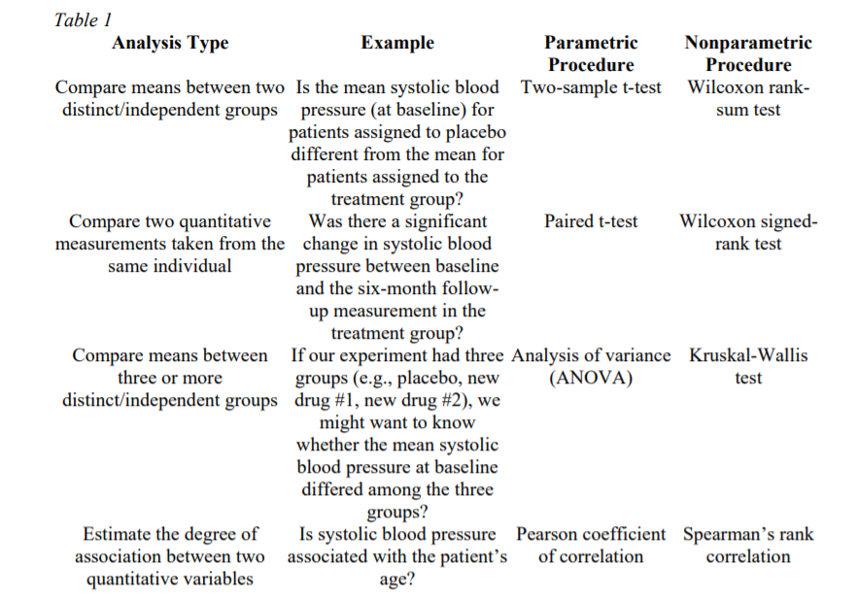
(Source from Hoskin, 2012)

Appendix4: Quantitative vs Qualitative
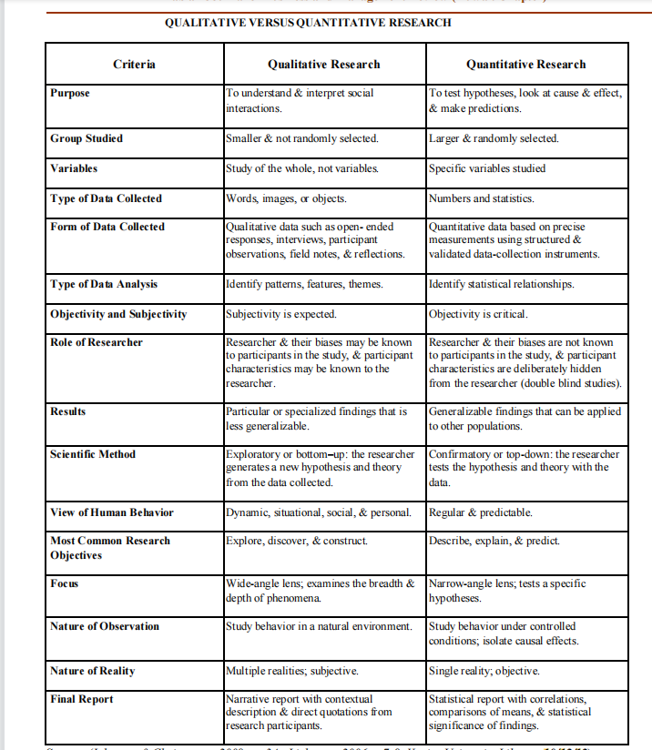
(Source from Apuke, 2017)

