THE IMPORTANCE OF EFFECTIVELY MONITORING GUEST SERVICE APPROACHES
Student Name: Ionela Madalina Cananau

Student Number: 2243593

Hospitality and Guest Service Management BMIH4003

Lecture Name: Charlotte Joyner

Word Count 1649
Executive Summary
The notion of guest service strategies is increasingly important for providing designated service to consumers and gathering better satisfaction. This report produces a brief highlight of different perspectives regarding the hospitality industry and its guest service tactics. A delivery of high-quality consumer service often tends to motivate consumers for repetitive consumption of hospitality services in the larger context. IoT and Voice assistant technological developments have been cited to offer better interaction capabilities and strive to develop a reputation. Employee satisfaction levels also have an important degree in determining the quality of consumer service. Multinational enterprises' examples have been integrated into the report to understand their employee satisfaction levels and deliver quality customer service.

Table of Contents
Introduction 5
Main Findings 5
Analysis of understanding the importance of guest service strategies and their use 5
Evaluation of guest needs and value of empowerment 6
Critical analysis of reputation management in the hospitality industry 7
Implications of service culture in the hospitality segment 8
Recommendations 9
Conclusion 10
References 11

Introduction
Guest service terminologies have been highlighted as the predominant factor in the enhancement of consumer orientation and loyalty in the hospitality industry. The report will illustrate perspectives that are conjugated with the hotel operations and their utilisation for upholding consumer relationships. Real-world examples of different organisations that successfully employed guest service strategies to enhance their performance and consumer satisfaction levels will also be taken into account. The importance of employee empowerment for improving service quality will also be described in the study along with their potential implications. Reputation management terminologies will be reciprocated to determine the degree of success and will be incorporated in the report along with their management tactics.

Main Findings

Analysis of understanding the importance of guest service strategies and their use
Adaption of guest service strategies become increasingly important for the hotel and hospitality segment to keep consumers oriented with their offerings as well as ensure an extensive degree of satisfaction. A notion of quality guest service tactics within the hospitality industry could be beneficial to uphold an extensive degree of good relationship with consumers and expect broader loyalty (Zhu, Lam and Lai, 2019). Moreover, the portrayal of a coherent consumer service could also assist in gaining comprehensive business leads as consumers would work as ambassadors for the business and offer larger prospects. It could also provide larger assistance regarding the promotion of the hospitality facilities and employ a higher degree of satisfaction among consumers. Apart from that, consumers could tend to be repetitive to utilise the hotel services as well as demonstrate a higher degree of loyalty to the facilities as they are being treated with high-quality of guest service (Teng, 2019). Employees would also required to be oriented to respond to every scenario a guest faces inside the hotel facilities.

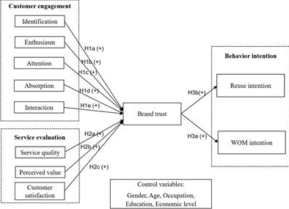
Figure 1: Relationship between consumer engagement and brand trust
(Source: Chen et al., 2022)
A higher degree of brand trust could be generated by hotel operators by providing quality consumer services as well as ensuring that they respond to their difficulties as necessary(Chen et al., 2022). It would further help to gain value among consumers as well as encourage them to reuse that would translate into business growth for hotel operators in the broader aspect. The multinational hotel company Hyatt Hotels have transformed their call centre and designated them to respond to every query of consumers as well as figure out their problems (Solomon, 2020). It has been highlighted as one of the key elements for small or big hospitality businesses to interpret guest responses and areas that could be improved further.

Evaluation of guest needs and value of empowerment
Empowerment of employees across the hospitality segment allows for broader participation of employees and their engagement in the procurement of consumer services in the broader context (Hoang et al., 2021). It is a positive terminology that offers higher prospects for low-level employees to participate in management functionality and feel more engaged with procedures. In order to comprehend quality consumer service across organisational functionalities, employee engagement through empowerment is required to be procured in a broader assortment and deliver quality consumer services. Empowerment of employees could be beneficial for producing an extensive degree of commitment towards the organisation and they will delightedly enquire about guest needs in the broader context (Shin and Perdue, 2022). Creative service tactics could be interpreted that would ensure more guest engagement with broader motivation.
A broader degree of empowerment through power sharing and allowing them to participate in management decision-making procedures are beneficial to developing a sense of self-sufficiency among staff and commitment to providing guest services (Murray and Holmes, 2021). Employees would have higher levels of satisfaction levels as well as psychological sound that would be devoted to guests with higher flexibility to respond to guests' requisites. J.W. Mariott has been identified for offering a higher degree of empowering employees as well as assisting them to participate in managerial decision-making procedures and offering quality treatment for guests (Hyken, 2022). Leadership and management decision-making could be role models for employees as they are committed to delivering better service for consumers across Marriott facilities.

Critical analysis of reputation management in the hospitality industry
Reputation management in the hotel segment comprises the perceived quality of service that is offered by the hospitality functionalities and its ability to uphold the perception in the broader context (Alrawadieh and Dincer, 2019). Nowadays, online platforms including social media, and ratings of travel agencies become crucial to managing the reputation of hotel operators in the industry. Management's response towards the negative reviews of consumers regarding the hotel operator is predetermined by the degree of reputation of the company (Alrawadieh and Dincer, 2019). It has been demonstrated that travel agencies and destinations are also being reviewed by tourists and that also become a crucial point of consideration regarding the reputation management. Financial benefits and consumer attraction levels regarding the hotel share closer proximity to the degree of reputation it holds across online and offline mediums (Perez-Aranda, Vallespín and Molinillo, 2019). Hotel managers are required to optimise the ratings and reviews from different mediums to procure a quality reputation management.
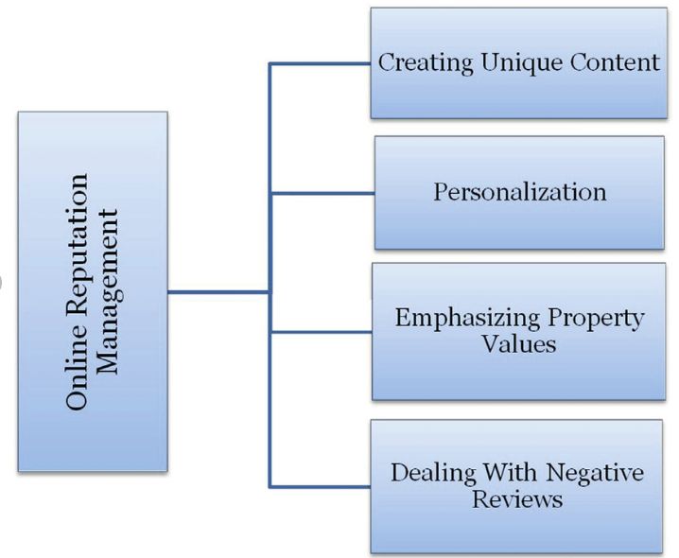
Figure 2: Reputation management across online platforms dimensions
(Source: Sechi Nuvole et al., 2021)
The creation of unique content and personalised interfaces for consumers across online platforms could be beneficial for managing the reputation more sophisticatedly and better prospects to deal with negative reviews (Sechi Nuvole et al., 2021). Moreover, a glimpse of property values could be portrayed among digital platforms that could be significantly get larger attention from consumers. A higher improvement in communication technologies has predominantly enhanced interaction mediums as well as managed reputation with anticipation and adequately responded to negative perspectives (Hristoforova et al., 2019). It has also significantly improved reputation management prospects across different functionalities in the hospitality segment.

Implications of service culture in the hospitality segment
A service culture largely determines the degree of quality service the consumers will get in the hospitality segment in the broader context. Service culture centred on the customer experience is beneficial for developing the consumer service quality and keeping oriented to the consumer benefits (Radojevic, Stanisic and Stanic, 2019). Moreover, a consumer-friendly culture within the organisational functionalities is beneficial for employees to develop an urgency to deliver quality consumer services in the broader context. A broader consideration of different cultural dimensions across the organisational sphere also assists in keeping employees satisfied and committing them towards the procurement of delivering coherent consumer service (Radojevic, Stanisic and Stanic, 2019). It assists workers from different regional professionals in engaging in the interaction with consumers as well as keeping committed to delivering of quality service culture. Therefore, it could be stated that service culture is the predominant aspect to consider for delivering quality consumer service in the hospitality functionalities in the broader context.

Recommendations
As technological growth becomes rampant across the world, integration of technologies could be advantageous for the hospitality industry to deliver better consumer service. “Voice Assistant” technology enhanced the interaction between human and computer terminologies as well as ensured the interpretation of consumer requisites and delivery of the required service (Buhalis and Moldavska, 2021). Moreover, guests' perspectives could be analysed with broader anticipation and understand their feelings in the broader context and offer better service for consumers. Apart from that, the “Internet of Things” (IoT) could be employed to develop a user-friendly interface that assists in the portrayal of personalised content and develops a broader attraction of consumers (Mercan et al., 2020). Operational procedures could be streamlined as well as offer better sophistication to analyse the consumer preferences. Concisely, it could be recommended that IoT and Voice assistant terminologies be determined to integrate with guest service strategies for larger improvements.
Job crafting terminologies could be replicated for empowering employees and determining the degree of employee satisfaction and their commitment towards the organisational proceedings and serving consumers' requisites in the hotel segment (Kurdi, Alshurideh and Alnaser, 2020). In addition, satisfied employees could deliver better consumer services and meet unexpected and diverse consumer needs. Hotel organisations are required to develop a proper framework for developing the satisfaction level of employees as well as keeping them devoted to consumers. Large organisations including JW Mariott is consider higher employee satisfaction levels and ensure the delivery of quality consumer service (Hyken, 2022). Hence, it is suggested that hotel segments to look after the employee satisfaction levels and procurement of quality consumer services.

Conclusion
The report demonstrates different perspectives associated with the hospitality industry along with the consumer engagement and the importance of guest services for consumers. Moreover, the degree of broader loyalty among consumers and their repetitive intention to consume hotel functionality have also been analysed in the study. Examples of several multinational organisations have also been described in the report. The degree of good relationships with consumers develop a broader degree of engagement with them and ensure broader attention. Suitable recommendations have also been procured in the report for improvements in broad context. Apart from that, the report also portrays the importance of reputation management in the hospitality industry and demonstrates good service quality committed to consumers. Conclusively, the report highlighted different aspects of the hospitality industry and consumer orientation and reputation in a broad spectrum.

References
Alrawadieh, Z. and Dincer, M.Z. (2019). Reputation management in cyberspace: evidence from Jordan’s luxury hotel market. Journal of Hospitality and Tourism Technology, 10(1), pp.107–120. doi:https://doi.org/10.1108/jhtt-09-2017-0093.
Buhalis, D. and Moldavska, I. (2021). Voice assistants in hospitality: using artificial intelligence for customer service. Journal of Hospitality and Tourism Technology, ahead-of-print(ahead-of-print). doi:https://doi.org/10.1108/jhtt-03-2021-0104.
Chen, X., Wang, Y., Lyu, X. and Zhang, J. (2022). The Impact of Hotel Customer Engagement and Service Evaluation on Customer Behavior Intention: The Mediating Effect of Brand Trust. Frontiers in Psychology, [online] 13. doi:https://doi.org/10.3389/fpsyg.2022.852336.
Hoang, G., Wilson-Evered, E., Lockstone-Binney, L. and Luu, T.T. (2021). Empowering Leadership in Hospitality and Tourism management: a Systematic Literature Review. International Journal of Contemporary Hospitality Management, 33(12), pp.4182–4214. doi:https://doi.org/10.1108/ijchm-03-2021-0323.
Hristoforova, I., Lyudmila, V., Silcheva, Arkhipova, T., Demenkova, A., Nikolskaya, E. and Russian, P. (2019). Improvement of Digital Technologies in Marketing Communications of Tourism and Hospitality Enterprises Journal of Environmental Management and Tourism. Journal of Environmental Management and Tourism, [online] X(36), pp.828–833. Available at: https://ies.unitech-mo.ru/files/upload/publications/15349/2b0ad14e453efb5d8ef6dd398f2eef87.pdf.
Hyken, S. (2022). Customer Service The Marriott Way. [online] Forbes. Available at: https://www.forbes.com/sites/shephyken/2022/07/17/customer-service-the-marriott-way/?sh=700a13d27807 [Accessed 1 Nov. 2023].
Kurdi, B., Alshurideh, M. and Alnaser, A. (2020). The impact of employee satisfaction on customer satisfaction: Theoretical and empirical underpinning. Management Science Letters, 10(15), pp.3561–3570.
Mercan, S., Cain, L., Akkaya, K., Cebe, M., Uluagac, S., Alonso, M. and Cobanoglu, C. (2020). Improving the service industry with hyper-connectivity: IoT in hospitality. International Journal of Contemporary Hospitality Management, 33(1), pp.243–262. doi:https://doi.org/10.1108/ijchm-06-2020-0621.
Murray, W.C. and Holmes, M.R. (2021). Impacts of Employee Empowerment and Organizational Commitment on Workforce Sustainability. Sustainability, 13(6), p.3163. doi:https://doi.org/10.3390/su13063163.
Perez-Aranda, J., Vallespín, M. and Molinillo, S. (2019). Hotels’ online reputation management: benefits perceived by managers. International Journal of Contemporary Hospitality Management, 31(2), pp.615–632. doi:https://doi.org/10.1108/ijchm-07-2017-0460.
Radojevic, T., Stanisic, N. and Stanic, N. (2019). The culture of hospitality: From anecdote to evidence. Annals of Tourism Research, [online] 79, p.102789. doi:https://doi.org/10.1016/j.annals.2019.102789.
Sechi Nuvole, M., Masia, S., Mazza, G.P. and Scanu, G.L. (2021). Tourism between Tradition, Sustainability, and Innovation in North-Western Sardinia. Euro-Asia Tourism Studies Journal, 2021(Special Issue in Italian). doi:https://doi.org/10.58345/uexk2090.
Shin, H. and Perdue, R.R. (2022). Developing creative service ideas through hotel customer engagement for open innovation: Focused on empowerment and motivation processes. International Journal of Hospitality Management, 100, p.103077. doi:https://doi.org/10.1016/j.ijhm.2021.103077.
Solomon, M. (2020). Customer Service Lessons From Hyatt’s Dramatic Call Center Overhaul. [online] Forbes. Available at: https://www.forbes.com/sites/micahsolomon/2020/01/18/customer-service-lessons-from-hyatts-call-center-overhaul/?sh=5201dcd97790 [Accessed 1 Nov. 2023].
Teng, H.-Y. (2019). Job crafting and customer service behaviors in the hospitality industry: Mediating effect of job passion. International Journal of Hospitality Management, 81, pp.34–42. doi:https://doi.org/10.1016/j.ijhm.2019.03.013.
Zhu, J.N.Y., Lam, L.W. and Lai, J.Y.M. (2019). Returning good for evil: A study of customer incivility and extra-role customer service. International Journal of Hospitality Management, [online] 81, pp.65–72. doi:https://doi.org/10.1016/j.ijhm.2019.03.004.

