Design, conduct and critically evaluate a close-to practice research project (case study) focusing on the model of the transformative teacher in developing practice that has a positive impact on the learner (4500 words)

Student number – 2300788
Word count – 4696

How do children interact while engaging in Lego enhanced play?

Aims, focus and purpose of the research/ research context.

This essay aims to research how children react while engaging in Lego-enhanced play, by looking at the communication between children whether it be positive or negative. As well as looking to see whether children work individually or whether they work as a group to build shapes out of Lego. Over recent years Lego has become a frequent area which children in early years have in their enhanced provision as research supports the benefits of having this area in a classroom. In practice I am constantly looking to develop my research in different areas and topics across the school classroom, this links with my professional learning passport as collaborating with the school to allow me to conduct this research then boosts my innovation skills when developing my knowledge in practice. As I in the future want to go into ALN teaching there is a lot of Lego therapy being introduced in schools and during interventions, so this is why I am interested in conducting this research project. I am going to be observing and evaluating whether I personally believe Lego is an essential part of the provision or whether there are other aspects of the provision which are more important and cover large developmental skills such as fine motor skills, sensory skills and everyday skills that children of this age need to develop such as social, communication, creativity skills,
My focus for this research is going to be looking at how children of a reception/ year one age interact while engaging in Lego-enhanced play. Going into my second placement school I noticed that the children did play with Lego, but it was on the weekly enhanced provision area, so going in I created a construction area in the classroom with approval from my class mentor as this then allowed me to observe the children in my classroom when they were in this provision area.

Literature review

Over recent years, Lego therapy and Lego play has become more involved in classrooms as there are so many benefits to having Lego as an enhanced play area in a reception classroom. For my research, I am going to compare literature already written on Lego in school to the case study which I will be completing and seeing if there is a correlation to research prior to conducting my own research on this topic.
Recent studies show that learning through play has a huge benefit to how children develop their knowledge, social and interaction skills as not all children at reception age have developed these skills before starting in school. Play is one of the most important ways in which children gain essential knowledge and skills and for this reason it is vital that there are play opportunities for the children amongst the learning environment, (Lego Foundation, 2018). When individuals think of the word ‘play’ it is associated with children having free time and playing in playgrounds or playing once they have finished work in a classroom, but play is a very important word as there has been a development on the understanding of the word and it is not seen as an ‘important aspect of play is children’s agency and control over their experience. With agency referencing to children’s initiative, decision making and self-choice in play’, (Lego Foundation, 2018).

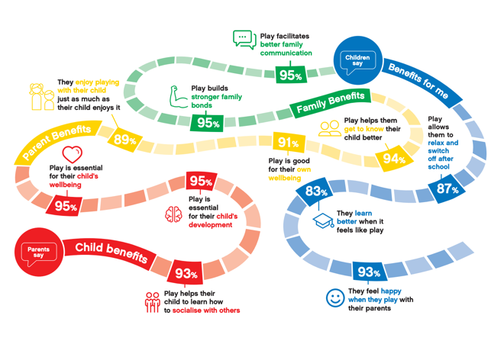
This diagram supports and reflects the importance of a child learning through play, (Lego Foundation, 2018).

When children engage in Lego-enhanced play their interactions can be quite dynamic and imaginative as they are developing their creativeness through imagining Lego has something else, (Lillard, 2015). Children often work together to build structures, scenes, animals and anything they would like to build using the Lego bricks. Children work together sharing ideas, negotiating the roles of who is building what and they work together to bring their vision together, this then helps the children with developing their teamwork and communication skills. In Vygotsky’s cultural-historical theory, play is an important part of early childhood and he believed that it promotes cognitive, social and emotional development in children, (Vygotsky, 1978).
Moreover, Lego play also often encourages storytelling and role-playing amongst the children as they might assign roles to different Lego figures and act out different scenes and scenarios embarking on adventures and their creativity, (Sutton-Smith, 1997). This then further develops the children’s language skills and how they interact amongst a group as they become a different character, (Singer et al, 2006).
Furthermore, Lego enhanced play encourages children to use and improve their problem-solving skills as they are figuring out and finding the right pieces which fit their design and their creation they are making. Problem-solving skills will then help develop and promote critical thinking and problem-solving skills and help teach the children to be more resilient as working the problem out will not always solve the problem they may have started with, (Sawyer, 2004).
There are many parts of developmental growth which Lego supports when children are developing their fundamental skills. Lego helps children develop their sharing and negotiation skills as they must learn to take takes, compromise and resolve problems peacefully, which develops important social skills along the way. (Dunn, 1988). As all Lego packages come with different-sized Legos, and different colours Lego not all children will be able to use them at the same time so this then helps develop their sharing skills, they can help each other and use the same piece to create their product together. Overall, Lego-enhanced play has proven to provide children with a rich and immersive experience where they can explore, create and socialise in a fun and engaging way.
Overall, Lego enhanced provision has so many positive parts to being in a classroom, it can help develop children’s fine motor skills as handling and manipulating Lego bricks can help children refine their fine motor skills, including hand-eye coordination and finger dexterity, (Cameron et al, 2012). As well as, promoting the fostering of spatial awareness as building three-dimensional structures using Lego bricks can help children develop their spatial reasoning skills alongside developing their understanding of shapes and spatial relationships, (Newcome, 2015).
Although Lego is seen as a positive aspect and addition to a classroom there are some negatives which go alongside having it as an enhanced provision area. There is a cause of concern whether the Lego area gender stereotypes as some sets may perpetuate gender stereotypes by featuring predominantly male or female characters and themes, which can then potentially influence children’s exposure to diverse interests and roles, (Sweet, 2018). This is why having blocks of Lego is important rather than having different sets such as flower sets, and rocket sets for example. Not always but sometimes there may be occasions in a classroom where children who are less interested in or proficient at Lego building may feel excluded or left out during play sessions as they can have a negative impact on their sense of belonging and engagement in the classroom, (Dockett, 2007).

Explanation of Case Study

When conducting my research, I will be using a case study to support my research question. A case study is ‘an empirical inquiry that investigates a contemporary phenomenon within its real-life context, especially when the boundaries between phenomenon and context are not clearly evident and relies on multiple sources of evidence’, (Yin 1994). There are many different definitions of a case study as there have been many different case studies which have been conducted. Gall et al (2005) suggest that a case study is the in-depth study of a phenomenon it its natural context and from the perspective of the participants involved in the phenomenon. Exploratory case studies can also help generate some form of hypothesis or help form a theoretical framework for further investigation if this research was to be conducted on a larger scale, (Eisenhardt, 1989).
For my case study I will be using an exploratory case study, this is a research method which is used to investigate a phenomenon within its real-life context, especially when the boundaries between the phenomenon and context are not clearly defined. It involves an in-depth examination of a single instance or a small number of instances of a particular phenomenon to understand its complexity and nuances, (Yin, 2018). Exploratory case studies are valuable research methods that allow researchers to investigate a phenomenon in-depth and explore new areas of inquiry. Exploratory case studies are flexible and adaptable, allowing researchers to modify their approach and research questions based on emerging findings and unexpected insights during the study, (Stake, 1995). Furthermore, this style of case study enables researchers to collect rich and detailed data through various sources such as interviews, observations and documents providing a comprehensive understanding of the phenomenon under study, (Yin, 2018). Additionally, when using an exploratory case study this can often employ multiple data sources and triangulation techniques to help enhance the validity and reliability of findings increasing confidence in the study’s conclusions, (Gerring, 2004). George & Bennett (2005) provide insights into the contextual factors that influence the phenomenon under study, helping researchers understand the social, cultural and organisational dynamics at play.
While exploratory case studies offer valuable insights, they also have limitations and potential drawbacks that researchers should consider. Some cases may lack generalisability due to the small sample size being used and unique characteristics of the case under study which can then make it difficult to apply the results to wider populations, (Yin, 2018). Furthermore, researchers’ interpretations and biases may influence the data collection and analysis process in exploratory case studies potentially leading to subjective conclusions or overlooking the alternative explanations, (Eisenhardt, (1989). When conducting a piece of research ethical considerations have to be encountered as part of the research gaining consent, during an exploratory case study ethical issues such as confidentiality, informed consent as well as researcher participant relationships may arise particularly when dealing with sensitive topics or vulnerable population, (George & Bennett, 2005). During my case study in my classroom there is a student and teacher relationship, but all ethical consent has been completed by parents as my research participants are under the age of 18 as well as the children being able to ascend from the research at any given point where they do not want to be observed during the case study for the research.

Research methods

When conducting my research, I will be using questionnaires and non-participant observations to gather the information needed to come to my conclusion on how children interact during Lego enhanced provision.

Questionnaires

Questionnaires are one of the most popular forms of research methods when gathering feedback and information regarding certain topics. For this research, quantitative questionnaires will be used as this will allow me to gather more detail about why the children enjoy Lego play and how it benefits them when they are in this area of the classroom. Furthermore, as the children in the classroom will not be able to read the questionnaire, I will be there to read and explain the questionnaires to the children for them to answer with their own opinion but just with guidance and help of understanding the question which has been provided for them to answer, this way the data I will be receiving will all be anonymous as I will be having no names on the short questionnaires which will be provided. The Likert Scale will be used when receiving responses from the children as this rating scale is used to measure opinions, attitudes or behaviours, there is usually five responses for the children to respond to.
There are many benefits when using questionnaires as a research method when collecting data, they allow researchers to collect standardised data from participants meaning that all the children will be asked the same questions in the same order, this way it reduces variability in responses collected, (Babbie, 2016). As this is a small-scale research project conducting questionnaires in the classroom is going to be more cost-effective as well as time effective as they can be conducted straight away when handed out during the day in the classroom, (Fowler, 2013). Although the questionnaire will be read out to the children answering the questions, there will be no names on the answered questionnaires which will then make the children feel more comfortable providing honest and candid responses to questions when they know that their identity will be protected throughout this whole research project, (Oppenheim, 2000). Furthermore, questionnaires are often straightforward to analyse allowing researchers to quantify responses, identify patterns and come to statistical conclusions, (Oppenheim, 1992). Conducting research with questionnaires typically requires less resources compared to other data collection methods which makes it cost effective for studies with limited budgets as I am a student conducting this research, (Alreck, 2004).
Using questionnaires with reception-aged children in research could present several disadvantages. One is that young children in a reception class may not possess the cognitive maturity to understand abstract or complex questions, leading to misunderstanding or inaccurate responses leading to the responses not being valid, (Ager 2016). This could happen in some research projects but for my research project the questions will be child-related so they can understand what they are being asked to respond to and they will be read out the question not given the questionnaire on a piece of paper and not being able to understand the question being asked but all of this will be done anonymously. Furthermore, researchers must ensure that the questionnaires for young children are developmentally appropriate and do not cause distress or discomfort, which requires careful consideration of ethical issues, (American Psychological Association, 2017).

Observations

What is a non-participant observation? A non-participant observation is a research method where the researcher observes and records many different aspects; behaviours, interactions and phenomena without direction participating in the activities which are being observed. In a non-participant observation, the researcher will remain in a passive or distant role abstaining from interaction with the children to avoid influencing the natural course of events but instead focusing on systematically observing and documenting the behaviours in the areas which they are observing during this period, (Flick, 2014). Although this is a non-participant observation the children have been made aware that I will be observing them just not getting involved in the area when I am observing. Just like questionnaires being used in research there are advantages and disadvantages to all research methods whilst being used in a research project.
Non-participant observations allow researchers to study behaviour in a natural setting without directly participating in or influencing activities being observed providing authentic context into real-life behaviours, (Bogdan & Biklen, 2006). To add to this, this type of observation allowed the researcher to gather yield rich and detailed data about participants’ actions, interactions and environmental factors which can offer a comprehensive approach and understanding of the question under study, (Emerson et al, 2011). Additionally, non-participant observations can complement other types of data collection such as interviews and questionnaires, enabling researchers to triangulate findings which then enhances the validity and reliability of the results found throughout the observation period, (Jick, (1979). Non-participant observations are seen to be particularly useful in situations where the researcher aims to study natural behaviour, in my case, I am observing how children interact whilst engaging in the Lego-enhanced area.
As well as all other types of research methods, non-participant observations have their disadvantages which go alongside them being conducted. Since researchers maintain a passive role in this form of observation they might have a limited understanding of the participants feelings, thoughts, perspectives so therefore they cannot directly interact with the participants and question them about any aspect of the observation which they may want too, (Bogdan & Biklen, 2006). Furthermore, without being able to be in direct contact with the participant, researchers may misinterpret or misattribute the behaviours which are being observed so therefore this could lead to having inaccurate conclusions and outcomes, (Emerson, 2011). From looking at the advantages and disadvantages of both research methods they are both very similar so therefore when conducting the research, I will have to be aware of this when conducting the research. Another downfall of using non-participant observations is that researchers will have limited control over environmental factors and variables of the situation which may influence the behaviours, which could then potentially affect the end results and outcomes, (Flick, 2014).

Using my chosen research methods

During my research time, I observed my class for a short period of time which allowed me some time to gather some information but going forward I would need a longer period to gather more in detail information based upon the topic. Furthermore, after observing I will ask the children closed questions as I want to keep them specific and narrow as they are reception age, they will not understand complicated questions provided.

Data presentation and analysis method

To be able to analyse my data from the research methods, I will be using thematic analysis to analyse the findings from the observation and pie charts to show my findings from my questionnaire. This way I will be able to gather a collective of information to support my research question.
When observing the children in the Lego enhanced provision, I will be taking notes which I can later use the thematic analysis strategy to look for any themes which help support evidence for my research. When reviewing my notes and data collected from the observation, there will be coded segments which capture interesting or relevant aspects of the observations, (Saldana, 2015). Then once I have set out initial coding, I will then be able to organise and search for themes and patters which are trending across the notes taken throughout the observation. This will then allow for any similarities, differences and recurring patters to be recognised, (Guest et al, 2012).
When using data analysis there are advantages and disadvantages to whichever type is used. Thematic analysis offers flexibility as it can be used in various applications across various research designs, data types and theoretical frameworks which makes it adaptable to different research contexts and can be used in many ways, (Braun & Clarke, 2006). Moreover, it is a relatively straightforward and accessible way to collect research as it does not require specialised training or software it can be done by recognising trends and patterns, (Braun & Clarke, 2019). One downfall of using thematic analysis is that it can be time consuming, this is for larger scale research project so for this scale research project it should not be as time consuming, (Boyatzis, 1998). Furthermore, there is a risk of oversimplifying the data as when categorising data, it could potentially lead to losing the in-depth data received, (Braun & Clarke, 2019).
When collecting my data from the questionnaires, I will be using pie charts as this will help organise and show the data as a whole population of the children who answered the questionnaire. My questionnaire will be using closed questions as this is more suitable for the age group answering the questionnaire. Pie charts provide simple data which will then be easier to read and easier to categorise at a quick glance, (Few, 2009). As well as they are easy to create with the software’s which are available to use or even by hand as they are usually colour coded to support the percentages of individuals answering each question, (Kosslyn, 2006). But on the other hand, pie charts do not portray the trends and patterns seen throughout the questions therefore if it was to change over time, visualising it will be harder, (Cleveland, 1984).

Ethical considerations

When conducting any research there must be ethical considerations as this is the most important document as it covers you if anything was to happen during the research. Ethical considerations ensure that the research participants rights, dignity and well-being is protected for safeguarding reasons throughout the research. As well obtaining informed consent and protecting participants from harm and maintaining confidentiality throughout the research project, (American Psychological Association, 2017). During my research, I have sent out consent forms to the parents of my participants as they are under the age of 18 and only the ones who have responded will be counted in the research conducted, and the children are made aware they can withdraw at any given choice and if they do not want to participant in the questionnaire then they have the right to. Furthermore, ethical considerations ensure that research projects comply with relevant laws, regulations and ethical guidelines established by institutional review boards. This will help protect both researchers and participants and maintains the integrity of the research process, (BERA, 2018). Furthermore, the UNCRC Article 12 says that every child has the right to express their views, feelings and wishes in all matters affecting them and people have to take their views seriously and must consider everything which has been said, (UNCRC, 1992).

To further view my ethic form and consent form sent home to the participants parents please see the appendix.

Results/ analysis of results/ discussion

Before carrying out my research I handed out consent forms to the parents/carers of the children in the classroom and I received 14 back so therefore out of the class of 20, only 14 children will be used throughout my research.

Results from the class observation

When I first got to my class, I noticed that there was not an area for Lego therefore I had a discussion with my class mentor to see whether I could implement a Lego area and we decided as a collective to turn the area into a construction area. There was a trend when it was first implemented that most children were excited to be in this area on the provision but there was the handful of children when in the area did not know how to interact with other children to engage in the task. Using the thematic analysis strategy to look for any trends and patterns, with my observation I came across three main themes; gender differences whilst in the area, engagement and collaboration whilst completing a task in the area as well as supporting and learning opportunities in this area.
From my observation in the first theme of gender differences whilst in the area I noticed that the girls were more imaginative and used creative play when they were constructing whereas the boys needed a more structures play and knowing what their end goal was using guided pictures to help them, this supports the Lego foundation (2018) as play is so important to a child’s development. The second theme I picked up on was the engagement and collaboration as most children showed high engagement when participating in the area compared to when they were in the sand area, as well as their teamwork skills developed the longer the enhanced area was there for them to use. The children were able to engage independently during the tasks provided, for example they had to build a castle from a story book we were reading, most children were able to engage in this task without the continuous need for the teaching assistant to step in. One theme I did pick up upon was the supporting and learning opportunities gathered in this area. This was an area which some children used to re-regulate before coming back to join the class, some children were not always fond of being in this area as they had no prior experience of using Lego to build, this supports research already conducted as children learning how to use Lego in vital as it develops hand eye co-ordination techniques, (Cameron et al, 2012).

Results from my questionnaire

When asking the children questions to find out the answers to help support my research, the questions were read out to the children and the children were all given choices to choose from as this then helped them understand the question more accurately.

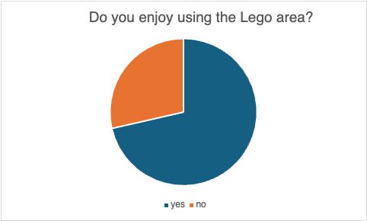

This is the main question I wanted to find out as not all children will enjoy using Lego and the results from this question support the findings out from the observations which took place in the classroom. I noticed that not every child enjoyed the Lego so from the children I had consent from I was then able to ask them if they enjoyed the Lego, the majority of children said that they enjoy the Lego area in the class but there was a handful of children which said that they did not enjoy using the Lego area but this does not mean they will not use it as Lego is incorporated during lessons as it so fundamentally beneficial for the children.

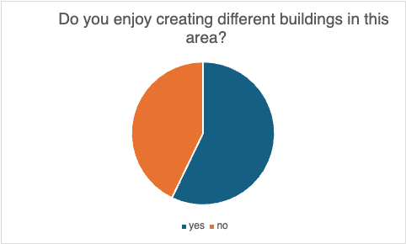
From the responses to this question, I can tell that more than half the children enjoy creating different buildings in the Lego area but there is a larger number of children who do not enjoy creating different buildings in this area. Again, this supports what I observed that some children preferred having the structure of following a picture to create a piece rather than using their imagination to create a building using the Lego.

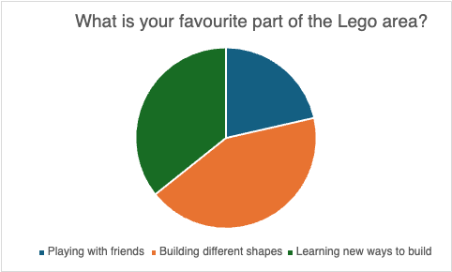

As I conducted my class observation first before writing my questionnaire, I could use the observation to help me with the questions I wanted to know from the children. This is an interesting split as each child said that they had a favourite part of using the Lego in the classroom, not one child said that they did not have a favourite part of the Lego area which is beneficial as it shows that they are all interacting and engaging when they are in this area of provision.

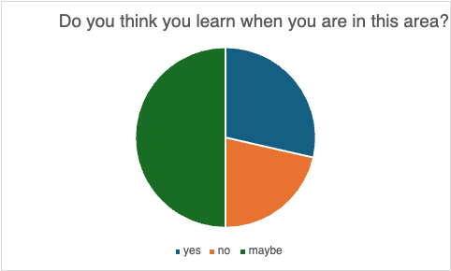

From the results of this question, it clearly shows that half the children thought they learnt something new when in this area, and then the other half of the children were unsure or did not think they learnt when they were in this area. Moving forward and reflecting on my practice I am now going to go in and ensure that all children think they are learning when being in this area as it is such an important part of play as it teaches children how to be resilient, have patience and so many other benefits when being in this area.

Overall conclusion from the research conducted.

This research project has been very beneficial to myself as it has allowed me to broaden my practice and teaching for the children. Some of the observation themes I came across were not what I expected but that is the whole point of this project is to learn about an area in more depth to open up and improve on the knowledge. My overall conclusion from the research conducted is that the Lego enhanced provision area does help some children interact while engaging this form of provision, but it does not work for every child as each child has their own needs moving forward to help the development.

Conclusion

From starting this research project and coming up with an area of interest to develop my understanding there are many positives and some improvements I can make if I was to conduct this research project as a larger scale. Using observations and a close ended questionnaire as it was a small-scale research project, and it was done over a short period of time. During my whole time as a primary school teacher, it is important to develop the understanding and knowledge at every given opportunity as this will help me understand the way in which helps children develop to their full potential.
Diving deeper into the understanding of how important play is for children when they are developing at reception age has been an eye opener as I have learnt that play of any kind is vital to developing many skills and needs of the child. If I was to do this research again and develop my findings, I would observe for a longer period, and I got the opportunity do it across reception, year 1 and year 2 to see how different ages use the role of play to progress their skills. Overall, I think this was a successful research project, but nothing is ever perfect, there will always be room for development as a practitioner.

Reference list
(2018) A short presentation. Available at: https://www.lego.com/cdn/cs/aboutus/assets/blt4ee78e0776fce92f/LEGO_Company_Profile.pdf (Accessed: 06 April 2024).
(2018) Learning through play. Available at: https://www.unicef.org/sites/default/files/2018-12/UNICEF-Lego-Foundation-Learning-through-Play.pdf (Accessed: 06 May 2024).
Ager, C.L & O’Meara, D.M (2016) Designing and Conducting Survey Research. A Comprehensive Guide (4th ed). Jossey-Bass.

Alreck, P.L & Setlle, R.B (2004) The Survey Research Handbook (3rd ed). McGraw-Hill.
American Psychological Association (2017) Ethical Principles of Psychologists and Code of Conduct. https://www.apa.org/ethics/code

Babbie, E (2016). The Practice of Social Research. Cengage Learning.

Bran, V & Clarke V (2006) Using thematic analysis in psychology, Qualitative Research in Psychology, 3(2) 77-101

Braun, V & Clarke, V (2019) Reflecting of reflexive thematic analysis. Qualitative Research om Sport, Exercise and Health 11(4) 589-597.

Bogdan, R & Biklen, S.K (2006) Qualitative Research for Education: An introduction to Theories and Methods.

Boyatzis, R. E (1998) Transofriming qualitiative information: thematic analysis and code development. Sage.

Cameron, C. E., Brock, L. L., Murrah, W. M., Bell, L. H., Worzalla, S. L., Grissmer, D., & Morrison, F. J. (2012). Fine Motor Skills and Executive Function Both Contribute to Kindergarten Achievement. Child Development, 83(4), 1229–1244. https://doi.org/10.1111/j.1467-8624.2012.01768.x

Cleveland, W.s & McGill, R (1984) Graphical perception and graphical methods for analysing scientific data. Science, 229(4716), 828-833.

Dockett, S and Perry, B (2007). Starting School: Young Children Learning Cultures. Open University Press.

Eisenhardt, K.M (1989) Building Theories from Case Study Research. Academy of Management Review, 14(4), 532-550.

Emerson, R. M., Fretz, R. I., & Shaw, L. L. (2011). Writing Ethnographic Fieldnotes (2nd ed.). University of Chicago Press.

Ethical Guidelines for Educational Research, (2018). Fourth edition.

Few, S (2009), Now you see it: Simple visualisation techniques for quantitative analysis, Analytics Press.

Flick, U (2014) An Introduction to Qualitative Research (5th ed) SAGE Publications.

Folwer, F.J (2013) Survey Research Methods.
Gerry, A.L & Bennett, A (2005) Case Studies and Theory Development in the Social Science. MIT Press.

Gerry, J (2004) What Is a Case Study and What Is It Good for? American Political Science Review, 98(2), 341-354.

Guest, G. MacQueen, K. & Namey, E (2012), Applied thematic analysis. Sage.

Kosslyn, S.M (2006) Graph design for the eye and mind.

Jick, T. D. (1979). Mixing Qualitative and Quantitative Methods: Triangulation in Action. Administrative Science Quarterly, 24(4), 602–611

Lillard, A.S (2015). The Impact of Pretend Play on Children’s Development: A Review of the Evidence. Psychological Bulletin, 141(1), 1-34

Newcombe, N. S., & Shipley, T. F. (2015). Thinking About Spatial Thinking: New Typology, New Assessments. In J. S. Gero (Ed.), Studying Visual and Spatial Reasoning for Design Creativity (pp. 179–193). Springer.

Oppenheim, A.N (1992) Questionnaire Design, Interviewing and Attitude Measurement. Continuum International Publishing Group.

Saldana, J (2015) The coding manual for qualitative researchers. Sage.

Sawyer, R.K (2012) Explaining Creativity: The Science of Human Innovation. Oxford Press University.

Singer, D.G, Golinkoff, R.M, and Hirsh-Pasek, K (2006), Play = Learning: How Play Motivates and Enhances Children’s Congitive and Social Emotional Growth. Oxford University Press.

Stake, R.E (1995) The Art of case Study Research. SAGE Publications.

Sutton-Smith, B (1997). The Ambiguity of Play. Harvard University Press.

Sweet, M. (2018). How Gender Stereotypes are Reinforced Through Play. Child Mind Institute. https://childmind.org/article/how-gender-stereotypes-are-reinforced-through-play/

Vygotsky, L. S. (1978). Mind in society: The development of higher psychological processes. Cambridge, MA: Harvard University Press.

Yin, R. K. (2018). Case study research and applications: Design and methods (6th ed) Sage publications.

