A report on ransomware, and how it can affect your company

Rose Plumley
2218443
- Introduction 3
- A brief synopsis on ransomware 3
- The CryptoWall Trojan 4
  - History (1.0 to 4.0) 4
  - What can it do? What is it capable of? 4
  - What happens if your files are infected? 7
  - Can your files be recovered? 8
- Prevention is better than cure – what can you do? 9
  - Antivirus 9
  - Firewall 9
  - Backup strategies 9
- Summary and conclusion 10
- References 10

- Introduction
Ransomware is a form of malware designed to extort a user, either by simply locking the desktop in the case of locker ransomware, or alternatively by encrypting files, holding them hostage with a (potential) decryption key as leverage until a condition is met – usually being fiscal. This is known as crypto ransomware. In most cases, the malware renders a user’s computer nigh, if not completely, unusable. Unlike other forms of malware however, ransomware does not aim to be hidden – it is ultimately designed to present the end user with an ultimatum, in most cases resulting in cryptoviral extortion. This report aims to brief the reader on ransomware; Informing on what it is, what it can do to your company, and how to best safeguard your business from this type of threat.

- A brief synopsis on ransomware
In 1989, Joseph Popp created the first ransomware program, titled “AIDS”, as a trojan. When a floppy disc carrying the trojan was inserted into a PC, the files would be encrypted, and a demand would be made of $189 to be sent to a PO box in Panama [1]. For various reasons, such as the infection method, encryption functionality and payment method, this first version failed. However, as time has gone on, the malware has become more advanced. Infection for example can now occur from phishing emails, exploit kits and malicious ads. Encryption uses RSA numbers (a large set of semiprimes), of which many have yet to be fully factorised as of February 2020 [2]. And payment methods are now mainly digital, to prevent tracking and tracing of transactions, with modern ransomware trojans typically only accepting cryptocurrencies, such as bitcoin, with an average ransom totalling $300 in value as of 2015 [3]. Over time, ransomware has become more and more prevalent; an article from Varonis [4] finds that, according to a 2018 report from Verizon, ransomware incidents made up 40% of all combined malware incidents. And according to the follow-up 2022 Data Breach Investigation Report, 66% of all combined reports involved ransomware (as well as phishing and stolen credentials) in some capacity, following an upward trend from previous years. The report also quotes a 13% rise in ransomware breaches overall, “more than in the last 5 years combined” [5].
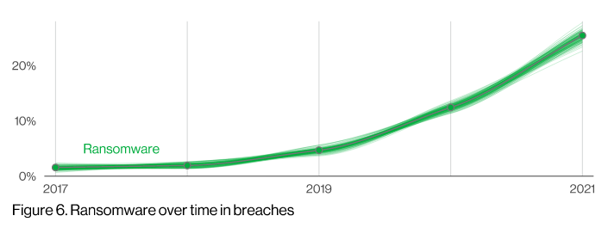[5]
The given data predicts a continual upward trend in ransomware incidents and breaches, and thus also implies the need to introduce further safeguarding methods and techniques to your business. As a detailed example, this report will cover the CryptoWall trojan – what it is, what it can do, and how one might prevent system infection.

- The CryptoWall Trojan
Like most ransomware, the CryptoWall trojan is a file-encrypting program, designed to hold a user’s files hostage through cryptoviral extortion. While several methods of infection exist, the most common methods involve phishing emails, exploit kits, and malicious ads [4]. The former most method is by far the most common, which tricks the user into clicking a link that downloads the malware onto their computer.
  - Version history

First released around April 2014, the first version of CryptoWall was loosely based on another program, CryptoDefence, incorporating a similar decryption service. An update in October of the same year introduced CryptoWall 2.0, which further developed the decryption service, adding “INSTALL_TOR.URL” alongside other text files, URLs, and html files in each infected folder, as well as on the desktop. Additionally, the new version included developer-run web-to-TOR gateways, unique bitcoin addresses tailored to each infection incident, and secure deletion of original unencrypted files – The lattermost point making usual recovery methods ineffective [6].

Additionally, around January 2015, the next version, CryptoWall 3.0, was released. While there were only a few minor changes to the software, it gained widespread use and rapid spread, causing around $325 million in damages alone [7] – Far more than the former versions, which had combined losses totalling over $18 million according to the FBI’s Internet Crime Complaint Centre [8]. Other changes included newer developer-run web-to-TOR gateways, as well as an increase in the ransom deadline.

The most recent version, CryptoWall 4.0, was released in November 2015. On top of more new developer-run web-to-TOR gateways, the ransom note filenames were changed, as well as their contents. Though most notably, file names were now being encrypted, and more robust shadow volume copy deletion was incorporated. In short, these shadow volume copies are what allow the operating system to restore potentially corrupted files by taking “snapshots” – backup copies, in essence.

Another version however, also exists; CryptoWall 5.1. Based on the HiddenTear malware (an open-source ransomware trojan), it utilises a different encryption method, AES-256, which exists as a variant of the Rijndael block cypher. Of note, AES encoding is the only publicly available cypher approved by the NSA for “SECRET” level data [9], with “TOP SECRET” requiring AES-192 or AES-256 (i.e., 192-bit key lengths or 256-bit key lengths).
  - What can it do? What is it capable of?
As crypto ransomware, the most recent versions are designed to encrypt file names, file contents, anything it might deem important enough. However, it is worth noting that the malware does not compromise critical PC systems – meaning, the hardware will be usable enough to the point of enabling the end user to pay the ransom. Additionally, later versions will also delete shadow volume copies of files, meaning simply restoring a backup no longer works. Once installed, the ransomware injects new code into the explorer executable, and then restarts it. This code does everything listed above, as well as disabling windows services, and spawning a new svchost.exe process with more injected modules. Moreover, CryptoWall also installs itself within the registry of your operating system, as well as your startup folder, meaning that simply restarting the system won’t remove the malware.
Once this process has completed, a Command-and-Control server operated by the developer will send an encryption key to the program, which is used to encrypt the files, running both locally on the infected unit and on any connected networks. Note that, because infection can travel between connected networks, cloud storage services such as DropBox can become infected as well. A breach in a singular system can affect other devices, as long as they remain connected through a network.
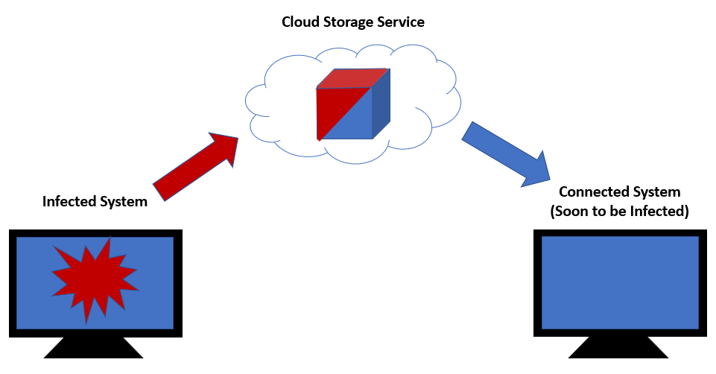
Normally, this process if done on versions 3.0 and above involves asymmetric encryption, whereby a pair of matching encryption keys (based on the RSA-2048 semiprime) are generated on the C&C server, with only the public key being sent to the infected machine. Of note, the private key is always retained on the server [10].
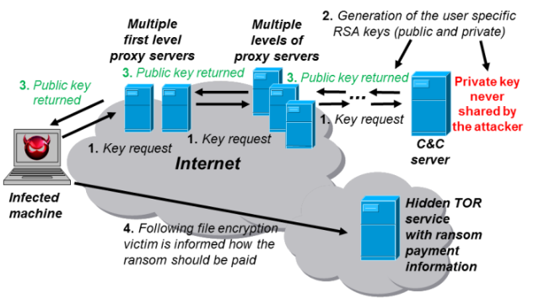[10]
In the case of CryptoWall 5.1, the AES-256 encryption involves a similar process known as symmetric encryption, whereby the same key is used to encrypt and decrypt files. Notably, both public and private keys are generated and stored on the infected machine, with this then being sent to the C&C server.
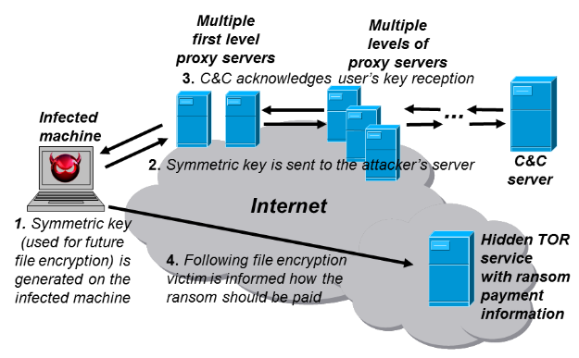[10]
Because of this difference, and because of the potential bit key lengths between the two encrypting methods, RSA encryption, if correctly implemented, is much harder to crack, resulting in a much more potent attack. Where AES-256 includes a 256-bit key length, RSA-2048 has 2048 bits, or 617 decimal digits [2]. However, it should be considered that, as AES encryption is based off the Rijndael block cypher, block and key sizes are multiples of 32 bits, with a minimum length of 128. So, while there is a block size limit of 256, key sizes are theoretically unlimited [11].
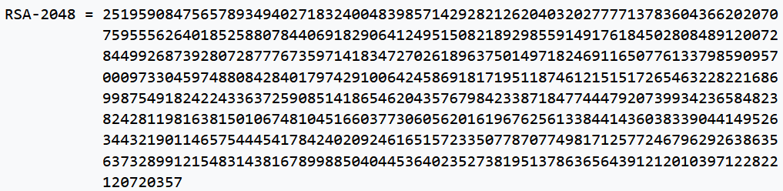[2]
Even so, data from Bhat et al. [11] demonstrates differences in time to encrypt and decrypt different sizes of data, with RSA showing far longer decryption time, implying a higher level of security. Though conversely, AES encryption times are much more rapid, meaning system or user response time to infection is far tighter. Thus, the given data suggests short-term infection may favour the use of AES, being the more efficient based on time, with long-term ransoms finding more use with RSA. And yet, the given data assumes keys in this instance are known – the data thus may not be relevant to comparisons based on breaking, or even brute-force attacking a given cypher.
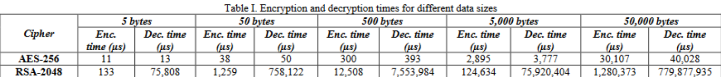[11]
Thus, more merit could be based off the number of possible key combinations. Drawing from the same study, the researchers found that AES-256 could generate a (theoretical) 1.1 × 10^77 number of keys, while RSA-2048 could generate 5.8 x 10^613 keys [11]. The higher number of possible keys would suggest higher resistance to brute force attacks to solve a given cypher.
Also of note, while CryptoWall will prioritise “original” files, or, files created by the user, it can detect, affect and infect many different file types, with most supported file types shown below. Once encrypted, files are essentially locked, and can only be retrieved with the generated decryption key. After the ransom notes are delivered, the malware deletes itself.
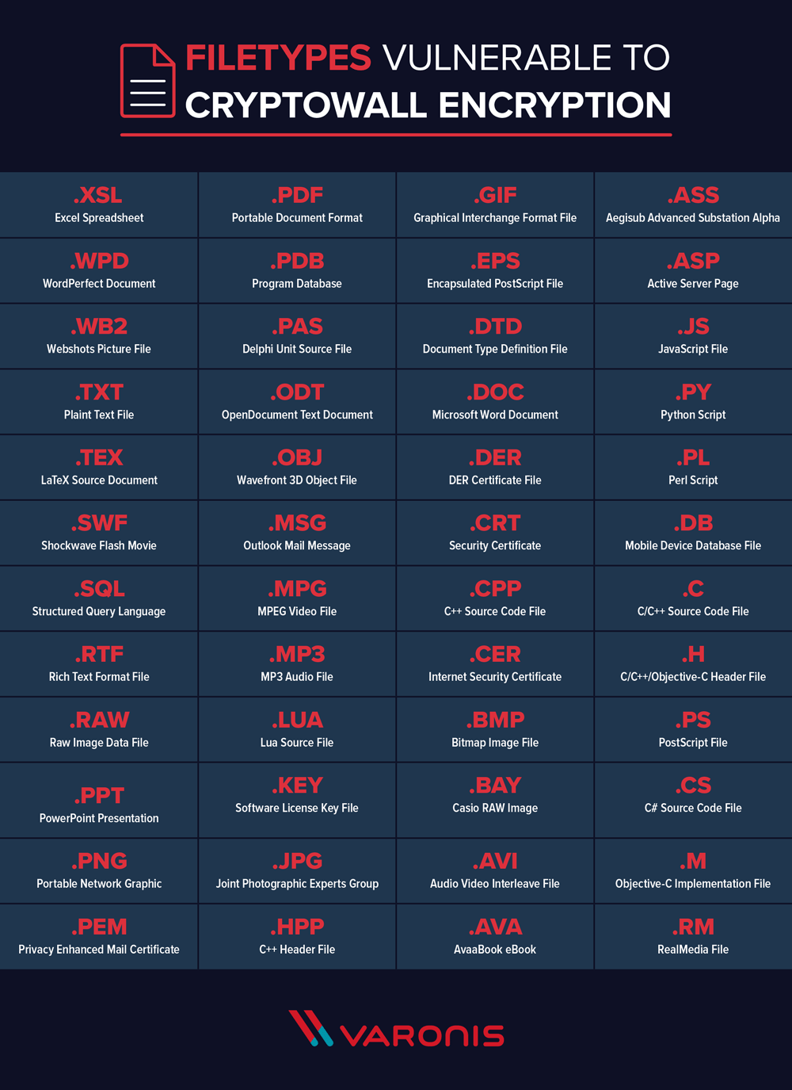[4]
  - What happens if your files are infected?
Once files are infected, CryptoWall creates various files containing ransom notes in all affected folders, as well as on the desktop itself. These are most commonly titled “DECRYPT_INSTRUCTION.TXT”, “DECRYPT_INSTRUCTION.URL” (or “INSTALL_TOR.URL” if infected with CryptoWall 2.0), and “DECRYPT_INSTRUCTION.HTML”, though later versions change the ransom note filenames to “HELP_YOUR_FILES.PNG”, “HELP_YOUR_FILES.HTML” and “HELP_YOUR_FILES.TXT”. Within these files is information on the malware, on what happened to your files, and instructions on how to pay the ransom, usually ubiquitously done through the TOR browser.
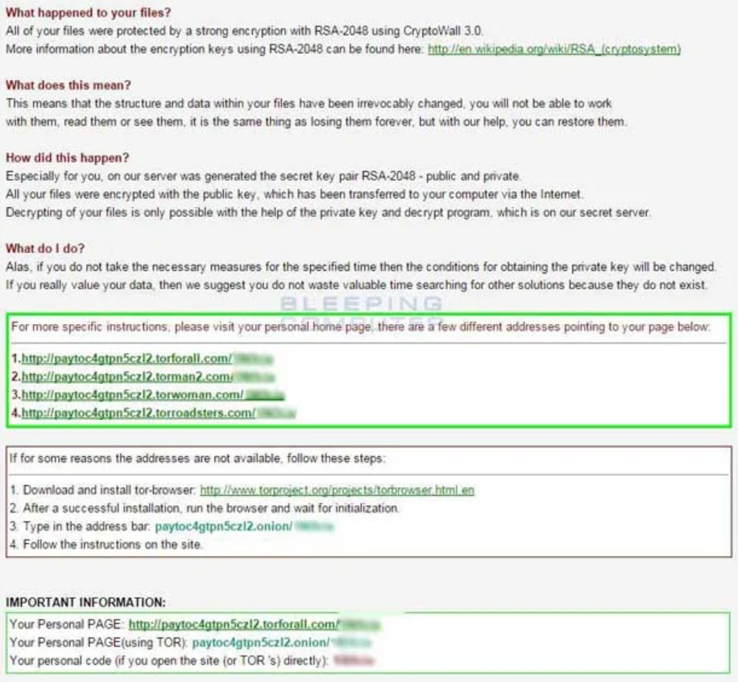[6]
  - Can your files be recovered?
In theory, all files can be recovered. However, in most cases, this involves paying the ransom, and doing so hastily. Unfortunately, according to a 2015 article from Varonis [4], this totals on average to $1000 of bitcoin. And even still, paying the ransom should always be a last resort. A Forbes article notes that only 19% of ransomware victims who pay get their files back [12]. And as noted in section 3.2 of this report, brute forcing a decryption remains unfeasible – even assuming infection from version 5.1 has occurred, meaning AES symmetrical encryption, a brute force attack could take an estimated 2.29 x 10^32 years to decrypt [13]. Thus, the only remaining methods of file recovery would be to restore from a backup, through file recovery tools, or if lucky, from shadow volume copies.

- Prevention is better than cure – What can you do?
Ultimately, attackers cannot be trusted to send a decryption key. Thus, the best thing the reader can do for their business is form backup strategies and incorporate further software defences, discussed briefly below.
  - Antivirus
When updated regularly, antivirus services such as Norton and McAfee can protect from a multitude of different malware attacks, ransomware or otherwise. These third-party applications “quarantine” potentially malicious programs and code, preventing them from being executed in the first place. For example, if a phishing link were followed and an executable were downloaded containing malware, the antivirus would flag it up, and quarantine the malicious software.
  - Firewall
A firewall is designed to prevent connection to certain servers, protecting a system (and by extension a network) from unauthorised access. This is done through the monitoring of incoming and outgoing network traffic, based on user-determined regulations. In essence, these act as a stopgap between trusted networks (such as a self-made home or business network) and unknown, untrusted networks.
  - Backup strategies
While less of a method of prevention, a solid backup strategy is nonetheless vital to the growth and security of a company. Its purposes are ultimately to recover data after its loss, and to recover data from an earlier period.
Every business, system and person will have methods that work best – for some, a USB stick copied manually at the end of every week is enough. For a larger business though, this wouldn’t be nearly enough. Thus, multiple things need to be considered when constructing a backup strategy, such as what needs to be backed up, who must be responsible for maintaining this system, how often should data be backed up, where should the backed-up data be stored, what hardware and software is needed, and so on. Every company will have its own needs, so a tailored strategy will work best. Although, it should be noted that a perfect strategy is nigh-impossible. Whether from space constraints, budget, human error, a completely sound system is rarely possible, let alone recommended or realistic. It always depends on the user’s needs, circumstances and budget.
However, a tenet that is worth being followed is the “3 places” rule, whereby data and backups are stored in 3 different places. For example, if a software developer had their data on their laptop, they could back up important source code and various projects on a cloud storage service, such as DropBox or Microsoft’s OneDrive service. The former service also copies uploaded files to other connected systems – so, the software developer could have their data on their laptop, in cloud storage (in a data centre far away), and perhaps on a home PC or storage solution, such as a NAS unit. The given example is known as a SAN (storage area network) system with remote mirroring. With the data safe in 3 separate locations, all that remains would be the efficacy of system and data restoration.
- Summary and conclusion
In summary, ransomware like the infamous CryptoWall trojan exists as a constant threat to any business, no matter how large or how prepared. Systems must be prepared and up to date, and should infection occur, backups must be safe and valid.

- References
[1] P. O’Kane, S. Sezer, and D. Carlin, “Evolution of ransomware,” IET networks, vol. 7, no. 5, pp. 321–327, 2018, doi: 10.1049/iet-net.2017.0207.
[2] “RSA numbers”, Wikipedia, [Online]. Available: https://en.wikipedia.org/wiki/RSA_numbers. [Accessed 5 November 2022].
[3] K. Savage, P. Coogan, H. Lau, “The evolution of ransomware,” Symantec., Tempe., Arizona, 2015.
[4] M. Buckbee, “The State of CryptoWall in 2018,” Varonis, 1 June 2018. [Online]. Available: https://www.varonis.com/blog/cryptowall. [Accessed: 5 November 2022].
[5] G. Bassett, C. D. Hylender, P. Langlois, A. Pinto, S. Widup, “DBIR 2022 Data Breach Investigations Report,” Verizon Communications Inc., New York, New York, 2022.
[6] BleepingComputer.com, “Cryptowall and HELP_DECRYPT Ransomware Information Guide and FAQ,” BleepingComputer, 22 December 2016. [Online]. Available: https://www.bleepingcomputer.com/virus-removal/cryptowall-ransomware-information. [Accessed: 8 November 2022].
[7] A. Kharraz, “Ransomware,” The SAGE Encyclopedia of the Internet. pp. 720–724, 2018.
[8] S. Gallagher, “FBI says crypto ransomware has raked in >$18 million for Cybercriminals,” Ars Technica, 25 June 2015. [Online]. Available: https://arstechnica.com/information-technology/2015/06/fbi-says-crypto-ransomware-has-raked-in-18-million-for-cybercriminals/. [Accessed: 8 November 2022].
[9] L. Chen, “Cryptographic Standards and Guidelines,” NIST, 29 December 2016. [Online]. Available: https://csrc.nist.gov/projects/cryptographic-standards-and-guidelines/archived-crypto-projects/aes-development. [Accessed: 8 November 2022].
[10] K. Cabaj and W. Mazurczyk, “Using Software-Defined Networking for Ransomware Mitigation: the Case of CryptoWall,” arXiv.org, 2016, doi: 10.1109/MNET.2016.1600110NM.
[11] K. Bhat, D. Mahto, and D. K. Yadav, “Comparison Analysis of AES-256, RSA-2048 and Four Dimensional Playfair Cipher Fused with Linear Feedback Shift Register,” International journal of advanced research in computer science, vol. 8, no. 3, 2017.
[12] L. Mathews, “Why you should never pay a ransomware ransom,” Forbes, 9 March 2018. [Online]. Available: https://www.forbes.com/sites/leemathews/2018/03/09/why-you-should-never-pay-a-ransomware-ransom/. [Accessed: 9 November 2022].
[13] E. Tobias, “128 or 256 bit encryption: Which should I use?,” Ubiq, 11 February 2022. [Online]. Available: https://www.ubiqsecurity.com/128bit-or-256bit-encryption-which-to-use/. [Accessed: 9 November 2022].

