BA (Hons) Management Skills for the Workplace
Developing Relationships and Workplace Management
BMSK5002 – Brynach Heffernan

TASK 1
There are several development vehicles of on organisation which helps to enhance the performance of the employees to be more productive and creative. All these development vehicles are really important and play a key part in the workplace as it motivates and prompts the employees to work harder to achieve targets and goals in professional and personal career.
Below are some of the important development vehicles that are essential in an organisation:
Working in an organisation as an employee motivation to work is significant as this demonstrates the employees increased productivity and also allows the organisation to accomplish its goals with higher levels of output.
Motivation is a development vehicle in an organisation as this means getting the employees actively involved in the decision-making process this entails them to work even harder to complete their part of the job role to help the company. There are several different motivation policies such as bonuses or other financial incentives. Recognising employee achievements and rewarding them is also a way of motivating them to do better. The main purpose of this is to give something back to the employees to look forward and achieve greater results. (Balle, L. 2017).
According to a recent journal published in 2017 Abraham Maslow in 1943 developed a theory of how all motivations are connected. He called his theory a ‘need hierarchy’. He divided the need hierarchy into different sections defining the needs of people in an organisation and after that level of need is met people are no longer motivated and they go up to the next level to meet their needs. According to Maslow the need of self-actualization is the most important aspect of the theory. (Suyono, J & Mudjanarko, S.W. 2017).
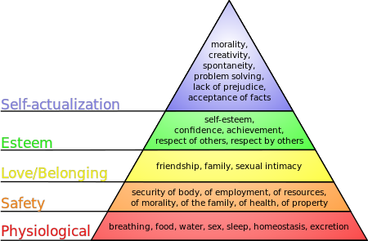

Performance Management is a critical and necessary component for individual and organisational effectiveness. Managing a large group of workers or focusing on own performance to sustain and improve further is an aim of performance management. It Is a process needed for improvement to occur.
The process of performance management in an organisation are:
Performance – Observation – Evaluation (Increasing accuracy) – Feedback – Dealing with feedback – Performance – Improvement – Future performance. (Cardy, R.L. 2011).
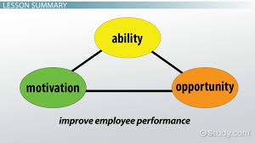
The AMO theory stands for Ability, Motivation and Opportunity to gain good employee performance. The theory helps increases the ability of the employees, motivating them and giving them a great opportunity to provide a better service to the organisation. However, if any of the elements is missing the performance is likely to be barred. The theory helps provide managers with a tool that can help improve and enhance performance of their employees.
According to a case study published in 2016 Google has topped the great place to work list in 2013 and 2014 and has remained in the top five. They rate their employee performances based on two things: What the employee achieved and their behaviour on how they achieved it. (How Google does performance review, 2016).
Engaging employees in an organisation is a crucial factor for productivity, effectiveness and success of an engaged employee as well as the organisation. Employee Engagement familiarises that engagement has to be seen in five different scopes: the company, the employee, the team, the network and the society. (Gartner, J. 2017).
Employee engagement is a development vehicle for any organisation as this means that the employees are not only satisfied with their jobs but they are willing to go that extra mile to accomplish the goals and vision of the company without worrying about the pay and rewards. An engaged employee is:
- Loyal to the organisation
- Seeks opportunities to grow
- Empowered to share ideas and opinions
- Puts in extra effort to accomplish the goals of the organisation
According to the CIPD research report produced in January 2010 Employee engagement is defined as being completely present throughout the performance of work by willingly contributing
Intellectual engagement – Thinking critically and creatively with a commitment to explore and perform better.
Affective engagement – Feeling optimistic as progressing further.

Social engagement – Can help keep the work environment stress free as everyone is engaging with each other to bring improvements to their work.
(Alfes, K, Truss, C, Soane, E. C, Rees, C & Gatenby, M. January 2010).

Learning Organisation in academic words defines “individuals, grouping and organizational learning with the simultaneous proceeding effort for organizational and individual learning”. (Örtenblad, A. 2018).
Learning organisations is a development vehicle as they have their own values which inspires and help supports their employees continuous learning within the organisation. It allows employees to critically think in certain activities also allowing the organisation to expand and rise with the sudden speed of change and competition.
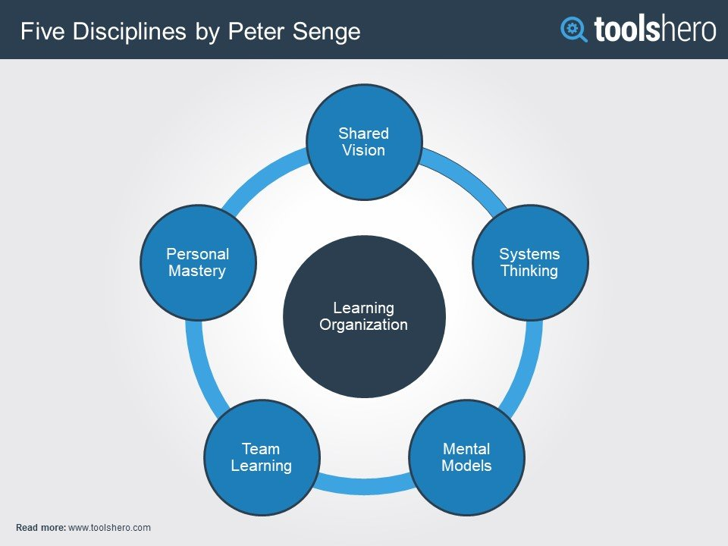
According to the Journal of Organisational Culture, Communications and Conflict, Peter Senge (1990) Learning organisations are where people constantly show their capability to achieve greater results mutually working together to achieve their ambitions. Peter Senge identifies the five different ways of innovate learning organisations which are:
- Systems thinking – The foundation.
- Personal mastery – Helps to constantly clarify and develop individual ideas.
- Mental models – expectations and overview that effect how individuals recognise and take action.
- Building shared vision – Connecting with all the members of the organisation to achieve its aims and targets.
- Team learning – When a team is learning collectively they grow individually as well as the organisation.
(Fillion, G, Koffi, V, Ekionea & Jean-Pierre. 2015).

Appraisal is a process for managers and their employees to review and discuss the performance of the employee. The aim of this is to recognize and understand certain areas for individual development and come up with a development plan to progress further.
Employee appraisal is a development vehicle in an organization as it helps to understand the needs of the employee and come up with a plan for future improvements if needed. It also helps to recognize achievements.
Based on several theorists they have talked about appraisal and how it helps in an organization to come up with an agreed plan where required, pay, bonuses, promotions, rewards and terminations. Performance appraisal is carried out by managers and should involve:
- Asking questions
- Actively listening
- Beneficial feedback
(CIPD, Performance Appraisal Factsheet, 2018).
John Whitmore and Graham Alexander (1979) established the GROW model which demonstrated how people can grow by learning and enjoying themselves. The GROW model stands for:
- Goals
- Reality
- Options
- Will
This model helps the managers in an organisation to train an employee accordingly so that they perform and develop better. If this model is used as part of the appraisal system it can help the employee realise what they need to improve on and how it should be done. It also helps to empower the employee on what their next target is and how it should be achieved.
(MTD Training , Running Effective Appraisals. 2010).
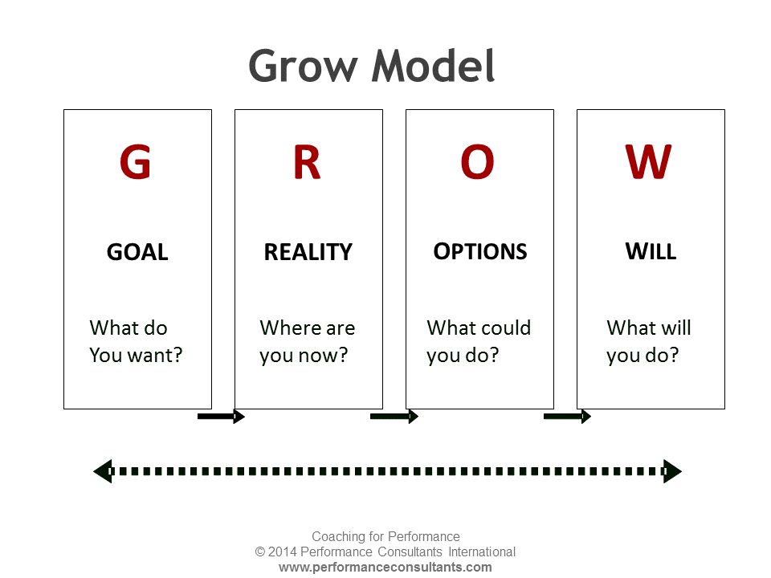

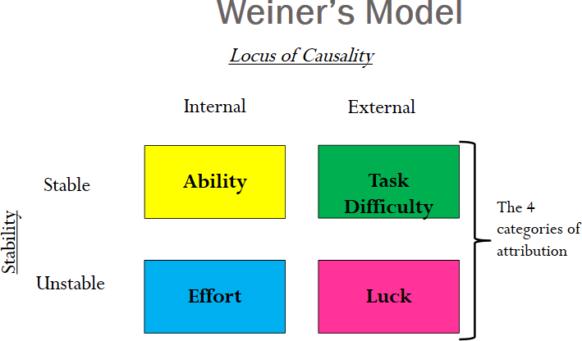
Feedback is a process of helping one another to be more efficient and effective. It is used as a basis for continuously improving performance. Feedbacks are effective when it is linked to the aims and purpose of the learning. It helps to focus on the behaviour of the individual. (Nicolls, R. 2016).
Bernard Weiners Three-Dimensional Theory of Attribution believes that people ascribe their behaviour to what they do and why they do it. “According to Weiner, there are three main characteristics of attributions that can affect future motivation”.
- Stability – Having a successful achievement can help motivate the employee for future performance as well as having a negative impact stable attributions can lead to reduced expectations in the future.
- Locus of Control – This explains an internal or external factor effecting the employees performance.
- Controllability – Control attributes explaines how controlable was the situation if it was outside of their control it will help to motivate the employee to work harder for future performances likewise if it was in their control it will demotivate them for future performances.
“Weiner’s Three-Dimensional theory of attribution has implications for employee feedback. Encouraging employees to attribute the failure to controllable factors”. (Mark, 2014).
Personal Development is a process to develop personal growth and to improve oneself keeping in mind the aims and goals in life to maximise the ability to be able to achieve it. It is a process of enhancing the skills and knowledge to create self awareness where improvements are needed. (Rolfe, A. 2018).
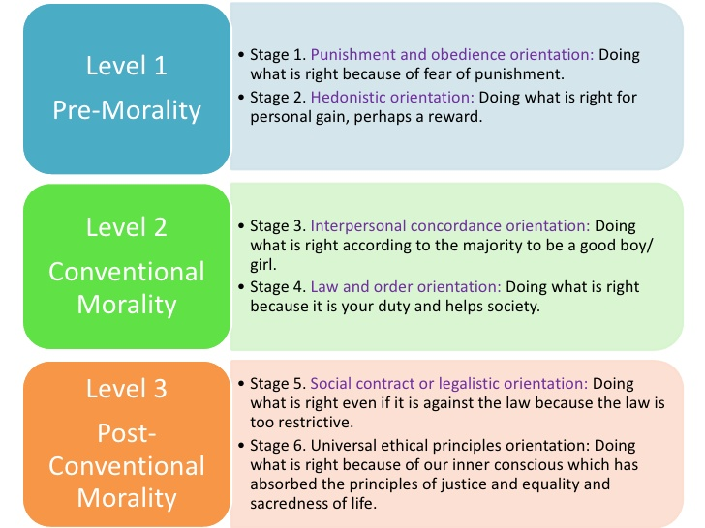
Lawrence Kohelberg (1958) came up with a theory of moral development and have said it is a process of maturation that arises from thinking about moral issues. According to Kohelberg there are three stages of development:
Pre–Conventional
Conventional
Post-conventional
(Cherry, K. 2018).
Personal Development in the workplace helps to boost individual motivation by realising the strengths and weaknesses of a situation and in turn helps to be more productive to attain bigger success. This in turn is linked to motivation where Abraham Maslow (1943) developed his theory ‘need hierachy’ which explains how people are motivated in the workplace to achieved their targets and set their goals for personal development.

Task 2
Individuals in the workplace are people who are committed and dedicated working towards the organisations goals as well as theirs to meet their needs and reach their aims. A great performing team place a greater approach towards expressing their viewpoint.
Developing individuals in the workplace has numerous benefits to the organisation and individual themselves some of which are:
- Improved job satisfaction and self esteem
- Improved motivation and effectiveness
- Increased capability to take on challenges and adopt new techniques
- Greater reputation and image of the organisation as employees are dedicated and fulfilling their targets to reach the organisations goals.
(Shaw, J. 2011).
Below are some case studies of individuals dedication to their work in reaching their aims as well as their organisations and how the company has motivated, trained and developed their employees to perform exceptionally.
Motivation
Googles commitment to its employees is the reason why they have topped the great place to work list in 2013 and 2014 and has remained in the top 5 since then. There are many ways that google maintain their employees to keep them motivated and engaged to produce high level of work.
Flexibility: They allow their staff to dedicate 20% off their time to concentrate on a project of their choice. This allows the employees to research and explore the different areas and can help build new ideas.
Free advantages: Google provide their employees with other benefits that keep their workforce motivated as well as their employees happy. Free haircuts, shuttles available to and from work, gym memberships etc. They also reimburse any programmes that help them to reach their goals and keep their employees motivated.
Health and Happiness: Health check-ups of their employees including health care packages where they have a full check up by the onsite medical services are taken care of to keep their staff well and content.
Google keeps pay discussions separate from the peer feedback with an aim to provide the right motivation to their employees, to grow and contribute to Google’s success.

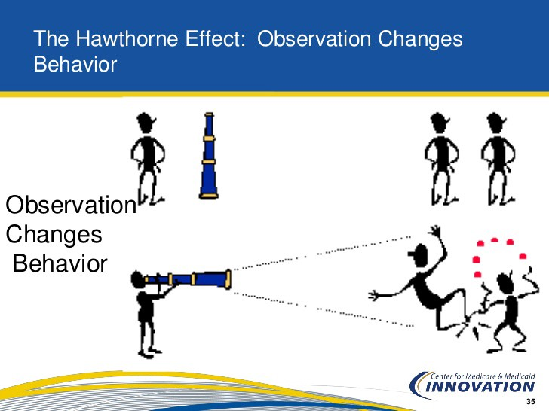
The Hawthorne effect shows how managers can keep their employees motivated to help them work more efficiently. It shows how managers and leaders can motivate and reward their employees in different ways other than pay incentives such as promotions, taking their opinions on certain areas and implementing it.

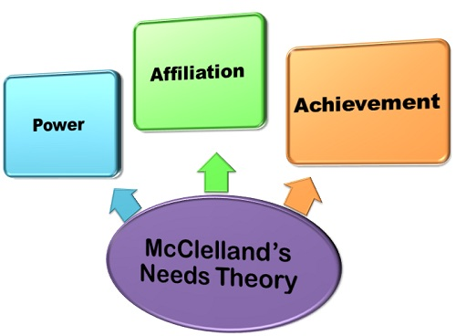
McClelland’s theory of motivation proposes three types of needs that motivate people:
Need for achievement, Need for affiliation, Need for power.
McClelland theory of motivation is applied in Google and it suggests that different employees have different needs and they should be approached differently. The theory suggests that employees with high need for achievement should be given a higher more challenging tasks which they can explore and experiment with their ideas to reach the goals. Employees with high need for affiliation can form good relationships with other members so they can be productive when working in a team. Whereas employees with high need for power can work as leaders where they can manage and lead a team. The theory help recognise individual abilities and place them in their position where they can be more productive and efficient.
Abraham Maslow ‘Need of Hierarchy’ suggests that as there are different stages of needs not all employees are satisfied with the same thing. After the first need is met individuals work towards achieving the next one until they are fully satisfied. Google allow their employees to take time off work whenever needed to manage their family life as well as work this keeps their employees motivated to be more productive and focused when at work.
A research done by Edward L Deci Professor of Psychology at the University of Rochester specifies that not all employees are motivated with external rewards such as money as it tends to decrease motivation. However, when verbally spoken to them and given a positive feedback it increases motivation. Google applies that to their employees and are transparent by performing quarterly, semi-annually and annually performance reviews. Performance are rated based on two things accomplishment and their behaviour towards the achievements. (How Google does performance review, 2016).

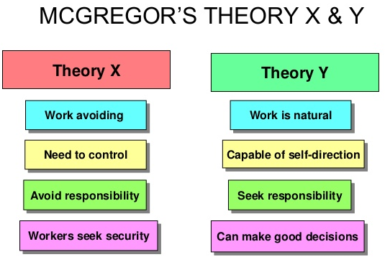
Douglas McGregor (1960) describes two styles of management. Theory X and Theory Y. Theory X is where more discipline and strict actions are taken against an employee as they tend to be lazier and less determined. Theory Y is where employees have a sense of responsibility and are ambitious. (Nuclear Decomissioning Authority , The Times 100. 2018).
Google uses theory Y in their organisation as a means of motivating and making the workplace more creative and innovative for people to work in at their own pace and flexibility. Although it has advantages there are also some disadvantages as not all employee’s motivation level is at the same pace which can lead to the company’s loss.
Google should also apply the theory X in the workplace so that the employees who are not motivated and ambitious can be trained and made responsible by offering incentives, rewards and positive feedback when required. This will help the employees to be more productive, better at their job and happy in the workplace. It will also help the organisation meet their targets, become more efficient, good reputation and beneficial turnover.

Training and Development
Admiral Group have been featured in the Sunday Times Best Companies to Work for list in 2018 placing them on the 2nd position. Their dedication towards their employees is the reason why they have been listed 2nd. Communication, equality, training and development, reward and recognition are the pillars upholding the companies working ethics.
Admirals training team the academy offers supports and learning opportunities as well as guidance for all their employees. They offer brochure with the list of courses and training programmes that are available. A feedback survey is sent out to their employees every 6 months to confirm the greatest opportunities available and to ensure the best is provided to train them appropriately. The academy supports and urges their employees self-learning through ‘David’s Buy a Book scheme’ where they are able to purchase books or DVD that are funded by the company and will help the employees towards their career development. External courses and training programmes are also there which are fully supported by the company so that the employees can gain professional qualifications. (Corporate Social Responsibility Report, Admiral CSR Report. 2017).
GROW model was introduced in 1980 by Sir John Whitmore which is used for coaching and training employees. It is a framework that is used to make sure employee’s goals are explored, progression for development is agreed and self-awareness is raised. (Sir John Whitmore, 2018).

Goal Setting
Reality Check
Options
Will
Admiral have applied the GROW model to their organisation when training employees. When having a conversation with the employee a goal is set for them using SMART measures and keeping in mind if the goal is achievable. Next the reality is checked where the admiral checks if steps are taken by the employee already to achieve their goal. Then all possible options are checked to be able to achieve the goal, any factors that are relevant are taken into consideration. The last part of the training system is to then find out now what should be done to prevent any barriers and to keep themselves motivated to reach their goal.
According to a former executive employee from Cardiff their personal issues was affecting their attendance however admiral has supported and provided options that will suit the employee. There are plenty of scope for learning and development in admiral which means there are different types of courses that are funded by the company themselves for the progression and development of their employees.
The management at admiral’s office do not have a separate office however sit together with their employees in an open place where communication is always open this motivates and encourages the employees to dedicate their time to meet the needs of the organisation.
The GROW model is used to help the team members improve performance and to help them reach their long-term goals. Although GROW model has many advantages and is used my companies like admiral it also has some disadvantages where managers can be too focused on following the model that the employee is not heard and the goals and ambitions are not kept in mind. Not every training session will result in an exact action that needs to be taken which can be easily overlooked by the manager. The underlying issues might be ignored as the manager is trying to come up with a solution that will benefit the organisation but not the employee.
According to reviews that are left on the job site Indeed one of their former employees a claims handler has said that the workload is intense and there is no support provided after the training more training should be provided on management skills and high staff turnover. (Indeed. 2018).

Systems theory identifies how different systems affect an employee or influence them to work harder. This is done by managers by observing different arrangements and how it affects the employee. Weighing up the risks and with the help of that the manager can then decided what programs or training is required for the employee to perform well to complete the goal of the organisation. This theory should be applied to admirals employee as different individuals have different learning abilities and the Systems theory can be used to provide training and development shaped around the employee themselves rather than one works for all.
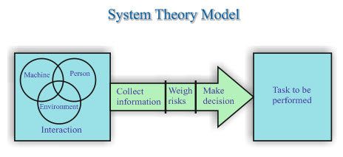
Personal development is about self-reflection and enhancing oneself to fulfil goals. Developing an individual in the workplace benefits both the organisation and the employee. Above two examples have been given regarding two organisations Google and Admiral and how they motivate, train and develop their employees not only for the organisations benefit but also for the individuals themselves. Both the organisations use different theories to motivate their employees. An appraisal system is also set up where a review is done by a manager to appraise the job performance and to discuss pay and promotions where necessary.
McGregor’s theory X and theory Y helps recognise individuals and put them accordingly as not everyone is motivated the same. Theory X and Theory Y helps realise the potential of an individual and train them according to that by being transparent and offering them more challenging tasks. This will ensure that they become more efficient and be self-aware of their strengths and weaknesses.

Task 3
Objectives | Measures | Priority | Support & Development  Internal External |  | Review Dates | Other Comments
Improve means of communication and interpersonal skills | Interact more with people and hold more meetings | High | More team work and Practice active participation | Involving in a focus group | Review in 6 months | Being observant of others, actively listening and asserting when required.
Have excellent management skills | Prepare and organise the day ahead, lead a work group & develop understanding of other duties | High | Involve more in group discussions, have a prominent role in departmental meetings | Starting up early to become more productive | Review in 3 months | Delegate tasks which helps to avoid stress, prioritise work that is time consuming and important.
Being more Reliable | Be punctual, improve performance management which motivates to work harder | High | Involve more in challenging tasks which improves productivity | Plan ahead of the day | Review in 3 months | Time management and organisational skills helps increase productivity
Be able to use technology and have good IT Skills | Actively set targets to be completed on the computer | Medium | Taking on simple tasks to be done using IT to improve the use of technology | Take up IT courses that help with the learning | Review in 6 months | See the finance office for a budget for the course
Problem solving and decision-making skills | Analysing the main factor adding to the situation | Medium | Implementing a plan to find a solution to clear the obstacle. | Keeping an idea journal. | Review in 6 months | Instead of mind mapping writing everything out on a paper to find solutions and make decisions.
Have self-awareness | Reflecting on the day at the end, know individual strengths and weaknesses | Low | Asking for informal feedback to understand what is lacking | Taking a personality test, jotting thoughts down on a journal | Review at next appraisal | Managing emotions helps to build self-confidence and become a critical leader.
Development Plan

A personal development plan helps to recognise the strengths and weaknesses of an individual in a workplace. It also helps to recognise how these skills can be transferred and enhanced to be successful in the workplace.
A personal development plan for managers is a great way to improve workplace performance and set targets for their employees accordingly.
The table above shows a personal development plan for an individual identifying the development needs and how it can be achieved taking following measures.
Communication and interpersonal skills are certainly the key to a successful workplace. Interacting with other people, working in a team or leading a group all requires communication. Good communication allows the organisation to be more productive and well organized. This is put at a high priority this is because without communication and interpersonal skills there will be no employee engagement, team development or innovative ideas.
Having excellent management skills means being able to face challenges the ability to take in charge and organise everything. Delegating tasks to team members, prioritising work helps to enhance that skill. This is put at a high risk because to become a successful employee in the workplace an individual need to possess management skills where necessary leading a team.
Reliability is important to individual performance to be able to get done what is expected of them. It helps to improve performance and efficiency. This is also put at a high risk because in a successful organisation there are targets that need to be met in challenging situations, being able to rely on a certain individual to complete those targets in those challenging situations is what is expected by the managers. Planning ahead of the day and keeping well organised helps to perform well and consistently.
Technology and IT skills are used in all types of organisations big or small it helps to simplify things and keep everything stored in one place so can be easily accessed by any authorised person. Although it is really important as an individual to be well skilled on using IT and technology it is put at medium risk. The reason being is that not all positions require the use of IT however, by taking lessons and IT classes this can help increase knowledge. Some organisations offer their employees funds which can help pay towards any courses that can be taken to enhance the use of IT and other technology.
Problem solving and decision making requires an individual to be observant of the situation and to remain calm under pressure. Implementing a plan to find out solutions to the problem is what an individual is expected to do. This is placed at a medium risk compared to the others as not all individuals are required to possess this skill although keeping an idea journal helps the individual to become more aware of certain situations coming up with a solution. Thinking creatively helps to come up with innovative solutions that reduce the impact it will have on the organisation.

Self-awareness and self-knowledge are important to realise strengths and weaknesses of an individual and how to overcome them. Reflecting back on the day helps to realise and point out the parts that could be done better and what is lacking. Compared to the other objectives this is prioritised low. Having informal feedback from other members helps to realise what is lacking.

References
Alfes, K, Truss, C, Soane, E. C, Rees, C & Gatenby, M. January (2010). CIPD Creating an Engaged Workforce.
Balle, L. (2017). Motivation Policy for Employees. [Online]
Available at: https://bizfluent.com/info-8684528-motivation-policy-employees.html
[Accessed 20 11 2018].
Cardy, R. L. (2011). Performance Management. 2nd ed. London : Routledge .
Cherry, K. (2018). The Psychology of Personality Formation. [Online]
Available at: https://www.verywellmind.com/personality-development-2795425
[Accessed 06 12 2018].
CIPD. (2018). Performance Appraisal. [Online]
Available at: https://www.cipd.co.uk/knowledge/fundamentals/people/performance/appraisals-factsheet
[Accessed 21 11 2018].
Corporate Social Responsibility Report. (2017). Corporate Social Responsibility Report: Admiral CSR Report.
Fillion, G, Koffi, V, Ekionea & Jean-Pierre. (2015). PETER SENGE'S LEARNING ORGANIZATION: A CRITICAL VIEW AND THE ADDITION OF SOME NEW CONCEPTS TO ACTUALIZE THEORY AND PRACTICE. Journal of Organizational Culture, Communications and Conflict, Vol - 19(3), pp. 73-102.
Gartner, J. (2017). Employee Engagement: A little book of big ideas. 2nd ed. TinyBig Books.
How Google does performance review (2016) Francisco S. Hamem De Mello.
Indeed. (2018). Admiral management reviews. [Online]
Available at: https://www.indeed.co.uk/cmp/Admiral/reviews?ftopic=mgmt&lang=
[Accessed 08 12 2018].
Mark. (2014). 5 Psychological Theories of Motivation to Increase Productivity. [Online]
Available at: https://contactzilla.com/blog/5-psychological-theories-motivation-increase-productivity/
[Accessed 21 11 2018].
MTD Training. (2010). Running Effective Appraisals. MTD Training and Ventus Publishing APS .
Nicolls, R. (2016). What is feedback and why is it important?. [Online]
Available at: https://leolearning.com/2016/11/what-is-feedback-and-why-is-it-important/
[Accessed 21 11 2018].
Nuclear Decomissioning Authority. (2018). Developing a motivated workplace. The Times 100, pp. 113-116.
Örtenblad, A. (2018). The Learning Organisation. What does 'Learning Organisation' mean?, Vol -25(3), pp. 150-158.

Rolfe, A. (2018). Five benefits of personal development. [Online]
Available at: https://www.reed.co.uk/career-advice/five-benefits-of-personal-development/
[Accessed 06 12 2018].
Shaw, J. (2011). The Caveman Guide To Training and Development. 1st ed.
Suyono, J & Mudjanarko, S.W. (2017). Motivation Engineering to Employee by Employees Abraham Maslow Theory. Journal of Education, Teaching and Learning, Vol - 2(1), pp. 27-33.
Sir John Whitmore. (2018). ‘Performance, learning and enjoyment are inextricably intertwined’. [Online]
Available at: https://cdn.southampton.ac.uk/assets/imported/transforms/.../GROW-Model.pdf
[Accessed 08 12 2018].

