The impact of Virtual Learning Environment (VLE) – Moodle on students’ learning experience at the University of Wales Trinity Saint David London Campus

Student Name:Marius Catalin Buica
Student ID: 2133741
Lecturer Name: KOUSHIK MODAK
Table of Contents
Chapter-1: Introduction 1
1.1 Project Background 1
1.2 Research Aim 1
1.3 Research Objectives 1
1.3 Research Questions 1
Chapter-2: Literature Review 3
2.1 Virtual Learning Environment 3
2.2 The impact of Virtual Learning Environment (VLE) on students’ learning experience 3
Chapter-3: Methodology 4
Chapter-4: Results and Discussion 5
4.1 Primary Quantitative Analysis 5
4.2 Secondary Qualitative Analysis 6
4.2.1 Question-1: What is the significance of the Virtual Learning Environment (VLE) for the students of the University of Wales, Trinity Saint David London Campus? 6
4.2.2 Question-2: How significantly Virtual Learning Environment (VLE) can impact the learning experience of the students of the University of Wales, Trinity Saint David London Campus? 6
4.3 Discussion 7
Chapter-5: Conclusion 8
Reference 9
Appendix 11
Close-Ended Survey Questions 11

Chapter-1: Introduction

Project Background
In educational technology virtual learning technology refers to a web-based model that facilitates the learning experience of the students by implementing some significant strategies, and by implementing effective technological tools (Fiaidhi, 2021). Just like other educational institutions, the Trinity Saint David London Campus of the University of Wales has been using the virtual learning environment also to support the learning process of the students and to ensure a better learning experience for the learners (Thomas, 2022). In this research, the researcher will make a comprehensive analysis to determine how a virtual learning environment can impact the learning experience of the students of the University of Wales, Trinity Saint David London Campus. The significance and implications of the virtual learning environment in higher education will be identified in this research.

Research Aim
This research report aims at investigating the impact of the Virtual Learning Environment (VLE) on the learning experience of the students of the University of Wales, Trinity Saint David London Campus.

1.3 Research Objectives
This study will achieve the following objectives-
- To determine the significance of Virtual Learning Environment (VLE) for the students of the University of Wales, Trinity Saint David London Campus.
- To investigate how significantly a Virtual Learning Environment (VLE) can impact the learning experience of the students of the University of Wales, Trinity Saint David London Campus.

Research Questions
This study will answer the following questions-
- What is the significance of a Virtual Learning Environment (VLE) for the students of the University of Wales, Trinity Saint David London Campus?
- How significantly Virtual Learning Environment (VLE) can impact the learning experience of the students of the University of Wales, Trinity Saint David London Campus?

Chapter-2: Literature Review

2.1 Virtual Learning Environment
According to the research by Henri and Pudelko (2019), virtual learning is a term taken from educational technology and it refers to a web-based model to support the learning process of the students. Goodfellow (2020) supported this research and stated that a virtual learning environment is the combination of some specific factors like content management, different types of networking devices, the curriculum of study, administration of the learning process, online project management tools, collaboration platforms, computers, and mobile devices, and others. Clark (2021) refuted this research and stated that virtual learning environment is a term taken from virtual reality and it supports the learning system of students by creating different types of web-based simulations and educational content management approaches. Russell (2022) denied this research and stated that the virtual learning environment is mainly a specialized aspect of the e-learning process and by accessing this students can get real-time support in learning from anywhere around the globe.

2.2 The impact of Virtual Learning Environment (VLE) on students’ learning experience
According to the study by Martinez (2020) in this post-pandemic situation the learning experience of the students can be impacted directly by the virtual learning environment implemented by educational institutions. Edgar et al. (2020) supported this research and added that at the time of the covid-19 pandemic when every type of direct classroom activity was prohibited then the students had to access their classes and exams by accessing the virtual learning environment of their educational institutions and now in this new normal state the students are using several elements of virtual learning environment too. Alshehri (2020) added that ensuring a better learning experience for the students’ virtual learning environment can contribute a lot because it minimizes the cost and effort of learning. Moreover, the article of Wales.ac.uk (2022) stated that a virtual learning environment makes the learning material easy to access and students can access their course material from anywhere around the globe with the help a virtual learning environment which is another contribution of VLE to students’ learning experience. Besides, Thomas (2022) stated that a virtual learning environment enhances students’ engagement in the study which is another noteworthy impact of VLE on the learning system.

Chapter-3: Methodology
The methodology is one of the most significant parts of a research project that explains and identifies the philosophical state of the research, methods, and approaches followed by the research, the strategy implemented by the research, and the process of selecting the sample of the study (Saunders, 2017). In this study, the philosophy of the researcher was to follow the positivism research philosophy which is undertaken from an epistemological philosophical view. As to investigate the research topic the researcher has to make different types of creative and personal justifications so the researcher has selected the epistemological research philosophy. Here the researcher has implemented deductive research to develop this study because the researcher assumed that to conduct this research he would have to use the available theories and conceptions of the industry because within this short time developing theories on his own was not possible for the researcher. So the researcher decided to follow the deductive research approach here to use the existing theories and conceptions. Moreover, here the researcher used both primary and secondary data collection methods to obtain the data for this research. To collect the primary data for this research the survey research strategy was followed. Moreover, in terms of the secondary data collection method, the desk research strategy was used by the researcher. Here the researcher has used mixed research methods to conduct this study. Both qualitative and quantitative data analysis processes were implemented in this study. The sample of this study was selected by following the simple random method and the purposive method of sampling. The researcher has made a survey questionnaire and collected primary data directly from 30 students of the University of Wales, Trinity Saint David London Campus. In terms of secondary data the researcher has selected 8 previous articles that have discussed the impact of the Virtual Learning Environment (VLE) on students’.

Chapter-4: Results and Discussion

4.1 Primary Quantitative Analysis
Here the researcher has identified the impacts of virtual learning environments on students’ learning experience by analyzing the primary data of this research.
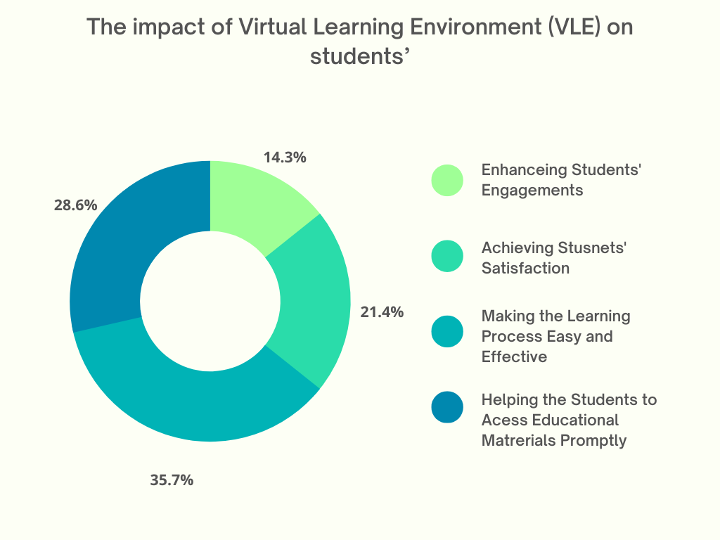
Figure 1: The impacts of virtual learning environments on students’
To identify the impacts of the virtual learning environment the researcher has asked some close-ended questions to 30 students of the University of Wales, Trinity Saint David London Campus and asked them some close-ended questions to investigate the impacts of Virtual Learning Environment-VLE on the learning experience of students. Here the researcher found that there are four specific impacts of a virtual learning environment on the learning experience of students including enhancing students’ engagements, achieving students’ satisfaction, making the learning process easier and effective, and helping the students to access educational material promptly. As per the responses of the participants the researcher found that 35.7% of the respondents identified that the most significant impact of VLE is it can make the learning process easy and effective for the students. Besides, 21.4% of participants stated that a virtual learning environment can help to achieve student satisfaction. Moreover, 28.6% of participants stated that a virtual learning environment can help students to access educational materials appropriately and promptly. Lastly, 14.3% of respondents agreed that a virtual learning environment can enhance students’ engagement which is one of the most significant impacts of VLE on students’ learning experience within the Trinity Saint David London Campus of the University of Wales.

4.2 Secondary Qualitative Analysis

4.2.1 Question-1: What is the significance of the Virtual Learning Environment (VLE) for the students of the University of Wales, Trinity Saint David London Campus?
To answer this question the researcher has analyzed some previous articles from the field of e-learning and educational technology. After that, the researcher found that the research by Fiaidhi (2021) has stated that a virtual learning environment is significant for students of the University of Wales, Trinity Saint David London Campus because the students can get real-time support in education by accessing VLE. When a VLE will be implemented on the University of Wales campus then the students of this university will be able to access their educational materials from anywhere they want, and they will be able to join cases from anywhere around the globe as well. According to Fiaidhi this real-time support will enhance the learning quality of the students. Moreover, as per the research of Schaper et al. (2022), the virtual learning environment is significant because it makes the learning process easier and more effective for the students and when the learning process will be effective then the quality of learning will increase automatically.

4.2.2 Question-2: How significantly Virtual Learning Environment (VLE) can impact the learning experience of the students of the University of Wales, Trinity Saint David London Campus?
While answering this question by analyzing secondary data here the researcher found that according to the article of Azis (2021) virtual learning environment can impact the learning experience of the students of the University of Wales, Trinity Saint David London Campus because VLE can help to achieve students’ satisfaction and at the same time it can contribute to enhancing students engagement in the learning process also. When the students will be satisfied with their learning programs and when their engagement in the learning process will increase then the learning experience of the students will be impacted positively it is needless to mention. Moreover, the research of Isaias (2022) stated that there are some major impacts of virtual learning environments on the learning experience of the students as VLE can help the students to access their educational material appropriately. Moreover, a virtual learning system can make the learning process easy and effective which is another significant influence of VLE on the learning experience of the students.

4.3 Discussion
In the first objective of this research the researcher wanted to determine the significance of the Virtual Learning Environment (VLE) for the students of the University of Wales, Trinity Saint David London Campus. After analyzing the primary and secondary data collected in this research the researcher found that a virtual learning environment is significant for the students of the University of Wales, Trinity Saint David London Campus because VLE can provide real-time support to the learning process which is significant to enhance the quality of learning. Thomas (2022) found the same thing in his research while evaluating the significance of e-learning and virtual learning. Moreover, as per the study of Henri and Pudelko (2019), virtual learning is significant because it can make the learning process, smart, effective, prompt, and relevant. In this research, the researcher has found quite a similar thing as well.
In the second objective of this study, the researcher wanted to investigate how significantly a Virtual Learning Environment (VLE) can impact the learning experience of the students of the University of Wales, Trinity Saint David London Campus. Here the researcher found that there are four direct impacts of VLE on the learning experience of the students’’ of the University of Wales, Trinity Saint David London Campus including achieving students’ satisfaction, enhancing students’ engagements, helping the students to access educational material promptly, and making the learning process easier and effective. Goodfellow (2020) stated the same thing in his research also while investigating the implications of a virtual learning environment. Moreover, the research of Fiaidhi (2021) stated that a virtual learning environment can enhance the quality of learning and by enhancing learning quality it can contribute to facilitating the learning experience of the students. In this research, the findings of the researcher were the same as well.

Chapter-5: Conclusion
Here the researcher has concluded this study by achieving all the pre-determined objectives of this study and by answering all the questions in association with this research. In this report first, the researcher has identified the significance of the virtual learning environment for the students of the University of Wales, Trinity Saint David London Campus. Here the researcher found that a virtual learning environment is significant because it enhances the quality of learning, it enhances the adaptability of the students, it helps the students to acquire appropriate knowledge and skills, and VLE can contribute to ensuring the continuous development of the learners as well. Moreover, here the researcher also investigated the impacts of VLE on the learning experience of the students of the University of Wales, Trinity Saint David London Campus and the central findings of the researcher were that the virtual learning environment and the learning experience of the students’’ are intimately connected. VLE can enhance student engagement, it can support to satisfaction of the students, VLE can make the learning process easy and participative, and VLE can make the learning process more accessible as well. All of these factors together will contribute to enhancing learning quality and in this way, the personal and professional development of the students will be ensured.

Reference
Alshehri, S., 2020. Active Learning Approaches to Teaching and E-Learning Astrophysics in Higher Education. The International Journal of Learning in Higher Education, 27(1), 31-39.
Azis, Y., 2021. Sharing Time Learning (Face to Face and Online Learning) in Blended Learning. International Journal of Psychosocial Rehabilitation, 24(02), 466-474.
Clark, 2021. Virtual Learning and technology. University Press: London.
Decius, J., Dannowsky, J., & Schaper, N., 2022. The casual within the formal: A model and measure of informal e-learning in higher education. Active Learning in Higher Education. Hampshire: England.
Fiaidhi, J., 2021. Virtual SceneBean: a Learning Object Model for Collaborative Virtual Learning Environment. Informatics in Education, 3(2), pp.191-218.
Goodfellow, R., &amp; Lamy, M., 2020. Learning cultures in online education. Continuum. In Higher Education, 14(1).
Henri, F. and Pudelko, B., 2019. Understanding and analyzing activity and learning in virtual communities. Journal of Computer Assisted Learning, 19(4), pp.474-487.
Isaias, P., & Issa, T., 2022. Virtual and Sustainability in Higher Education. The International Journal of Learning in Higher Education, 19(4), 77-90.
Livingstone, D., Kemp, J. and Edgar, E., 2020. From Multi-User Virtual Environment to 3D Virtual Learning Environment. Research in Learning Technology, 16(3).
Martinez, 2020. Open learning and e‐learning. Open Learning: The Journal of Open, Distance and Virtual-Learning, 22(1), 1-4.
Russell, M., 2022. Virtual Learning Communities: Implications for Adult Learning. Adult Learning, 10(4), 28-31.
Saunders, M., Lewis, P., and Thornhill, A., 2017. Research methods for business students. 9th ed. Harlow (Essex): Pearson, pp.290-302.
Thomas, 2022. Distance Learning | UWTSD. [online] Uwtsd.ac.uk. Available at: <https://www.uwtsd.ac.uk/postgraduate-research/distance-learning/> [Accessed 1 September 2022].
Wales.ac.uk. 2022. Home - University of Wales. [online] Available at: <https://www.wales.ac.uk/en/Home.aspx> [Accessed 1 September 2022].

Appendix

Close-Ended Survey Questions
Dear participants,
You are requested to answer these questions because you are a student of the University of Wales, Trinity Saint David London Campus and you have a clear idea about the Virtual Learning Environment of your university.
Question-1. What are the elements of a Virtual Learning Environment?
Answer:
Question-2. How Virtual Learning Environment can enhance the quality of learning?
Answer:
Question-3. Why implementing a Virtual Learning Environment is significant for the students of the University of Wales, Trinity Saint David London Campus?
Answer:
Question-4. What is the influence of the Virtual Learning Environment on your learning experience?
Answer:
Question-5. How your learning journey at the University of Wales, Trinity Saint David London Campus has been affected by the Virtual Learning Environment of this institution?
Answer:

