

Measuring Training Value: A Data-Driven Approach to ROI in Central Government

by
Michael Oldham

Supervisor: James Williams

Project submitted as part of the requirements for the award of
BSc (Hons) Computing (Data & Information Systems)

2026

DECLARATION

DECLARATION

I, Michael Jeffrey Oldham, declare that I am the sole author of this Project; that all references cited have been consulted; that I have conducted all work of which this is a record, and that the finished work lies within the prescribed word limits.

This work has not previously been accepted as part of any other degree submission.

Contents
DECLARATION 2
Abstract 5
1 Introduction 6
1.1 Aims & Objectives 7
1.1.1 Project Aim: 7
1.1.2 Project Objectives: 7
2 Literature Review 8
2.1 Training Evaluation Models 8
2.1.1 - Kirkpatrick Model – (The current approach) 8
2.1.2 – Alternative Models (Philips ROI Methodology) 9
2.1.3 – Industry Standards (CIPD) 11
2.1.4 – Data-Driven Approaches to Training Evaluation 12
2.1.5 – Dashboards and Tools (Technology) 13
2.1.6 – Literature Gaps 15
3.1 Research Methodology 17
3.1.1 Research Philosophy - Pragmatism 17
3.1.2 Research Approach – Inductive 17
3.1.3 Research Strategy – Case Study 18
3.1.4 Techniques and Procedures 18
3.2 Research Development Methodology 19
3.2.1 Software and Tools 20
4.1 Design & Implementation 21
4.1.1 Requirements Analysis and Existing System Review 21
4.1.2 Existing Process Analysis 21
4.2 Enhanced Data Collection Framework (EDCF) 24
4.2.1 Booking Process Redesign 25
4.2.2 ROI Data Capture Framework 27
4.3 User Interface Design 30
4.3.1 Existing Booking Interface 30
4.3.2 Redesigned Booking Interface 31
4.3.3 ROI Data Capture Interface 35
4.4 System Architecture 36
4.4.1 Architecture Overview 36
4.4.2 Power Apps 37
4.4.3 SharePoint 37
4.4.4 Power Automate 37
4.4.5 Power BI 38
4.4.6 Architecture Summary 38
4.5 Dashboard Design 39
4.5.1 Dashboard Design Objectives 39
4.5.2 Dashboard Structure 40
4.5.3 Executive Overview Dashboard 40
4.5.4 Strategic Alignment Dashboard 42
4.5.5 Skills and Workforce Development Dashboard 43
4.5.6 Training Value and ROI Dashboard 44
4.6 Implementation 45
4.6.1 Power App Implementation 45
4.6.2 SharePoint Implementation 48
4.6.3 Power BI Implementation 49
4.6.5 Implementation Summary 52
4.7 Testing 53
4.7.1 Testing Strategy 53
4.7.2 Functional Testing 53
4.7.3 Future User Evaluation 54
5 Evaluation 55
5.1 Introduction 55
5.2 Evaluation Against the Project Aim and Objectives 55
5.3 Evaluation Against the Literature 56
6 Conclusion and Recommendations 57
7 Reflection 58
References: 59
Appendices 60
DAX Code 60
Screenshots 69

Abstract

Training evaluation within many organisations is often limited to measuring attendance, completion rates and associated costs, providing little insight into the wider organisational value of learning and development activities. This project aimed to design, implement and evaluate an enhanced data-driven framework for measuring training return on investment (ROI) within a local government organisation.

The project adopted a mixed methods research approach, combining a review of existing training evaluation models with the development of a working prototype using Microsoft Power Apps, SharePoint and Power BI. The enhanced framework introduced additional data capture relating to strategic alignment, workforce skills and training justification, enabling more comprehensive reporting through an interactive dashboard.

The completed prototype demonstrated that enhanced data collection can improve the quality of information available to support evidence-based decision-making and provide greater insight into organisational training value. Functional testing confirmed that the prototype operated as intended, while the evaluation showed that the framework aligns with recognised training evaluation approaches discussed within the literature. The project provides a practical foundation for improving the measurement and reporting of training value and offers recommendations for future organisational implementation and development.

1 Introduction

The evaluation of training effectiveness is an important topic within organisational computing and data analytics, especially in local government where budgets are limited and accountability is essential. Public sector organisations are increasingly expected to demonstrate value for money, creating a need for more reliable and data-driven approaches to measuring training return on investment (ROI). However, traditional evaluation models, although widely used, often struggle to fully capture the wider organisational impact of training. This highlights a gap between established theory and practical application.

This project is based within an Information Technology Services (ITS) department in a government organisation, where a dedicated team manages all staff training bookings. Whilst this team is responsible for the booking process, the author’s role is focused on data. This includes managing the datasets where training information is stored and developing a Power App that staff use to submit their training requests. This involvement provides valuable insight into how training data is collected, structured, and used, as well as the limitations of the current system when attempting to measure meaningful ROI.

This chapter reviews key research and models related to training evaluation and ROI measurement. It begins by discussing established frameworks such as the Kirkpatrick Model, the Phillips ROI Methodology, and guidance from the Chartered Institute of Personnel and Development (CIPD), considering both their strengths and limitations. It then explores issues with current data collection practices, before examining more modern, data-driven approaches and the use of analytics dashboards to support decision-making.

Overall, gaps in existing approaches are highlighted, supporting the need for a more effective data-driven framework.

1.1 Aims & Objectives

1.1.1 Project Aim:

To design, implement and evaluate an enhanced data-driven framework for measuring training return on investment (ROI) within a central government organisation

1.1.2 Project Objectives:

- Critically review existing training evaluation models (This will include the Kirkpatrick model, Phillips ROI methodology and CIPD (Chartered Institute of Personnel and Development) guidance.

- Assess the limitations of the current training data capture system in supporting meaningful ROI analysis

- Design an enhanced data collection framework that captures strategic alignment, skills development and efficiency gains

- Develop a prototype analytics dashboard (Power BI or Tableau) to visualise ROI metrics for Senior Management

- Evaluate the feasibility, reliability and organisational impact of the proposed ROI measurement framework.

2 Literature Review

This section critically examines key training evaluation models, including the Kirkpatrick Model, the Phillips ROI Methodology, and guidance from the Chartered Institute of Personnel and Development (CIPD), with particular focus on their ability to support data-driven measurement of training return on investment.

2.1 Training Evaluation Models

2.1.1 - Kirkpatrick Model – (The current approach)

The Kirkpatrick Model is one of the most widely used frameworks for evaluating training effectiveness. Developed by Donald Kirkpatrick in 1959, it proposes a four-level structure consisting of reaction, learning, behaviour, and results. These levels aim to measure training from immediate participant feedback through to its overall organisational impact.

A key strength of the model is its clear and structured approach, which enables organisations to assess training across multiple stages. Its simplicity makes it widely accessible and easy to apply in practice, particularly in environments with limited resources. However, despite its popularity, there are notable limitations with its application.

A recent meta-analysis by Nawaz et al. reviewed 41 studies conducted between 1982 and 2021 and found that, whilst there are generally positive relationships between the four levels of the model, there is limited evidence of consistent improvement in training effectiveness over time.

The study also highlighted that significantly fewer studies examine the higher levels of the model, particularly behaviour and results, due to the difficulty of measurement. This suggests that, in practice, organisations often prioritise lower-level evaluation methods, such as participant reaction and learning, rather than long term impact.

Furthermore, the meta-analysis identified mixed findings regarding the relationships between the four levels, indicating that the assumed progression from learning to organisational results is not always clearly supported by empirical evidence.

This challenges one of the core assumptions of the Kirkpatrick Model and raises concerns about its reliability as a comprehensive evaluation framework.

In addition, the model does not provide explicit guidance on data collection or analysis, which can lead to inconsistent implementation across organisations. It also lacks a clear mechanism for measuring financial return, making it less suitable in contexts where demonstrating value for money is essential. As a result, whilst the Kirkpatrick Model provides a useful foundation for understanding training effectiveness, it may be insufficient when used in isolation within modern, data-driven environments. (Kirkpatrick Model and Training Effectiveness: A Meta-Analysis 1982 To 2021)

2.1.2 – Alternative Models (Philips ROI Methodology)

Whilst the Kirkpatrick Model provides a widely recognised foundation for evaluating training effectiveness, a signification limitation identified in the literature is its lack of direct financial measurement. In response to this gap, researchers such as Phillips [1] developed the Phillips ROI Methodology, which extends Kirkpatrick’s framework by introducing a fifth level focused on return on investment (ROI). This model has been widely discussed in both academic and professional literature as an attempt to align training evaluation with organisational performance and financial accountability.

Phillip’s work builds directly upon Kirkpatrick’s 4-levels, reaction, learning, behaviour, and results by adding a financial evaluation stage that quantifies the economic value of training outcomes. According to Phillips and Phillips [2], this approach enables organisations to move beyond measuring whether training was effective, to assessing whether it was worthwhile in financial terms. Their research highlights that organisations increasingly require this level of analysis, particularly in environments where budgets are constrained and justification of expenditure is necessary.

Empirical and practitioner-based studies suggest that the Phillips model offers several advantages over earlier frameworks. For example, Parry [3] found that ROI-based evaluation supports more informed decision-making by allowing organisations to compare training programmes based on measurable outcomes. Similarly, Bassi et al. [4] demonstrated that investment in human capital, when effectively measured, can have a positive impact on organisational performance indicators such as productivity and financial returns. These findings reinforce the argument that training should be treated as a strategic investment rather than a solely operational activity.

A key contribution of the Phillips methodology is its structured approach to data collection and analysis. It encourages the identification of performance indicators, the collection of baseline and post training data, and the use of techniques to isolate the impact of training from other variables. This aligns closely with principles within computing, particularly in relation to data analytics and evidence based decision making. From a systems perspective, the model highlights the importance of reliable data capture and processing, which are essential for producing meaningful outputs such as ROI metrics.

However, despite these strengths, the literature also identifies several significant limitations. One of the most widely discussed challenges is the difficulty converting training outcomes into monetary values. Swanson and Holton [5] argue that many important outcomes, such as improved communication or employee engagement, are essentially qualitative and cannot be easily quantified. As a result, organisations may either exclude these factors or rely on estimation techniques, which can reduce the validity of the results.

In addition, research indicates that the practical implementation of the Phillips model can be complex and resource intensive. Saks and Haccoun [6] highlight that collecting the necessary data requires time, expertise and appropriate systems, which may not be available in all organisations. This is particularly relevant in public sector contexts, where legacy systems and bad data structures can limit the ability to perform detailed analysis. Whilst the models theory is robust, its application in practice is often inconsistent.

When compared to the Kirkpatrick model, the Phillips methodology represents a clear advancement in terms of financial accountability and structured evaluation. However, both models share reliance on effective data collection, and neither fully addresses the challenges associated with modern data environments. In particular, the literature highlights a lack of integration between evaluation frameworks and digital systems used to capture and analyse training data.

This is where the relevance to this project becomes clear. Whilst the Phillips ROI Methodology provides a useful framework for measuring the value of training, it depends heavily on having accurate, consistent, and accessible data. From a computing perspective, this highlights the need for better data systems, improved data collection processes, and tools such as dashboards to support analysis.

Overall, the literature shows that although the Phillips model improves on traditional approaches, it does not fully address issues around data quality, system integration, and practical use. These limitations suggest a need for more data-driven and technology-based approaches to training evaluation, which are explored in the following sections.

2.1.3 – Industry Standards (CIPD)

In addition to academic models such as Kirkpatrick and Phillips, professional bodies provide practical guidance on how training should be evaluated in real organisations. In the UK, the Chartered Institute of Personnel and Development (CIPD) is one of the most influential organisations in this area. CIPD research focuses on improving workplace learning and development practices, and its guidance is widely used across both the private and public sectors.

CIPD promotes a more flexible and practical approach to training evaluation compared to traditional models. Rather than following a fixed framework, CIPD encourages organisations to focus more on measuring outcomes that are aligned with business goals. This includes assessing whether training has improved performance, supported organisational objectives, and delivered value for money. According to CIPD [7] evaluation should not be treated as a separate activity carried out at the end of training but instead should be planned from the beginning and integrated throughout the training process.

One of the key ideas in CIPD guidance is the concept of learning value rather than just return on investment. Whilst financial ROI is important, CIPD highlights that not all benefits of training can or should be measured in monetary terms. For example, improvements in employee confidence, engagement, and collaboration can have a significant impact on organisational performance, even if they are difficult to quantify financially. This reflects a broader and more balanced view of training effectiveness compared to models that focus only on measurable financial outcomes.

Research by CIPD also shows that many organisations struggle to carry out effective evaluation in practice. A common issue is that evaluation tends to focus on basic measures such as attendance, completion rates, or participant satisfaction, rather than long-term impact [8]. This is like the limitations identified in the Kirkpatrick Model, where higher levels such as behaviour and results are often not fully assessed. CIPD suggests that this is often due to lack of time, resources, or data, rather than a lack of understanding of the importance of evaluation.

CIPD also recognises that many organisations face challenges in using data effectively. Data may be stored across different systems, be incomplete, or lack consistency, making it difficult to carry out meaningful analysis. This is particularly relevant in public sector organisations, where systems are not designed for evaluation purposes. There is often a gap in what organisations would like to measure and what they are able to measure in practice.
In this project, CIPD guidance is highly relevant as it highlights both the importance of data-driven evaluation, and the challenges organisations face in achieving it. It supports the idea that better data collection and analysis processes are needed to improve the way training is evaluated. This aligns with the aim of developing a more structured and data-driven framework, supported by tools such as dashboards to provide a clearer insight into training outcomes.
Overall, CIPD provides a practical and UK focused perspective on training evaluation. Whilst it does not offer a strict model like Kirkpatrick or Phillips, it highlights key issues such as the importance of aligning training with organisational goals, the need for better use of data, and the challenges of implementing evaluation in practice. These insights help explain why a more modern, data-driven approach is needed and is explored further in continued sections.

2.1.4 – Data-Driven Approaches to Training Evaluation

As discussed in previous sections, traditional training evaluation models such as Kirkpatrick and Phillips provide structured ways of assessing training effectiveness. However, a common limitation identified in the literature is their reliance on the availability and quality of data. In response to this, researchers have increasingly explored data-driven approaches, which use data and analytics to provide more accurate and reliable insights into training outcomes.

Data-driven evaluation involves collecting and analysing data from multiple sources to assess the impact of training. Bersin [9] suggests that organisations can improve evaluation by combining data such as training records, assessment results, and employee performance metrics. This allows organisations to move beyond basic measures, such as satisfaction surveys, and instead assess whether training leads to measurable improvements in performance.

A Key area of development within this field is the use of people analytics. The Chartered Institute of Personnel and Development (CIPD) [10] defines people analytics as the use of workforce data to support better decision making. This includes identifying patterns and trends to understand how training affects employee performance and organisational outcomes. Supporting this, Marler and Boudreau [11] found that organisations using people analytics are more likely to adopt evidence-based approaches, leading to improved decision making and organisational performance.

One of the main advantages of data-driven approaches is that they provide more objective evaluation. Rather than relying on self-reported feedback, organisations can use actual performance data to measure impact. For example, training can be linked to improvements in productivity, reduction in errors, or enhanced service delivery. Davenport, Harris and Morison [12] argue that analytics enables organisations to make better decisions by identifying trends and relationships that would not be visible through traditional evaluation methods.

In addition, data-driven approaches allow organisations to monitor training outcomes over time. This is important because the impact of training is often not immediate. By analysing data over a longer period, organisations can assess whether learning is being applied in the workplace and whether it leads to sustained improvements. This provides a more complete understanding of training effectiveness compared to one off evaluations methods.

However, despite these benefits, the literature also highlights several challenges. One of the most significant issues is data quality. Marr [13] expresses that poor quality data, including incomplete or inconsistent datasets, can limit the effectiveness of analytics. In many organisations, training data is stored separately from performance data, making it difficult to link the two. This reduces the accuracy and usefulness of evaluation.

Another challenge is the lack of standardisation in data collection. Without clear processes, different departments may record data in different ways, leading to inconsistencies. This makes it difficult to compare results or identify trends across the organisation. As noted by Marler and Boudreau [11] the success of people analytics depends not only on the data availability but also on now consistently and effectively it is used.

There are also practical challenges related to skills and resources. Data-driven approaches require technical knowledge, including data management and analysis skills. Not all organisations have these capabilities, particularly in public sector environments where resources may be limited. This can restrict the extent to which data-driven evaluation is implemented in practice.

From a Computing perspective, these challenges highlight the importance of well-designed data systems. Effective training evaluation depends on systems that can capture accurate data, integrate information from multiple sources, and support analysis in a clear and accessible way. This includes the use of databases, automated data collection tools, and analytics platforms.

In relation to this project, data-driven approaches are particularly relevant as they address many of the limitations identified in earlier models. Whilst the Phillips ROI Methodology provides a way to measure financial return, it relies heavily on the availability of high-quality data. By improving data collection and analysis processes, it becomes possible to apply such models more effectively and produce more reliable results.

Overall, the literature suggests that data-driven approaches have strong potential to improve training evaluation. However, their success depends on the quality of data and the systems used to manage it. These challenges highlight the need for tools that can support analysis and present information clearly, such as dashboards, which are explored in the next section.

2.1.5 – Dashboards and Tools (Technology)

As organisations move towards more data-driven approaches to training evaluation, the use of dashboards and analytical tools has become increasingly important. Dashboards provide a visual way of presenting data, allowing users to quickly understand key information and make informed decisions. Within the context of training evaluation, dashboards can be used to display metrics such as training participation, performance improvements, and return on investment (ROI).

According to Few [14] dashboards are designed to present key information clearly and efficiently, enabling users to monitor performance at a glance. This is particularly useful in organisational settings where decision makers need access to up-to-date information without having to analyse large amounts of raw data. By presenting data visually through charts, graphs, and tables, dashboards make complex information, more accessible and easier to interpret.

Modern business intelligence (BI) tools, such as Microsoft Power BI and Tableau, have made it easier for organisations to develop interactive dashboards. Eckerson [15] highlights that these tools allow users to combine data from multiple sources, create visual reports, and update information in real time. This is especially relevant for training evaluation, where data may come from different sources, such as training platforms, HR systems, and performance management tools.

A Key advantage of dashboards is their ability to support data-driven decision making. Davenport, Harris and Morison [12] argue that organisations that effectively use analytics tools are better able to identify trends, measure performance, and improve outcomes. In the context of training, Dashboards can help organisations identify which programmes are most effective, where improvements are needed, and how training contributes to organisational goals. This aligns closely with the need for accountability and value for money, particularly in public sector environments.

In addition, dashboards allow for the continuous monitoring of training outcomes. Rather than relying on one-off evaluation reports, organisations can track performance over time and identify changes as they occur. This supports a more proactive approach to training evaluation, where issues can be identified and addressed quickly. For example, a dashboard could highlight low completion rates or limited performance improvement following training, allowing manages to act early on.

However, the literature also highlights several challenges associated with the use of dashboards and analytical tools. One of the main issues is data integration. As noted by Marr [13], data is often stored across multiple systems or databases, and combining this data into a single dashboard can be complex. If data is not properly integrated, the insights produced may be incomplete or misleading.

Another challenge is ensuring that dashboards are designed effectively. Poorly designed dashboards can be difficult to understand and may lead to incorrect conclusions. Few [14] emphasises that dashboards should be simple, focused, and designed with the user in mind. This includes selecting appropriate visualisations, avoiding unnecessary complexity, and ensuring that key information is clearly highlighted.

From a computing perspective, dashboards represent an important application of data systems and analytics. They rely on the integration of databases, data processing tools and visualisation software to transform raw data into meaningful insights. This highlights the importance of designing systems that support efficient data collection, storage and analysis.

In relation to this project, dashboards are a key component of the proposed solution. The development of a prototype dashboard using tools such as Power BI provides a practical way of applying data-driven approaches to training evaluation. By bringing together data from different sources and presenting it in a clear and accessible format, the dashboard can support more effective measurement of training ROI and organisational impact.

Overall, the literature suggests that dashboards and analytical tools play a critical role in modern training evaluation. They provide a way of applying data-driven approaches and support better decision-making. However, their effectiveness depends on the quality of the data, the design of the dashboard and the ability of the users to interpret the results. These factors must be carefully considered when developing and implementing dashboard-based solutions.

2.1.6 – Literature Gaps

The review of existing literature highlights that, whilst there are a number of established models and approaches for evaluating training, there are still several important gaps. These gaps limit the effectiveness of current methods and support the need for more modern, data-driven solutions.

One key gap identified across the literature is the lack of integration between evaluation models and data systems. Traditional models such as Kirkpatrick and Phillips ROI Methodology provide structured frameworks for evaluation, but they do not offer clear guidance on how data should be collected, stored, or analysed. As noted by Phillips and Phillips [2], the success of ROI measurement depends heavily on the availability of reliable data, yet many organisations lack the systems needed to support this. This creates a gap between theory and practice, where models are well-defined but difficult to implement effectively.

A second gap relates to data quality and accessibility. As highlighted by Marr [13], data-driven approaches rely on accurate, consistent, and well managed data. However, in many organisations, data is incomplete, stored across multiple systems, or not collected in a structured way. This makes it difficult to carry out meaningful analysis or link training activities to organisational outcomes. Similarly, Marler and Boudreau [11] emphasise that whilst interest in people analytics is growing, many organisations still struggle to use data effectively due to limitations in data quality and analytical capability.

Another important gap is the limited focus on the public sector within existing research. Much of the literature on training evaluation and ROI is based on private sector organisations, where financial performance is the primary measure of success. However, public sector organisations operate in a different context, where outcomes such as service quality, efficiency, and public value are equally important. As a result, existing models may not fully reflect the needs and challenges of local government environments, particularly in relation to accountability and budget constraints.
In addition, the literature often focuses on either qualitative or quantitative evaluation methods, rather than combining both. For example, CIPD guidance highlights the importance of considering both measurable outcomes and less tangible benefits, such as employee engagement and development. However, there is limited guidance on how these different types of data can be integrated into single evaluation framework. This creates a gap in understanding how to balance financial ROI with wider organisational value.
Another limitation is the lack of user-focused design in evaluation systems. As noted by Few [14], dashboards and reporting tools must be designed clearly and accessible to users. However. Many existing approaches focus more on data collection than on how the results are presented and used. This can reduce the effectiveness of evaluation, as decision-makers may struggle to interpret the data.
In relation to this project, these gaps are highly significant. The literature shows that whilst there are strong theoretical models for training evaluation, there is a lack of practical, data-driven solutions that can be easily implemented in real organisational contexts. In particular, there is a need for systems that can improve data collection, integrate information from different sources, and present results in clear and meaningful way.
This project aims to address these gaps by developing an enhanced data-driven framework for measuring training ROI. This includes improving how data is captured and designing a structured approach to analysis and creating a dashboard to support decision making. By combining elements from existing models with modern data and visualisation tools, the project seeks to provide a more practical and effective solution to training evaluation.
Overall, the literature highlights that current approaches to training evaluation are limited by issues related to data, system integration, and practical implementation. These gaps provide a clear justification for development of more advanced, technology-supported approaches, which form the focus of this project.

3.1 Research Methodology

This project adopts a case study-based, mixed-methods research approach to investigate how training return on investment (ROI) can be improved through data-driven methods within a central government organisation.

A Case study methodology has been selected as the project is based within a specific Information Technology Services (ITS) department. This allows for an in-depth investigation of real-world processes, particularly how training data is currently collected, managed, and used. The main advantage of this approach is that it provides detailed, context-specific insights, making the findings highly relevant to the organisation. However, a limitation of case studies is that results may not be fully transferable to other organisations. This is addressed by linking findings to existing literature and widely used models such as Kirkpatrick and Philips.

The research also adopts a mixed-methods approach, combining both qualitative and quantitative data. Qualitative data includes observations of current processes and feedback from stakeholders, whilst quantitative data includes training records, usage data, and performance-related metrics. This approach has been chosen as it provides a more complete understanding of the problem. Whilst quantitative data supports objective analysis, qualitative insights help explain why certain issues exist. A potential limitation is the complexity of combining different data types, which will be managed by structuring data clearly and focusing on key metrics.

3.1.1 Research Philosophy - Pragmatism

A pragmatic approach is used, as the project focuses on solving a real-world problem rather than testing a specific theory. Pragmatism allows the use of both qualitative and quantitative data, making it suitable for a project that involves both system development and organisational analysis. The advantage of this approach is its flexibility, although it may lack the theoretical depth of more rigid methodologies.

3.1.2 Research Approach – Inductive

An inductive approach is adopted, where insights are developed based on collected data rather than starting with a fixed hypothesis. This is appropriate as the project explores existing systems and identifies improvements based on findings. The advantage is that it allows patterns and issues to emerge naturally. However, it may introduce subjectivity, which is managed by linking key findings to established research.

3.1.3 Research Strategy – Case Study

The case study strategy focuses on a single organisation, allowing detailed analysis of current training processes and systems. This provides practical and relevant insights but may limit generalisability. This limitation is addressed by comparing findings with existing research.

3.1.4 Techniques and Procedures

This project adopts a mixed methods approach to data collection, combining both quantitative and qualitative data to provide a more comprehensive understanding of the current training evaluation process. Quantitative data will be collected from existing training datasets, including training records, course attendance information, and data captured through feedback questionnaires. This data will be used to identify patterns, assess data quality, and support the development of measurable ROI indicators. Qualitative data will be gathered through observation of current processes and discussions with the relevant stakeholders involved in training administration and management. Using a mixed methods approach allows the project to benefit from the strengths of both data types. Quantitative data provides objective and measurable evidence, whilst qualitative data offers context and insight into the challenges and limitations of the existing system. This combination helps ensure that the proposed framework is based on both factual evidence and practical organisational requirements.

The proposed framework and dashboard will be evaluated using a combination of technical testing and practical assessment methods. Data validation checks will be carried out to ensure that the data collected is accurate, complete and suitable for analysis. The framework will be assessed against key evaluation criteria, including data quality, usability, readability, and its ability to support meaningful ROI measurement. The dashboard prototype will be tested to ensure that information is presented clearly and that key metrics can be easily interpreted by users. Where possible, outputs generated using the enhanced framework will be compared with those produced by the existing process to determine whether improvements have been achieved. Basic statistical techniques, such as descriptive analysis, averages, percentages and trend identification, will be used to analyse the collected data and assess the effectiveness of the proposed solution. Feedback from stakeholders may also be gathered to evaluate the usefulness and practicality of the framework within the organisational environment.

3.2 Research Development Methodology

This project will adopt an Agile development methodology, using an iterative approach to design, develop and evaluate the proposed training ROI framework and analytics dashboard. Agile has been chosen because the project involves both data analysis and software development activities, where requirements may evolve as new insights are gained throughout the project.

Unlike traditional waterfall approaches, which require all requirements to be defined at the beginning of a project, Agile allows developments to take place in smaller stages. This is particularly beneficial for this project as the final dashboard design and data requirements may change as existing data is explored and analysed. The iterative nature of Agile shows improvements to be made throughout development, ensuring that the final solution remains aligned with project objectives and organisational requirements.

The development process will consist of several iterations. Initially, existing training datasets and processes will be analysed to identify current limitations and data requirements. An enhanced data collection framework will then be designed to address these issues. Following this, a prototype dashboard will be developed using Power BI to visualise key training metrics and ROI indicators. Each stage will be reviewed and refined before progressing to the next phase.

A major advantage of Agile is its flexibility. As new requirements or challenges are identified, changes can be incorporated without significantly impacting the overall project. This is particularly important when working with organisational data, where data quality issues or system constraints may only become apparent during development. Agile also supports regular testing and evaluation, helping to identify issues early and reduce the risk of developing a solution that does not meet user needs.

One limitation of Agile is that the scope of the project can expand if requirements continually change. To mitigate this risk, clear project objectives and deliverables have been defined at the outset. Regular reviews will be conducted to ensure that development remains focused on achieving the agreed project outcomes.

Overall, Agile provides a flexible and practical approach that supports the development of a data-driven framework and dashboard solution, whilst allowing continuous improvement throughout the project lifecycle.

3.2.1 Software and Tools

Several software tools will be used throughout the development of this project. Microsoft Power BI has been selected as the primary analytics and visualisation platform due to its ability to connect to multiple data sources, transform data, and create interactive dashboards. Power BI is widely used within organisations and provides suitable functionality for presenting training ROI metrics to senior management.

Microsoft Power Apps will also play an important role in the project, as the existing training booking process already uses a Power App developed within the organisation. Understanding how data is captured though this system will support the design on the enhanced data collection framework.

Microsoft Excel and organisational datasets will be used for data preparation, validation and analysis. These tools provide a practical way to review existing training records and identify opportunities for improving data quality and consistency.

The combination off these technologies provides an integrated environment for collecting, managing, analysis and visualising training data, making them appropriate for the aims and objectives of this project.

4.1 Design & Implementation

4.1.1 Requirements Analysis and Existing System Review

The requirements for the proposed solution were identified through analysis of the existing training management process within the Information Technology Services (ITS) directorate, combined with findings from the literature review and author’s experience of developing and managing the organisation’s training data systems. As the developer of the existing Power App used to manage training bookings, the author was able to critically evaluate the current data capture process and identify limitations that prevent meaningful measurement of training return on investment (ROI). These findings were reinforced by the literature, which highlighted the importance of capturing information beyond course attendance and cost to effectively evaluate training value. The resulting requirements therefore reflect both organisational needs and recommendations identified within existing research.

4.1.2 Existing Process Analysis

Capability Development Manager
│
Identify Training Needs
│
Capability Coordinator
│
Contact Delegate
│
Arrange Course Booking
│
Power App
(Capture Booking Details)
│
SharePoint List
│
Power Automate
│
Power BI Dashboard
│
Training Administration
Figure 1 Current Training Booking Process.
The current training booking process begins with Capability Development Managers working alongside training contacts within each service area to identify organisational training needs. Once suitable courses have been identified, Capability Coordinators contact delegates to confirm availability before arranging bookings with external training providers. Each booking is then recorded using the existing Microsoft Power App, which was developed by the author to standardise the booking process and automate several administrative tasks.

The Power App captures operational information required to manage each booking, including delegate details, course information, supplier, training costs, booking status, course dates, delivery method and automated communication preferences. This information is stored within a SharePoint List, which acts as the central data repository. Power Automate workflows then use this data to distribute booking confirmations, calendar invitations and post-training surveys, whilst Power BI dashboards provide administrative reporting on training activity across financial years.

This process has significantly improved the efficiency of training administration by reducing manual data entry, standardising booking records and automating repetitive tasks. However, analysis of the existing system identified several limitations that restrict its ability to support strategic evaluation of training value.

Although the existing system successfully manages the administration of training bookings, its primary purpose is operational rather than analytical. The system captures sufficient information to organise training events, automate communications and report booking activity, but it does not collect the information required to evaluate whether training provides value to the organisation. For example, the system records details such as course costs, supplier and attendance, but it does not capture why the training was required, which organisational objectives it supports, what skills are expected to be developed, or whether the training delivered measurable benefits. As identified in the literature review, these limitations make it difficult to apply ROI evaluation models such as Phillips’ methodology in practice.

Current Data Captured | Required for ROI
Delegate Name | Reason for Training
Staff Number | Strategic Objective
Course Name | Expected Skills Development
Course Cost | Expected Business Benefits
Training Supplier | Expected Performance Improvement
Course Dates | Success Measures
Booking Status | Post-Training Evaluation
Training Location | Manager Evaluation
Capability Area | Organisational Impact
Coordinator | ROI Indicators
Figure 2 Existing data vs Required for ROI

Figure 2 demonstrates that the existing system primarily captures operational data required to administer training bookings. Whilst this information supports scheduling, communication and reporting, it provides limited evidence of the value generated by training activities. The proposed framework therefore extends the existing data model by introducing additional fields that capture business justification, expected outcomes and post-training evaluation, providing the information necessary to support ROI measurement.
Requirements Table

ID | Requirement | Reason | Source
FR1 | Record all training requests | Existing booking process | Organisation
FR2 | Capture training costs | Support ROI calculations | Phillips
FR3 | Capture strategic objectives | Align training with business goals | CIPD
FR4 | Capture expected skills development | Measure learning outcomes | Kirkpatrick
FR5 | Capture post-training evaluation | Assess organisational impact | Literature Review
FR6 | Produce interactive Power BI dashboards | Support management decisions | Organisation
FR7 | Automate reporting processes | Reduce administration | Current System
FR8 | Support filtering and drill-down analysis | Improve data analysis | Users
Figure 3 Functional Requirements table.

The requirements identified within this section form the basis of the proposed Enhanced Data Collection Framework (EDCF). Analysis of the existing training management process highlighted opportunities to improve both the efficiency of the booking process and the quality of data collected for training evaluation. The following section presents the proposed framework and explains the design decisions made to address these identified limitations.

4.2 Enhanced Data Collection Framework (EDCF)

Based on the requirements identified in Section 4.1, an Enhanced Data Collection Framework (EDCF) was designed to address the limitations of the existing training management system. Rather than replacing the current booking process, the framework extends the existing Microsoft Power App by redesigning the booking workflow and introducing additional data capture fields that support the measurement of training return on investment (ROI). The framework has been designed to collect both operational and strategic information, enabling training activities to be linked to organisational objectives, expected learning outcomes and measurable business benefits.

The design of the Enhanced Training Management Framework followed an iterative process informed by the requirements analysis presented in section 4.1. Existing workflows were analysed to identify inefficiencies, which were then compared with the findings of the literature review. Potential improvements were evaluated against the project objectives to ensure that each design decision addressed an identified limitation whilst remaining practical for users of the existing training management system. This iterative approach ensured that the proposed framework remained aligned with both organisational requirements and established research.

The proposed framework consists of two complementary design improvements. The first redesigns the existing booking process by replacing the person-centric approach with a course-centric model, reducing duplicated data entry and improving the overall efficiency of managing training bookings. The second extends the information captured during the booking process by introducing additional ROI data fields that record the business justification, strategic alignment and expected learning outcomes of each training activity. Together, these improvements provide a stronger foundation for measuring the organisational value of training whilst maintaining compatibility with the organisation’s existing Microsoft Power Platform environment.

Enhanced Data Collection Framework (EDCF)
Existing System

Person-Centric Booking
Course-Centric Booking

ROI Data Capture
Operational Data Only

Power BI Dashboard & ROI Reporting
Identified Limitations

Figure 4 – Overview of the Enhanced Data Collection Framework

4.2.1 Booking Process Redesign

Following the requirements analysis presented in section 4.1, the first major design decision was to redesign the existing training booking process. The existing training booking system was originally designed around a person-centric approach, where every delegate attending a training course is recorded as an individual booking within the Power App. Whilst this design has successfully supported the administration of training events, analysis of the current process identified several inefficiencies. When multiple delegates attend the same course, Capability Coordinators are required to repeatedly enter identical course information for each individual booking. Although functionality already exists within the application to simplify this process, significant duplication of data entry remains, increasing the administrative effort required to manage large training events.

Following analysis of the current workflow, it was concluded that a course-centric booking model would provide a more efficient approach whilst maintaining compatibility with the existing reporting processes. Rather than creating a separate booking record for every delegate, the redesigned process captures the course information once before delegates are associated with that course. This significantly reduces duplicated data entry, improves consistency across booking records and simplifies the overall booking process for Capability Coordinators.

Figure 5 - Existing Person-Centric Booking process
Course: Power BI Training
|
Delegate A – Booking Record
|
Delegate B – Booking Record
|
Delegate C – Booking Record
|
Delegate D – Booking Record

Figure 6 - Proposed Course-Centric Booking Process
Course: Power BI Training
|
Single Course Record
|
Delegate A
Delegate B
Delegate C
Delegate D
|
Automation
|
Individual Delegate Records Created

Existing Process | Proposed Process
One booking per delegate | One booking per course
Duplicate course information | Course entered once
High administrative effort | Reduces data entry
Greater risk of inconsistent data | Improved data consistency
Individual records created manually | Individual records created automatically
Figure 7

The proposed booking model separates course information from delegate information. Common course details, including the course name, supplier, cost, delivery method and course dates, are captured once within a single course record, whilst delegates are associated with that record through a separate stage of the booking process. The design keeps the individual delegate records required for reporting and historical analysis but delays their creation until the course booking reaches a completion status. This approach preserves compatibility with existing reporting processes whilst significantly reducing manual administration during booking.

Whilst it would have been possible to extend the existing person-centric booking process by adding the additional ROI fields, this approach would have required users to repeatedly enter identical strategic information for every delegate attending the same course. This would have increased the amount of manual data entry and reduced the likelihood of users consistently completing the additional fields. Redesigning the booking process before introducing the enhanced ROI framework therefore provides a more efficient and user-friendly solution.

The course-centric model was selected because it improves the usability of the application whilst reducing repetitive administrative tasks. Capturing shared course information only once minimises the risk of inconsistent data, reduces duplicate entry and creates a more scalable solution as training volumes increase. Furthermore, by generating individual delegate records automatically after course completion, the redesigned process maintains compatibility with existing reporting and evaluation processes whilst providing a more efficient user experience. This redesign also provides a stronger foundation for the enhanced ROI data collection framework described, as strategic information can now be associated with a course rather than repeatedly entered for each delegate.

4.2.2 ROI Data Capture Framework

Whilst redesigning the booking process improves efficiency and reduces administrative effort, it does not by itself enable meaningful evaluation of training return on investment (ROI). Analysis of the existing system identified that the information captured was primarily focused on the administration of training activities rather than their organisational value. As discussed in the literature review, evaluation models such as Kirkpatrick and Phillips ROI Methodology require organisations to collect additional information relating to learning outcomes, strategic objectives and organisational benefits. The proposed ROI Data Capture Framework therefore extends the existing Power App by introducing several additional fields designed to support more effective evaluation of training value.

The additional data fields were designed around two key principles. Firstly, the framework should capture sufficient information to support future ROI analysis without significantly increasing the amount of work required by the Capability Coordinators. Secondly, the information collected should provide measurable links between training activities and organisational objectives, enabling decision makers to better understand the value generated by training investment.

Several approaches to extending the existing data collection process were considered during the design stage. One option was to significantly increase the amount of information collected for every training request, including post-course evaluation questions and detailed competency assessments. Whilst this may have provided a richer dataset, it would also have increased the administrative workload placed upon Capability Coordinators and delegates. The final decision therefore prioritised a small number of strategically important data fields that could be captured during the booking process whilst minimising additional user effort.

Proposed ROI Data Fields

Data Field | Design Purpose | Supports
Why is this training required? | Records the business justification for the training | Organisational need
What topic or skill are covered? | Identifies expected learning outcomes | Skills Development
Will this training support the achievement of the strategy? | Links training to strategic objectives | Strategic alignment
Which skills from the relevant career framework will this support? | Supports workforce capability planning | Capability Development
Figure 8

4.2.2.1 Justification of Proposed Data Fields

Following the identification of the additional data fields, each field was evaluated to ensure that it addressed a limitation identified during the requirements analysis whilst supporting the project’s objective of improving training ROI evaluation. The following section explains the rationale for including each field within the Enhanced Data Collection Framework.

Why is this training required?

The Existing training management system records that training has been requested but does not capture the business justification for the request. Without this information, it is difficult to determine whether the training was intended to address a specific organisational need or simply support general professional development. Introducing this field enables managers to record the reason for the training request, providing valuable context that can later be used to evaluate whether the intended objectives were achieved and whether the training delivered organisational value.

What topics or skills are covered?

The current system records the course title but provides little information about the knowledge or competencies the training is expected to develop. As course titles can often be broad or inconsistent, they do not provide sufficient detail for meaningful analysis. Capturing the specific topics or skills covered enables training activities to be grouped by competency area, supports workforce capability analysis, and provides a clearer understanding of the learning outcomes that each course is designed to deliver.

Will this training support the achievement of the strategy?

One limitation identified during the requirements analysis was the inability to demonstrate how training contributes to the organisation's strategic objectives. By including a field that links each training activity to a relevant organisation objective, the proposed framework provides evidence that training investment supports wider business priorities rather than isolated learning activities. This information strengthens the organisation's ability to justify training expenditure and supports future evaluation of strategic impact.

Which skills from the relevant career framework will this support?

The organisation uses career frameworks to define the skills and competencies required for different roles; however, the existing booking process does not record how training contributes towards these frameworks. Introducing this field enables each training activity to be linked directly to relevant career framework skills, providing greater visibility of employee development and supporting workforce planning. This design decision also improves the organisation's ability to identify skills gaps and monitor progress towards long-term capability development.

Collectively, these additional data fields extend the existing training management system beyond its original administrative purpose by capturing strategic information that was previously unavailable. The selected fields were prioritised because they directly address the limitations identified during the requirements analysis whilst remaining straightforward for users to complete. This balance between usability and data quality ensures that the Enhanced Data Collection Framework supports meaningful ROI evaluation without placing unnecessary administrative work on Capability Coordinators.

4.3 User Interface Design

The Enhanced Data Collection Framework required changes to the existing Power App interface to support the redesigned booking process and additional ROI data fields. The interface was redesigned with the aim of reducing administrative effort, maintaining familiarity for existing users and improving the quality of data collected. The following sections compare the existing and proposed interfaces, explaining the rationale behind the design decisions.

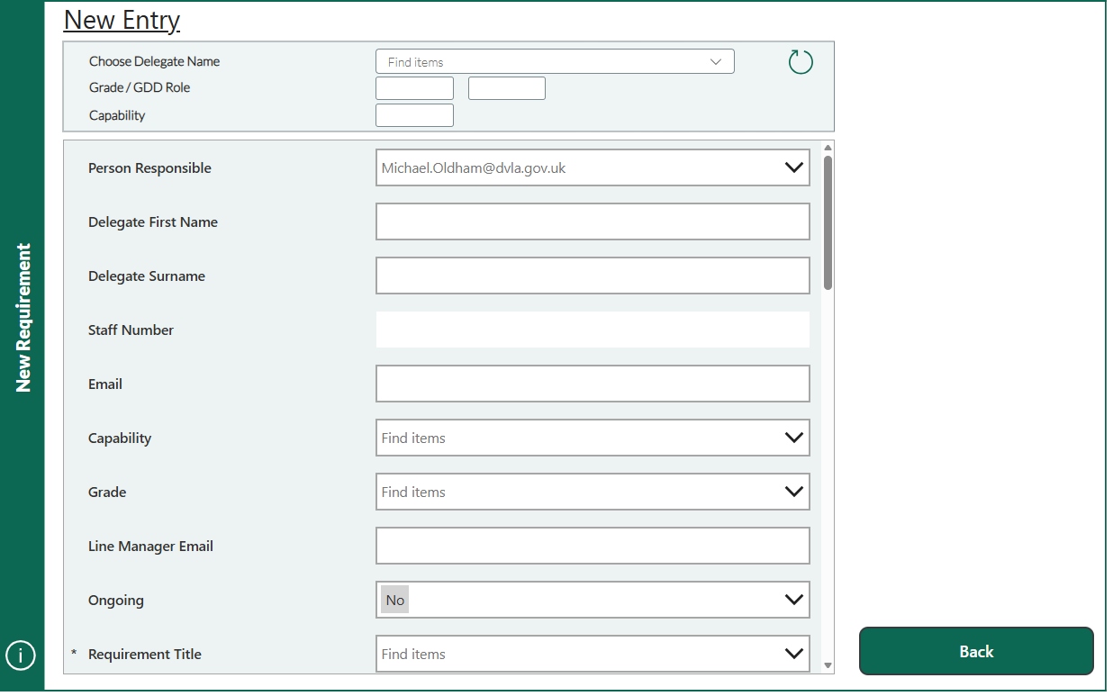
4.3.1 Existing Booking Interface
Figure 9 – Screenshot (New entry booking screen)
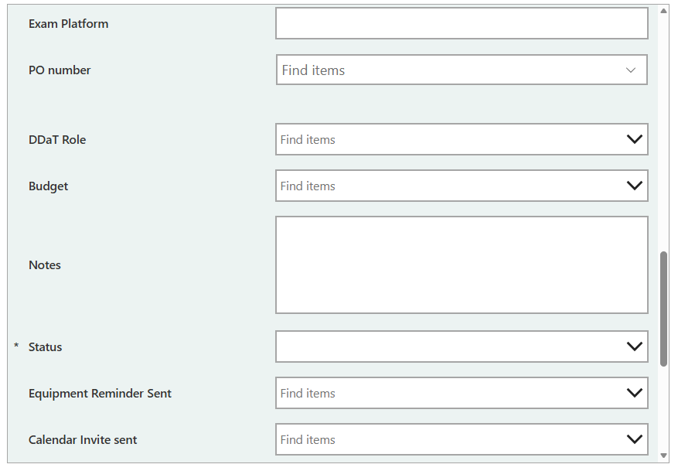
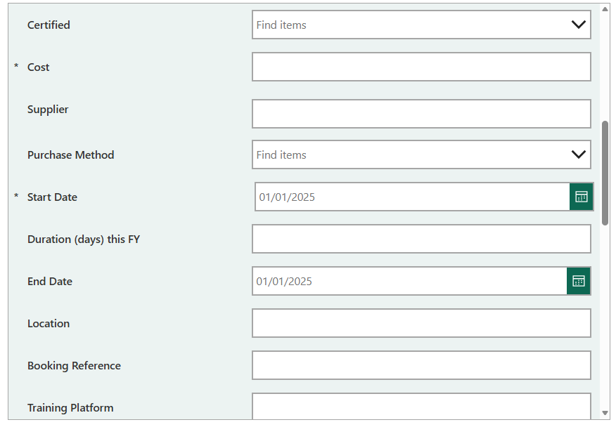
Figure 10 – Screenshot (New entry booking screen)
Figure 11 – Screenshot (New entry booking screen) booking screen

Figures 9 shows the existing booking interface within the Microsoft Power App, which is used to create individual training bookings. Under the current design, a separate booking record is created for each delegate attending a course. Additional fields shown in figure 10 and figure 11 are accessed by scrolling further down.

Analysis of the existing interface identified several limitations that informed the redesign of the booking process. When multiple delegates attend the same training course, common course information such as the course name, supplier and delivery details, must be entered repeatedly for each booking. This increases the administrative effort required by Capability Coordinators and creates opportunities for inconsistency data entry. Furthermore, the interface has been designed primarily to support the operational administration of training bookings and does not capture strategic information, such as the business justification for the training or its alignment with organisational objectives. These limitations highlighted the need for a redesigned interface capable of supporting both efficient booking management and enhanced ROI data collection.

4.3.2 Redesigned Booking Interface
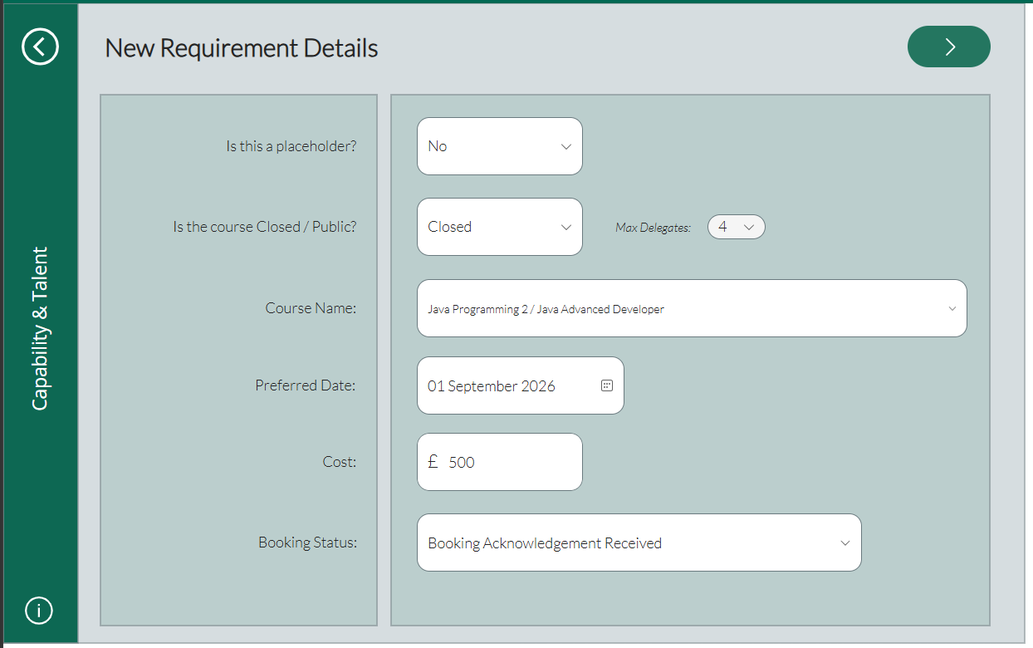
Figure 12 – Screenshot of redesigned screen1

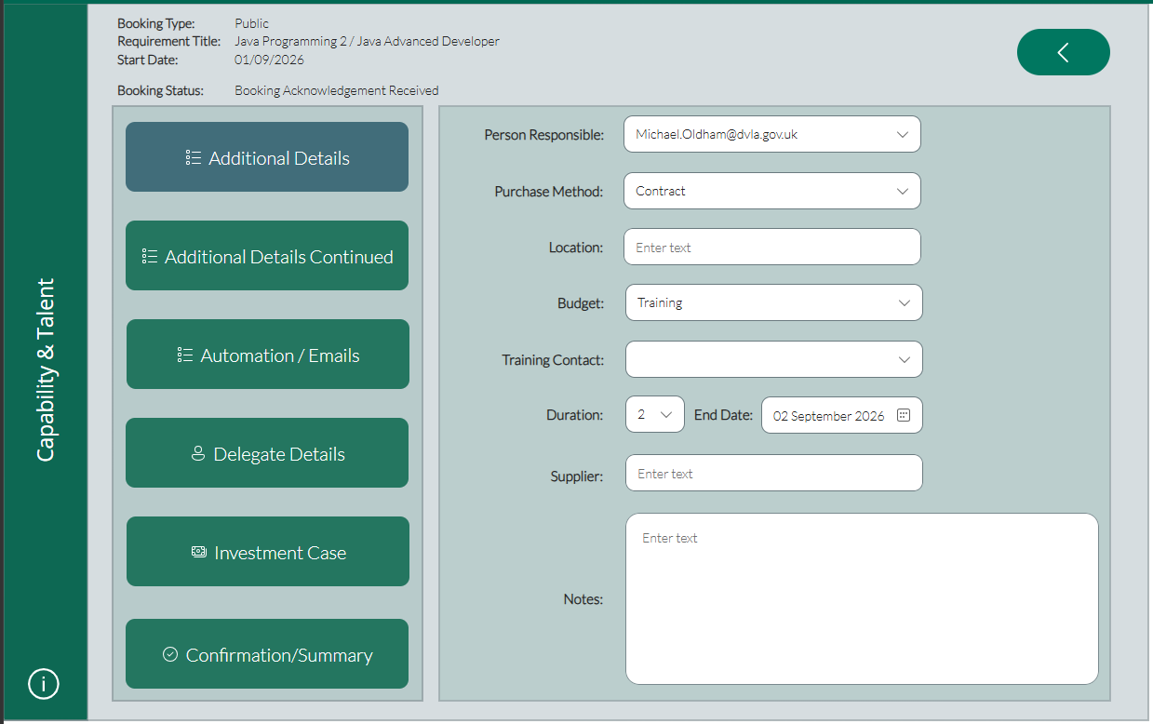
Figure 13 – Screenshot of redesigned screen2
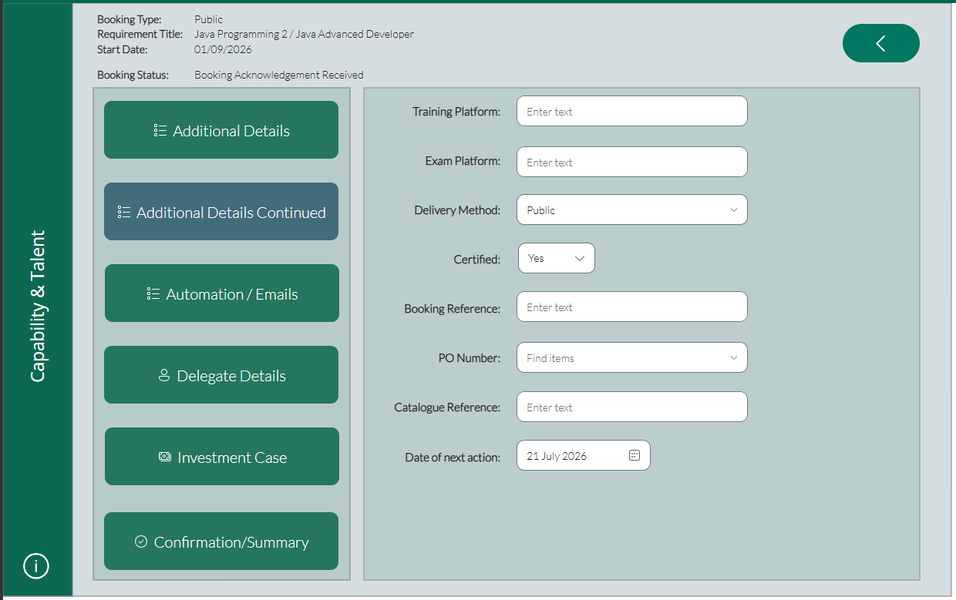
Figure 14 – Screenshot of redesigned screen3

Figure 15 – Screenshot of redesigned screen4
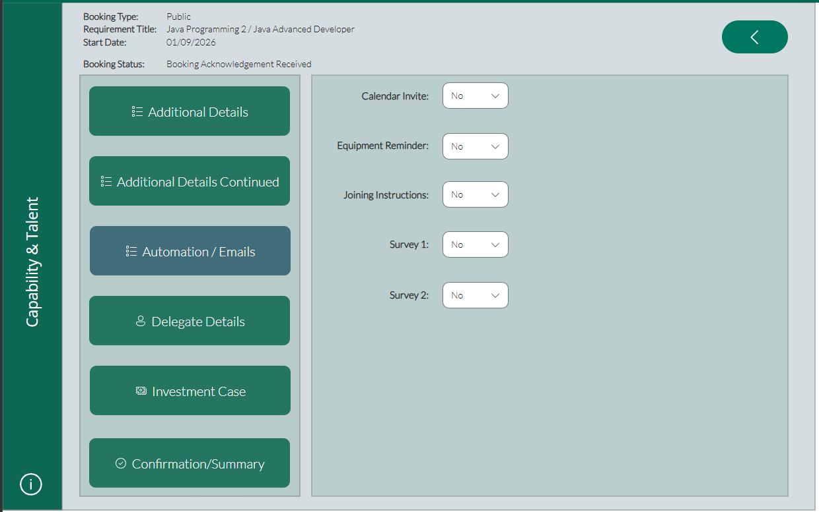
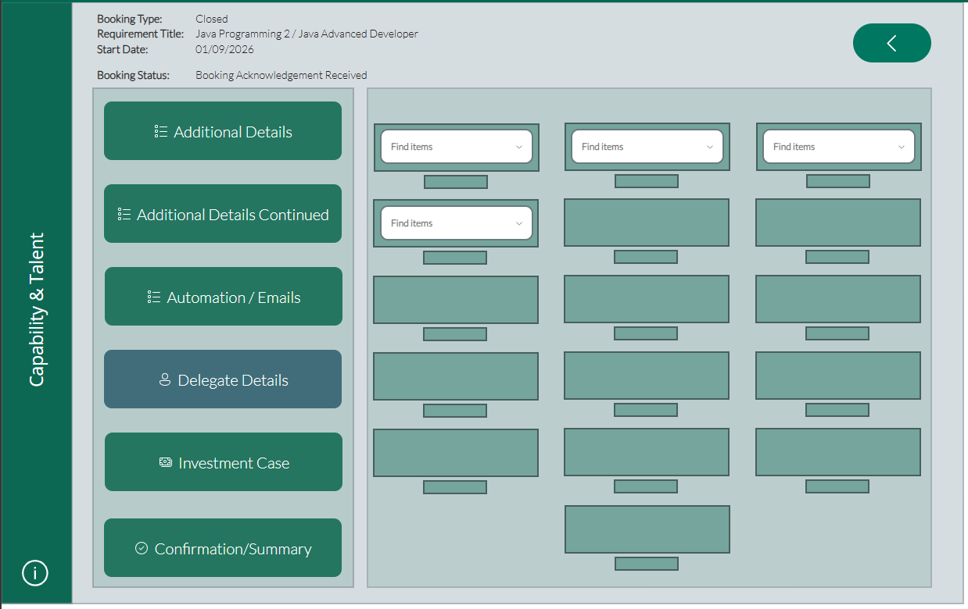
Figure 16 – Screenshot of redesigned screen5
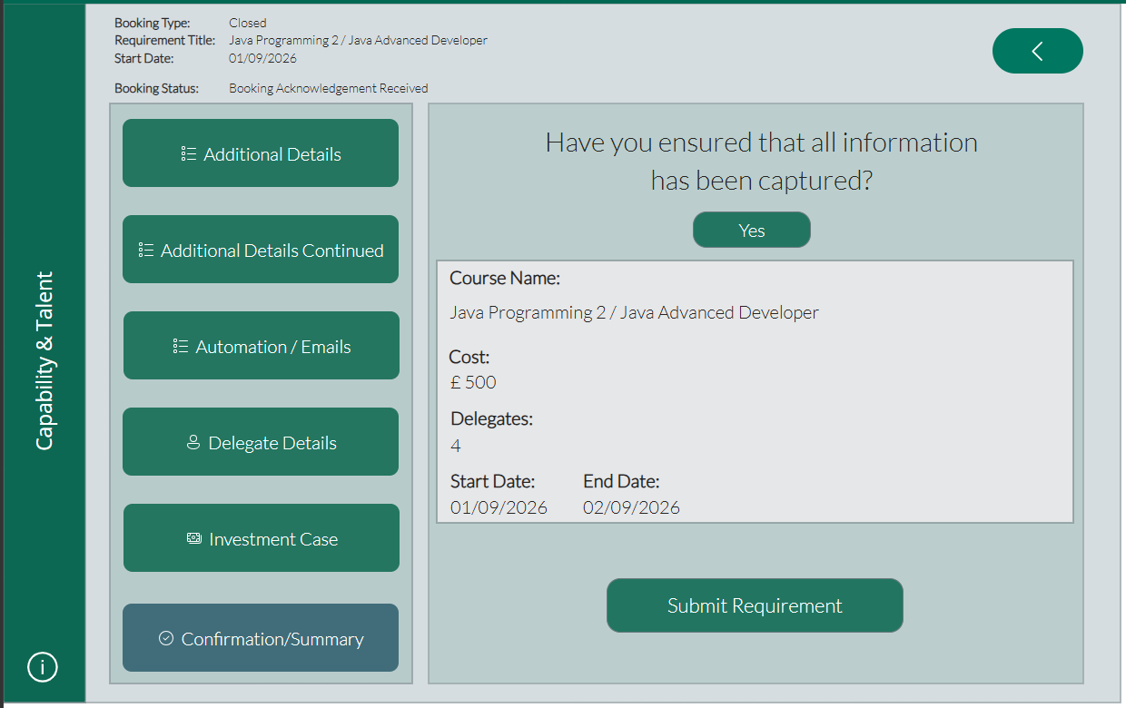
Figure 17 – Screenshot of redesigned screen6

Figures 12-17 show the redesigned booking interface developed as part of the Enhanced Data Collection Framework. The Interface adopts a course-centric approach, enabling information that is common to all delegates, including the course title, supplier, delivery method and course dates, to be entered once before delegates are associated with the booking. This redesign removes the need to repeatedly enter identical course information for each delegate significantly reducing the administrative effort required to manage larger training events.

The layout has been designed to present related information in a logical sequence, making the booking process more intuitive whilst maintaining consistency with the existing application. This familiar design reduces the learning curve for Capability Coordinators while improving the quality and consistency of the data collected. Unlike the original interface, the redesigned booking process also provides the foundation for capturing strategic training information through the additional ROI data fields introduced within the Enhanced Data Collection Framework.

4.3.3 ROI Data Capture Interface
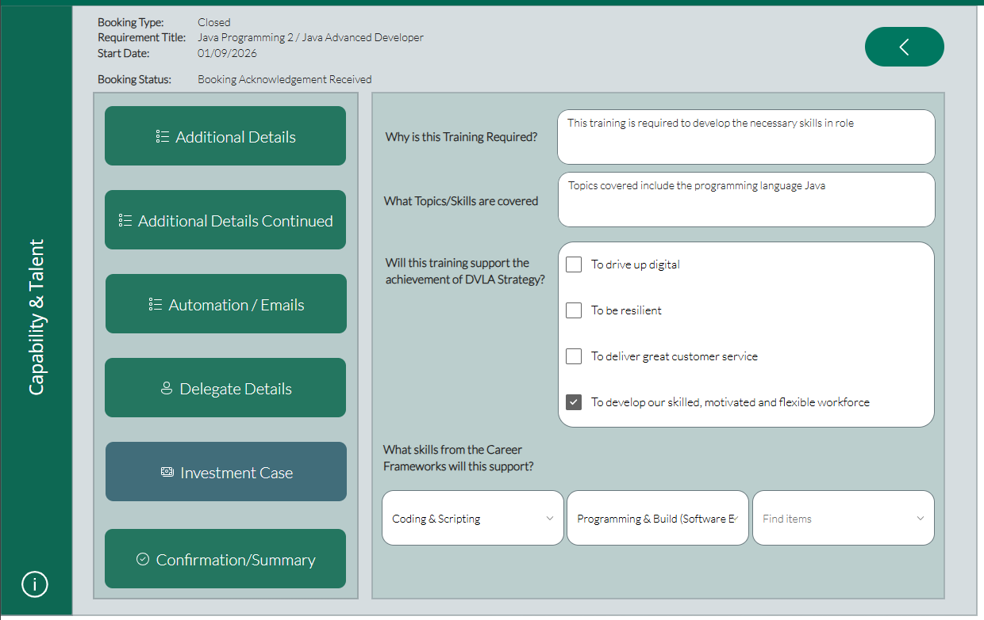

Figure 18 – Screenshot of new ROI screen
Figure 18 shows the new ROI data capture interface introduced as part of the Enhanced Data Collection Framework. The additional questions have been incorporated into a dedicated section of the booking process, allowing strategic information to be captured alongside the operational course details without disrupting the existing workflow. Separating the ROI questions from the core booking information provides clear distinction between administrative data required to arrange the training and strategic data required to support later evaluation.

The interface has been designed to present the additional questions in a logical sequence, beginning with the business justification for the training before progressing to the expected learning outcomes, strategic alignment and career framework skills. This ordering encourages users to consider why the training is being requested before identifying the organisational and professional benefits it is expected to deliver. Grouping the questions together also provides a consistent user experience and reduces the likelihood of important information being overlooked during the booking process.

The design aims to balance improved data collection with usability. Rather than introducing many additional fields throughout the booking process, only a small number of strategically important questions have been included within a dedicated section of the interface. This minimises the additional administrative effort required from Capability Coordinators whilst significantly improving the quality of information available for future ROI analysis.
The redesigned user interface translates the design decisions described in Section 4.2 into a practical booking application that supports both operational administration and strategic data collection. By redesigning the booking interface, introducing dedicated ROI data capture screens and organising the workflow into a logical sequence, the application provides a more efficient user experience whilst improving the quality and consistency of training data. The following section describes the underlaying system architecture that supports the redesigned application.

4.4 System Architecture

4.4.1 Architecture Overview

The proposed solution has been designed using Microsoft’s Power Platform to integrate the redesigned booking process with the organisation’s existing training management environment. The architecture combines Microsoft Power Apps, SharePoint, Power Automate and Power BI to provide a single workflow for capturing, processing and analysing training data. By extending the existing platform rather than replacing it, the solution minimises implementation costs, reduces disruption for existing users and maintains compatibility with current organisational processes.

Capability Coordinator

Microsoft Power Apps

SharePoint Lists

Power BI
Power Automate

ROI Dashboard
Reporting

Figure 19 – Architecture Diagram

4.4.2 Power Apps

Microsoft Power Apps was selected as the primary development platform due to its existing adoption within the organisation and its seamless integration with the Microsoft Power Platform. As the original training management application had already been developed using Power Apps, extending the existing solution was considered more appropriate than developing an entirely new application. This approach minimised disruption for existing users, reduced the learning curve for Capability Coordinators and ensured compatibility with established business processes. Furthermore, Power Apps provides the flexibility to rapidly modify user interfaces and data capture forms, making it well suited to implementing the redesigned booking process and Enhanced Data Collection Framework whilst maintaining integration with SharePoint, Power Automate and Power BI.

4.4.3 SharePoint

Microsoft SharePoint was selected as the primary data storage solution due to its existing use within the organisation and its close integration with the Microsoft Power Platform. The existing training management system already utilised SharePoint Lists to store booking information, making it the most practical solution for extending the application without introducing additional infrastructure or migration requirements. Using SharePoint provides a centralised data source that can be accessed by Power Apps for data entry, Power Automate for workflow automation and Power BI for reporting and analysis. This integration supports a consistent flow of information throughout the proposed architecture whilst maintaining a familiar and cost-effective platform for managing training data.

4.4.4 Power Automate

Microsoft Power Automate was incorporated into the proposed system architecture to support the automation of routine processes within the training management system. The existing application already utilises Power Automate to perform tasks such as sending email notifications and distributing post-training evaluation surveys, making it a logical component to retain within the enhanced solution. By integrating Power Automate with Power Apps and SharePoint, manual administrative tasks can be reduced whilst ensuring business processes are completed consistently and reliably. The platform also provides flexibility for future workflow enhancements, including the automation of data processing and notifications as the Enhanced Data Collection Framework evolves. Selecting Power Automate therefore supports the project’s objective of improving operational efficiency whilst maintaining compatibility with the organisation’s existing Microsoft Power Platform environment.

4.4.5 Power BI

Microsoft Power BI was selected as the reporting and visualisation platform due to its ability to transform training data into meaningful insights that support organisational decision making. The existing training management system already uses Power BI to report on operational metrics; however, the Enhanced Data Collection Framework extends the range of information available by capturing strategic data relating to training objectives, expected learning outcomes and organisational benefits. This enables the development of more comprehensive dashboards capable of supporting ROI analysis rather than simply reporting training activity. Furthermore, Power BI integrates directly with SharePoint Lists, providing near real-time reporting without requiring additional data migration or third-party software. Selecting Power BI therefore ensures that the enhanced training data can be presented through interactive dashboards, enabling managers to monitor training investment, identify trends and make more informed decisions based on evidence rather than administrative records alone.

4.4.6 Architecture Summary

The proposed system architecture integrates Microsoft Power Apps, SharePoint, Power Automate and Power BI to provide a unified training management solution that supports both operational administration and strategic ROI evaluation. By extending the organisation’s existing Microsoft Power Platform environment, the proposed architecture minimises disruption whilst introducing enhanced functionality for data collection, workflow automation and reporting. The close integration between each component ensures that training information can be capture, processed and visualised efficiently, providing a robust foundation for the implementation described in the following section.

4.5 Dashboard Design

The Enhanced Data Collection Framework captures significantly more strategic information than the existing training management system. Whilst this additional data improves the organisation’s ability to measure training value, it’s benefits can only be realised if the information is presented in a meaningful and accessible format. Consequently, a Power BI dashboard was designed to transform the collected data into interactive visualisations that support evidence-based decision making by senior management. The dashboard extends beyond traditional operational reporting by incorporating measures relating to strategic alignment, skills development and training investment, enabling managers to evaluate both the delivery and purpose of organisational training.

4.5.1 Dashboard Design Objectives

The dashboard was designed to transform the enhanced training data collected through the Enhanced Data Collection Framework into meaningful information that supports evidence-based decision making. Whilst the existing reporting solution primarily focused on operational metrics, such as training bookings and costs, the redesigned dashboard was intended to provide greater insight into the strategic value of organisational training by incorporating measures relating to business justification, strategic alignment and workforce development.

A key design objective was to present information in a clear and accessible format that could be easily interpreted by senior management. To achieve this, the dashboard was designed to provide high-level key performance indicators alongside interactive visualisations that enable users to identify trends and explore training data from different perspectives. Interactive filtering was also included to allow reports to be viewed by factors such as capability area, training supplier and financial year.

The dashboard was further designed to complement the Enhanced Data Collection Framework by presenting the additional strategic information captured during the redesigned booking process. Rather than simply reporting what training had taken place, the dashboard enables managers to understand why training was delivered, how it supports organisational priorities and which workforce skills are being developed. This supports more information decision making and provides a stronger foundation for evaluating the value of training across the organisation.

4.5.2 Dashboard Structure

The dashboard was designed using a multi-page structure to ensure that information could be presented in a logical and organised manner without overwhelming the user. Rather than displaying all available metrics on a single screen, related information was grouped into dedicated dashboard pages, allowing managers to navigate between high-level organisational summaries and more details strategic analysis. This approach improves usability by reducing visual complexity whilst ensuring that key information can be accessed quickly.

The dashboard consists of 4 pages, each designed to support a different aspect of training management and evaluation. The first page provides an executive overview of training activity through a series of key performance indicators and summary visualisations. The second page focuses on strategic alignment, enabling managers to assess how training investment supports organisational objectives. The third page presents workforce development information by visualising the skills and competencies being developed across the organisation. Finally, the fourth page supports return on investment (ROI) analysis by presenting training expenditure alongside the additional strategic information captured through the Enhanced Data Collection Framework.

Organising the dashboard in this manner provides a logical progression from operational reporting to strategic evaluation, ensuring that both senior managers and training administrators can access the information most relevant to their responsibilities. Each dashboard page is discussed in the following sections.

4.5.3 Executive Overview Dashboard

The Executive Overview Dashboard was designed to provide senior managers with an immediate summary of organisational training activity through a collection of key performance indicators and high-level visualisations. The purpose of this dashboard is to present the most significant training metrics in a single location, allowing users to quickly assess overall training performance without navigating through detailed reports. By providing an overview of training activity, the dashboard supports evidence-based decision making and enables managers to identify areas that may require further investigation.

The dashboard presents key performance indicators relating to training activity, including the total number of delegates, overall training expenditure, average cost per delegate and the number of certified courses delivered. These metrics provide an immediate summary of organisational investment in workforce development and established a baseline from which more detailed analysis can be undertaken within the remaining dashboard pages.
To complement these summary indicators, the dashboard includes visualisations that illustrate training expenditure, delivery methods and activity across capability areas. Presenting this information graphically enables managers to identify patterns and trends more effectively than through tabular reports alone. Interactive filtering further enhances usability by allowing information to be viewed according to criteria such as financial year, capability area and training supplier, ensuring that both organisation-wide and department-specific reporting requirements can be supported.

The Executive Overview Dashboard acts as the entry point to the wider reporting solution, providing users with an accessible summary of training performance before progressing to the more detailed strategic alignment, workforce development and training evaluation dashboards.
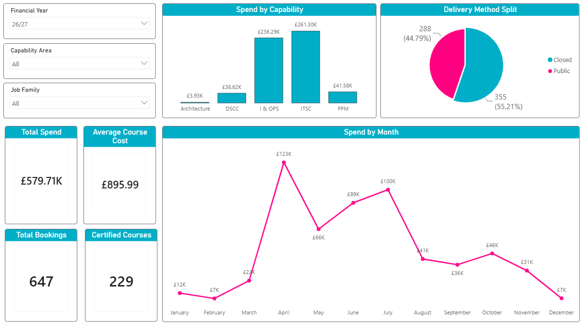

4.5.4 Strategic Alignment Dashboard

The Strategic Alignment Dashboard was designed to demonstrate how organisational training supports strategic priorities. Unlike the Executive Overview Dashboard, which provides a summary of overall training activity, this dashboard focuses on the relationship between training investment and the organisation’s strategic objectives. The additional data captured through the Enhanced Data Collection Framework enables managers to evaluate whether training activities contribute to one or more strategic priorities, providing information that was not available within the previous reporting approach.

The dashboard combines key performance indicators with visualisations that present strategic contribution, training expenditure and the distribution of courses across organisational objectives. Interactive filtering enables managers to examine strategic alignment by capability area, supplier or financial year, allowing comparisons to be made across different parts of the organisation. By presenting this information in a single view, the dashboard supports evidence-based decision making and helps ensure that future training investment remains aligned with organisational goals.
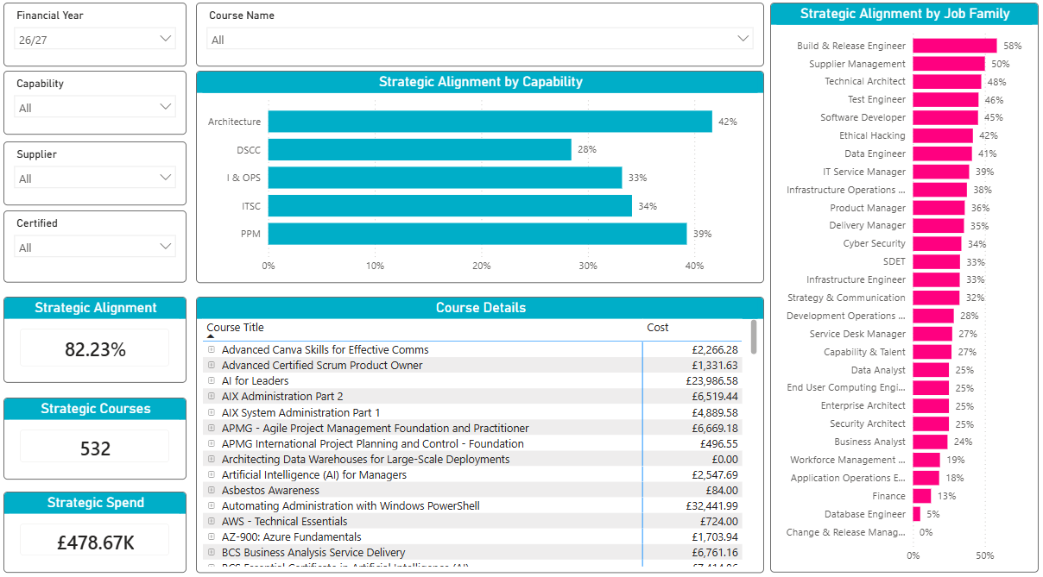

4.5.5 Skills and Workforce Development Dashboard

The skills and Workforce Development Dashboard was designed to provide greater visibility of the knowledge and skills being developed across the organisation through training activities. While traditional training reports typically focus on attendance and expenditure, this dashboard uses the additional skills data captured though the Enhanced Data Collection Framework to identify the areas of capability being strengthened. This enables managers to gain a better understanding of how training contributes to workforce development beyond simply recording course completion.

The dashboard presents key performance indications alongside visualisations that summarise the training activity by job family, capability area and primary skill. By allowing users to explore the distribution of training across different workforce groups, the dashboard helps identify skills that are receiving significant investment, as well as areas where further development may be required. Interactive filtering supports more detailed analysis, enabling managers to review workforce development across different organisational functions and make informed decisions when planning future training programmes.
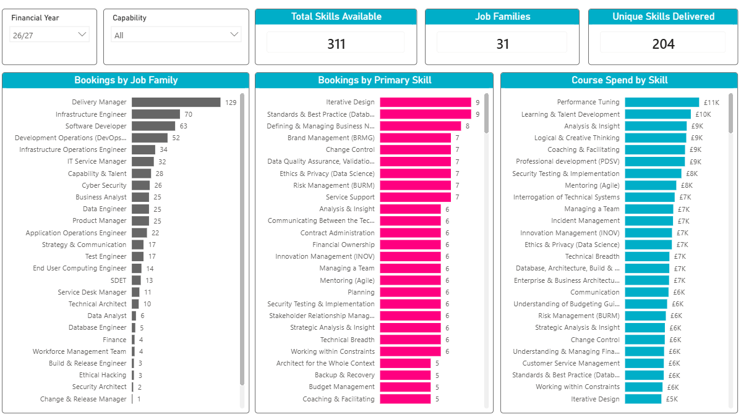

4.5.6 Training Value and ROI Dashboard

The Training Value and ROI Dashboard was designed to bring together the information required to evaluate the effectiveness and value of training activities. Rather than focusing solely on training volumes or expenditure, this dashboard combines financial, strategic and operational measures to provide a broader view of the training outcomes. By utilising the additional information captured through the EDCF, the dashboard supports a more comprehensive approach to training evaluation than was previously possible.

The dashboard presents key performance indicators alongside visualisations that highlight training expenditure, strategic contribution and certification outcomes. Interactive filtering enables managers to compare results across capability areas, suppliers and financial years, providing flexibility to investigate specific areas of interest. By presenting these measures within a single dashboard, decision-makers are better equipped to assess whether training investment supports organisational priorities and to identify opportunities for improving future workforce development initiatives.
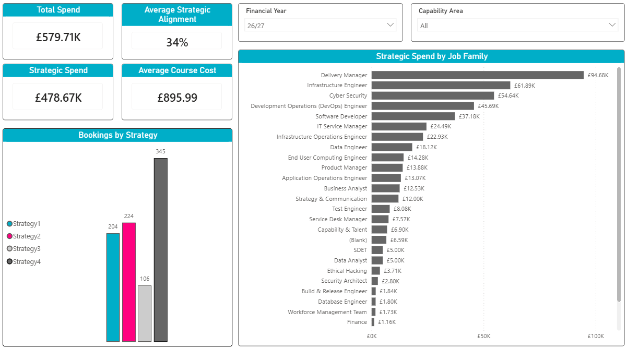

4.6 Implementation

This section describes the implementation of the enhanced training management solution developed for the organisation. Building upon the design presented in the previous sections, the implementation focused on extending the existing Microsoft Power Platform solution rather than developing a completely new system. Enhancements were made to the Power App used for training requests, the SharePoint data source, automated workflows and the Power BI reporting dashboard to support the Enhanced Data Collection Framework. The objective of the implementation was to improve the capture, management and reporting of training information while integrating seamlessly with the organisation’s existing process and technology infrastructure.

4.6.1 Power App Implementation

Rather than developing a new application, the existing Power App was extended to support the requirements of the EDCF. A signification redesign of the user interface was undertaken to improve the user experience whilst accommodating the additional information required for training evaluation. Instead of presenting users with a single, lengthy form, the application was divided into a series of logical sections, allowing related information to be grouped together and completed in a structured manner.

Although the application appears to consist of multiple pages, the implementation was achieved using a single Power Apps screen. Navigation between sections was controlled through a series of variables that determined the visibility of each content area. When a navigation button was selected, the corresponding variable was updated, causing the relevant module to become visible while hiding the remaining sections. This approach reduced the complexity of the application by avoiding unnecessary screen transitions, improved performance by keeping all entered data within a single interface and provided users with a smoother navigation experience.

The navigation buttons therefore acted as page selectors rather than loading separate screens. An example of this implementation is shown is Figure 20, where selecting a navigation button updates the visibility variables controlling the user interface.

// Code to set the variables
Set(varReqDetails, 1) & Set(varReqDetails2, 0) & Set(varAutoDetails, 0) & Set(varDelDetails, 0) & Set(varCaseDetails, 0) & Set(varSummaryDetails, 0)

// Code which changes the base palette colour of the buttons
If(varReqDetails = 0, RGBA(13, 104, 83, 1) , RGBA(13, 70, 83, 1) )

// Each item on the screen has the following code associated with it on the visible attribute which means that they only show when the corresponding variable is activated
If(varReqDetails = 1, true, false)
Figure 20

Once all the required information had been entered, a single Patch() operation was used to submit the completed record to the SharePoint list. Since all sections formed part of the same screen, the entered data remained available throughout the process, allowing the application to collect the values from each module before creating a single training record. This implementation simplified the submission process while ensuring that the additional fields, including the primary skill supported by the training and the associated organisational strategic objectives, were captured consistently to support the enhanced reporting functionality developed within Power BI.

Patch(preDatasetCC, Defaults(preDatasetCC),

// Page 1

{placeholder: PlaceholderDropdown.Selected.Value},
{maxDelegates: maxDelegatesNum.Selected.Value},
{closedPublic: courseTypeDropdown.Selected.Value},
{temporaryCourseName: If(PlaceholderDropdown.Selected.Value = "Yes", temporaryCourseNameInput.Text, "")},
{requirementTitle: If(PlaceholderDropdown.Selected.Value = "No", courseNameInput.Selected.'Course Name', "")},
{startDate: courseDateInput.SelectedDate},
{cost: Value(costInput.Text)},

// Page 2 Requirement details

{personResponsible:personResponsibleInput.Selected.Value},
{purchaseMethod: purchaseMethodDropdownInput.Selected.'Purchase Method'},
{location: locationTextInput.Text},
{budget: budgetDropdownInput.Selected.Value},
{trainingContact: trainingContactDropdown.Selected.'Training Contact'},
{duration: Value(durationDropdown.Selected.Value)},
{endDate: courseEndDate.SelectedDate},
{supplier: supplierInput.Text},
{notes: notesInput.Text},

);

Notify("New Requirement successfully submitted", NotificationType.Success);

//Reset Delegate Dropdowns

Reset(delegate1);
Reset(delegate2);
Reset(delegate3);

// Reset Requirement Details
Reset(PlaceholderDropdown);
Reset(courseTypeDropdown);
Reset(maxDelegatesNum);
Reset(temporaryCourseNameInput);
Reset(courseNameInput);
Reset(courseDateInput);
Reset(costInput);
Reset(bookingStatusDropdown);
Navigate(trainingHomePage);
Figure 21 Example of the Patch() code used to post to SharePoint – Full code shown in Appendix

4.6.2 SharePoint Implementation

To support the enhanced data collection requirements, a new SharePoint list was created rather than extending the existing training data source. This decision was made because the enhanced application adopted a course-centric approach to training administration, whereas the original system was based on an individual delegate model. Separating the new data structure from the existing operational data reduced the risk of affecting the live booking process whilst allowing the enhanced solution to be developed and tested independently.

The new SharePoint list was designed to capture all information relating to a single training course, including course details, scheduling information, supplier information, purchase method, training justification, topics covered, strategic objectives, career framework skills and the delegates assigned to the course. Rather than creating an individual record for each delegate during the initial booking process, all assigned delegates were temporarily stored within the same course record using dedicated email address fields. Each course was assigned a unique coursed, providing a consistent identifier throughout the booking lifecycle.

The proposed implementation allows a course booking to be expanded into individual delegate records within an existing SharePoint list. This process is intended to ne achieved using a Power Automate workflow, which will utilise the stored delegate email address to create a separate record for each attendee while retaining the original coursed as a common identifier. Although this functionality was not fully implemented within the project timescale, the underlying data structure was specifically designed to support this future enhancement.

Several implementation challenges were encountered during the development of the SharePoint data structure. One challenge was ensuring that the new course-centric model remained compatible with the existing delegate-based reporting solution. This was addressed by introducing the coursed as a common identifier allowing all duplicated delegate records to be linked back to their original course. A further challenge involved storing multiple delegates within a single course record whilst maintaining sufficient flexibility to generate individual records at a later stage. This was overcome by allocating dedicated columns for delegate email addresses, providing a straightforward method of identifying each attendee during the record duplication process while avoiding unnecessary complexity within the SharePoint data model.

4.6.3 Power BI Implementation

The Power BI dashboard was implemented to demonstrate how the Enhanced Data Collection Framework could support improved training reporting and evaluation. At the current stage of development, the dashboard continues to use the existing delegate-centric SharePoint list as its primary data source. As the automated transfer of data from the proposed course-centric booking system had not yet been implemented, representative data was populated within the additional fields to demonstrate the intended reporting capabilities and validate the dashboard design.

Several data transformation activities were undertaken within Power Query to prepare the dataset for analysis. These included cleaning the imported data, applying appropriate data types and restructuring fields to ensure consistency across the reporting solution. A series of DAX measures were also developed to calculate key performance indicators used throughout the dashboard, including training expenditure, average cost per delegate and measures relating to strategic contribution. These calculations enabled summary information to be generated dynamically based on user selections and dashboard filters.

To further enhance the reporting capability, relationships were established between the training dataset and organisational workforce data using staff numbers as the primary key. This enabled additional employee information, including career framework and organisational structure, to be incorporated into the analysis without duplicating data within the training dataset. Interactive functionality was also implemented using slicers, cross-filtering and bookmarks. Bookmarks were used to create a ‘Clear Filters’ function, allowing users to restore each dashboard page to its default state after applying multiple filters, thereby improving usability and ensuring a consistent reporting experience.

// DAX code if either of the strategy columns were marked with ‘Yes’

Strategic Courses =
CALCULATE(
DISTINCTCOUNT(trainingDataset[ID]),
trainingDataset[strategicStrat1] = "Yes" || trainingDataset[strategicStrat2] = "Yes" || trainingDataset[strategicStrat3] = "Yes" || trainingDataset[strategicStrat4] = "Yes")

Figure 22 – Example of DAX code used to count the number of strategic courses
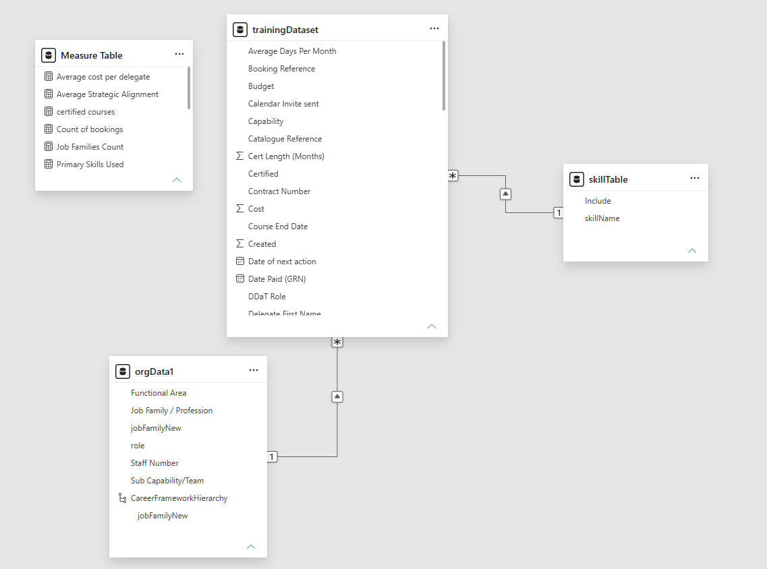
Figure 23 – Screenshot of data model in Power BI showing relationships
4.6.4 Implementation Challenges and Solutions

Throughout the implementation of the prototype, several technical challenges were encountered that influenced the final design of the solution. These challenges primarily related to the complexity of developing within Microsoft Power Apps and ensuring the solution remained responsive whilst integrating with SharePoint Online.

One of the most significant challenges involved the implementation of the Power App user interface. Rather than using multiple screens, the application was designed around a single screen containing several modules that were displayed or hidden using variables. Whilst this approach improved the overall user experience and reduced unnecessary screen transitions, it required careful management of the applications state. Each navigate button needed to set multiple variables to ensure that the correct section was displayed whilst all other sections remained hidden. As additional functionality was introduced, maintaining this visibility logic became increasingly complex and required extensive testing to ensure that users could navigate the application without unexpected behaviour.

Development was also affected by the performance of the Power Apps development environment. As the application increased in size and complexity, the Power Apps Studio became noticeably slower when loading controls, editing formulas and previewing changes. This increased development time and required changes to be implemented and tested incrementally to reduce the likelihood of introducing errors.

A further challenge was encountered when integrating the application with SharePoint. During development, several delegation warnings were identified when querying larger SharePoint lists. If left unresolved, these warnings could have resulted in incomplete data being returned once the dataset exceeded the delegation threshold. To overcome the issue, delegable functions including ‘Filter()’ were used where appropriate to ensure that queries were processed by the SharePoint data source rather than locally within the Power App. This improved both the reliability and scalability of the solution, ensuring that the application would continue to perform correctly as the volume of training records increased.

// Example of Filter() being used to prevent delegation warnings
SortByColumns(
Filter(
'preDatasetCC',

//Requirement Title Check

(IsBlank(requirementTitle2.Selected.Value) || requirementTitle = requirementTitle2.Selected.Value) &&
(IsBlank(statusDropdown.Selected.Value) || status = statusDropdown.Selected.Value) &&

personResponsible = personResponsibleInput_1.Selected.Value &&

(IsBlank(trainingContactDropdown2.Selected.Value) || trainingContact = trainingContactDropdown2.Selected.Value) &&

startDate >= startDateRange.SelectedDate &&
startDate <= endDateRange.SelectedDate ||

// Temporary course name check

(IsBlank(requirementTitle2.Selected.Value) || temporaryCourseName = requirementTitle2.Selected.Value) &&
(IsBlank(statusDropdown.Selected.Value) || status = statusDropdown.Selected.Value) &&

personResponsible = personResponsibleInput_1.Selected.Value &&

(IsBlank(trainingContactDropdown2.Selected.Value) || trainingContact = trainingContactDropdown2.Selected.Value) &&

startDate >= startDateRange.SelectedDate &&
startDate <= endDateRange.SelectedDate

),
"startDate", SortOrder.Ascending, "ID", SortOrder.Descending
)
Figure 25

4.6.5 Implementation Summary

The implementation phase successfully transformed the proposed design into a functional prototype that extended the organisation’s existing training management solution. Enhancements to the Power App improved the collection of training information through a redesigned user interface, whilst the new SharePoint data structure provided the foundation for capturing additional information required by the Enhanced Data Collection Framework. The implementation of the new Power BI dashboard demonstrated how this enhanced dataset could be transformed into meaningful management information through interactive reporting and data visualisation. Although certain functionality, including the automated transfer of course-based records into the existing delegate-centric data structure, remains a planned enhancement, the implemented prototype demonstrates the technical feasibility of the proposed framework and provides a solid foundation for future development. The following section evaluates the implemented solution through a series of testing activities to assess its functionality, usability, and overall effectiveness.

4.7 Testing

4.7.1 Testing Strategy

Testing was undertaken throughout the development of the prototype to verify that the implemented functionality operated as intended and met the project requirements. Consistent with the iterative development approach described within the research methodology, testing was performed as new features were implemented, allowing issues to be identified and resolved before progressing to subsequent stages of development. The primary focus of testing was to validate the functionality of the Power App, SharePoint integration and Power BI Dashboard. Whilst formal user acceptance testing was beyond the scope of this project, future evaluation involving members of the team and senior management is recommended to assess the usability of the application and the effectiveness of the reporting solution within a live environment.

4.7.2 Functional Testing

Functional testing was undertaken to verify that the core features of the prototype operated as expected. Testing focused on the Power App, SharePoint integration and Power BI Dashboard, ensuring that user inputs, data storage and reporting functionality performed correctly.

Test ID | Function Tested | Expected Result | Actual Result | Status
FT01 | Navigate between application sections | Correct module displayed | Correct module displayed | Pass
FT02 | Submit training request | Record successfully saved to SharePoint | Record saved successfully | Pass
FT03 | Mandatory field validation | User prevented from submitting incomplete form | Validation performed correctly | Pass
FT04 | Store primary skill | Selected skill written to SharePoint | Data stored correctly | Pass
FT05 | Store strategic objectives | Selected objectives saved correctly | Data stored correctly | Pass
FT06 | Dashboard filters | Visualisations update based on selected filters | Filters operated correctly | Pass
FT07 | KPI calculations | Measures return correct values | Calculations verified | Pass
FT08 | Clear Filters button | Dashboard returns to default view | Bookmark restored original view | Pass
Figure 26

The results of the functional testing demonstrated that the core functionality of the prototype operated as expected. All tested features successfully met their intended outcomes, providing confidence that the Power App, SharePoint integration and Power BI dashboard functioned correctly within the scope of the implemented prototype. Any remaining functionality, such as the automated generation of delegate records from course bookings, has been identified as future development rather than a defect within the current implementation.

4.7.3 Future User Evaluation

Although functional testing confirmed that the prototype operates as intended, further evaluation involving end users has been identified as an important stage prior to deployment. In line with the mixed methods research approach adopted within this study, future evaluation will focus on gathering qualitative feedback from members of the team who will use the enhance Power App as part of the training administration process. Their feedback will be used to assess the usability of the redesigned interface, the effectiveness of the new course-centric booking approach and the overall efficiency of the enhanced data capture process.

In additional to operational users, senior managers will be invited to evaluate the Power BI dashboard to determine whether the enhanced reporting provides meaningful insight into organisational training activity, strategic alignment and workforce development. This feedback will help assess whether the proposed Enhanced Data Collection Framework supports evidence-based decision making and achieves the objectives established for the project. The findings from the future evaluation will provide recommendations for improvement of the prototype prior to full implementation within the organisation.

5 Evaluation

5.1 Introduction

This chapter evaluates the effectiveness of the development prototype in relation to the project aim, objectives and findings presented within the literature review. The evaluation considers how successfully the EDCF addressed the limitations of the existing training management process and assesses whether the proposed solution supports a more comprehensive approach to measuring training value and return on investment (ROI).

5.2 Evaluation Against the Project Aim and Objectives

The aim of the project was to design, implement and evaluate an enhanced data-driven framework for measuring training return on investment (ROI) within a central government organisation. Overall, the aim was achieved through the development of a working prototype comprising an enhanced Power App, revised SharePoint data structure and Power BI dashboard. Together these components demonstrated how improved data collection and reporting can provide a more comprehensive understanding of training value and support evidence-based decision-making.

The first objective was to critically review existing training evaluation models and identify best practice approaches to measuring training value. This was achieved through the literature review, which highlighted the limitations of traditional training evaluation methods and informed the design of the proposed framework.

The second and third objectives focused on assessing the limitations of the existing training management process and designing an enhanced data collection framework. These objectives were met through the introduction of additional data fields that capture strategic alignment, training justification and workforce skills, enabling a broader evaluation of training outcomes than was previously possible.

The fourth objective was to develop a prototype analytics dashboard for senior management. This was successfully achieved through the implementation of an interactive Power BI dashboard that presents key performance indicators alongside strategic and workforce development metrics, providing improved visibility of training activity.

The final objective was to evaluate the feasibility and organisational value of the proposed framework. Functional testing confirmed that the prototype operated as intended and demonstrated the technical feasibility of the solution. Although further user evaluation is recommended before deployment, the completed prototype provides a strong foundation for enhancing the measurement and reporting of training value within the organisation.

5.3 Evaluation Against the Literature

The findings of this project are consistent with the literature reviewed in Chapter 2, which identified that effective training evaluation requires organisations to collect data beyond attendance records and course costs. The enhanced data collection framework addresses this by capturing additional information relating to training justification, strategic objectives and workforce skills, providing a richer dataset to support the evaluation of training value.

The framework aligns with the principles of the Kirkpatrick Model by enabling organisations to collect information that can support the evaluation of training outcomes beyond participation alone. Similarly, the additional data fields provide a foundation for applying aspects of the Philips ROI Methodology by capturing information that may contribute to future ROI analysis, although full financial ROI measurement remains outside the scope of the current prototype.

The project also supports CIPD guidance, which highlights the importance of aligning learning and development activities with organisational objectives and using evidence to inform decision-making. By integrating strategic alignment and workforce development data into the training management process, the proposed framework provides senior management with improved reporting capabilities through the Power BI dashboard.

Overall, the prototype supports the findings presented within the literature review by demonstrating that enhanced data collection can provide organisations with a more comprehensive approach to measuring training value than traditional administrative training records alone.

6 Conclusion and Recommendations

The project successfully achieved its aim of designing, implementing and evaluating an enhanced data-driven framework for measuring training return on investment (ROI) within a central government organisation. The completed prototype demonstrated how enhanced data collection, supported by an improved Power App, data structure and Power BI dashboard, can provide more meaningful insight into training value and support evidence-based decision-making.

To maximise the benefits of the proposed framework, several recommendations are made for future development. The highest priority is the completion of the planned Power Automate workflow to automate the conversion of course bookings into individual delegate records, reducing manual administration and improving data consistency. It is also recommended that the prototype be piloted within the organisation, allowing the team and senior management to evaluate its usability and reporting effectiveness before full deployment. Finally, future enhancements could include integration with additional organisational systems and the collection of post-training outcome data to support more comprehensive long-term ROI analysis and continuous improvement of the framework.

7 Reflection

Throughout this project, I developed both my technical and research skills by designing and implementing a prototype to enhance the organisation’s existing training management process. Applying the knowledge gained from my literature review enabled me to develop a solution that addressed a real organisational problem whilst considering both technical implementation and business requirements.

One of the biggest challenges was balancing the project’s scope with the available time. Developing the Power App, redesigning the SharePoint data structure and creating the Power BI dashboard required careful planning to ensure the project remained achievable within the timeframe. This experience reinforced the importance of project management, iterative development and regular testing throughout the implementation process.

If I were to undertake this project again, I would allocate more time to completing the planned Power Automate workflow and conducting formal user evaluation with the team and senior management. This would provide valuable feedback on the usability of the prototype and allow further refinement before deployment.

Overall, this project has strengthened my understanding of data-driven decision making, the Microsoft Power Platform and the importance of aligning technology solutions with organisational objectives. It has also improved my ability to manage a complete software development project, from requirements analysis through to implementation and evaluation, providing valuable experience that will support my future professional development.

References:

[1] | J. J. Phillips, Return on Investment in Training and Performance Improvement Programs, Oxford: Butterworth-Heinemann, 1997.
[2] | J. J. Phillips and P. P. Phillips, “Measuring ROI in Learning and Development.,” ATD Press, 2016.
[3] | S. Parry, “Evaluating the Impact of Training: ROI and Beyond,” Training Journal, 2010.
[4] | L. J. Bassi et al, “The Impact of U.S. Firms’ Investments in Human Capital on Stock Prices,” Academy of Management Journal, 2004.
[5] | R. L. Swanson and E. F. Holton, Foundations of Human Resource Development, Berrett-Koehler, 2009.
[6] | A. M. Saks and R. R. Haccoun, Managing Performance Through Training and Development, Nelson Canada, 2018.
[7] | CIPD, Learning and Development: Practice and Strategy, 2023.
[8] | CIPD, Measuring the Impact of Learning and Development, 2020.
[9] | J. Bersin, The Blended Learning Book: Best Practices, Proven Methodologies, and Lessons Learned, San Francisco: Pfeiffer John Wiley & Sons, 2004.
[10] | CIPD, People Analytics: Driving Business Performance with People Data, 2021.
[11] | J. H. Marler and J. W. Boudreau, “An evidence-based review of HR Analytics,” he International Journal of Human Resource Management, vol. 28, no. 1, 2017.
[12] | T. H. Davenport, J. G. Harris and R. Morison, Analytics at WorkL Smarter Decisions, Better Results, Harvard Business Press, 2010.
[13] | B. Marr, Data Strategy: How to Profit from a World of Big Data, Analytics and AI, London, 2017.
[14] | S. Few, Information Dashboard Design: Displaying Data for At-a-Glance Monitoring, Analytics Press, 2013.
[15] | W. W. Eckerson, Performance Dashboards: Measuring, Monitoring, and Managing Your Business, Wiley, 2010.

Appendices

DAX Code

Code used within Power Apps and Power BI to create measures and functions.

// In the onSelect attribute of a button

Set(varReqDetails, 1) & Set(varReqDetails2, 0) & Set(varAutoDetails, 0) & Set(varDelDetails, 0) & Set(varCaseDetails, 0) & Set(varSummaryDetails, 0)

// Code to change the colour of a button when the page is either active or not

If(varReqDetails = 0, RGBA(13, 104, 83, 1) , RGBA(13, 70, 83, 1) )

// Visible attribute to show and hide elements within the app depending on the button clicked

If(varReqDetails = 1, true, false)

// Code to display staff members name along with their role within a choice dropdown

ThisItem.Name & Text(" - (") & ThisItem.Role & Text(")")

// Gallery code to display results of course bookings filtered by different dropdown options on the page if selected

SortByColumns(
Filter(
'preDatasetCC',

//Requirement Title Check

(IsBlank(requirementTitle2.Selected.Value) || requirementTitle = requirementTitle2.Selected.Value) &&
(IsBlank(statusDropdown.Selected.Value) || status = statusDropdown.Selected.Value) &&

personResponsible = personResponsibleInput_1.Selected.Value &&

(IsBlank(trainingContactDropdown2.Selected.Value) || trainingContact = trainingContactDropdown2.Selected.Value) &&

startDate >= startDateRange.SelectedDate &&
startDate <= endDateRange.SelectedDate ||

// Temporary course name check

(IsBlank(requirementTitle2.Selected.Value) || temporaryCourseName = requirementTitle2.Selected.Value) &&
(IsBlank(statusDropdown.Selected.Value) || status = statusDropdown.Selected.Value) &&

personResponsible = personResponsibleInput_1.Selected.Value &&

(IsBlank(trainingContactDropdown2.Selected.Value) || trainingContact = trainingContactDropdown2.Selected.Value) &&

startDate >= startDateRange.SelectedDate &&
startDate <= endDateRange.SelectedDate

),
"startDate", SortOrder.Ascending, "ID", SortOrder.Descending
)

// Code on a button to reset dropdown boxes

Reset(personResponsibleInput_1);
Reset(requirementTitle2);
Reset(financialYearFilter);
Reset(startDateRange);
Reset(endDateRange);
Reset(donaDropdown);
Reset(statusDropdown);
Reset(bookingsInProgressGallery);
Reset(trainingContactDropdown2);

// Code to save the details when editing a course booking record

// Datasource , lookup datasource,column = ...

Patch(preDatasetCC, LookUp(preDatasetCC,ID = bookingsInProgressGallery.Selected.ID),

// Additional Details

{personResponsible: personResponsibleInput_2.Selected.Value},

{requirementTitle: courseNameDropdown2.Selected.Value},

{purchaseMethod: purchaseMethodDropdown.Selected.Value},

{location: locationTextInput_1.Text},

{budget: budgetDropdownInput_1.Selected.Value},

{trainingContact: trainingContactDropdown_1.Selected.Value},

{duration: durationDropdown_1.Selected.Value},

{endDate: courseEndDate_1.SelectedDate},

{supplier: supplierInput_1.Text},

{notes: notesInput_1.Text},

// Additional Details 2

{trainingPlatform: trainingPlatformInput_1.Text },

{examPlatform: examPlatformInput_1.Text},

{deliveryMethod: deliveryMethodDropdown_1.Selected.Value},

{certified: certifiedDropdown_1.Selected.Value},

{bookingReference: bookingReferenceInput_1.Text},

{poNumber: poNumberDropdown_1.Selected.Value},

{catalogueReference: catalogueReferenceInput_1.Text},

{dona: donaDateInput_1.SelectedDate},

// Automation Details Page

{calendarInvite: calendarInviteDropdown_1.Selected.Value},

{equipmentReminder: equipmentReminderDropdown_1.Selected.Value},

{joiningInstructions: joiningInstructionsDropdown_1.Selected.Value},

{survey1: survey1Dropdown_1.Selected.Value},

{survey2: survey2Dropdown_1.Selected.Value},

// Delegate Details - Update Delegate Names

{maxDelegates: maxDelegatesNum_1.Selected.Value},

If(varEditDelegate1 = 1, {delegate1: delegate1_1.Selected.'Email Address'}),
If(varEditDelegate2 = 1, {delegate2: delegate2_1.Selected.'Email Address'}),
If(varEditDelegate3 = 1, {delegate3: delegate3_1.Selected.'Email Address'}),
If(varEditDelegate4 = 1, {delegate4: delegate4_1.Selected.'Email Address'}),
If(varEditDelegate5 = 1, {delegate5: delegate5_1.Selected.'Email Address'}),
If(varEditDelegate6 = 1, {delegate6: delegate6_1.Selected.'Email Address'}),
If(varEditDelegate7 = 1, {delegate7: delegate7_1.Selected.'Email Address'}),
If(varEditDelegate8 = 1, {delegate8: delegate8_1.Selected.'Email Address'}),
If(varEditDelegate9 = 1, {delegate9: delegate9_1.Selected.'Email Address'}),
If(varEditDelegate10 = 1, {delegate10: delegate10_1.Selected.'Email Address'}),
If(varEditDelegate11 = 1, {delegate11: delegate11_1.Selected.'Email Address'}),
If(varEditDelegate12 = 1, {delegate12: delegate12_1.Selected.'Email Address'}),
If(varEditDelegate13 = 1, {delegate13: delegate13_1.Selected.'Email Address'}),
If(varEditDelegate14 = 1, {delegate14: delegate14_1.Selected.'Email Address'}),
If(varEditDelegate15 = 1, {delegate15: delegate15_1.Selected.'Email Address'}),
If(varEditDelegate16 = 1, {delegate16: delegate16_1.Selected.'Email Address'}),

// Remove unwanted delegates

With(
{ maxDel: maxDelegatesNum_1.Selected.Value },
If(
maxDel < 2,
{
delegate2: "", delegate3: "", delegate4: "", delegate5: "",
delegate6: "", delegate7: "", delegate8: "", delegate9: "",
delegate10: "", delegate11: "", delegate12: "", delegate13: "",
delegate14: "", delegate15: "", delegate16: ""
},
maxDel < 3,
{
delegate3: "", delegate4: "", delegate5: "",
delegate6: "", delegate7: "", delegate8: "", delegate9: "",
delegate10: "", delegate11: "", delegate12: "", delegate13: "",
delegate14: "", delegate15: "", delegate16: ""
},
maxDel < 4,
{
delegate4: "", delegate5: "",
delegate6: "", delegate7: "", delegate8: "", delegate9: "",
delegate10: "", delegate11: "", delegate12: "", delegate13: "",
delegate14: "", delegate15: "", delegate16: ""
},
maxDel < 5,
{
delegate5: "",
delegate6: "", delegate7: "", delegate8: "", delegate9: "",
delegate10: "", delegate11: "", delegate12: "", delegate13: "",
delegate14: "", delegate15: "", delegate16: ""
},
maxDel < 6,
{
delegate6: "",
delegate7: "", delegate8: "", delegate9: "",
delegate10: "", delegate11: "", delegate12: "", delegate13: "",
delegate14: "", delegate15: "", delegate16: ""
},
maxDel < 7,
{
delegate7: "",
delegate8: "", delegate9: "",
delegate10: "", delegate11: "", delegate12: "", delegate13: "",
delegate14: "", delegate15: "", delegate16: ""
},
maxDel < 8,
{
delegate8: "",
delegate9: "",
delegate10: "", delegate11: "", delegate12: "", delegate13: "",
delegate14: "", delegate15: "", delegate16: ""
},
maxDel < 9,
{
delegate9: "",
delegate10: "", delegate11: "", delegate12: "", delegate13: "",
delegate14: "", delegate15: "", delegate16: ""
},
maxDel < 10,
{
delegate10: "",
delegate11: "", delegate12: "", delegate13: "",
delegate14: "", delegate15: "", delegate16: ""
},
maxDel < 11,
{
delegate11: "",
delegate12: "", delegate13: "",
delegate14: "", delegate15: "", delegate16: ""
},
maxDel < 12,
{
delegate12: "",
delegate13: "",
delegate14: "", delegate15: "", delegate16: ""
},
maxDel < 13,
{
delegate13: "",
delegate14: "", delegate15: "", delegate16: ""
},
maxDel < 14,
{
delegate14: "",
delegate15: "", delegate16: ""
},
maxDel < 15,
{
delegate15: "",
delegate16: ""
},
maxDel < 16,
{
delegate16: ""
}
)
)

);

Notify("Record Updated Successfully", NotificationType.Success);

Set(varEditDelegate1, 0);
Set(varEditDelegate2, 0);
Set(varEditDelegate3, 0);
Set(varEditDelegate4, 0);
Set(varEditDelegate5, 0);
Set(varEditDelegate6, 0);
Set(varEditDelegate7, 0);
Set(varEditDelegate8, 0);
Set(varEditDelegate9, 0);
Set(varEditDelegate10, 0);
Set(varEditDelegate11, 0);
Set(varEditDelegate12, 0);
Set(varEditDelegate13, 0);
Set(varEditDelegate14, 0);
Set(varEditDelegate15, 0);
Set(varEditDelegate16, 0);

Reset(delegate1_1);
Reset(delegate2_1);
Reset(delegate3_1);
Reset(delegate4_1);
Reset(delegate5_1);
Reset(delegate6_1);
Reset(delegate7_1);
Reset(delegate8_1);
Reset(delegate9_1);
Reset(delegate10_1);
Reset(delegate11_1);
Reset(delegate12_1);
Reset(delegate13_1);
Reset(delegate14_1);
Reset(delegate15_1);
Reset(delegate16_1);

// Changing text displayed based on variables being set

If(varEditDelegate1 = 0, "Edit", "Undo")

// Calculating the average cost per delegate/booking
Average cost per delegate =
DIVIDE(
SUM(trainingDataset[Cost]),
COUNTROWS(trainingDataset)
)

// Calculating the Average of strategic alignment %
Average Strategic Alignment =
AVERAGE(trainingDataset[Strategic Alignment %])

// Count of certified courses
certified courses =
CALCULATE(
COUNTROWS(trainingDataset),
trainingDataset[Certified] ="Yes")

// Strategic course count
Strategic Courses =
CALCULATE(
DISTINCTCOUNT(trainingDataset[ID]),
trainingDataset[strategicStrat1] = "Yes" || trainingDataset[strategicStrat2] = "Yes" || trainingDataset[strategicStrat3] = "Yes" || trainingDataset[strategicStrat4] = "Yes")

// Strategic alignment %
StrategicAlignment% = DIVIDE([Strategic Courses], [TotalCourses])

// Strategic spend
StrategicSpend =
CALCULATE(
SUM(trainingDataset[Cost]),
trainingDataset[strategicStrat1] = "Yes" || trainingDataset[strategicStrat2] = "Yes" || trainingDataset[strategicStrat3] = "Yes" || trainingDataset[strategicStrat4] = "Yes")

// Number of unique skills delivered
Unique Skills Delivered =
VAR AllSkills =
UNION(
SELECTCOLUMNS(trainingDataset, "Skill", TRIM(trainingDataset[skill1])),
SELECTCOLUMNS(trainingDataset, "Skill", TRIM(trainingDataset[skill2])),
SELECTCOLUMNS(trainingDataset, "Skill", TRIM(trainingDataset[skill3]))
)
RETURN
COUNTROWS(
FILTER(
DISTINCT(AllSkills),
[Skill] <> ""
)
)

Screenshots

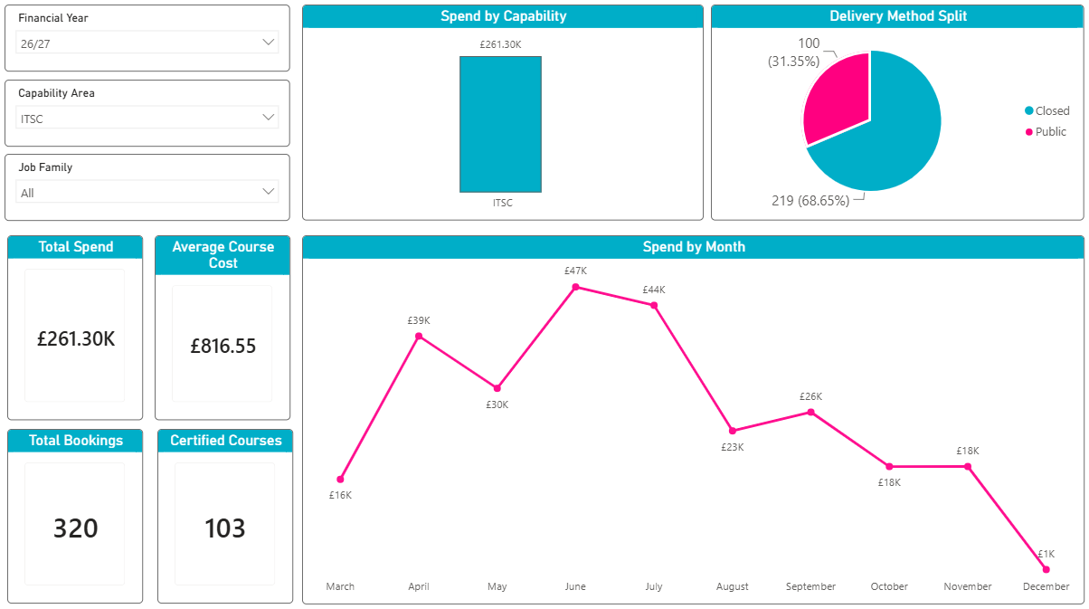
Using filters on the visuals for Capability Area and Financial year

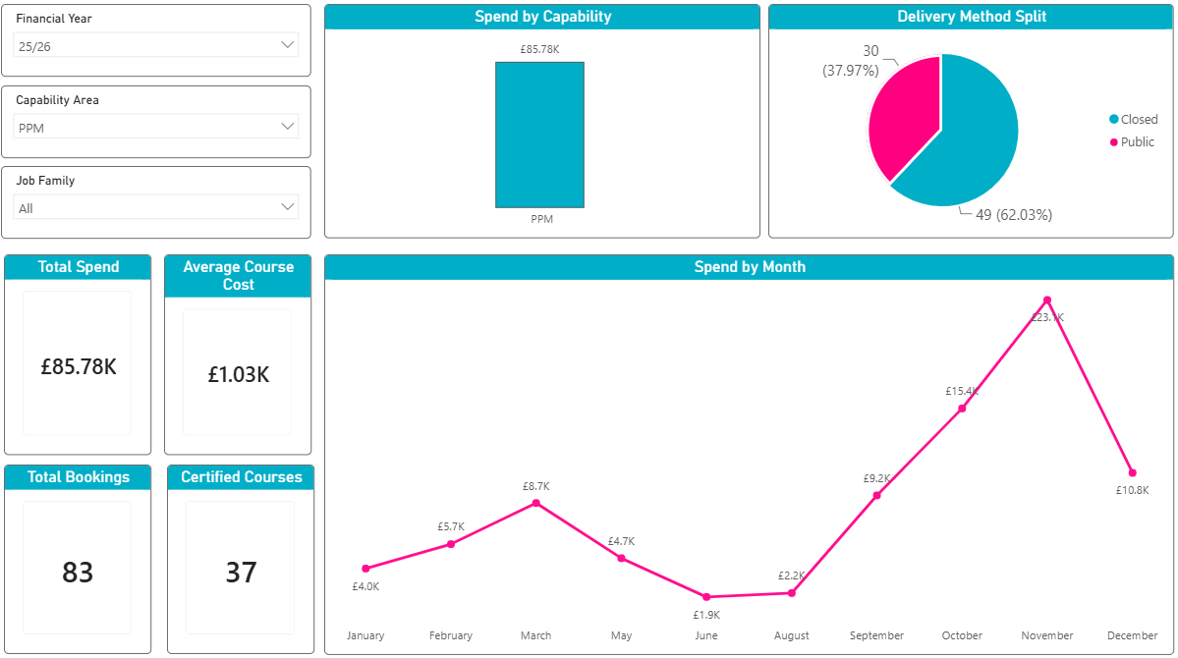
Using the Capability Area filter

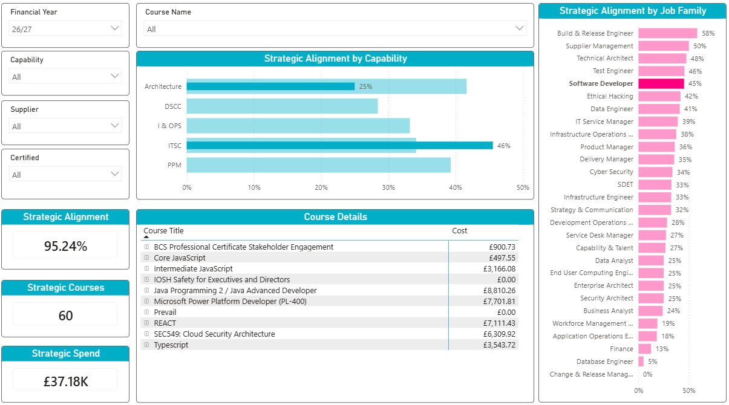
Choosing Software Developer within a visualisation to only filter on their booking details

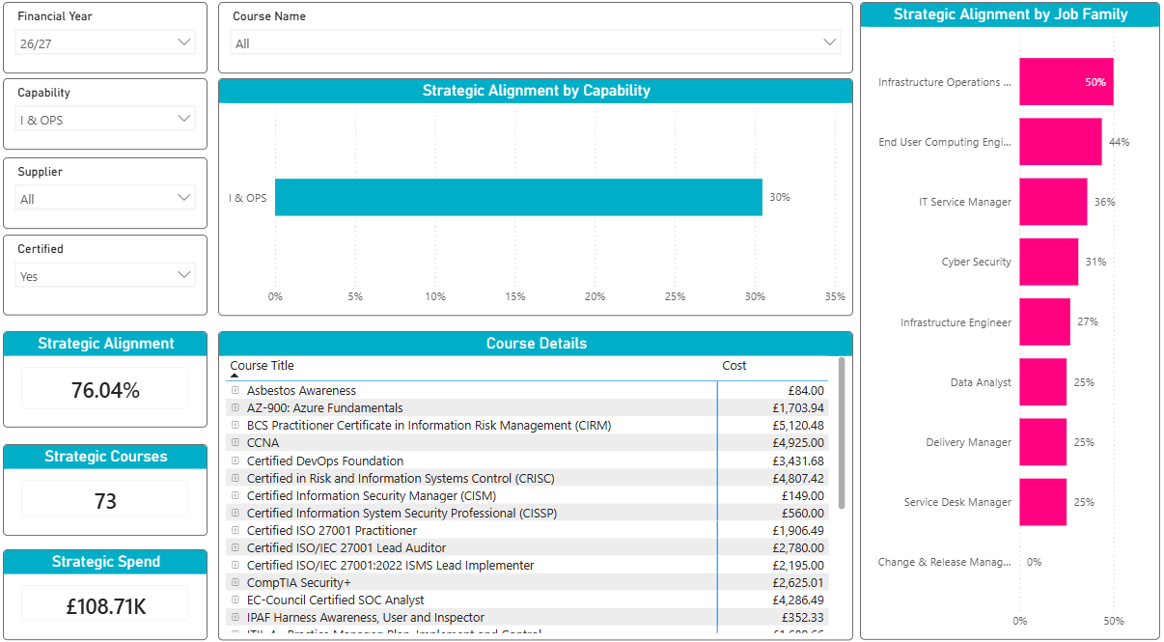
Capability Area filter being used

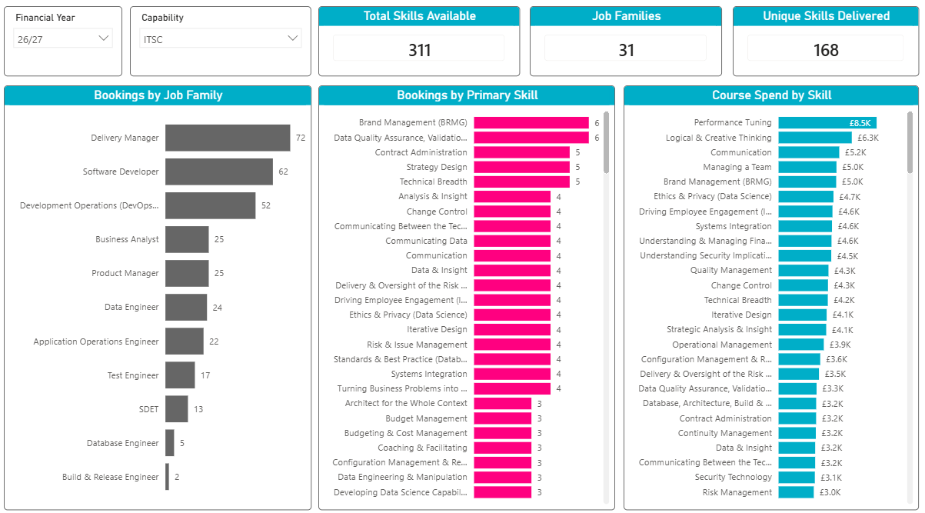
ITSC Capability filter being used to update the visuals

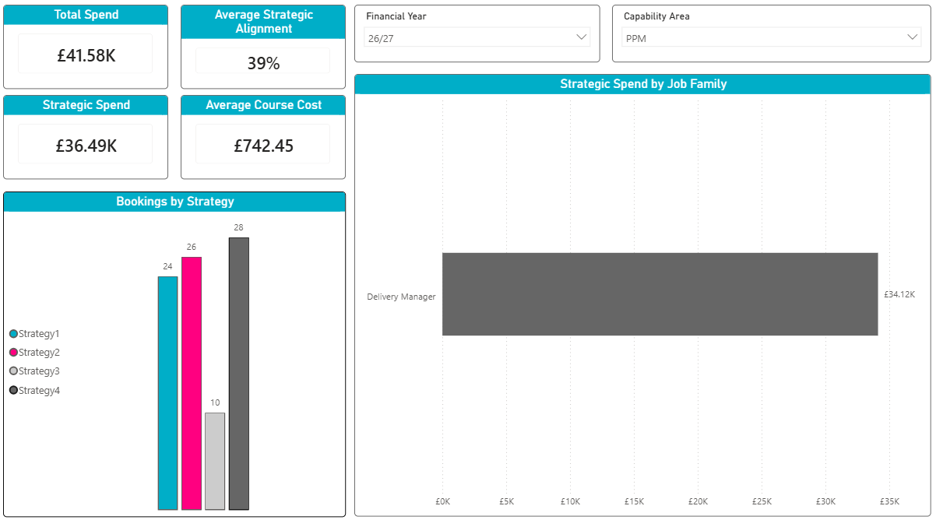
Capability Area filter showing details in PPM for Delivery Managers

