Digital Skills and Research
Methods ( BMSK4003)
Marcus Thomas
Student number 1905296

Contents
Section 1: Digital skills at the workplace introduction 3
section 2: Digital skills at my workplace 4
Section 3: Social Media apps I have considered I am going to use to grow my business into a success 5
Section 4: Instagram Social media app 6
Section 5: Snap Chat social media app 7
Section 6: Shpock app how it will benefit my business 8
Section 7: PayPal app how it will benefit my business 9
Section 8: Twitter app how it will benefit my business using the app to its full potential 10
Section 9: Storage account for business data 11
Section 10: Office 365 Personal data account 12
Section 11: Google Drive storage 13
Section 12: Drop box storage 14
Section 13: Data Protection act selling online 15
Section 14: Creating My LinkedIn Page 16
Section 15: LinkedIn Profile Page 17
Section 16: Gap Analysis 18
Section 17: PDP social media skills at the workplace 19
Section 18: conclusion 20

Section 1: Digital skills at the workplace introduction
From engaging in research in digital skills I have learn you can reach so many people quicker by using these social media apps. They are good for advertising your brand, business name, products and much more. The technology is so advance you can now do live broadcasting build an audience of your own advertise your products for sale. Accordingly, to information received from Snap Chat self-serve tools (Simon Kemp 2020) there has been a big increase of 19% of audience in July 2019 with figures of 369 million users end of July 2019. Facebook is the most successful estimated to have 113.3 million members aged 13-17 years of age. Instagram estimated to have 52.9 million aged 13-17 years of age. Twitter estimated to have 20.2 million users aged13-17. At the end of July 2019. Ever since COVID 19 the way we work has come to a change. People losing jobs and the individual how still has a job are working from home because coronavirus outbreak has gone out of control which is eliminating the population rapidly. In chapter 1 I will further discuss digital skills at my workplace. What social media apps are used. Also, How the apps that are used Can be used to its best ability to benefit the business.
reference https://thenextweb.com/podium/2019/07/17/over-3-5-billion-people-are-on-social-media-facebook-still-biggest-with-teens-esports-on-the-rise/ - November 13, 2020 by Simon Kemp

section 2: Digital skills at my workplace
I am self-employed I specialise in repairing Smartphones and PC tablets I also sell refurbished stock. The mobile phone social media app I use for engaging with customers is Facebook. Gumtree, Shpock are the 2 selling apps I use as well. I use these apps just to advertise and sell new products. I use these apps for nothing else. I have never really considered other options which you can use with these apps that can really benefit my business and make it expand. WhatsApp, Instagram, imessenger are all a part of the same family of Facebook which I never knew. They are all common apps used daily by individual’s communicating with family and friends. It’s the perfect place to get in touch with new customers for business. Which is important it can take my small business to reach audience I could not reach before. Which will generate into more views, likes, shares, etc. also keep in contact with customers and build a long-term relationship.

Section 3: Social Media apps I have considered I am going to use to grow my business into a success

Facebook Business Page
I do not have a Facebook business Page after engaging in research I learnt I need to have one. Facebook business page comes with more options than a standard account its designed to make your business successful. You can do so much on your Facebook page you can add a link of your website to your Facebook business page so customers can go straight to your website, upload videos of new products for customer to see, take payment using PayPal, link your Facebook page with your Instagram page attracting more audience which will possibly lead to more sales.
Benefits for using the social media App
I believe by using Facebook Business page I will expand my company brand, create larger audience, and increase traffic to my website. As Facebook business Page is free it will cut down a lot of marketing cost and make my time more efficient. For me to get full use of this app as well I will need some selling strategies for example engaging regular posting daily. Do a sale on some products to get audience attention. Once a month I could repair lcd screens for Samsung’s smartphones for half price or do bundle deal. You can also Link your PayPal to your Facebook page. Which is a big advantage to take payments from customers. You can put your work hours on your page as well giving customers knowledge of opening hours.

Section 4: Instagram Social media app
The next social media app I am going to use is Instagram. On Instagram most big companies advertise their brand. Having a business page in Instagram is the future it’s great for advertise your products meet new customers. There are options to upload photos off your device or take a live picture from your device, can upload videos as well. Some features are like Facebook features. You can also have a link to your website to attract more sales. When researching Instagram one key point to be a successful business or brand you need to be consistent for example regular posting of products. There is an option available in Instagram where you can also keep up to date with audience how liked your page and products by simply clicking heart symbol button its placed at the bottom of page that’s where you can also see comments mentioned about your company which I found amazing. No cost to open Instagram business page. For you to setup a Instagram business page you will need to have official Facebook business page. Interesting part is that you can link your PayPal account to Instagram business page to take payment through Promotion Payments option in settings making it easier to reach out to the whole of the United Kingdom. Know all this through researching has open my mind to a different way of thinking more critical thinking. I am slowly learning there are more ways of communicating to the world.

Section 5: Snap Chat social media app
Snap Chat is one of most popular apps out there which I never used before. I have heard loads of people talking about Snap Chat but never bothered to investigate. After engaging in research, I have acknowledged the options available and key points and learnt how to advertise my services and stock. The members of snap chat are growing rapidly. It would be in my best interest for my business to put my advertisement and repair service there.
Geo filter is a great option you can use it to share to local audience. Custom filters are an option for customers to use which they can share with friends and get more audience aware of your presents. To use such option Geo filter as an option you will needed to pay. 1800 square feet is minimum, and maximum is 450,000 square feet. It rough cost daily £5.99 plus it depends on the amount of courage you want to cover you can choose which area you want to cover. Its best to use the app for events as you will be changed for square footage.
benefits to my business
I believe my company will benefit using Snap Chat
- .It will attract more audience to my website and page
- When using Geo filter can generator more work by targets local areas
- Save my company on marketing and advertisement fees.
- Give me more time to concentrate on new projects using my time more efficiently.

Getting started on snap chat is the way forward for my company. The more I research about these apps the more I see opportunities.

Section 6: Shpock app how it will benefit my business
Shpock is more like an online car boot sale. Shpock is a German app which is worldwide. Good for selling second-hand stuff and new. There's an option that allows You to share your product on Facebook, Instagram, etc. Shpock does not have much selling options. I have been using this app to just advertise stock for sale and advertise my repair services. There are more options available like you can link your PayPal which will give you the ability to receive payments online. By using PayPal, I can reach more customers. On the shpock website Customer can make offers as well on the product you are selling. The business will benefit from these options by more sales, bigger audience. On Shpock website available to customers they can ask questions about the item you have for sale. They can leave reviews as well. The app can be used on mobile phone, laptops, PC tablet. Which is good for customer to get easy access to me. Its free to set up an account with no fees to sell an item on the website. Another option which is good on Shpock is Shpock wallet you get paid when customer receives item. Which you can then transfer funds from Shpock wallet into your bank account. It normally takes 5 Working day for you to receive money in your account it could take longer depending on your bank. The delivery options are useful you can pay a courier to deliver your goods. The courier company is called parcel 2 go they deliver your parcel to customer for a fee. Full tracking is provided with parcel which is good to know when I am ready to start my own business.
How returns work on Shpock buyers pay for postage. Only let down is that when doing a post for an item for sale you can only post 5 pictures. You can also purchase the premium membership which gives you the option to upload 10 pictures and option to Keep 2 of your items at top of page, so audience see your product first. You have a week trial with Premium membership then after there is a fee to continue with the service.

Section 7: PayPal app how it will benefit my business
After engaging in research, I have identified that PayPal is a good payment system where you can make payments to customer and friends and receive payments from customer and friends. Best feature is you do not have to show your bank details to nobody. Protecting customers from a lot of things like fraud and computer hackers. PayPal business account has more option then the normal account. You can add PayPal to your website to receive payment from customers when you have a business account. All purchases through PayPal is covered under 6 months warranty on goods for customers. To use PayPal, you must have a valid bank account. Your bank details must be registered with PayPal so you can make payments and receive. Only down fall I found is if a customer is not happy with an item they have purchased, or item is faulty. The customer can open a return case and PayPal will then freeze money in your account. To when the problem between the customer and seller is resolved.
benefit my business
Benefits to the company using PayPal is that I do not hold the customer bank details data in case fraud happens and customers bank details are exposed. It’s the best way of transferring money and receiving. When a sale is complete the payment goes direct into your PayPal account. The payment process I used as a self-employed mobile phone technician is cash. PayPal is an established successful company that is known to people worldwide. I never had access to a system that’s linked to my bank account before receiving payments off customers. Now knowing this it would be a good idea for my business to open a PayPal business account it will generate more sales and customers.

Section 8: Twitter app how it will benefit my business using the app to its full potential
Twitter account I never had one before I always thought it would not really benefit the business within sales. Now after researching about twitter I have learnt a lot. New strategies to gain more followers that can lead to sales and more networking with other business. One key point I found interesting that you can link your LinkedIn page to your twitter account. What I found different about twitter you do not have to be friends of an individual to reply to any of their comments on twitter. Not like Facebook you must be a member of a selling group to contact members. On twitter There are industry conference which are interesting to know. To open an account with twitter is free. The number of tweets sent per minute 350,000. In a year a total 2000 billion tweets are sent. Twitter is most famous for big firms what are already established there brand. Making it hard for small business to gain great value out of the twitter app.
benefits of using twitter
I believe having a twitter account is necessary for my business future. Engaging with executives of other companies in my industry will be great advantage and can lead to a good long-term business relationship. Knowing that LinkedIn and twitter can be linked together is an advantage. The strategies I came up with linking the two is that I can use LinkedIn as a search engine to find individual I am looking for. LinkedIn is a social media app for professionals to connect with each other. Once I have the information, I need about individual I will then go onto twitter find the individual twitter account then start a conversation. I believe it will save me time using this method instead of looking online for the individuals email address or contact details.

Section 9: Storage account for business data

I am not using no data storage account to store customer data now. I just use my laptop. From doing research regarding data storage accounts like, Google drive, One drive, Dropbox, etc I really need one. If my laptop was to get damaged or stolen, I would not have no way of reiving all business files. Having a backup is important for the business. Further into research I have identified one app that will work well with my business as it is a small business. I will explain next about storage accounts I have researched and the storage account I am going to use to store business data.

Section 10: Office 365 Personal data account

Price plan
Microsoft business standard account
1TB of data storage
Free for the first month then after £9.40 per month
You can install this program on Apple Mac, IOS devices, Xbox console, mobile phone devices
You can have multiple account users which can view edit files at same time.
Customers how do not have Microsoft accounts can edit files you send to them without the person having a Microsoft 365 account.
You can put a passcode to access files which I found a good option to have.

Section 11: Google Drive storage

Price Plan
Google drive business standard account

- 14 free day trail after price per month £8.28 per month
- You can sign in with 3 different google accounts at the same time
- Different Users using the account can edit files at the same time
- Google drive store your data on your device. If you want to store data in your cloud you will have to do it manually.

Section 12: Drop box storage

Price Plan
Dropbox business standard account

- 5TB of storage
- 30 Day free trail the after £10 per month
- Share file externally
- Share files with others they can only view not edit file. For file to be edited by the receiver they will need Dropbox account.
I have chosen to use Dropbox as my storage. You get a lot for your money. As a small business I will benefit from using this storage account.

Section 13: Data Protection act selling online

The data protection act entered force on 25th May 2018. You must state clear to customer the procedures of delivery and how to make payments for items. Languages available for different ethnic backgrounds. Terms and conditions must be available on website to download. GDPR which means general data protection regulations all are data that are gathered every time you make a purchase, open an account, etc. More of our personal data received by companies are traded between government companies. Are name and contact details, computer location, colour, sexual orientation is all sorted. A company must ask for your approval before storing your information on their system. The fine for not looking after customer data is a astonishing. If your company data is hacked the company as up to 3 days to tell customers. In 31 December 2020 the UK will leave the E.U. we will then after applying by new GDPR and DPA (data protection act 2018) regulations. This regulation applies to all data controllers and processors that have customer data.
If E.U and U.K do not come to an agreement. U.K will be classed as a third country which will have to depend on BCR (blind corporate rules) or SCC (standard contractual clauses. I have learnt if I am not too clear about GDPR I can take a course to get a clear understanding before I start trading and taking customers data. At the end of course you receive a certificate.

Section 14: Creating My LinkedIn Page

Profile picture
I hate taking pictures they never come out good. I went through my photo selection I could not find a good picture for my profile picture. Instead I just took a picture from my mobile phone camera.
Job tile
For my job tile I choose my profession which I am a mobile phone technician. I showed which company I worked for. The hardest challenge was finding the correct category for my business I was there for about 40 mins.
Profile intro
The reason I choose to include in my headline was to give audience quick preview on what company services available and all repairs come with warranty.
Background Photo
Reason why I choose to use the background photo displayed on my LinkedIn page. It explained my work profession and the company I work for.
Photo Section
Reason why I choose to put up refurbished stock. It’s to give audience image of what my refurbished stock will look like.
About Section
I put where I am currently also studying description about the company I worked for. So, audience have some knowledge of the company and their services and knowledge about myself.

Section 15: LinkedIn Profile Page

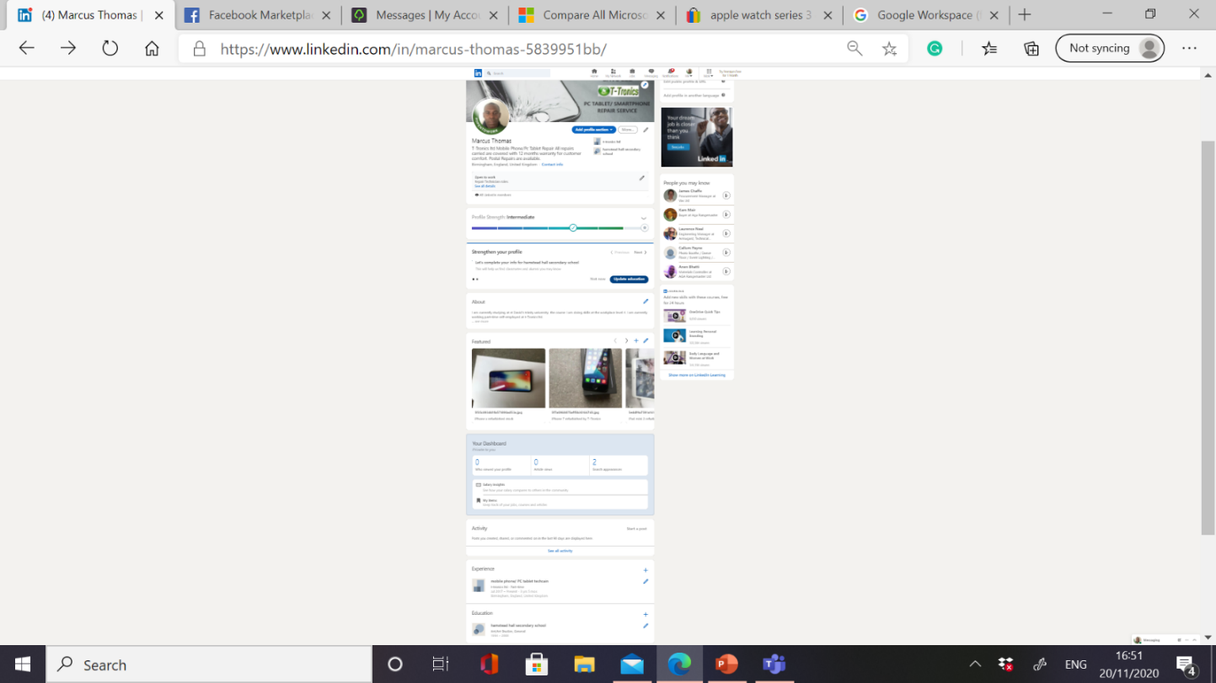

Section 16: Gap Analysis
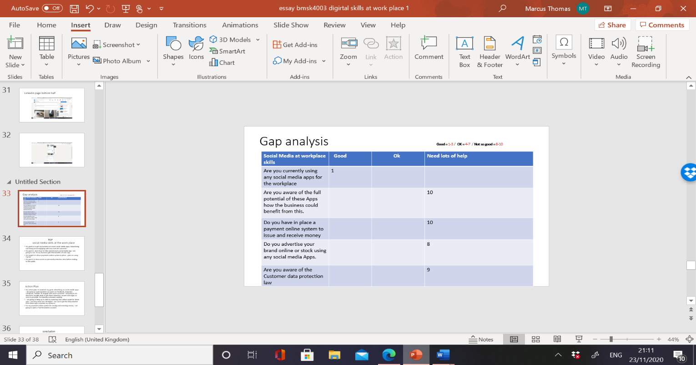

Section 17: PDP social media skills at the workplace

- My goals is to get my business on more social media apps. Advertising and doing more engaging with new and old customers
- My goal to Learn how to fully operate each social media app I am going to use. So, my business gets the benefits of each app.
- My target is to have payments online system in place. I plan on using PayPal.
- My goal is to learn more on personal protection data before trading to the public.

Action Plan
- My action plan to maintain my goals advertising on social media apps. I am going to open business accounts on Facebook, Snapchat, Instagram, Twittier. To engage with more customer, I am going to do discounts, bundle deals to get their attention, answer messages as soon as possible. Not leaving customers waiting.
- I am going to keep up to date by watching new videos made for these apps. Learning what new strategies I can use to get the full potential from these apps to better my business.
- For my payment online system for issuing and receiving money. I am going to open a PayPal business account.

Section 18: conclusion

After engaging in research, I have learnt a lot of new things. New strategies what I can use to gain more traffic to my website. As before I would use Facebook and gumtree, shpock to sell my items and advertise my services and that it. There so much more you can do with these apps Saving money in market, advertisements. All apps are free to use.

References

- https://thenextweb.com/podium/2019/07/17/over-3-5-billion-people-are-on-social-media-facebook-still-biggest-with-teens-esports-on-the-rise/

- https://www.facebook.com/business/learn/lessons/how-business-owners-can-use-facebook?course_id=1042513649280895&curriculum_id=1066271893760429

- https://www.smartinsights.com/social-media-marketing/social-media-strategy/snapchat-statistics/#:~:text=Snapchat%20reached%20210%20million%20daily%20users%20in%20Q4,The%20current%20longest%20Snapchat%20streak%20stands%20at%201%2C802.

- https://www.shpock.com/en-gb/help/web/5baa251b5ad4ae41b80f12a6

- https://www.which.co.uk/consumer-rights/l/online-shopping
- https://smecomply.co.uk/eu-representative/

- https://www.itgovernance.co.uk/shop/product/certified-gdpr-foundation-training-course

- https://www.dsayce.com/social-media/tweets-day/

- https://www.gumtreeforbusiness.co.uk/

- https://www.quicksprout.com/snapchat/#:~:text=15%20Ways%20to%20Use%20Snapchat%20for%20Your%20Business,10%20Reply%20to%20your%20followers.%20More%20items...%20

- https://www.paypal.com/uk/business?kid=p29015929058&gclid=670d55e010b917e1fc4d0a4ebba5749d&gclsrc=3p.ds&
- https://www.microsoft.com/en-gb/microsoft-365/business/compare-all-microsoft-365-business-products-b?ef_id=046fc688ff0d1d6c9ca6993f17661041:G:s&OCID=AID2100139_SEM_046fc688ff0d1d6c9ca6993f17661041:G:s&lnkd=Bing_O365SMB_Brand&msclkid=046fc688ff0d1d6c9ca6993f17661041
- https://www.linkedin.com/in/marcus-thomas-5839951bb/

- https://workspace.google.com/pricing.html
- Data protection and your business - GOV.UK (www.gov.uk

