Dissertation Proposal

Name: Anisa Salianji
Student ID: 2246765
Module Name: Dissertation
Module Code: LCMB7020
Supervisor Name: Isaiah Oino

Contents
Introduction 2
Aim: 2
Objective: 2
Research Questions 3
Literature Review 3
Research Gap 4
Research Methodology 5
Research Phases: 5
Target Participants: 6
Ethical Considerations 6
Timeframe 7
Conclusions 7
References 9

Topic: Leveraging Big Data Analytics for Enhanced Fraud Detection and Prevention in the Financial Sector

Introduction
Fraud in the financial sector, which includes acts such as embezzlement, identity theft, and fraudulent transactions, is a serious and rising danger to firms. Occupational fraud is estimated to cost organisations a median loss of $427,000 each incidence, according to research conducted by the Association of Certified Fraud Examiners (ACFE) (Association of Certified Fraud Examiners (ACFE), 2022). The conventional techniques of detection, which often rely on rule-based systems and statistical analysis, are having a difficult time keeping up with the ever-increasing sophistication of fraudulent schemes. According to Bolton and Hand (2021), these approaches have the potential to produce false positives, fail to identify growing fraud tendencies, and need the manual assessment of massive datasets, which ultimately hinders real-time detection. Big data, which is characterised by enormous quantities, velocity, and diversity of information, has the potential to revolutionise fraud detection as a result of its enormous potential. Businesses are able to get a more comprehensive perspective of consumer activity and uncover abnormalities that are suggestive of fraud by conducting an analysis of a variety of data sources, such as transaction logs, customer profiles, and maybe even behaviour on social media platforms (while taking ethical issues into account). The objective of this dissertation is to study the ways in which big data analytics may be efficiently used to detect and prevent financial fraud, which might possibly result in considerable cost savings and increased financial security for firms.

Aim:
The aim of this research is to evaluate the ways in which big data analytics has the potential to enhance the effectiveness of financial fraud detection and prevention in business settings.

Objective:
To be more precise, the following goals will be addressed in order to achieve this particular aim:
- To determine the limits of big data-driven strategies for fraud detection in compared to traditional methods.
- Identify the primary data source categories that are most helpful for identifying fraud.
- Analyse the effectiveness of various big data analytics methods.
- Develop a framework or methodology for businesses to implement big data-driven fraud detection systems, considering data acquisition, analysis techniques, and alert generation.

Research Questions
- Effectiveness: What is the extent to which big data analytics, as opposed to traditional rule-based as well as statistical techniques, can improve the effectiveness and precision of fraud detection in a business environment?
- Data Sources: When taking into account the quality of the data, concerns about privacy, and ethical considerations, which big data sources, such as transaction logs, consumer behaviour, and data from social media, are the most helpful for detecting and preventing financial fraud?
- Analytics Techniques: What is the level of effectiveness of various big data analytics technologies, such as network analysis, anomaly detection methods, as well as machine learning algorithms, when it comes to identifying fraudulent behaviour in financial data?
- Implementation Framework: What necessary components, such as data collecting, pipelines for analysis, the development of warnings, as well as connectivity with an organization's existing systems, are required to be included in a framework for the detection of fraud that is powered by big data?

Literature Review
Fraud in the financial sector is a pervasive issue that results in significant financial losses for businesses all around the globe. According to the Association of Certified Fraud Examiners (ACFE) (2022), the typical amount of money lost as a result of employees engaging in fraudulent activities in the workplace is $427,000. Traditional methods of identifying fraud, which often rely on rule-based systems and statistical analysis, are becoming less successful as fraud schemes continue to advance (Bolton and Hand, 2021). The purpose of this literature review is to examine the current research that has been conducted on the topic of how big data analytics, which makes use of large volumes, velocity, and variety of information, can revolutionise the identification of fraudulent activity.
According to Bolton and Hand (2021), traditional techniques, such as rule-based systems, need human intervention on a frequent basis in order to function properly and are unable to accommodate changing fraud patterns. When statistical methods are used to identify irregularities, it is possible that they will also generate a large proportion of false positives. This may lead to an overload of analysts and a delay in the investigations (Richhariya and Singh, 2012). The prevalence of these limitations highlights the need of developing more sophisticated approaches that are capable of managing the complexity of modern financial data.
Big data offers a tremendous amount of promise for detecting fraudulent activity due to the fact that it can examine a broad variety of data sources, including ones that are not typically associated with transaction logs. According to Husain and Khan (2023), this includes consumer profiles, conduct on social media platforms (which may raise ethical concerns), and network analysis to identify relationships that may be ethically dubious. On the other hand, dealing with the sheer volume and complexity of big data offers challenges, which calls for the implementation of robust data processing frameworks and the employment of competent analysts (Ashtiani and Raahemi, 2021).
The use of machine learning algorithms has shown promise in the area of fraud detection (Nisbet, 2016). These algorithms make use of historical data to identify patterns that are indicative of fraudulent behaviour. According to Wang, Wong, and Miner (2004), anomaly detection methods may be used to identify any unusual changes in consumer behaviour that may be indicative of the possibility of fraudulent financial activity. Zinin et al. (2018) state that network analysis has the potential to reveal linkages between the parties involved in fraudulent transactions that are suspicious.
This review highlights the challenging aspects of traditional methods of fraud detection and the ways in which big data analytics might potentially assist in overcoming those problems. It is necessary to do more research in order to explore the usefulness of various approaches to big data, create robust implementation frameworks, and address concerns about data privacy and ethics.

Research Gap
Although prior research has recognised the potential of big data analytics in the detection of financial crime, the purpose of this dissertation is to fill in a number of significant gaps, including the following:
- Limited Comparative Analysis: Only a limited amount of comparative analysis is performed, since the bulk of studies evaluate big data methodologies independently. Through an examination of the effectiveness of different approaches, the purpose of this dissertation is to ascertain which techniques, such as machine learning, anomaly detection, and network analysis, are most effective in addressing a variety of fraudulent circumstances.
This void is brought to light by Jha, Sivasankari, and Krishnappa (2020), who point out the need of a comparison framework that measures the effectiveness of various methods for detecting fraudulent credit card activity.
- Data Source Integration: When doing research, it is common practice to concentrate on certain data sources, such as transactions. The purpose of this dissertation is to examine the integration of many big data sources, maybe including social media data with ethical concerns, in order to design a fraud detection model that is more thorough.
The article by Rosnidah et al. (2022) highlights the limits of existing methodologies as well as the possibilities of big data for a more complete approach towards the problem.
- Implementation Framework Development: The literature that is presently being published does not offer a comprehensive framework that businesses can use to implement fraud detection that is powered by big data. The objective of this dissertation is to develop a framework that is capable of functioning, which will include the creation of alarms, the collection of data, pipelines for analysis, and the integration of systems.
In their study, Rosnidah et al. (2022) demonstrate how big data analytics has the ability to identify fraudulent activity. Our dissertation has the potential to expand upon this by putting out a framework for the actual implementation of the system.
- Ethical Concerns and Data Privacy: We need to do further study to discover how big data may be utilised in an ethical manner for the purpose of fraud detection. A discussion of potential algorithmic biases and the provision of solutions to ensure compliance with data privacy regulations will be included in this dissertation.
The article by Rizvi (2021) investigates the role that big data analytics plays in the identification of financial fraud; however, it does not dive into the ethical considerations involved. For the purpose of adding value, our study would investigate algorithmic bias as well as concerns around data privacy.
- Economic Impact Quantification: The primary emphasis of the present research is on technical concerns concerning the economy. This dissertation will investigate the economic impact of using big data analytics for fraud detection, as well as the potential cost savings and greater financial security that organisations may experience as a result of using such analytics.
This dissertation will make a substantial contribution to the field of financial fraud detection by filling up these gaps. It will also assist businesses in making better use of big data analytics in order to build a more secure financial environment.

Research Methodology
The purpose of this dissertation is to investigate the most effective methods that businesses may employ to identify and prevent financial fraud by using big data analytics. A mixed-methodologies approach that incorporates both qualitative and quantitative research techniques will be used in order to get a comprehensive understanding of the topic.

Research Phases:
Phase 1: Literature Review
- Carry out a thorough assessment of the information that has been published on the subject of financial fraud detection tactics, taking into consideration both big data analytics (machine learning, anomaly detection) and more traditional approaches (rule-based systems, statistical analysis).
- Investigate the advantages and disadvantages of each technique, giving special attention to its efficiency, scalability, and adaptability to any new fraud schemes that may emerge.
- Determine the primary challenges that must be overcome in order to put big data-driven fraud detection systems into action. These challenges include issues with data integration, a lack of available labour, and concerns around privacy.
Phase 2: Quantitative Analysis - Survey
- Develop a survey instrument for the purpose of gathering information from fraud detection experts who are employed by various financial institutions and associated sectors (for example, insurance-related businesses and online retailers).
- During the survey, we will delve into:
- Present the techniques and challenges involved in identifying instances of fraud.
- Knowledge and perspectives on fraud detection utilising big data analytics.
- This dissertation will discuss the potential benefits and challenges associated with putting big data-driven systems into reality.
- To concentrate on occupations that are relevant, use an approach known as purposive sampling.
- Utilise descriptive and maybe inferential statistics (depending on the survey design) to investigate the data from the survey in order to identify patterns and relationships between the variables.
Phase 3: Integration and Synthesis
- The findings of the survey analysis, case studies, and literature review have to be included into the process of developing a comprehensive understanding of how businesses might utilise big data analytics to identify fraudulent activity in an effective manner.
- Make a list of the most important aspects and optimal procedures for putting fraud detection systems that are powered by big data into operation.
- Have a discussion on the ethical implications of big data analytics in this scenario, with a particular focus on the potential for bias in algorithms and the protection of personal information.

Target Participants:
Those individuals who are directly involved in the process of detecting fraudulent activity and managing risks in financial institutions and other industrial sectors that are linked will be the target audience for this survey. The ideal attendance is broken down into the following categories:
- Financial Institutions: Fraud analysts, risk management professionals, security specialists working in banks, credit unions, investment firms, etc.
- E-commerce Platforms: Fraud prevention specialists, risk analysts responsible for online transaction security.
- Fintech Companies: Fraud detection specialists, data analysts working on developing or implementing fraud detection solutions.
- Insurance Companies: Fraud investigators, claims adjusters with experience in identifying fraudulent insurance claims.
This dissertation will give insightful analysis and helpful suggestions for businesses who are interested in using big data analytics for the purpose of detecting financial fraud in an effective manner. The study will adhere to a mixed-methods methodology.

Ethical Considerations
No personally identifying information will be connected to any of the replies submitted by participants since the survey will be anonymous.
There is a guarantee that all collected data will be safely kept and shielded from unwanted access. The information gathered from participants will be kept anonymous throughout the reporting and analysis procedures.
To preserve the privacy of all survey respondents, any quotes or passages taken from the open-ended survey replies will be rendered anonymous.

Timeframe
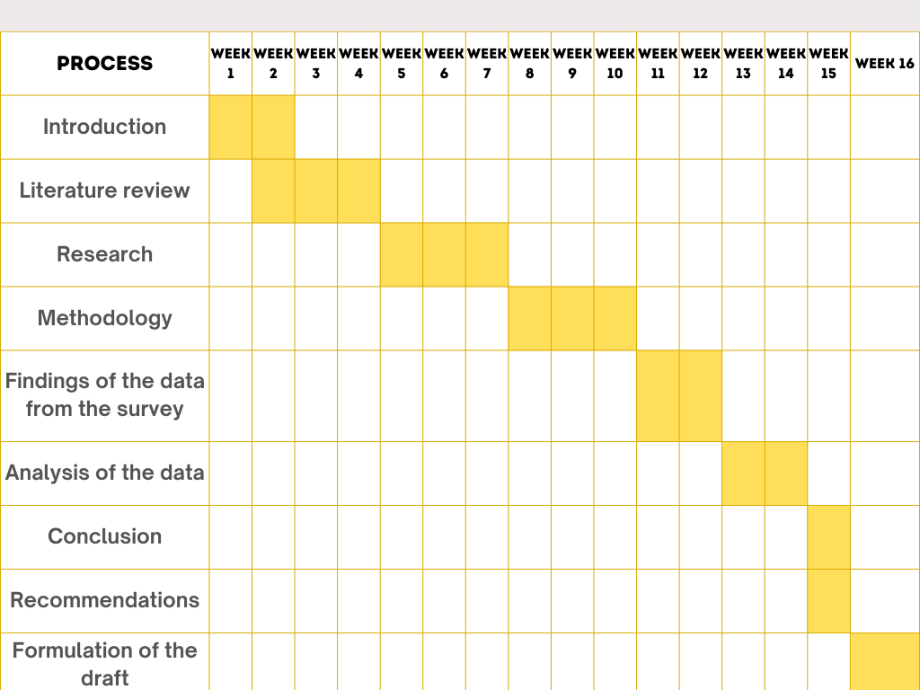

Conclusions
In conclusion, the purpose of this research is to investigate the possibility of bridging the gap in the detection of financial fraud by using the huge potential of big data analytics. It may be challenging for conventional methods to stay up with the most recent advancements in scam strategies. Because of its immense volume, pace, and variety, big data is a powerful tool that may be used to acquire a more comprehensive knowledge of customer behaviour and to discover hidden inconsistencies that may be indicative of fraudulent activity. This study examines a number of different approaches to big data, as well as the integration of data sources and ethical concerns. The goal of this research is to give a framework that is feasible for businesses to employ in order to implement powerful fraud detection systems that are powered by big data. Businesses will see significant cost savings as a consequence of this, in addition to the improvement of their financial stability. For businesses who are interested in using big data analytics to combat financial crime, the findings of this study will offer them with invaluable ideas and information that is both informative and practical.

References
Ashtiani, M.N. and Raahemi, B. (2021). Intelligent Fraud Detection in Financial Statements using Machine Learning and Data Mining: A Systematic Literature Review. IEEE Access, 10, pp.1–1. doi:https://doi.org/10.1109/access.2021.3096799.
Association of Certified Fraud Examiners (ACFE) (2022). A Report to the nations ® OCCUPATIONAL FRAUD 2022: A REPORT TO THE NATIONS. [online] Available at: https://www.acfe.com/-/media/files/acfe/pdfs/rttn/2022/2022-report-to-the-nations.pdf.
Bolton, R.J. and Hand, D. (2021). Statistical fraud detection: A review. [online] Quality Engineering. Available at: https://www.semanticscholar.org/paper/Statistical-fraud-detection%3A-A-review-Bolton-Hand/d9665992ee36699b8ae4a2e2294552cd4be9003a.
Husain, M.S. and Khan, M.Z. (2023). Big Data Analytics for Fraud Detection. [online] pp.pp.148-160. doi:https://doi.org/10.1201/9781003441595-13.
Nisbet, R. (2016). Handbook of statistical analysis and data mining applications. Academic Press.
Richhariya, P. and Singh, P. (2012). A Survey on Financial Fraud Detection Methodologies. International Journal of Computer Applications, 45(22), pp.15–22.
Wang, Y., Wong, J. and Miner, A.S. (2004). Anomaly intrusion detection using one class SVM. [online] Information Assurance Workshop, 2004. Proceedings from the Fifth Annual IEEE SMC. Available at: https://www.researchgate.net/publication/4147561_Anomaly_intrusion_detection_using_one_c.
Zanin, M., Romance, M., Moral, S. and Herrero, R.C. (2018). Credit Card Fraud Detection through Parenclitic Network Analysis. [online] Available at: https://www.researchgate.net/publication/317399780_Credit_Card_Fraud_Detection_through_Parenclitic_Network_Analysis.

