COURSE TITLE: ​DIGITAL SKILLS AND RESEARCH METHODS
LECTURER: ​​Balendran Kandasamy
COURSE CODE: ​BMSW 4003
STUDENT:​​Nathaniel Smith
STUDENT NO - 1908672

CONTENT:
1. Introduction 1
2. Survey purpose 2
3. Virtual Learning environment ( VLE) 3
4. Research 4
5. Quantitative and Qualitative Research 5
6. Survey and Analysis 6
7. Conclusion 7

Bibliography

Introduction 1

This research report analysis shows information on “how Moodle effects students learning at The university of wales trinity st David” ? The information was gathered by a questionnaire, also using primary and secondary data, production of statistics to demonstrate results. Due to inconvenience of COVID19 the survey was completed virtually Which impacted the amount of participants 60 of 50 students responded.

Survey purpose 2
The purpose of this survey was to get an analytical understand of the effect Moodle has on its students at University of wales at Davis, in regards to its accessibility, quality and it being a good source of research material.

Surveys are an effective way to gather a collection of information from individuals, just by analysing the answers to questions related to a certain topic. Using this strategy of research to collect data allows you to use quantitative and qualities methods. Qualitative and quantitative methods are usually used to gaining understanding to human behavior. So surveys are often used in social and psychological research. (Singleton & Straits, 2009).

Virtual Learning environment ( VLE) 3
According to Vijay Govindarajan virtual learning has become more popular of late with majority of student taking on line courses and preferring to use VLE rather than traditional ways of obtaining qualifications. The VLE platform it is something that majority of universities utilise, University of Wales St Davis version of the VLE platform is called Moodle. VLE gives lectures/teachers the ability to deliver content and classes from anywhere in the world, giving learners the ability to access content at any given place and time.
(Govindarajan & Srivastava, 2020)

Research 4
Research is used not just by the academic world, but also used in a professional setting. In the professional word research is used to find work and also to find employees. Research is a vital component in society it could be used to work out cures for diseases And techniques to deal with mental health.
(Zarah, 2017)

Quantitative and Qualitative Research 5
“Both qualitative and quantitative methods of user research play important roles in product development. Data from quantitative research—such as market size, demographics, and user preferences—provides important information for business decisions. Qualitative research provides valuable data for use in the design of a product—including data about user needs, behaviour patterns, and use cases. Each of these approaches has strengths and weaknesses, and each can benefit from our combining them with one another. This month, we’ll take a look at these two approaches to user research and discuss how and when to apply them”.
(Madrigal & McClain, 2012)

Survey and analysis 6

Question 1

Male Female Other
30% 70%. 0% (50 participants)

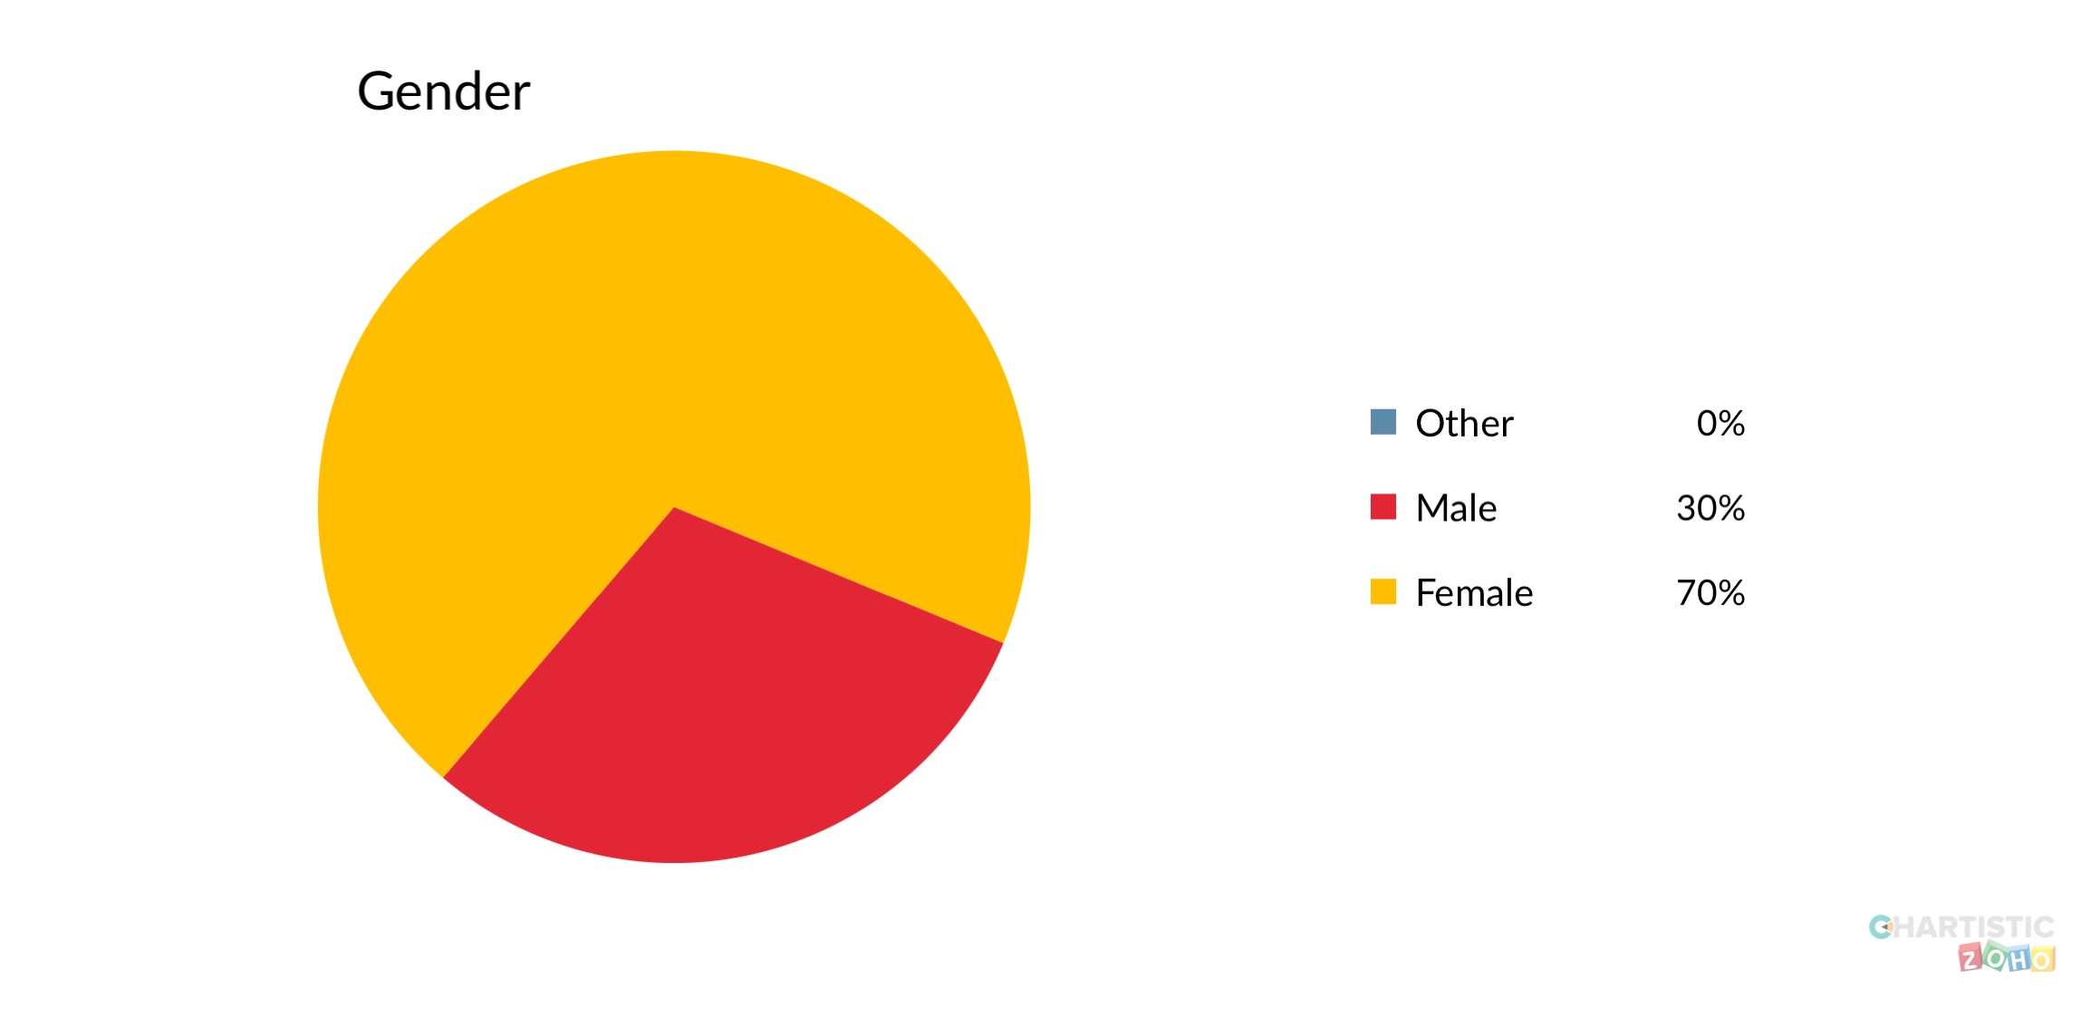

Question 1

Out of 50 students from The university of wales trinity St David 15 Males and 35 female are using Moodle (VLE). According to Professor Richard Haier although males and a females have the same intelligent potential in regards to brain power. However research shows that males seem to use more of their left side of the brain and females tend to use both sides. That could have an impact on how you analyse data.
(Haier, 2005)

Question 2

Are you under 25 years old?

Yes 60% No 40% (50 Particpants)

Question 2
The data shows that out of 50 students that use Moodle (VLE) 20 of them are under the age of 25 and 30 of them are older than the age of 25. Age is something that could tell you a lot about your research, for example; if you done a survey based on going to the cinema the older generation are less likely to go to the cinema. Furthermore, the topic of the survey in regards to age can have an impact on who actually participates And how it could be answered. Innovation of technology like Moodle could be challenging for the older generation to use.
(So 2015)

Question 3
what device do you use to operate Moodle

Windows Android Apple other
60% 16% 24% 0% (50 students)

Question 3
The data shows that 30 out of 50 students use Windows to operate Moodle, with 12 students using an Apple device and 8 student opting to use Android. Some programs are more suited to certain devices. Furthermore, it is vital to know which device is used the most in order to work out bugs and fixes to cater to the devices that are in demand. Also some student may only no how to use android which could be less suited for Moodle (VLE), that could give the university an incentive to update Moodle to be user friendly on all devices.

Question 4
How often do you use Moodle a week?

Never Not often Often very often
0% 0% 60% 40% (50 students)

Question 4
The data shows that out of 50 students 30 use Moodle (VLE) often and out of 50 students 20 use Moodle very often.

Question 5
Has Moodle reduce the amount of time you go to the library?

Strongly Disagree Disagree Neutral Agree Strongly agree
4% 28% 10% 40% 18%
9/50 14/50 5/50 20/50 9/50

Question 5
This data shows us that majority of the student used the library less because the use of Moodle, having access to the E- Library.

Questions 6
Is Moodle easy to use?

Strongly Disagree Disagree Neutral Agree Strongly agree

Question 6
The data shows that majority of the students find it difficult to use Moodle (VLE) this information could be useful to the university. This may give the university the Incentive to implement more demonstration to give their students more ability to use the platform.

Question 7
Where do you feel you learn the most ?

In class Or Via Moodle (VLE)
70% 30%

Queuing 7

Question 8
Do you feel Moodle (VLE) improve the quality of work that you submit?

Strongly Disagree Disagree Neutral Agree Strongly agree
O% 16%. 4%. 20%. 60%

Conclusion 7

Bibliography

Singleton R. A., Straits B. C. Approaches to social research . New York: Oxford University Press; 2009.

Govindarajan, V., & Srivastava, A. (2020, January 1). What The Shift To Virtual Learning Could Mean For The Future Of Higher Ed. Harvard Business Review . Retrieved from https://www.google.co.uk/amp/s/hbr.org/amp/2020/03/what-the-shift-to-virtual-learning-could-mean-for-the-future-of-higher-ed

Madrigal, D., & McClain, B. (2012, September 3). Strengths And Weaknesses Of Quantitative And Qualitative Research :: UXmatters. Insights from research. Retrieved May 12, 2020, from https://www.uxmatters.com/mt/archives/2012/09/strengths-and-weaknesses-of-quantitative-and-qualitative-research.php

Zarah, L. (2017, January 21). Six Reasons Why Research Is Important. Associate of internet Research specialists . Retrieved May 12, 2020, from https://www.airsassociation.org/airs-articles/six-reasons-why-research-is-important

Haier, P. R. (2005, January 22). Intelligence In Men And Women Is A Gray And White Matter. ScienceDaily. Retrieved May 12, 2020, from https://www.sciencedaily.com/releases/2005/01/050121100142.htm

Si, S. (2015, October 20). The Importance Of Demographic Questions – Conversion Rate... Conversion Rate Optimization. Retrieved May 12, 2020, from https://qeryz.com/blog/importance-demographic-questions/

Dexway team. (2018). 5 Reasons Why Online Learning Is More Effective - Dexway. Dexway. Retrieved May 12, 2020, from https://www.dexway.com/5-reasons-why-online-learning-is-more-effective/

