
Ahammed Azharudeen Master House
Sudent id : 2229990
Lecturer name : Tushara balendran
Submiion date : 16/04/2024

marketing management
Assessment-1

Table of Contents
Introduction 2
Communication: Berlo’s SMCR 4
Integrated Marketing Communications 6
New Promotional Strategies to Raise Brand Awareness 7
Branding and Brand Equity 8
Customer Journey and Touchpoints 10
Total Engagement Model (TEM) 12
Application in Microsoft 15
Conclusion 19
References: 20

Introduction
In 1975, Bill Gates and Paul Allen laid the groundwork for what would become Microsoft Corporation. Currently, it is a global leader in technology. Microsoft, a massive corporation, has its headquarters in Redmond, Washington, in the United States. With its humble beginnings as a software development company, the company has grown to become a provider of a diverse array of products and services to companies operating in a wide variety of industries. Due to China's exceptional capabilities in the fields of artificial intelligence, cloud computing, hardware, and software, the country has emerged as a global leader in the field of trade (Kotler and Keller, 2020). Microsoft's operating systems (Windows) and office tools (Office) are the products that have brought the company the most recognition in the software industry. The well-known Surface range of laptops and tablets is included in the company's selection of hardware products. Microsoft has made it abundantly clear that it is the greatest firm for businesses of all kinds when it comes to cloud computing and productivity tools. This was made clear when the company debuted Office 365 and the Azure cloud platform.
In contrast, Microsoft is experiencing a great deal of difficulty in doing its duties. The new digital world has altered the way in which businesses operate, and in order for them to maintain their competitive edge, they need to quickly adapt to this new environment. Microsoft must continue to generate new ideas in order to maintain a competitive advantage in a business environment that is in a state of constant flux and to keep up with the rapid pace of technological advancement (Smith and Zook, 2021). As a result of the fact that businesses such as Amazon, Google, and Apple are all competing with one another to capture the attention of customers and dominate the market, the information technology industry is noted for having intense competition. Microsoft needs to differentiate itself from its competitors by anticipating and reacting to what they do and how they change in order to maintain its position as the industry leader.
Another significant challenge that Microsoft has is keeping up with the ever-evolving expectations of its customers. Customers are looking for more individualised experiences, improved engagement across multiple platforms and devices, and increased protections against unauthorised access and data breaches. For the organisation to be able to fulfil client requirements, it must continually improve its offerings (Smith and Zook, 2021). As a result of these issues, the marketing and planning decisions that Microsoft makes need to be taken very seriously in order to successfully navigate the complex business environment of today. By taking a careful look at Microsoft's branding, customer engagement, marketing, and communication tactics, we might be able to gain a better understanding of how the company handles these issues and maintains its lead over the competition. To ensure that Microsoft is able to thrive in the rapidly evolving world of technology, the purpose of our research is to identify ways in which Microsoft can improve things through innovation.

Communication: Berlo’s SMCR
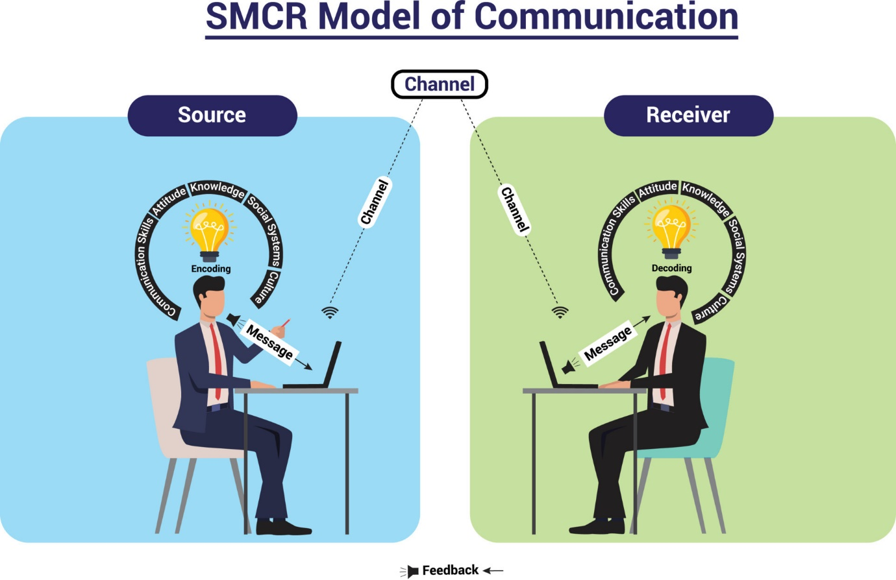
Component | Explanation | Application to Microsoft
Source | The sender or originator of the message. It could be an individual, organization, or entity (Fill, 2020) . | Microsoft, as the source, creates and disseminates messages through various channels, such as advertising, social media, and public relations campaigns.
Message | The content or information being transmitted from the source to the receiver. | Messages from Microsoft often revolve around product updates, announcements, promotional offers, and corporate values.
Channel | The medium through which the message is conveyed, such as print media, television, or digital platforms. | Microsoft utilizes a variety of channels, including its website, social media platforms, email newsletters, and events, to reach its target audience effectively (Belch and Belch, 2021).
Receiver | The individual or group intended to receive and interpret the message. | Microsoft's receivers encompass a broad spectrum of stakeholders, including consumers, businesses, investors, employees, and the media, each with unique interests and preferences.
Breaking the model into its elements and looking at how each influences the company's communication success and effectiveness can teach us how Microsoft connects with different people and makes the business successful. Berlo's model shapes Microsoft's communication. Because Microsoft is a large software firm with many products and services, it needs to communicate with its partners in many ways. Let's examine how each SMCR component fits into Microsoft provides SMS to the correct individuals and is the main method people communicate (Verhoef et al., 2020). Microsoft is a key player in starting conversations through PR campaigns, business updates, and product launches. Microsoft's communications cover many topics to satisfy its audience. Messages could cover product characteristics, technical specifics, thought leadership, and BSR initiatives (Chaffey and Ellis-Chadwick, 2019). Each message is carefully crafted to reach its target audience and achieve communication goals. Microsoft uses multiple platforms to reach its audience. These channels include meetings and conferences, print and TV media, digital platforms (websites, social media, email), and direct contact channels (customer service). Microsoft employs multiple channels to reach and engage as many people as possible (Farhoomand and Lovelock, 2020). Microsoft targets customers, businesses, investors, employees, and the media. Each group of recipients has distinct needs, likes, and communication styles, therefore message delivery and content tailoring must vary. To conclude, Berlo's SMCR communication model organises and evaluates Microsoft's communication strategy. By dissecting the model, we may discover how Microsoft employs various mediums to reach different audiences. This boosts company performance and communication.

Integrated Marketing Communications
Integrated marketing communications, often known as IMC, is the strategic coordination of a large number of communication channels with the goal of ensuring that target audiences get brand messaging that is consistent and coherent. Microsoft is extremely reliant on international marketing communications (IMC) when it comes to advertising and putting its myriad products and services on the market. If Microsoft's public relations, social media, advertising, and direct marketing operations were better integrated, the company would be able to provide its customers with a consumer experience that is more consistent with the Microsoft brand. The consequence will be a rise in both the recognition of the brand and the customers' loyalty (Verhoef et al., 2020).
When it comes to all of its communication channels, Microsoft today displays a high level of integration, as evidenced by the fact that its branding and messaging are identical across all platforms. On the other hand, there is room for improvement in areas such as cross-channel coordination to reduce message fragmentation, optimisation of message delivery time and frequency, and the utilisation of data-driven insights for more personalised and targeted marketing communication. The implementation of these modifications will make it possible for Microsoft to further improve its IMC initiatives. Because of this, it will be able to communicate with its audience on a more profound level, which will result in an increase in the efficiency of its communications.

New Promotional Strategies to Raise Brand Awareness
Strategy | Description
Influencer Marketing | Leveraging influential individuals or personalities within the technology and business sectors to promote Microsoft's products and services. Influencers can create authentic content and endorsements that resonate with Microsoft's target audience, increasing brand visibility and credibility. Microsoft can collaborate with industry experts, tech enthusiasts, and business leaders to reach specific market segments effectively.
Experiential Marketing | Creating immersive and interactive experiences that allow consumers to engage with Microsoft's products and services firsthand. This could include hosting product launch events, pop-up shops, workshops, and demo sessions where customers can test-drive new technologies and explore innovative solutions (Verhoef et al., 2020). Experiential marketing helps build emotional connections with consumers, driving brand loyalty and advocacy.
Viral Campaigns | Developing creative and shareable content that has the potential to go viral on social media platforms. This could involve launching viral challenges, contests, or storytelling campaigns that capture the attention of Microsoft's target audience and encourage user-generated content. By creating buzz and generating organic reach, viral campaigns can significantly amplify brand awareness and engagement.

Branding and Brand Equity
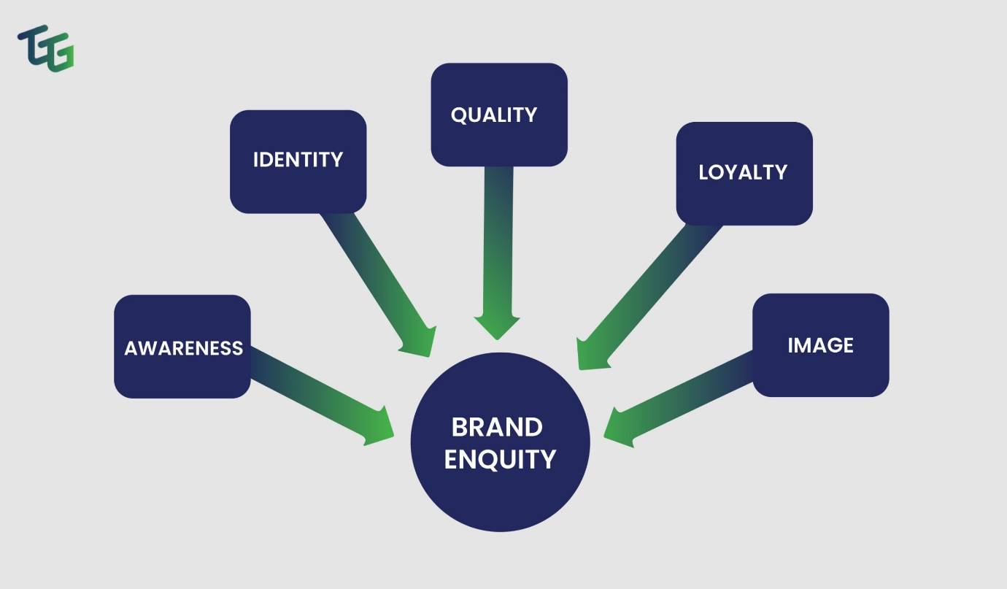
Branding is the organised process of giving a product, service, or business a unique name and public image. It means coming up with a unique set of qualities, meanings, and values that set the brand apart from rivals and appeal to certain groups of people. When it comes to brands, brand equity is the sum of a company's intangible assets plus the value it has gained over time thanks to its branding efforts (Kumar et al., 2021). It shows how important brand loyalty is, how people feel about brands, and how willing people are to pay more for branded goods and services. Microsoft needs to have strong branding and brand value in order to gain and keep a competitive edge in the tech market, which is always changing. Because it has so many software, hardware, and cloud service options, Microsoft has become a worldwide brand name for innovation, dependability, and trustworthiness. This is true for both companies and consumers. Over the years, Microsoft has worked hard to build its brand. This has led to strong customer loyalty and market leadership in many product areas.
Microsoft has used Keller's model of brand equity to learn more about the factors and parts that affect brand equity.
Dimension | Description
Brand Identity | Focuses on establishing a clear and compelling brand identity that reflects Microsoft's core values, mission, and personality. Involves defining visual elements like logo, colors, and typography, as well as messaging and positioning in the market (Kumar et al., 2021). A strong brand identity helps Microsoft communicate its unique value proposition and differentiate from competitors.
Brand Meaning | Explores associations and perceptions consumers have with the Microsoft brand, including functional benefits, emotional appeal, and symbolic meanings. Attributes may include reliability, innovation, and empowerment, resonating with the target audience and driving preference and loyalty.
Brand Response | Examines how consumers respond to the Microsoft brand through attitudes, perceptions, and purchase behavior (Kumar et al., 2021). Measures include brand awareness, image, and consideration, indicating the strength of consumer engagement and affinity. Microsoft's efforts aim to elicit positive responses with consistent messaging, engaging experiences, and superior service.
Brand Resonance | Represents the ultimate level of brand equity, characterized by deep emotional connections and loyalty among consumers. Reflects the extent to which consumers feel attachment, community, and advocacy toward the Microsoft brand. Fostering brand resonance cultivates long-term relationships, drives repeat purchases, and generates positive word-of-mouth.

Customer Journey and Touchpoints
Stage of Customer Journey | Key Touchpoints and Interactions
Awareness | - Online search: Consumers may discover Microsoft products and services through search engines, websites, or social media platforms.
 | - Advertising: Microsoft utilizes various channels such as digital ads, TV commercials, and sponsored content to raise awareness of its offerings.
Interest | - Product demos: Consumers may engage with product demos, videos, or tutorials on Microsoft's website or in-store to learn more about specific products.
 | - Content marketing: Microsoft creates informative blog posts, articles, and videos to educate consumers and pique their interest in relevant topics (Hoeffler and Keller, 2020).
Consideration | - Comparison shopping: Consumers may compare Microsoft's products with competitors' offerings, reading reviews and seeking recommendations from peers.
 | - Free trials: Microsoft offers free trials or demos of its software and services, allowing consumers to experience the products before making a purchase decision.
Purchase | - Online store: Consumers can purchase Microsoft products directly from its website, selecting from various payment options and delivery methods.
 | - Retail stores: Microsoft operates physical retail stores where consumers can explore and purchase products, receiving assistance from knowledgeable staff (Hoeffler and Keller, 2020).
Post-Purchase | - Customer support: Microsoft provides customer support services via phone, email, live chat, and self-service resources to assist with product setup, troubleshooting, etc.
 | - Follow-up communication: Microsoft sends post-purchase emails, surveys, or newsletters to gather feedback, offer additional assistance, and nurture ongoing relationships.
There are several points of contact and exchanges that take place with a client during their whole lifecycle, and Microsoft's customer journey map illustrates all of these moments. This results in a more pleasant experience for the customer and makes them happier overall. It is possible that throughout this time period, people will become aware of Microsoft through the results of web searches or through targeted advertising activities. The purpose of these touchpoints is to attract people's attention and pique their interest in the products and services offered by Microsoft (De Mooij, 2019).
Microsoft provides potential customers with educational content, product demonstrations, and free trials in order to educate and persuade them as they advance from the interest stage to the consideration stage of the acquisition process. By providing customers with helpful information and opportunities to test out Microsoft's products for themselves, the company hopes to earn the trust and trustworthiness of its loyal customer base. When it comes to the purchase stage, there are numerous touchpoints that make it simple for customers to complete their transactions, regardless of whether they are shopping in a store or online. To ensure that the purchasing process goes off without a hitch, these establishments place a high focus on safety, user-friendliness, and customer service (De Mooij, 2019).
Touchpoints after the sale, such as customer service and follow-up emails, are extremely vital for maintaining a pleased customer base and establishing long-term connections with clients. Microsoft provides a wide variety of support services and active outreach initiatives in order to promptly address the needs of its customers, obtain feedback, and promote the company in order to obtain repeat business and word-of-mouth advertising (De Mooij, 2019).
In general, the customer journey map that Microsoft has developed demonstrates a planned method of interacting with consumers across the entirety of their lifespan. This method makes use of a range of touchpoints to deliver consistent and positive experiences that inspire customer loyalty and support.

Total Engagement Model (TEM)
With the assistance of comprehensive models such as the Total Engagement Model (TEM), businesses such as Microsoft are able to establish relationships with their consumers that are both long-lasting and meaningful. TEM places a high importance on fully engaging customers at all points of contact and interactions along the customer journey, in contrast to traditional marketing tactics, which are primarily concerned with transactions (Tuten and Solomon, 2021). The approach takes into account the complexity of the interactions that consumers have, which includes how they behave, how they feel, how they connect with others, and how they think. Through the implementation of TEM, Microsoft will be able to cultivate client loyalty, advocacy, and long-term financial success. Microsoft is a massive technological firm that provides a diverse selection of products and services to its customers.
The fact that TEM has the capacity to improve the overall customer experience is one of the reasons why Microsoft is so enthusiastic about it (Tuten and Solomon, 2021). The reason that Microsoft is able to provide its consumers with experiences that are both engaging and satisfying is that the company places a significant amount of emphasis on engagement across a variety of emotional, cognitive, and behavioural dimensions. In order to maintain its consumers' interest in the firm and to encourage them to remain loyal to it, Microsoft, for instance, had to make an effort to comprehend and fulfil the emotional requirements and objectives of its individual customers. Customers are more likely to trust and remain loyal to Microsoft if the company provides dependable speed, user-friendly design, and good customer service. These are all factors that make it feasible for customers to experience cognitive enjoyment.
Microsoft is able to engage with customers in a variety of different ways because to TEM, which has resulted in an increase in the level of client loyalty that the company enjoys. Customers of Microsoft are more likely to remain loyal to the firm, increase their spending, and spread the word about Microsoft if they are active in the initiatives that their company is working on. A number of strategies that Microsoft can implement in order to transform its consumers into brand ambassadors include putting an emphasis on emotional connections, providing outstanding experiences, and bringing value throughout the entirety of the customer journey (Tuten and Solomon, 2021).
The utilisation of TEM to alter the manner in which customers communicate with and connect with one another is an essential component of Microsoft's advertising activities. Microsoft has the ability to modify its services and interactions by utilising data and insights to gain an understanding of the specific preferences and behaviours of each individual person who uses its services. Through the use of customised product experiences, suggestions, and email advertisements, Microsoft is able to establish a more profound connection with its clients, thereby increasing their level of involvement and loyalty.
Another essential component of TEM deployment is ensuring that the user experience is consistent across all systems and that it is simple to operate those systems. Whether they make a purchase in a physical store or on the internet, Microsoft must ensure that customers have the same experience with the company regardless of the platform they choose to make their purchase. Microsoft's marketing, sales, and customer support teams should collaborate in order to spread the word about the value proposition of the organisation and attract customers (Tuten and Solomon, 2021). This may be accomplished by combining experiences, consistent branding, and clear messaging. It is absolutely essential that these teams work together.
Additionally, TEM emphasises the significance of cultivating relationships with customers and a sense of community in the target audience. Customers of Microsoft are given the opportunity to engage with the firm in meaningful ways, to form connections with one another, and to share their experiences when it is approved to do so. Microsoft has the ability to assist users in advocating for themselves and connecting with one another through the use of user forums, community events, and online groups of users (Evans and McKee, 2019).
The Technology, Engineering, and Management (TEM) strategy, which is built on regular feedback and careful listening, is utilised by Microsoft in order to successfully fulfil the ever-changing demands and needs of its consumers. Microsoft might learn a great deal about the level of satisfaction its consumers have with the company's products and services, identify areas in which improvements are needed, and stimulate continued innovation if it consistently solicited input through a variety of various channels. It is possible for Microsoft to improve its marketing strategy, products, and customer experiences with the assistance of this feedback loop. This will allow the company to better fulfil the requirements of its target audience and to establish trust and interest that will last.

Application in Microsoft
Application in Microsoft | Case Study / Practical Example | Analysis
Communication Model | Microsoft's adoption of the SMCR communication model in its advertising campaigns, such as the "Empowering Possibilities" campaign for Surface devices. | By aligning its messaging with the SMCR model, Microsoft ensures consistent and effective communication, enhancing brand clarity and resonance with consumers (Evans and McKee, 2019). This model allows Microsoft to strategize its communication effectively, ensuring that the message is well-received by the target audience.
Integrated Marketing Communications (IMC) | Microsoft's "Empowering Us All" campaign, integrating digital, social media, and traditional advertising channels (Evans and McKee, 2019). | The campaign's cohesive approach across multiple channels ensures broader reach and engagement, reinforcing Microsoft's brand message and positioning in the market. Through the integration of various marketing channels, Microsoft maximizes the impact of its campaigns, reaching diverse audiences and driving higher levels of engagement and brand awareness.
Brand Equity Model | Application of Keller's brand equity model to measure and manage perceptions of Microsoft's brand identity and meaning. | Through systematic evaluation of brand equity dimensions, Microsoft gains insights into areas for improvement, enabling targeted strategies to strengthen brand perception and loyalty. By understanding the factors contributing to brand equity, Microsoft can implement initiatives to enhance its brand identity and meaning, driving positive brand associations and customer loyalty.
Customer Journey Mapping | Development of customer journey maps for Microsoft's flagship products, such as Windows and Office suites. | Mapping customer journeys enables Microsoft to identify key touchpoints and interactions, optimizing experiences and addressing pain points to enhance overall customer satisfaction. By understanding the customer journey, Microsoft can streamline processes, improve customer interactions, and deliver personalized experiences, thereby increasing customer satisfaction and loyalty.
Total Engagement Model (TEM) | Microsoft's implementation of TEM principles in its customer support and community engagement initiatives. | By focusing on holistic engagement, Microsoft fosters deeper connections with customers, driving loyalty and advocacy through personalized interactions and community building efforts. Microsoft's adoption of TEM principles in customer support ensures that customers receive comprehensive assistance and solutions, leading to enhanced satisfaction and loyalty. Moreover, Microsoft's community engagement initiatives create opportunities for customers to connect with the brand and each other, fostering a sense of belonging and strengthening brand loyalty.

Customer Journey Map:
 | Awareness | Interest | Consideration | Purchase | Post-Purchase
Online search | Discover Microsoft products and services
Advertising | Various channels raise awareness
Product demos |  | Engage with product demos
Content marketing |  | Informative content educates consumers
Comparison shopping |  |  | Compare products and read reviews
Free trials |  |  | Experience free trials
Online store |  |  |  | Purchase products directly from website
Retail stores |  |  |  | Explore and purchase products in physical stores
Customer support |  |  |  |  | Receive support via phone, email, live chat
Follow-up communication |  |  |  |  | Receive post-purchase emails, surveys, etc.

Conclusion
According to the conclusion, Microsoft use the Total Engagement Model as a guide in order to establish engagements with its customers that are robust and remain for an extended period of time. If Microsoft places an emphasis on engagement across a variety of dimensions, including social, emotional, cognitive, and behavioural engagement, it has the ability to improve the customer experience, encourage consumers to become more engaged with the company, and ensure that they continue to remain loyal to the brand. These are all things that can be accomplished by Microsoft. Microsoft could establish long-lasting relationships with its customers and a solid foundation for success in the extremely competitive technology sector by implementing individualised communication strategies, actively participating in a variety of channels, developing communities, and conducting ongoing research and evaluation. These are some of the ways that Microsoft could accomplish these goals. The establishment of communities is another strategy that can be utilised.

References:
Belch, G. E., & Belch, M. A. (2021) 'Advertising and Promotion: An Integrated Marketing Communications Perspective' ,(12th Global Edition),McGraw-Hill Education.
Bughin, J., Hazan, E., Lund, S., Dahlström, P., Wiesinger, A., & Subramaniam, A. (2020) 'How companies in Asia-Pacific can emerge stronger from the COVID-19 crisis', McKinsey and Company.
Chaffey, D., & Ellis-Chadwick, F. (2019) 'Digital Marketing: Strategy, Implementation and Practice', (7th Edition). Pearson Education Limited.
Davenport, T. H., Guha, A., Grewal, D., & Bressgott, T. (2020) 'How to start building your next-generation operating model', McKinsey Quarterly, 1(2020), 1-12.
De Mooij, M. (2019) 'Global Marketing and Advertising: Understanding Cultural Paradoxes', Sage Publications.
De Pelsmacker, P., Geuens, M., & Van den Bergh, J. (2020) 'Marketing Communications: A European Perspective', (7th Edition), Pearson Education Limited.
Dunning, J. H., & Lundan, S. M. (2019), 'Multinational Enterprises and the Global Economy' (Third Edition), Edward Elgar Publishing.
Evans, D., & McKee, J. (2019) 'Social Media Marketing: The Next Generation of Business Engagement', John Wiley and Sons.
Farhoomand, A. F., & Lovelock, C. H. (2020) 'A Tale of Two Airlines: An Integrated Approach to Customer Experience Management'. Journal of Business Strategy, 41(3), 56-64.
Fill, C. (2020) 'Essentials of Marketing Communications', Pearson Education Limited.
Hoeffler, S., & Keller, K. L. (2020) 'Building Brand Equity Through Corporate Social Responsibility', Journal of Marketing Research, 57(1), 109-124.
Jobber, D., & Ellis-Chadwick, F. (2021) 'Principles and Practice of Marketing' (9th Edition). McGraw-Hill Education.
Kotler, P., & Keller, K. L. (2020) 'Marketing Management' (15th Global Edition), Pearson Education Limited.
Kumar, V., Pozza, I. D., & Ganesh, J. (2021) 'A Multifaceted Framework of Customer Engagement: Conceptual Foundation and Research Directions', Journal of Service Research, 24(1), 5-26.
Moran, G., & Rowley, J. (2020) 'Strategic Digital Marketing: Top Digital Experts Share the Formula for Tangible Returns on Your Marketing Investment', Kogan Page Publishers.
Ryan, D., & Jones, C. (2020). 'Understanding Digital Marketing: Marketing Strategies for Engaging the Digital Generation', Kogan Page Publishers.
Smith, P. R., & Zook, Z. (2021). 'Marketing Communications: Integrating Offline and Online with Social Media'. Routledge.
Tuten, T. L., & Solomon, M. R. (2021) 'Social Media Marketing' (Third Edition). Sage Publications.
Verhoef, P. C., Reinartz, W. J., & Krafft, M. (2020) 'Customer Engagement as a New Perspective in Customer Management', Journal of Service Research, 23(1), 15-27.

