University of Wales Trinity Saint David
Rhian Gould
P151179
BA Surface Pattern
Creative Research M5X01599

Define the skill in the context of your own practice and the work of two designers.

Glory of the latest catwalk shows belongs to the designers, whether it be a collection of intricate, classic or simplistic designs. But, absorbed in this glory is the unmentioned skill of pattern cutting, which plays a crucial role in making these clothes in to fine masterpieces. A pattern is used to create a lot that we see surrounding us from crafts to what we wear in our daily lives. As pattern cutting is not only a process in garment making, but is also used for the templates of soft furnishings. Therefore,
it is the hidden skills that underpin the outer look of such clothing and objects.
To begin the essay, I shall be talking about the process of pattern making of how to create the pattern shapes from three certain techniques along with the skills needed to create patterns. I shall also be looking at two fashion designers showing the new and the traditional pattern shapes used for their collections and comparing them to each other. I shall be using many different books to do with the two designers I have chosen and websites that will help with understanding the role of a pattern cutting and the skills needed.
“Pattern cutters act as a link between the design and manufacturing stages, translating the 2D sketch into the 3D plan for the garment” (Grade House, 2013). Patterns are used to cut the right shapes for the garment. The process of being a pattern cutter will be to work with the designer to research and look at many unique designs drawn by the designer, to create the perfect template to cut out the final garment shape; this will be made from paper or card. According to Natalie Bray (1980:1) the patterns will be planned against various fabrics which will have different practical purposes to consider; the figure, look of the posture, the size and shape of the person. Fabric, the texture of the fabric, the width measurement of the fabric and most importantly the weight. The weight of the fabric could change the whole look of the patterns cut out and created in to a garment, therefore the designer would have to consider what patterns will hold structure when cut out on certain fabrics. The templates are the most important part of creating a garment, the hard material acts as a model for everyone to copy, a guide to help the person step by step through the process. Without a template the finished garment or furnishing will not be accurate in measurement and shape. The pattern cutter will have to decide on the thickness of card to use depending on the structure of the garment or how complex the template will be. However, pattern cutting can be mistaken for textile patterns onto garments (Grade House, 2013) which in fact pattern cutting is just the template pieces to creating a garment. Creating a pattern is crucial for being a designer especially in the fashion industry when approaching manufactures you will not be able to show them just a sketch of your design (Grade House, 2013). As Alexander McQueen stated, “You’ve got to know the rules to break them. That’s what I’m here for, to demolish the rules but to keep the tradition.” Alexander McQueen is trying to emphasise, being a pattern cutter/fashion designer, you need to know the basics of pattern cutting to manipulate templates, creating new fresh garments. Therefore, intricate garment shapes today are developed by the simple and elaborate basic patterns to begin off with. As designers will need the basic knowledge of tailor-cutting with the special qualities achieved from this traditional and classic method to be able to create new patterns. Natalie Bray (1980:1).
To be a pattern cutter you will need skills in certain fields such as understanding a designer’s drawings who you’ll work closely with during the process of creating the patterns and the garment technologists. The designs must be understandable and comprehendible for the pattern cutter to understand too. An understanding of how to alter a basic pattern shape into a more stylish approach, through looking at latest trends every season for inspiration. With the knowledge of good judgement, fashion sense and taste, Natalie Bray (1980:1). To be able to work well as a team, communication skills are necessary to work as a group, especially with the manufacturers to create sample garments. You will need mathematical skills which are crucial for calculating and measuring out the templates correctly to ensure the proportion and detail of the garment comes out precise and the final garment made from the templates fit well to the client. Technical drawing skills are a must whether it’s drawing by hand or using a computer as the patterns will be hand drawn or computer-aided. This is a necessity for other designers and pattern cutters to read. Good concentration levels go hand in hand with the precision of the template to create an accurate layout on the card/paper. Good concentration levels also help to reduce the companies waste and save money, by making sure the pattern shapes are closely put together when being manufactured.
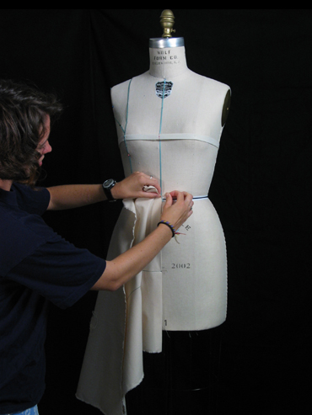
There are three different techniques when creating patterns. The first technique is called draped this process is manually done using a mannequin to drape the fabric over it till they fit and to transfer it onto paper and adapting the shape (Grade House, 2014) as demonstrated in the picture on the left (Cornell University, 2008). Draping can be carried out using calico or muslin or this process can be done using the final fabric (The Cutting Class, 2014) depending on how confident the designer is using the technique. This technique allows you to mock up various ideas on designs onto the mannequin, allowing you to experiment creating different silhouettes (The Cutting Class, 2014). By using this process, you can move on quick in changing various looks of the garment without making sure you’re keeping on track with the changes you’re making. It’s important to make sure that you take sketches of your design, photographs or notes (The Cutting Class, 2014) as you might want to return to an idea earlier on in the process of changing the garment. It will also be helpful to take note of what position the grain line is in as this could have an overall effect on the finished garment due to stretches or the way the fabric will mould to the body shape. By draping the fabric on the mannequin, you are also able to see how the fabric will change due to gravity as this will help with deciding on the right fabric to use. This is another advantage of using draping over flat pattern as it can be harder to picture how the fabric will fall on an area of the garment using the flat pattern technique, (The Cutting Class, 2014). The disadvantage to this technique is that your end designs come out looking quite generic to other garments and as a designer/pattern cutter you want to stand out and create new fresh designs. To achieve a more unique looking garment you could manipulate the shape first by using the flat pattern process and then to drape it over the mannequin as you will come across more unusual shapes by mixing the two processes together, (The Cutting Class, 2014). The pattern cutter/designer will also have to take in consideration when creating the garment to be aware of how the client will be able to fasten it up. The designer must consider where the zip or buttons are located on the garment but also making sure the armholes are visible for the wearer to get in to (The Cutting Class, 2014).
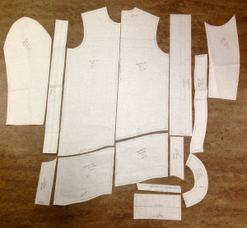
The next process of creating patterns is called flat pattern cutting, this is a more precise method and faster than draping (Pamela_P, 2017). For this method you need a basic pattern block which are simple templates of garment shapes that are used as a stencil to develop unique styles as shown in the image (Louisa, 2014). On the pattern blocks they have features marked out onto them, the bust point, hip line placement, waistline and armhole placement, (Pamela_P, 2017). To help the designer/pattern cutter as a guide to when changing the pattern shape and when creating the garment. From these blocks you can change the hemlines, widen certain areas of the garment such as the trouser leg or arm sleeve, also to manipulate dart points and add design lines, to change the look of the garment when finally made (Pamela_P, 2017). By using this method your overall design will be accurate, as the pattern block is the secret behind flat pattern cutting and will guide the designer/pattern cutter to create unusual patterns from the stencil traced on high quality pattern cutting paper. The advantage of this technique using a block pattern, the fabric waste is greatly reduced therefore saving the designer money. These offcuts are often used as spare fabric in case more material is required for the garment.
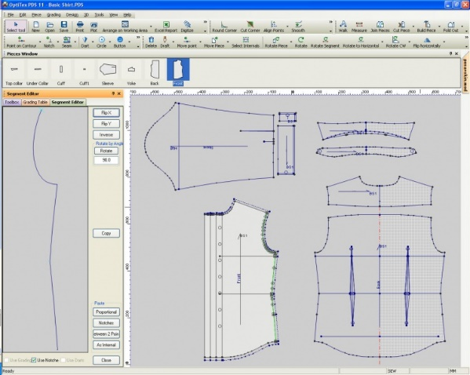
The final process in pattern cutting is called digital pattern cutting, also known as CAD or Gerber methods (Pamela_P, 2017). This method is very similar to the flat creative pattern cutting, the designer/pattern cutter would have to take the measurements from the final garment design and the measurements will be put in to the computer (Pamela_P, 2017) as shown in the picture on the left (Bullmer, n.d.). Using this technique, you’ll be able to create your own blocks of pattern and distinctive styles, and to re-create new pattern blocks from the basic shapes. From this method your outcome of the garment will fit the client perfectly, down to the accuracy of the measurements and the simulation for folds and darts to add onto the pattern to give the garment shape when worn by the client, (Pamela_P, 2017). However as this is a creative field it would benefit the pattern cutter/designer to learn how to do pattern cutting by hand, this will improve your design ideas of unique garment shapes (Pamela_P, 2017). To also have a good eye for the aesthetic look of the garment and to build the skill in scaling up sizes and placing of different details onto the garment, (Pamela_P, 2017).
“I think some people would love to be able to make the clothes I make - and of course, I do influence them, but they keep simplifying, and minimalism doesn't quite work” is a quote by Vivienne Westwood (Brainy Quote, 2014), explaining that through her experience in pattern cutting/designing, that this generation of designers use her as inspiration in creating their own garments. But, designers of today do not have the same experience in creating quirky pattern shapes therefore their collections are simple and basic.
Linda Watson (2013:121)

As shown in the photo, Vivienne Westwood creates unusual pattern cuts from her Autumn/Winter 2007/8 collection called “Wake up, cave girl!” inspired by the stone age Linda Watson (2013:120). This is a tailored style garment which unusually has no seams as the pattern cuts are held together by buttons Linda Watson (2013:120). From looking at the garment, it seems like the structure has been influenced by a more traditional look, fused with her own twist. The traditional look of the garment has been chopped to be recreated into a similar style to the original garment with Vivienne Westwood’s experience of pattern cutting. As she’s known to break the rules of pattern cutting to create daring looks to wear.

(Chanel, 2017)
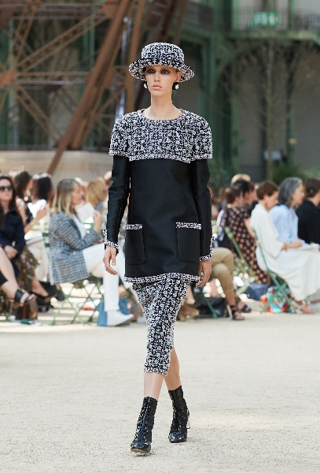
“Simplicity is the key for elegance” (Goodreads, 2017) is a quote by Coco Chanel. Chanel emphasises that complexity isn’t always needed in garments as simplicity is appreciated in the fashion industry. Whereby creating simple, traditional pattern shapes brings as much elegance to a garment as Vivienne Westwood’s more intricate designs.
(Chanel, 2017)
Chanel’s essence of style was derived from a masculine model of power. This is a direction that a lot of designers have followed and has dominated the late 20th century fashion, (Buttolph, 1998:98). Chanel worked directly off her mannequin, so she was sure that the fabric would sit correctly on the wearer, (Millbank, 1989:122). Chanel made sure all her work was perfect by removing and remaking until they were a perfect fit. The basic ideas for her garments came from the design of military uniforms such as this example in her latest collection, Haute Couture. This is a very formal and masculine look created with simple pattern shapes.

From garment cutting, it’s essential that designers are required to recognize a good fit and to be trained to visualize the fit of the garment on a figure taking in the shape of the body whilst working in flat pattern making, (Bray, 1974:1). The skill of pattern cutting is slowly becoming a dying process as everything is being made by computer and students of today are not being shown the traditional method of pattern cutting.

References

House, G. (2013). What is pattern cutting? | Pattern Grading London UK. [online] Gradehouse.co.uk. Available at: http://www.gradehouse.co.uk/what-is-pattern-cutting/ [Accessed 8 Dec. 2017].
Vam.ac.uk. (2016). Alexander McQueen: Savage Beauty - About the Exhibition - Victoria and Albert Museum. [online] Available at: http://www.vam.ac.uk/content/exhibitions/exhibition-alexander-mcqueen-savage-beauty/about-the-exhibition [Accessed 9 Dec. 2017].
The Cutting Class. (2014). Draping and Moulage - The Cutting Class. [online] Available at: http://www.thecuttingclass.com/draping-and-moulage/ [Accessed 9 Dec. 2017].
P, P. (2017). The Importance of Pattern Cutting in Creating Collections - Pamela_P. [online] Pamela_P. Available at: http://pamela-p.com/the-importance-of-pattern-cutting-in-creating-collections/ [Accessed 8 Dec. 2017].
BrainyQuote. (2017). Vivienne Westwood Quotes. [online] Available at: https://www.brainyquote.com/quotes/vivienne_westwood_296209 [Accessed 9 Dec. 2017].
Louisa, E. (2014). Flat Pattern Cutting. [image] Available at: https://emilybeblog.wordpress.com/ [Accessed 14 Dec. 2017].
Cornell University (2008). Draping The Human Form. [image] Available at: https://fit.cit.cornell.edu/textiles/draping/drapes/flaredskir/steps/drapingpro/default.html [Accessed 14 Dec. 2017].
Assyst Bullmer (n.d.). Pattern Design. [image] Available at: http://assystbullmer.co.uk/industries/clothing/pattern-design/ [Accessed 14 Dec. 2017].
Goodreads.com. (2017). Coco Chanel Quotes (Author of The Gospel According to Coco Chanel) (page 3 of 4). [online] Available at: https://www.goodreads.com/author/quotes/3004479.Coco_Chanel?page=3 [Accessed 10 Dec. 2017].
image: Chanel.com. (2017). CHANEL - Fall-Winter 2017/18 Haute Couture - Look 46. [online] Available at: http://www.chanel.com/en_GB/fashion/haute-couture/the-looks/look-n46.html [Accessed 10 Dec. 2017].
Bray, N. (1974). Dress pattern designing. 4th ed. Oxford: Blackwell Science, p.1.
Bray, N. (1970). Metric supplement to Dress pattern designing ; More dress pattern designing. 3rd ed. London: Crosby Lockwood, p.1.
Watson, L. (2013). Vogue on : Vivienne Westwood. London: Quadrille, p.120.
Buttolph, A. (2017). The fashion book. London: Phaidon, p.98.
Milbank, C. (1985). Couture, the great designers. New York: Stewart, Tabori & Chang, p.122.

