Student name: Constantin Acatrinei
Student ID number: 1816245
Programme: BA Dip CertHE International Gastronomy Management
Module code: BMGM4003
Lecturer: Antoinette Milne
Assignment title: Customer Experience and Service Skills
Submission deadline: March 25, 2024
Word count: 1650

In the ever-changing world of the hospitality industry, ensuring customer satisfaction is crucial for achieving success (Collins, 2023). Meeting and surpassing customer expectations is crucial for businesses to thrive and maintain a strong reputation. This portfolio explores the diverse world of customer service within the culinary and hospitality industries, examining the crucial skills, strategies, and principles that contribute to outstanding service delivery. By referencing well-known authors and drawing from personal experiences, this compilation seeks to explore the importance of customer satisfaction, the complexities of service-oriented professions, and the ways to continuously grow and develop in these fields.
Organisations are highly focused on meeting the needs and expectations of their valued patrons in order to ensure customer satisfaction (Collins, 2023). Thus, meeting the needs and expectations of customers is crucial for a company's success (Coursera Staff, 2023).
Developing excellent customer service skills is essential for creating positive interactions between businesses and their customers. With the focus on customer experience, individuals in various industries in the United Kingdom need to have a solid understanding of these skills (Mastering Customer Service Skills, 2024).
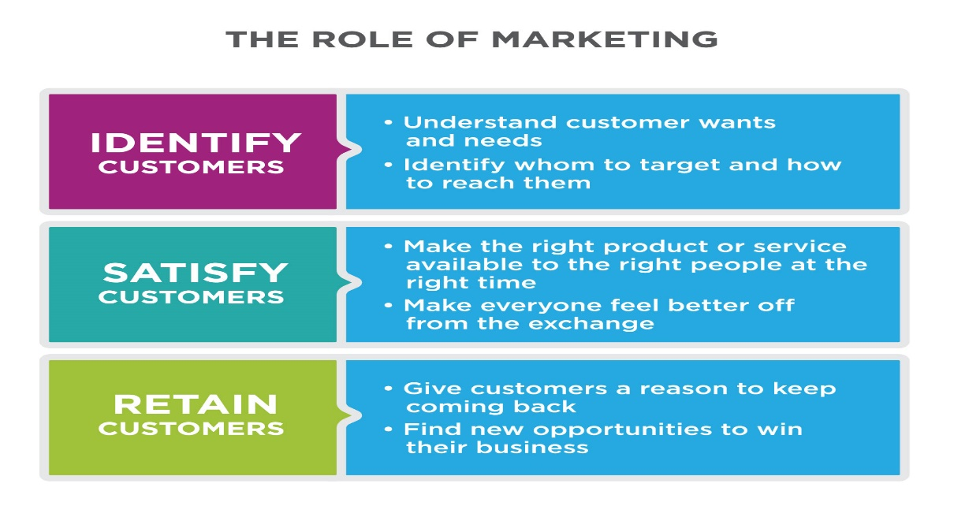
This Photo by Unknown Author is licensed under CC BY

Having strong customer service skills is essential for effectively meeting the needs and desires of customers. These skills extend beyond basic transactions and prioritise developing relationships, guaranteeing customer contentment, and boosting the overall prosperity of an organisation (Mastering Customer Service Skills, 2024).
Ensuring customer satisfaction is vital for the prosperity of any business. When people are satisfied, they believe that the product or service they received has adequately fulfilled their needs and expectations, providing them with good value for their money. Satisfied customers are more likely to become loyal patrons, consistently choosing the same business and sharing positive recommendations with others (Customer Alliance, 2024).
Ensuring customer satisfaction is not only essential for enhancing the organization's reputation but also vital for its overall success (Customer Alliance, 2024).
The excerpt from Cousins, Lillicrap, and Weekes (2019) offers a thorough set of guidelines for maintaining professionalism and cultivating essential qualities in the food and beverage service industry. The organisation places a strong emphasis on the appearance, knowledge, punctuality, personality, and cultural awareness of its staff members. These qualities are crucial for upholding exceptional service standards and guaranteeing customer contentment.

Throughout my culinary training and work experiences, I have honed a diverse set of customer service skills that are vital in the food service industry. It is crucial to possess certain skills such as strong communication abilities, empathy, problem-solving skills, and a keen eye for detail (Wood, 2015). Throughout periods of high activity, I have successfully managed customer inquiries and complaints, fostering a welcoming atmosphere (Brown, 2019). Challenges have arisen when it comes to providing outstanding customer service, particularly in high-pressure situations. However, I have developed the skill to remain calm and collected, prioritising customer satisfaction above all else (Walker, 2013).

Understanding the significance of customer service in the culinary industry has been essential, as it directly impacts the experiences of guests and the reputation of the establishment (Johnston & Clark,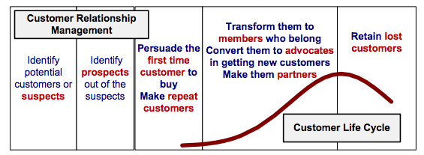2012). When there is minimal distinction between your product and that of your competitor, the quality of service you offer becomes vital (Wood, 2013).
This Photo by Unknown Author is licensed under CC BY-SA
The mindset plays a crucial role in this matter, as even small actions can have a significant impact on customer satisfaction (Wood, 2013). Appreciating and leveraging the abilities of exceptional employees can establish a foundation for attracting new team members, ensuring a superior level of service excellence (Walker, 2013). To maintain our high standards, it is essential that employees undergo thorough training on store policies (Fanthorne, 2004). It is crucial for individuals in the workforce to observe and adopt the behaviour demonstrated by their superiors, as it sets a valuable example (Johnston & Clark, 2012). Implementing clear policies, such as engaging with customers, avoiding gossip, and providing prompt assistance, contributes to creating a customer-centric culture (Walker, 2013). The importance of promptly greeting customers is emphasised by the "10-foot rule," while policies like mandatory carryout for three sacks ensure proactive assistance (Wood, 2013).

Customising services to meet individual needs can significantly enhance the overall customer experience (Vázquez, 2014). Individuals with a service-oriented mindset exhibit qualities such as a positive attitude, a sincere enjoyment of working with others, and a commitment to putting the client's needs first (Walsh, Chang, & Tse, 2015).
Customer feedback management is the process of integrating customer feedback into an organization's strategy and operational procedures (Stewart & QuestBack, 2016). It involves systematically gathering feedback from customers, analysing the collected information, and organising distinct activities for sharing and follow-up. This practice is a crucial component of mainstream market intelligence, enabling companies to tackle customer service problems following instances of dissatisfaction (McCollough, Berry & Yadav, 2000).

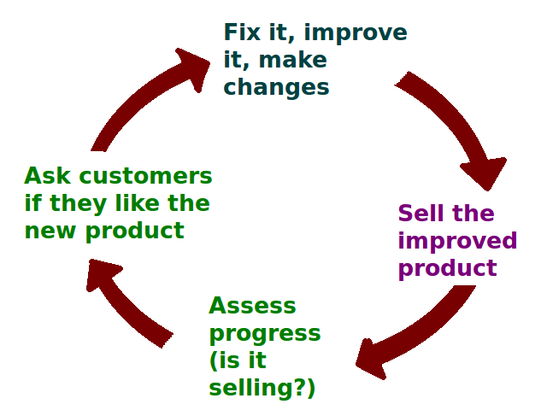
This Photo by Unknown Author is licensed under CC BY-SA
To establish an efficient feedback management system, it is crucial to have a comprehensive grasp of company objectives, foster a collective sense of accountability within the team, present data in a transparent manner, ensure competent IT management, encourage open communication regarding customer complaints, seamlessly integrate and execute policies, and consistently evaluate the feedback process to enhance customer service (Eiriksdottir & Thorarensen, 2012; Goodman, 2019).
Chloe (2023) is convinced that food possesses an extraordinary power to bring together individuals from diverse cultures and foster a sense of inclusiveness. It serves as a common thread that unites people from all walks of life. Sharing meals can be a wonderful way to experience different cultures and develop a greater appreciation for diverse culinary traditions. It offers a one-of-a-kind chance to gain perspective on various values and beliefs. Exploring various cuisines can contribute to breaking down stereotypes and promoting connections between cultures, fostering a sense of belonging, unity, and community. Embracing diversity in the culinary world involves celebrating a variety of cuisines, accommodating various dietary needs, and acknowledging the valuable contributions of people from all walks of life. Food can play a significant role in driving social change, empowering communities that have been marginalised and promoting a deeper understanding of different cultures. In the end, by recognising the cultural importance of food, we can promote inclusiveness and enhance global relationships.
In today's fast-paced world, it is crucial to meet customer expectations for prompt responses and effective issue resolution. Furthermore, customers highly value the sense of being appreciated during their interactions. The importance of customer service has become crucial for service businesses, necessitating them to meticulously create, provide, evaluate, and measure the effects of outstanding service experiences (Khan, 2011). Organisations must meticulously handle all aspects of the service encounter to ensure customer satisfaction. The perception of a company by its customers has a direct impact on the reputation it develops online, as seen through reviews and word of mouth ("The Power of Customer Feedback for Business Growth," 2023).
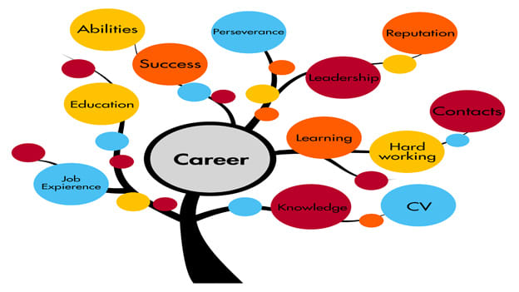
This Photo by Unknown Author is licensed under CC BY-SA-NC
Throughout my time in the culinary industry, I've had the opportunity to interact with a wide range of customers, each with their own distinct preferences and expectations. Dealing with various challenges has required managing dietary restrictions and addressing service delays (Cousins, Lillicrap, & Weekes, 2019). Working together with other students has been crucial in overcoming these challenges and cultivating a mindset of collaboration to consistently provide exceptional service (Solomon, 2018). Receiving feedback from guests, regardless of its nature, has proven to be incredibly helpful in honing my customer service skills (Lucas, 2015). Receiving feedback, whether it is constructive or positive, has played a crucial role in promoting self-reflection and personal growth (McCollough, Berry & Yadav, 2000). It has also given me valuable reinforcement for effective strategies. Being receptive to helpful feedback and promptly implementing changes has been shown to greatly improve the level of service, as evidenced by various studies (Shyju et al., 2023).
Having a strong support system is crucial when navigating difficult situations. It is invaluable to have a group of dependable individuals who can provide motivation, guidance, and assistance with practical matters (Njobe, 2024).

Developing meaningful connections with loved ones, peers, coworkers, and mentors who provide steadfast encouragement and understanding is essential (Muthoni, 2023). Equally important is nurturing meaningful partnerships. When faced with challenges, it is crucial to seek support from peers. They can provide comfort, guidance, and fresh perspectives (Parasuraman, Zeithaml & Berry, 1985).
Additionally, it might be beneficial to explore support groups or communities comprised of individuals who have faced similar challenges to the ones you are currently facing. These venues can provide a sense of understanding, validation, and practical strategies for navigating difficult circumstances. Developing a strong support system of friends and loved ones can greatly enhance your resilience and problem-solving skills (Njobe, 2024).
One must possess a considerable amount of patience, unwavering determination, and a genuine willingness to adapt to new circumstances in order to embark on a journey of self-discovery and personal growth (Today, 2023). As per eSoft Skills (2024), regular self-reflection is crucial for personal growth and progress. By engaging in this process, individuals can develop a deeper understanding of themselves, recognising both their strengths and weaknesses, and gaining insight into their own motivations and goals. As Muthoni (2023) suggests, adopting a growth mindset is crucial when faced with change as it allows individuals to turn challenges into chances for growth. As per therapist Israa Nasir, "Change has the power to awaken our dormant dreams and inspire us to imagine a whole new world" (Muthoni, 2023). This is an example of how embracing a more positive outlook towards change can result in a healthier mindset.
As Perry (2023) explains, goal setting involves clearly defining an objective and creating specific and measurable targets to work towards. Reflecting on my time during the placement, there were certain moments that truly stood out and presented significant challenges. Adapting to high-speed work environments and efficiently managing numerous tasks has proven to be quite demanding, yet incredibly rewarding. I have experienced personal growth due to the challenges I have faced, which have allowed me to cultivate qualities like resilience and adaptability, crucial traits in the culinary field. I plan to utilise these valuable experiences in the future to accomplish my career goals. I am eager to enhance my skills in the culinary arts and showcase my leadership and creative abilities along the way. In order to advance in my career, it is crucial for me to adopt a mindset that values continuous growth and improvement. This involves staying open to new ideas and constantly seeking opportunities for development (Kolb, 2014; Gibbs, 1988; Dweck, 2006).

This Photo by Unknown Author is licensed under CC BY
After delving into this portfolio, it becomes clear just how important it is to prioritise customer satisfaction in the fields of hospitality and culinary (Collins, 2023). Mastering the art of exceptional customer service and navigating challenges with resilience and adaptability are essential for delivering top-notch service. It requires a holistic approach that blends technical expertise with strong interpersonal skills (Walker, 2013). By continuously seeking knowledge, fostering meaningful connections, and prioritising the well-being of others, individuals can thrive in their professional endeavours and contribute to the success of their organisations (Tesone, 2014). As we adapt to the dynamic world of customer expectations and industry standards, let us remain committed to delivering exceptional service and crafting memorable experiences for all our customers (Coursera Staff, 2023).

References
Brown, D. R. (2019). The Restaurant Manager's Handbook: How to Set Up, Operate, and Manage a Financially Successful Food Service Operation (5th ed.). Atlantic Publishing Group Inc.

Collins. (2023). UNIT 4 4 Principles of customer service. [PDF document, Collins]. Retrieved from https://resources.collins.co.uk/free/173538BTECBusinessU4.pdf

Coursera Staff. (2023, November 29). Good customer service: Definition, examples, and tips. [Article, Coursera]. Retrieved from https://www.coursera.org/articles/customer-service

Customer Alliance. (2024). Why customer satisfaction is important: A guide for businesses. [Article, Customer Alliance]. Retrieved from https://www.customer-alliance.com/en/resources/article/the-importance-of-customer-satisfaction-guide-for-businesses/

Domínguez, G., & Herrera, A. F. (2020). Learning framework for the development of key skills in the hospitality industry. School of Tourism and Hospitality Management Sant Ignasi, Universitat Ramon Llull, Spain. DOI: https://doi.org/10.31559/IJHTS2020.1.2.6

eSoft Skills. (2024). The Importance of Self-Reflection for Personal Growth. Retrieved from https://esoftskills.com/importance-self-reflection-growth/#:~:text=Self-reflection%20promotes%20selfawareness%2C%20which%20is%20crucial%20for%20personal,make%20conscious%20choices%20and%20improve%20your%20decision-making%20skills.

Fanthorne, C. (2004). Work Placements: Survival Guide for Students. Macmillan.

Improving the Customer Service Experience. (2021, September 17). Harvard Business Review. Retrieved from https://hbr.org/sponsored/2021/09/improving-the-customer-service-experience.

Johnston, R., & Clark, G. (2005). Service Operations Management: Improving Service Delivery. Pearson Education.

Kansas State University. (n.d.). Golden rules of customer service. [PDF document, Kansas State University]. Retrieved from https://www.kstate.edu/cecd/docs/pdfs/Session%201-%20Option%203%201.pdf

Kolb, D. A. (2014). Experiential Learning: Experience as the Source of Learning and Development. FT Press.

Lucas, R. W. (2015). Customer Service: Skills for Success. McGraw-Hill.

Mastering Customer Service Skills. (2024, January 19). Retrieved from https://uk.jobsora.com/blog/customer-service-skills

McCollough, M., Berry, L., & Yadav, M. (2000). A conceptual model of service quality and its implications for future research. Journal of Marketing, 49(4), 41-50.

Muthoni, J. (2023, August 24). Embracing Change: A Guide to Personal Growth and Well-being.

Njobe, L. (2024, February 23). Thriving Amidst Challenges: Cultivating Resilience in the Face of Adversity. Retrieved from https://www.linkedin.com/pulse/thriving-amidst-challenges-cultivating-resilience-face-lithemba-njobe-xda0f

Parasuraman, A., Zeithaml, V. A., & Berry, L. L. (1985). A conceptual model of service quality and its implications for future research. Journal of Marketing, 49(4), 41-50.

Perry, E. (2023, May 8). 10 tips to set goals and achieve them. Retrieved from https://www.betterup.com/blog/how-to-set-goals-and-achieve-them#:~:text=Personal%20goal-setting%20tips%201%201.%20Consider%20your%20passions,achieve%20it.%20...%203%203.%20Imagine%20your%20future

Shyju P.J., Kunwar Singh, Jithendran Kokkranikal, Rahul Bharadwaj, Somesh Rai & Jiju Antony (2023). Service Quality and Customer Satisfaction in Hospitality, Leisure, Sport and Tourism: An Assessment of Research in Web of Science. Journal of Quality Assurance in Hospitality & Tourism, 24(1), 24-50. DOI: 10.1080/1528008X.2021.2012735

The Power of Customer Feedback for Business Growth. (2023). Retrieved from https://www.3chambers.co.uk/post/the-power-of-customer-feedback-for-business-growth#:~:text=Here%20are%20some%20tips%20on%20how%20to%20do,it.%20...%203%203.%20Communicate%20Changes%20to%20Customers

Today, A. (2023, February 2). The Journey to Self-Discovery and Personal Transformation: Exploring Inner Growth and Mindset Changes. ILLUMINATION. Retrieved from https://medium.com/illumination/the-journey-to-self-discovery-and-personal-transformation-exploring-inner-growth-and-mindset-c74729d1147b

Zeithaml, V. A., Bitner, M. J., & Gremler, D. D. (2006). Services Marketing: Integrating Customer Focus Across the Firm. McGraw-Hill.

