

LEVEL 5 ASSESSMENT SPECIFICATION

Module: | Business Inquiry & Research
Module code: | BMSP5007 | Contribution to Overall Module Assessment (%): | 30%
Lecturer: | Dr Alex Bell | Internal Verifier: | Dr Roisin Mullins
Assignment Title: | Assessment 2: Quantitative Study | Word count (or equivalent): | 1500
Submission deadline: | April 22th, 2020 | Return date of provisional marks & written feedback: | 20/05/2020
Submission method: | All written assessments, where practical and possible, must be submitted via Turnitin unless otherwise instructed by the Lecturer. (Please DO NOT put this assessment specification into Turnitin or it will match many similarities with other students’ submissions.)  Alternative submission method (if applicable):  Late submission of the assessment will result in a late penalty mark. Penalties for late submission: Up to one week late, maximum mark of 40%. Over one week late, 0%. Only the Extenuating Circumstances Panel may approve a change to submission dates.
Academic honesty / referencing: | Academic honesty is required. In the main body of your submission you must give credit to authors on whose research and ideas your work is based. Append to your submission a reference list that indicates the books, articles, etc. that you have used, cited or quoted in order to complete this assessment.

TASK DESCRIPTION

Coursework: Presentation of Quantitative Findings and Critical Reflection (1500 words)

A personally selected small-scale exercise in quantitative data collection and analysis

GUIDANCE FOR Students IN THE COMPLETION OF TASKS

Structural Layout Guide
For Assessment 2 (1500 words +/- 10%)
(Note this is only for guidance)

Name:

Student number:

Programme of Study:

Module: Business Inquiry and Research

Tutor: Dr Alex Bell

Date:

Introduction
This report presents the study of …. [study title, a few sentences about the study background, reason for choosing this study area, data collection methods (e.g. survey), participant selection and population, sampling justification, analysis approach (e.g. cross-tabulation / correlation). In this section you should just have1/2/3 references to good relevant literature in relation to the study background and the quantitative research approach and techniques.

Procedure
Introduction to the Quantitative approach: nature, characteristic principles practices.
Description of Data Collection procedures carried in detail (survey design decisions etc.)
Description of Data analysis method in detail
(In this section you should have 2/3 references to the quantitative research literature and perhaps something on the data collection method (e.g. survey design) and SPSS

Data Presentation and Findings
In this section you should present your data (not in raw form but in tables, charts etc. with interpretation)
How you present this is up to you: e.g. either table, chart or both.

It’s important that your provide your interpretation that you have drawn from the data.
(References are less likely in this section)

Conclusion/Reflection
Reflection on the procedures identifying strengths and weakness to your data collection and/or data analysis. Suggestions what you would do differently if undertaking the study again next time.
(References to quantitative methods research that underpin the suggestions you make)

References:
(Harvard / APA style)

Note: You can use any styling you see as fit for purpose. But structure, grammar, spelling, page numbers, labelling and appropriate referencing technique are the basic criteria.

Assessment Criteria

NOTE: The guidance offered below is linked to the five generic assessment criteria that follow in the table.

Engagement with Literature Skills
Your work must be informed and supported by scholarly material that is relevant to and focused on the task(s) set. You should provide evidence that you have accessed an appropriate range of sources, which may be academic, governmental and industrial; these sources may include academic journal articles, textbooks, current news articles, organisational documents, and websites. You should consider the credibility of your sources; academic journals are normally highly credible sources while websites require careful consideration/selection and should be used sparingly. Any sources you use should be current and up-to-date, mostly published within the last five years or so, though seminal/important works in the field may be older. You must provide evidence of your research/own reading throughout your work, using a suitable referencing system, including in-text citations in the main body of your work and a reference list at the end of your work.

Guidance specific to this assessment:

Knowledge and Understanding Skills
At level 5, you should be able to demonstrate: sound knowledge and critical understanding of the well-established concepts and principles of the subject area and the way in which those principles have developed; knowledge of the main methods of enquiry in the discipline. Knowledge relates to the facts, information and skills you have acquired through your learning. You demonstrate your understanding by interpreting the meaning of the facts and information (knowledge). This means that you need to select and include in your work the concepts, techniques, models, theories, etc. appropriate to the task(s) set. You should be able to explain the theories, concepts, etc. meaningfully to show your understanding. Your mark/grade will also depend upon the extent to which you demonstrate your knowledge and understanding.

Guidance specific to this assessment:

Cognitive and Intellectual Skills
You should be able to critically analyse information, and propose solutions to problems arising from that analysis, including the critical evaluation of the appropriateness of different approaches to solving problems. Your work must contain evidence of logical, analytical thinking, evaluation and synthesis. For example, to examine and break information down into parts, make inferences, compile, compare and contrast information. This means not just describing what! But also justifying: Why? How? When? Who? Where? At what cost? At all times, you must provide justification/evidence for your arguments and judgements. Evidence that you have reflected upon the ideas of others within the subject area is crucial to you providing a reasoned and informed debate within your work. Furthermore, you should provide evidence that you are able to make sound judgements and convincing arguments using data and concepts, with an understanding of the limits of knowledge, and how this influences analyses and interpretations. Sound, valid conclusions are necessary and must be derived from the content of your work. Where relevant, alternative solutions and recommendations may be proposed.

Guidance specific to this assessment:

Practical Skills
At level 5, you should be able to use/deploy a range of established techniques within the discipline, and apply underlying concepts and principles outside the context in which they were first studied, including, where appropriate, the application of those principles in an employment context. You should be able to demonstrate how the subject-related concepts and ideas relate to real world situations and/or a particular context. How do they work in practice? You will deploy models, methods, techniques, and/or theories, in that context, to assess current situations, perhaps to formulate plans or solutions to solve problems, or to create artefacts, some of which may be creative. This is likely to involve, for instance, the use of real world artefacts, examples and cases, the application of a model within an organisation and/or benchmarking one theory or organisation against others based on stated criteria. You should show awareness of the limitations of concepts and theories when applied in particular contexts.

Guidance specific to this assessment:

Transferable Skills for Life and Professional Practice
Your work must provide evidence of the qualities and transferable skills necessary for employment requiring the exercise of personal responsibility and decision-making. This includes demonstrating: professional development to advance existing skills and acquire new competences that will enable you to assume significant responsibility within organisations; that you can initiate and complete tasks and procedures, whether individually and/or collaboratively; that you can use appropriate media to effectively communicate information, arguments and analysis in a variety of forms to specialist and non-specialist audiences; fluency of expression; clarity and effectiveness in presentation and organisation. Work should be coherent and well-structured in presentation and organisation.

Guidance specific to this assessment:

Student FEEDBACK FORM

This section details the extent to which the assessment criteria are demonstrated by you, which in turn determines your mark. The marks available for each category of skill are shown. Lecturers will use the space provided to comment on the achievement of the task(s), including those areas in which you have performed well and areas that would benefit from development/improvement.

Generic Assessment Criteria | Marks available | Marks  awarded
1. Engagement with Literature Skills  . | 10
2. Knowledge and Understanding Skills | 20
3. Cognitive and Intellectual Skills | 20
4. Practical Application Skills | 40
5. Transferable Skills for Life and Professional Practice | 10

Assessment Mark (Assessment marks are subject to ratification at the Exam Board. These comments and marks are to give feedback on module work and are for guidance only until they are confirmed. ) | Late Submission Penalties (tick if appropriate) |  | %
 | Up to 1 week late (40% Max) |  | %
 | Over 1 week late (0%) |  | %

Presentation of quantitative Findings and critical reflection.

Within this report I have included a small scale that was conducted on Tuesday the 7th of April. The purpose of the survey was to find out “what can be done to motivate young people to go outdoors”. I put my survey together using a website called “surveymonkey.com” where I used its online facilities to form my survey. Once my survey was completed, I then went on to publish my completed survey on social media consisting of ‘Facebook’ and ‘WhatsApp’. I did this in order to collect the most results from my friends of family and even more.

“Spending time in forests, hiking in the mountains, and just being outside can lead to significant health benefits. Studies have shown that walking in the woods can improve blood pressure, and decrease cancer risk” (Loria, 22/4/2018)

I have used this statement because it relates to my main question of young people needing motivation to explore the outdoors.

Procedure

My survey was created through a survey website called surveymonkey.com, survey monkey is a free digital webpage where you can make and create your own survey using its facilities. I completed my survey using 7 questions. 6 questions being multiple choice and the last question including a comment section where people can input their own ideas. Out of 193 participants, I have chosen the first 40 participants to get the best results. My survey was distributed and shared on social media apps such as Facebook and WhatsApp. My reason for using social media is that people are constantly checking social media every day and by sharing a survey via Facebook I have collected the best results in a short period of time. The participants were also informed that the survey is anonymous so that they could be reassured that I would not know not know who has participated and who put what ideas.

Data Presentation and findings

In this section I have included all the statistics in form of charts and tables taken from survey monkey. This section will also give me the opportunity for interpretation which is “the action of explaining the meaning of something” (English dictionary, 2020)

Question 1
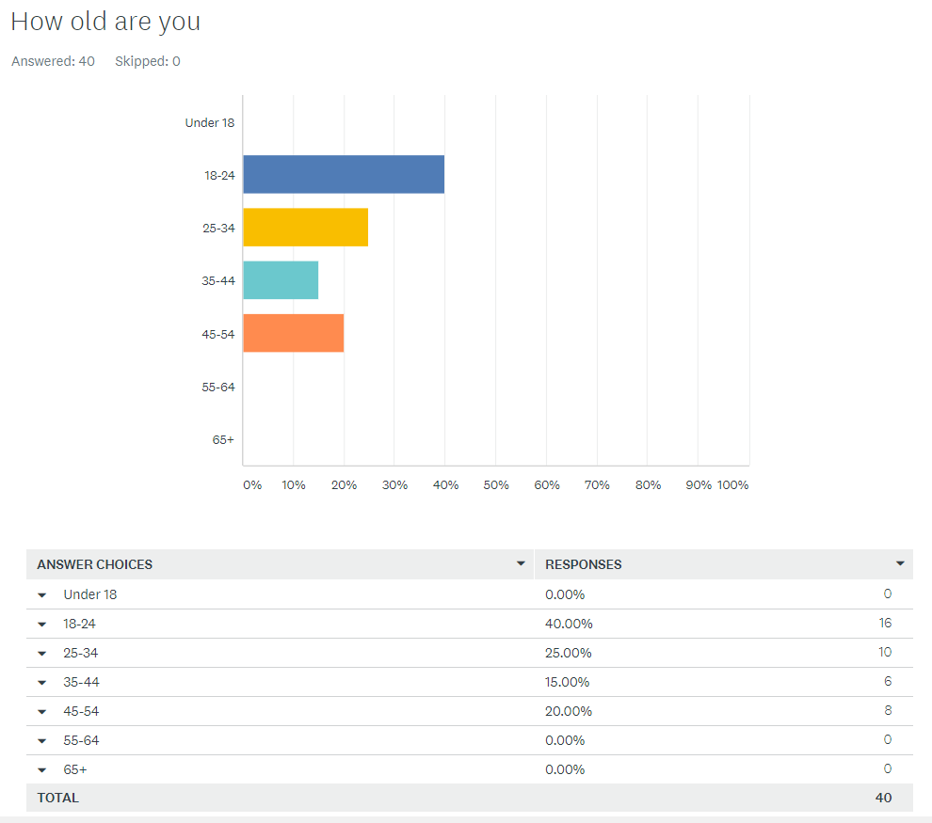

After sharing my survey online. I discovered that the majority of the participants were between 18 and 24 years of age meaning that 40.00% of participants were under the age of 25. it is always important to have a wide mixture of ages so that you can determine whether age is a factor and how different people of different ages have different ideas and opinions.

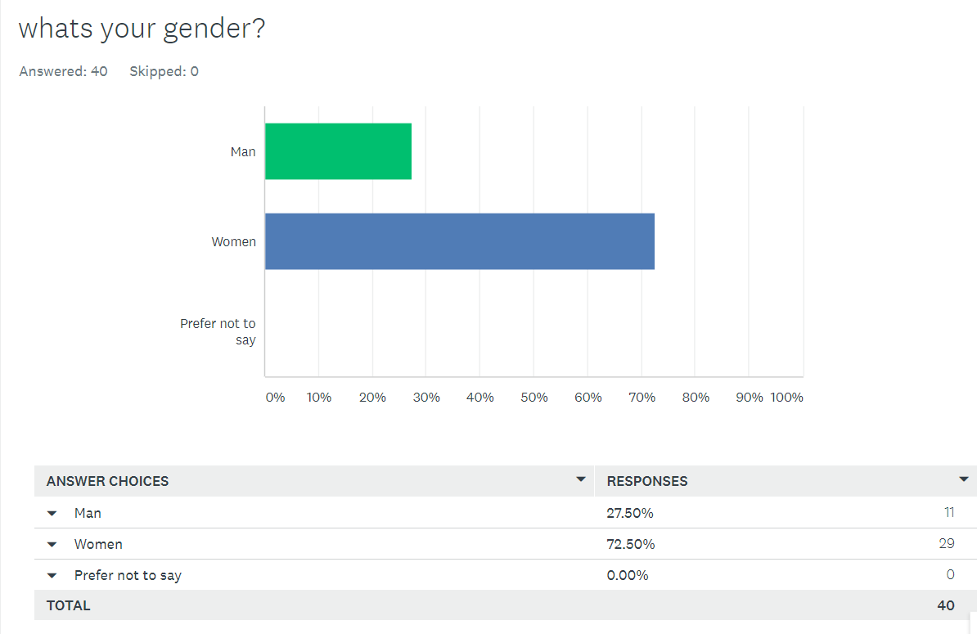

Upon looking at the results. More women than men took part in the survey with 72.50% which means out of 40 participants, 29 women answered this question. 27.50% were men meaning that only 11 men answered this question.

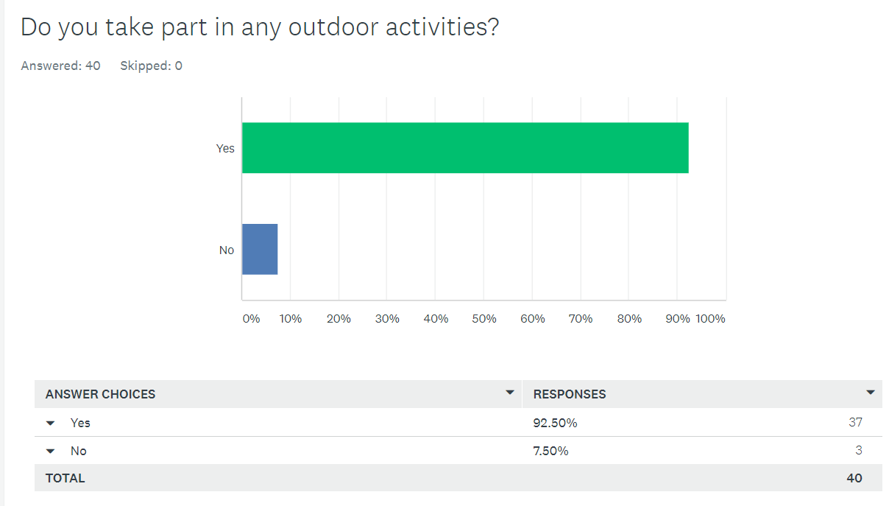

From looking at these results 92.50% of participants answered yes to whether or not they take part in any outdoor activities. Only 7.50% of participants answered no. in conclusion to this question 37 participants answered yes and only 3 participants answered no.

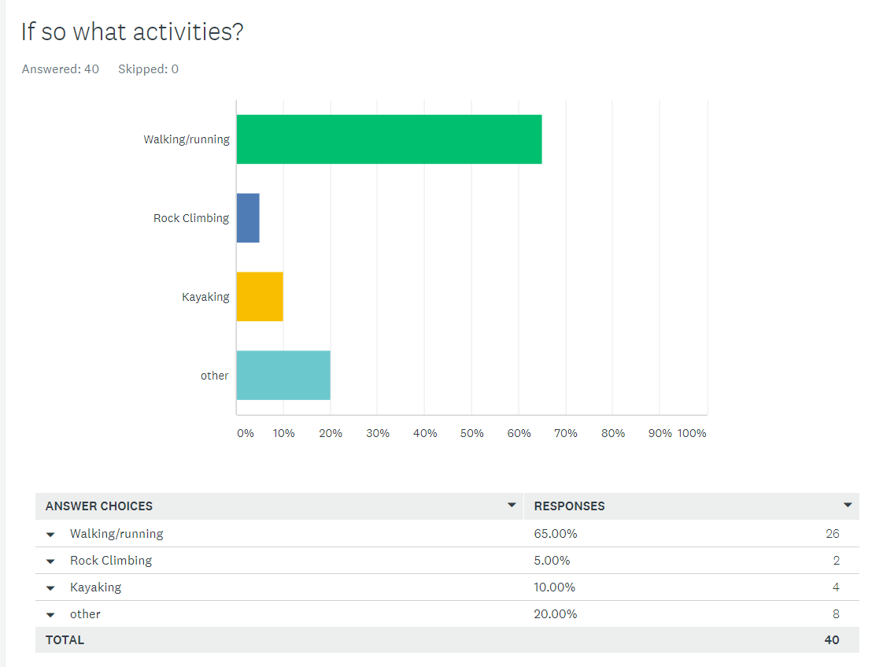

The next question that was asked was what specific activities the participants take part in. the multiple available answers consisted of walking, rock climbing, kayaking or other. As you can see from the results above, majority of those who answered, chose walking/running with 65%, This means that 26 people either go walking or running. Only 15% of the participants chose rock climbing or kayaking and the last 20% chose other.

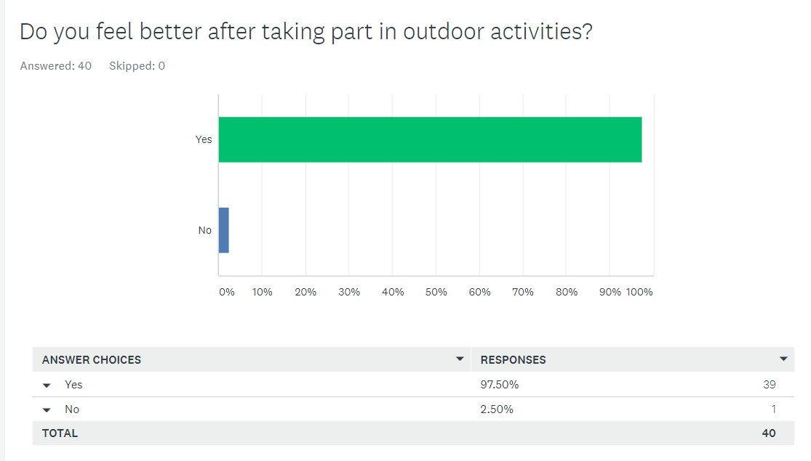

I asked this particular question so I could see whether participants gain anything from going outside which will help them with their idea for the final question. All 40 people successfully answered this question with 39 (97.50%) people answered with yes, they do in fact gain something and feel better from doing outdoor activities and only 1 person answered with no and believe that they do not feel better after taking part in outdoor activities.
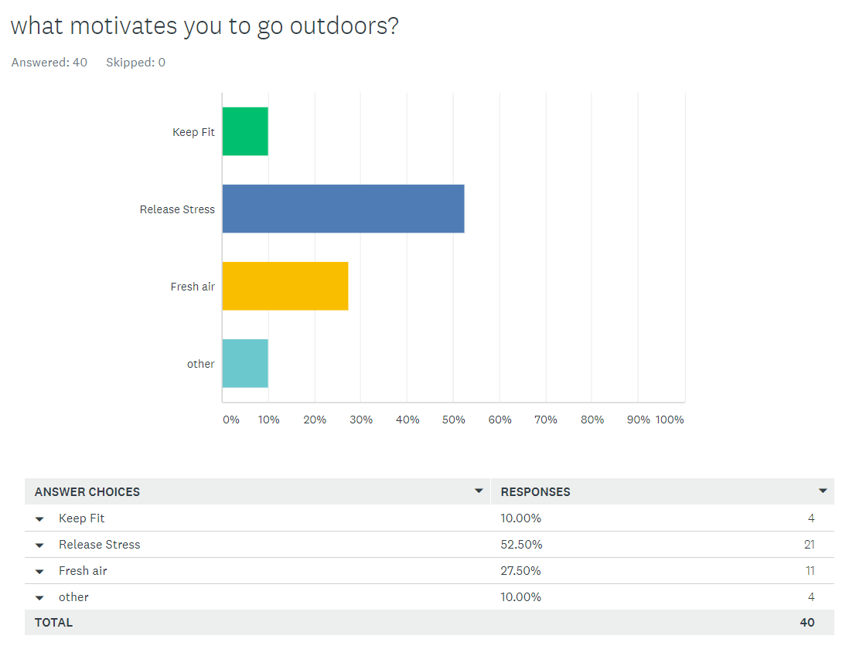

I asked this question because I felt it would help with gathering more information to get better results at the end. In relation to what motivates participants to go outdoors, 4 people said that they use outdoors to keep fit. 21 people (52.50%) agreed that they venture outdoors in order to relieve stress. This is understandable as there are numerous studies online proving that there are some positive health benefits of going outdoors and improving stress levels is one of the benefits. 11 people (27.50%) said that they explore outdoors for the breath of fresh air and then 4 people said that they have other factors that motivate them to go outdoors.

Finally the last question that I included within my survey was the main question which consisted of “what do you think can be done to motivate young people to go outdoors”. In this part of the survey, I included a comment box where participants could include their own ideas. All the ideas that were produced where really good and useful.

One participant suggested “better education on what’s around in the area and more knowledge on activities”
I agree with this suggestion as most young people are just unaware of the opportunities of outdoor activities and what they can get from exploring outdoors. especially with the modern generation growing up with technology which makes lives easier, it can also divert young people from doing more natural activities like going for a walk or maybe something more adventurous such as kayaking or rock climbing.

What also got my attention was the idea that a participant suggested was that there should be “more introductory to indoor centres, such as climbing centres and watersports centres where young people can get involved in the introduction to the outdoors in a safe and controlled environment and trained by proper qualified instructors” I really like this idea from this participant as they have added the detail of “safe and controlled” meaning that for those who are scared of going outdoors because it can be dangerous, they can be reassured knowing that they are being taken care of by proper experienced instructors who know what they are doing and also who have safety measures and risk assessments in place just incase anything goes wrong. I like how they have included that detail that it should be conducted indoors in a safe environment before going outdoors so at least when they do go outdoors, they have that bit of experience to keep themselves safe and to stop them from getting themselves into trouble.

Another participant had a good suggestion of “putting hidden challenges around your local area that you and a group of people can go and find and take part in” I really like this idea because it gets people involved and also promotes exercise from a social aspect of working in a team. It can also be used to improve navigation within young people which will always become useful throughout life. After doing some research. This method of exercise and adventure has already been thought out and created. It is an adventure and expedition exercise called geocaching.

Geocaching is a real-world outdoor adventure that is happening all the time. In order to play, participants can either use the geocaching app or a GPS device to look for and find the cleverly hidden containers and geocaches. There are millions of geocaches spread out amongst 100 different countries waiting to be discovered. Geocaching started in early 2000. When the website launched. 75 geocaches had been hidden. Today, there are over 3 million geocaches and millions of geocachers playing the game. Geocaches come in different shapes, sizes and difficulties and are hidden in both rural and urban settings. (Geocaching.com, 5th march 2018)

Conclusion

After asking I group of participants, “what do you think can be done to motivate young people to go outdoors”
I have learnt that there are multiple ways on how to motivate young people to go outdoors for example like introducing certain tasks how carrying out lessons and training in order to catch young people’s attention. Another good idea was geogaching. This was a good idea and an effective way to get young people involved because it introduces a sense of competition as well as working in a team which can then lead to social skills and decrease antisocial behaviour. As well the competition aspect. What has also been demonstrated in the survey as an idea to improve confidence in young people by bringing training in outdoor activities indoors, in a safer environment where they can be trained by qualified and experienced instructors. In conclusion, in relation to motivation and outdoor exercise, I have learnt that social skills, team building, and navigation can enhance our experience of exercise which can motivate young people as well as everyone else to go outside.

Wordcount: 1460

References

Being outside can improve memory, fight depression, and lower blood pressure — here are 12 science-backed reasons to spend more time outdoors.
Kevin Loria
Business insider
Located at: https://www.businessinsider.com/why-spending-more-time-outside-is-healthy-2017-7?r=US&IR=T
Accessed: 15/04/2020

What is geocaching?
Geocaching.com
Located at: https://www.geocaching.com/blog/2018/03/what-is-geocaching/
Accessed: 24/04/2020

GENERIC ASSESSMENT CRITERIA

Level 5
In accordance with the Framework for Higher Education Qualifications, at the end of Level 5 students will be expected to have developed sound knowledge and critical understanding of the well-established concepts and principles in their field of study, and of the way in which those principles have developed. They will have learned to apply those concepts and principles more widely outside the context in which they were first studied, including, where appropriate, the application of those principles in an employment context. They will have knowledge of the main methods of enquiry in the subject area, and ability to evaluate critically different approaches to problem solving. They will possess an understanding of the limits of their knowledge, and how this influences their analyses and interpretations. They will be able to use a range of established techniques to initiate and undertake critical analysis of information, and to propose solutions to problems arising from that analysis. They will be able to effectively communicate information, arguments and analysis in a variety of forms to specialist and non-specialist audiences, and deploy key techniques of the discipline effectively. They will be able to undertake further training, develop existing skills and acquire new competences that will enable them to assume significant responsibility within organisations. They will have the qualities and transferable skills necessary for employment requiring the exercise of personal responsibility and decision-making.

Level 5 | FAIL | MARGINAL FAIL | SATISFACTORY  (3rd / Pass) | GOOD  (2.2 / Pass) | VERY GOOD  (2.1 / Merit) | EXCELLENT  (1st / Distinction) | EXCEPTIONAL  (1st / Distinction)
Category | 0-29% | 30-39% | 40-49% | 50-59% | 60-69% | 70-84% | 85-100%
Engagement with literature (including reading, referencing,  academic conventions and  academic honesty) | Little or no evidence of reading and/or reliance on inappropriate sources.  Views and findings mostly unsupported and non-authoritative.  Referencing conventions used incoherently or largely absent. | Poor engagement with essential reading. No evidence of wider reading. Reliance on inappropriate sources, and/or indiscriminate use of sources. Heavily reliant on information gained through class contact. Inconsistent and weak use of referencing. | Engagement with a limited range of mostly relevant and credible sources. Some omissions and minor errors.  Referencing conventions evident though not always applied accurately or consistently. | Engagement with an appropriate range of literature, including sources retrieved independently. Some over-reliance on texts. Referencing may show minor inaccuracies or inconsistencies. | Engagement with a wide range of literature, including sources retrieved independently.  Selection of relevant and credible sources. Very good use of referencing, with no/very few inaccuracies or inconsistencies. | Engagement with an extensive range of relevant and credible literature. Consistently accurate application of referencing. | Exceptional engagement with an extensive range of relevant and credible literature. High-level referencing skills consistently applied.
Knowledge and understanding (Sound knowledge and critical understanding of the well-established concepts and principles in their field of study; knowledge of the main methods of enquiry in the discipline.) | Major gaps in knowledge with unsatisfactory, uncritical understanding of the subject matter. Much irrelevant material. Substantial inaccuracies. Significantly flawed understanding of the main methods of enquiry in the discipline. | Fragmentary knowledge, with only superficial critical understanding. Some significant inaccuracies and/or irrelevant material. Incomplete or partially flawed understanding of the main methods of enquiry in the discipline. | Limited but adequate knowledge and critical understanding of the well-established concepts and principles within the subject area, with a few gaps in the selection of material. A narrow critical understanding of the main methods of enquiry. | Knowledge is reasonably detailed and accurate. A good critical understanding of the well-established concepts and principles and the main methods of enquiry, with minor gaps in the selection of material. | Knowledge is reasonably extensive. Exhibits very competent critical understanding of the well-established concepts and principles of the subject and the main methods of enquiry. Breadth and depth of knowledge. | Excellent, detailed knowledge and highly critical understanding of the well-established concepts and principles of the subject and the main methods of enquiry. | Exceptionally detailed knowledge and outstanding critical understanding of the well-established concepts and principles of the subject and the main methods of enquiry. May go beyond established theories.
Cognitive and intellectual skills  (Critical evaluation and analysis of concepts and principles; argument and judgement; the limits of their knowledge, and how this influences their analyses and interpretations.) | Wholly or almost wholly descriptive work. Little or no critical evaluation and analysis of concepts and principles.  Failure to develop arguments, leading to illogical or invalid judgements. Unsubstantiated generalisations or opinion, made without use of any credible evidence. | Largely descriptive work, with superficial use of critical evaluation and analysis of concepts and principles. Weak development of arguments and judgements. Information accepted uncritically, uses generalised statements made with scant evidence and unsubstantiated opinions. Ideas sometimes illogical and contradictory. | Limited attempt at critical evaluation and analysis of concepts and principles, tending towards description.  Some evidence to support arguments and judgements but these may be underdeveloped, with a little inconsistency / mis-interpretation or failure to fully recognise limits of knowledge. | Some critical evaluation and analysis of concepts and principles, though descriptive in parts.  An emerging awareness the limits of their knowledge and ability to use evidence to support the argument though with some tendency to assert/state opinion rather than argue on the basis of reason and evidence.  Mostly valid arguments and logical judgements. | Sound critical evaluation and analysis of concepts. Is selective in the range of evidence used and synthesises rather than describes. Ability to devise arguments that show awareness of different stances, and use evidence convincingly, to support appropriate and valid judgements. | Excellent critical evaluation and analysis of concepts and principles leading to logical, evidence-based, reasoned arguments and judgements. Explicit recognition of other stances and a strong awareness of the limits of their knowledge.  A capacity for independent thought and ability to ‘see beyond the question’, suggesting some grasp of the broader field and wider concepts. | Outstanding critical evaluation and analysis of concepts and principles. Uses evidence exceptionally well to connect ideas, and support highly logical and persuasive, arguments and judgements. Evidence of independent thought and ability to ‘see beyond the question’, suggesting a clear grasp of the broader field and wider concepts. Perceptive recognition of the limits of their knowledge, and how this influences their analyses and interpretations.
Practical skills  (Apply underlying concepts and principles more widely outside the context in which they were first studied; use a range of established techniques; propose solutions to problems arising from analysis.) | Limited or no use of established methods, materials, tools and/or techniques.  Little or no appreciation of the context of the application.  Limited understanding of the application of theory to practice or making appropriate links between the two.  Very weak problem-solving skills outside the context in which they were first studied. | Rudimentary application of established methods, materials, tools and/or techniques but without consideration and competence. Flawed appreciation of the context of the application.  Weak understanding of the application of theory to practice, with only occasional evidence of making appropriate links between the two. Weak problem-solving skills outside the context in which they were first studied. | An adequate awareness and mostly appropriate application of established methods, materials, tools and/or techniques.  Basic appreciation of the context of the application. Theoretical knowledge and understanding applied in practice, but not always making logical links between the two.  Can identify problems and propose basic solutions outside the context in which they were first studied. | A good and appropriate application of established methods, materials, tools and/or techniques.  Clear appreciation of the context of the application. Mainly consistent, accurate and logical application of theory to practice, making appropriate links between the two.  Can identify problems and propose mostly appropriate solutions outside the context in which they were first studied. | A very good application of a range of established methods, materials, tools and/or techniques.  Very good consideration of the context of the application, with perceptive insights. Consistent, accurate and logical application of theory to practice, making appropriate links between the two. Can identify problems and propose appropriate solutions outside the context in which they were first studied.  Evidence of some creativity. | An advanced application of a range of established methods, materials, tools and/or techniques.  The context of the application is well considered, and insightful.  Consistent, accurate and logical application of theory to practice, making well-developed links between the two. Can identify problems and propose excellent, creative solutions outside the context in which they were first studied. | Exceptional levels of application and deployment skills using established methods, materials, tools and/or techniques. Consistent, accurate and logical application of theory to practice, making highly developed links between the two. Can identify routine and non-routine problems and propose quite sophisticated, creative solutions outside the context in which they were first studied.
Transferable skills for life and professional practice  (Effectively communicate in a variety of forms  to specialist and non-specialist audiences; the qualities and transferable skills necessary for employment requiring the exercise of personal responsibility and decision-making.) | Communication medium is inappropriate or misapplied.  Work is poorly structured, disorganised and/or confusingly expressed. Very weak use of language and/or very inappropriate style. Failure to work effectively as part of a group. Little or no evidence of the skills for employment requiring the exercise of personal responsibility and decision-making. | Communication medium is poorly designed and/or not suitable for the audience.  Work is poorly presented in a disjointed manner. It is loosely, and at times incoherently, structured, with information and ideas often poorly expressed. Weak use of language and/or inappropriate style. Flawed approach to group work, meeting only partial obligations to others. Limited evidence of the skills for employment requiring the exercise of personal responsibility and decision-making. | Can communicate in a suitable medium for the audience but with some room for improvement.  Mostly ordered presentation and structure in which relevant ideas / concepts are reasonably expressed. Work may lack coherence in places. Can work as part of a group, meeting most obligations to others but perhaps with limited involvement in group activities.  Demonstrates the basic skills for employment requiring the exercise of personal responsibility and decision-making, with some areas of minor weakness. | Can communicate effectively in a suitable medium for the audience, but may have minor errors.  Mostly coherent, organised work, in a suitable structure and is for the most part clearly expressed. Can work effectively independently and/or as part of a team, with clear contribution to group activities.  Demonstrates the skills for employment requiring the exercise of personal responsibility and decision-making, with some areas of strength and some of minor weakness. | Can communicate well, confidently and consistently in a suitable medium for the audience.  Work is coherent, fluent, well-structured and organised. Can work very well autonomously and/or as part of a team, with very good contribution to group activities.  Demonstrates very good skills for employment requiring the exercise of personal responsibility and decision-making, with just occasional minor weakness. | Can communicate professionally confidently and consistently in a suitable medium for the audience.  Work is coherent, very fluent and is presented proficiently. Can work autonomously with initiative. Where relevant can work professionally within a team, showing leadership skills as appropriate, and meeting obligations. Demonstrates excellent skills for employment requiring the exercise of personal responsibility and decision-making and an appetite for further development. | Can communicate with an exceptionally high level of professionalism, highly suitable for the audience.  Work is exceptionally coherent, very fluent and is presented professionally. Can work exceptionally well within a team, showing leadership skills. Demonstrates exceptional skills for employment requiring the exercise of personal responsibility and decision-making and an appetite for further development.

