Artúr: The Cambro-Gaelic Background Reconsidered

The personal name Art[h]ur was characterised by a highly specific geo-ethnic distribution in the early middle ages. It seems to have been current among a group of Cambro-Gaelic communities located on the British side of the Irish Sea, over two generations around the turn of the seventh century. A secondary cluster occurs amongst a specific group of Leinster kindreds, where the name appears sporadically across the ninth, tenth and eleventh centuries. Beyond these Irish and Cambro-Gaelic attestations, the name of Arthur is conspicuously absent from the epigraphic and literary record of Britain itself prior to the ninth century. It seems to have been almost entirely unused as a personal name in Welsh-speaking communities until the later Middle Ages. Were it not for its fairly unambiguous derivation from the Roman gentilic Artōrius (Fig. 1), it would be tempting to regard the name of Art[h]ur as a primarily Gaelic form.
Oliver Padel (1994, p. 24) and Thomas Green (2007, pp. 49, 196), among others, have attempted to explain the apparent absence of this form from the Brythonic name-stock as a reflex of the ‘superstitious awe’ surrounding the figure of Arthur during the medieval period – a taboo that was evidently not felt by the Gaelic-speaking communities of western Britain. This assumption is founded on the hypothesis of a pan-Brythonic pagan cult of Arthur, for which, quite simply, no evidence exists. It also depends on some shaky assumptions about the respective cultural and religious positions of Gaelic and Brythonic speakers in the Irish Sea region in the post-Roman period, which also tend to run contrary to the evidence of a highly integrated, largely Christian environment suggested by the literary sources.
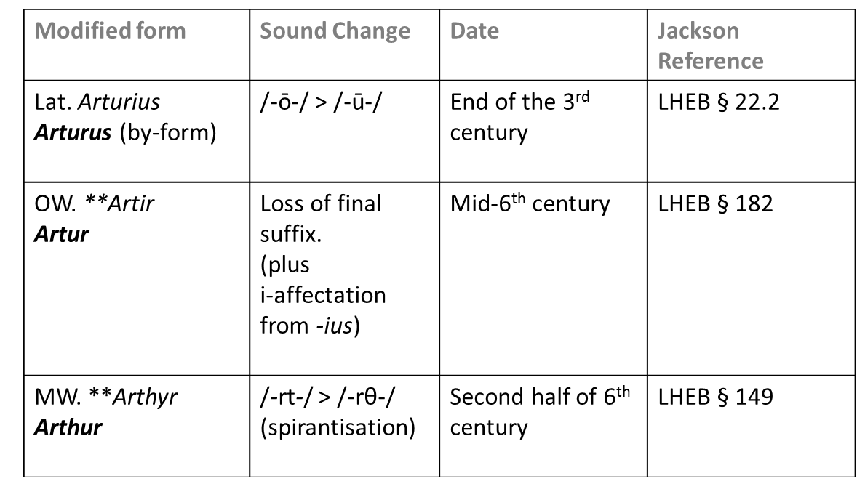
Fig. 1 – Artorius > Arthur
A rather less tortuous explanation has been offered by Ann Dooley who suggests ‘the naming impulse may be a simple one – the wish to remember a grandfather or uncle’ (2004, p. 19). Such a dynamic explains how a given name could be transmitted between kindreds linked by marriage. Among the elites of the Insular medieval world, such unions were often the expression of a political alliance. As we will see, this anthroponomastic model explains not only how the name might have spread from British to Irish-speaking communities in the first place, it also presents a plausible fit with its subsequent transmission across specific Irish kin-groups during the early medieval centuries.
The roster of Cambro-Gaelic Artúrs is fairly well-known (see Fig.2 below). The earliest and best-known of these is Artúr mac Áedáin, probably born around 565 AD. He was the son of the famous Dál Riatan warlord Áedán mac Gabráin. A number of British family connections are implied by both Welsh and Irish tradition. Hagiographical sources from Wales identify Áedán mac Gabráin as the son of a British mother: Luan daughter of Brychan Brycheiniog. Meanwhile, the Irish Life of St Laisrén describes the saint’s mother as a daughter of Áedán, and the niece of a certain re[x] Britaniae (cited TYP p. 265). The implication seems to be that this British king was either Áedán’s brother or brother-in-law. A plausible candidate would be Rhydderch Hael, of the neighbouring British kingdom of Strathclyde.
Artúr mac Aedain’s adult life seems to have coincided with a prolonged period of warfare that took place in the final decades of the sixth century, between Áedán mac Gabráin and his allies and the so-called Picts of the northeastern Central Belt. This campaign is documented in a number of sources, including those of a relatively contemporary and authoritative character. As was the case with many of the geopolitical power-struggles of the sixth and seventh centuries, this supposed Gaelo-Pictish war is probably more accurately characterised as a clash between two multi-ethnic regional coalitions, each involving participants from a variety of cultural backgrounds. The role of the Brythonic populations of the Central Belt in these wars can be interpreted in a number of ways. For me, the evidence seems to point most clearly towards a kind of proxy war, nominally between rival British dynasties. The court community led by the warlord Rhydderch Hael seems to have been supported by Aedán mac Gabrain, who (as we have seen) may have even been his own brother-in-law. A rival dynasty, which would eventually gain control of the Central Belt region following the battle of Strathcarron in 642 AD, seems to have had more obviously Pictish connections.
However, in the late sixth century, it was the Gaelic Dál Riata along with its British proxies that was the ascendant power in the Central Belt region. The high-water mark of this Dál Riatan advance seems to have been the battle of Circind (AT 595), which took place somewhere towards northeastern end of the Central Belt region, in the sixth century’s final decade.
This is the context in which we should situate the account of Artúr mac Áedáin’s death, as reported in the Vita Columbae. The first of the relevant passages occurs in Chapter 7 of Book 1, describing the saint’s vision of a battle taking place ninety miles away on the Scottish mainland:
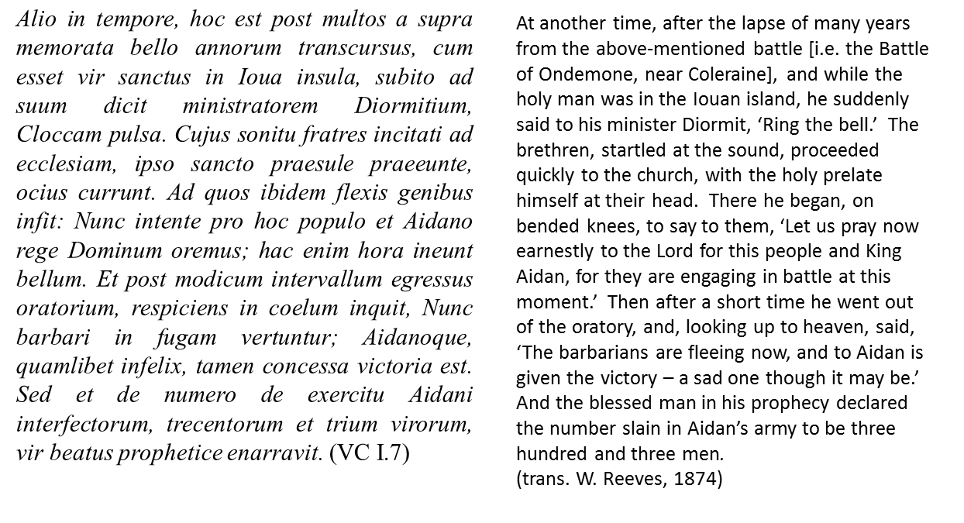
This is immediately followed by a passage which names Artúr directly, confirming that he had been among these three hundred and three men to fall in that battle, which the text describes as the Bello Miatorum, the Battle of the Miaithi. Whether or not (as some scholars have suggested) this should be identified with the Battle of Circind, it certainly seems to belong within the same general geopolitical context:
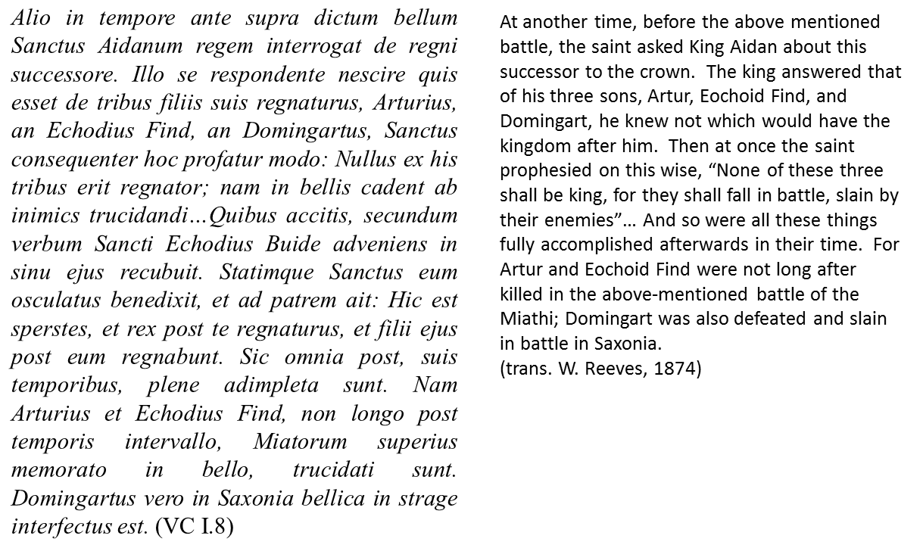
Thus, Artúr mac Áedáin might be identified as a prominent member of the Cambro-Gaelic aristocracy in the Central Belt region, one who could have potentially inherited the vast territorial hegemony of his father had he not died prematurely in battle. Furthermore, his part-British ancestry, as well as his role in defending what would have been British-speaking communities in these areas of eastern and central Scotland, would account for his subsequent celebration among the Gododdin of the Lothian and Strathclyde regions, from where (I would suggest) his fame would subsequently spread into early medieval Wales.
Artúr’s royal birth, combined with his early death in action and his lack of any recognised offspring, presented the ideal circumstances for his posthumous memorialisation as a subject of heroic biography. We will have more to say about this distinctive but ubiquitous genre in due course. But first we should briefly consider each of the other documented Artúrs, about whom rather less is known, but who collectively confirm the specific association of this name with the Cambro-Gaelic communities of the Irish Sea region.
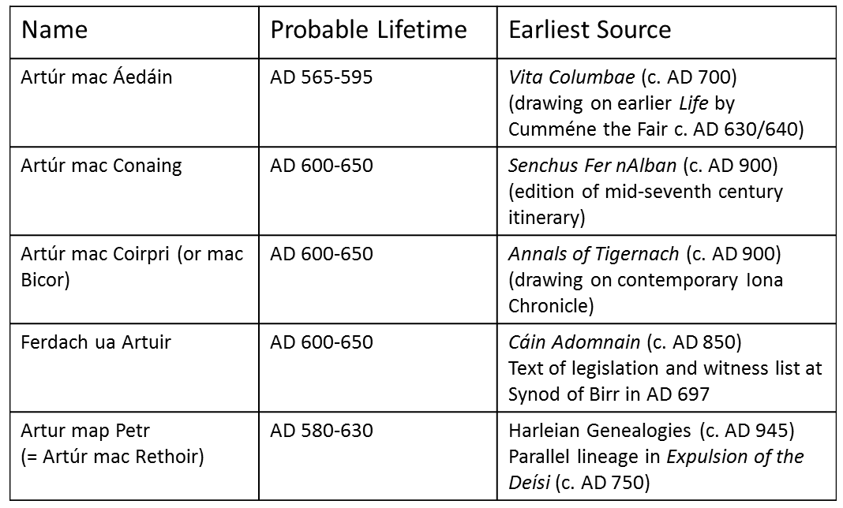
Fig. 2: The Cambro-Gaelic Artúrs
Artúr mac Conaing, the second on this list is named in the tenth-century Senchus Fer nAlban (l.23), a Dál Riadan genealogy-cum-census. He seems to have been the nephew of Artúr mac Áedán himself. He would have been born around 595 AD and had his adult career in the early decades of the seventh century.
Another Arthur, probably from the same generation, is named in the Annals of Tigernach. He appears here as the killer of Mongán mac Fiachnai, a prince of the Antrim-based Dál nAraide, an event which is also noticed in the Annals of Ulster under the year 624. The exact identity of this Arthur remains slightly unclear, but he was probably connected with one segment or other of the fragmented Dál Riata-Strathclyde alliance and appears to have participated in the defence of the Mull of Kintyre against this raid by the Dál nAraide.
The next Arthur in our list appears in the avonymic of Ferdach ua Arthuir, one of the signatories to Cáin Adomnáin, the so-called Law of Innocents. This was formulated at the Synod of Birr in 697 AD under the auspices of the Iona confederacy. If this Artúr was indeed Ferdach’s grandfather, we can probably situate his adult career in the decades around 640 AD, and his birth in the first or second decade of the same century. He may or may not have been identical with one of the two Arthurs previously discussed, but was certainly connected to the same general North Channel context.
Ferdach himself has been identified with Feriacus, regulus of Monchestree, mentioned in the Aberdeen Breviary (cited in Mac Shamhráin, 1999, p.68). This Manx (or perhaps Mancunian) warlord seems to have been the son-in-law of Cellach Cualann, Lord of the Uí Mail – another one of the signatories of the Cáin Adomnáin. It was perhaps through this marital connection that the name Artúr first entered the naming-stock of mainland Ireland. Among the genealogies of the Uí Mail kindred we find a certain Artúr mac Coscraich (CGH, Vol.1, pp.78), whose floruit we can probably assign to around the beginning of the tenth century. The name also occurs sporadically over the ninth, tenth and eleventh centuries in the Uí Muiredaig segment of the Uí Dunlaing dynasty, with whom the Uí Mail were intermarried during the late seventh century (Dooley, 2004, p. 20).
It is worth considering the position of the Uí Mail dynasty in a little more detail. They had long-standing links with the Cruithin territories of Ulster as well as an interest in the geopolitics on both sides of the Irish Sea. Cellach Cualann is described as deploying British mercenaries (e.g. AU 704), and these may well have been led by his son-in-law, the aforementioned Feriacus (Mac Shamhráin, 1999, pp. 66-67). This web of connections between Leinster, Ulster and the west coast of Britain bears an interesting correspondence with the trade network implied by the distribution of so-called E-ware pottery, which seems to have flourished during the sixth, seventh and eighth centuries (Doyle, 2009, p. 25). (see Fig.3).

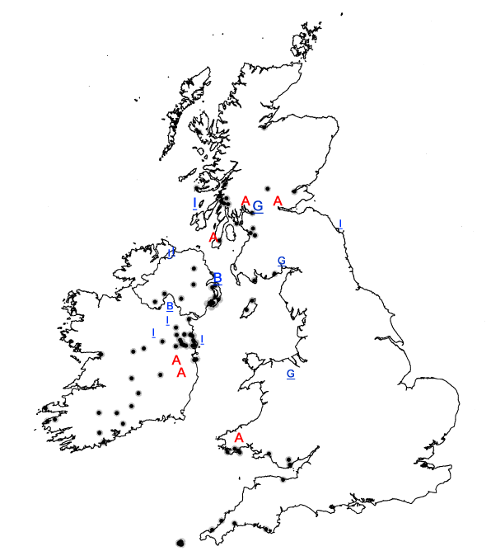
Fig 3: The Distribution of E-Ware Pottery in the Irish Sea region (finds indicated by black dots)
Key
A Documented individuals with the name Artúr (top to bottom: A. mac Conaing, A. mac Aidain, A. mac Coirpre, A. mac Muirdaig (Uí Dunlaing) A. mac Coscraich (Uí Mail), A. map Petr.
I/I Ecclesiastical mother-house/daughter-house I = Iona network, B = Bangor network (Comgall), G = Glasgow network (Kentigern)
The name Art[h]ur, in other words, seems to have been current in a particular network of Cambro-Gaelic communities centred on the Irish Sea. This network was probably cohered by a variety of connections: commercial, familial, religious and diplomatic. The Bristol Channel region, the Boyne Valley, the southern coastlands of the Ards Peninsula, and the complex shoreline of Scottish Dál Riata each represented nodes in this network, none of which was more than a day’s journey from the next, as the ship sails. The entire circuit from Iona to Penzance via the coasts of Ireland and Wales could have been circumnavigated in little more than a week. Within this context, the appearance of another Arthur, among the Cambro-Gaelic dynasty of Dyfed, is not as surprising as it might initially appear.
This sense of a coherant Irish Sea community is confirmed when we turn to the historical record, where we find some significant personal connections between the ecclesiastical and secular elites across the generations of the sixth and seventh centuries (see Fig. 4). The cult of Kentigern provides a link between Rheged and Strathclyde, whose leaders also fought alongside one another in the Northumbrian wars described in Chapters 62-63 of Historia Brittonnum. Iona’s Colum Cille takes confession from the kings of both Strathclyde and Dál Riata, reinforcing an alliance that may have also been sealed by marital and diplomatic ties. The spiritual friendship between Colum Cille and his older contemporary, Comgall of Bangor, mirrors the client ‘relationship of equals’ between Áedan mac Gabráin and Fiachne mac Baetáin, king of the Cruithin Dál nAraide.
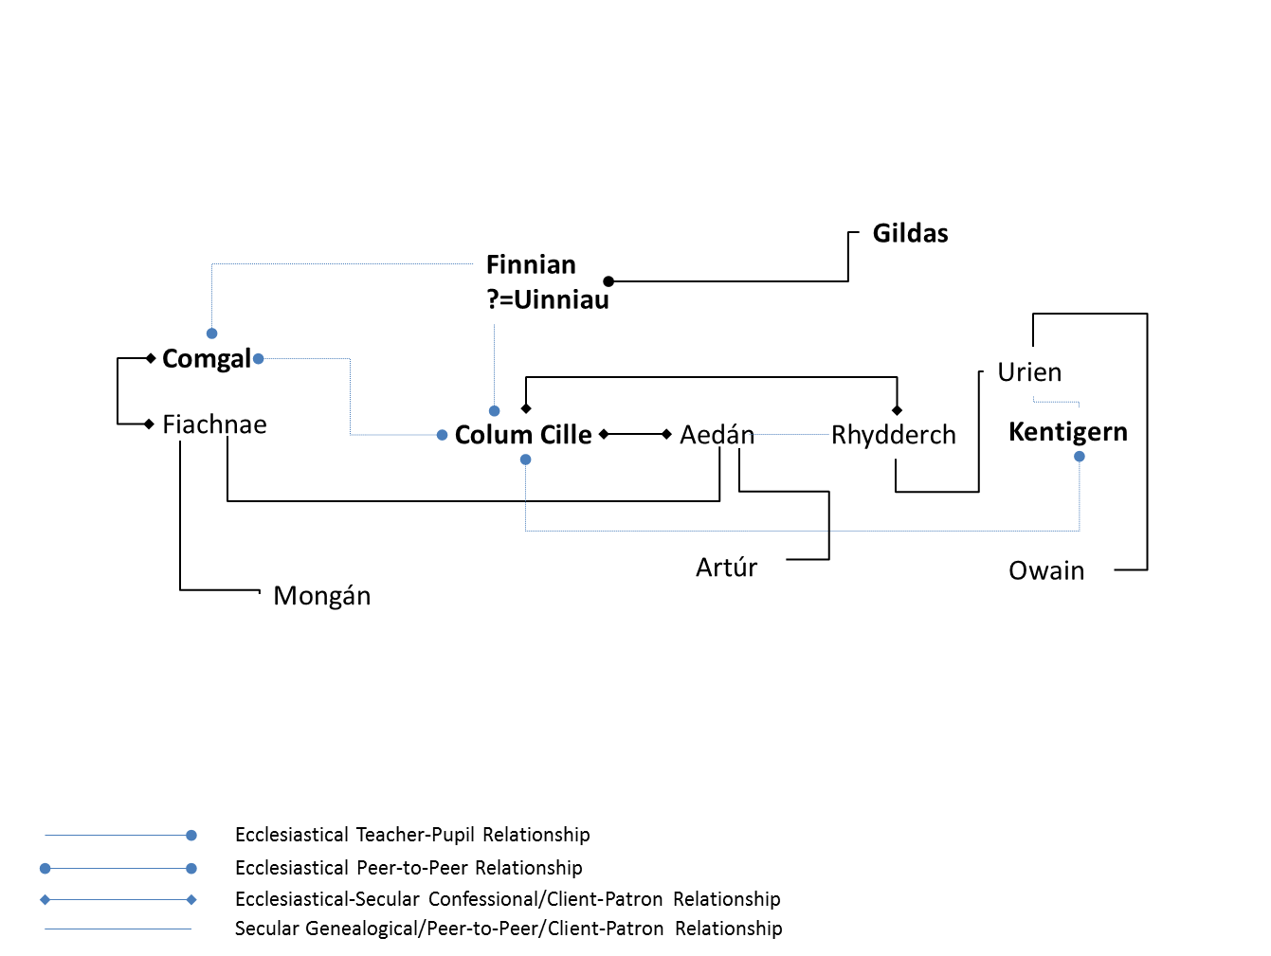
Fig 4: Eccelsiastical and Secular Connections across the Irish Sea c. 500-620 AD

It is this latter relationship that plays such an instrumental role in the opening episode of the birth-story of Mongán, which offers a convenient starting point of our brief analysis of the heroic narratology of this North Channel region. Like the Siege of Lindesfarne, which provided the context for the tragic death of Owain’s father Urien, Mongán’s birth-story is set against the backdrop of ‘the Saxon Wars’, at the turn of the seventh century. While the Ulster prince Fiachne mac Baetáin was in Scotland fighting alongside his Dál Riatan ally, it is said his wife was seduced by the divinity Manannán mac Lir, who came to her magically disguised as her husband. The hero Mongán was thereby conceived (White, 2006, pp. 71-72). A comparable birth-story, in which divine and mortal parents conceive a hero under morally-ambivalent circumstances, is associated with Owain Rheged in a landscape tale recorded in the Denbeighshire village of Llanferres in the sixteenth century (TYP p.459). It would not be a great leap to suppose that a similar story may have once been told of Artúr mac Aidáin, a distant echo of which perhaps survives in Geoffrey of Monmouth’s famous account of Uther and Igraine (HRB VII.137-138).
These three princes of the Irish Sea network exhibit further similarities. All three were believed to maintain a special connection to the supernatural realms, as a result of their atavistic origins. All three were credited with fantastical adventures, yet (paradoxically) all three were also clearly part of the ‘photo-realistic’ world of recent historical memory. All three seem to have suffered a premature death and therefore left ‘no descendants to complicate politics’ (Bruford, 1994, pp. 25-26) . In the Insular context at least, this was an almost universal feature of the heroic biography.
This widespread but fairly well-defined genre was extensively studied by twentieth-century scholars such as Otto Rank (1909 [2004]), Lord Raglan (1936 [2003]), Vladimir Propp (1944 [1995]) and Joseph Campbell (1949 [1993]). These studies display a degree of meta-analytical convergence, as can be seen from this comparanda of the Rank and Raglan morphologies (Fig 5).
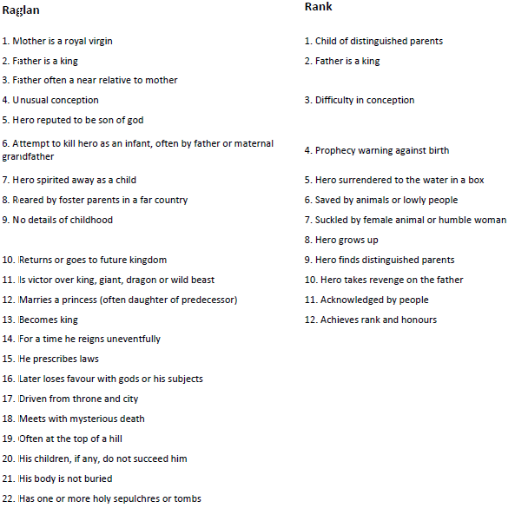
Fig 5: Episodes of the Raglan-Rank Mythotype
https://en.wikipedia.org/wiki/Rank-Raglan_mythotype (11/05/18)

Examples of the form have been found in almost all traditional cultures, including those of Ancient Greece, South East Asia and pre-Columban America. A particular variant is well-attested in the Insular world, with its salient characteristics defined by Marie-Louise Sjoestedt (1949 [2000]), Alwyn and Brinley Rees (1961 [1989]) and Tomás Ó Cathasaigh (1977), among others. A synthesis of these morphologies has been suggested here, summarising the incidents in the lives of a number of Insular heroes, and showing how these correspond both to the episodes of the Rank/Raglan typologies and the Tale List categories which form the basis of the Rees brothers’ analysis:
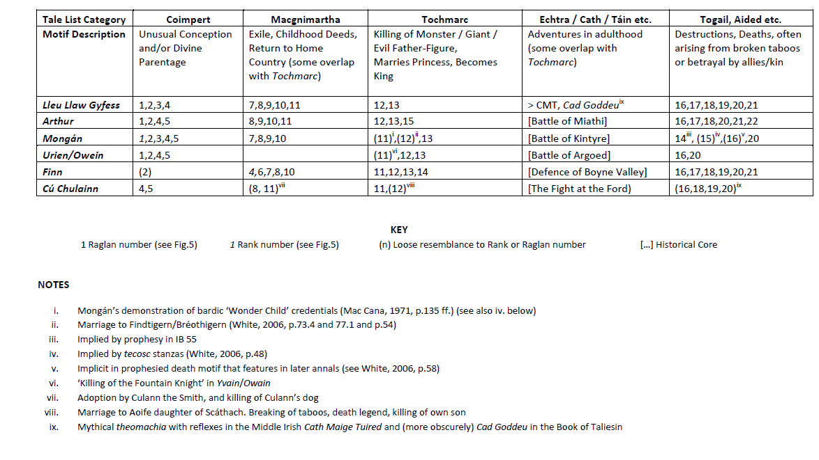
Fig 6: Episodes of the Raglan-Rank Mythotype

While heroic biographies of this kind are found in all traditional societies, there seems be a fairly decisive point in the arc of cultural development when the habit of mythologising contemporary figures in this way comes to an end – a development that is almost certainly to be associated with the growing historiographic sophistication that accompanies the establishment of literacy. In the Insular world, this change seems to have occurred somewhere between the seventh and the ninth centuries. The battle of Magh Rath, fought in 637 AD, was one of the last significant geopolitical events to be memorialised in ‘mythological’ terms. The same period, significantly, also signals the end of the Age of the Saints. The abbot Adomnán, who died 704 AD, was among the last great churchmen to become the subject of a hagiographical Vita of the traditional type.
Crucially, in the period immediately before this stoppage of the mythological clock, the North Channel region was enjoying an unusual prominence. For the Insular World of the sixth and seventh centuries, so many of the key questions of the age (religious, cultural and geopolitical) were being played out in this area of North Britain and north-eastern Ireland. The events and personalities of the North Channel zone just happened to be centre stage, then, as the last generations of the oral thought-world left their imprint on the earliest strata of the Insular literary record.
While none of this ‘proves’ that a heroic biographic based on the life Artúr mac Áedáin lies at the core of the Arthurian legendary complex, it certainly establishes this as a credible possibility. Further evidence would need to be derived from a close critical scrutiny of medieval Welsh sources, in which so much North British material survives. As well as the overt northern references such as Arthur’s defence of Edinburgh in Pa Gur, and the stray Arthurian allusion in the Gododdin B-text (BA 37.21), we would also need to note the strong incidence of ‘Gododdin’ nomenclature in the Court List of Culhwch ac Olwen (e.g. CO 176-177, 184, 189 etc.), or the Strathclyde connections of the cult of Cadog (in which the ‘native’ Arthur plays a prominent role). We would need to revisit the contentious ‘Battle List’ of the Historia Brittonum: not only reassessing the whereabouts of locations such as ‘Coed Celidon’ and ‘the River Douglas in Linnuis’; but also recognising the significance of the textual history of this passage, accounting for its secondary associations with the Welsh border region as well as the North British Bernician frontier. The Arthur we find in the Latinate sources owes much to this particular ‘Powys Connection’; while the back-channels of the ‘Gwynedd’ and the ‘Dyfed’ connections are more strongly represented in vernacular texts such as Culhwch ac Olwen and Pa Gur. The fact that these channels had converged in South Wales by the beginning of the Central Middle Ages may explain the subsequent association of Arthur with the Bristol Channel region, where he seems to have been celebrated at all levels of society. The timely prominence of our hero in this well-connected region accounts for the subsequent spread of the complex into wider medieval culture via Geoffrey of Monmouth and other Anglo-Norman intermediaries, suggesting a possible answer to the question ‘why Arthur?’ (as opposed, for example, to Urien, Cadwaladr or Magnus Maximus).

ABBREVIATIONS

AT | The Annals of Tigernach [Vol 1] Edited and translated by Whitley Stokes. Reprinted from Revue Celtique (1895-1896) (Felinfach : Llanerch Publishers, 1993)
AU | Annals of Ulster. Vol. I AD 431-1056 Edited with translation and notes by William Hennessey (Dublin : HMSO, 1887)
BA | Llyfr Aneirin. Facsimile. Edited with an introduction by Daniel Huws. Reproduction of the text transcribed by J. Gwenogvryn Evans. (Aberystwyth : National Library of Wales, 1989)
CGH | Corpus Genealogiarum Hiberniae. Vol. 1. Edited by M.A. O'Brien (Dublin : DIAS, 1962)
CMT | Cath Maige Tuired: The second battle of Mag Tuired. Edited by Elizabeth Gray. (Kildare : Irish Texts Society, 1982)
CO | Culhwch ac Olwen – An edition and study of the oldest Arthurian tale. Edited by Rachel Bromwich and D. Simon Evans (Cardiff : University of Wales Press, 1992)
DE | De Excidio Britanniae in Gildas – The Ruin of Britain and other works. Edited and translated by Michael Winterbottom (Chichester : Phillimore, 1978 [2002])
HB | Historia Brittonum in Nennius – British History and The Welsh Annals edited and translated by John Morris (London : Phillimore, 1980)
HG | Harleian Genealogies – Welsh Genealogies from Harleian MS. 3859 in Early Welsh Genealogical Tracts ed. P. C. Bartrum (Cardiff : University of Wales Press, 1966) pp.9-13
HRB | Historia Regum Britanniae in The History of the Kings of Britain - An Edition and Translation of the De Gestis Britonum [Historia Regum Britanniae]. Edited by Michael D. Reeve, translated by Neil Wright. (Woodbridge : Boydell, 2007)
HVK | The Herbertian Vita Kentigern in The Historians of Scotland Volume V – Lives of S.Ninian and S. Kenitigern. Edited and translated by A. P. Forbes (Edinburgh : Edmonston and Douglas, 1874)
IB | Immram Brain – Bran’s Journey to the Land of the Women. Edited and translated by Séamus Mac Mathúna. (Niemeyer : Tübingen, 1985)
JVK | Jocelyn’s Vita Kentigern in The Historians of Scotland Volume V – Lives of S.Ninian and S. Kenitigern. Edited and translated by A. P. Forbes (Edinburgh : Edmonston and Douglas, 1874)
LHEB | Language and History in Early Britain - a chronological survey of the Brittonic Languages 1st to 12th c. A.D. K. H. Jackson (Dublin : Four Courts Press, 1954 [1994])
LPBT | Legendary Poems from the Book of Taliesin. Edited and translated by Marged Haycock. (Aberystwyth : CMCS, 2007)
Mab. | The Mabinogion. Translated with an Introduction and Notes by Sioned Davies. (Oxford : OUP, 2007)
Macgnímartha | Macgnímartha Finn. The Boyhood Deeds of Finn. Edited and translated by Kuno Meyer in Revue Celtique V (1891) pp.195-204
PT | The Poems of Taliesin. Edited and annotated by Sir Ifor Williams. English version by Caerwyn Williams. (Dublin : DIAS, 1987)
Senchus Fer nAlban | Senchus Fer nAlban. Text and translation (with notes) in Kinship, Church and Culture - Collected Essays and Studies by John Bannermann (Edinburgh : John Donald - Birlinn, 2006)
TBC | The Tain. Translated from the Irish epic Táin Bó Cuailnge by Thomas Kinsella. (Oxford : OUP, 1969)
TYP | Trioedd Ynys Prydein - Triads of the Island of Britain. Edited and translated by Rachel Bromwich (Cardiff : University of Wales Press, 1978
VC | Vita Sancti Columbae. [The text printed from a manuscript of the 8th century to which area added copious notes and dissertations by William Reeves] (Dublin : University Press, 1857)
VSB | Vitae Sanctorum Britanniae et Genealogiae – The Lives and Genealogies of the Welsh Saints. Edited and translated by A. W. Wade-Evans. New edition edited by Scott Lloyd (Cardiff : Welsh Academic Press, 2013)

BIBLIOGRAPHY

Bruford, A. (1994). Why an Ulster Cycle? In J. P. Mallory, Ulidia - Proceedings of the First International Conference of the Ulster Cycle of Tales (pp. 23-30). Belfast: December Publications.
Campbell, J. (1949 [1993]). The Hero With a Thousand Faces. London: Fontana Press.
Clarkson, T. (2011). The Makers of Scotland: Picts, Romans, Gaels and Vikings. Edinburgh: Birlinn.
Dooley, A. (2004). Arthur of the Irish: a Viable Concept? In C. (. Lloyd-Morgan, Arthurian Literature XXI: Celtic Arthurian Material (pp. 9-28). Cambridge: D. S. Brewer.
Doyle, I. W. (2009). Mediterranean and Frankish pottery imports in early medieval Ireland. The Journal of Irish Archaelogy 18, 17-62.
Dumville, D. (1993). Saint Patrick AD 493-1993. Woodbridge: Boydell Press.
Fraser, J. E. (2009). From Caledonia to Pictland: Scotland to 795. Edinburgh: Edinburgh University Press.
Green, T. (2007). Concepts of Arthur. Stroud: Tempus.
Jackson, K. H. (1953 [1994]). Language and History in Early Britain - a chronological survey of the Brittonic Languages 1st to 12th c. A.D. Dublin: Four Courts Press.
James, S. a. (1997). Britain and the Celtic Iron Age. London: British Museum Press.
Mac Cana, P. (1972). Mongán mac Fiachna and Immram Brain. Ériu 23, 102-142.
Mac Shamhráin, A. S. (1999). Church and Polity in Pre-Norman Ireland: the Case of Glendalough. Maynooth: An Sargart.
Ó Cathasaigh, T. (1977). The Heroic Biography of Cormac Mac Airt. Dublin: DIAS.
Padel, O. (1994). The nature of Arthur. Cambrian Medieval Celtic Studies, 1-31.
Propp, V. (1944 [1995]). Oedipus in the Light of Folktale. In L. a. Edmunds, Oedipus: A Folklore Casebook (pp. 76-121). Madison: University of Wisconsin Press.
Raglan, F. (1936 [2003]). The Hero - A Study in Tradition, Myth and Drama. Mineola, New York: Dover Publications.
Rank, O. (1909 [2004]). The Myth of the Birth of the Hero. Baltimore: Johns Hopkins.
Rees, A. a. (1961 [1989]). Celtic Heritage - Ancient Tradition in Ireland and Wales. London: Thames and Hudson.
Rhŷs, J. (1891). Studies in the Arthurian legend. Oxford: Clarendon.
Sjoestedt, M.-L. (1949 [2000]). Celtic Gods and Heroes. New York: Dover Publications.
Wainwright, F. T. (1955 [1980]). The Problem of the Picts. Perth: Melvern Press.
White, N. (2006). Compert Mongáin and Three Other Early Mongán Tales. Maynooth: Department of Old and Middle Irish, University of Ireland.
Woolf, A. (2017). On the Nature of the Picts. The Scottish Historical Review Vol. XCVI No.243, 214-217.

This term will be used principally to refer to Gaelic-speaking settlements in the West Coast of Britain, and in particular the imputable Irish or bilingual groups associated with the incidence of ogham inscriptions in Cornwall and Dyfed. The Dál Riata, although belonging to a slightly different cultural tradition, might also be described in this way.
Not only is there no evidence whatsoever for this supposed pan-Brythonic bear god, even in theoretical terms such a phenomenon would be highly anomalous. The very concept of an Insular deity universally acknowledged throughout Iron Age Britain conflicts with just about everything we know about the localised character of religious and cultural life in the late Prehistoric (e.g. James, 1997, p. 51).
The derivation of Arthur < Lat. Artōrius is widely accepted, and broadly consistent with the historical phonology of the early post-Roman Brythonic languages outlined by Kenneth Jackson (1953 [1994]). However, it does depend on an acceptance of the interim by-form Arturus, which would avoid the i-affectation that would otherwise be left by the fronted semi-vowel in the lost final suffix at the end of Arturius. (Arturius and Arturus, it might be noted, are both attested in medieval Insular Latin sources.)
A phenomenon that occurs with some regularity in the genealogical record, alongside the more familiar vertical dynamic in which names were recycled down the generations of a given patriline.
For Luan, Áedán’s British (or Cambro-Gaelic) mother see Cognacio Brychan and De Situ Brycheiniog (VSB pp.315-318, 313-315).
The validity of this term has been questioned, most recently by Woolf (2017). The term will be used here, for convenience rather than ethnographic accuracy, to designate the non-Gaelic inhabitants of the northeastern areas of present-day Scotland.
e.g. AU 580, 582, 589; AT 596. The locations of Mannan, Leithreid and Circind are all conjectural, but have been identified with the Slamannanan (< Sliab Manann) parish in West Lothian (AU Vol.1 p.69), Leddrie near Strathblane (Clarkson, 2011) and the general area of Angus and Mearns (Wainwright, 1955 [1980], p. 47) respectively.
The dynasties in question are represented by the represented by the lineages found in HG VI and V respectively, where (along with a third branch represented by HG VII) they are presented as collateral branches of a single dynastic tree, descending from Cynwyt map Ceretic and his ancestors (who themselves exhibit a mixture of Latin, Brythonic and Gaelic-sounding names). There are good reasons to be wary of this suspiciously neat genealogical formulation, which looks most like a pseudo-historic construct reflecting the geopolitical perspectives of the ninth-/tenth-century, when this particular body of northern material seems to have found its way in Early Medieval Wales (c.f. Miller, 1978, p.518). The line of Rhydderch, perhaps the ‘true’ descendants of Cynwyd ap Ceredig, is imperfectly grafted onto the lineage of HG V (Dumville, 1993, p. 111), which would become the dominant dynasty of the Brythonic Strathclyde from the seventh century onwards. It might well be suspected that the line of Clinog Eidin (HG VI) was originally an autonomous dynastically-unconnected Votadinian court community.
A client relationship between Rhydderch and Áedán might be inferred by the latter’s unimpeded access to the Brythonic territories of the Central Belt region during the period of the Pictish wars. Rhydderch’s confessional relationship with Colum Cille implied by the final prophesy described in VC I:8 supports the same conclusion. The Welsh triadic tradition identifying Áedán as responsible for the ‘unrestrained ravishing’ (drut heirua) of Rhydderch’s court (TYP p.147) has been interpreted by scholars including as Chadwick and Jarman as a fracturing of this alliance (TYP pp.264-265). For an alternative reconstruction of the politics of the Central Belt region during the late sixth century, see Fraser (2009, pp. 133-138).
The Pictish character of some of the names found in the HG V (Guipno < Uepenos ‘Fife Born’, Neithon = Nechtan etc.) suggests this connection may have been an enduring one. Its most unambiguous manifestation is in the apparent kinship between Owain ap Beli and Bridei mac Bili. See Fraser op. cit.
Authored by the Abbot Adomnán, who died in 704 AD, the Vita was based substantially on a set of earlier written records compiled by the saint’s immediate successor Cumméne the Fair in the first half of the seventh century, and might therefore be regarded as reasonably authoritative for the events of the late sixth century.
The precise location of this ‘Battle of the Miathi’ remains a matter for speculation. If we can accept the traditional identification between Adomnán’s Miathi and Dio Cassius’s Maeatae, then we might assume the battle took place not far from the tribal territory ‘close to the [Antonine] wall’ which this Pictish grouping were believed to have occupied in the early third century, a possibility that is supported by the occurrence of a number of place-names in the Ochil Hills area containing the element -myot (e.g. Dumyat in Stirlingshire). However, if we are to accept the authority of the Annals of Tigernach in associating this action with the Battle of Circinn (AT 596), then we may be looking at an engagement that took place rather deeper into Pictish territory, perhaps even north of the Tay.
It may indeed be the case that the Artúr of VC I:8 and AT 595 was one and the same as this grandson of Áedán’s listed in the Senchus Fer nAlban, with corruption of text or oral memory causing the generational dislocation in one direction or another (pace Bannerman, 2016, pp. 90-91). However, it is perhaps simpler to explain this apparent discrepancy in terms of two men within this family bearing the same name. Artúr mac Áedáin’s ommission from the Senchus may simply reflect his lack of relevance to the later descendants of the Dál Riata who maintained this genealogical record. We might note a similar ommission of VC I:8’s Domingart son of Áedán, who also seems to have died without issue.
The text of AT would appear to be corrupt, and it is unclear whether this man was son of a certain Coirpre or ‘Bicor the Briton’ (Whitley Stokes’ more fanciful interpretation). The AT text reads ab Artuir fl. bi coirp tene lapite. The widely-accepted emendation suggested by Whitley Stokes (ab Artúr filio Bicor Britone) suggests an Arthur who is son of ‘Bicor the Briton’ – a patronymic that is not however attested in any contemporary sources or indeed anywhere else in the Brythonic name-stock. A less drastic emendation (e.g. ab Artuir f[i]l[io] bi Coirpre tene lapide) would give this Arthur a more recognisable patronymic, as well as according more closely to the death legend of Mongán found in later sources.
The primary meaning of Úa is ‘grandson’, but it was frequently used in a less specific sense, i.e. ‘descendant of’.
Cruithin (also Cruithne or Cruithni) was a Gaelic ethonym which encompassed a disparate group of peoples located across north and east Ireland in the early middle ages, with a particular concentration in southern and western Ulster. Some of their more significant ruling families included the Dál nAraide of Antrim and the Uí Echach Coba of the southern Ards peninsula. The ethonym Cuithin, interestingly, was also used to describe the Picts of North Britain, and its derivation from a Goidelic cognate of Pretani > Prydain is still widely accepted (e.g. Ó Cróinín, 2008, p. 213). Whether or not we can follow Alex Woof (2012) in his specific suggestion that these populations may have originally been P-Celtic speakers from the Ptolemaic Epidii of present-day Argyllshire, the evidence would certainly suggest that this group of early medieval peoples (some of whom were found as far south as the Leinster midlands) did share a sense of identity which extended to other groups on both sides of the Irish Sea. To what extent this sense of communal idenity arose from genuine shared origins in a prehistoric continuum of early proto-Celtic peoples extending throughout this area (as Woolf implies ibid. p.5-6, 11), or more recent economic and diplomatic contingencies, remains an open question.
We see this most clearly in the case of Mongán mac Fiachne, whose friendly relations with the mound-dwellers of the sídhe seem to be enabled by his divine ancestry. Owain’s supernatural connections are less explicit, but just as Mongán’s father is aided in battle by the divinity Mannanan mac Lir, the prophetic poem found in the Book of Taliesin (PBT, pp.161-182) Mabon appears as a supporter (or adversary) of his mortal brother Owain. Likewise, in Pa Gur, Arthur is represented as commanding authority over Manawydan and Mabon (and other similar pagan figures), perhaps as a result of father’s status (see ll.13-14).
Both Mongán and Artúr died in battle at a relatively young age, as we have seen. We know less about Owain, but there is no record in the genealogies of his having left any descendants and the presence of his Marwnad in the Book of Taliesin (BT 67) suggests that he may have been understood to have predeceased the poet, and perhaps also his own father (for whom no such Marwnad is recorded).
Some input from the Dyfed-based Artúr ab Petr might also be suspected. The traditio of the hunting of the Twrch Trwyth (c.f. the Torc Tríath of Cormac’s Glossary) seems likely to have come from this southern Cambro-Gaelic source.
I hope to discuss these in more detail in a forthcoming publication.

