What makes a great leader?

20/11/202

Leadership module

Taslima Begum

Brynach Heffernan

Introduction
In this assignment I will be talking about the entrepreneur Alan sugar and how he became a successful businessman and what made me choose him. I will also be discussing him critically with evidence and mainly explaining what style of leadership style he uses and why.
I have chosen the leader Alan sugar. This is because Alan Sugar is an inspiring individual. He is motivated and is instinctive which are some of his excellent qualities. Alan Sugar draws from humble beginnings and has developed into a wealthy man, making him a motivational and admirable role model. Alan sugar is also someone who leads on taking full responsibility and is full of wisdom and success. His journey in life was very hard from the beginning to where he is now coming from a working-class family. Which shows anything is possible to become a successor if you put your full mind and soul into like Alan did.
Alan and family!
Robbin (2019) states Alan has one brother and two sisters he is the youngest out of all the siblings his parents were almost forty when they had him.
Alan is married to Ann Simons; she was a hairdresser when she first met businessman Alan sugar. They have 3 children together two boys and 1 girl.

Beginning of Alan’s career

Live and learn (2020) state He was not born as a rich kid. He grew up poor but had the entrepreneurial spirit from a young age.
Alan was born in 1947 into a Jewish family. Then to becoming a rich wealthy businessman, politician and tv personality, his journey from a young boy to a successful entrepreneur has been an eventful and successful one.
Murray stated in (2010) that Alan sugar quotes ‘that he was very much influenced by his father’s fruitless efforts to earn money for the family, and decided very early on that he would never follow his father’s footsteps:’ “I didn’t want to have to live that way, while I was at school, I was making more money selling bits and pieces than what my father was earning.”

Earlier on his day’s money was a shortage for Alan and his family times were difficult him growing up in a council flat in hackney London. Alan’s father was a tailor. At the age of 12 Alan earned his first earnings by becoming a greengrocer which provided a small income to survive. By the time he was 16 his ambitions grew bigger of becoming a successful businessman by selling cigars, car ariels and other electrical items.

Jessica (2018) initiates that According to the metro in 1966 when Alan was 19, Alan set up his first business Amstrad and the first Amstrad branded product he sold was a cigarette lighter. Alan sugar become a successor in business by selling cigarette lighters and then growing Amstrad into an electronics and technology business. The company was bought by BsykB for £120 million.
BBC news (2007) state that though Alan sugar came across as a feisty and tempered man. He was very generous when it comes to giving charity. He has been a generous supporter to great Ormand street children’s hospital as well as an instrumental in the hackney empire theatre.

What made Alan a leader?
Alan states (2010) having the lack of money was always the main agenda. They could only make most of what they could afford. Seeing the rich kids and the possessions they bought in school has bought into focus for him to be able to achieve and have what he wants. It made Alan more determined to do something for himself to become more self-sufficient.
Alan sugar is a self-made billionaire starting from selling scraps and rags to becoming one of the richest men in the UK. Alan became an entrepreneur and a leader by his own hardship he faced in his earlier days which motivated him towards becoming something big in life.

What is a leadership?
MSG (2020) commence Leadership is the ability to inspire behavior of others. It is also defined as the leader motivating the team members towards their organisational goal. Leaders are to develop future visions and motivate team members wanting to achieve the vision.
The theorist Kurt Lewin who is a psychologist, developed his framework in 1930’s stating that there are 3 major styles of leadership.
1. Autocratic leaders make their own decisions not consulting with other team members, even if the team members have useful ideas. (mindtools, 2020)
2. Democratic leaders make the final decisions but only after consulting with the team which means including team members in the decision-making process. This encourages creativity and people are often highly engaged in projects and decisions. (mindtools, 2020)
3. Laissez-faire is a style of leadership which is more of a laid-back role allowing team members a lot of freedom in how to do their work and how they set their deadlines. (mindtools,2020)
According to Daft (2008) Alan Sugar is known for his autocratic leadership style, characterised by high levels of control which allows him to make all the decisions without consulting his staff.
G.M.C (2008) follows on to say Alan sugar presents himself as the only leader with all the power, its either his way or no way. Although Alan sugar continues the way he is, there are many entrepreneurs who would perish for this opportunity to work with him, by participating in his reality tv show ‘the apprentice’. Alans style of work is that he expects high of his potential business partners and he intimidates them and humiliates them in front of other competing team members in the show if he feels like they are lacking in making the progress and they didn’t follow his instructions. Alan feels this is the best way to get the best out of his employees through these humiliating methods. His style of leadership has led to a number of disagreements. Many people do not agree with his style because they believe he belittles people and disrespects their abilities. Most people will not allow themselves to be treated like this which then increases the level of absences in the workplace and loss of revenue in the business. There are individuals who like this method of style of being a leader which allows quick and efficient decision making. This method of leadership can be beneficial when managing a large number of inexperienced workers. However sometimes this type of autocratic leadership style has advantages to outweigh other styles of leadership.
According to Rachel (2006) she states on The BBC news that “As millions of viewers tune in every week to see the latest "victim", it raises the question of whether this is a management approach that all UK businesses should be taking to get the most out of its employees. Luckily for Sir Alan, his potential apprentices continue to keep trying to impress him despite the hard line he takes with them. Alan Sugar's leadership style is very one-dimensional.”
Martin. R (2014) states in the Guardian an opposite saying "Autocratic, bureaucratic, and mistrustful leadership styles are associated with declining organisations and lower productivity, as well as worse wellbeing and unhappy employees. It is not rocket science, if you work for someone who is scary and does not trust you, how would it make you feel? You would be stressed, and you will do less well.
This paper evidence Alan sugars style of leadership is effective to certain individuals but distressful to others. Its either your strong enough to accept his autocratic style of leadership or you are too weak to handle it.

Alan sugars traits/ personality
Kendra (2020) illustrates that Nature versus nurture is one of the oldest moral issues within psychology. This means nature refers to who we are from our personality to our physical appearance and characteristics in our genes. Nurture refers to the environmental factors how we have been bought up and whose had an impact on our life while growing up our early childhood experiences and our surrounding culture. Does the genetic environment have a great impact on your behavior? Does inheriting traits of life experiences play a role in bringing out your personality? The nature vs nurture debate has been an argument for a long time. This argument centers you are being related to someone of genetic inheritance and environmental factors to human development.
In other words, did Alan sugar get his traits from his parents or just grown into being his own individual who has his own personal traits for him to become a successful businessman.
According to Alan sugars ‘The Biography’ (2009) it states that he associates many traits such as courageous, initiative, stubbornness, straightforward and creative and mostly being ambitious. His teachers would say these traits have been carried on from his childhood. when he used to give lectures in front of his class, he used to sound passionate about his speeches which self-motivated him to move forward in life. This demonstrates that Alan is passionate about being an entrepreneur.
Bock, (2006) explains that Leadership cannot be taught. As a leader it just becomes an essential intelligence and the psychological personality traits to become a leader. However, leadership can be observed as an ‘apprentice trade’ with leaders building up on themselves about 80% when they are working.
Swaroop and prasad (2013) did research on this matter to come to found that most of their candidates believed that leaders were not born as leaders in fact made into leaders. They state that if you have the motivation and the will power on you this can make an effective leader. Good leaders self-taught themselves by never ending process self-studying educating themselves, training as well as experiences in life. Which Alan sugar has many experiences in different work environments for him to understand being a leader. Stephenson (2004) also states that leaders appreciate the value of openness and trust- “they seek to understand and be understood.”

Going back on to Alan sugar, this can be stated that dues to Alan’s lower class background and how he started developing business ideas from the age of 16, you could say Alan was born with these qualities and skills that make him an motivational and inspirational entrepreneur as well as a leader. But also bearing in mind due to Alan’s life experience and education throughout the years has made him the big business entrepreneur he is today.
According to Anderson (2013) Alan sugar is a motivating and inspirational figure. Alan being intuitive and opportunistic are just some of his good qualities. Anderson states that Alan originates from humble origins and has become a successful businessman making him a motivational leader. Who takes on full responsibility and the wisdom of how to be successful in life? Which also relates him to vrooms style of leadership.
So, does this make Alan a psychological contract? Alan is very straight forward in his words and actions, there is no lacking when it comes to work, especially when he is set a task or has asked for something to be completed. From the show the apprentice you can see Alan has a fairly good relationship with his two colleagues that sit beside him and follow his rules. They follow the apprentice’s round while they are doing their tasks and giving honest feedback to Alan. He then decides which team has worked well based on their feedback from his two colleagues.
According to Melissa she stated in the article ‘Breath’ (2017) Being a psychological contract means having the trust and understanding between and employer and employee as well as forming a daily interaction with your employees on a day to day basis. This could mean your body language or tone voice towards your employee can have a negative or positive impact. Rewarding your employees for doing the work on time and appreciating and valuing their hard work. Alan can be psychological contract from what we see on television his relationship with his two colleagues and also others that interview the apprentice’s that he has a fairly good understanding and trust in his colleagues to give him honest feedback.
What is motivation?
Kendra (2020) states that “Motivation is the process that initiates, guides, and maintains goal-oriented performances. It is what causes you to act, whether it is getting a glass of water to reduce thirst or reading a book to gain knowledge.”
Kendra (2020) also adds that “Motivation involves the biological, emotional, social, and cognitive forces that activate behaviors. In everyday usage, the term "motivation" is frequently used to describe why a person does something. It is the driving force behind human actions.”
Will (2020) initiates that There are many theorists that have different methods of motivation for example Hersey and Blanchard (1969) method of theory is leaders match their styles to subordinates and competence the situation in which they find themselves. In other words, ‘do as I say I will help you reach the goal’. This in other words is having expert power in his characteristics. Which is by Knowing your workforce, ability and their attitude is the way to get the best out of them. This model is not a strategic leadership style. Instead its more on the flexible side where the leaders adapt around the workforce environment including the relationship with their teams. By following this theory, it means some leaders may need to follow up closely in how the team are working and if they have a good workforce then the guidance can be minimal.
Alan follows the Hersey and Blanchard method in motivating his team as he is one-man decision maker per the following quote ‘do as I say I will help you reach your goal’. Focusing on his team and the task presented, giving them a time limit for the ability to achieve the goal. This is a way of motivating your team as the ones that do succeed will be able to become his business partner and become an entrepreneur like him as shown on his reality tv show the apprentice.
According to mindtools (2020) Looking at another method of motivation theory is McGregor’s theory x-y (1960). This theory is that if you believe your teams are disliking their work and have little motivation, then according to McGregor you will be using the autocratic style of leadership. This is a practical style of leading the team and making sure the work is getting done in the right manner. McGregor called this theory X. this would be more of Alan’s method of working with his team.
Mindtools also states that (2020), if a team appreciates their job, take pride in it and take their work as a challenge, then mostly likely your theory of leading would be democratic style of leadership. Which means the team members take ownership of their work effectively. McGregor called this theory Y. This style is not related to Alan’s style of leadership as it is mentioned earlier, Alan only has an autocratic style which is a one-way system to leadership.

Is Alan Transformational or Transactional
According to Edward (2012) “Transformational leadership is a process which leaders and followers help each other to advance and higher level of morale and motivation.” After thirty years burns suggestion shows that transformational leadership is a partnership between the leader and the member, motivating each other as well as having high level of interest in engaging and interaction which leads to ethical benefits for both parties.
Edward (2012) also states that “Transactional leadership is based on rules and transactions using rewards rather than inspiration and self-choice.” Transactional leadership is more of a rigid structure as in you will have to follow some set of rules and if not followed then you will be punished. It is also a very motivational structure to improve the performance of your team, which can also lead to rewards if targets are achieved. This does not mean transactional leadership style does not reach goals or targets but in most cases the job gets done but the style used is to motivate and engage the team members. This method is used to improve the organisational culture with the passion of motivation.
Looking at both leadership process and comparing it to Alan’s traits, Alan sugar comes across as a transactional leadership as he follows by his own rules. Alan would like his team to follow the same rules and if not followed like in his show the apprentice he would fire them. Alan likes to have his own method and structure for his business to motivate his employees to achieve the target he has set them. when the target is achieved as showed on his reality tv show he rewards them with a fancy dinner or party etc. Alan style is more keeping you on your toes than being laid back and allowing you to take time and complete a task instead he wants it done in a time limit he has set.

Mindtool (2020) explains that “The approach that you take will have a significant impact on your ability to motivate your team members. So, it's important to understand how your perceptions of what motivates them can shape your management style.”
Admin (2014) summaries,’ As you know Alan sugar is an autocratic leader who follows Kurt Lewins theory who makes his own decisions and from looking at his tv show he is strict and straight forward businessman who expects the results back in the time slot given.’
In conclusion, Alan is an autocratic leader who mainly follows Kurt lewin’s theory and the leadership style McGregor theory X. As well as being an transactional leader, his attitude is motivating towards millions of young entrepreneurs as why they join his reality tv show to get that kind of leadership guidance off Alan so they can become his business partner as well an entrepreneur like him in the future. His determination motivates others as this evidence his success of becoming a billionaire, and so therefore many young people may not find his style of leadership wrong instead inspiring and motivating. Besides everything now, he is just a very successful motivated leader which every apprentice he appoints wants to become like him. Alan had a very successful journey in his business with a lot of hardship and difficulties on the way of making his successful business.

Part 2 essay:
Task 1 and Task 2:
My traits as a leader and comparing contrasting leadership styles.
I have undertaken two leadership style questionnaires which I will be discussing the results and comparing and contrasting it with other leadership styles.
When applying leadership style to myself I have come across the democratic style. This is an open approach leadership style where I share discussion with my team members and value their opinions which contributes to building vision and goals. L& PP 2019 state that the democratic leadership style is one of Kurt Lewin s theory of leadership. Which explains the benefits of democratic leader are to gain different ideas from the team, share views and opinions and find ways to be more creative. By working as a team, it will boost confidence within the team and help an organisation to achieve their targets.
Mullins 2016 significates that being a leader is a two-way process which influences both the individual and organisational performance.

Mullins 2016 also states that building a team requires effective leadership with an emphasis on trust and clear communication with your team. Also delivering supervisory and control methods but from the ability such as training counselling and coaching the team to have high standards of performance. Mullins indicates this style as being democratic leader.
However, there are few limitations to the style, some of them being too many ideas can make it more difficult to work with. Decision making process becomes more slower and communication barrier can collapse.

When I was a room leader in a nursery, we had to work as a team to plan the days ahead to achieve our vision. We used to discuss how we will manage the children’s needs and the parent’s expectations.
At the end of the day, the whole team discuss what they have done throughout the day. I will make notes and gather opinions on how we can improve or make changes for the following day and according to the children needs by putting a plan together, which is then monitored by me throughout the week.

There are some limitations working in a nursery, when it comes to decision making related to a child where I will have to make the final decision which benefits the child. Sometimes the team can have different opinions which may cause confusion and disagreements this is where I step in and handle the situation and take full responsibility of being a room leader which then makes me an autocratic leader.
In some cases I’m also very laid back as a room leader if I have given my team tasks and what needs to be achieved I will leave them to it but will ask for feedback at the end of the day to see how they got on. This also makes me a laissez-fair leader.
Scoring very closely on the questionnaire 4.2 with me being the 3 leadership styles I think it’s more to do with the situation I am in and the circumstances in front of me which makes me switch leadership styles within in my organisation.
Which therefore makes me a situational leader where according to indeed (2020) that Blanchard and heresy’s situational leadership style may use one of these behavioural styles according to the situation: telling, selling, participating, and delegating. No particular style is considered the best leadership style it is the style that is suited best for the situation. A situational leadership style is where the leader has to adapt its style of leading according to the current situation in the workplace. This is not a skill that a leader has in fact it’s based on the leader’s ability to adjust to the requirements of the team or workplace which makes you a more effective and better leader.
According to Collin (2005) Hersey, Blanchard, and Johnson 1996 their understanding of a leadership style is that a leader needs to be effective enough in order to motivate their team members in order to achieve their organisational goals. In other words, leaders match their styles to subordinates and competence the situation in which they find themselves in. so basically knowing your workforce and their attitude and beliefs to get the best out of them.
However the style democratic can be seen as the leader being insecure and unable to make the right decision without consulting the team 1st. which then, when a difficult situation comes up it will be hard for the leader to make decision by themselves which in some cases isn’t good for the organisation. But looking at my results from the questionnaire I have scored high in democratic but also very near to the other to styles which means I know which approach I should take due to the circumstances in the organisation. Not just sticking to being democratic relying on my team’s decisions.
Moving on to the second questionnaire, conceptualizing leadership questionnaire where I have scored high in ability emphasis. The questionnaire is saying how my view of leadership style is. I agree with this score being the highest as being an ability emphasis leadership style this makes a style separate from many other skills.
As indeed (2020) indicate this style has the ability to teach and mentor. Teaching your team effectively helps the organisation achieve its goals. This style is often seen as where leaders think less about themselves and more about the whole team and how to make them successful. To be able to mentor and teach your team on becoming a successful leader the following skills are related: Motivation, able to recognise and reward, understanding employee differences, and positive reinforcement. this indicates towards me being a transformational leader having a good understanding of my team always trying to keep the team together creating a bond with individuals and a team as a whole. By giving work to my team according to their strengths and weaknesses.
This can be also seen as a disadvantage according to Keith (2020) if the leader has not thought through something when deciding the results can turn to something negative and the chances of the subordinates will be in trouble. Also as a leader if you have such a strong team and you’re having to make a decision without consulting them it may offend your team as they are so used to you having their say in it which sometimes can cause issues between leaders and employees.
In conclusion I follow 3 leadership styles being democratic and following the other 2 styles of Kurt lewin, situational leader and transformational leader. These styles follow on from each other going back and forward when it comes to leading and decision making on the work environment.

Appendix
Brief timeline of Alan’s life.
Alan was born in March 24th 1947 and he was a son of a tailor.
In 1966 Alan sugar started selling lighters, cigarettes, tv aerials and intercoms.
1968 Alan sugar got married
Amstrad and business success:
1985 Alan sugar made a huge launch of the PCW8256 which was a word processor.
Amstrad reached a stock market valuation of 1.2billon.
1991 Alan sugar was hotspur for Tottenham
1997 Amstrad split into viglen and betacom.
2000 Alan sugar was knighted
2006 he was the 71st richest man going up to 2016 where he became almost top
2005 Alan sugar joined reality TV where his show the Apprentice was a success on BBC.
2007, The Telegraph reported that Alan Sugar was take a step back from his daily management of Amstrad,
2008, following its acquisition by BSkyB.
2009, Alan Sugar was appointed enterprise tsar in Gordon Brown's cabinet reshuffle and the house of lords.
2009 he took his seat in the House of Lords as Baron Sugar of Clapton.
2010, Lord Sugar released his autobiography, What You See Is What You Get.
He later released another autobiographical book Unscripted, My Ten Years in Telly.
In 2015, Lord Sugar announced that he was leaving Labour because of his disillusionment with the party.
2016 Alan sugars net was worth 1.16 billion.
2017 Alan sugars net was worth 1.25 billion

Leadership questionnaires
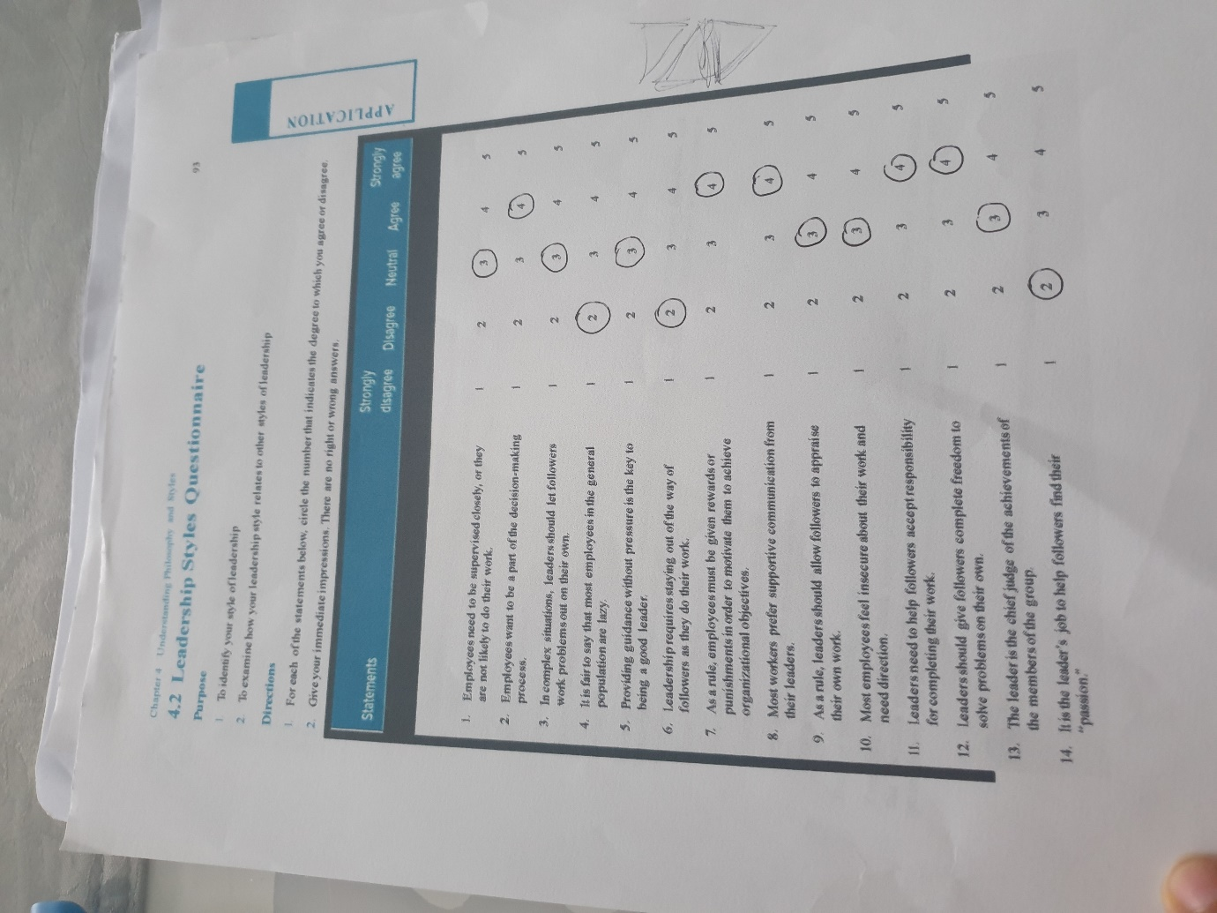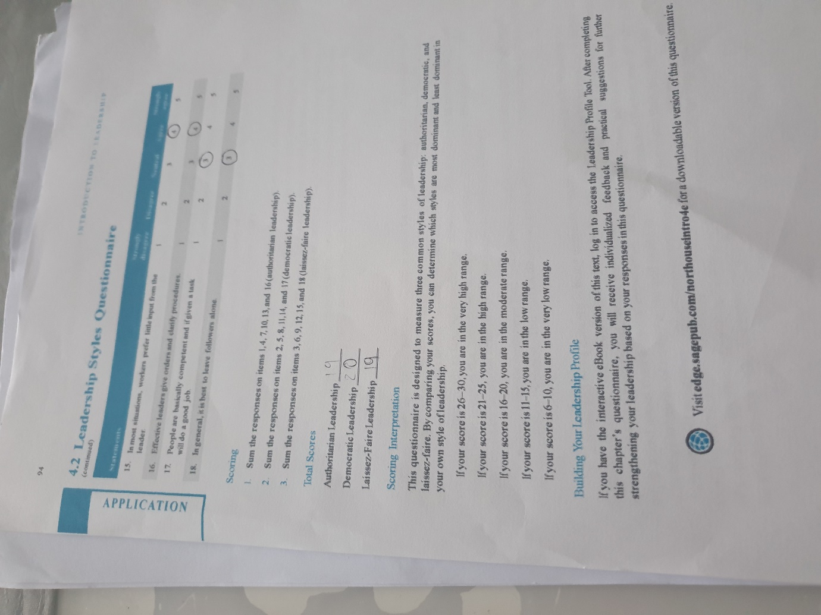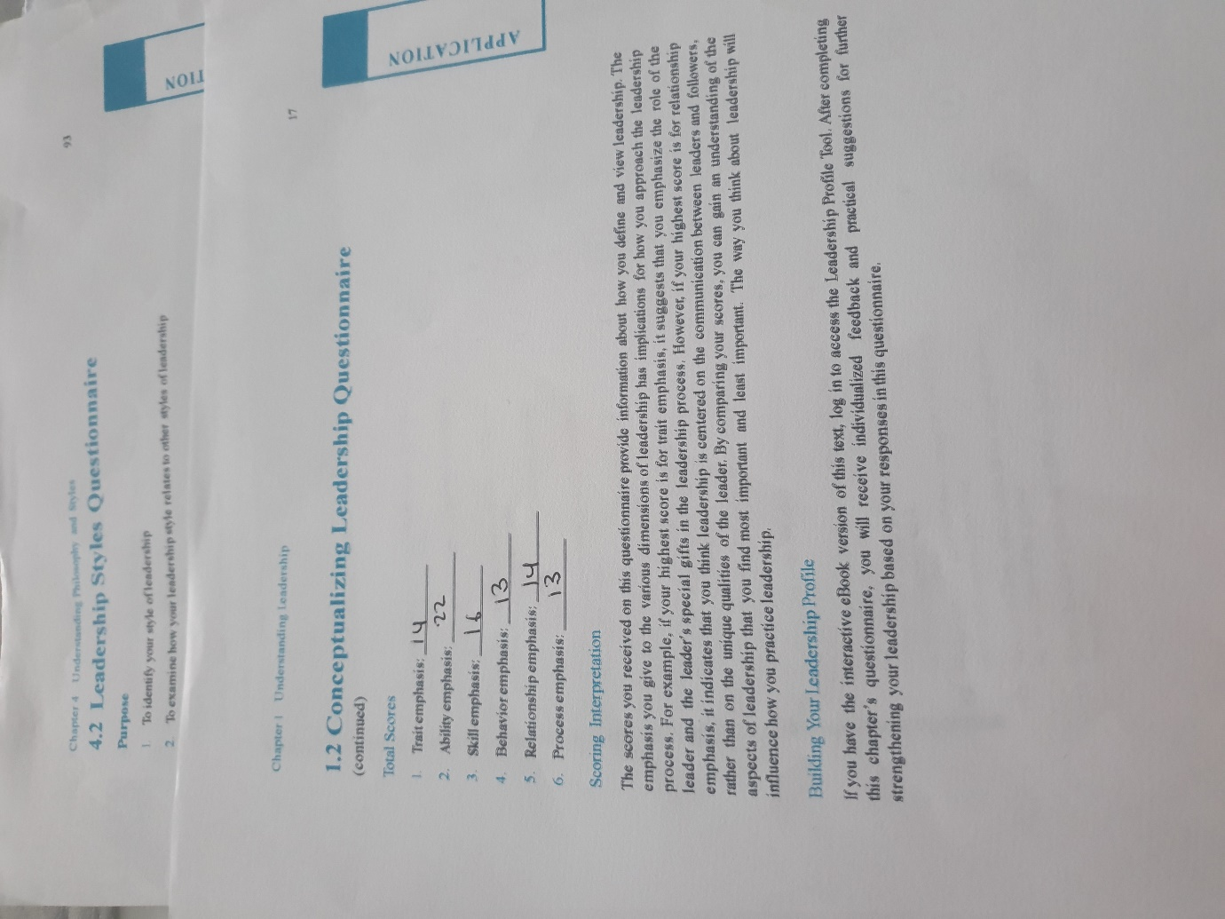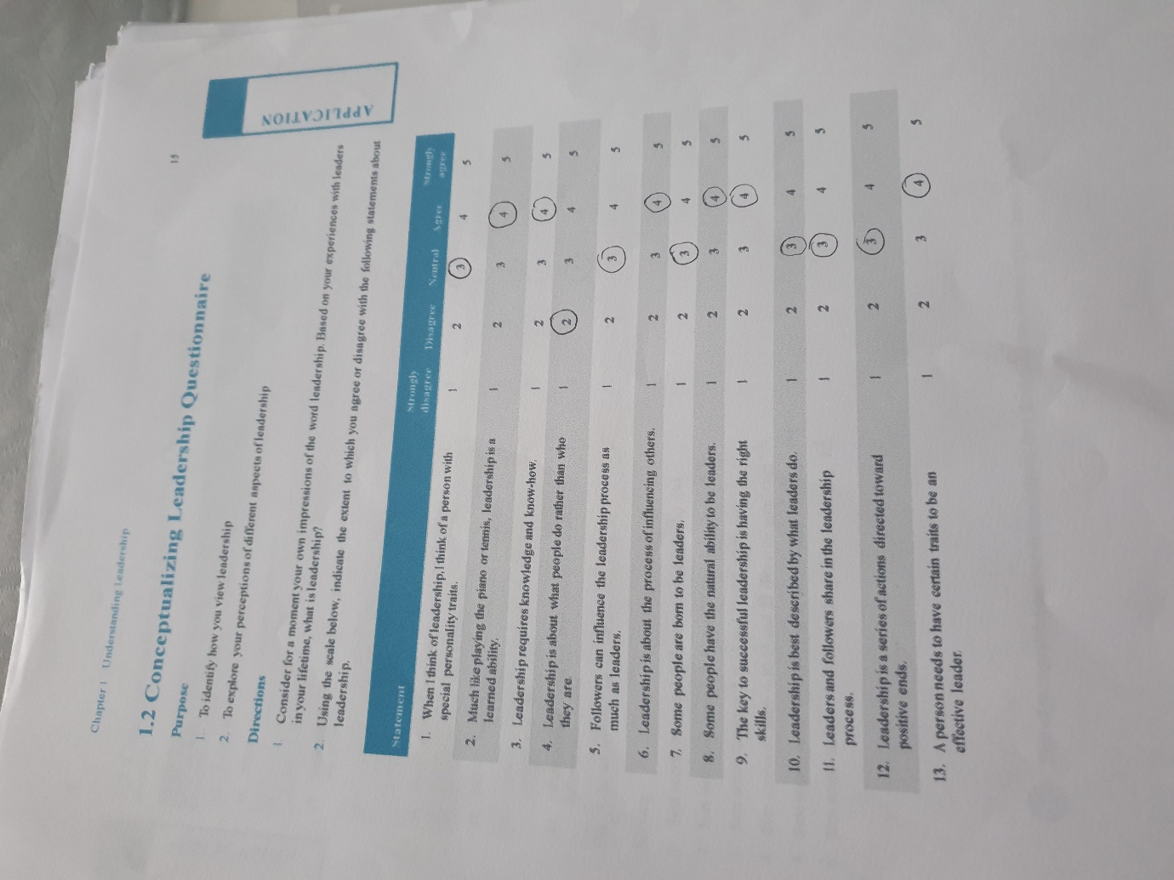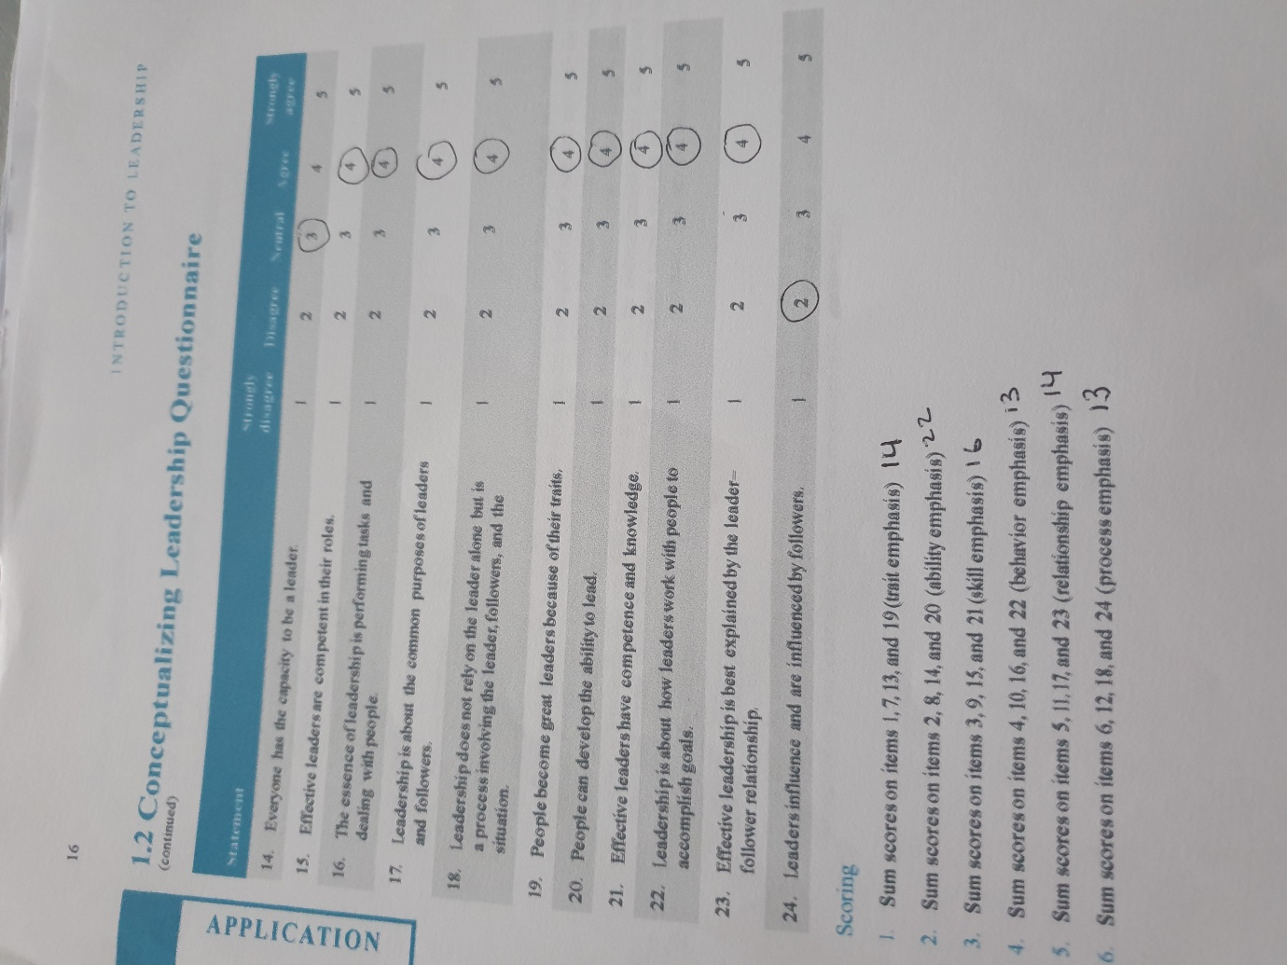

Reference list Alan sugar

Admin, 2014, 10 interesting facts about Alan Sugar available at : https://www.10interestingfacts.com/facts-about-alan-sugar.html accessed: 19/10/2020

Alan Sugar (2010) [Alan Sugar what you see is what you get] McMillan 2011 pg. 11
Anderson, 2013. 10 reasons why Alan Sugars autobiography is so inspiring. Available at: http://www.thereferralauthority.com/10-reasons-alan-sugars-inspiring/ accessed: 31/10/2020

BBC, News, 2007 profile sir Alan sugar available at: http://news.bbc.co.uk/1/hi/business/6923678.stm accessed: 27/10/2020

Bock, W 2006 Are Leaders Born or Made? Available at: http://www.threestarleadership.com/articles/bornormade.htm
accessed: 31/10/2020

Colin. P Silverthorne 2005 [organizational psychology in cross culture perspective] cataloguing publication New York – London pg. 61

Charlie. B 2009 Sir Alan Sugar The Biography john Blake publishing LMTD. London

Daft, R.L. 2008 The Leadership Experience. 4th Edition, Thomson Corporation, Stamford.

Edward. J.S 2012 [Transformational leadership: Trust, Motivation and Engagement] Trafford publishing united states of America pg.2

EPM 2009-2018 Expectancy Theory available at : https://expertprogrammanagement.com/2018/10/expectancy-theory/ accessed: 12/11/2020

Emma. M (2010) The unauthorized guide to doing business the Alan sugar way first edition capstone publishing limited United Kingdom pg. 5

Gitman .JL, McDaniel, 2008 [The future of the business :The essentials ] third edition united states of America pg.208

Indeed (2020) What Is Situational Leadership? Definition, Advantages vs Disadvantages and Examples available at : https://www.indeed.com/career-advice/career-development/situational-leadership accessed: 14/11/2020

Indeed (2020) Leadership Skills: Definitions and Examples available at : https://www.indeed.com/career-advice/resumes-cover-letters/leadership-skills accessed: 14/11/2020

Jessica.L, 2018 lord sugar’s net, worth, age ,wife and children as the apprentice returns available at: https://metro.co.uk/2018/10/03/lord-sugars-net-worth-age-wife-and-children-as-the-apprentice-returns-8003353/ accessed: 19/10/2020
Kendra. C, 2020 the old age debate of nature vs. nurture available at : https://www.verywellmind.com/what-is-nature-versus-nurture-2795392 accessed: 31/10/2020

Kendra 2020 What is motivation? Available at: https://www.verywellmind.com/what-is-motivation-2795378 accessed: 1/11/2020

Keith. M 2020 10 Disadvantages of Transformational Leadership available at : https://futureofworking.com/10-disadvantages-of-transformational-leadership/#:~:text=10%20Disadvantages%20of%20Transformational%20Leadership.%201%201.%20Influence,Assumption%20of%20Motivation.%205%205.%20Risky.%20More%20items accessed: 14/11/2020

Live and Learn, 2020, why is Alan sugar an successful entrepreneur? available at: https://www.liveandlearnconsultancy.co.uk/alan-sugars-business-tips/ accessed: 27/10/2020

L&PP 2019 Lewin’s leadership style explained available at : https://leadershipandperformance.com.au/leadership-development/lewins-leadership-theory-explained/ accessed: 14/11/2020

Michael Armstrong ( 2006) [performance management key strategies and practical guidelines]
(3rd edition) Great Britain and the united states in 1994 by Kogan Page limited

Mindtools, 2020, leadership styles available at : https://www.mindtools.com/pages/article/newLDR_84.htm accessed: 30/10/2020

MSG, 2020 leadership basics available at : https://www.managementstudyguide.com/leadership_basics.htm accessed: 30/10/2020

Mindtools, 2020 Theory X and Theory Y available at : https://www.mindtools.com/pages/article/newLDR_74.htm accessed: 01/11/2020

Martin. R 2014 leadership skills: should it be a love or hate relationship? Available at: https://www.theguardian.com/careers/careers-blog/leadership-skills-successful-leader accessed: 01/11/2020

Melissa. J 2017 what is a psychological contract? Available at : https://www.breathehr.com/blog/topic/employee-engagement/what-is-a-psychological-contract#:~:text=%20What%20is%20a%20psychological%20contract%3F%20%201,important%20aspects%20of%20the%20psychological%20contract.%20More%20 accessed: 11/11/2020

Mullins. LJ 2016 Management and organisational behaviour Eleventh edition Pearson Education limited Great Britain pg. 311

Robbin. M, 2019, sugar scoop available at : https://www.thesun.co.uk/tvandshowbiz/6580328/alan-sugar-wife-ann-simons-children-wedding/ accessed: 19/10/2020

Rachel. K 2006 Head to head: tough boss , god boss? Available at : http://news.bbc.co.uk/1/hi/business/4758833.stm accessed: 01/11/2020

Swaroop and Prasad(2013 Are Leaders Born or Made? Pacific Journal of Marketing and Management Review. Vol 2. [Online] Available at: http://indianresearchjournals.com/pdf/APJMMR/2013/August/3.pdf
accessed: 31/10/2020

Stephenson, C 2004 Are Leaders Born or Made? Ivey Business Journal [Online] Available at:http://iveybusinessjournal.com/departments/from-the-dean/are-leaders-born-or-made#.UtUxZvRdVto accessed: 31/10/2020

Unknown no date 1.2 conceptualizing leadership questionnaire available at : https://edge.sagepub.com/system/files/questionnaire_ch01_0.pdf accessed: 14/11/2020

Unknown no date 4.2 leadership style questionnaire available at: https://edge.sagepub.com/sites/default/files/4.2_Leadership_Styles_Questionnaire.pdf accessed: 14/11/2020

Will. K 2020 Hersey Blanchard model available at : https://www.investopedia.com/terms/h/hersey-and-blanchard-model.asp accessed: 01/11/2020

Your coach 2009-2020 Vroom expectancy motivation theory available at: https://www.yourcoach.be/en/employee-motivation-theories/vroom-expectancy-motivation-theory.php accessed: 12/11/2020

Bibliography
Cottrell. S 2005 Critical thinking skills developing effective analysis and argument Palgrave Mc Millan New York pg. 13

Cottrell. S 2003 The study skills handbook second edition Palgrave McMillan limited New York pg. 90

Cottrell. S 2010 skills for success second edition Palgrave Macmillan limited New York pg. 52
Mullins. LJ 2016 Management and organisational behaviour Eleventh edition Pearson Education limited Great Britain pg. 311
Knox. S, Maklan. S Payne. A, Peppard. J, Ryals. L 2003 Customer relationship management perspective from the marketplace Butterworth Heinemann oxford

