Investigating how 'No-Frills' stores Aldi and Lidl have taken on Supermarket Giant Tesco

By
UWTSD Number:
May 2016



Investigating how 'No-Frills' stores Aldi and Lidl have taken on Supermarket Giant Tesco

UWTSD Number:
May 2016

I declare that the following study is the result of my own work, which has been conducted in line with UWTSD standards.
All references within the dissertation are acknowledged.

Signed……………………………………. Dated………………………………………

Acknowledgements

I would like take this opportunity to thank my dissertation supervisor, Helen Evans, for the support and guidance received over the last year, together with my other lecturers, Karen Neville and Mike Thomas for their input.
I would also like to thank my mother, father and sister as well as other family and close friends, who have supported me to do my best and achieve my goals, especially my mother who has been studying on this degree course with me. Although it has been brilliant, difficult and stressful at times, we have both managed to complete the course to an excellent standard and this is a great achievement. For this I am forever grateful and proud of what we have both achieved.
I would also like to thank,xxxxx my fellow students who have helped throughout my time of study, both in and out of lectures. Together we have helped each other overcome difficulties throughout the year and the duration of this course. Thank you for your support and friendship, I am sincerely grateful.

Through their support, I have been able to complete my studies to my highest ability.

Thank you.

Abstract

This dissertation researches grocery shopping in the UK and aims to identify how 'no-frills' stores Aldi and Lidl have taken on Supermarket Giant Tesco. Research focused on investigating changing consumer shopping trends in the UK, to identify how no-frills stores had changed the perception of consumers. Customer loyalty was also research to determine what factors create loyalty in the supermarket industry.
These objectives helped focus the research which was conducted through secondary and primary research. Quantitative data was collated through a questionnaire, whilst additional interviews enabled more in depth qualitative data to be obtained. By using Facebook to generate responses, a snowball sample was produced that led to 112 questionnaires being completed.
The results obtained from analysed findings helped identified that consumer shopping trends are changing, with convenience shopping becoming a major current trend. German no-frills stores have managed to change perceptions of consumers and are gaining market share as a result. Although many believe that customer loyalty is created by price, the research identified that this is not the consumer’s main focus within the food retail sector. Quality was acknowledged as key to retaining a loyal customer base.
The findings from this study help provide evidence into changing consumer trends, shifts in customer loyalty and the improving consumer perception of Aldi and Lidl in the UK market.

Contents

  - Introduction 8
  - Aims and Objectives 8
  - Study Structure 8
  - Literature Review 10
  - Introduction 10
  - Market share 11
  - An investigation into changing consumer shopping trends in the UK 11
  - How no-frills stores have changed the perception of consumers 13
  - To assess what determines customer loyalty within the supermarket industry 15
  - Conclusion 18
  - Research Methodology 20
  - Introduction 20
  - Primary research 21
  - The Questionnaire 21
  - Piloting 22
  - Conducted Interview 22
  - Secondary Research 23
  - Sample type and size 23
  - Validity and Reliability 24
  - Ethical considerations 24
3.9 Outcomes 24
  - Findings and Analysis 27
  - Introduction 27
  - Findings 27
  - Summary 44
  - Conclusion 46
  - Introduction 46
  - Research Objective 1: An investigation into changing consumer shopping trends in the UK 46
  - Research Objective 2: How no-frills stores has changed the perception of consumers 47
  - Research Objective 3: To assess what determines customer loyalty within the supermarket industry 48
  - Limitations 50
  - Future Research Direction 50
References and Bibliography 52
Appendices 59
Appendix A - Ethics Form 59
Appendix B: Blank Questionnaire 63
Appendix C: Blank interview questions 67
Appendix D: Interview Responses 68
Appendix E: Interim report 73

Chapter One
Introduction, Aims and Objectives

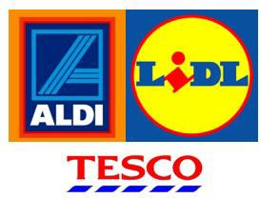

Introduction

Supermarket giant Tesco has dominated the food retail industry, as the market leader in the UK. However, as competition between supermarkets has significantly increased, this has allowed no-frills supermarket stores Aldi and Lidl to gain market share.
The aim of this research was to investigate how no-frills stores Aldi and Lidl have taken on supermarket giant Tesco. The approach and strategy used to conduct research is referred to as a methodology (Wilson 2012:304); the methodology applied in this study to obtain the necessary data was through conducting a questionnaire and subsequent interviews.
The secondary research identified within the literature review was used to design the primary research questions that followed. These questions were intended to expand on published concepts of consumer trends, customer perceptions and customer loyalty.

Aims and Objectives
The aim of this research study is to identify how 'no-frills' stores Aldi and Lidl have taken on Supermarket Giant Tesco.
The following objectives will help answer this research aim:

    - An investigation into changing consumer shopping trends in the UK

    - How no-frills stores have changed the perception of consumers?

    - To assess what determines customer loyalty within the supermarket industry?

Study Structure

The next chapter provides a relevant literature review and is followed by Chapter 3 which addresses the research methodology. Chapter 4 contains detailed findings and analysis, which also includes tables and graphs. Chapter 5 concludes the full dissertation study.

Chapter Two
Literature Review

Literature Review

Introduction

The concept of supermarkets has captured the grocery market and ended the era of the small grocer (Wimberley and McClean, 2012). Increasing competition between these supermarkets has significantly changed the structure of the food retail sector (Revoredo-Giha and Renwick, 2012). This category has become dominated by supermarkets, with food stores now accounting for over 40% of total retail sales in the UK (ONS, 2014). Increased price competition amongst supermarkets has allowed discounted supermarket chains to increase their market share (ONS, 2014). By 2019, the UK food retail industry is predicted to be worth
£209.9 billion, increasing by an estimated 8.8% since 2014 (Marketline, 2015).

Tesco is one of the biggest supermarkets within the UK, with a market share of 28.6% (Rickard Straus, 2014). However, year on year this figure has been slowly falling, as cheaper no-frills stores’ market shares has been rising. In 2007, ‘£1 in every seven’ was being spend in Tesco across the UK (Wallop, 2007). However, by 2014, it was reported that Tesco was ‘losing one million shoppers a week’ to no-frills businesses Aldi and Lidl, resulting in an estimated average expenditure loss of £25 per lost visit (Ruddick, 2014). Tesco have lost the most market share in 20 years to rival discounters, and consequently, Aldi and Lidl have begun to ‘grab shoppers’ from the leading grocery chain (Ruddick, 2014).
Aldi and Lidl are both global German discount stores, who strategically stock their own branded products at a significantly lower price than those of the larger supermarkets. The Aldi and Lidl experience is noticeably different from regular supermarkets; they choose to stock less products, whilst regularly offering a changing array of bargains (Osborne, 2012). In a 2012 Guardian survey, a comparison was made of shopping baskets containing 33 items; Aldi were 16% cheaper than Asda, 20% cheaper than Tesco and 40% cheaper than Waitrose (Osborne, 2012).

Market share
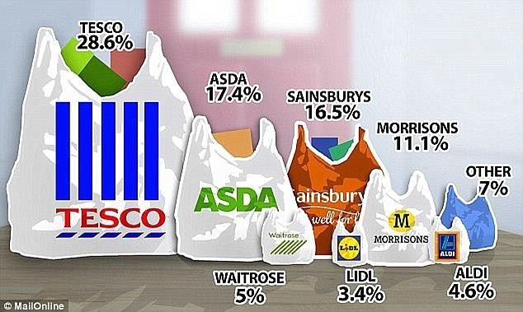
Tesco | 27.9%
Sainsbury’s | 16.6%
Asda | 16.4%
Morrisons | 10.8%
The co-operative | 6.3%
Aldi | 5.6%
Waitrose | 5.2%
Lidl | 4.4%

2014 Market Share 2015 Market Share
Source: www.thisismoney.co.uk November 2015 Market Share, (BBC 2015)

These above illustrations indicate the changing market share of Tesco, Aldi and Lidl, from 2014 to 2015. This confirms the view of Butler (2014) who acknowledges that Aldi is growing fast then Lidl (Butler, 2014).

An investigation into changing consumer shopping trends in the UK

In the UK, customer shopping habits have changed considerably. The joint market share of discount supermarkets has doubled to 10% in just three years (BBC, 2015). McKevitt (2015), acknowledged that in 2012, Aldi and Lidl only held a 5% share of the market and it took them 9 years to double their combined share. Aldi and Lidl are now attracting an additional million shoppers per week, with the average spend per trip increasing by 4% to £18.85. The discounters are showing no sign of stopping and plan to open 100 stores between them, to reach a wider British population (BBC, 2015).
Stevens (2014), suggests that customer shopping trends have changed, as shoppers now ‘shop to a budget, spread over the week and in a simpler format’ (Wallop, 2014). Don (2015) confirms this view by acknowledging that the once traditional Friday and Saturday shop has declined, whilst midweek shopping is growing, indicating that more customers are convenience shopping. With many shoppers now do a ‘top up shop’ rather than the usual ‘weekly shop’, it has been reported that the younger demographic shopper has also moved to convenience shopping, with the suggestion that this may be due to an increase in spontaneous cooking (The Grocer, 2015).

Convenience shopping is an increasing trend, particularly as 16% of consumers in a nationwide survey confirmed they never use a shopping list and 60% only write down the key products they require (The Grocer, 2015). IGD figures show the convenience market is now worth £37.7 billion, with forecasted growth of 17% to £44.1 billion by 2020 (Don, 2015). In response to this consumer trend, Aldi have recently started to open convenience stores, which are smaller than their usual 10,000 square feet stores whilst still offering customer parking (Halliwell, 2013).
Consumers now choose not to travel any unnecessary distance to a supermarket, unless they are fairly certain that they will be able to get everything they want due to the increasing trend of convenience shopping (Vizard 2014). Aldi and Lidl’s strategy is to offer competitive prices in stores located close to where people live, which have smaller square footage and therefore quicker to get around (Craven, 2014), in comparison to large supermarket stores, which are generally located in out of town locations. Tesco has a presence in every single postcode in the UK (Marketline, 2014), and actively targets a large proportion of UK shoppers. However, convenience shopping in general has also been fuelled by the availability of these smaller stores, as consumers now make more frequent shopping trips, rather than making one weekly trip to an out of town supermarket (Ruddick, 2015).
Supermarkets generally offer a wide range of products for weekly shoppers, however, the German competitors Aldi and Lidl have strategically aimed at ‘little but often shoppers’ with a more limited range of products whilst still including high quality goods (BBC, 2015). Copestake (2015), has identified that due to demand, a typical Aldi store which previously offered consumers 800 items has now increased its product range to 1,200 items. However, this is still significantly less than the supermarket giant Tesco, which holds approximately 50,000 items, leading critics to suggest that it overstocks its stores and offers far too much choice (BBC, 2015).
Whilst the popularity of Aldi and Lidl has been related to the difficult economic times consumers experienced during the recession (Retail Gazette, 2014), Aldi and Lidl are now also reaching a wider audience by encouraging all consumers to shop around (Wallop, 2014). They are gaining further market share by recently attracting ‘middle and upper class shoppers’ with their award winning wine, lobster tails and Belgian chocolates (BBC, 2015). This trend is statistically supported, as more than 31% of shoppers at Aldi and Lidl are now from the AB

demographic (A being upper class, B being middle class), (Shadbolt, 2015). This can be compared to figures from two years ago, which show this segment was only represented by 12% shopping at Aldi and Lidl. This trend has also been supported by middle class people on holiday in Europe, who purchase groceries from the continental Aldi or Lidl stores (BBC, 2015). This introduction to low store prices and high quality produce, encourages continued shopping in Aldi and Lidl in the UK (BBC, 2015).
With consumer shopping trends continuing to change in the UK, customer loyalty has also been affected. Previously, consumers were considered loyal to one trusted supermarket and it brands, but this has changed as shoppers are now easily able to ‘shop around’. Caminal (2012), suggests supermarkets retain customers by treating repeat buyers better then newcomers.

How no-frills stores have changed the perception of consumers

Aldi and Lidl both invest in television marketing campaigns to promote their products, and these may have been instrumental to changing the perception of consumers in the UK. Aldi and Lidl’s marketing strategy has been to make memorable adverts ‘sprinkled with humour’ (Aldi, 2016). Not only have these encouraged consumers to buy their cheaper products it has also changed customer perspective by providing a credible alternative to the big-name brands (Aldi 2016). Aldi and Lidl have also stressed that consumers do not have to ‘compromise on quality’ (Aldi 2016) to benefit from a more economic shopping experience.

Aldi and Lidl have also attracted consumers through marketing their random array of middle aisle bargains referred to as ‘special buys’ (Aldi, 2015) in weekly ‘Pick of the Week’ printed publications. These topical themed goods include ‘Back to School’ and Christmas ranges, as well as a seasonal weekly theme such as ‘Going Skiing’ (Butler, 2014). Such product ranges are also supported by their regularly updated TV advertising, which advise consumers to ‘best be quick, once they’re gone, they’re gone.’ This is strategic marketing to attract customers to discount stores.

Aldi and Lidl both use good instore marketing prompts, to entice customers to purchase items they may not have intended buying. This spontaneous purchasing is also encouraged by strategically placed products, displayed at eye level (Wimberley and McClean, 2012).

Previously, many shoppers visited Aldi and Lidl in search of a bargain (BBC, 2013). However, in recent years these stores have become increasingly more popular with the British consumer, with up to half of all households now shopping at these no-frills stores (BBC, 2013). This is partly because of the way in which they have changed consumers’ perception of supermarkets. Garner (2013), acknowledges that Aldi and Lidl have progressively managed to ‘change the perception from being a shop that only sells cheap stuff, to a shop that sells stuff cheaply’ (BBC News, 2013). Aldi and Lidl have recently won awards for quality food and drink, especially on their wine range and Aldi were awarded Grocer of the Year in 2014 (Marketline, 2014). This may have positively influenced consumer perceptions of no-frills stores.
Wallop (2014) acknowledges that Aldi and Lidl have removed the ‘stigma attached to them’; through the concept of ‘not selling cheap stuff, but selling stuff cheaply’ and their key award winning product ranges have helped the discount stores change the perceptions of the UK customers (Wallop, 2014). Simon (2015), supports this view and acknowledges that Lidl and Aldi are ‘not only successful because they are cheap, they are successful because whilst they are cheap, they are still able to offer consistent quality’. Aldi keeps its prices low as it currently stocks 90% of own branded goods, (Dryburgh, 2014). The quality is suggested to be about 10% lower than the classical brands, but as the prices are 30% lower, this means that the customer gets more value per pound spent (BBC, 2015).
Dryburgh (2014), acknowledges that it is difficult for Tesco to compete with no-frills stores on price and cost, as the whole business strategy of no-frills stores is systematically cheaper. Aldi and Lidl have optimised their systems to save time and money, allowing them to keep their costs low. These concepts include cheaper lighting, swifter check out conveyor belts that drop the items straight into customers trolleys, and displaying bar codes on each side of the products to save the check-out operator time (BBC, 2015). Improved store organisation and layout has helped change customer perceptions, from shopping in a basic warehouse to a far more organised and acceptable store concept. Less stock has resulted in extremely effective and efficient working practices that keep prices low, whilst too much choice can produce a costly shopping experience (Butler, 2014). The following perceptual map of supermarkets conducted by Nottingham University Business School acknowledges that Aldi and Lidl’s product range is far narrower than that of Tesco.

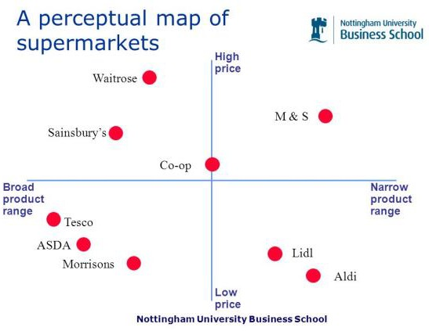

Source: http://www.nottingham.ac.uk/search.aspx?q=perceptual+mapping

Aldi is perceived to offer high quality at low prices, compared to Lidl who appear to offer lower quality at relatively higher prices (Riley, 2014). However, (Wallop, 2014) suggests that consumers perceptions must be changing favourable toward no-frills stores, as it is now commonplace and socially acceptable to go to a dinner party and there be Aldi or Lidl products presented, including their award winning wine. This supports the earlier acknowledgement that discount stores are now attracting a wealthier class demographic (Butler, 2014).

To assess what determines customer loyalty within the supermarket industry

It has been suggested that the real supermarket war is not over pricing strategies, it is over customer loyalty (Ward, 2014). The Institute of Customer Service (ICS), state that ‘customer loyalty should remain a key driver amongst those retailers considering switching to a price slashing philosophy’ (Ward, 2014). Although price does influence customer decisions on where to shop, it is not just price alone that makes customers switch supermarkets. Customer service and high quality are still key drivers in people’s choice of retailers. Avaya (2008) suggest that the longer a company can keep customers loyal, the more likely it is to increase profits.
Aldi use to target ‘fickle, hard core bargain hunters looking for a few items’. However, the chain are now strategically attracting far more loyal shoppers, by opening more local, easier access stores (Wallop, 2014). Aldi’s loyal shoppers now make up to 4.5% of its customer base (Wallop, 2014).

85% of UK households have at least one loyalty card from one of the Big Four (Trench, 2010). Tesco were the first to market supermarket loyalty cards with their Clubcard, and it is not a concept that Aldi and Lidl chose to offer (Osborne, 2012). Tesco Clubcard collects huge amounts of information on customer shopping habits (Poulter 2013) and with 15 million users this indicates they still retain loyal customers. Tesco use data collected to micro segment their customers into different categories, such as affluence and age (Wallop, 2012). The level of data now collected through loyalty cards allows supermarkets to target, personalise and customised promotions for specific customer. However, some critics now believe that Tesco stereotype their customers (Wallop, 2012), by directing value range vouchers to price sensitive customers and Tesco Finest range vouchers to their more upmarket customers (Steiner, 2012).
Sirohi et al. (1998), criticises loyalty cards, and refers to customers that use coupons and vouchers as ‘cherry pickers’ who go into stores to only purchase these certain items, rather than buying additional items which then creates profits and loyalty. Critics also suggest that loyalty schemes are expensive and a significant number of customers do not claim the awards and benefits that they are due (Butler and Henery, 2005). They also state consumers lack interest in loyalty programmes, with many customers not bringing their loyalty cards to the checkout. This could be related to consumers’ privacy concerns regarding the level of data held on them by the supermarkets. Many believe that customer loyalty towards supermarkets is ‘dead’ (Wallop, 2014). This is supported by reports suggesting that customer loyalty cards are ‘becoming meaningless to the customer’ (Poulter, 2013), as many consumers now want instant benefits when shopping, rather than having to collect points over a period of time and then having to wait for discount coupons to be sent in the post.
Pettijohn and Rozell (2009), state that store loyal customers were found to hold a lower education level, be in lower social economic groups and lower incomes. By comparison, disloyal shoppers were found to hold higher incomes, higher education levels and be part of higher social economic groups. This however, could relate to the locations of stores. East et al. (1995), argue that there is no correlation between someone’s income or education and the likelihood of them being more or less loyal. However, it was identified that store loyal shoppers are more likely to fall into the 25 to 44 age range. Huddleston et al. (2003), state store loyal customers spend approximately 32% more than non-loyal shoppers.

Customer loyalty is also disappearing in an increasing technological world, therefore it is essential for supermarkets to have a good online presence. Online grocery shopping has increased to 60% in the last five years, compared to only 5% back in 2009 (Food Navigator, 2014). This new convenience trend has allowed consumers to shop around online, looking for the best deals and prices in the comfort of their own homes. Online grocery sales are predicted to double from £5.6 billion to £11.1 billion in 2018 (Wilcock, 2015). The new trend of home delivery has led to many supermarkets having an online presence. Tesco have been online for over a decade, now offering their free ‘Click and Collect’ service to customers. However, Aldi and Lidl still do not have an online presence, although Aldi are due to launch online grocery services across Europe (Telegraph, 2015). Barber (2015) confirms that Aldi and Lidl have plans to take on the Big Four’s home delivery service within the next year.
According to Daneshku (2014), online shoppers tend to be more loyal than in store shoppers. Tesco’s online shoppers spend 46% of their total grocery budg88et with the retailer, however in store shoppers spend just 29% (Marketline, 2014). This could be due to instore shoppers visiting more than one store when out shopping, in comparison to shopping online, when generally all shopping is purchased from one site and less impulse purchasing takes place. Increasing e-commerce has also encouraged the trend for supermarkets to provide recipe apps on m-commerce, not only to promote recipe ideas, but also to locate where ingredients can be found in store and to track home deliveries (Wimberley and McClean, 2012).
In the run up to Christmas 2015, it was suggested that a third of shoppers were still undecided about where they would do their Christmas shopping. 42% were thought to be leaving it to the last week, with 12% leaving it to the last minute; it is therefore essential for supermarkets to attract customer in the run up to Christmas and the party season (KamCity, 2015). 12% of consumers state their minds can be changed from the supermarket Christmas TV advertising. However, Nevens (2015), believes that shoppers will remain loyal to the retailer they shop with all year around, as shopping habits are hard to break even at Christmas. 70% of shoppers were predicted to use Aldi and Lidl over Christmas, due to their prices, quality of product and new Christmas product range (KamCity, 2015).This concept is contradicted by Tuttle (2014), who suggested that many consumers will dismiss shopping in Aldi and Lidl due to the absence of brands they recognise, their smaller stores, smaller sections and no coupons offered for their loyalty.

Brand matching has now become a new strategy between the Big Four retailers to help retain and gain customers’ loyalty (Marketline, 2015). Along with the benefits provided by the Tesco Clubcard, Tesco has recently launched a price-beating guarantee for consumers, however Manez (2006), suggests this is just an advertising strategy to signal low prices.

Conclusion

Consumer shopping trends in the UK have changed, with many consumers beginning to shop in no-frills stores as a result of having less disposable income during the recession. However, consumers have now started using Aldi and Lidl out of choice as they are enjoying the benefit of purchasing high quality produce with a reduced shopping bill. With consumer perceptions of no-frills stores improving, it would be debateable whether this new trend will revert back to more expensive and time consuming shopping habits. Therefore previous customer loyalty is being tested within the supermarket industry.
No-frills stores currently show no sign of stopping their takeover of supermarket giants, particularly as their future strategy includes opening hundreds of stores between them to reach a wider British population (Schram, 2015). Lidl has ambitious plans to move into the USA in the next three years (Brown, 2015), whilst Aldi has a huge expansion plan of opening new stores across the UK. Aldi is set to outgrow Tesco by almost ten times in 2015, as opposed to Tesco who have announced earlier in the year that they are scrapping 49 store openings (Ruddick, 2015).
Critics however argue the game is not over for the supermarket giants. Dennis (2015) recognises that Aldi and Lidl’s growth in Germany has begun to plateau, which could eventually be mirrored in the UK. For the supermarket giants to make a comeback, they need to differentiate and play to their strengths (BBC, 2015). Dennis (2015) also believes that Aldi and Lidl are in an identity crisis, as they either need to push themselves to the premium end of retailing or push themselves to the discount end (BBC, 2015). Therefore, Shadbolt (2015) concludes that ‘discounters might have won the battle, but the Big Four could yet win the war’.

Chapter Three
Research Methodology

Research Methodology

Introduction

The aim of this research was to investigate how no-frills stores Aldi and Lidl have taken on supermarket giant Tesco. The approach and strategy used to conduct research is referred to as a methodology (Wilson 2012:304). To obtain the data required in this study, several research methodology were applied.
The secondary research identified within the literature review was used to design the primary research questions that followed. These questions were intended to expand on published concepts of consumer shopping behaviour, and were devised to obtain more current and up to date shopping related information.
Research is the acquisition and analysis of information (Cole 1996:279). Information was gathered using a combination of primary research, backed by secondary research from academic journals, books and the internet. The questionnaire was designed to contain mostly closed questions, in order to analyse quantitative data. Quantitative data enables statistical analysis (Creswell 2003:18). Open questions were also used to gather respondents’ feelings and opinions. Open questions enabled the collection of qualitative data, based primarily on perspectives of individual experiences (Creswell 2003:18). A mix of qualitative and quantitative research was therefore necessary.
The methodology choices will be used to answer the following objectives:

    - An investigation into changing consumer shopping trends in the UK
    - How no-frills stores has changed the perception of consumers?

    - To assess what determines customer loyalty within the supermarket industry?
The primary research methods used were:

    - Initially, an online questionnaire was created and posted via Facebook social media, to engage with the widest range of respondents possible.
    - Secondly an interview was conducted, based on the main trends identified from the completed questionnaires. This resulted in richer data being obtained.

Primary research

Primary research is data collected by the researcher rather than relying on external resources. Three main types of primary research include questionnaires, interviews and observation (Wilson 2012:166). A questionnaire was chosen as the first primary research method to gather the most valid and reliable data available. This was a fully structured technique (Jankowicz 2005:222).

The Questionnaire

A questionnaire is a form of primary research which provides a huge amount of information about the chosen customer base (Williams 2005:162). The questionnaire was designed to collect both quantitative and qualitative data. It was important to word the questions so that the research aims and objectives were answered in a focused manner. The questionnaire was created with software called Typeform, which provided a professional image in a user-friendly format.
The questionnaire was distributed through Facebook to allow for a high volume of respondents. Facebook is increasingly emerging as a valuable research tool that provides unique advantages to researchers (Moreno, 2013). Facebook is the largest social network in the world with over a billion and a half active users (Smith 2016), which included 894 million daily active users (CNN, 2016). By using this social media platform, it provided the researcher with access to hundreds of users a day. It also enabled users to share posts such as the questionnaire, resulting in an increasing number of views and therefore expanding the respondents frame. It was therefore essential that the structure of the questionnaire was simple, clear and quick to complete, so respondents did not lose interest, prior to the required information being obtained. Therefore a maximum number of 12 to 15 questions were asked, in order to keep the respondents engaged. A range of questions types were used such as multiple choice, rating scale and dichotomous questions which required one of two given answers.

Piloting

Misunderstanding a question can be an issue when completing research, as different respondents may read questions in a different way. Therefore it was essential to test the format and then send out a pilot questionnaire, to ensure all questions were correctly worded and to identify that they were effective in gathering the relevant information required. A pilot questionnaire was completed by 6 known respondents.
Gudmundsdottir (2010) emphasise how important the piloting process is, in order to learn from it and reduce mistakes in the main research study. As a result of the piloting process, an ambiguous question was made clearer.
It was originally hoped that 50 completed questionnaires would be received, to help aid in the reliability and validity of the results. However, due to Facebook and a snowball effect sample, a total of 112 questionnaires were collected and all data was collated into clear graphs, to visibly display the analysed results.

Conducted Interview

Having completing the questionnaire, the second method of primary research was obtained through a conducted interview. A 10% proportion of respondents were interviewed to gather more qualitative data, such as feelings, reasons and explanations. This was completed using a semi structured technique (Jankowicz, 2005:221), which allowed more in depth, flexible and elaborate responses to be collected (Wilson, 2012:147). Therefore, as 112 responses were obtained, 11 interviews were completed. It was vital for the interviewer to remain unbiased, to ensure the interviewees were not influenced when providing their responses. The data gathered during the interviews helped explain the reasoning behind the data collected from the questionnaire. The interview questions were chosen as a result of data collected from the questionnaire, as these findings backed up secondary research or disagreed with it. These additional questions therefore helped to provide a more in depth, richer data being collected.
By using both the questionnaire and interview techniques, this allowed for cross referencing and a direct comparisons of results; this approach is referred to as triangulation (Jankowicz, 2005:225)

Secondary Research

Secondary research is ‘information available from published sources externally and from company records,’ (Cole 1996:279). The full secondary research was provided in the comprehensive literature review in Chapter 2. Data was collected through books, academic journals, case studies, websites and newspapers. Newspaper articles were referred to, as the focus of this research study is on the supermarket industry which is current and rapidly changing.
The secondary data collected was used as a basis for the primary research and allowed key questions to be raised in the questionnaire and interviews enabling the main aim and objectives of this study to be answered.

Sample type and size

There are many sampling approaches which can be applied to a research study, and for this research, convenience sampling was chosen. Convenience sampling does not highlight a specific sample frame, and allowed for respondents who were ‘convenient’ sources of data for the researcher to question (Battaglia, 2008). A convenience sample was created through those online on social media, at the time the questionnaire was initially posted on Facebook. This escalated following the post being shared between respondents, and resulted in achieving a larger snowball sample of respondents completing the questionnaire. This can also be referred to a non-probability sample, as not everyone can be given the same chance of being asked, as those that are available at the time. This could have led to biased or inaccurate findings being collated, so to reduce this risk, a large sample size was chosen. Snowballing occurred as additional members of the population were generated from the original sample (Oakshott, 2014). Through the snowballing effect, a wider range of responses were collected. The initial aim of gathering 50 completed questionnaires was set to provide a good range of data to be analysed. However, by using the social networking site, the snowball effect took place and the amount of respondents increased to 112.

Validity and Reliability

It is always important for gathered information to be reliable, valid and accurate, and to ensure information was obtained in an unbiased way (Jankowicz, 2005). Validity confirms whether an item measures or describes what it is supposed to measure or describe (Bell, 1993:65), and identifies the extent to which a measure accurately reflects the concept that it is proposed to measure. (Wilson 2012:308) Therefore, it was vital for the questions used within the questionnaire were clear, and designed to meet the dissertation aims and objectives.
In order to be reliable, the questionnaires were consistently issued in the same way, under constant conditions on all occasions (Bell, 1993:64). All of the questionnaires were completed utilising the Typeform software, and all respondents were given the same questions, in the same order to ensure reliable data could be collected. Reliability is also concerned with repeatability (Wilson 2012:116). If the research was to be issued again, the method used would be able to be repeated. This allowed for more reliable and valid data to be collected. As the sample size double the expected level, this also increased the validity and reliability of the data collated.

Ethical considerations

Ethical considerations were applied when conducting this research study. All research complied with University of Wales Trinity St David’s guidelines and were completed to a high standard. The first consideration ensured all respondents were over the age of 16 years old. Ethical considerations when conducting a research study must also address confidentially and anonymity (Finn et al. 2000). All data research was conducted in line with the Data Protection Act 1998 (Gov, 2015). The Ethical Considerations Form can be found in Appendix A.

3.9 Outcomes

Data collected was analysed to identify the research objectives:

- to investigate the changing consumer shopping trends in the UK
- to identify how no-frills stores have changed the perception of consumers
- to assess what determines customer loyalty within the supermarket industry

Once 112 completed questionnaires were received and the subsequent 11 interviews were conducted, the information gathered was collated into visual graphs and tables. The results are displayed clearly within the research findings in Chapter 4, to indicate effective analysis of the data received. This was all done personally, for each individual questionnaire.
A black questionnaire is shown in Appendix B and the blank interview questions can be found in Appendix C.

Chapter Four
Findings and Analysis

Findings and Analysis

Introduction

The following findings shows the data collected in March 2016, on consumer shopping habits and respondents’ opinions on Aldi, Lidl and Tesco. 112 questionnaire were completed and 10% of these were asked 5 additional interview questions, to obtain more in-depth findings. 11 interviews were completed. This far exceeded the anticipated return of 50 questionnaires and resulted in the collation of more valid and reliable data. This can be attributed to the snowballing effect as the questionnaire was repeatedly shared on Facebook by friends.
By analysing the findings, the following research objectives will be addressed:

    - investigating changing consumer shopping trends in the UK

    - identifying how no-frills stores have changed the perception of consumers

    - assessing what determines customer loyalty within the supermarket industry

Interviews were then conducted and 5 questions were asked to 11 respondents in order to obtain more in depth, richer data. The following interview questions allowed respondents to explain why they shopped in these stores and allowed for a more in depth research to be collected. From the 11 interviewees, 7 were female (64%) and 4 were male (36%).
The findings contained in this chapter will be displayed in graphs, pie charts and tables. All data is given in percentages (%), if not otherwise stated.

Findings

Figure 1: Gender


FIRSTLY, ARE YOU...
Female Male

19%

81%

Figure 1.1: Gender
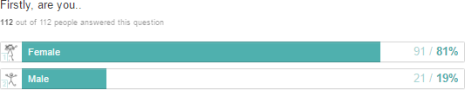

81% of respondents who answered the questionnaire were female. 21% of respondents who answered the questionnaire were male. The vast majority of responses were therefore obtained from females; however this is because females still do the majority of the grocery shopping and are more like to engage and respond to a shopping survey. Two-thirds of females are the primary grocery shoppers in their households (Retail Leader, 2013), with six in 10 women spending more than an hour shopping in the supermarket (Grocer, 2013).

Figure 2: Of the following three supermarkets: Where do you do the majority of your grocery shopping?
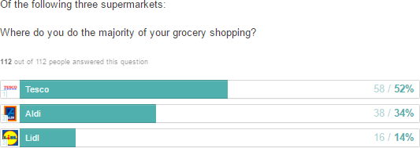

Figure 2.1: Of the following three supermarkets: Where do you do the majority of your grocery shopping?



OF THE FOLLOWING 3 SUPERMARKETS: WHERE DO YOU DO THE MAJORITY OF YOUR GROCERY SHOPPING?
Aldi Lidl Tesco

14%

52%
34%

This was a fundamental question as it showed that the majority of respondents (52%) do their main shopping in Tesco. Tesco is still the market leader in the UK with 28.6% market share (Rickard Straus 2014), so this analysis concurs with the secondary research found in the literature review. Aldi came second with 34% and Lidl had 14%. Collectively this is nearly half of the respondents, which is a high proportion of people and indicates the collective popularity of Aldi and Lidl is increasing.

Figure 3: Which of the following statements most closely reflects your shopping habits?

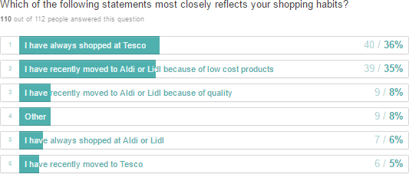

Where respondents answered ‘other’, the table below provides their fuller responses,
allowing for more qualitative data.

Other
Shop at both Aldi and Tesco | 6
I shop where it is cheaper | 1
I shop at Tesco as it is the easiest to get to and they home deliver | 1
I have no preference. Location is a bigger factor. | 1  =9

This shows that although 36% of respondents have always shopped at Tesco, 35% have recently moved to Aldi and Lidl because of low cost products; this is a high percentage and also backs up the secondary research highlighted in the literature review, that show many shoppers are moving to no-frill stores, for lower cost equivalent products. Tesco is reported to be losing ‘1 million shoppers a week’ to no-frill stores (Ruddick 2014).

Aldi and Lidl are gaining further market share by recently attracting ‘middle and upper class shoppers’ with their award winning products such as wine, lobster tails and Belgian chocolates (BBC, 2015). 8% confirmed they had moved to Aldi or Lidl due to the quality of their produce and this is due to their award winning collections.
These responses prompted more in-depth analysis which led to interview questions on what their shopping habits were and why. Many respondent mentioned they were influenced by the ‘locality’ of stores and favoured those that were geographically close to them, especially if they were university students or unable to drive. Others mentioned Aldi and Lidl’s products being ‘low cost.’ Also respondents mentioned Tesco was more ‘convenient’ as it offered all products in one place. A full list of interview responses can be found in Appendix D.

Figure 4: Shopping regularity
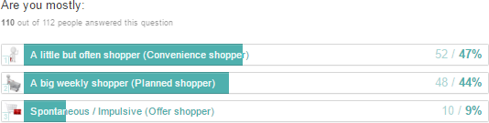

Figure 4 was to ascertain how often respondents went grocery shopping. ‘Little but often’ convenience shoppers accounted for 47%. This is a new trend in the UK, identified within the literature review, where many shoppers buy when they need groceries, rather than doing a big weekly shop. This would support Aldi’s decision to open convenience stores which are smaller than its usual stores (Halliwell, 2013). This also shows the big weekly shop is on the decrease, as many shoppers now do a ‘top up shop’ rather than the usual ‘weekly shop’, (The Grocer, 2015). 9% of shoppers confirmed they shopped spontaneously on impulse, or when discounts were on offer.

Figure 5: Do you use a shopping list?

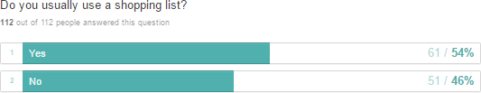

Figure 5.1: Do you use a shopping list?


DO YOU USE A SHOPPING LIST?
Yes No

46%
54%

From the respondents who answered the questionnaire, the majority (54%) confirmed they use a shopping list. This supports the findings in The Grocer, (2015), which reported that only 16% of consumers nationwide never use a list, whilst 60% write down the key products. This could be down to a more convenience shopping culture.














Figure 6: Which day are you mostly likely to do your main grocery shopping?
WHICH DAY ARE YOU MOST LIKELY TO DO YOUR MAIN GROCERY SHOP?
30
25
20
15
10
5
0
PEOPLE

(Data relates to the number of respondents, and not the percentage)

Don (2015), states that shopping traditionally done on a Friday and Saturday is declining. Most people used to shop on the weekend due to mothers working in the week, however this has now changed and more people are now shopping in the week as they are doing ‘top up shops’ (Grocer 2015). Collectively weekday shoppers accounted for 67 respondents and weekend shoppers accounted for 36 respondents. Monday is clearly the most popular day to do the main grocery shop.

Figure 7: Do you usually grocery shop online?

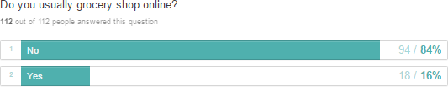

Figure 7.1: Do you usually grocery shop online?


DO YOU USUALLY GROCERY SHOP ONLINE?
Yes No

16%

84%

Online shopping has increased 60% in the last five years, compared to the 5% who shopped on line in 2009 (Food Navigator, 2014), however this is not reflected in the findings. The majority of respondents (84%) still do not shop online, which is a high proportion. Therefore, it could be argued that Aldi and Lidl do not need to be overly concerned about having an online presence.

Figure 8: Do you consider yourself to be a loyal grocery shopper?

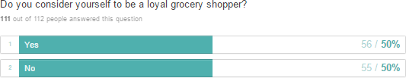

Figure 8.1: Do you consider yourself to be a loyal grocery shopper?

DO YOU CONSIDER YOURSELF TO BE A
LOYAL GROCERY SHOPPER?
Yes No
50%
50%

Many believe that customer loyalty towards supermarkets is ‘dead’ (Wallop, 2014). However, Figure 8 revealed that half of the respondents consider themselves to be loyal grocery shoppers, with the other half often shopping around either for the best price or due to convenience. Avaya (2008) suggest that the longer a company can keep customers loyal, the more likely it is to increase profits.

Figure 9: Do you consider yourself a more loyal online grocery shopper?
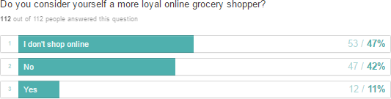

Figure 9.1: Do you consider yourself a more loyal online grocery shopper?



DO YOU CONSIDER YOURSELF A
MORE LOYAL ONLINE GROCERY SHOPPER?
I don’t shop online Yes No
42%
47%
11%

This graph indicates that shopping online does not make shoppers more loyal, as only 11% confirmed their loyalty to a certain store. However, it must be taken into account that 47% of respondents stated they did not shop online. 42% confirmed they did not consider themselves to be more loyal online grocery shoppers. This concurs with the new convenience trend which has allowed consumers to shop around online, looking for the best deals and prices in the comfort of their own homes.
Online grocery sales are predicted to double from £5.6 billion to £11.1 billion in 2018 (Wilcock, 2015). The easy accessibility of being able to shop around from the comfort of your own home, and being able to make direct product comparisons online before purchasing (MySupermarket, 2016).

Figure 10: Do you have a loyalty Tesco clubcard?

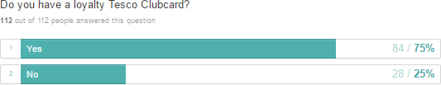

Figure 10.1: Do you have a loyalty Tesco clubcard?


DO YOU HAVE A LOYALTY TESCO CLUBCARD?
Yes No

25%

75%

Three quarters of respondents confirmed having a Tesco Clubcard, regardless of where they actually did their shopping. This supports the research conducted by Wallop (2012) who identifies that Tesco have over 15 million users. However, it is vital that Tesco keep this 75% majority interested and engaged in shopping in their stores, to maintain their customer loyalty.

Figure 11: Do you view your loyalty card as…

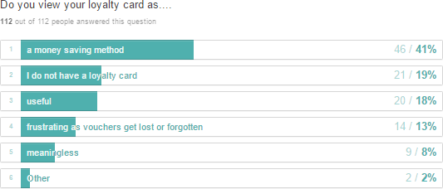

Where respondents answered ‘other’, the table below provides their fuller responses,
allowing for more qualitative data.

Other
Enjoy Clubcard points for hotel breaks | 1
Money saving aspect is good, however it is also a way for supermarkets  to monitor your purchasing habits which is more concerning | 1  =2

This highlighted that many consumers have a lack of interest in loyalty programmes, particularly because of the frustrations 13% experienced when they forget their loyalty cards or vouchers. However, findings indicate that 41% regard their loyalty card as a money saving method, which is one of the main reasons for its popularity. Poulter (2013), suggested that customer loyalty cards are ‘becoming meaningless to the customer’, which indicated why only 8% of respondents believed their Tesco Clubcard to be meaningless.

Figure 12: How likely are you to shop around for the best price?
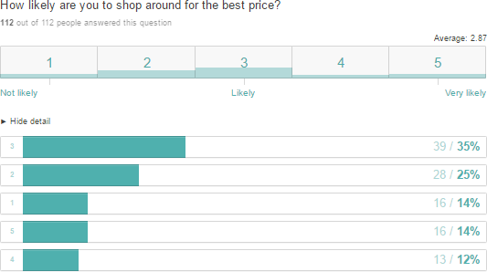

Over a third of respondents (35%) confirmed they were ‘likely’ to shop around for the best price. 14% strongly confirmed that they were not likely to look around for the best price, with an equal proportion (14%), strongly confirming they were very likely to shop around. This figure could potentially increase, due to the ease of comparing product prices and shopping around online. MySupermarkets (2016), and UK supermarkets work together to update their website daily, which means that all the latest prices and promotions are available for customers (MySupermarket, 2016).

Figure 13: Which do you mostly purchase?
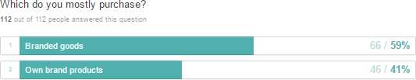

Figure 13.1: Which do you mostly purchase?


WHICH DO YOU MOSTLY
PURCHASE?
Branded goods Own brand products

41%
59%

59% respondents confirmed purchasing branded goods, however own branded products are becoming increasingly popular due to increasing visits to no-frill stores. Aldi and Lidl stock 90% of own branded goods (Dryburgh, 2014), which is leading consumers to try their own brand products. In many instances, consumers are not being able to tell the difference to their regular brand because of their comparable quality. However, the difference is being seen at the checkout, as the majority of own brand products are often much cheaper alternatives to the big branded goods.

Figure 14: When purchasing groceries; what do you consider more?

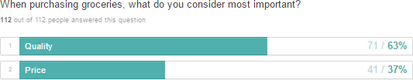

Figure 14.1: When purchasing groceries; what do you consider more?


WHEN PURCHASING GROCERIES, WHAT DO YOU CONSIDER MOST IMPORTANT?
Quality Price

37%

63%

A proportion of respondents (63%) confirmed that they place higher importance on quality than on price. This was a surprising finding as it had originally been anticipated that price would have been the more important factor to consumers, particularly in the economically tough times the UK has been experiencing having recently come through a recession. This economic factor may have led many consumers to start shopping at Aldi and Lidl, due to their lower prices. The continental Aldi and Lidl stores were introduced to the UK as low priced stores with high quality produce (BBC, 2015). However, since their introduction to these no- frills store, consumers have been impressed by the excellent quality produce available and stayed with them as a result.
Aldi and Lidl advertise award winning quality products and Tesco have their ‘Finest’ quality ranges. Consumers have therefore started using Aldi and Lidl out of choice, as they are enjoying the benefit of purchasing high quality produce with a reduced shopping bill. This concurs with Wallop, (2014) who suggests that consumer’s perceptions must be changing favourably towards no-frills stores, as it is now commonplace and socially acceptable to go to a dinner party and there be Aldi or Lidl products presented, including their award winning wine.

Figure 15: What is you perception of Aldi and Lidl products?

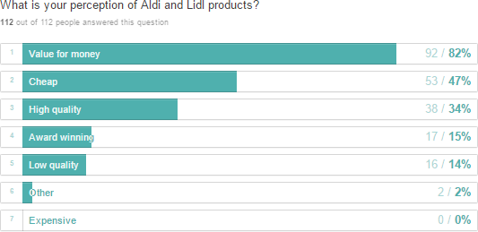

Where respondents answered ‘other’, the table below provides their fuller responses,
allowing for more qualitative data.

Other
Time consuming due to layout of store | 1
Never been inside Aldi and Lidl | 1  = 2

A high majority of respondents (82%) perceive Aldi and Lidl products to offer good value for money. This would indicate that the no-frills stores have been able to turnaround consumers’ perceptions over recent years from just being regarded as cheap no-frills stores to viable alternatives to Tesco as they both now offer great value for money. Aldi and Lidl prices are 30% lower than Tesco, this means that the customer gets more value per pound spent (BBC, 2015). No one suggested thinking the no-frills stores were expensive.
These responses prompted more in-depth analysis, which led to interview questions on why respondents felt perceptions have changed. The most common responses received from interviewees were that Aldi and Lidl offered ‘value for money’ as well as good ‘quality’. However, some stated that products such as fresh fruit and vegetables didn’t ‘last as long’ as other supermarket ranges and supermarket layouts were more ‘confusing’. However they did like the ‘bargain’ aisle products. A full list of interview responses is shown in Appendix D.

Figure 16: What is your perception of Tesco?
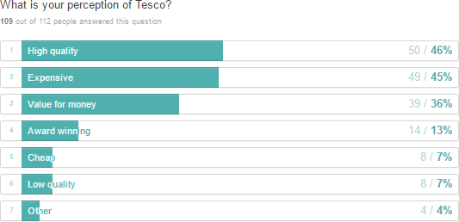

Where respondents answered ‘other’, the table below provides their fuller responses,
allowing for more qualitative data.

Other
Too big and layout is confusing | 2
Convenient | 2  =2
Collectively, 91% of respondents confirmed they perceived Tesco to offer high quality produce, with an expensive price tag. Tesco may need to focus on changing these perceptions, in order to retain its loyal customer base so that they do not choose to shop elsewhere. However, during semi-structured interviews, two respondents expressed the view that Tesco is considered as convenient, as all groceries and household products can be bought in one location. This has been identified by Vizard (2014) who states customers are unlikely to shop in stores unless they are fairly certain that they will be able to get everything they want due to the increasing trend of convenience shopping.
These responses prompted more in-depth analysis, which led to interview questions on why respondents felt perceptions have changed. Many considered Tesco to be ‘expensive and overpriced’ although much more ‘convenient’ as all products from groceries to clothes and electricals can be bought together ‘all in one place’, alongside the availability of ‘branded goods’. Many also appreciated the fact that Tesco offered a home ‘delivery’ service, which Aldi and Lidl do not offer. Many also stated that they visited Tesco as an ‘activity’, as they enjoy the experience of looking around the store. A full list of interview responses can be found in Appendix D.

Figure 17: As Aldi and Lidl have won awards such as grocer of the year 2014, would this make you shop there?
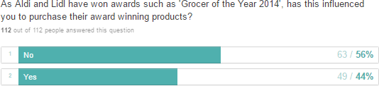

Figure 17.1: As Aldi and Lidl have won awards such as grocer of the year 2014, would this make you shop there?


AS ALDI AND LIDL HAVE WON AWARDS SUCH AS 'GROCER OF THE YEAR 2014' HAS THIS INFLUENCED YOU TO PURCHASE THEIR AWARD WINNING PRODUCTS?
Yes No

44%
56%

44% of respondents confirmed that they had been influenced to shop at Aldi and Lidl due to them receiving ‘Grocer of the Year, 2014’ and through the advertising of their award winning products (Marketline, 2014). This has helped to change consumer perception on their delivery of quality produce. However the majority of respondents (56%) said these marketing campaigns had not influenced their shopping habits. Aldi and Lidl may potentially need to increase their advertising campaign to attrach new and retain their existing customer base.

Figure 18: has Aldi and Lidl’s TV campaigns influenced you shopping there?

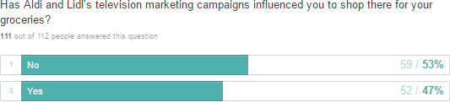

Figure 18.1: has Aldi and Lidl’s TV campaigns influenced you shopping there?


HAS ALDI AND LIDL'S TV MARKETING
CAMPAIGNS INFLUENCED YOU TO SHOP THERE FOR YOUR GROCERIES?
Yes No
53%
47%

Aldi and Lidl’s marketing strategy has been to make memorable adverts ‘sprinkled with humour’ (Aldi, 2016). 47% of respondents are affected by this and have consequently been influenced to shop there, which supports the company’s strategy. However, just over half of respondents (53%) stated the TV marketing campaign had not influence them to shop there. Therefore it can be considered essential to attract customers in various way, in order to gain their customer and for the consumer to enjoy the benefit of their lower prices.

Figure 19: of the following three supermarkets where did you do the majority of your Christmas shopping in 2015?

Figure 19
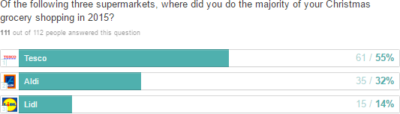

Figure 20: of the following three supermarkets where did you do the majority of your Christmas shopping in 2010?

Figure 20
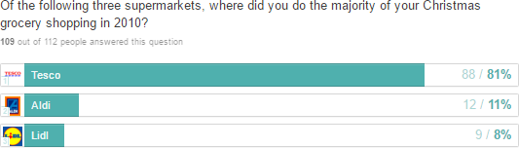

In both 2015 and 2010, the majority of respondents confirmed they had purchased the majority of their Christmas shopping in Tesco. However, when making a direct comparison of these figures, they show that there has been a significant increase in Aldi and Lidl shopping in 2015, with 46% shopping at these no-frill stores, compared to only 19% in 2010. This clearly shows that the German alternatives have successfully changed customer perceptions, and are taking customers from Tesco and the fellow big four supermarkets.
These responses prompted more in-depth analysis, which led to interview questions on where and why they did their Christmas shopping in 2010 and 2015.
The majority of interviewees did their 2015 Christmas shopping in ‘Aldi’, due to the ‘high quality’, ‘continental’ ‘different’ product ranges, such as ‘gin and tonic crisps.’ They appreciated being able to have this for a much ‘lower cost’ then Tesco. However, some key products such as ‘branded goods’, were subsequently picked up in Tesco. A full list of interview responses can be found in Appendix D.

Out of the 11 interviewees, 10 stated they did their Christmas shopping for 2010 in ‘Tesco’. This was because Aldi and Lidl did not have the ‘reputation’ for high quality produce at low prices, so were therefore not as popular at the time. Tesco also benefits the consumer as they are able to get everything they may need in one place, as well as offering ‘discount vouchers’ and money off services, which neither Aldi nor Lidl offer. A full list of interview responses can be found in Appendix D.

Summary

Although more questions were asked than the originally estimated 12-15 questions, this was required in order to ensure the aims and objectives of this research study could be addressed. By utilising Typeform, the created user friendly questionnaire, was quick to complete and required on average 3 mins 17 seconds to answer. An interim report of key findings can be found in Appendix E. The findings contained within this study, indicate that Aldi and Lidl have definitely managed to change consumer perceptions. Customers are no longer truly loyal and will shop around for the best price and high quality produce. Consumer shopping trends and habits have therefore changed significantly.

Chapter Five
Conclusion

Conclusion

Introduction

This conclusion is a ‘summary of the findings and discusses the extent to which the objectives
and research aim have been achieved’ (Wilson 2012:283).

The aim of this research study was to investigate how no-frills stores Aldi and Lidl have taken on supermarket giant Tesco. Data was collected and analysed to identify how consumers shopping trends have changed, whether Aldi and Lidl have changed customer perceptions, and to confirm whether customer loyalty still exists within the supermarket industry. The questionnaire and interviews conducted were a very useful, reliable and valid method of collecting data, to support the findings and objectives of this dissertation.
A fundamental question identified that 52% of respondents do their main shopping in Tesco, which backs up secondary research that confirmed Tesco is still the UK market leader (Rickard Straus, 2014). 48% collectively confirmed shopping at Aldi and Lidl, which clearly indicates the new and rising popularity of Aldi and Lidl. This was surprising as collectively they only hold 8% of the market share (Rickard Straus, 2014). This increase is due to the no-frills stores now offering consistent quality for price sensitive consumers.

Research Objective 1: An investigation into changing consumer shopping trends in the UK

Consumer shopping trends in the UK have changed, as many consumers are now shopping in no-frills stores, as a result of initially being introduced to Aldi and Lidl during the recession, when disposable income levels lowered. It has been identified that consumers are now using Aldi and Lidl out of choice, as they can enjoy the benefit of purchasing high quality produce with a reduced shopping bill.
Collectively, weekday shopping has become more popular than weekend shopping, with Monday identified as the most popular day to do the main grocery shop. This change in consumer shopping trend concurs with Don (2015), who acknowledged that the once traditional Friday and Saturday shop has declined, as midweek shopping is growing.

The trend of convenience shopping has increased, with many shoppers now doing a ‘top up shop’ rather than the usual ‘weekly shop’ (Don, 2015) This is supported by the findings as 47% of respondents stated they were convenience shoppers, doing ‘little but often’ grocery shopping. This would support Aldi’s decision to open convenience stores which are smaller than its usual stores (Halliwell, 2013).

One trend that has not changed is that females are still doing the majority of the grocery shopping. Two-thirds of females are the primary grocery shoppers in their households (Retail Leader, 2013), with six in 10 women spending more than an hour shopping in the supermarket (Grocer, 2013). This was supported as 81% of questionnaire respondents were female, who were happy to engage and respond to a shopping survey.
It is clear from these findings that consumer grocery shopping trends in the UK have shifted from traditional methods. Therefore Objective 1 has helped answer the research aim.

Research Objective 2: How no-frills stores has changed the perception of consumers

In previous years, shoppers mainly visited Aldi and Lidl in search of a bargain (BBC, 2013). However, consumer perceptions of no-frills stores have significantly improved, and these stores have become increasingly popular with the British public; half of all households now shop at these no-frills stores (BBC, 2013).
Aldi and Lidl have therefore removed the ‘stigma attached to them’; by promoting the concept of ‘not selling cheap stuff, but selling stuff cheaply’ (Wallop, 2014). This is supported by 82% of respondents who now perceive Aldi and Lidl as offering products that are good value for money. This would indicate that no-frills stores have been able to turnaround consumers’ perceptions over recent years, from being initially regarded as cheap no-frills stores, to becoming viable alternatives to Tesco. They both now offer great value for money and have become a credible alternative to the big-name brands.
However 91% of respondents still perceive Tesco to offer high quality produce, but at a more expensive price. Many respondents believed that the high prices at Tesco cannot be justified, and there is no legitimate need. However, respondents also considered Tesco to be highly

convenient as both branded and non-branded goods can all be bought in one place. Tesco would be recommended to focus on changing these perceptions, in order to retain its loyal customer base and avoid the foreseeable situation where consumers continue to drift towards shopping at Aldi and Lidl stores.
From the conducted questionnaire, it was identified that 46% of respondents went to Aldi and Lidl to do their Christmas shopping in 2015, compared to just 19% in 2010. This clearly shows that the German alternatives have successfully changed customer perceptions, and are taking customers from Tesco and the fellow Big Four supermarkets. This trend could explain why Tesco was ‘losing 1 million shoppers a week’ to no-frills businesses Aldi and Lidl, which resulted in an estimated average expenditure loss of £25 per lost visit (Ruddick, 2014).
To conclude it is clear that the perceptions of Aldi and Lidl are changing, as more consumers choose to shop at the German no-frills stores. 82% of respondents perceive the stores as offering ‘value for money’ with good quality products. This reinforces that they have been successful in removing the ‘cheap store’ stigma (Wallop 2014) particularly as over half of the households in the UK now shop at no-frills stores (BBC, 2013). Interestingly, the research conducted also identified that consumers’ perceptions of Tesco is also changing, with many shoppers now seeing it as an unnecessarily expensive store, offering slightly better quality than the alternative no-frills stores.

Objective 2 has therefore provided help in answering the research aim.

Research Objective 3: To assess what determines customer loyalty within the supermarket industry
Customer loyalty is being tested within the supermarket industry. Although price does influence customer decisions on where to shop, it is not just price alone that makes customers switch between supermarkets. Quality has been found to be a very important factor when consumers consider where to shop, and this has influenced consumers’ loyalty. 63% of respondents confirmed that they place higher importance on quality than on price. This was an unexpected outcome, as Aldi and Lidl originally gained popularity during the recession because of their very low prices (BBC, 2015). This also supports the improved perception change towards Aldi and Lidl. However, since their introduction to these no-frills store,

consumers have been impressed by the excellent quality produce available and have stayed with them as a result. Consumers now realise that they do not have to ‘compromise on quality’ (Aldi 2016), to benefit from a more economic shopping experience.
This indicates that consumers are shopping at Aldi and Lidl out of choice, which has enabled no-frills stores to create their own loyal customer base. This therefore challenges Wallop’s (25014) view that customer loyalty towards supermarkets is ‘dead’, (Wallop, 2014), as 50% of respondents revealed they consider themselves to be loyal grocery shoppers, with the other half often shopping around, either for the best price or due to convenience.
Tesco Clubcard collects huge amounts of information on customer shopping habits (Poulter 2013) and with 15 million users this indicates they still retain loyal customers. This was backed up by 75% of respondents confirming they have a Tesco Clubcard regardless of where they actually do their shopping. Therefore, Aldi and Lidl could be advised to create a similar points collecting card for customers, in order to gather information on their shopping habits and reward customers for shopping with them as a result. This would generate more loyal and returning shoppers, and could in turn be financially beneficial as store loyal customers spend approximately 32% more than non-loyal shoppers (Huddleston et al. (2003).
However, loyalty schemes can be expensive and a significant number of customers do not claim the awards and benefits that they are due (Butler and Henery, 2005). Poulter, 2013 identified that many consumers now want instant benefits when shopping, rather than having to collect points over a period of time and then having to wait for discount coupons to be sent in the post.
The home delivery trend has led to many supermarkets having an online presence, with online grocery sales predicted to double from £5.6 billion to £11.1 billion in 2018 (Wilcock, 2015). Tesco have been online for over a decade, and offer a free ‘Click and Collect’ service to customers. However, 84% of respondents stated they do not grocery shop online and this contradicts this trend. Aldi and Lidl still do not have an online presence or offer delivery. However findings from the interviews showed that many shoppers would use the delivery service if they were to offer one, and this would also lead to more loyal shoppers.

As 37% of respondents indicate they considered price the most important factor of grocery shopping, this shows that consumers are still price conscious and will shop around for the best deals. Therefore, as consumers shop around and use more than one store, it can be concluded that there is a lack of customer loyalty in the supermarket industry. Comparison grocery websites and online shopping access may have also influenced the lowering levels of loyalty.
As the future strategies of no-frills stores include opening hundreds of stores between them to reach a wider UK population, this indicates that they have no plans to stop with their takeover of supermarket giants (Schram, 2015), which helps answer the research aim.
Collectively, the objectives which have shaped this research study have therefore answered the research aim. Aldi and Lidl have been able to take on the supermarket giant Tesco, as they have positively changed the perceptions of UK grocery consumers by creating customer loyalty that fits with their business model, which have both changed the shopping trends of the UK grocery consumer.

Limitations

As this is a very topical area of study, one limitation is considered to be the lack of published academic theory available to support secondary research. Another limitation could be through the use of Facebook, as the respondents include a young demographic from the researcher’s friends and family. This could have potentially influenced the respondents’ responses.

Future Research Direction

By completing this dissertation, it has highlighted an area in which future research could be completed. Future research could be focused on investigating the identified changing consumer perceptions of Tesco, on factors other than price. This could examine in detail, the reasons why consumers are turning away from the supermarket giant and favouring supermarkets who offer less choice, less quantity of stock and less branded goods.

Chapter Six
References and Bibliography

References and Bibliography

Aldi (2015) https://www.aldi.co.uk/en/specialbuys/ Online Accessed 6th December 2015 Aldi (2016) https://www.aldi.co.uk/campaigns Online Accessed 11th December 2015
Armstrong M (2009): Armstrong’s Handbook of Human Resource Management Practice, 11th Edition, Kogan Page, London
Avaya (2008) 'Essential Managers Guide to Extraordinary Customer Service' 2008, CRM Magazine, 12, 2, p. 15, Business Source Complete, Online Accessed 6th March 2016.
Barber, L (2015) http://www.cityam.com/229434/now-lidls-getting-into-the-online-grocery- delivery-business-after-amazon-freshs-uk-debut-and-aldis-plans-taking-on-tesco-sainsburys- asda-and-morrisons?ITO=related-content Online Accessed 11th December 2015
Barford, V (2014) http://www.bbc.co.uk/news/magazine-25762466 Online Accessed 25th October 2015
Battaglia, M (2008) http://srmo.sagepub.com/view/encyclopedia-of-survey-research- methods/n105.xml Online Accessed 19th April 2016
BBC (2013) http://www.bbc.co.uk/news/business-25448357 Online Accessed 3rd November 2015
BBC (2015) http://www.bbc.co.uk/news/business-34772883 Online Accessed 18th November 2015
BBC (2015) http://www.bbc.co.uk/news/business-34842198 Online Accessed 18th November 2015
BBC (2014) http://www.bbc.co.uk/news/business-28547793 Online Accessed 25th October 2015
Bell J, (1993): Doing Your Research Project Second Edition, Open University Press
Boyce, L (2015) http://www.dailymail.co.uk/money/news/article-3321847/Aldi-bigger- market-share-Waitrose-Kantar.html Online Accessed 11th December 2015
Brown, C (2015) http://www.retailgazette.co.uk/blog/2015/09/lidl-is-going-upmarket Online Accessed 11th December 2015
Buchanan D A & Huczynski A A (2010): Organizational Behaviour Seventh Edition, Financial Times Prentice Hall, London
Butler, S (2014) http://www.theguardian.com/business/2014/dec/18/lidl-german- discounters-uk-supermarkets-ronny-gottschlich Online Accessed 25th October 2015
Butler, S and Henery, M. (2005) ‘so, what is the point of loyalty?’, the times, June 2005, Available from http://www.factiva.com

Caminal, R. (2012). The design and efficiency of loyalty rewards Journal of Economics and Management Strategy, Vol 21, No 2, 329-371
Campbell, Edgar and Stonehouse (2011): Business Strategies: An Introduction Third Edition, Palgrave MacMillan
Cavazza, M (2008) http://www.thisismoney.co.uk/money/markets/article-1646002/Tesco- not-immune-from-recession-chill.html Online Accessed 25th October 2015
CNN (2016) http://edition.cnn.com/2014/02/11/world/facebook-fast-facts/index.html Online Accessed 19th April 2016
Cole G A (1996) Management Theory and Practise Fifth Edition, Letts Educational, London
Craven, N (2014) http://www.thisismoney.co.uk/money/news/article-2533768/German- Aldi-Lidl-crush-British-Big-Four-checkouts.html Online Accessed 11th December 2015
Craven, N (2015) http://www.thisismoney.co.uk/money/news/article-3113612/Aldi-surge- goes-snaps-heels-Britain-s-five-supermarkets.html Online Accessed 25th October 2015
Creswell J W, (2003): Research Design, Qualitative, Quantitative and Mixed Methods Approaches Second Edition, Sage Publications
Data Protection Act (1998) https://www.gov.uk/data-protection/the-data-protection-act Online Access 9th November 2015
Daily Mail (2015) http://www.dailymail.co.uk/wires/reuters/article-3275669/Tesco-sticks- Every-Little-Helps-Christmas-campaign.html Online Accessed 3rd November 2015
Daneshkhu, S. (2014). UK consumers spend five-times more online. http://www.ft.com/cms/s/0/9cddc9e6-f491-11e3-bf6e- 00144feabdc0.html#axzz41VNN8YCU Online Accessed 28th February 2016
Davies, F. Goode, M. Moutinho, L and Ogbonna, E (2001) Critical factors in consumer supermarket shopping behaviour: A neural network approach. Journal of consumer behaviour. Vol. 1 No. 35-49
Don, A (2015) http://www.thegrocer.co.uk/stores/consumer-trends/shopping-lists-going- out-of-style-claims-co-op-report/526572.article Online Accessed 3rd November 2015
Dryburgh, A (2014) http://www.managementtoday.co.uk/news/1317297/why-tesco-cant- compete-aldi-lidl/ Online Accessed 25th October 2015
Finn, M. Elliot-White, M. and Walton, M (2000) Tourism and leisure research methods: data collection, analysis and interpretation, Harlow: Longman Pub Group.
Gov (2015) https://www.gov.uk/data-protection/the-data-protection-act Online Accessed 30th March 2016
Grocer (2013) http://www.progressivegrocer.com/women-dominate-grocery-shopping- study Online Accessed 26th April 2016

Guardian (2014) http://www.theguardian.com/business/2014/jan/02/high-street-retailers- winners-and-losers Online Accessed 11th December 2015
Gudmundsdottir, G, & Brock-Utne, B 2010, 'An exploration of the importance of piloting and access as action research', Educational Action Research, 18, 3, pp. 359-372, Academic Search Premier, Online Accessed 16th April 2016.
Halliwell, J (2013) http://www.thegrocer.co.uk/companies/aldi-targets-convenience-sector- with-smaller-london- store/238087.article?utm_source=rss_feed&utm_medium=rss&utm_campaign=rss&redirCa non=1 Online Accessed 25th October 2015
Helmrich, B (2016) http://www.businessnewsdaily.com/7761-facebook-business-guide.html Online Accessed 19th April 2016
Henderson, N.R. (2011), 'Is There a Role for Social Media in Qualitative
Research?', Marketing Research, 23, 3, pp. 36-37, Business Source Complete, Online Accessed 19th April 2016.
Independent (2013) http://www.independent.co.uk/news/business/super-discounters-aldi- and-lidl-lure-customers-away-from-big-four-as-shoppers-go-bargain-hunting-8952103.html Online Accessed 11th December 2015
Jankowicz, A.D. (2005) Business Research Projects. Thomson, Fourth Edition
Jefford, K (2014) http://www.cityam.com/article/1397002532/big-four-grocers-all-lose- ground-discounters Online Accessed 25th October 2015
Jefford, K (2015) http://www.cityam.com/229812/how-german-discounter-lidl-became-the- uks-fastest-growing-supermarket- Online Accessed 11th December 2015
Jefford, K (2015) http://www.cityam.com/226955/the-nightmare-before-christmas-aldi- and-lidl-hammer-british-supermarkets?ITO=related-content Online Accessed 11th December 2015
Jefford, K (2015) http://www.cityam.com/228796/discounters-aldi-and-lidl-pick-up-the- space-race-left-by-big-four-supermarkets?ITO=related-content Online Accessed 11th December 2015
KamCity (2015) http://www.kamcity.com/namnews/asp/newsarticle.asp?newsid=82984 Online Accessed 11th December 2015
KamCity (2015) http://www.kamcity.com/namnews/asp/newsarticle.asp?newsid=82955 Online Accessed 11th December 2015
Lawson, A (2014) http://www.independent.co.uk/news/business/news/aldi-and-lidl-take-a- bite-out-of-big-four-supermarkets-9246680.html Online Accessed 11th December 2015
Little E & Marandi E (2003): Relationship Marketing Management First Edition, Thomson

Marketline (2015) Case Study: Changing customer behavior in the UK, the rise of smart customer, June 2015
Marketline (2011) Case Study: Location-based mobile apps case study, harnessing location- aware technology in consumer packaged goods mobile marketing, May 2011
Marketline (2014) Case Study: Online grocery sales. Successful revival of a failed strategy, December 2014
Marketline (2015) Case Study: Retailer response to changes in consumer behavior in the UK. Remaining relevant to the smart consumer, September 2015
Marketline (2014) Case Study: Supermarket price wars. A response to the rise of discount retailers, December 2014
Marketline (2015) Case Study: The big 6 UK food retailers. How supermarkets are responding to the discounter threat, July 2015
Manez, J. A. (2006) Unbeatable value low-price guarantee: Collusive mechanism or advertising strategy? Journal of Economics and Management Strategy, Vol. 15 No. 1 143-166.
Misiri, T (2015) http://www.retailgazette.co.uk/blog/2015/11/lidl-to-take-on-big-four-in-all- areas Online Accessed 11th December 2015
Moreno, M, Goniu, N, Moreno, P, & Diekema, D (2013), 'Ethics of Social Media Research: Common Concerns and Practical Considerations', Cyberpsychology, Behavior & Social Networking, 16, 9, pp. 708-713, Business Source Complete, Online Accessed 19th April 2016.
MySupermarket (2016) http://help.mysupermarket.co.uk/index.php/faq/about- mysupermarket/ Online Accessed 26th April 2016
Mullins L J (2010): Management & Organisational Behaviour Ninth Edition, Prentice Hall FT
Neilan, C (2014) http://www.cityam.com/1409129242/tesco-loses-market-share-aldi-and- lidl-continue-uk-assault Online Accessed 25th October 2015
Oakshott, L. (2014) Quantitative Methods. Palgrave, MacMillan
Office for National Statistics, (2015) http://www.ons.gov.uk/ons/rel/rsi/retail- sales/september-2014/sty-uk-supermarket-spending-stalls.html Online Accessed 25th October 2015
Osborne, H (2012) http://www.theguardian.com/money/blog/2012/oct/08/aldi- supermarket-shopping-difference Online Accessed 25th October 2015
Perceptual Mapping (2016) http://www.nottingham.ac.uk/search.aspx?q=perceptual+mapping Online Accessed 25th October 2015
Pope, C (2015) http://www.irishtimes.com/life-and-style/food-and-drink/store-wars-the- big-three-v-the-little-two-1.2438310 Online Accessed 11th December 2015

Poulter, S. (2013) http://www.dailymail.co.uk/news/article-2529987/Benefits-offered- supermarket-loyalty-cards-meaningless-customers-claims-Waitrose-boss.html Online Accessed 3rd November 2015
Quinn (2015) http://www.thegrocer.co.uk/buying-and-supplying/marketing/tesco-kicks-off- christmas-tv-campaign-with-ruth-jones/527356.article Online Accessed 6th December 2015
Retail Gazette, (2014) http://www.retailgazette.co.uk/blog/2014/08/43213-five-reasons- for-the-rise-of-lidl Online Accessed 11th December 2015
Retail Leader (2013) http://www.retailleader.com/top-story-consumer_insights-
study women_still_dominate_grocery_shopping-2053.html Online Accessed 26th April 2016
Revoredo-Giha, C. and Renwick, A. (2012). Retailers price behaviour in the UK fresh fruit and vegetable market, Agri Business, An International Journal, Vol. 28 No 4, 451-468.
Reynolds, M (2014) http://www.express.co.uk/news/uk/535714/Aldi-Lidl-to-open-high- street-stores Online Accessed 11th December 2015
Riley, J (2014) http://www.tutor2u.net/business/blog/teaching-resource-super-market- mapping Online Accessed 11th December 2015
Rickard Straus, R.(2014) http://www.thisismoney.co.uk/money/news/article- 2610219/Tesco-cuts-prices-basics-win-customers-lost-Aldi-Lidl.html Online Accessed 3rd November 2015
Rickard Straus, R (2015) http://www.dailymail.co.uk/money/news/article-2947529/Tesco- wins-extra-236-000-shoppers-12-weeks.html Online Accessed 25th October 2015
Ruddick, G (2014) http://www.telegraph.co.uk/finance/newsbysector/epic/tsco/10872572/Tesco-losing-1m- shoppers-a-week-as-shocking-figures-reveal-pressure-on-supermarkets.html Online Accessed 25th October 2015
Ruddick, G (2014) http://www.telegraph.co.uk/finance/newsbysector/retailandconsumer/10577685/Clubcard
-built-the-Tesco-of-today-but-it-could-be-time-to-ditch-it.html Online Accessed 3rd November 2015
Ruddick, G (2015) http://www.telegraph.co.uk/finance/newsbysector/retailandconsumer/11486638/Aldi-to- open-more-stores-than-Tesco-Sainsburys-and-Morrisons-combined.html Online Accessed 25th October 2015
Schram, B (2015) http://www.ibtimes.co.uk/rise-discounters-aldi-lidl-hold-10-market-share- big-four-continue-slip-1529105 Online Accessed 11th December 2015
Shadbolt, P (2015) http://www.bbc.co.uk/news/business-34315643 Online Accessed 3rd November 2015

Smith, C 2016 http://expandedramblings.com/index.php/by-the-numbers-17-amazing- facebook-stats/ Online Accessed 30th March 2016
Telegraph (2015) http://www.telegraph.co.uk/finance/newsbysector/retailandconsumer/11484345/Aldi-to- launch-online-store-in-Britain.html Online Accessed 25th October 2015
The Retail Bulletin (2015) http://www.theretailbulletin.com/news/almost_3_billion_worth_of_items_stolen_annually
_through_supermarket_grazing_02-12-15/ Online Accessed 11th December 2015
Trench, V (2010) http://news.bbc.co.uk/1/hi/business/8505031.stm Online Accessed 11th December 2015
Tuttle, B 2014, 'There's a Good Chance You Dumped Your Supermarket Last Year', Time.Com, p. 1, Academic Search Premier, Online Accessed 30th April 2016
Vizard, S 2014, 'Price wars push grocery market into decline for first time’, Marketing Week (Online Edition), p. 1, Online Accessed 6th March 2016.
Wallop, H (2007) http://www.telegraph.co.uk/news/uknews/1548742/1-in-every-seven- now-spent-in-Tesco.html Online Accessed 11th December 2015
Wallop, H (2012) http://www.telegraph.co.uk/finance/newsbysector/retailandconsumer/9356088/Tesco.co m-to-split-customers-according-to-wealth-and-age.html Online Accessed 11th December 2015
Wallop, H (2014) http://www.telegraph.co.uk/news/earth/agriculture/supermarkets/10991100/Loyalty-to- supermarkets-is-dead.html Online Accessed 25th October 2015
Ward, C (2014) http://www.mycustomer.com/news/forget-aldi-pricing-strategy-real- supermarket-war-over-customer-loyalty Online Accessed 3rd November 2015
Wilcock, O (2013) http://www.bristolbis.co.uk/future-trends-in-uk-groceries-and-analysis- of-market-participant-strategies/ Online Accessed 25th October 2015
Wilson, J (2012) Essentials of business research: A guide to doing your research project. Los Angeles: Sage Publications.
Williams S (2005): Lloyds TSB Small Business Guide Eighteenth Edition, Vitesse Media plc
Wimberley, S and McClean, J (2012) Supermarket Savvy: The everyday information-seeking behaviour of grocery shoppers. Information and Culture. Vol. 47 No. 2

Chapter Seven
Appendices

Appendices


Appendix A - Ethics Form
E3 FORM
APPLICATION FOR ETHICAL APPROVAL – BA level

CAIS AM GYMERADWYAETH MOESEGOL – Lefel BA
This form is to be completed by all BA students conducting research, projects or productions. This form should be completed by the student. All forms must be considered by the Module tutor. A copy of the form must be kept centrally and on the student file.
Mae'r ffurflen hon i'w chwblhau gan bob BA myfyrwyr. Rhaid i bob ffurflen gael ei ystyried gan diwtor y modiwl.
Dylai un copi o'r ffurflen yn cael ei roi ar y ffeiliau Gyfadran ac un copi cadw ar y ffeil myfyrwyr.

ADRAN 1 – MANYLION MYFYRIWR SECTION 1 - STUDENT DETAILS
Enw Llawn Full Name

Ysgol/Cyfadran/ School/Faculty

Cydlynydd prosiect / Tiwtor
Module Tutor/ Programme Co-ordinator
Rhif Myfyriwr Student Number

Enw'r Gradd Name of Degree
Supervisor: Helen Evans
University of Wales Trinity Saint David -
via Pembrokeshire College
BA (Hons) Business Management

Teitl dangosol yr Traethawd Hir: Indicative Title of Dissertation:
Investigate how ‘No-Frills’ stores have taken on Supermarket Giants

ADRAN 2 – MANYLION CYFRANOGWYR / CYNULLEIDFA |  | SECTION 2 - PARTICIPANT / AUDIENCE DETAILS
Pwy yw’r cyfranogwyr arfaethedig? | Who are the intended participants? |  | Ydw  / Yes | Na /  No
Myfyrwyr / staff Y Drindod Dewi Sant | Students / staff of Trinity Saint David |  | ✓
Oedolion (dros oed 16 ac yn gymwys i gydsynio) | Adults (over the age of 16 and competent to give consent) |  | ✓
Plant a phobl ifanc dan oed | Children / legal minors |  |  | x

Cleifion neu gleientiaid gweithwyr proffesiynol |  | Patients or clients of professionals |  |  | x
Rhywun sy’n cael ei gadw yn y ddalfa neu y  mae’r llys wedi cymryd cyfrifoldeb amdano |  | Anyone in custodial care or for whom the court has assumed responsibility |  |  | x
Aelod o unrhyw sefydliad lle mae’n bosibl bod  angen i unigolyn arall hefyd gydsynio. |  | A member of any organisation where another individual may also need to give consent. |  |  | x
Eraill: Nodwch: / Others: please identify:
Nifer, Oed a Ffynhonnell y Cyfranogwyr  Rhowch fanylion yr demograffeg y cyfranogwyr / gynulleidfa. |  |  | Participant / Audience Number and Age  Provide details of the demographics of the participants / audience.
Nifer o Gyfranogwyr / yn y Gynulleidfa | Participant/ Audience number |  | Facebook users and friends, Approx. 50 respondents
Grŵp oedran y Cyfranogwyr/y  Gynulleidfa | Participant/ Audience age group |  | An approximation of age range: Minimum: 18 years+  Maximum: 80 years

ADRAN 3 – GWEITHGAREDD YMCHWIL |  | SECTION 3 – RESEARCH ACTIVITY
1. | Ydy’r prosiect yn cynnwys: | Does the project include: | Ydy / Yes | Nac ydy  /No
Defnyddio holiadur neu offeryn ymchwil tebyg |  | Use of questionnaire or similar research instrument | ✓
Defnyddio prawf ysgrifenedig neu gyfrifiadurol |  | Use of written or computerised test |  | x
Cyfweliad (cysylltwch gwestiynau posibl) |  | Interview (attach provisional questions) | ✓*
Dyddiaduron |  | Diaries |  | x
Arsylwi ar gyfranogwyr a hwythau'n  ymwybodol o hynny |  | Participant observation with their knowledge |  | x
Arsylwi ar gyfranogwyr a hwythau ddim yn  ymwybodol o hynny |  | Participant observation without their  knowledge |  | x
Recordio fideo neu sain |  | Video or audio-taping |  | x
Mynediad i wybodaeth bersonol neu gyfrinachol heb gydsyniad penodol y  cyfranogwyr |  | Access to personal or confidential information without the participants specific  consent |  | x

Defnyddio unrhyw gwestiynau, ysgogiadau prawf, cyflwyniad y gallai rhai cyfranogwyr eu profi fel rhywbeth sy'n achosi niwed /  tramgwydd corfforol, meddyliol neu emosiynol | Administration of any questions, test stimuli, presentation that may be experienced as physically, mentally or emotionally harmful /  offensive |  | x
Cyflawni unrhyw weithredoedd allai achosi embaras neu effeithio ar hunan-barch | Performance of any acts which may cause embarrassment or affect self-esteem |  | x
Ymchwilio i gyfranogwyr sy’n ymwneud â  gweithgareddau anghyfreithlon | Investigation of participants involved in illegal activities |  | x
Gweithdrefnau lle defnyddir twyll | Procedures that involve deception |  | x
Gweini unrhyw sylwedd, cyfrwng neu blasebo | Administration of any substance, agent or placebo |  | x
Dull arall o gasglu data neu fformat cyflwyno (esboniwch) | Other method of data collection or presentation format (please explain) |  | x

2. | Restru eich dull o gasglu data | List your method of data collection:
Questionnaire completed online and semi-structured interviews

3. | Risg Posibl:  (corfforol, seicolegol, cyfreithiol, cymdeithasol neu economaidd) | Potential Risk:  (physical, psychological, legal, social or economic)
A oes unrhyw risg bosibl i: |  | Is there any potential risk to: | Ydw / Yes | Na  /  No
A | Cyfranogwyr? | Participants? | ✓
B | Ymchwilydd? | Researcher? |  | x
C | BrifYsgol/Cyfadran? | University? | ✓

4. | Rheoli Risg:  Os oes, beth yw'r risg a sut y bydd yn cael ei reoli? | Management of Risk:  If yes, what is the risk and how will it be managed?
Participant Risk:
I will ensure that all data collected during my research will be stored in line with the Data Protection Act 1998.

University Risk:
I realise that I have to conduct my research in a professional manner, in order to maintain the reputation of the college.
5. | Os ydych yn delio â phlant a / neu oedolion agored  i niwed, rhaid i chi gyflwyno eich tystysgrif DBS i'ch | If you are dealing with children and/ or vulnerable  adults you must present your DBS certificate to your

 | tiwtor goruchwylio i'w cymeradwyo cyn i unrhyw  gysylltiad â cyfranogwyr hyn. |  | supervising tutor for approval before any contact  with these participants.
 |  |  |  |  |  | Ydw  / Yes |  | Na /  No
A | Ydych chi wedi gwneud cais am dystysgrif DBS? |  | Have you applied for a DBS  certificate? |  |  |  |  | N/A
B | A yw eich tiwtor weld a'i gadarnhau eich tystysgrif  DBS? |  | Has your tutor seen and approved  your DBS certificate? |  |  |  |  | N/A
6. | A fyddwch yn cael cydsyniad gwybodus  ysgrifenedig gan eich cyfranogwyr? |  | Will you obtain written informed consent from your  participants?
 |  |  |  |  |  | Ydw  / Yes |  | Na /  No
A | Os na fyddwch, pam hynny? |  | If no, why not? |  |  | ✓
B | Os byddwch, sut byddwch yn sicrhau cydsyniad  gwybodus? |  | If yes, how will you secure informed  consent?
Rhowch eglurhad / Please explain:
A worded statement will be added to my questionnaire to confirm that the respondent agrees with the information collected be used and stored in the correct manner.
Cynhwyswch gopi o’r ffurflen gydsynio os ydych yn  defnyddio un. |  |  | Please include a copy of the consent form if you are  using one.
ADRAN 4 |  |  | SECTION 4
CEFNOGWYD /APPROVED |  |  | NIS CEFNOGWYD/ NOT SUPPORTED
Datganiad  Mae'r wybodaeth a gynhwysir yma yn gywir, hyd eithaf fy ngwybodaeth a’m cred. Rwyf wedi ceisio dynodi unrhyw risgiau a phroblemau sy’n gysylltiedig â’r prosiect / ymchwil neu gynhyrchiad ac rwyf yn cydnabod  f’ymrwymiadau innau a hawliau’r cyfranogwyr. |  |  | Declaration  The information contained herein is, to the best of my knowledge and belief, accurate. I have attempted to identify any risks and issues related to the project/research or production and acknowledge  my obligations and the rights of the participants.
Llofnodau  Dylai'r ffurflen hon gael ei chwblhau a'i llofnodi gan y myfyriwr a'r Cydlynydd y prosiect /Twitor |  |  | Signatures  This form should be completed and signed by the  student and the Module tutor/Programme Co- ordinator.
Myfyriwr / Student |  |  |  |  | Dyddiad: / Date:  25th November 2015
Cydlynydd y prosiect /Twitor Project co-ordinator / Tutor |  |  |  |  | Dyddiad: / Date:

Appendix B: Blank Questionnaire
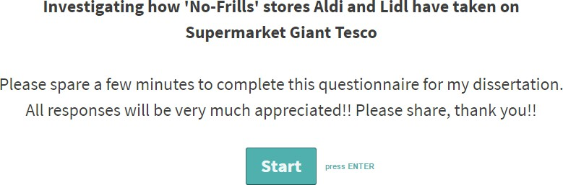

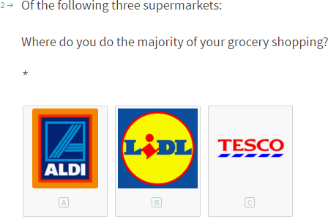
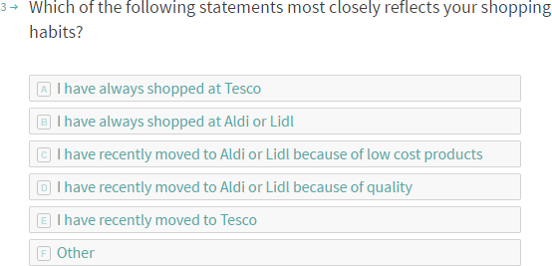

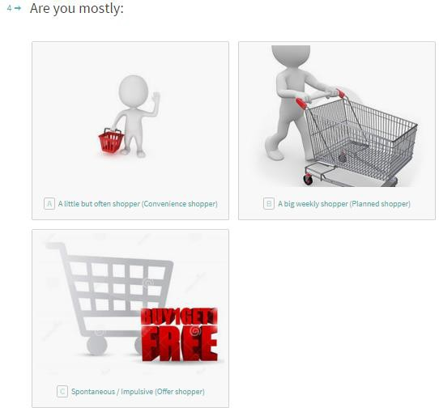

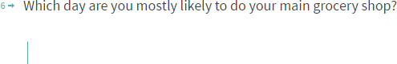
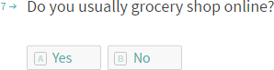
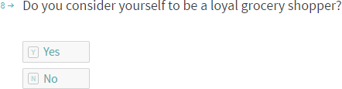
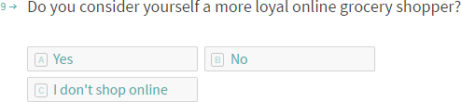
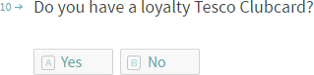

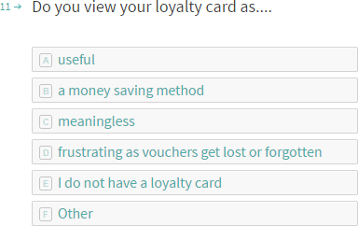
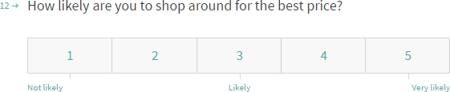
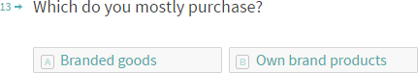
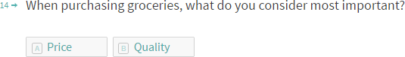
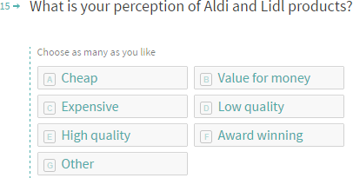
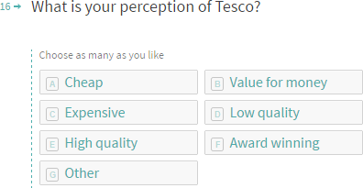
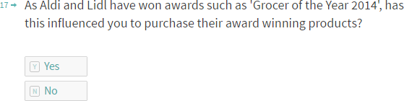
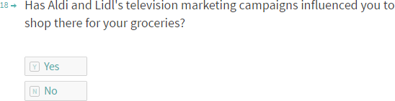

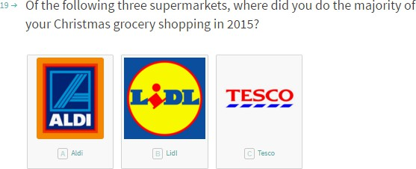
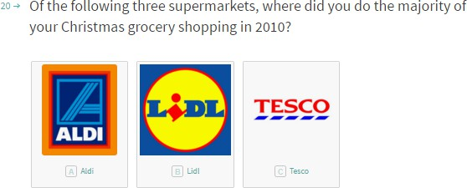
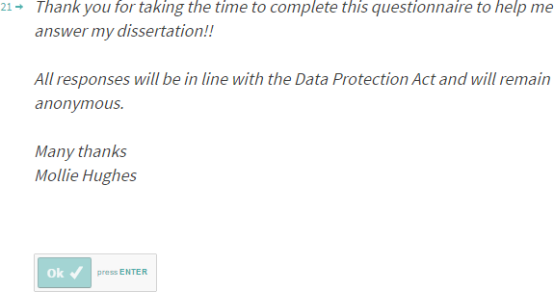

Appendix C: Blank interview questions

Semi Structured Interview Questions




To allow for more in depth answers, please complete the following questions regarding your shopping habits on Aldi, Lidl and Tesco.
- Which of the following statements most closely reflects your shopping habits and why?
  - I have always shopped at Tesco
  - I have always shopped at Aldi or Lidl
  - I have recently moved to Aldi or Lidl because of low cost products
  - I have recently moved to Aldi or Lidl because of quality
  - I have recently moved to Tesco
  - Other

- What is your perception of Aldi and Lidl products and why?
Choose as many as you like: Cheap, Value for money, Expensive, Low quality, High quality, Award winning, Other

- What is your perception of Tesco and why?
Choose as many as you like: Cheap, Value for money, Expensive, Low quality, High quality, Award winning, Other

- Of the following three supermarkets, Aldi, Lidl and Tesco, where did you do the majority of your Christmas grocery shopping in 2015 and why?

- Of the following three supermarkets, Aldi, Lidl and Tesco, where did you do the majority of your Christmas grocery shopping in 2010 and why?

Appendix D: Interview Responses

Semi Structured Interview Questions

Interview Gender | Amount
Female | 7
Male | 4
To allow for more in depth answers, please complete the following questions regarding your shopping habits on Aldi, Lidl and Tesco.
- Which of the following statements most closely reflects your shopping habits and why?
  - I have always shopped at Tesco
  - I have always shopped at Aldi or Lidl
  - I have recently moved to Aldi or Lidl because of low cost products
  - I have recently moved to Aldi or Lidl because of quality
  - I have recently moved to Tesco
  - Other

Interviews | Responses
Interview 1 | ‘Recently moved to Aldi and Lidl for low cost products. Similar products for just as good quality and for a fraction of the price.’
Interview 2 | ‘Other: Moved back to Tesco due to locality and convenience. Student with no Aldi or Lidl close by. Tesco do delivery service which Aldi and Lidl don’t offer, but if they did, I would get deliveries from them.’
Interview 3 | ‘Other, shops at all of them due to locality of closest stores, due to lack of transport as student’
Interview 4 | ‘Aldi and Lidl due to low cost. As recently had a family and the money  goes further at Aldi, and have more money left over in pocket.’
Interview 5 | ‘I have always shopped at Tesco as they aim vouchers to specific customers for different product ranges.’
Interview 6 | ‘I have always shopped at Tesco due to getting everything in one shop,  therefore convenient.’
Interview 7 | ‘I recently moved to Aldi and Lidl because of their low costs and out of frustration at Tesco’s prices, they seem to be so unnecessarily  expensive.’
Interview 8 | ‘Other, I use a mix of them all, not loyal but go for best price.’
Interview 9 | ‘I have always shopped at Lidl, Lidl is located at end of the road and I can get everything needed at a low price.’
Interview 10 | ‘I have always shopped at Tesco, however there are no local products in  Tesco or Aldi or Lidl. Such as Pembrokeshire fish.’
Interview 11 | ‘Always been Lidl or Aldi, as its cheap, low budget, get everything there, in and out in 10 mins, get what you need quickly.’

- What is your perception of Aldi and Lidl products and why?
Choose as many as you like: Cheap, Value for money, Expensive, Low quality, High quality, Award winning, Other

Interviews | Responses
Interview 1 | ‘High quality, enjoy the continental things that you can’t get in Tesco. Aldi and Lidl provide European food not just British food. High quality and good value for money.’
Interview 2 | ‘Good, sometimes taste the difference in a good and bad way. However Aldi’s fruit and veg doesn’t last as long as Tesco’s.’
Interview 3 | ‘Value for money, high quality, however you need to go to Tesco for  branded products. So be good if they started doing key brands.’
Interview 4 | ‘Aldi and Lidl is value for money, I do most of my shopping there but  aren’t able to get everything there, so still need to go to Tesco for a few  items.’
Interview 5 | ‘Cheap and low quality. Fruit and veg are out of date 95% of the time and don’t seem to last very long.’
Interview 6 | ‘Aldi and Lidl have value for money products and well as random bargain products, for example you can come out with a frying pan. However the layout of these stores can be more confusing, such as zigzag aisles. Once you’re in, you can’t get out.’
Interview 7 | ‘If you choose the right products you can get lovely products of good quality at the fraction of the price than they would have been in Tesco. But choosing what to buy is key. But do have limited stock.’
Interview 8 | ‘Good quality at reasonable price.’
Interview 9 | ‘Good quality, low price, has everything you need, however don’t do delivery and carpark isn’t that big.’
Interview 10 | ‘Limited stock, no local products, tills so frustrating, limited parking, no toilets, no café, no variety, no make-up or cards, not as convenient as having everything in one shop.’
Interview 11 | ‘Low cost, but at reasonable quality.’

- What is your perception of Tesco and why?
Choose as many as you like: Cheap, Value for money, Expensive, Low quality, High quality, Award winning, Other

Interviews | Responses
Interview 1 | ‘Tesco can choose to give customers lower prices, however they choose not to. They only seem interested in making the most money. Often the Value ranges from Tesco are more expensive then the Aldi and Lidl  equivalent products.’
Interview 2 | ‘You can go to Tesco as an activity ‘day out’. Tesco have better store layout. Feel like you’re having an experience rather than doing the shopping. Don’t have to spend too much money, if you just buy what you need.’
Interview 3 | ‘In recent years it’s declined due to increasing higher costs and not improving the quality. However the reward scheme from the Clubcard is good and the home delivery is a good service.’
Interview 4 | ‘Tesco is expensive, however more deals and offers in Tesco and better advertising on TV of offers, as well as extra savings from Clubcard  points.’
Interview 5 | ‘More expensive, higher quality, meat is award winning. And have price/brand guarantee. Instant savings on shopping rather than future savings.’
Interview 6 | ‘Tesco is highly convenient, everything in one place, simply lay out. Go to the right section quickly and easily.’
Interview 7 | ‘Expensive, but convenient as everything is there. Good quality branded  products you don’t get in Aldi and Lidl.’
Interview 8 | ‘Overpriced, Tesco try their best to get you to spend as much as possible on things you don’t need, loads more offers then Aldi and Lidl which is good and bad.’
Interview 9 | ‘Too big, too much choice that distracts you from what you actually  need and spend more money.’
Interview 10 | ‘Large product range, everything in one place including clothing, homeware, electricals, opticians and foreign exchange, as well as branded goods including alcohol.’
Interview 11 | ‘Very expensive, takes a long time to do your shopping, too many  distractions and too easy to over spend, sometimes out of town  location is annoying if don’t drive.’

- Of the following three supermarkets, Aldi, Lidl and Tesco, where did you do the majority of your Christmas grocery shopping in 2015 and why?

Interviews | Responses
Interview 1 | ‘Aldi, good range of products, including drinks, meat and veg at the fraction of the cost.’
Interview 2 | ‘Aldi due to family shopping there so not personal choice but influenced  by others.’
Interview 3 | ‘Tesco, due to wide product range and brands. Occasionally go to Aldi for the odd product.’
Interview 4 | ‘Aldi and Tesco, but mostly Aldi but go to Tesco for key branded items.’
Interview 5 | ‘Tesco, high quality, good offers and can get everything there such as presents, card and CDs which the German stores do not offer.’
Interview 6 | ‘Tesco as you can get presents, cards and clothes there, and discount codes make you go their more. You can also save on fuel if you shop there which encourages me to go there more.’
Interview 7 | ‘Aldi, because fantastic range of continental quality products that you can’t get anywhere else in main stream UK stores. Due to the savings you make at Aldi, you can go to other stores and get more luxury items.’
Interview 8 | ‘Aldi, Lidl and Tesco, used a mixture of them all but mostly Lidl, nice choice of products at a better price.’
Interview 9 | ‘Lidl, as good products for much lower prices, so more money for presents.’
Interview 10 | ‘Tesco, as everything is in one place. It has Tesco’s Finest range, money off vouchers and savings on fuel. Can also get your fuel after shopping which Aldi and Lidl cannot offer, as they have no fuel stations.’
Interview 11 | ‘Lidl, as its cheap but good continental range with different and unique  products, e.g. Gin and tonic crisps.’

- Of the following three supermarkets, Aldi, Lidl and Tesco, where did you do the majority of your Christmas grocery shopping in 2010 and why?

Interviews | Responses
Interview 1 | ‘Tesco as it was the thing to do at the time. Aldi and Lidl’s perception made them look like a cheap shop, however they have now changed to a value for money shop.’
Interview 2 | ‘Tesco due to family shopping there, so not personal choice but  influenced by others.’
Interview 3 | ‘Tesco as Lidl wasn’t popular and Aldi wasn’t in the local town.’
Interview 4 | ‘Tesco, as I don’t personally like Lidl, and Aldi wasn’t popular.’
Interview 5 | ‘Tesco, has everything there in one place rather than shopping around  and having to go to different shops for things.’
Interview 6 | ‘Tesco as you can get presents cards and clothes there, and discount codes make you go their more.’
Interview 7 | ‘Tesco, at the time the best local store, convenient and Aldi and Lidl didn’t have such a good reputation to go make you shop there.’
Interview 8 | ‘Tesco because you can get everything there, and Aldi and Lidl didn’t have good reputation.’
Interview 9 | ‘Tesco as Lidl didn’t have good reputation, probably hadn’t been into Lidl before 2010.’
Interview 10 | ‘Tesco as everything in one place and Finest ranges, plus the benefits of money off vouchers.’
Interview 11 | ‘Lidl due to low cost, high quality and different ranges.’

Appendix E: Interim report

Interim Report

Investigating how 'No-Frills' stores Aldi and Lidl have taken on Supermarket Giant Tesco

These are the key findings identified:

112 questionnaires were completed.

- 81% of respondents were females
- 52% of respondents did the majority of their shopping in Tesco
- 48% of respondents collectively did their shopping in Aldi and Lidl
- 35% of respondents have recently moved to Aldi and Lidl because of low cost products
- 47% of respondents are a little but often shoppers (convenience shoppers)
- 54% of respondents use a shopping list
- 67 respondents do their shopping on a weekday
- 36 respondents do their shopping on a weekend
- 84% of respondents do not usually grocery shop online
- 50% of respondents consider themselves as loyal shoppers and 50% of respondents do not consider themselves as loyal shoppers
- 75% of respondents have a Tesco Clubcard
- 59% of respondents usually buy branded goods
- 63% of respondents consider quality as the most important factor
- 82% of respondents consider Aldi and Lidl offer value for money
- 46% of respondents consider Tesco provide high quality produce
- 55% of respondents did their Christmas shopping in Tesco in 2015
- 81% of respondents did their Christmas shopping in Tesco in 2010 11 respondents completed the Interview. These are the key findings:
- 7 respondents were female
- 4 respondents were male

Factors affecting consumer’s decisions are displayed in the Word Cloud below:

- Locality
- Low Costs
- Convenience
- Value for Money
- Brands
- Delivery
- Experience
- Reputation
- Vouchers


