Chapter 2: Literature Review
2.0 Introduction
The intent of this chapter is to evaluate a variety of current academic literature that is available surrounding the importance for organisations to actively implement strategic recruitment processes within the workplace and how having recruitment strategies in place can assist to meet organisational objectives.
The purpose of this literature review is to achieve this dissertation first objective of:
“To highlight why strategic recruitment methods are required”
To help meet this objective a number of relevant sources such as textbooks, academic journals, online publications, independent Human resource bodies such as CIPD and newspaper articles will be analysed. The literature that is used will also be taken into consideration to aid the researcher in forming an extended hypothesis based on already standing theory conducted through a series of both qualitative and quantitative data.
The purpose of this literature review is to further extend on research already carried out on the importance of having an effective recruitment process for any given organisation and how financing appropriate recruitment methods will see a positive return on investment. Secondly, to explore current academic and theoretical frameworks which are accessible within the Human resource field. Finally, this literature review pursuit is to identify and fulfil any limitations within the field being researched to achieve a well-rounded thesis on the importance of recruitment processes.
2.1 Recruitment Strategy
In accordance with what the CIPD states about recruitment, that it is essential within every organisation and that good recruitment consists of finding the right talent for the appropriate roles at the right time. The CIPD furthers this by stating how recruitment ensures that the employees at an organisation attain the relevant skills for both the organisations current and future requirements and growth. Recruitment is not about filling vacancies but the potential of having an influence on the long-term success of the organisation (CIPD, 2020). In support of this, (Ekwoaba, 2015) explains that recruitment is closely linked to performance and the success of the organisation. They argue that the right recruitment strategy partnered with determination and qualifications are all the components needed to achieve the organisations needs maximally and any recruitment costs can be counterbalanced by recruiting the best talent.
There are numerous variations of what the recruitment process should consist of. (James A. Breaugh, 2009) alongside SHRM foundation has developed a four-step recruitment process model that if followed consistently, the employer can usually enhance their recruitment practices. This employee recruitment process model consists of these four steps:
1. Establish Recruitment Objectives
2. Develop a Recruitment Strategy
3. Carry out Recruitment Activities
4. Evaluate Recruitment Results
If the hiring manager follows these steps consistently, along with making informed conscious decisions throughout, then it is highly probable that the employer will see improvement in their recruitment process.
2.1.2. Recruitment Theory
There are substantial international theories and studies available concerning the recruitment and selection process, (Gamage, 2014) indicates the notion that there is a constructive relationship between the recruitment and selection process and the performance of an organisation. In addition, further research conducted by (Sang, 2005) also discovered a desirable association between both the recruitment process and increased organisational performance. An additional study from (Syed, 2012) equally support the theory that by implementing a strategic recruitment process, in turn the organisational performance will be positively impacted.
There are numerous theories surrounding the importance of recruitment for an organisation, however, there needs to be much more scope on why having a strategic recruitment process can positively impact on organisational performance and pigeonhole what exactly is involved to produce a tactical recruitment strategy.
2.1.3. Internal v External Recruitment
The two general factors that impact the recruitment process are separated into internal and external groupings as claimed by (Kapur, 2018). The internal factors include the size of the organisation, the organisations recruitment policy which pinpoints the objectives of the recruitment and offers a framework for the application of the recruitment programme going ahead. Another factor that can affect internal recruitment is the job image, by jobs having the possibility of a desirable working environment, recognition, and promotion it is expected to arouse the attention and enthusiasm of a skilled candidate within the organisation.
The external factors differ with focusing on demographic factors and the labour market, for example if quantity of candidates required to have specific skills is less than the demand, then the recruitment process will require greater efforts. However, if demand is less than what can be provided then the recruitment time and process will be more practicable.
(Myrna Gusdorf, 2008) explains that the advantage of internal promotion for employers is that the promoted employee is already comfortable with the corporate culture, however on the other hand the organisation puts itself at a disadvantage of missing out on fresh ideas and skills from an external candidate. There are evident pros and cons to both external and internal recruitment. There is no correct way to hire your candidates, it alters on the type of job and level within the organisation. Higher-level positions are more presumably to be filled by promotion compared to lower level.
2.2 Employee Relations
The universal definition of the employment relationship as described by (John, 2019) as the connection between both the employers and employees through which individuals offer their labour. This relationship is crucial regardless of the situation or job role involved, both parties have important underlying interests that they engage in through the employment relationship.
Employee relations begin at the initial stage of employment which is the recruitment and selection process and poses a considerable impact on whether the role is suitable for the employee and whether they will integrate well into the working environment and this should be communicated well throughout the recruitment process. According to (Sharon Armstrong, 2019), the employer and employee relationship is an ongoing process throughout employment which should be productive, fair, and smoothly functioning for both parties within the workplace.
Employee relations and relationship management is a commonly overlooked skill in recruitment, (Steven Mostyn, 2016) who is a leading specialist in recruitment and sourcing contends that in order for the recruitment process to be profitable, an effective relationship with the hiring managers is desired. It is critical to establish whether the relationship between employer and employee will be a successful one early on in the recruitment process as it will save unprecedented difficulty and time in the future if the candidate is not the correct fit.
2.2.1 Corporate Culture
An organisations work culture and values should be utilised to influence the way in which recruiters promote the organisation to potential candidates. This can be done by branding your corporate culture as a benefit of working for the organisation, pervious evidence has shown that the key for satisfaction within the workplace is the culture and values that the organisation upholds.
In support of this, (Pierce, 2019) Forbes council member, asserts that cultural fit has the potential to impact on both retention and performance levels. Employees who enjoy their working environment and the culture are more likely to be motivated to perform to their greatest ability and remain loyal to the organisation. In order for organisations to achieve admirable retention levels, they need the candidates to love the organisation, not primarily the job role.
A study carried out by (Herriot, 1981) examined different recruitment sources and preliminary decisions and concluded from the findings that recruitment brochures actively influenced potential candidates’ intentions of applying to organisations. However, this study is limited as it failed to verify the specific characteristics of the brochures that sparked those intentions.
In slight contrast to the previous study, (Rynes, 1991) makes a case of given the small amount of information provided to applicants early on in the recruitment process, early application decisions are heavily dependent on general impressions. Ryne’s (1991) further goes on to label these impressions as the “organisational image” and advocates that for future research it would be useful to pinpoint what makes up the organisational image and whether these can be cost effectively altered or communicated to enhance candidate attraction to roles.
2.2.2 Diversity, legislation and Ethical considerations
In today’s modern labour market, engaging in diverse and ethical practices in the workplace is the common expectation from organisations, especially for potential candidates seeking employment. Prior research has profiled the potential benefits of organisations actively promoting racial diversity in the workplace (McLeod, 1996). In support of this research by (Robinson, 1997) and (Thaler-Carter, 2001) , has highlighted the rise in minority candidates being recruited by organisations. For HR professionals, it is food for thought that by increasingly improving on recruiting minority candidates, it will influence a wider scale of candidates to seek employment opportunities.
Under current UK Legislation, the Equality act (2010) requires all public sector employers to eradicate any discrimination or harassment within the workplace (GOV). Between 2017 and 2018, the (DFID, 2017) released a set of objectives for diversity and inclusion for themselves which organisations could take on board. These objectives for example include, obtaining a varied representative workforce which enforces values for workers to achieve their full potential and to methodically consider diversity and inclusion across all organisational activities.
Recruitment and selection should be important to any organisation, if the wrong candidates are recruited then the organisation will be faced with expense repercussions. In 1995, the updated labour relations act was introduced resulting in employers revisiting their recruitment procedures to examine the fairness and ethical nature of their process (Brand, 2008). Below is a model (see figure 1) that demonstrates how ethics can be integrated into the recruitment process.
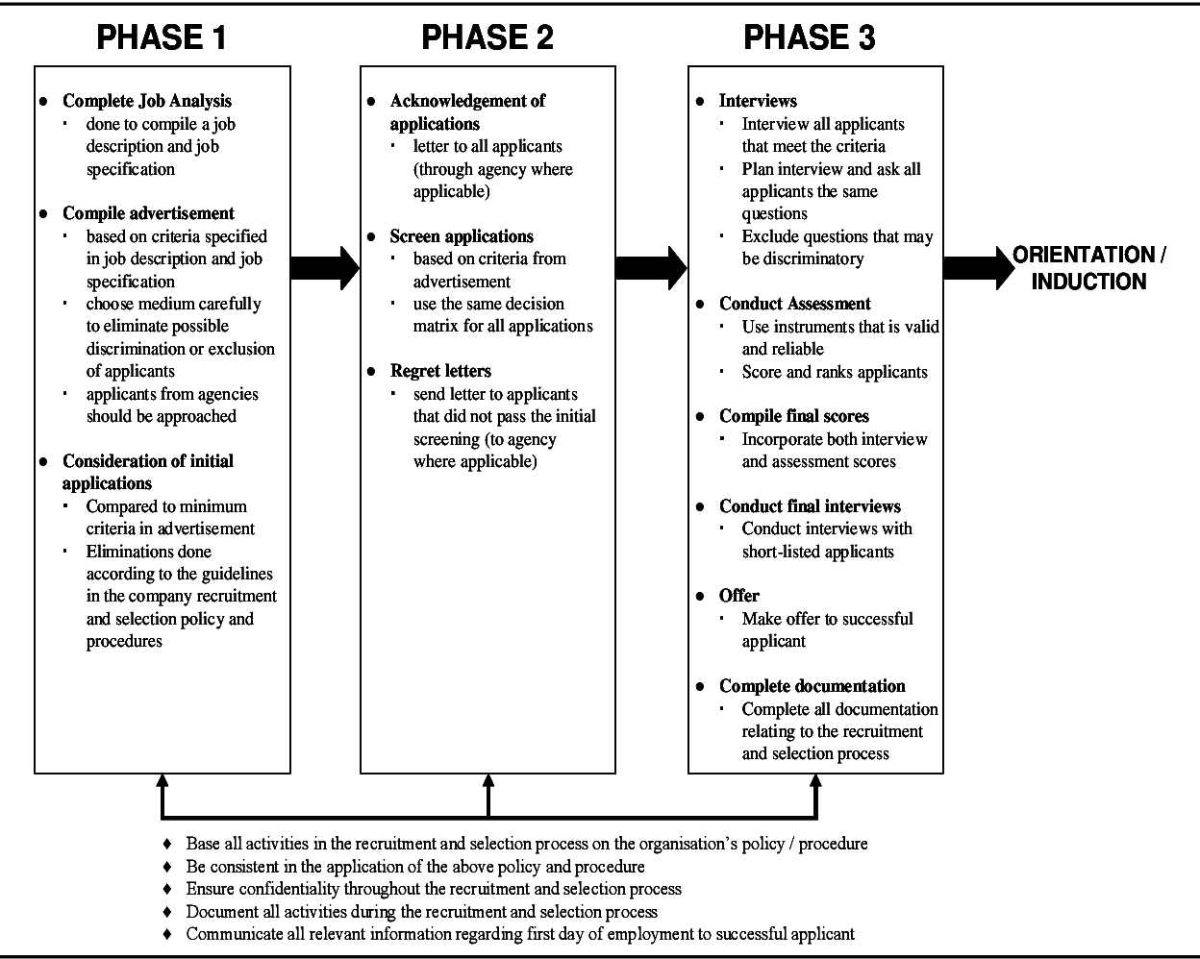
Figure 1. ‘Model of ethics incorporated in the recruitment process’ Accessed: (Brand, 2008)
2.3 The future of recruitment
With the ever-changing and fast paced environment of the labour market, reports have shown that the recruitment industry is arguably disjointed and challenged with the lack of regulations. Additionally, the evolution of technology has resulted in the industry becoming highly competitive on a global scale (Nagaraj Ijari, 2019). For organisations to become profitable in an environment such as this, recruitment managers will need to update their technology in order to reflect what the market is moving towards.
According to (McHugh, 2019) Senior Marketing Manager at Bullhorn, Digitalisation and automation will become more prominent in the year 2019, but not without potential barriers, which could be forecasted by organisations (see Figure 2). Statistics show that Forty-nine percent of recruiters determined that embracing digital transformation was their leading organisational challenge being faced. Bullhorn reiterates that the technological revolution has been designed to aid completion of tasks, allowing recruiters to focus on more valued tasks such as building those employee relationships.
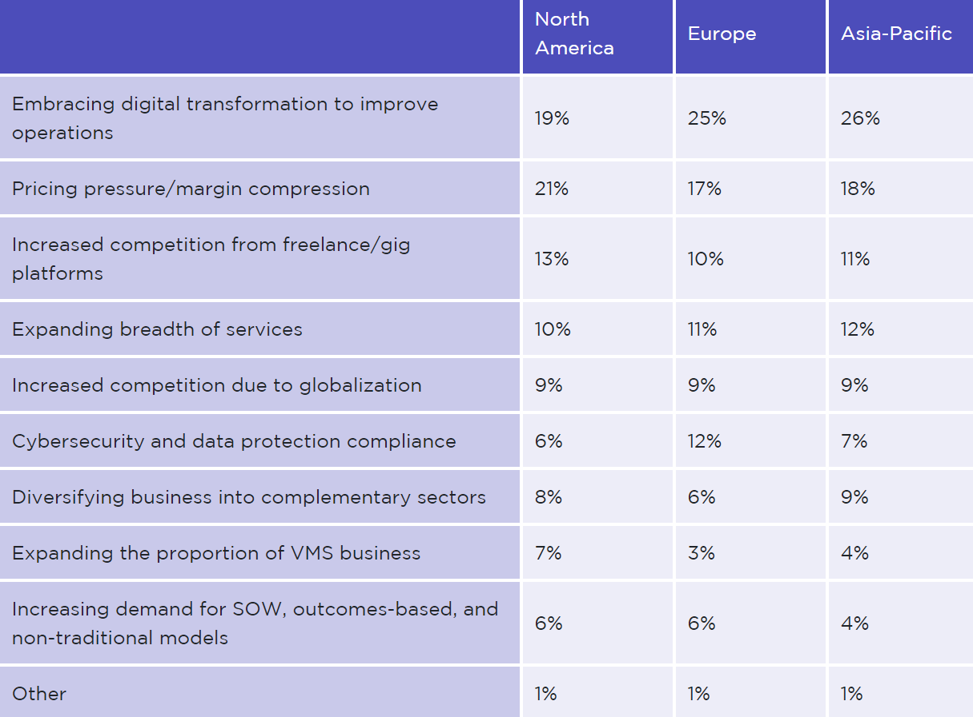
Figure 2. ‘findings of top hiring challenges recruiters face over the next 3-5 years’ Accessed: (McHugh 2019)
The future of recruiting is uncertain; however, projections have been speculated. A report from (Major Players, 2019) highlights the reluctancy individuals have towards the introduction of AI and new automation into the recruiting process with 21.3% of participants claim the use of AI in recruitment does not enhance the process at all. In contrast, 25.5% of participants asked did support the use of AI in the recruitment process and 17.4% believed it could improve the screening process. it is a common misconception that AI is being introduced to replace the human workforce when in reality it can be a useful tool to filter skills that you are looking for in the organisation and can speed up the pace of the hiring process.
2.3.1 Age of Social Media
The dawn of the social media era comes with the new generation of applicants and it is a movement that organisations are inherently trying to adapt to. Recruiters are keenly recognising the potential of these social media channels to attract a broader pool of potential applicants, (Sinha, 2013) highlights networking sites such as Linkedin, facebook and twitter to market to and attract potential candidates to job positions and screen potential candidates, even those who do not essentially apply for that position. Supporting evidence by (Nikolaou, 2014) has shown that there is a strengthening relationship between the use of sites such as Linkedin and the sourcing of identifying and enticing potential candidates.
In order for organisations to be able to keep up with a technological driven society and economy (Madia, 2011) urges recruiters to intertwine social media into their recruitment strategies. By doing this it will help organisations and the recruiters to target potential candidates, remain competitive in the market and source and retain the best possible talent required.
2.3.2 Impact of COVID-19
The impact that the current COVID-19 pandemic has had on the world has been alarming and the recruitment industry did not evade it, organisations that have continued to recruit during the pandemic have and continue to face challenges throughout. Organisations have found it increasingly difficult to navigate their business activities throughout this testing and turbulent period. The challenges that organisations are up against is strict social distancing rules which heavily effects the ability to conduct face to face interviews, due to this restriction organisations need to re-evaluate their recruitment strategy in order to abide by government regulations and being unable to recruit in physical means (Faragher, 2020).
A survey completed by (Arlington, 2020) consisting of a group of 334 Human resource leaders observed that eighty six percent of organisations are having to introduce innovative virtual technology for the candidate interviewing process due to the current COVID-19 pandemic. In addition, eighty two percent of organisations expect to see a decrease in external hiring processes due to the restrictions on human contact.
2.4 Conclusion
This literature review has satisfied the objective:
“To highlight why strategic recruitment methods are required”
This chapter has explored a variety of broad academic literature from obtainable sources such as (Steven Mostyn, 2016), (Brand, 2008) and (Gamage, 2014) to dissect why having a strategic recruitment process in place is a beneficial asset towards achieving the overall goals of the organisation. However, upon research it was evident the lack of more contemporary academia on the recruitment industry and its strategies. This thesis aims to build on the current research on this topic and apply it to the expectations from the economy and society in todays climate.
Furthermore, this literature review has touched on relevant variables that need to be considered when constructing and an organisations recruitment strategy, with issues concerning ethics and diversity in the workplace (DFID, 2017) and the fundamentals of the employee relationship (John, 2019). Evidence retrieved has support the objective of why strategic recruitment in organisations should be adapted. nevertheless, there is vast room for development on why having a strategy in place improves organisational performance so future organisations can inherit a successful recruitment process with ease.
The prominence for organisations to review their recruitment strategy has never become more prominent than with the introduction of advance technologies (Arlington, 2020) and the current COVID-19 pandemic (Faragher, 2020), this chapter provides an overview of the impact of these external factors and what this means for the recruitment industry. It is important for organisations to get on board with the technological movement and the new generation as it will not go anywhere, only advance further and if recruiters do not amend their strategies in order to fit the needs of the market then it imposes the risk of the given organisation losing out to its competitors and exceptional candidates.
The following chapter aims to identify the relevant methodology and research methods in order to develop a hypothesis based on the existing theories and tops discussed in the literature review.

References
Arlington, V. (2020, April 30th). Recruiting Leaders Are Employing New Hiring Strategies During the COVID-19 Pandemic. Retrieved from Gartner: https://www.gartner.com/en/newsroom/press-releases/2020-04-30-gartner-hr-survey-shows-86--of-organizations-are-cond#:~:text=A%20Gartner%2C%20Inc.,to%20the%20COVID%2D19%20pandemic.
Brand, H. E. (2008). Proposing and evaluating a model for ethical recruitment and selection. Journal of Contemporary Management, 205-222.
CIPD. (2020, October 27th). Recruitment: an introduction. Retrieved from CIPD: https://www.cipd.co.uk/knowledge/fundamentals/people/recruitment/factsheet
DFID. (2017). Diversity and Inclusion Annual Report. Glasgow: Department for International Development .
Ekwoaba, J. O. (2015). The Impact of Recruitment And Selection Criteria On Organizational Performance, . Global Journal of Human Resource Management Vol.3, No.2, 22-33.
Faragher, J. (2020, June 4th). How coronavirus has driven innovation in recruitment. Retrieved from People Management: https://www.peoplemanagement.co.uk/long-reads/articles/how-coronavirus-driven-innovation-recruitment
Gamage, A. (2014). Recruitment and selection practices in manufacturing SMEs in Japan: An analysis of the link with business performance. Ruhuna Journal of Management and finance, 37-52.
GOV. (n.d.). Equality and diversity. Retrieved from GOV.UK: https://www.gov.uk/government/organisations/department-for-international-development/about/equality-and-diversity
Herriot, P. &. (1981). Organizational choice and decision theory: Effects of employers' literature and selection interview. Journal of Occupational Psychology, 17-31.
James A. Breaugh, P. (2009). A Guide to Understanding and managing the recruitment process. United States: SHRM Foundation.
John, W. B. (2019). THE EMPLOYMENT RELATIONSHIP: KEY ELEMENTS, ALTERNATIVE FRAMES OF REFERENCE, AND IMPLICATIONS OF HRM. Sage Handbook of Human Resource Management, 2nd ed. Chapter 3, 3-1.
Kapur, R. (2018). Recruitment and Selection.
Madia, S. (2011). Best practices for using social media as a recruitment strategy. Strategic HR Review, Vol 10, No.6, 19-24.
Major Players. (2019). The Future of Recruitment. Retrieved from https://www.majorplayers.co.uk/future-of-recruitment/major_players_report_future-of-recruitment.pdf
McHugh, B. (2019). Overcoming the Obstacles in 2019: The Top Challenges for Global Recruitment Firms. Retrieved from Bullhorn : https://grid.bullhorn.com/insights/overcoming-the-obstacles-in-2019/
McLeod, P. L. (1996). Ethnic diversity and Creativity in small groups. Small Group Research, 248-264.
Myrna Gusdorf, M. S. (2008). Recruitment and Selection: Hiring the right person. SHRM, 1-2.
Nagaraj Ijari, G. I. (2019). Intelligent Hiring: Enhancing Recruitment and Elevating Performance. Tata Consultancy Services Ltd.
Nikolaou, I. (2014). Social networking web sites in job search and employee recruitment. International Journal of Selection and Assessment, 170-189.
Pierce, J. (2019, Febuary 8th). When It Comes to Recruiting, Put Company Culture First. Retrieved from Forbes: https://www.forbes.com/sites/forbeshumanresourcescouncil/2019/02/08/when-it-comes-to-recruiting-put-company-culture-first/?sh=1022e69d1fee
Robinson, G. &. (1997). Building a business case for diversity. Academy of Management Executive, 21-31.
Rynes, S. (1991). Handbook of industrial and organizational psychology, vol. 2. 2nd ed. Palo Alto, CA: Consulting Psychologists .
Sang, C. (2005). Relationship between human resource management practices and perception of organizational Taiwan performance, roles of management style, social capital, and culture: Comparison between manufacturing firms in Cambodia and Taiwan . Taiwan: National Cheng Kung University.
Sharon Armstrong, B. M. (2019). Employee Relations. In The essential HR Handbook (pp. 103-104). Newburyport: CareerPress.
Sinha, V. &. (2013). A review on changing trend of recruitment practice to enhance the quality of hiring in global organizations. Management : Journal of Contemporary Management Issues, Vol. 18 No. 2, 228-237.
Steven Mostyn, M. (2016). 2: Relationship Management . In Recruiting 101: The fundamentals of being a great recruiter (pp. 23-24).
Syed, Z. J. (2012). Universalistic perspective of HRM and organizational performance: metaanalytical study. International Bulletin of Business Administration.
Thaler-Carter, R. E. (2001). Diversify your recruitment advertising. HR Magazine , 92-100.

