
Applied Leadership Level 5
Module Assignment Submission
Student Name: | Allison Dight
Student Number: | 2318460
Module No: | BMSK5012
Module Title: | Understanding and Engaging in Customer Experience

Statement of Confirmation of Authenticity
By the act of making this submission, the student declares that this is the work of the student named above. The work has not, in whole or in part, been knowingly presented elsewhere for assessment, or where assessment has been built on a previous assessment, this has been identified. Where materials have been used from other sources it has been properly acknowledged. If this statement is untrue, the student acknowledges that an assessment offence has been committed.
Attention is drawn to the plagiarism and unfair practice policies of both the University and of IL

Table of content

Introduction 3
Main findings 3
Customer Experience 4
Positive aspects of the customers experience (CX) 6
Negative or challenging Aspects of CX 6
Customer life cycle 6
Awareness 6
Consideration 6
Booking / Purchase 6
Service / Experience 6
Post-Visit Engagement 7
Retention & Loyalty 7
Advocacy 7
Customer values 7
Customer loyalty 15
Academic Definition & Insight 15
Drivers of Customer Loyalty in a Salon 18
Business Benefits 16
Customer expectations 16
Customer centrality 16
The 5 Stages of a Customer Journey 16
The 5 E’s in the Customer Journey 17

Introduction
In the highly competitive personal care industry, customer retention is both a challenge and a strategic opportunity. Salons, in particular, face the constant threat of client churn due to low switching costs and the abundance of local alternatives. With increasing customer expectations and the growing importance of personalised service, businesses must move beyond transactional engagements and focus on relationship-based strategies to achieve loyalty and maximise customer value.
The primary aim of this report is to critically analyse how a salon can apply customer life cycle principles to encourage repeat visits, increase customer satisfaction, and strengthen long-term relationships. The report shows a structured business framework, drawing on established marketing and service quality theories, including the Customer Lifecycle Model (Kotler et al.), the SERVQUAL framework (Parasuraman et al., 1988), and the Customer Value Hierarchy (Levitt, 1980). These models serve as lenses through which key salon processes, such as customer engagement, segmentation, value creation, and quality assurance are examined in detail.
The analysis begins by establishing the theoretical foundations before mapping the salon customer journey, identifying service gaps, and evaluating quality management practices. It then explores segmentation and centrality concepts to align service offerings with customer needs. Finally, retention strategies and loyalty-building techniques are discussed with a focus on long-term relationship cultivation. The report concludes with actionable recommendations designed to support service consistency, customer delight, and business sustainability.
By integrating these critical concepts into a coherent service strategy, salon managers can better align their operations with client expectations, enhancing not only loyalty but also competitive advantage in a dynamic marketplace.

Main findings
When looking at a positive customer experience and Analysis of customer engagement within the hair salon context reveals several critical insights into service delivery and client satisfaction. Firstly, personalisation of services emerged as a key determinant of positive customer experience. Clients consistently value consultations that consider individual preferences, lifestyle, and hair type, which not only offering trust but also increase perceived service quality .Secondly, the physical environment, or services of the salon plays a significant role in shaping clients with emotional responses. Factors such as cleanliness, lighting, ambient music, younger clientele will like more upbeat music while the more senior customer will like softer music, and seating comfort contribute to an overall impression that influences repeat visits and brand perception. Thirdly, staff professionalism and communication skills were found to be central to client engagement. Attentive listening, clear explanations of treatments, and respectful interaction consistently led to higher satisfaction scores .Additionally, the study identified that digital touchpoints, including online booking systems and social media presence, enhance customer convenience and engagement pre- and post-visit. Salons that maintained active communication across digital platforms often reported stronger client retention and loyalty.
Finally, it was noted that managing expectations and handling complaints effectively can significantly mitigate negative experiences and reinforce a sense of value and care, even in less than ideal situations.

Customer Experience
A client visits "Hair by Allison" for a colour and cut appointment. She is welcomed warmly by the receptionist and offered a drink while waiting. Her stylist, greets her by name, consults her about the desired colour and hairstyle, and double-checks her preferences and hair condition. Throughout the appointment, the stylist remains professional, engaging in light conversation, ensuring she’s comfortable and informed about each step of the process.
After the service, she is shown the result, and provides aftercare advice and product recommendations tailored to her hair type. She is delighted with the outcome and books her next appointment before leaving. (“A Study on the Relationships among Body Sensory Experience, Customer Satisfaction and Customer Loyalty-Beauty SPA Centre as an Example,”(2015).

This is MoSCoW and Kano Model
This model shows different ways of prioritising methods by analysing ,must have, should have, could have, will not have. kano model showing satisfaction, best, performance, frustration. And functionality. An impact effort matrix, with big bets, quick wins, this will impact and effort the customer experience. Also has a RICE Method, Reach, Impact, Confidence, Effort. And a table of feasibility desirable, and viability, scorecard, this can help to keep track on findings.
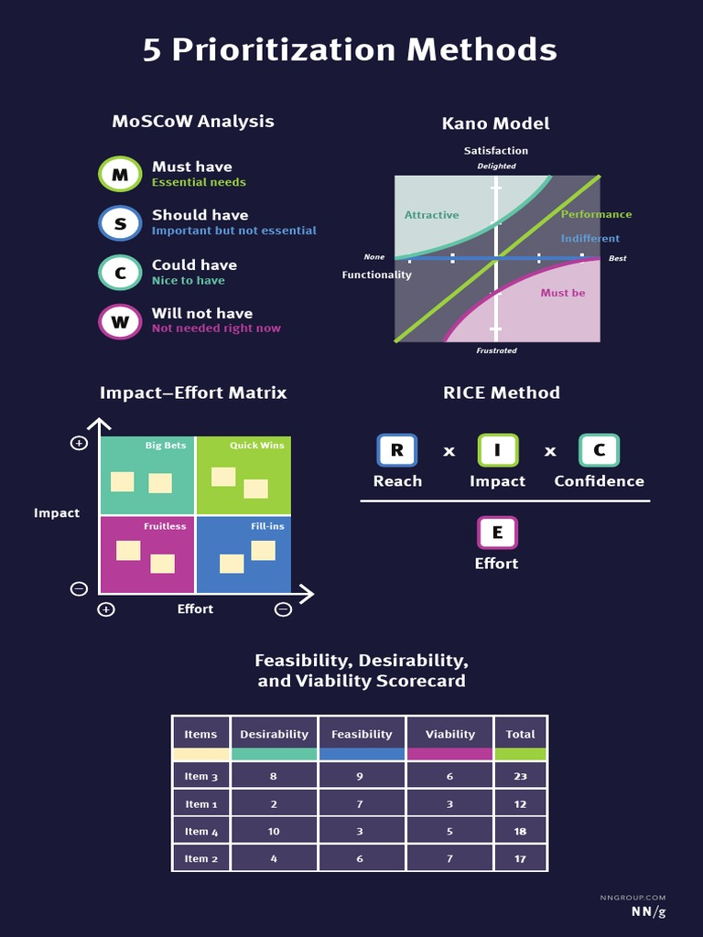

Positive Aspects of the Customers Experience (CX)
Personalised consultation, will make the client feel her needs were understood (this a lady’s only salon) and valued. Professional communication, The stylist balanced friendliness with professionalism. The Aftercare advice will Help build trust and encourages return visits. Using Efficient service delivery The appointment ran on schedule with minimal delays.

Negative or Challenging Aspects of CX
Reception area was slightly noisy, This affected the relaxing atmosphere during the initial wait. When Upselling products felt a bit rushed although the suggestions were helpful, She felt slightly pressured to purchase. Limited privacy The open plan layout of the salon meant private conversations could be overheard. (Al-Mashhadani et al., 2020)

Customer life cycle

Awareness

What happens. When Potential clients discover the salon through online ads, social media, recommendations, or walking by. What can the salon do. The salon can Use engaging Instagram content with before and after pictures of the stylist work, strong Google reviews, and local partnerships to stand out.

Consideration
What happens. When Clients research services, look at prices, compare to other salons, and maybe read client reviews. Salon strategies, The salon Has a clear and attractive website, visible pricing, and portfolios of stylists’ work.

Booking / Purchase
What happens when the client books their first appointment ,this is the conversion point. Salon strategies are offer an easy to use booking system, possibly with first-time offers or a welcome package.

Service / Experience
What happens, The actual appointment is the most critical stage. This includes the atmosphere, stylist interaction, and treatment results. Salon strategies, They Deliver excellent service, maintain professionalism, ensure a comfortable environment, and add personal touches.

Post-Visit Engagement
What happens, The client receives a follow-up (e.g. thank you message, aftercare tips, rebooking reminders). Salon strategies, the salon can Send a personalised email or text, offer loyalty points, or request a review.

Retention & Loyalty
What happens, The client returns regularly, refers others, and engages with the salon on social media. Salon strategies, The salon will Build relationships through loyalty programs, client exclusive events, or birthday offers.

Advocacy
What happens, The client actively recommends the salon, posts about it, or brings friends. Salon strategies, The Encourage referrals, feature client transformations on social media, or reward reviews.

Customer values
Customer values refer to the principles, priorities, and expectations that influence consumers decision making processes and perceptions of service quality. In a salon environment, understanding and aligning with these values is crucial to delivering a client centred experience that offers satisfaction, loyalty, and advocacy.
From a customer value point of view it can be defined as the perceived benefits gained from a service relative to the costs incurred , These benefits may be tangible (e.g. the quality of a haircut) or intangible (e.g. feelings of relaxation, trust, or personal expression).

Theoretical Framework
This section presents the academic of customer engagement, loyalty, and value creation within service organisations, specifically for a salon environment. By applying well established theories, the aim is to construct a critical lens through which customer experience strategies can be designed, implemented, and evaluated.

customer Lifecycle Model (Kotler et al.)
The Customer Lifecycle Model delineates the progression a customer follows from the awareness stage to the advocacy stage: Attract → Convert → Retain → Grow. In salon services, where client retention is vital, this model allows service providers to pinpoint intervention opportunities across the cycle. For example, the retention stage can be reinforced by post-visit communications or loyalty incentives. However, its limitation lies in treating customer progression as linear, while in reality, salon clients may exit and re-enter the cycle unpredictably (Winer, 2001).

Customer Value Hierarchy (Levitt, 1980)
Levitt’s hierarchy asserts that value evolves in layers, from core benefits to augmented offerings such as atmosphere and emotional appeal. In salons, the haircut or treatment is the core, but ambience, interpersonal interaction, and personalisation create significant perceived value. A key point here is that emotional value, not just technical quality, influences loyalty (Woodruff, 1997).

Service Quality Framework (SERVQUAL)
Parasuraman, Zeithaml and Berry (1988) propose that perceived service quality is determined by five factors: Tangibles, Reliability, Responsiveness, Assurance, and Empathy. Applied in salons, tangibles include equipment cleanliness, while assurance stems from the stylist’s skill. The gap model embedded in SERVQUAL helps identify service delivery failures by comparing expectations with perceptions, invaluable tool for driving quality improvements.
Criticism of SERVQUAL centres on its limited adaptability to experiential services like salons, where emotional and aesthetic experiences often outweigh functional dimensions (Buttle, 1996).

Analysis of the Salon Customer Journey
To implement effective loyalty strategies, salon managers must first understand how customers experience the brand across each stage of the customer lifecycle. This section maps out that journey using real world salon processes and identifies friction points that could deter repeat business.

Awareness and Consideration
A client’s journey begins with brand discovery. This could stem from social media, word of mouth, or digital advertising. First impressions both online and physical carry significant weight. Research shows that visual branding and online reviews play a decisive role in forming expectations (Verhoef et al., 2009). If the salon’s digital presence lacks consistency or personality, it undermines credibility during the consideration phase.

Purchase and Experience
The point of sale experience reflects the salon's operational quality and service culture. Critical factors include: ease of booking (via app or phone), Ambience and cleanliness, Staff professionalism and empathy, Service personalisation
This is where SERVQUAL becomes essential. Customers subconsciously evaluate tangible and intangible elements. For instance, delays, inattentiveness, or robotic service interactions create dissonance even if the haircut is technically flawless.
Service outcomes and emotional experiences. The haircut alone doesn’t dictate satisfaction, empathy and rapport are equally influential (Berry et al., 2002).

post-Service Retention
Post-visit interactions are often overlooked. A simple “thank you” message or personalised discount for the next visit reinforces emotional value and brand attachment. Data-driven CRM systems can enable segmentation and timely outreach. for Best practice A stylist mentioning a client’s upcoming event during follow-up shows attentiveness-turning service into relationship.

Growth and Advocacy
Loyal clients become brand advocates. Encourage referrals through a tiered loyalty programme that rewards not just frequency, but influence. Emotional loyalty founded on trust and shared values outperforms economic incentives alone. Challenge, This phase is often mismanaged by relying on discounts over connections. The report later critiques this transactional mindset as counterproductive in high touch industries.

By dissecting the salon experience through this lifecycle lens, it becomes clear that loyalty building is a holistically rooted as much in emotional resonance and micro-interactions as it is in quality services or pricing.

Evaluating Customer Expectations and Value Creation
In the salon industry, value perception is shaped as much by intangible experiences as by tangible service outcomes. Understanding and bridging the gap between what customers expect and what they experience is essential to cultivating loyalty.

Understanding Customer Expectations
Expectations are shaped by multiple touchpoints past experiences, peer recommendations, marketing communications, and cultural norms. Parasuraman et al. (1988) distinguish between desired expectations (ideal outcomes) and adequate expectations (minimum acceptable service). In salons, desired expectations often include personalised consultation, flawless execution, and emotional uplift. Failure to acknowledge the emotive dimension of salon experiences such as self-image, confidence, and comfort risks creating a mismatch, even when the technical service is sufficient. Emotional satisfaction strongly influences return intentions (Oliver, 1999).

Applying the SERVQUAL Framework
The SERVQUAL model assesses service quality along five dimensions Tangibles, Physical appearance of the salon, cleanliness, and staff grooming. Reliability Consistency in service delivery (e.g., haircut results). Responsiveness Willingness to help and address concerns. Assurance Competence and trustworthiness of the staff. Empathy Personal attention and emotional intelligence.
Gap Analysis can identify shortfalls between expectations and perceptions. For example, if a client expects empathy and receives transactional treatment, emotional dissonance occurs, lowering perceived value-even if the haircut was technically perfect.

Customer Value
Levitt’s Customer Value Hierarchy suggests that customers evaluate services beyond the core offering. In salons: Core value - haircut, colour, or treatment. Expected value - clean environment, timely service. Augmented value - drinks offered, stylist remembering preferences, personalised advice. This layered model reveals that value creation occurs across both the tangible and affective dimensions of service (Grönroos, 2004). Personalisation enhances perceived value. A stylist who remembers previous styles or upcoming events elevates the customer’s emotional connection to the brand.

Services to Expectations
Naturally into Segmentation and Centrality, where we examine how to put customer insight into targeted practice. Segmented marketing enables the salon to tailor communications and service enhancements. For instance: Millennials may value sustainability and digital booking systems. Older customers may prioritise familiarity and consistent staff. Understanding which attributes matter most to each segment informs both service design and marketing tone. This section underscores that service consistency isn’t enough-meeting emotional, and aesthetic expectations is vital to maximising customer value. These insights transition us

Customer Segmentation and Centrality
Understanding that not all salon clients are alike is crucial to building meaningful, lasting relationships. Customer segmentation allows businesses to tailor their service delivery, marketing communication, and value propositions based on specific group needs-maximising customer value and loyalty over time.

Importance of Customer Segmentation
Segmentation is the process of categorising customers based on shared characteristics that influence their buying behaviour. In the salon context, four key segmentation types stand out. Demographic Segmentation, Age, gender, income level, occupation Example, Younger adults may be more trend conscious, whereas older clients may prioritise consistency and rapport. Behavioural Segmentation, Booking patterns, service frequency, feedback responsiveness Example, Clients who book monthly colour treatments may respond better to loyalty programmes than walk-in customers. Psychographic Segmentation, Values, lifestyle, personality for Example, Eco conscious clients may favour salons that use cruelty free or organic products. Geographic Segmentation, Local preferences, commute distance, area specific trends, Each segment reveals different needs, priorities, and emotional drivers, which can be leveraged to tailor everything from service design to pricing strategy. Key message, One size fits all approaches limit perceived value. Segmentation personalises the customer experience and fosters emotional engagement. Involving regular clients in service innovation trials. Co-developing loyalty programmes based on real client input, Redesigning appointment systems around observed pain points
This approach aligns with Peppers & Rogers' (1993) One-to-One Marketing concept, which argues that treating customers as individuals, not segments, yields higher satisfaction and loyalty.

Tools for Effective Segmentation
To action these insights, many salons implement, CRM analytics, Track frequency, monetary value, and recency (RFM model) Customer feedback loops, Surveys, reviews, and suggestion boxes. However, reliance on past behaviour can risk reinforcing the limiting outreach to potentially high-value but low-frequency users (Reinartz & Kumar, 2000). This reinforces the need for continuous reassessment of segmentation models.
Segmenting smartly and practicing customer centrality enables salons to serve not only their most frequent visitors, but also unlock loyalty potential across broader customer types. This sets the stage for implementing systems that support consistent, memorable service.
Quality Processes and Service Innovation
Here is an image to show the process of Quality (Dmaic Model - Bing, 2025)
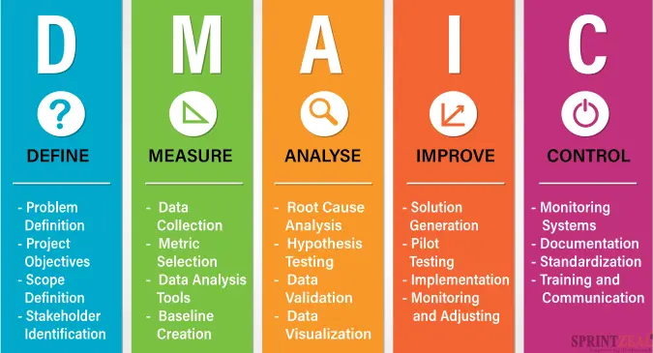
Delivering quality in a salon isn’t a one time achievement it’s a continuous process that requires alignment between people, procedures, and customer expectations. This section unpacks how quality practices and innovation can enhance loyalty and create a resilient client base.

Defining Service Quality in a Salon Context
While quality often conjures thoughts of technical skill (e.g., haircutting precision), salon clients evaluate quality holistically. This includes, Environment Cleanliness, aesthetics, lighting, comfort, Interactions: Courtesy, active listening, stylist confidence, Outcomes Personalised results, aftercare advice services
According to Grönroos (1990), quality in services is both technical (what is delivered) and functional (how it is delivered). Overlooking either dimension degrades the overall experience even if the technical result meets expectations. service quality is co-created in real time through each staff-client interaction.

Implementing Quality Assurance Systems
Salons can ensure consistency by embedding structured quality processes Standard Operating Procedures (SOPs) for greeting, consultation, service delivery, and checkout. Service Audits to assess staff adherence to protocols and customer satisfaction. Feedback Systems such as Net Promoter Score (NPS) or post-service surveys, Mystery Shoppers for unbiased evaluation.
Frameworks like Total Quality Management (TQM) emphasise continuous improvement through staff involvement and cross-functional training (Deming, 1986). Encourage frontline employees to suggest service tweaks. Innovation often comes from those closest to the client.

Staff Training and Development
Training isn't a one-off induction it’s a lifelong process. Effective quality cultures invest in, Soft skills active listening, handling complaints, reading body language. Technical excellence, style trends, chemical handling, hygiene protocols. Cultural awareness, understanding diverse hair types and sensitivities Empowered staff are more engaged and confident, translating into better client interactions and trust.

Embedding Service Innovation
Innovation in salons goes beyond trendy hairstyles it’s about customer convenience and delight, having Digital Booking Platforms with customisable service menus. Virtual Consultations pre-appointment for style planning. Subscription Services for monthly treatments or care bundles. Sustainable Practices (e.g. recycling programs, green products) to match evolving client values. According to Prahalad & Ramaswamy (2004), value is co-created when clients engage in the service experience. Inviting client input into new offerings enhances both relevance and attachment.

Pyramid Diagram
This framework not only defines the theoretical scaffolding for the salon's strategy but also surfaces key tensions such as the balance between automation and human touch, or consistency versus personalisation. These tensions are explored throughout the report as we transition into a practical analysis of the salon customer journey
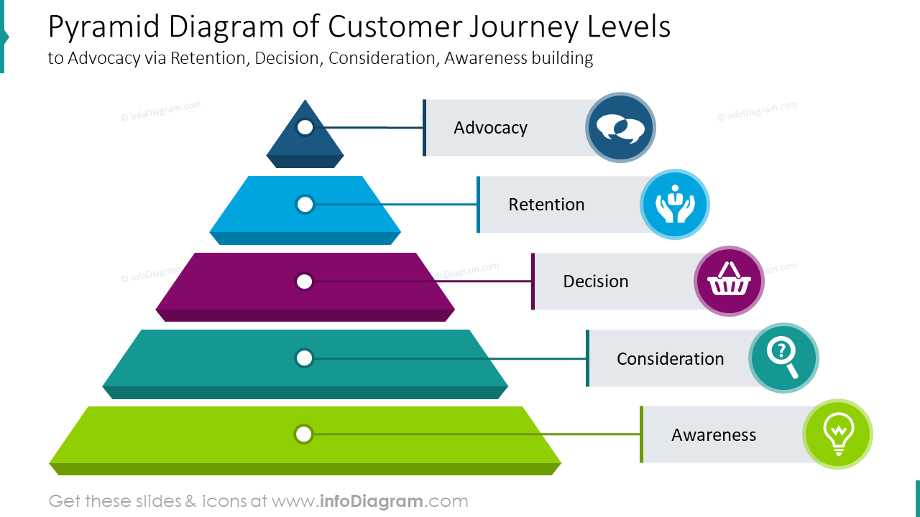

Key customer values in a salon context include:
Quality and Expertise: Clients expect high professional standards, including skilled techniques, up-to-date styling knowledge, and appropriate consultation.
Personalisation: Consumers increasingly value bespoke services that reflect their individual needs, preferences, and lifestyles.
Convenience and Efficiency: From flexible booking systems to timely appointments, clients seek services that respect their time and provide ease of access.
Emotional Connection: A sense of trust, familiarity, and comfort, often created through positive staff interaction, is integral to building long-term relationships.
Value for Money: While price is a factor, clients often equate value with the total service experience, including ambience, hospitality, and aftercare support.
Meeting these values not only enhances customer satisfaction but also contributes to business performance through increased client retention, positive word-of-mouth, and brand loyalty

Customer loyalty
Customer loyalty refers to the ongoing preference and commitment a customer shows toward a brand, product, or service provider, often demonstrated through repeat business, positive referrals, and emotional attachment. In a salon setting, loyalty goes beyond satisfaction, it's about creating relationships that make clients feel seen, valued, and understood. (Witkowska, 2021).

Academic Definition & Insight
According to Oliver (1999), customer loyalty is a deeply held commitment to repurchase or a preferred product or service consistently in the future, despite situational influences and marketing efforts having the potential to cause switching behaviour. This means loyalty isn’t just about habit, it’s about trust, satisfaction, and perceived value over time.
Consistent Service Quality, Skilled stylists and reliable outcomes build confidence and repeat visits.
Personal Connection, Familiarity with staff, use of client names, and remembering preferences create emotional ties. Hair by Allison will write notes about the client cards. to help them remember. Client Rewards Programs, Points, discounts, or free treatments such as a free Olaplex treatment. Exceptional Customer Experience, Every touchpoint, from booking to aftercare, contributes to lasting impressions. Processing Brand Alignment Clients are more loyal when they feel the salon reflects their personal identity or lifestyle (e.g. eco-friendly practices, inclusive atmosphere).

Business Benefits
Lower marketing spend due to word-of-mouth referrals, will cut costs. Keeping cost low Will reflect on a Higher average spend per visit. Customer are more likely to buy products to use at home. Increased resistance to competitors’ promotions.

Customer expectations
Customer expectations play a massive role in shaping service delivery outcomes, particularly within the personal care sector where individual preferences, comfort, and emotional fulfilment are highly valued. According to Parasuraman, Zeithaml, and Berry (1988), expectations serve as benchmarks against which service quality is evaluated, they influence perceptions of satisfaction and directly affect client retention and loyalty. When expectations are met or exceeded, clients are more likely to return, recommend the service to others, and form a strong emotional connection with the brand. ultimately contributing to positive word-of-mouth and long-term business sustainability. However, consistently meeting these expectations may present operational challenges. High and sometimes unspoken customer demands can increase pressure on staff performance, strain resources, and restrict flexibility in delivering creative or personalised services. as customer expectations evolve it often becoming more complex over time the salons must continuously invest in training, technology, and customer service strategies to stay competitive. Failure to manage expectations effectively can result in dissatisfaction, negative reviews, or client churn, particularly in cases where the perceived service falls short of the anticipated standard.

Customer centrality

The 5 Stages of a Customer Journey
The most commonly used five stages of a customer journey are awareness, consideration, purchase, retention, and advocacy. But much has been written about the path a potential customer takes to becoming brand loyal to a business, and writings often refer to multiple architectural models. Sometimes marketers refer to these models as a funnel, other times a path, journey, map, steps, or stages. But all of them are getting at the same multi-faceted truth of consumer behaviour. Here are the details about one common breakdown of the five stages and how they work.
Awareness - The decision maker at a business becomes aware of your brand, often through social media, word-of-mouth, or other brand awareness marketing campaigns.
Consideration - A company recognises that they have a pain point your solution could help with, and they actively contemplate making a purchase.
Purchase - The business decides your offerings would benefit them, and they buy your product or service.
Retention - A combination of positive customer success experiences and reaping the rewards of your product or service maintains a customer in good standing.
Advocacy - The loyal business client becomes an effective customer advocate for your brand, sharing their positive experiences through advocacy work such as word-of-mouth promotion, reference calls, case studies, testimonials and speaking engagements.
Automating and integrating the advocacy stage into your marketing plays with a tool like Orca ensures this last step especially is not neglected.

The 5 E’s in the Customer Journey
Another framework used to talk about the customer journey is the five E’s: entice, enter, engage, exit, and extend. These closely align with the five stages discussed in the last section, although they do encourage a slightly different way of considering each.
Entice - Attract ideal customers to learn more about your business offerings, often using marketing tactics like LinkedIn ads, informative topic blogs, or word-of-mouth recommendations.
Enter - Impress potential clients with your website once they arrive with good functionality, well-written content, and modern design.
Engage - Create website functionality that offers customer interaction, like tools with benefits they can use or trials of your solution.
Exit - Provide follow-up to clients when they leave an interaction with your brand. This process could include a positive checkout experience, or reminder check-ins to revisit their trial subscription.

Extend - Encourage repeat purchases and brand advocacy on your behalf to highly satisfied customers. A top-notch customer marketing and reference management application, can enable a seamless path for customers who fit this role.

Executive Summary
This summary report shows how a salon business can build long-term customer loyalty by analysing the customer life cycle and applying core service marketing theories. In today’s competitive market, where switching costs are low and expectations high, repeat business is crucial for sustainable growth in personal care services.
A comprehensive analysis reveals that inconsistencies in quality, unmet expectations, and impersonal customer engagement are major factors in client churn. Particular attention is paid to service reliability, emotional resonance, and post-visit follow-up, with segmentation insights (e.g. behavioural and psychographic) guiding targeted retention strategies.
The findings highlight the importance of emotional value creation, the need for tailored services based on customer profiles, and the power of relationship-building mechanisms such as loyalty programs and personalised communications. Process-driven quality management and total staff engagement are shown to be key in delivering consistent, memorable service.
The report recommends a strategic shift from transactional encounters to a relationship-based service culture. Investments in training, CRM tools, and feedback systems are identified as critical enablers. Ultimately, fostering deeper customer relationships not only maximises individual customer lifetime value but also enhances brand advocacy, positioning the salon for long-term success.
The primary aim of this report is to critically analyse how a salon can apply customer life cycle principles to encourage repeat visits, increase customer satisfaction, and strengthen long-term relationships. The report adopts a structured business framework, drawing on established marketing and service quality theories, including the Customer Lifecycle Model (Kotler et al.), the SERVQUAL framework (Parasuraman et al., 1988), and the Customer Value Hierarchy (Levitt, 1980). These models serve as lenses through which key salon processes such as customer engagement, segmentation, value creation, and quality assurance are examined in detail. (lifestyle, self-image), or behavioural (visit frequency, spend)—allow salons to create distinct value propositions. RFM Analysis (Recency, Frequency, Monetary) is an effective tool to prioritise high-value clients, though it risks marginalising new or irregular customers (Reinartz & Kumar, 2000). This framework not only defines the theoretical scaffolding for the salon's strategy but also surfaces key tensions such as the balance between automation and human touch, or consistency versus personalisation. These tensions are explored throughout the report as we transition into a practical analysis of the salon customer journey. CRM is both a philosophy and system for cultivating long-term customer relations. In a salon, CRM tools can monitor visit frequency, track preferences, and schedule targeted promotions. Peppers and Rogers (1993) advocate for one-to-one marketing that aligns precisely with the personalisation expectations of modern salon clients. However, the misuse of CRM—for instance, through over-automation or impersonal follow-ups can diminish authenticity and alienate clients.

Reference
- ‌ A Study on the Relationships among Body Sensory Experience, Customer Satisfaction and Customer Loyalty-Beauty SPA Center as an Example. (2015). International Journal of Business and Administrative Studies, 1(1). https://doi.org/10.20469/ijbas.10003-2
- ‌ Al-Mashhadani, A. S. F., Aldori, M. K. M., & Elsayed, A. T. A. (2020). Develop a negativeand positive customer experience model in online retailing by study the differences between customer experience models in successful and failure situations. International Journal of Psychosocial Rehabilitation, 24(04), 12–24. https://doi.org/10.37200/ijpr/v24i4/pr200982
- dmaic model - Bing. (2025). Bing. https://www.bing.com/images/search?q=dmaic+model&FORM=HDRSC3
- ‌ Oliver, R. L. (1999). Whence consumer loyalty? Journal of Marketing, 63(Special Issue), 33–44. https://doi.org/10.2307/1252099
- Buttle, F. (1996). SERVQUAL: Review, critique, research agenda. European Journal of Marketing, 30(1), 8–32. https://doi.org/10.1108/03090569610105762
- Deming, W. E. (1986). Out of the Crisis. Cambridge, MA: MIT Center for Advanced Manufacturing Study/Addison-Wesley.
- Drivers of Customer Loyalty in a Salon Al-Mashhadani, A. S. F., Aldori, M. K. M., & Elsayed, A. T. A. (2020). Develop a negativeand positive customer experience model in online retailing by study the differences between customer experience models in successful and failure situations. International Journal of Psychosocial Rehabilitation, 24(04), 12–24. https://doi.org/10.37200/ijpr/v24i4/pr200982
- Grönroos, C. (1990). Service Management and Marketing: Managing the Moments of Truth in Service Competition. Lexington, MA: Lexington Books.

International Journal of Business and Administrative Studies, 1(2), 61–67. https://doi.org/10.20469/ijbas.1.10003-2
- Kotler, P., Kartajaya, H., & Setiawan, I. (2017). Marketing 4.0: Moving from traditional to digital. Wiley.
- Kotler, P., Kartajaya, H., & Setiawan, I. (2017). Marketing 4.0: Moving from traditional to digital. Wiley.
- Levitt, T. (1980). Marketing success through differentiation––of anything. Harvard Business Review, 58(1), 83–91.
- Levitt, T. (1980). Marketing success through differentiation––of anything. Harvard Business Review, 58(1), 83–91.
- Oliver, R. L. (1999). Whence consumer loyalty? Journal of Marketing, 63(Special Issue), 33–44.
- Parasuraman, A., Zeithaml, V. A., & Berry, L. L. (1988). SERVQUAL: A multiple-item scale for measuring consumer perceptions of service quality. Journal of Retailing, 64(1), 12–40.
- Parasuraman, A., Zeithaml, V. A., & Berry, L. L. (1988). SERVQUAL: A multiple-item scale for measuring consumer perceptions of service quality. Journal of Retailing, 64(1), 12–40.
- Peppers, D., & Rogers, M. (1993). The One to One Future: Building Relationships One Customer at a Time. New York, NY: Doubleday.
- Prahalad, C. K., & Ramaswamy, V. (2004). Co-creation experiences: The next practice in value creation. Journal of Interactive Marketing, 18(3), 5–14. https://doi.org/10.1002/dir.20015
- Prahalad, C. K., & Ramaswamy, V. (2004). Co-creation experiences: The next practice in value creation. Journal of Interactive Marketing, 18(3), 5–14. https://doi.org/10.1002/dir.20015
- Reinartz, W. J., & Kumar, V. (2000). On the profitability of long-life customers in a noncontractual setting: An empirical investigation and implications for marketing. Journal of Marketing, 64(4), 17–35.
- Witkowska, A. (2021). Creating own Brand Equity Versus Customer Loyalty in a Commercial Enterprise. JOURNAL of INTERNATIONAL STUDIES, 3(1), 109–115. https://doi.org/10.14254/2071-8330.2010/3-1/12

