Software Applications for Business
Student name
Date

Contents
Introduction 3
Task 1. E-Commerce Website builders & e-Portfolio creation 3
a. Analysing e-Commerce website software solutions 3
b. Online e-portfolio 3
Task 2. Mind-map of contemporary software applications 3
Office Applications: 3
Communication/Collaboration: 3
Project Management: 3
E-Commerce Website Builders: 4
Digital Dashboard/Data Analytics: 4
Task 3. Office Applications for creating, storing, analysing & presenting information/data 4
a. Analysing contemporary Office applications 4
b. Testing of free business-related features 4
Task 4. Poster of Digital Dashboard and Data Analytics software 4
a. Analysing key features of contemporary Digital Dashboard/Data Analytics software 4
b. Testing features available Digital Dashboard 4
Task 5. Communication, Collaboration & Project Management applications 5
a. Analysing contemporary Communication/Collaboration/Project Management applications 5
b. Testing of available Communication application 5
Conclusion 5
References 7

Introduction
Software applications and tools have become increasingly important in today's fast-paced business environment for various reasons, including increased productivity, streamlined workflows, enhanced communication, and improved decision-making. This report aims to investigate and evaluate current software packages that can be useful in a business setting (Ang and Buttle, 2006). This report will thoroughly understand the key features and practical applications of e-commerce website builders, office applications, digital dashboards, and data analytics software, and communication, collaboration, and project management applications by examining these tools in detail. In addition, the report will provide simulations and examples of using the chosen software applications, guaranteeing that the information presented is both applicable and useful. This knowledge can be used in various professional contexts to improve productivity and teamwork.

Task 1. E-Commerce Website builders & e-Portfolio creation

a. Analysing e-Commerce website software solutions
Shopify: Shopify is an easy-to-use, comprehensive e-commerce platform that can scale with any business. It has numerous editable storefront layouts, a safe shopping cart, and over four thousand available apps to further the store's capabilities (Ma, 2007).
WooCommerce: WooCommerce is an add-on for WordPress that extends WordPress's capabilities to function as an online store. It is very versatile, but unlike other platforms, it requires a higher level of technical expertise to utilise fully.
Wix: Wix is an easy-to-use website editor that includes shopping cart functionality right out of the box. It is user-friendly and has several sample documents that can be a starting point when starting a business (Hart, 2006). However, its lack of scalability makes it less than ideal for more expansive web shops.
Portfolio Link: https://manage.wix.com/dashboard/cd2decb0-248e-4d53-890e-0183f4ccd3cb/portfolio/project/5c993310-295a-4183-b8ba-3e045782bcf6

b. Online e-portfolio
Wix, WordPress, and Google Sites are all excellent options for building an online portfolio. Create a polished online portfolio to present the work with the help of these platforms, which provide a wide range of premade layouts and editing tools (Bashir et al., 2001).

Task 2. Mind-map of contemporary software applications
The following are examples of possible categories and applications to include in a mind map (figure below) of modern software used to aid in the running of a business:
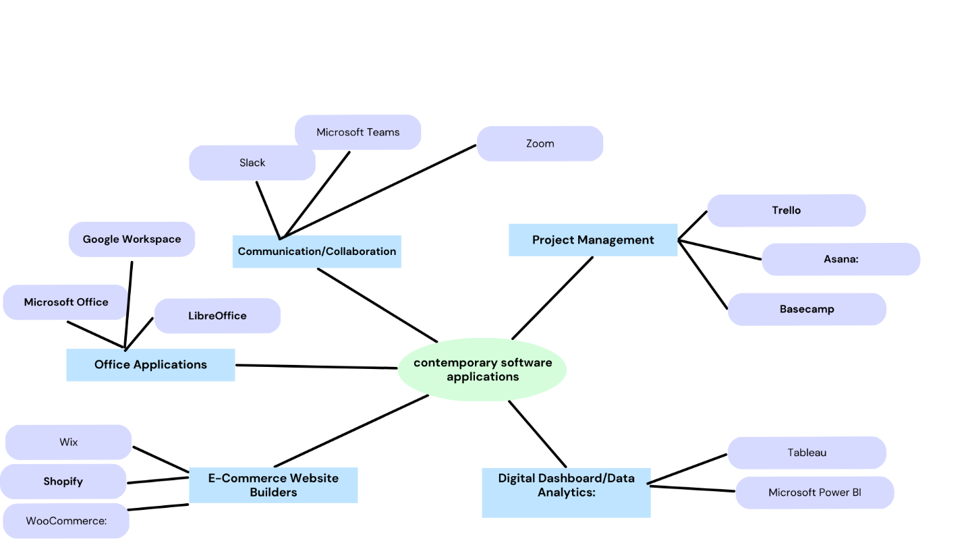
Figure 1: Mind map of contemporary software applications

Office Applications:
- Microsoft Office: Word, Excel, PowerPoint, Access
- Google Workspace: Docs, Sheets, Slides, Forms
- LibreOffice: Writer, Calc, Impress, Base

Communication/Collaboration:
- Slack: Team messaging, file sharing, and integration with other business tools
- Microsoft Teams: Chat, video conferencing, file sharing, and integration with Microsoft Office
- Zoom: Video conferencing, webinars, and screen sharing

Project Management:
- Trello: Visual project management with boards, lists, and cards
- Asana: Task and project management, team collaboration, and workflow automation (Cusumano et al., 2004)
- Basecamp: Project management, team communication, file sharing, and task assignments

E-Commerce Website Builders:
- Shopify: User-friendly platform with templates, secure shopping cart, and app integrations
- WooCommerce: Open-source WordPress plugin for customisable e-commerce websites
- Wix: Drag-and-drop website builder with built-in e-commerce features

Digital Dashboard/Data Analytics:
- Tableau: Data visualisation and analytics software for creating interactive dashboards
- Microsoft Power BI: Business intelligence tool for creating data-driven visualisations and reports

Task 3. Office Applications for creating, storing, analysing & presenting information/data

a. Analysing contemporary Office applications
Microsoft Office: Word, Excel, PowerPoint, and Access are all part of Microsoft Office, which is a suite of productivity software databases. Microsoft Office is well-known for its advanced capabilities, extensive formatting choices, and app-to-app integration.
Google Workspace: Documents word processing, Spreadsheets spreadsheets, Presentations, and Forms are all part of Google's cloud-based Productivity Tools Suite (Hart, 2006). With Google Workspace, distributed teams can easily share and collaborate on documents in real-time.
LibreOffice: A free and open-source alternative to Microsoft Office that includes word processing, spreadsheets, presentation software, and a database management system databases (Cecchet et al., 2002). LibreOffice is a free alternative to Microsoft Office compatible with the latter's file formats.

b. Testing of free business-related features
Created a document, spreadsheet, or presentation to evaluate the functionality of the business-related features of an office suite application that is freely available, such as LibreOffice (Marr and Neely, 2003). Screenshots should be documented, and detailed descriptions of the evaluated features should also be provided. Some of the features evaluated include the ability to format text, insert images, create charts, and use formulas in spreadsheets.

Task 4. Poster of Digital Dashboard and Data Analytics software

a. Analysing key features of contemporary Digital Dashboard/Data Analytics software
Tableau: Tableau is an advanced data analytics and visualisation programme that lets its users make interactive dashboards that can be shared with others (Wan-Kadir and Loucopoulos, 2004). The most notable features are data integration, real-time analysis, and integrated collaboration tools. Tableau has powerful visual analytics features and supports numerous data formats.
Microsoft Power BI: Power BI is a data visualisation and analysis solution for turning raw data into engaging reports and dashboards (Cecchet et al., 2002). Data modelling, individualised visualisations, and tight integration with other Microsoft programmes are some highlights. Power BI has powerful data analysis tools and works with various data sources.

b. Testing features available Digital Dashboard
Use PowerPoint or another design programme to make a fake A3 digital dashboard poster for any company or project you like. Use KPIs, charts, and graphs to highlight the benefits of digital dashboard software like Tableau and Microsoft Power BI.

Task 5. Communication, Collaboration & Project Management applications

a. Analysing contemporary Communication/Collaboration/Project Management applications
Slack: Slack is a popular app for communicating with teams that includes features such as direct messaging, group channels, file sharing, and integration with several different business tools (Wan-Kadir and Loucopoulos, 2004). Slack makes it easier for teams to communicate effectively with one another and work together.
Microsoft Teams: Chat, video conferencing, file sharing, and integration with other Microsoft Office programmes are some of the features that are included in Microsoft Teams, which is a platform for communication and collaboration developed by Microsoft (Offutt, 2002). Teams are beneficial to organisations because they help streamline the processes of communication and project management.
Trello: Trello is a visual project management tool that allows users to organise their projects and tasks using boards, lists, and cards. Trello is flexible enough to accommodate a wide variety of workflows and applies to managing projects in a wide variety of fields.
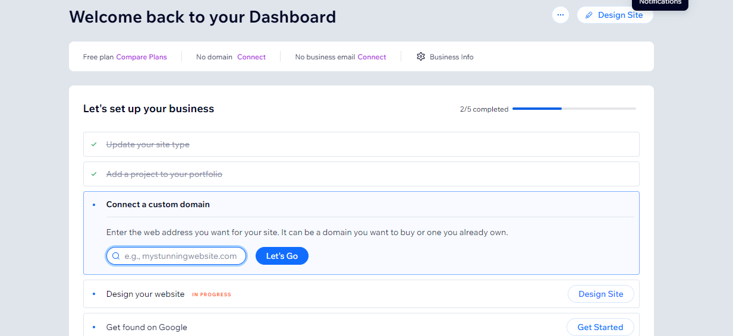
Figure 2: Project creation on Wix
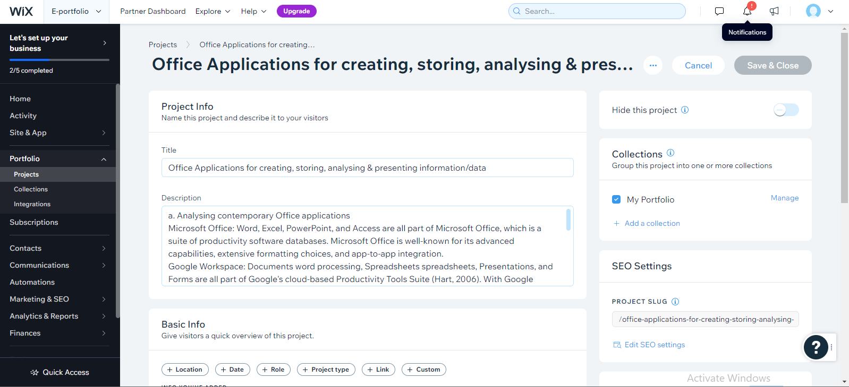
Figure 3: Project creation on Wix
Following these easy instructions, I was able to add a project to my Wix site. Open the Wix Editor for the site where I want to add the project and log in to my Wix account. To add something, use the editor's "Add" (+) button on the left. The option "Portfolio & CV" will appear. To view the various project templates, go to the "Projects" tab. Add the selected project template to site by clicking on it. Click on the project's layout to open the editor and make changes. The project's title, description, images, and associated links all need to be updated. Simply move the online template for current project by dragging and dropping. Select "Save" in the editor's menu bar at the top right to permanently store modifications. To make the new site live and accessible to users, click the "Publish" button.

b. Testing of available Communication application
Created a project, assigned tasks, and communicated with members of the team in order to evaluate the capabilities of a communication, collaboration, and project management application like Trello that is freely available to users (Adams et al., 2004). Make a new Trello board and label it with the project's name. Identify the board by name and set an appropriate wallpaper. This will be the nerve centre where everything related to the project can be managed and stored (Dubey and Wagle, 2007). Use To-Do, In-Progress, and Completed lists to illustrate the various steps in completing a project. Make index cards for each task in these lists for a straightforward visual representation of the project's development. Add members of the team to individual cards and assign them tasks. This establishes unambiguous accountability and duty. Team members can better prioritise their workload and complete their assignments on time if deadlines are established.

Conclusion
This report explains a variety of cutting-edge apps and programmes that can improve efficiency, effectiveness, and creativity in the workplace. Our in-depth research into e-commerce website builders, office software, digital dashboard and data analytics software, conferencing, document sharing, and project management tools has yielded important insights into these programmes' most salient characteristics and useful functions.
In addition, this report has shown how to use specific software programmes by providing working examples and simulations to see how they work in practice. Using such resources will be increasingly important as businesses try to meet the challenges of the modern workplace and encourage greater productivity, teamwork, and overall success in the workplace. The right software solutions, tailored to the workplace's needs, can dramatically impact an organisation's performance and growth in today's cutthroat business climate.

References
Adams, B., Berner, E. S. & Wyatt, J. R. 2004. Applying Strategies To Overcome User Resistance In A Group Of Clinical Managers To A Business Software Application: A Case Study. Journal Of Organizational And End User Computing (Joeuc), 16, 55-64.
Ang, L. & Buttle, F. 2006. Crm Software Applications And Business Performance. Journal Of Database Marketing & Customer Strategy Management, 14, 4-16.
Bashir, I., Serafini, E. & Wall, K. 2001. Securing Network Software Applications: Introduction. Communications Of The Acm, 44, 28-30.
Cecchet, E., Chanda, A., Elnikety, S., Marguerite, J. & Zwaenepoel, W. 2002. A Comparison Of Software Architectures For E-Business Applications.
Cusumano, M., Iyer, B. & Venkatraman, N. 2004. The Software Business, Springer.
Dubey, A. & Wagle, D. 2007. Delivering Software As A Service. The Mckinsey Quarterly, 6, 2007.
Hart, M. 2006. Customer Relationship Management: Are Software Applications Aligned With Business Objectives? South African Journal Of Business Management, 37, 17-32.
Ma, D. The Business Model Of" Software-As-A-Service". Ieee International Conference On Services Computing (Scc 2007), 2007. Ieee, 701-702.
Marr, B. & Neely, A. 2003. Automating The Balanced Scorecard–Selection Criteria To Identify Appropriate Software Applications. Measuring Business Excellence, 7, 29-36.
Offutt, J. 2002. Quality Attributes Of Web Software Applications. Ieee Software, 19, 25-32.
Wan-Kadir, W. M. & Loucopoulos, P. 2004. Relating Evolving Business Rules To Software Design. Journal Of Systems Architecture, 50, 367-382.

