Introduction
This poster examines the key concepts of health, well-being, and lifestyle in early childhood, highlighting how lifestyle influences a child’s health and development. It also explores the practitioner’s role in supporting these areas, insights from relevant theorists, and the resources available to promote and sustain children’s health and well-being.
According to UNICEF (2022) and Analdu Consulting et al. (2018), Article 24 of the UNCRC states that all children have the right to the best possible healthcare and to physical and emotional well-being. This includes access to nutritious food, medical care, and a safe environment for a healthy start in life.
Health
The World Health Organization (2025) defines health holistically, covering physical, mental, and social well-being beyond just absence of illness. It stresses everyone’s right to health without discrimination based on gender, race, culture, or status. Early infancy is crucial, with investments in nutrition, care, education, and strong parent-child bonds benefiting individuals and society. Caring, safe, and culturally respectful environments are essential for healthy development and lifestyles.
Moreover, Musgrave (2017) notes health is a complex concept without a single agreed definition. The World Health Organization (1986) defines health as the ability to meet obligations and goals while adapting to one’s environment, highlighting physical and social aspects. Understanding how to adjust surroundings is especially important for supporting children with health issues, particularly in early learning settings.
Additionally, Marmot (2010) explains that health is a social construct influenced by age, occupation, living conditions, and birth. Both mental and physical health matter, and social factors are crucial for improving outcomes. Positive early experiences and quality early childhood programs support healthy development. Socioeconomic status, early experiences, and healthcare access impact holistic well-being.
Young children's health and self-care are essential helping them understand their bodies and enhance their general well-being, particularly considering rising obesity rates and a lack of exercise. Children may learn the value of exercise, healthy eating, safety and hygiene via active play and teaching (Tickell, 2011).
The Parliamentary and Health Service Ombudsman (2015) explains that government and disability advocates are adopting the social model of disability, focusing on accessibility and inclusion. This changes the view of disability from a personal issue to a societal one, emphasizing the social environment over individual limitations.
According to WHO (1986), early childhood health is vital as it forms the foundation for lifelong well-being. A child’s future relies on physical growth as well as emotional and cognitive development, both shaped by early health. Good early health supports social and learning skills needed for academic success, reduces chronic disease risk, and encourages healthier lifestyles later in life.
Furthermore, Musgrave (2017) stresses that understanding health determinants is crucial as they greatly affect individual and community well-being. Early childhood health is especially shaped by factors like environment, socioeconomic status, education, and relationships. Practitioners can enhance children’s development and create inclusive environments by recognizing and addressing these influences.
Berlinski & Schady (2015) argue that one of the major obstacles to early childhood health is economic status, which frequently prevents children from low-income families from having access to basic resources like good healthcare, nutritious foods, and educational opportunities. According to the Children's Commissioner for Wales (2024), approximately 30% of children in Wales are living in poverty, with around 26% of these children residing in households where at least one adult is employed.
Likewise, Mwangi et al. (2021) highlight barriers to healthcare for children with neurological impairments, including financial constraints that limit treatment access and geographic distance that hinders regular visits. Limited resources and low caregiver health literacy reduce awareness of services, while cultural beliefs and societal attitudes may discourage care-seeking. Domestic responsibilities and concerns about confidentiality also restrict access. Addressing these barriers is crucial to improving care quality and availability.
Moreover, Hesketh, Lakshman, and van Sluijs (2017) stress the need for improved nutrition and physical activity education to combat rising childhood obesity. Parental understanding is crucial, but barriers such as limited time, finances, and unhealthy family environments hinder children’s activity and diet. Public Health Wales (2024) reports 11.4% of 4-5-year-olds were obese and 13.4% overweight in 2022-2023.
However, Jackson and Third (2023) noted early childhood facilities have several challenges, including insufficient finance, inadequate training, and a lack of essential resources such specialised equipment. These challenges make it more difficult to provide comprehensive and equitable care since financial assistance is sometimes insufficient to meet the various needs of children.
Wellbeing
Berlinski & Schady (2015) define early childhood well-being as encompassing physical health, emotional stability, social skills, and cognitive development. They highlight the importance of nurturing relationships, secure environments, and supportive educational experiences in building resilience and promoting long-term positive outcomes. Well-being is viewed as a state of overall health, emotional balance, and personal fulfilment.
Moreover, Statham and Chase (2010) define well-being as the overall quality of life, characterized as a dynamic state that improves through achieving social and personal goals. It includes both subjective elements, such as happiness and satisfaction, and objective factors like financial stability and education.
Furthermore, Hong, Ra, and Jang (2014) claims well-being as a general sense of life satisfaction that includes emotional, psychological, and social aspects. It involves the ability to handle stress, build healthy relationships, and experience satisfaction, joy, and purpose. Well-being ultimately means feeling happy, valued, and connected to a community in daily life.
Additionally, Chan and Hazan (2022) maintain that early Childhood is crucial for developing emotional and psychological stability, which is necessary for long-term mental health. They highlight the significance of supporting environments and strong connections, underlining that adverse childhood experiences can result in long-lasting mental health issues.
Bracknell Forest Council (2024) explains social well-being in the early years include acquiring social skills, establishing healthy relationships, abiding by social standards, and gaining confidence and resilience in new situations. The ability of children to comprehend, control, and express their emotions as well as demonstrate self-control when necessary is referred to as emotional wellbeing.
Manning-Morton (2014) stresses that well-being in early childhood is essential for encouraging risk-taking, managing emotions, and forming strong relationships. It also fosters kindness and empathy, and builds confidence, allowing children to express their feelings and thoughts more freely.
Yates et al. (2008, cited in Darling-Churchill & Lippman, 2016) state that early social and emotional development involves safe interactions, healthy emotional expression, and exploring cultural and social environments. However, Darling-Churchill and Lippman (2016) note challenges in assessing well-being due to developmental differences and unclear definitions. They stress focusing on positive development and accurately assessing children from diverse cultural and language backgrounds to avoid misinterpretation.
One challenge that may arise is ensuring quality care at home and in nurseries, as inadequate conditions can negatively affect children's emotional, mental, and physical development. Parental support and knowledge are also crucial, as stress, limited understanding, or lack of resources can hinder effective parenting, which may impact a child’s well-being, resilience, and confidence later in life. (Berlinski & Schady, 2015).
Furthermore, Mainstone-Cotton (2017) claims a child's entire well-being is greatly impacted by poverty and studies show that this economic disadvantage can have a negative impact on a child's mental health.
Additionally, Bradshaw (2016; National Institute for Health and Care Excellence (NICE), 2021) explain that barriers to children’s well-being include individual challenges such as learning needs, mental health issues, and social difficulties; family factors like neglect, abuse, and lack of emotional support; social barriers that affect children’s ability to settle in and fit in with peers; and institutional barriers when adequate support is unavailable.
Hong, Ra, and Jang (2014) link positive emotions like pleasure and love to happiness. Children often feel joy through hobbies, relationships, encouragement, and achieving goals. However, many struggle to express what happiness means to them, so educators must understand children’s happiness to create loving, supportive environments.
Davies (2024) states that health and well-being are essential to education, giving children opportunities to explore life challenges. Focusing on physical, mental, social, and emotional health helps students see their connection, fostering a holistic understanding that prepares them to manage life effectively.
Chan and Hazan (2022) present the Health Hexagon, a holistic model that prioritizes well-being by emphasizing meaning, purpose, and social relationships. It identifies six essential elements for mental health: adequate sleep, healthy eating, regular exercise, spending time in nature, supportive relationships, and a strong sense of purpose. The model supports individual and community well-being, particularly during crises like the COVID-19 pandemic.
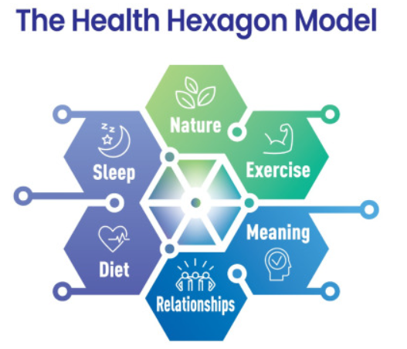
Chan, C.S. and Hazan, H. (2022) ‘The Health Hexagon Model: Postulating a holistic lifestyle approach to mental health for times and places of uncertainty’, SSM - Mental Health, 2, pp.100071. doi:https://doi.org/10.1016/j.ssmmh.2022.100071.

Lifestyle
Brivio et al. (2023) highlight that the term "lifestyle" lacks a singular definition, as it is a multifaceted concept shaped by various psychological and sociological influences.
According to Van Acker (2016) and Brivio et al. (2023), lifestyle refers to the actions and decisions that are influenced by attitudes, values, motives, and viewpoints and that represent one's social standing. It includes activity patterns as well as the driving forces behind behaviour. Furthermore, values and cultural ideas impact that lifestyle by defining what is seen acceptable in social circumstances, which in turn promotes or restricts actions.
However, Cambridge Dictionary (2019) states it as one concept. The term "lifestyle" refers to the way an individual lives, encompassing their behaviours, dietary choices, hobbies and how they allocate their time. Each person's lifestyle is unique, shaped by a variety of factors including cultural influences, social circles, friendships and personal preferences.
Thomas and Lewis (2016) assert that a child's lifestyle can be significantly shaped by their exposure to peers who exhibit positive habits. These relationships foster an environment that encourages constructive thinking and behaviour, ultimately promoting a healthier lifestyle for the child.
Estyn (2013) emphasizes the critical role of physical education in fostering a child's development, health and overall well-being. Engaging in healthy living practices is essential for promoting well-being, which encompasses not only nutritious eating and drinking but also the cultivation of meaningful relationships. These elements collectively contribute to a child's holistic development, underscoring the interconnectedness of physical health and social interactions.
Lioret et al. (2020) maintains barriers to a child's healthy lifestyle often stem from the influence of parents or caregivers, including excessive screen time and poor dietary choices. Additionally, lower levels of maternal education are associated with unhealthy lifestyle patterns in children. These factors can contribute to the development of future unhealthy habits, ultimately affecting the child's overall health and well-being.
Furthermore, Lekše, Prosen and Prosen (2023) explain parental difficulties, such as a lack of time for physical activity, financial limitations or a lack of awareness and enthusiasm in offering nutritious food options, may act as obstacles to young children leading healthy lifestyles. Environmental factors are also important; children's ability to adopt healthy behaviours is further hampered by hazardous communities, a lack of facilities for physical activity and restricted access to nutritious food.
Adopting healthy lifestyles is essential for both individual and community well-being, as it significantly influences physical, mental and social health. Conversely, unhealthy lifestyle choices can result in various health issues, including mental health disorders and diminished overall well-being (Vaquero-Abellan, Marquez and Martínez, 2022).
The Foresight Mental Capital and Wellbeing Project (2008) claims that a healthy lifestyle, including regular physical activity, a balanced diet, and adequate sleep, can lower illness and obesity risks, improve mental well-being, and strengthen bones and muscles. Research indicates that physical activity can elevate mood, while a nutrient-rich diet supports cognitive function. Social connections also play a crucial role in emotional resilience and mental health.
Theorists
Bronfenbrenner's ecological systems theory emphasizes the interconnectedness of a child's environment, including macrosystems, mesosystems, and microsystems such as home and early childhood settings. This framework helps practitioners address children’s needs by highlighting the shared responsibility of families, professionals, and society in promoting children's health and well-being (Musgrave 2017).
Bronnfrenbrenners Theory Photo
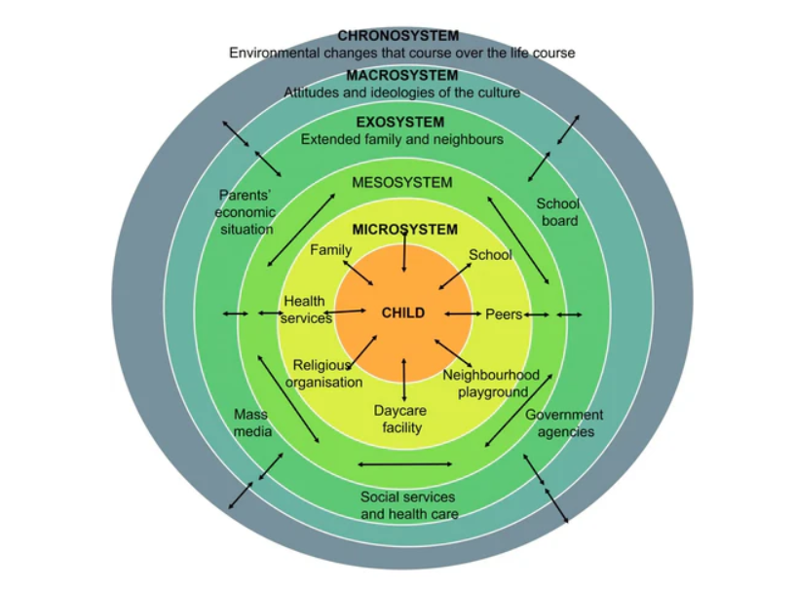
Flavin, G. (2023) Theorist in the Spotlight: Urie Brofenbrenner and the EYLF. Available at: https://www.sticksandstoneseducation.com.au/blogs/educators-notebook-the-early-years-edition/theorist-in-the-spotlight-urie-brofenbrenner (Accessed: 25 May 2025).
Pichère and Cadiat (2015) argue that Maslow’s hierarchy of needs influences well-being, with basic physiological needs being essential for personal growth. Unmet lower-level needs can harm health, well-being, and lifestyle.
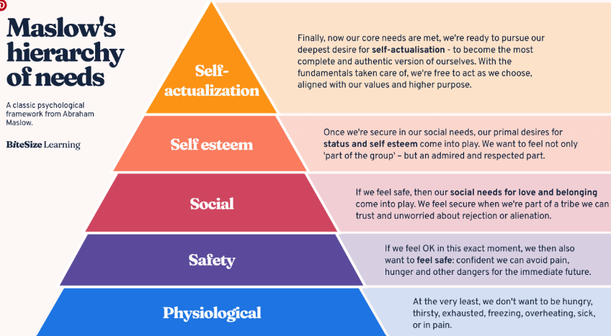
Bitesize Learning (2024) Maslow’s hierarchy of needs, explained. Available at: https://www.bitesizelearning.co.uk/resources/maslows-hierarchy-of-needs-theory. (Accessed: 23 May 2025).
Practitioners’ role
Musgrave (2017) maintains practitioners are crucial in promoting health outcomes in diverse settings by creating inclusive environments for children from diverse backgrounds. They implement health promotion initiatives, engage parents and collaborate with professionals to address health challenges. They must consider socioeconomic factors and cultural beliefs.
The Department for Education (2023) stresses that children thrive in nurturing environments supporting emotional and social well-being. Practitioners foster relationships, encourage co-regulation, and collaborate with families to understand each child’s needs. Similarly, Mainstone-Cotton (2017) states the importance of partnerships with families and agencies to support children’s development, encouraging risk-taking and problem-solving to build confidence and well-being.
Transitioning from childcare to home can be difficult for children and requires patience. Building trust between practitioners, parents, and children supports confidence and resilience. Collaborating with professionals like school nurses and educational psychologists is essential for promoting well-being and addressing diverse needs through a holistic approach in early years settings. (Wilson 2016).
Norfolk (2025) presents a variety of techniques and exercises aimed at enhancing self-regulation, overall health and relaxation. Among these methods are the TIPP technique, the practice of opposite action, and the STOP strategy, all of which offer practitioners effective tools for managing stress and promoting well-being.

Support
The 2025 poverty report highlights challenges impacting young people’s health and well-being, including higher living costs for disabled individuals compared to non-disabled ones, and 54% of low-income families lacking access to nutritious food. Low wages and limited support worsen poverty. Policies focus on job aid, affordable housing, debt help, and health support (Joseph Rowntree Foundation, 2025).
Health promotion, as defined by the World Health Organization (1986) The procedure emphasises physical, mental, and social well-being and gives people and communities the ability to manage their own health. Along with an increased understanding of general health and well-being, it places an emphasis on establishing personal objectives, adjusting to one's environment, and making use of available resources.
Welsh Government (2022b) launched the Healthy Child Programme, a national initiative promoting early intervention, healthy nutrition, mental health, parenting support, and physical activity to support children's development. Targeting families with children under seven, it provides essential health assessments and interventions to ensure their well-being and growth (Gov 2025).
Public Health Wales (2024) has implemented a program in primary schools across Wales to assess the health and service needs of young children aged 4 and 5, aiming to gather data to develop targeted services, particularly in addressing childhood obesity, and create more effective strategies for their well-being.
Furthermore, Welsh Government (2022) has launched a free breakfast club to provide equal access to nutritious breakfasts to low-income families, aiming to address obesity among young children. The initiative aims to improve children's overall well-being, concentration, and health. All children have equal access thereby reducing discrimination.
Welsh Government (2019) states efforts are underway to introduce initiatives like Active Wales to promote equal access to sports by investing in new facilities and providing free swimming lessons, enhancing participation in physical activity for all.
The Dahlgren and Whitehead Model provides a framework for understanding health determinants, including behavioural, social, economic, and environmental factors. It promotes a holistic approach to health, emphasizing social equity and structural influences. The model encourages cross-sector collaboration, focuses on addressing root causes over individual behaviours, and supports research into social and economic factors affecting health (Dahlgren and Whitehead, 2021).
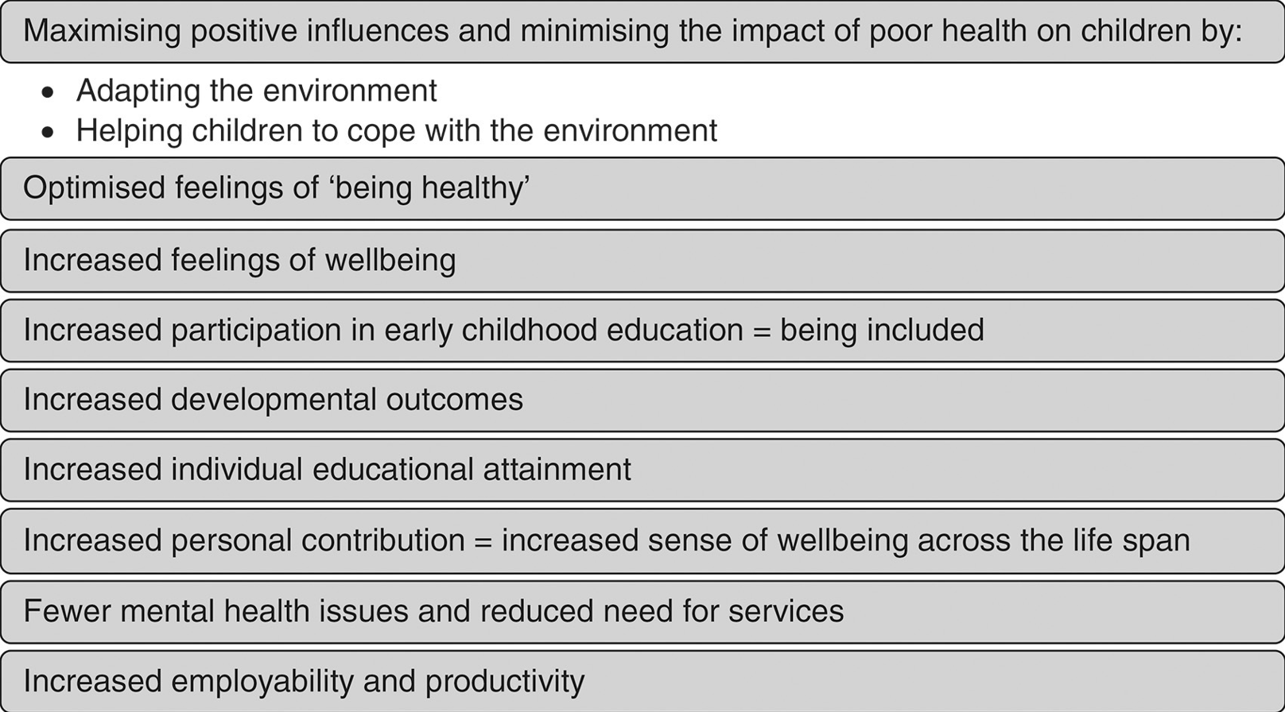
Musgrave, J. (2017) Supporting Children’s Health and Wellbeing. London: SAGE Publications Ltd.
Llywodraeth Cymru (2022) explains that Wales’ new curriculum promotes resilience, empathy, mental and emotional health, and physical fitness to develop healthy individuals. It prepares children for independent living and active societal participation, encouraging good lifestyle choices, regular exercise, seeking help, and strong relationships. This holistic approach benefits both individuals and society. The Reggio Emilia Early Learning Centre (2024) closely aligns with the Welsh curriculum by prioritizing well-being and safe environments but also views the environment as the “third educator,” fostering child-led learning and creativity to enhance children’s sense of worth and belonging. The Welsh Government (2022) notes the non-maintained curriculum similarly emphasizes a child-centred approach like Reggio Emilia.
Conclusion
In conclusion, a child’s health and well-being are influenced by various factors that affect their overall quality of life. Emphasizing holistic health—including mental, social, and physical aspects—is crucial despite challenges. Theories support this approach, and practitioners play a key role in promoting children’s well-being. Governments and educational institutions have introduced initiatives to encourage healthy lifestyles, addressing issues like obesity and poverty.

