

MASTER OF BUSINESS ADMINISTRATION
MARKETING MANAGEMENT
Module Code: LCMB7024
COMPONENT 2
Assignment Title: Portfolio (Brand Development)
LECTURER: TAONGA KAONGA SOBERA-SNITHERS
Submitted by
Ritiben Vishwanath Machhi
Student ID: 2538062

Table of Contents
Element 1: Sustainable Brand Extension Poster Presentation 3
Element 2: Segmentation, Targeting, Differentiation, and Positioning (STDP) Analysis 4
Market segmentation 4
Targeting strategy 5
Differentiation 5
Positioning strategy 6
Element 3: Marketing Mix (4Ps) Analysis 7
Product (advanced material science and sustainable value creation) 7
Price (Value-based premium pricing and lifecycle costing) 9
Place (Sustainable logistics and circular supply chains) 9
Promotion (B2B relationship marketing and evidence-based credibility) 10
Element 4: Personal and Professional Reflection 11
Reflection on strategic development (the strategic process) 11
Reflection on the poster presentation experience (the communication challenge) 11
Evaluation of professional skills and future action plan 12
References 13

Element 1: Sustainable Brand Extension Poster Presentation
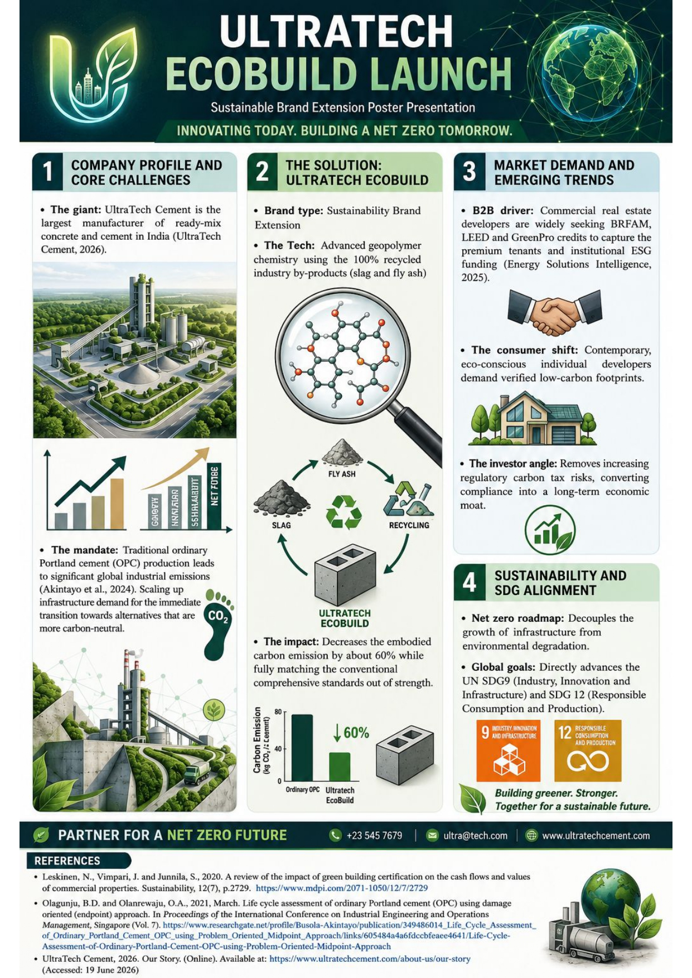

Element 2: Segmentation, Targeting, Differentiation, and Positioning (STDP) Analysis

Market segmentation
To effectively introduce the sustainable brand extension into the traditionally critical market, which is given by commodity, the wider construction sector needs to use segmentation. Segmenting the market helps the organisation to divide the heterogeneous population into different, manageable divisions of consumers who can share the uniform features, needs or behaviours (Kotler and Keller, 2016). In the case of UltraTech EcoBuild, a multidimensional segmentation approach is used through geographic, demographic, psychographic and behavioural variables.
Geographic segmentation
The geography strategy emphasises tier 1 and tier 2 metropolitan urban centres (including Bengaluru, Mumbai, Hyderabad, Delhi NCR, and Chennai) that are experiencing vast and rapid real estate expansion at present. These high-density urban areas are featured by large-scale commercial, manipal and luxury residential projects. Moreover, with the increasing global urbanisation, there is an increasing demand for residences, not only for exclusivity, but for wellbeing and sustainability (Sehrawat, 2025). They are also subject to the district's local environmental regulations and laws, and smart city urban planning mandates, which make them highly receptive to low-carbon building materials.
Demographic segmentation
Demographically, the market is divided into the business-to-consumer (B2C) and business-to-business (B2B) segments:
- The B2B segment: It includes tier-1 corporate real estate developers, public sector construction units, institutional infrastructure conglomerates and prominent structural and architectural engineering consultancies.
- The B2C segment: It focuses on the affluent individual home builders (IHBs) who are aged between 35 and 60 years, with postgraduate or tertiary qualifications, high disposable income, and executive or professional roles.
Psychographic segmentation
Psychographic division moves beyond the outward demographics so that internal motivations, consumer values and lifestyles can be effectively evaluated (Wedel and Kamakura, 2012).
- The B2C cluster: it aligns with LOHAS (lifestyle of health and sustainability) consumers. These are the people who view their choice of home architecture as the direct expression of their social responsibility and personal ethics.
- The B2B cluster: It targets the teams of corporate leaders whose corporate culture focuses on compliance with ESG (environmental, social and governance), active alignment with the national carbon reduction goals and carbon accounting transparency.
Behavioural segmentation
Behavioural variables are helpful to assess the royalty status, usage rates and readiness stages. Behavioural segmentation is used to divide the clients as per the fact that how they act when making purchases (Sakhawalkar and Pawar, 2023). The market is divided into continuous buyers who need structural reliability and high volume, and those who need low volume, high margin and demand for premium quality. The major behavioural advantage sought across these segments is verified, 3rd party documented carbon reduction that assists in green certification (like BREEAM, LEED and GreenPro) without compromising structural integrity or early setting compressive strength.

Targeting strategy
UltraTech EcoBuild uses the concentrated (niche) targeting strategy during the initial entry into the market, before expanding into a differentiated strategy as the environmental development mandates have increased. The major target market includes institutional contractors and A-Grade corporate real estate developers who handle the commercial and premium residential green projects. The segment is focused, as it offers higher volume and immediate demand, as well as the technical potential to evaluate the long-term life cycle advantages of the low-carbon materials. By emphasising institutional buyers, UltraTech can establish high-profile case studies that prove the trustworthiness of its geopolymer technology, setting up the solid base to capture the secondary target segment, which is eco-conscious individual home builders. As per Nodehi and Aguayo (2021), the creation of such high-performance composite materials can be seen as the outcome of the increasing requirements for durable and long-lasting infrastructure materials.

Differentiation
To protect the project of UltraTech EcoBuild from falling into the standard commodity price trap, the company uses the strong differentiation strategy across the four different operational layers as given below:
- Service differentiation: UltraTech moves beyond the delivery of material to offering an integrated solution. Here, the construction managers handle the budgeting, scheduling, communication and safety compliance between distinct team members (UltraTech Cement, 2026). Every company client is paired with a dedicated EcoBuild Technical Consultant who will offer on-site mix optimisation testing and issue the formal carbon offsetting certifications to feed directly into the corporate ESG audits of the clients.
- Product differentiation: While standard cement depends on the traditional clinker burning, EcoBuild utilises an advanced geopolymer formula which is made of 100% recycled industrial by-waste (fly ash and slag). This proprietary chemical profile decreases the embodied carbon by about 60 per cent while matching the quick early compressive strength of traditional Ordinary Portland Cement (OPC) 53 grade.
- Channel differentiation: The brand extension is backed by a dedicated network of green logistics. Shipments are made for the large B2B deliveries from the zero-emission production hubs through the use of liquefied natural gas (LNG) or electric bulk tankers, which decreases the Scope 3 transport emissions and protects the purity of the product.
- Image differentiation: EcoBuild uses the market presence and extensive trust of the parent brand ‘UltraTech’ while establishing a different green identity. This credibility is validated through rigorous, international eco labels and certified 3rd party environmental production declarations (EPDs).

Positioning strategy
The positioning strategy for UltraTech EcoBuild is developed on the ‘More for More’ value proposition (Kotler et al., 2024). It positions the product as a premium and high-performance eco-engineered material that offers both top-tier industrial strength and environmental compliance
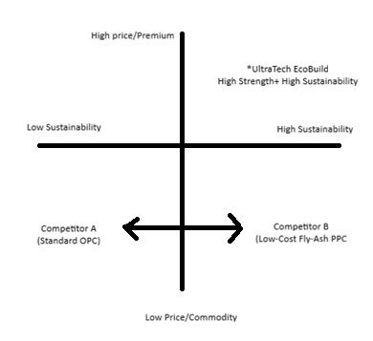
Figure 1: Positioning strategy
(Source: Author, 2026)
For the visionary corporate developer and the progressive home builders who want world-class structural integrity as well as urgent compliance with the environment, UltraTech EcoBuild is the ultra-low-carbon cement extension that offers peerless structural durability to consumers while also decreasing the carbon footprint by about 60%. Unlike conventional green cements, EcoBuild blends the advanced science of materials with verified ESG certifications to develop a sustainable future without compromising strength.

Element 3: Marketing Mix (4Ps) Analysis
In order to successfully commercialise the sustainable brand extension with the highly conservative, commodity-heavy industrial sector, the operational marketing mix needs to transcend the fundamental product-plus tactics. The 4 major elements of the marketing mix (product, price, place and promotion) need to act as an integrated and reinforcing system that translates the abstract ecological advantages into a commercially viable and clear value proposition for the target segments (Xia, 2023).

Product (advanced material science and sustainable value creation)
The UltraTech EcoBuild productive strategies have been developed to redefine industrial materials by shifting cement from a basic structural object into an advanced eco-engineering solution. To effectively analyse this, it can be mapped across 3 levels of the product network: the actual, the core and the augmented product layers.

Figure 2: Product
(Source: Author, 2026)
- The core benefit: It goes beyond the fundamental development of material access, and it delivers long-term and high-performance structural durability combined with immediate compliance with contemporary decarbonization standards.
- The actual product: This includes the physical, tangible formulation. Unlike the traditional OPC, which depends on the clinker-burning, energy-intensive procedure, EcoBuild leverages an advanced geopolymer matrix. This proprietary formula consists of 100% recycled industrial byproducts like fly ash and blast furnace slag. It decreases the carbon footprint by almost 60% while also matching or improving the early compressive strength of the traditional OPC 53-grade. The physical packaging also leads towards a green identity through the use of 100% moisture-proof, biodegradable recycled paper bags printed with soy-based inks so as to ensure zero generation of plastic waste.
- The augmented product: This layer offers the competitive rivalry that is needed to capture the large-scale enterprise consumers (Jobber and Ellis-Chadwick, 2020). UltraTech augments EcoBuild by using dedicated on-site technical mixing teams to fine-tune the concrete mix on the basis of structural and local climate conditions. Moreover, the product offers independent, 3rd party validated environmental product declarations (EPDs) and issues the digitised ‘Carbon Offsetting Certificates’ to the clients. It allows the corporate developers to feed clean data directly into their formal audits of ESG.

Price (Value-based premium pricing and lifecycle costing)
Pricing of an eco-friendly product material needs to move beyond cost-plus accounting towards a value-based, sophisticated pricing model. A value-based pricing model helps companies to justify the premium prices by signalling the added value (Huang et al., 2026). UltraTech EcoBuild will launch a 12% to 15% price premium over standard Portland Pozzolana Cement (PPC). While this premium price positions the company at the top of the category, it is also strategically justified to the target market segment through concrete life cycle value:
Value Proposition= Reduced Carbon Penalties + LEED Premium Capital + Parent Brand Trust
For the B2B institutional segment, this premium cost is offset by the economic returns that are generated by the green buildings. The commercial office spaces that will have the verified green ratings (like BREEAM or LEED) command a high volume of sales velocities and rental premiums from multinational tenants with strict mandates towards net zero. Hence, the premium payment on the raw material acts as the investment that improves the market value of the real estate asset. Moreover, this premium price acts as the strategic buffer against tightening environmental compliance audits and impeding carbon taxes. For premium individual home builders (B2C), the high prices use the behavioural principle of price-quality inference. In the areas of luxury residential construction, the premium price tag represents premium status, advanced engineering and elite social responsibility. As per Baum et al. (2021), in the property market, prices are not available, as each property is unique and the market is private, and there are no market makers.

Place (Sustainable logistics and circular supply chains)
Industrial logistics are inherently carbon-heavy. That is why the distribution strategy used by UltraTech EcoBuild must carefully preserve the green narrative of the brand by decreasing the supply chain emissions. Let us use a regulatory framework that uses the split model, which is tailored to the needs of B2B and B2C.
The B2B Direct-to-Site Model
To decrease transit and handling emissions and the cost paid to middlemen, EcoBuild bypasses the traditional multi-tiered retail dealer network for the clients of the enterprise. The product directly moves from the dedicated eco-certified production plants to the construction site of the client.
The B2C Green Hub Model
In the case of premium individual builders, the distribution process majorly emphasis on exclusive, franchise-owned ‘UltraTech Green Zones’ that are located in major markets, including urban buildings. These centres handle the specialised storage so as to protect the green polymer elements from moisture degradation without using the single-use plastic wraps.
Green Fleet Transport
To decrease the scope 3 emissions within the distribution network, the company agrees with the specialised logistics partners who operate on liquefied natural gas (LNG) bulk trucks and electric delivery tankers for the short-mile urban transport. Contracts for the long-distance transport between the metropolitan distribution centres and plants, the brand is fully on the rail network, which is significantly less carbon-intensive in comparison to traditional road transport.

Promotion (B2B relationship marketing and evidence-based credibility)
- Fostering the industrial green brand extension needs a data-driven approach that focuses mainly on the development of credible and long-term relationships instead of broad consumer advertising that could be misconceptualised as greenwashing.
- Digital tools and embodied carbon calculators: The company will launch an interactive platform of a web and mobile app that includes the ‘embodied carbon life cycle calculator’. This tool allows the structural engineers to instantly see the projected carbon savings and LEED points earned by selecting EcoBuild over the traditional options, and they can also input the building blueprints into it.
- Consultative selling and expert advisory: a specialised industrial sales engineer will be deployed by UltraTech to contribute to the technical workshops directly with the top-tier architectural firms, and corporate sustainability heads will handle structural engineering councils. These sessions will cover low-carbon material durability, structural physics and green building calculations.
- Ingredient branding and shared marketing: to foster adoption through B2B, UltraTech will offer the enterprise clients a co-branding package. The construction sites developed with the product receive prominent structural signage and digital wedges reading “Built for the Future with UltraTech EcoBuild- 60% Carbon Reduced”. Deswal encourages the green marketing efforts of the developers while also improving their awareness and the market for the EcoBuild brand.
- Targeted B2C air cover: to assist the premium consumer segment, the promotional efforts will focus on the premium programmatic digital advertisements, high-end architectural magazines and professional LinkedIn networks, which will present the real-world case studies of the iconic, low-carbon structures.

Element 4: Personal and Professional Reflection
The creation of this sustainable brand extension for the industrial heavy brand like UltraTech Cement has provided me with a powerful context for examining how the traditional marketing framework engages with Urgent contemporary sustainability goals. This reflective section has used the adjusted experiential learning framework to analyse their strategic knowledge, skills and personal growth, which is developed throughout the creation of the presentation of this portfolio.

Reflection on strategic development (the strategic process)
At the start of this portfolio, I was feeling extremely challenged as I had to apply the sustainable brand theories to a highly commoditised, carbon-intensive industrial product like cement. Historically, B2B building materials have been bought purely on the technical and cost grade instead of ecological values. I have deeply researched and analysed the market dynamics of UltraTech, which has helped me to bridge this gap. I have understood that the successful sustainability strategy must connect the abstract carbon metrics with clear, bottom-line financial incentives for real estate builders, like the LEED certification points and access to green institutional capital. This process has taught me how one should shift from the fundamental cost-plus thinking towards the value-based, strategic pricing model. It also presented the significance of transparency in the supply chain, presenting that the green product cannot stand alone without an equally sustainable network of distribution to back up its claims.

Reflection on the poster presentation experience (the communication challenge)
Making and delivering the concise, 3-5 minute poster presentation led to the high-stakes, realistic professional challenge. I was initially anxious due to the density of the data, and it felt extremely tough to me to compress the whole low-carbon B2B marketing strategy into a single poster layout and the script, which was only 200 words roughly. This barrier forced me to understand the art of executive-level brevity. I learned to drop the highly critical descriptions and instead emphasise the high-impact data points, like the 60% carbon reduction metrics and explicit UN SDG alignments. I used the clean visual layout in Canva, which was presented by the delivery during the live presentation, shifting my initial nerves into an energetic and authoritative consulting pitch. This experience helped me to learn that visual clarity and structured data are vital tools for maintaining engagement with the audience when pitching critical industrial strategies.

Evaluation of professional skills and future action plan
This model has driven vital professional and personal growth, along with sharpening various critical transferable skills. I moved beyond the descriptive writing pattern to constructing data-backed arguments that present the ‘how’ and ‘why’ behind the strategic decisions. I have also learned to mix the traditional marketing models with the contemporary circular economy frameworks. Moreover, I have also learned to present the critical industrial material science clearly and persuasively to both the financial and technical stakeholders. In order to further improve my skill set in future projects, I plan to expand my training in quantitative carbon accounting and green supply chain analytics. Depending wholly on qualitative data and arguments is no longer enough, according to me, in the highly data-driven corporate business environment. Improving the mastery of environmental metrics will help me to create future marketing strategies backed by auditable ESG data, preparing me effectively to lead sustainable, authentic business growth as a forward-thinking corporate consultant.

References
Akintayo, B.D., Olanrewaju, O.A. and Olanrewaju, O.I., 2024. Life cycle assessment of ordinary Portland cement production in South Africa: mid-point and end-point approaches. Sustainability, 16(7), p.3001. https://www.mdpi.com/2071-1050/16/7/3001
Baum, A.E., Crosby, N. and Devaney, S., 2021. Property investment appraisal. John Wiley & Sons.
Energy Solutions Intelligence, 2025. LEED, BREEAM & WELL in 2026: Costs, Benefits, and Which Label Matters. (Online). Available at: https://energy-solutions.co/articles/sub/green-building-certifications-leed-breeam-well (Accessed: 19 June 2026)
Huang, G., Lanzrath, A.I. and Homburg, C., 2026. When do high prices sell better for sustainable products in business-to-business markets? The role of price–sustainability fit. Industrial Marketing Management, 134, pp.172-185. https://www.sciencedirect.com/science/article/pii/S0019850126000271
Jobber, D. and Ellis-Chadwick, F., 2020. Principles and Practice of Marketing. 9th ed. London: McGraw-Hill Education.
Kotler, P. and Keller, K.L., 2016. Marketing Management. 15th global ed. Boston: Pearson.
Kotler, P., Armstrong, G., Opresnik, M.O. and Barkin, L., 2024. Principles of Marketing. 19th global ed. London: Pearson.
Leskinen, N., Vimpari, J. and Junnila, S., 2020. A review of the impact of green building certification on the cash flows and values of commercial properties. Sustainability, 12(7), p.2729. https://www.mdpi.com/2071-1050/12/7/2729
Nodehi, M. and Aguayo, F., 2021. Ultra high performance and high strength geopolymer concrete. Journal of Building Pathology and Rehabilitation, 6(1), p.34. https://www.researchgate.net/profile/Mehrab-Nodehi/publication/354870389_Ultra_high_performance_and_high_strength_geopolymer_concrete/links/61ba082063bbd9324295f31d/Ultra-high-performance-and-high-strength-geopolymer-concrete.pdf?_sg%5B0%5D=started_experiment_milestone&_sg%5B1%5D=started_experiment_milestone&origin=journalDetail
Olagunju, B.D. and Olanrewaju, O.A., 2021, March. Life cycle assessment of ordinary Portland cement (OPC) using damage oriented (endpoint) approach. In Proceedings of the International Conference on Industrial Engineering and Operations Management, Singapore (Vol. 7). https://www.researchgate.net/profile/Busola-Akintayo/publication/349486014_Life_Cycle_Assessment_of_Ordinary_Portland_Cement_OPC_using_Problem_Oriented_Midpoint_Approach/links/605484a4a6fdccbfeaee4641/Life-Cycle-Assessment-of-Ordinary-Portland-Cement-OPC-using-Problem-Oriented-Midpoint-Approach
Sakhawalkar, A. and Pawar, S., 2023. Impact of behavioral segmentation on customer satisfaction–a conceptual review. The Online Journal of Distance Education and e-Learning, 11(2). https://www.tojned.net/journals/tojdel/articles/v11i02b/v11i02b-65.pdf
Sehrawat, K., 2025. The future of high-rise luxury living. (Online). Available at: https://www.constructionweekonline.in/people/luxury-living-high-risen (Accessed: 19 June 2026)
UltraTech Cement, 2026. Construction Management. (Online). Available at: https://www.ultratechcement.com/home-building-basics/construction-management (Accessed: 20 June 2026)
UltraTech Cement, 2026. Our Story. (Online). Available at: https://www.ultratechcement.com/about-us/our-story (Accessed: 19 June 2026)
UltraTech Cement, 2026. Our Story. (Online). Available at: https://www.ultratechcement.com/about-us/our-story (Accessed: 19 June 2026)
Wedel, M. and Kamakura, W.A., 2012. Market Segmentation: Conceptual and Methodological Foundations. 2nd ed. Boston: Springer Science & Business Media.
Xia, Y., 2023. The 4Ps of marketing and applications in various brands. Journal of Education, Humanities and Social Sciences, 16, pp.165-170. https://pdfs.semanticscholar.org/0063/9e03801397b6d20ee1c059da83663e8ce065.pdf

