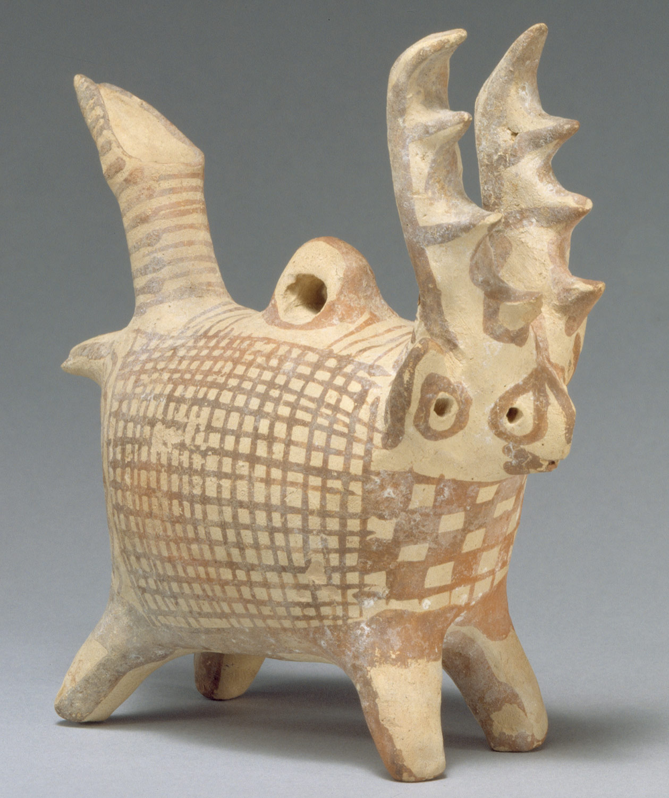
Object analysis

For this analysis, I have chosen what is broadly described as a “Terracotta zoomorphic askos (vessel) with antlers” and has an accession number of 74.51.795 in the Metropolitan Museum of Art in New York (The Metropolitan Museum of Art, 2020).

This object being described as a vessel on the museum’s website indicates that it is hollow on the inside, how much of the vessel is actually hollow is not specified but it can be inferred that the whole vessel is likely hollow otherwise it would weigh too much to be of much use besides ornamentation. With a simple colour scheme of cream and paintwork of a light orangey brown with some signs of wear although these could possibly be reflections from the lighting in the image reflecting off polished paint. The colours are more clearly defined on the forward-facing surface, with the colours towards the rear legs being the most faded, with colour on the bottom surfaces also looking more weathered. The choice of colours is likely used to reflect any deer specimens that used to live on the island. The ‘tail’ of the creature forms the shape of a spout; the neck of the tube facing up at a steep angle appears to be a few centimetres long and then tapers into a long and well-formed spout. The neck and spout have a banded pattern at regular intervals with a few larger and thinner strokes. The body of the deer has a very rotund shape, forming what almost looks like a rounded cuboid shape, with a wider top half, if only by a centimetre or two. The body appears to have two main patterns: on the left and right sides (assuming they are mirrored) has a simple grid pattern of consistent, straight lines, and a filled in chequered pattern on the front surface. The head of the animal is punctuated by what can be inferred as four eyes, each having a painted ring around them. The main feature of the head are the two tall handles, undoubtedly representing the antlers of a stag. These antlers also are shaped in such a way that they form easy hand grips, with indentations for the user’s fingers, rising a good six or seven centimetres above the head. There is a small ring like structure on the back of the vessel, which could possibly be used to hang the item up or maybe provide ventilation to the contents inside.
In terms of the objects purpose, Robert Koehl mentions how these kinds of vessels, though not specifically this one, can have different meanings and purposes depending on where they are found. He says “while some evidence may derive from elite contexts, other vessels may come from more mundane domestic ones; and domestic contexts may well yield different data than cemeteries” (Koehl, p. 46), this will obviously have a large influence on what the vessels are used for and what their implicit cultural meaning is; a vessel found in a house may be seen and used as an ornate storage item and maybe also a sign of personal wealth as items like these would likely be expensive to make and buy. Whilst a vessel found in a temple or a palace may hold a different meaning, it may be used to represent a deity, an aspect of a religion or some other cultic meaning; whether it be a piece of art that can be practically utilised and made to honour the pantheon or used as a suitably ornate vessel to hold offerings. In a short reference in a catalogue book, John Myres briefly explains that some of these zoomorphic vessels have been found to be “very common in tombs of the Middle Bronze Age, and in the early part of the Later Period” (Myres, 1914, p. 27) which adds another kind of meaning to these vessels as a kind of burial treasure. Whilst the function of the object can still be debated, there are other aspects that are more evident, such as external influences and Cyprus’ place in the ancient world. In a joint essay, Colette and Sean Hemingway elaborate on how there was “Undeniable influence of the Aegean on Cypriot culture during the Late Bronze Age can be seen in the development of writing, bronzeworking, seal stone carving; jewellery production, and some ceramic styles” (Hemingway & Hemingway, 2004). It is possible that influences from Cyprus’ trade with the wider world brought in cultural wealth as well as material, leading to the development of a more complex artistic tradition on the island. With greater material wealth comes cultural development which can then lead to more material wealth, so if it is assumed that this vessel came about from the large amount of cultural exchange through trade, this kind of vessel could become less luxurious in terms of artistic value within the island’s ‘cultural economy’ which could explain why they are found commonly within tombs, with the main focus being on the fact that they were mass produced to an extent where they became a common grave good. As for the choice of animal, a deer, Koehl believes that the choice has a symbolic meaning in that “Perhaps the deer and ibex were admired for their speed […]. It is also true that each of these species served as a food source for the community” (Koehl, p. 48), so possibly these vessels took on an animistic role, in that any offerings made in such as a vessel was back to the animal it was modelled after, as a kind of thanks for providing.
As an object, this vessel is very appealing to look at, with its impressive craftsmanship in the formation of the features. Many possible uses for it can be theorised, and I believe that this object was used in a ritualistic sense: it would be used to contain offerings given to the god(s) related to the animal, or even the animal itself.

References
Hemingway, C., & Hemingway, S. (2004, October). Prehistoric Cypriot Art and Culture. Retrieved from Heilbrunn Timeline of Art History: https://www.metmuseum.org/toah/hd/pcyp/hd_pcyp.htm
Koehl, R. B. (n.d.). Animal Shaped Vases from the Neolithic to the Bronze Age, from Mesopotamia to the Aegean. Retrieved from Academia: https://www.academia.edu/37536958/Animal_Shaped_Vases_from_the_Neolithic_to_the_Bronze_Age_from_Mesopotamia_to_the_Aegean
Myres, J. L. (1914). Handbook of the Cesnola Collection of Antiquities from Cyprus. New York: Metropolitan Museum of Art.
The Metropolitan Museum of Art. (2020, March 25). Terracotta zoomorphic askos (vessel) with antlers. Retrieved from The Met 150: https://www.metmuseum.org/art/collection/search/240382

