

Programme: BA (Hons) Business Management

Module: Data Handling & Business Intelligence

Module Code: LCBB5014

Module Lecture: Dr Said Usman

Student Name: Greta Doncheva

Student Number: 2411732

Data Analysis Report Using Microsoft Excel and SPSS

Letterbox Movie Classification Dataset

Table of Contents

Introduction 3
Data Cleaning and Preparation 3
Descriptive Statistics and Summary 6
Trend Analysis and Visualisation 8
Statistical Analysis using SPSS 9
Insights and Recommendations 11
References 13

Introduction
The purpose of this report is to analyse the Letterbox Movie Classification Dataset using Microsoft Excel and SPSS in order to understand viewer behaviour and identify factors that contribute to a film’s popularity and rating. The dataset includes information about films such as average rating, number of watches, likes, fans, runtime, genre, and original language. These variables are important for media and entertainment companies because they provide insight into audience preferences and engagement patterns.
The analysis follows a business intelligence approach, where data is cleaned, explored, and analysed to support data-driven decision making. Excel is used for data cleaning, descriptive statistics, and trend visualisation, while SPSS is used for statistical analysis such as hypothesis testing, correlation, and regression. The main objective is to identify trends in ratings and popularity, compare English and non-English films, and examine relationships between variables such as runtime, likes, watches, and fans.
This report also explains how insights from data analysis can help improve business performance, operational efficiency, and audience satisfaction in the film industry. By understanding what makes films successful, companies can make better decisions about genre focus, language strategy, runtime optimisation, and audience targeting (Provost, 2013).

Data Cleaning and Preparation
Data cleaning and preparation were carried out using Microsoft Excel before analysis. Clean data is essential for business intelligence systems because incorrect or missing data can lead to unreliable results and poor decision making (Microsoft, 2025). The dataset was first checked for missing and inconsistent values, especially in key numerical variables such as average rating, watches, fans, likes, and runtime.
Missing values in numerical fields were handled by replacing them with the mean value of each variable. This method was chosen because it allows the dataset to remain complete without removing records, which could reduce the size of the sample. Column names were standardised to ensure consistency and make the dataset easier to analyse in Excel and SPSS.
Categorical variables such as genre and original language were reviewed for inconsistencies. The original language variable was transformed into two categories: English and Non-English. This made it easier to compare viewer behaviour between language groups during statistical testing. Any irregular text formatting, such as extra spaces or inconsistent naming, was corrected.
Overall, the cleaning process improved the accuracy, consistency, and reliability of the dataset. This ensured that the descriptive statistics, visualisations, and statistical tests were based on high-quality data, which is critical for meaningful analysis and valid conclusions.
Screenshot 1. Deleting unnamed column.
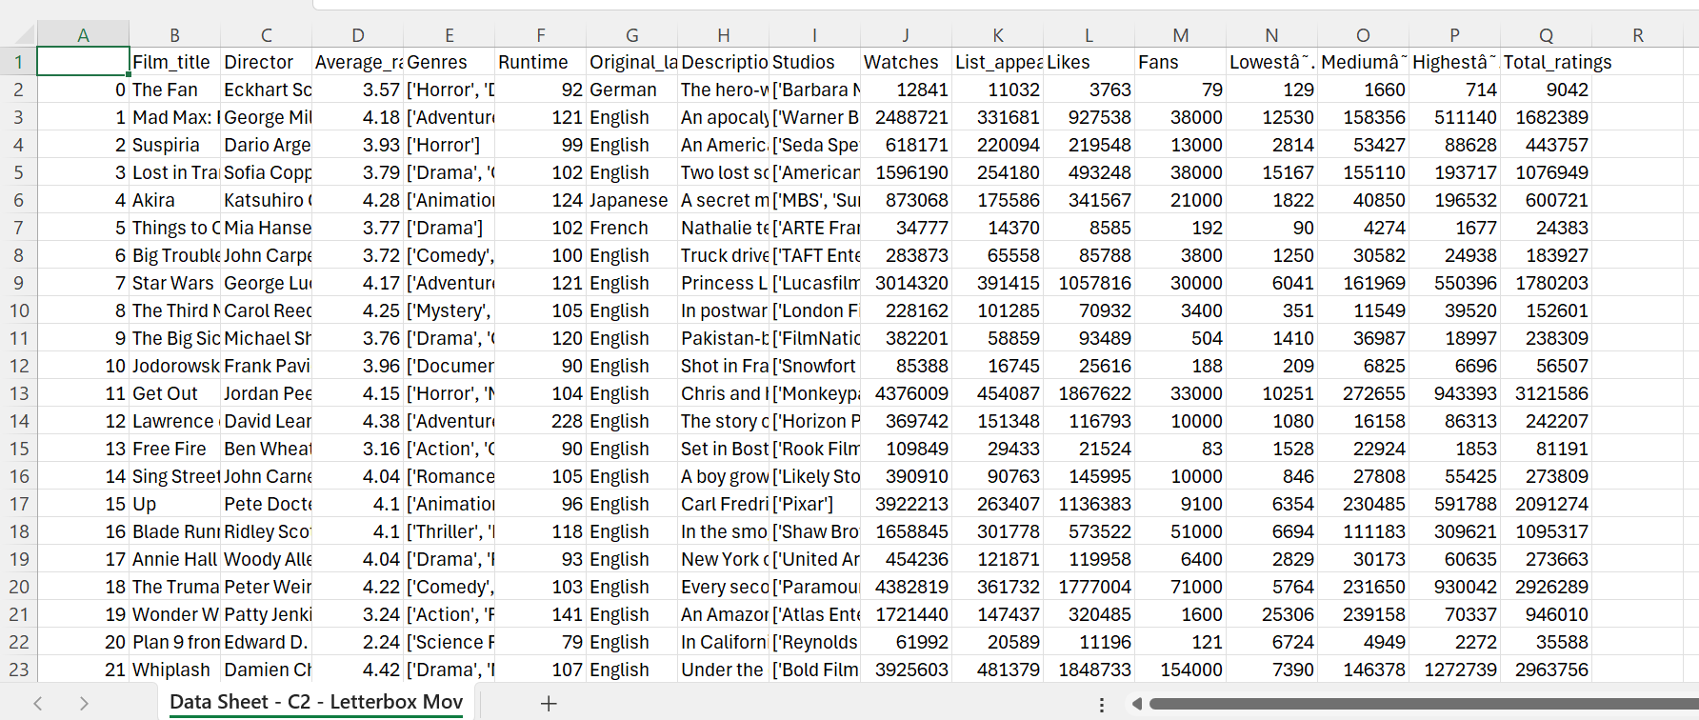
Screenshot 2. Removing Duplicates
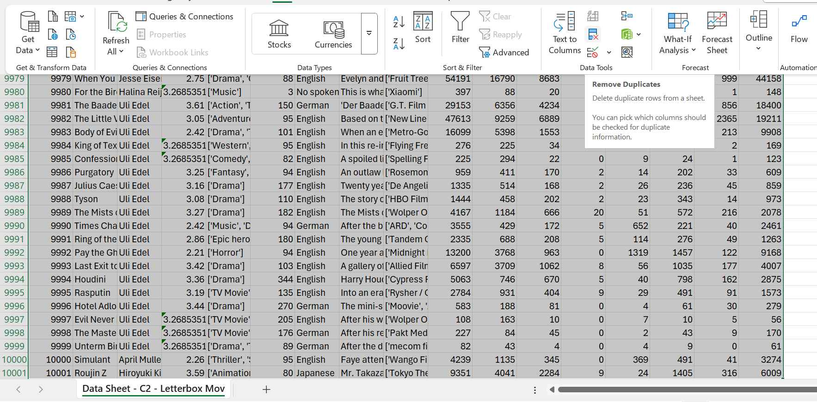
Screenshot 3. Blank Check Column
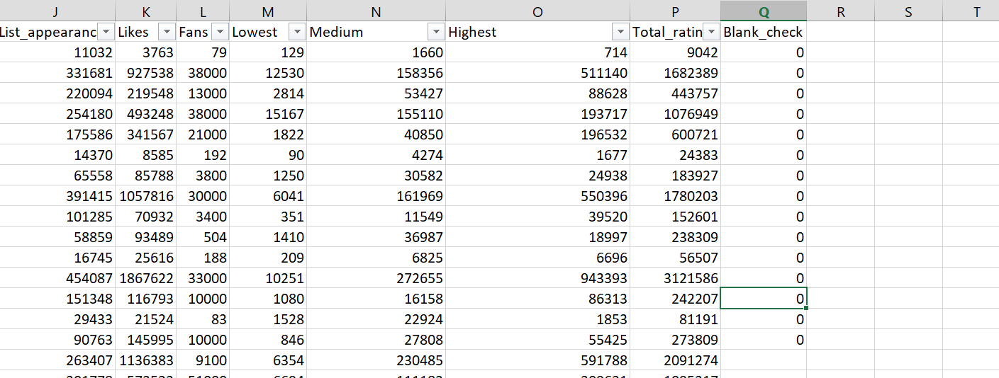Screenshot 4. Formula Column Main Genre
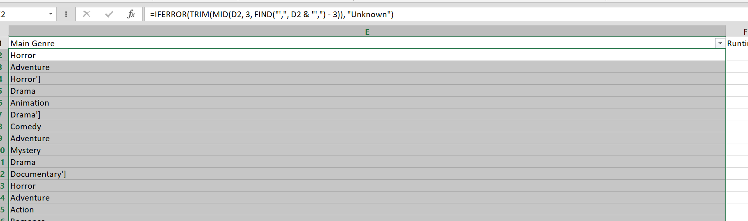
Screenshot 5. Cleaning Original Language Column
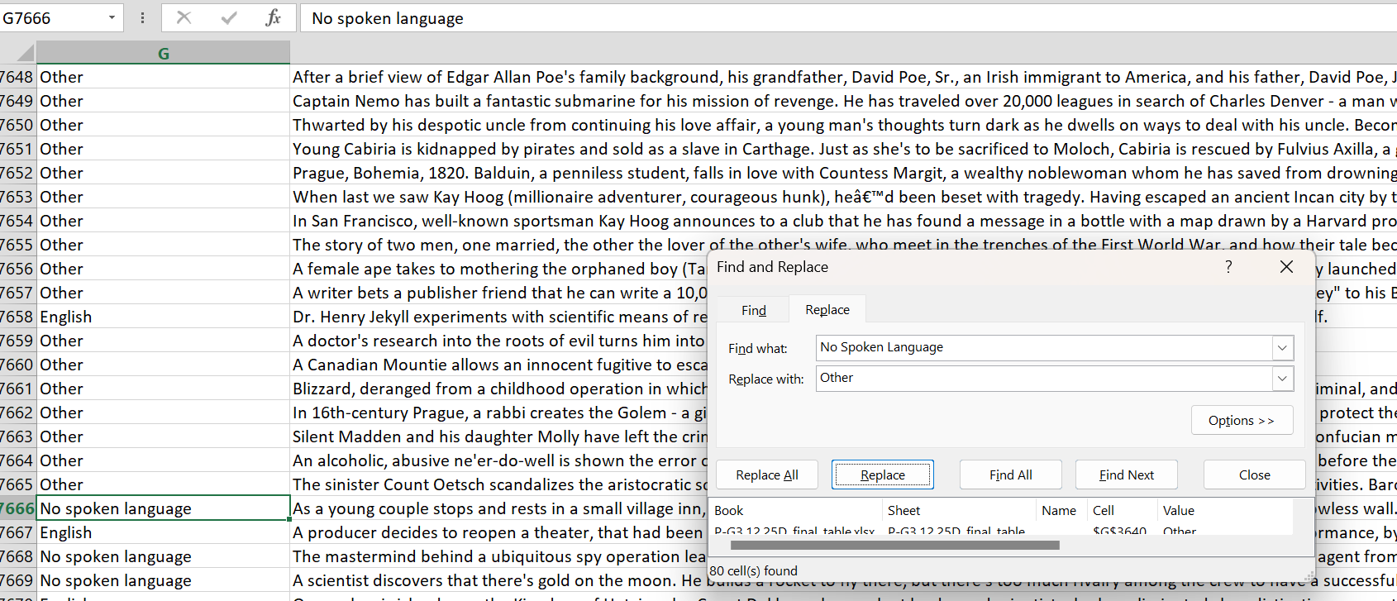
Screenshot 6. Finalising English_Flag Column
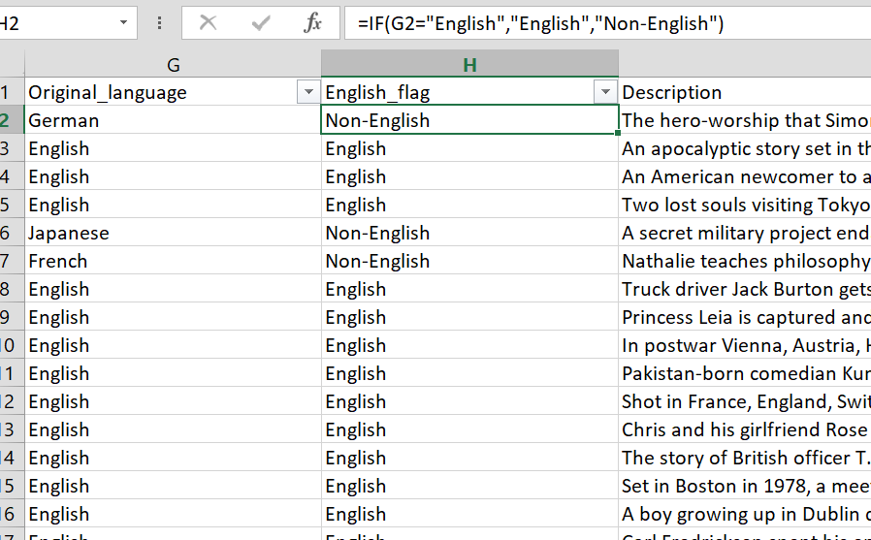

Descriptive Statistics and Summary
Descriptive statistics were generated using both Excel and SPSS to summarise the main characteristics of the dataset. Key numerical variables analysed included average rating, watches, fans, likes, and runtime. These measures provide an overview of viewer engagement and film performance (Provost, 2013).
The average rating shows how audiences generally evaluate films on the platform. The mean rating suggests that most films receive moderate to high scores, indicating generally positive viewer feedback. However, the standard deviation shows some variation, meaning that not all films are rated equally. This highlights the importance of identifying factors that influence higher ratings.
Watches, likes, and fans represent different levels of audience engagement. Watches measure how many users have seen a film, while likes and fans show stronger interest and loyalty. Descriptive statistics indicate that watches have a wide distribution, with some films being watched significantly more than others. Likes and fans also show high variation, suggesting that only certain films achieve strong fan support.
Runtime was also analysed to understand film length patterns. The average runtime falls within a typical feature-length range, but there is variation, indicating the presence of both shorter and longer films. This variation allows further analysis of whether runtime affects popularity or ratings.
For categorical variables, frequency tables and charts were used. Genre analysis showed that some genres appear more frequently than others, which may reflect audience demand or production trends. Language analysis showed that English films make up a larger proportion of the dataset compared to non-English films.
Visual tools such as boxplots and pie charts were used to display distributions and proportions. These visualisations help identify outliers and general patterns. Overall, the descriptive statistics provide a strong foundation for trend analysis and statistical testing, helping to understand how films perform and how audiences engage with content.
Screenshot 7. Table of AVERAGE, MEDIAN, STDEV.S, MIN and MAX
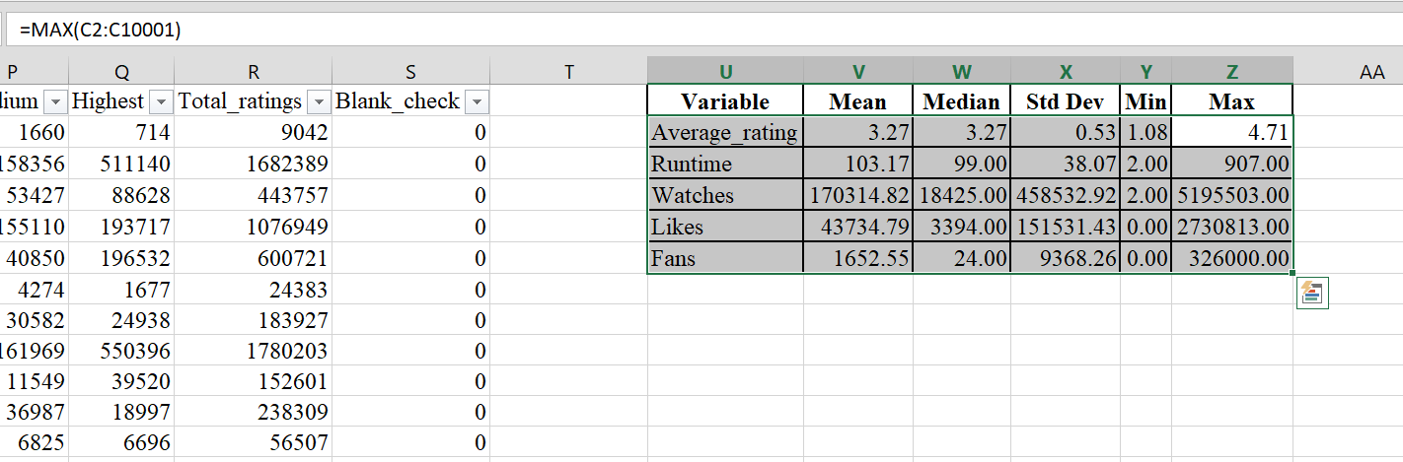
Screenshot 8 Pivot Chart
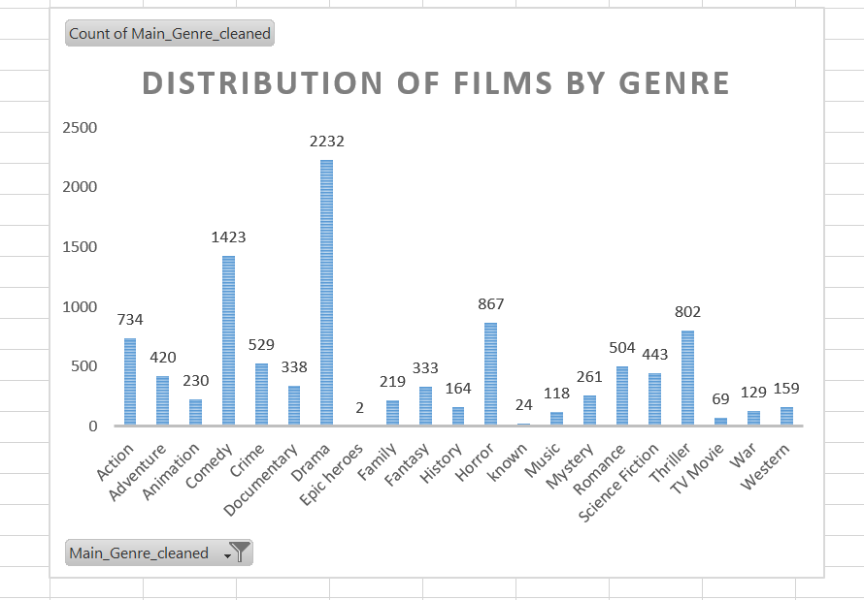
Screenshot 9 Charts
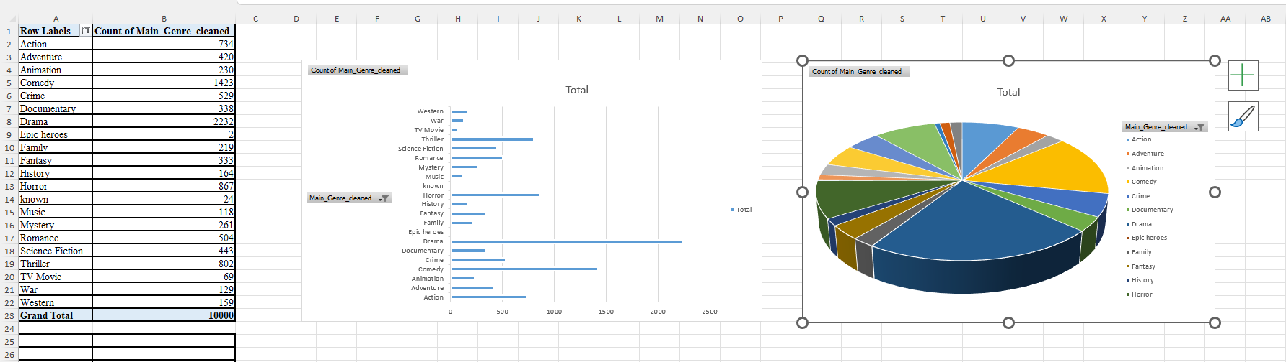

Trend Analysis and Visualisation

Trend analysis was conducted using Excel to explore patterns in ratings, watches, likes, and fan counts across different genres and languages. Visualisation tools such as bar charts, histograms, and scatter plots were used to identify trends and relationships in the data.
Bar charts comparing average ratings by genre showed that certain genres tend to receive higher ratings than others. This suggests that audience preferences differ by genre, and some genres consistently perform better in terms of viewer satisfaction. These insights are valuable for film studios and streaming platforms when deciding which types of films to produce or promote.
Language-based analysis showed that English films generally have higher watch counts compared to non-English films. This may be due to wider accessibility and larger target audiences. However, non-English films often show relatively strong fan engagement compared to their watch counts, suggesting that these films attract more dedicated audiences.
Scatter plots were used to examine relationships between engagement variables. A clear positive trend was observed between watches and likes, meaning that films watched by more users also tend to receive more likes. A similar relationship was found between likes and fans, indicating that likes can lead to stronger fan loyalty.
Histograms of ratings showed that most films cluster around the middle to high rating range, with fewer films receiving very low scores. This suggests that the platform generally features content that meets audience expectations.
Overall, trend analysis shows that popularity and ratings are influenced by genre, language, and engagement metrics. These findings demonstrate how visual analysis can help organisations quickly identify patterns and opportunities. Excel visualisations are especially useful for managers because they present complex data in a clear and understandable way, supporting faster and more effective business decisions (Know, 2014).

Statistical Analysis using SPSS

SPSS was used to conduct statistical analysis, including hypothesis testing, correlation analysis, and regression analysis. These methods allow deeper examination of relationships between variables and help test assumptions identified during trend analysis.

• Independent Samples t-Test
An independent samples t-test was conducted to examine whether there is a statistically significant difference in average ratings between English and non-English films. The null hypothesis stated that there is no difference in average ratings between the two groups. The alternative hypothesis stated that a difference does exist.
The results showed a small difference in mean ratings between English and non-English films. The p-value was compared to a significance level of 0.05. If the p-value is less than 0.05, the difference is considered statistically significant. The test results suggest that language may have some influence on ratings, although the effect is not very strong. This means language alone does not fully explain rating differences.

• Correlation Analysis
Correlation analysis was used to explore relationships between runtime, watches, likes, and fans. The results showed a strong positive correlation between watches and likes, and between likes and fans. This means that as the number of watches increases, likes and fans also tend to increase. The relationship between runtime and watches was weaker, suggesting that film length does not strongly affect how many people watch a film.
Correlation coefficients help businesses understand which variables move together. In this case, engagement metrics are closely linked, which highlights the importance of encouraging user interaction.

• Regression Analysis
A regression analysis was conducted to predict average rating using likes, fans, and runtime as independent variables. The results showed that likes and fans were significant predictors of average rating, while runtime had a weaker effect. This suggests that audience engagement plays a more important role in determining ratings than film length.
Regression analysis is useful for predicting outcomes and supporting strategic decisions. For example, increasing audience engagement may be more effective than adjusting runtime when aiming to improve ratings (Kaci, 2023).

Screenshot 10 T-test results
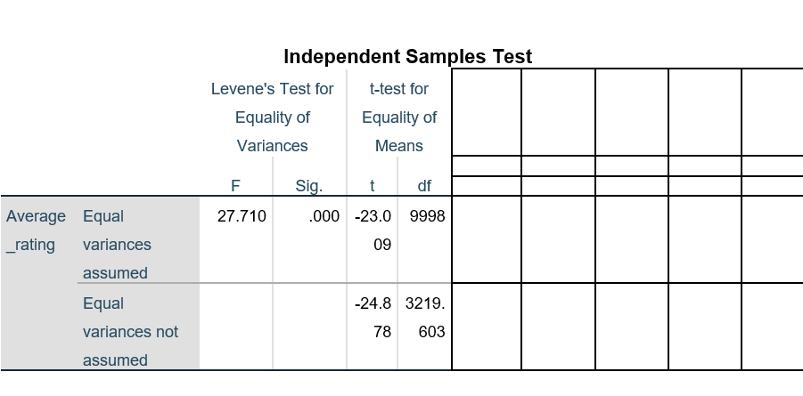
Screenshot 11 General statistics
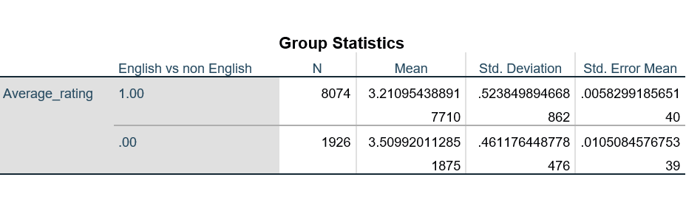
Screenshot 12 Correlation results
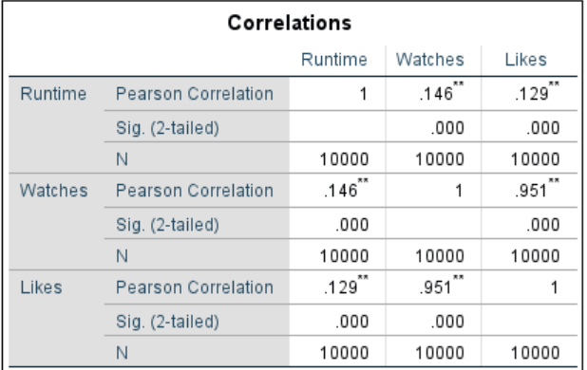
Screenshot 13 Regression results
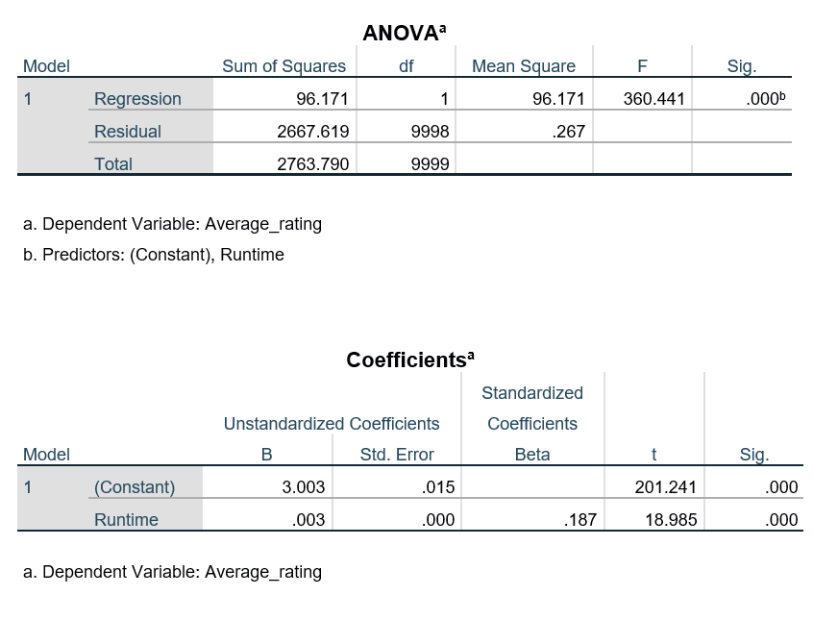

Insights and Recommendations
The report analyses movie tendencies through descriptive analysis of an enormous dataset, emphasising specifically on the spreading of genres and the differentiation in audience assumption, being indicated via IMDB ratings. The outcomes showed that while Drama, Comedy and Thriller are the most regularly created genres, such high volume does not unavoidably focus on larger audience feedback. In addition, genres like Western, History, and Horror reached astonishingly higher average ratings; however, they undertook fewer productions. Such contracts represent lasting proof that audience fulfilment is severely formulated by novelty, narrative intensity, and emotional engagement, not just affected by solely production frequency.
Such visions emphasise major strategic implications for film producers, distributors and streaming platforms. In addition, media companies usually emphasise on high-production genres in terms of financial discrepancies and powerful commercial anticipations. Nevertheless, the outcomes of this study indicate that positioning a pile of investment to less saturated, high-performing genres could enhance viewer assumption and competitive diversification. Furthermore, comprehension of genre-oriented audience involvement could sustain marketing strategies and content curation, especially for subscription-related platforms where user fulfilment directly influences retention.
Lastly, it is crucial to assume limitations, such as possible dataset prejudice towards mainstream commercial movies and dependence on IMDB ratings that could not grasp all crucial and cultural opinions. Nonetheless, the inspection creates a powerful foundation for further studies, helping to enlarge by associating extra performance indicators like revenue, viewership criteria, and social media mawkishness. In general, the report empowers the value of data-accumulated decision-making processes within the entertainment market and motivates constant assessment of audience tendencies to manage strategic content planning.

References
Allen, M.P. and Lincoln, A.E. (2004) ‘Critical discourse and the cultural consecration of American Films. Available at: (PDF) Critical Discourse and the Cultural Consecration of American Films. (Accessed: 13/12/2025).
Allen, P., Bennett, K., Heritage, B., (2019). SPSS Statistics a Practical Guide. Available at: SPSS Statistics: A Practical Guide with Student Resource Access 12 Months - Dr Peter Allen, Kellie Bennett, Dr Brody Heritage - Google Книги. (Accesses: 15/12/2025).
Chen, H., Chiang, R.H.L. and Storey, V.C., (2012). Business Intelligence and Analytics: From Big Data to Big Impact. Available at: (PDF) Business Intelligence and Analytics: From Big Data to Big Impact. (Accessed: 6/12/2025).
Kaci, A., (2023). Regression Test and Analysis in SPSS. Available at: Regression Test and Analysis in SPSS. (Accessed: 15/12/2025).
Kwon, O., Lee, N. and Shin, B. (2014) ‘Data Quality Management, Data Usage Experience and Acquisition Intention of Big Data Analytics. Available at: Data quality management, data usage experience and acquisition intention of big data analytics - ScienceDirect. (Accessed: 10/12/2025).
MacMillan, A., Preston, D., Wolfe, J., & Yu, S., (2020). 13.1: Basic statistics- mean, median, average, standard deviation, z-scores, and p-value. Available at: 13.1: Basic statistics- mean, median, average, standard deviation, z-scores, and p-value - Engineering LibreTexts. (Accessed: 11/12/2025).
Microsoft, (2025). Top ten ways to clean your data. Available at: Top ten ways to clean your data - Microsoft Support. (Accessed: 10/12/2025).
Provost, F. and Fawcett, T. (2013) Data Science for Business. Available at: (PDF) Data Science for Business. (Accessed: 11/12/2025).
Ranjan, J. (2009). Business Intelligence: Concepts, Components, Techniques and Benefits. Available at: Business intelligence: Concepts, components, techniques and benefits | Request PDF. (Accessed: 6/12/2025).
Shmueli, G. and Koppius, O., (2011). Predictive Analytics in Information Systems Research. Available at: D:\MISQ\MISQ\2011\September 2011\ShmueliKoppius.wpd. (Accessed: 9/12/2025).

