[Date]
Szilard Szanto

Student name:Szilard Szanto
Student id:Szilard Szanto
Module cod:(BMHP6022_Lon)
Lecturer Name: Bianca Sanfilippo

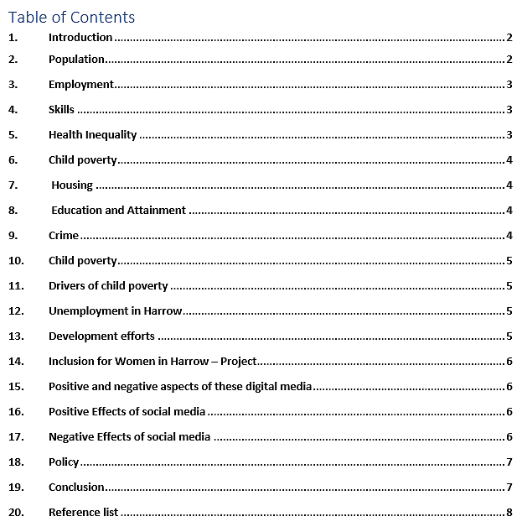

- Introduction
Harrow is one of London’s most religiously and ethnically diverse boroughs, with residents from various origins and life experiences. We feel that the depth of this variety and the good influence on the borough and our community contribute to Harrow’s appeal as a place to work, live,and visit. We recognise and cherish the borough’s variety, and this report demonstrates our commitment to preserving and expanding on our strengths by ensuring equality and diversity are integrated into all we do.
The Council intends to provide equality of opportunity for all residents, service users, workers, elected members, stakeholders, and partner organisations. To stop unlawful discrimination, promote equality of opportunity, and foster good relations among Harrow's many populations, we acknowledge our obligation to end unlawful discrimination.(Our Harrow, Our Community -Equality Profile Annual Data Report 2017/18 2, n.d.).”
- Population
Harrow’s resident population is predicted to be 248,7501, which means the town’s population has expanded by 42,550 (20.5 per cent) since 2001.
Additionally, it is anticipated that the number of children (0-15) would rise by 14% during the ten years from 2014 to 2024.
Disability — 13.7 per cent of Harrow’s working-age population, or 22,100 persons, identified as disabled. Disability Living Allowance is received by 6,470 persons or 2.6 per cent of the total population. 6 During 2016-17, a total of 2302 persons got long-term social care services, the majority of which were for physical assistance requirements. This represents around 1% of the overall resident population.
“Pregnancy and Maternity - In 2016, the UK average of 11.8 live births per 1000 people was 14.5 in 2016. The fertility rate is 2.03 children per woman, more significant than the 1.79 in the United Kingdom (Our Harrow, Our Community -Equality Profile Annual Data Report 2017/18 2, n.d.).”
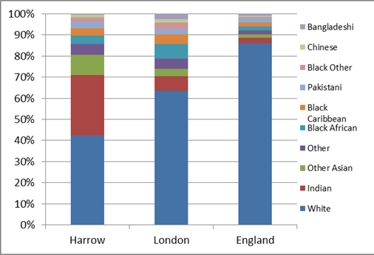
Race (Ethnicity) - 61.8 percent of inhabitants identify as minority ethnic groups. The remaining 38.2 per cent of the population is composed of White British people (down from 50 per cent in 2001). Indians make up 26.4 per cent of Harrow’s population, making them the borough’s most significant minority ethnic community, followed by Kenyans and Sri Lankans. Harrow is home to the country’s most significant Sri Lankan population. Residents make up 8.2 per cent of the population, up from 4.5 per cent in 2001.
In 2015/16, Harrow had seen the second-highest migration levels in a decade, indicating a considerable shift in demographic composition from the 2011 census. Romanian, Indian, and Polish are the top three nationalities among these most recent entrants.
English, Gujarati, Tamil, Romanian, and Arabic are the top five documented community languages in Harrow, while over 155 languages are spoken in Harrow schools.
Religion or Belief - Harrow is also the country’s most religiously diverse borough. The borough has the most considerable proportions of Hindus, Jains, and Unification Church members, the second-highest proportions of Zoroastrianism, and the sixth-highest proportions of Judaism. Christianism accounts for 37% of the population, the fifth-lowest rate in the nation. Muslims constituted 12.5% of the population8. Greenhill and Wealdstone have more Muslims and a somewhat smaller proportion of Hindus.
Gender— 49.9% of the population is male, while 51% is female.
- Employment
In Harrow, both unemployment and the number of long-term jobless claims have decreased. However, many inhabitants work in low-wage professions and possess limited functional skills.
Income deprivation -
According to the Income Deprivation scale, 30,733 citizens of Harrow are living in poverty. Wealdstone is the most impoverished ward in Harrow in terms of financial deprivation and child poverty, followed by Marlborough and Harrow Weald.
- Skills
Skills - 45% of Harrow inhabitants (aged 16-64) have a higher level of education (NVQ Level 4+), whereas 2.8 percent have no credentials at all. At 11.5 per cent, the borough has a high proportion of inhabitants with ‘Other’ credentials (including international qualifications), compared to London (8.2 per cent) and England as a whole (6.7 per cent). Kenton East, Edgware, Roxbourne, and Roxeth have the most significant percentage of residents without qualifications or low-level credentials within Harrow (Our Harrow, Our Community -Equality Profile Annual Data Report 2017/18 2, 2018).”
Language barriers prevent work advancement. Local authority areas with significant demand for English Language services were identified by the Department for Communities and Local Government. 28.5 percent of Harrow residents are bilingual. English is not the predominant language of any household inhabitant in 15.9% of houses, ninth nationally and far higher than the national average of 4.3%. In 2011, 1% of Harrow residents couldn't converse in any form of English, compared to 0.6% in London and 0.3% overall.
- Health Inequality
Harrow’s health deprivation rating has improved and is now better than the national average. However, the borough still maintains health inequalities. The borough’s overall health statistics are favourable. According to the 2011 census, 14.6 percent of Harrow inhabitants had a limiting long-term disease or disability. This is a 13.2 per cent (+4,000) growth from 2001. Harrow’s rate is presently more significant than the London average (14.2 per cent).
- Child poverty
Poverty among children is growing. In 2016/17, 4.1 million children were living in poverty in the UK (up from 3.7 million in 2013/14), or 30% of children, or nine in a classroom of thirty. London has the country’s highest percentage of child poverty.
- Housing
Harrow has the third-lowest proportion of social housing households in London, at 10%. In March 2018, there were 4,759 council homes and a similar number of HA properties. Families from many ethnicities inhabit social housing in Harrow, reflecting the borough's demographics. Whites predominate Asians and Blacks in the Council's stock, respectively.
- Education and Attainment
On average, Harrow’s schools are among the top-performing in the UK, a status that has been maintained for many years. There are 59 schools in the borough, with 96 per cent receiving an Ofsted rating of excellent or exceptional. Our primary schools rank in the top 10% nationally for key stage 2 results in writing, reading, and mathematics, while our secondary schools rank 15th out of 150 local authorities in terms of pupils achieving Grade 5 or higher in English and mathematics and 22nd in terms of the Attainment 8 score at KS4 (Whymark, 2019).”
- Crime
Harrow borough is the safest city in London and the safest town, village, or city in the capital. In 2020, the total crime rate in Harrow was 60 offences per 1,000 residents. This compares well to London’s general crime rate, which is 45 per cent lower at 87 crimes per 1,000 people in the capital. Harrow is in the top ten safest cities in England, Wales, and Northern Ireland and is the 2,057th most dangerous place of all towns, cities, and villages.
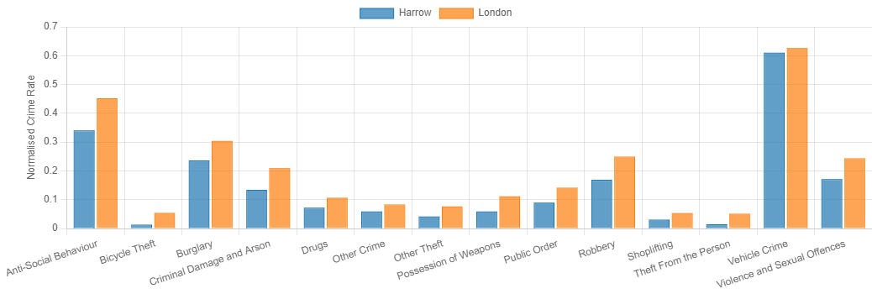
“In Harrow, violence and sexual offences are the most prevalent crimes, accounting for 4,667 offences in 2020, resulting in a crime rate of 19. This is a decrease of 2.0 per cent from the 4,759 offences reported in 2019 and a decrease of 0.37 per cent from the 19 crime rate reported in 2019. Possession of weapons is Harrow’s least prevalent crime, with 93 offences registered in 2020, the same as in 2019 (crimerate.co.uk, 2021).”

- Child poverty
Local authorities have identified child poverty as a priority, which is reflected in the Harrow corporate plan 2016-2019 and the health and wellness policy. Harrow does better than the rest of London’s boroughs on the index of multidimensional deprivation (IMD) and child poverty measures. However, this data indicates that children and families live in poverty in the borough. For instance, Harrow’s high housing and childcare prices make it more difficult for low-income families and low-skilled individuals to make ends meet (CHILD POVERTY AND LIFE CHANCES A STRATEGY AND ACTION PLAN FOR HARROW, 2017).”
- Drivers of child poverty
Families endure poverty for various reasons, but the primary cause is a lack of funds to deal with their current circumstances. A family may fall into poverty due to rising living expenses, job loss, or benefit changes. Childcare and housing are two of the most significant expenditures for families. Wealdstone, followed by Roxbourne, are the most impoverished wards in Harrow in child poverty.
- Unemployment in Harrow
In January 2017, 745,000 persons claimed jobless benefits. This decreased 42,400 from December 2016 and an increase of 2,800 from a year earlier. This included 498,100 claimants of Jobseeker’s Allowance and 246,900 claimants of Universal Credit. There were 1.60 million jobless persons (those who are not working but are looking for employment) in September, scarcely changed from July to September 2016, but 97,000 fewer than a year earlier. Count of Harrow Claimants: In January 2017, there were five more claims than the previous month and a 17% (271) rise over the same month last year.
Low employment may be attributed to various causes, including poverty, criminality, drug addiction, poor health, low educational attainment, and family breakup. In August 2014, Harrow had 2,490 people seeking Jobseeker’s Allowance, a percentage of 2.3 per cent, the lowest of the West London boroughs. According to the study, unemployment and other life changes might impair a family’s capacity to acquire fresh meals and maintain a balanced diet due to the high cost of nutritious foods (CHILD POVERTY AND LIFE CHANCES A STRATEGY AND ACTION PLAN FOR HARROW, 2017b).”
- Development efforts
The worldwide COVID-19 epidemic has created an uncertain environment for millions of families, resulting in an unprecedented food supply crisis; many individuals are suffering financially, and many more are unable to get basic food requirements owing to isolation. We have established a Food Distribution Hub in the heart of Harrow to ensure that thousands of people throughout the borough get food supplies. We collaborate with grassroots organisations and local volunteer partners to reach out to our most disadvantaged neighbourhoods with as much food as possible. We are assisting shelters, isolated individuals, the elderly, and families that cannot deal with the present situation. Our work also extends to local NHS trusts, care homes, and organisations that assist persons with mental illness and disabilities; our activities are critical for the foreseeable future (Crowdfunder UK, 2020).”
- Inclusion for Women in Harrow – Project
The purpose of this project is to address economic and social exclusion for disadvantaged women in Harrow, to improve their skills and employability, to increase opportunity equality, to decrease social isolation, and to improve their mental and/or physical health through counselling, advice, complementary therapies, and training opportunities.
- Positive and negative aspects of these digital media
Today’s media is more powerful than ever. It keeps us informed about international events. It has altered every area of human existence, including how we socialise, do business, and obtain an education.
- Positive Effects of social media
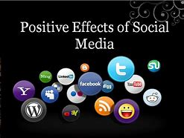
Social media platforms benefit companies in several ways. However, companies may engage with their targeted clients for free through social media; energy and time are only costs. You may significantly reduce your marketing costs by using Facebook, Twitter, LinkedIn, or other social media platforms.
Due to the growing popularity of social media platforms such as Twitter, Facebook, and LinkedIn, social media has emerged as the most feasible communication option for bloggers, article writers, and content providers.
Social networks have eliminated all barriers to communication and connection, allowing individuals to share their perceptions and ideas on a wide range of issues. Students and specialists alike may collaborate and connect with like-minded individuals and solicit information and opinions on a specific subject.
Another beneficial effect of social networking sites is that they bring individuals together on a large scale to accomplish a common goal. This is critical to effecting constructive change in society (Ali, 2015).”
- Negative Effects of social media

Addiction is one of the drawbacks of social media. Spending too much time on social media might cause attention and focus issues. It demotivates people, especially kids and students. They rely on technology and the internet rather than gaining real knowledge and experience.
These social networking platforms might also negatively impact youngsters if they are used. The reason is because occasionally people post violent and sexy photos on social media, which may badly effect children and teenagers..
Students and teens spend an inordinate amount of time on social media sites, which causes them to lose concentration on their academic studies. Consequently, they fail to finish their professors’ assigned work in school, college, and university. As a result, individuals cannot perform at their optimal level during tests. (Ali, 2015b).”
- Policy
“It came into action on October 1, 2010. It consolidates over 116 sections of law into one Act. The Act protects individual rights and promotes equality of opportunity for everyone. It protects people from unjust treatment and fosters a fair and equitable society. The nine key laws that combined are:
1 Equal Pay Act 1970
2 Sex Discrimination Act 1975
3 Race Relations Act 1976
4 Disability Discrimination Act 1995
5 Employment Equality (Religion or Belief) Regulations 2003
6 Employment Equality (Sexual Orientation) Regulations 2003
7 Employment Equality (Age) Regulations 2006
8 Equality Act 2006, Part 2
9 Equality Act (Sexual Orientation) Regulations 2007 (www.equalityhumanrights.com, n.d.).”

- Conclusion
High housing and childcare costs make it more difficult for low-income families and low-skilled people to make ends meet. Excessive time spent on social networking sites may divert one's attention away from other pursuits, such as homework or studies. It demotivates young people who rely largely on technology and the internet.



