Personal Development Plan ECEY4009-2310796
This is the knowledge, skills, and behaviours that I will change and develop to achieve my vision and goals, adhere to my values, and become as resilient as possible, I have learnt that I will need support in achieving my goals.
 | Improvement and Development Goals | What do I know already? | The actions I will take to achieve the goal | What will this help me to achieve? | Success criteria | Achievements/Target Date
1 | Personal Goal-  Adjust my Time Management skills. | I struggle with fitting things in my life as there aren’t enough hours in the day. I work full-time and have a family to look after. However, if I adjust my time management skills, there is enough time to complete this. I tend to put things off and say I will do it tomorrow and then tomorrow never comes. Then it starts piling up and I start rushing and I make mistakes. | To start planning by using a weekly planner and get myself into a routine at home to fit my assignments in. | To be a professional learner. | Complete all my assignments and the Early years degree and move forward to my next course by having good time management. | Ongoing while I finish my degree.  (2 years)
2 | Education Goal-  Be more academic, don’t let my dyslexia affect me and have more confidence in myself. | I will need to get the right support needed to help me with my dyslexia, which I’m already in the process of doing. Start using the right resources to build my confidence back. I will do research myself by looking at other methods to change the way I learn. This will help and support me in the future to be a better academic learner. | I will reach out to the right people for help and support for my dyslexia. To build my confidence I need to start believing in myself and find the right way of learning that suits me as an individual. | This will help me learn new things and become the best academic learner I can be. | I will be confident in my studies and myself. | On going through my career path.
3 | Career Goal-  I am working towards being a speech and language therapist. | I work in a SEN school as a teaching assistant. We deliver to the students SALT programs which are provided by the speech and language therapist. We receive training so we can deliver this to the students. It is so rewarding knowing how well it works for the students, especially when you see them going from nonverbal to using words. This was when I decided this was what career I wanted to do as there so much more you can do as a speech and language therapist. | Keep studying my early years degree course.  Seek out some advice for further study.  Look into speech and language therapist assistant roles. | This will help me to get onto the right path of my career. | To have completed my BA2 Early years Education and care: practitioner status.  Investigate further relevant courses for speech and language therapist.  Have contact with a speak and language therapist for information and advice.  Change job role. | September 2025  (2 years)

Reflection and reflective practice are a great way to reflect on your work, so you know what to do next time to improve, or what has worked for you, so you are on the right track. This is essential for professional development. According to Cattaneo and Motta (2020, p.185) Reflection is essential for professional competence development in every profession. Reflection-on-action (taking place a posteriori when the task is already accomplished) and reflection-in-action (occurring while performing the task) are equally important to increasing one’s professionalism. Some evidence supports the effectiveness of promoting the former by using metacognitive prompts that encourage vocational education apprentices to reflect. These to methods, reflection on action and reflection in action are a great way to improve your development in your profession as you can reflect on your work while completing an activity or when the activity has finish so your doing your own observation which helps you improve which then you will know what doesn’t work to well or has worked effectively so by doing your own observation is helping you reflect on your own work, which is helping your professional development. According to Brock (2015, p.2) Reflection is about analysis, about delving into an issue or problem to explore different perspectives from a range of aspects and standpoints. The more complex or tricky the problem or issue is, the deeper the analysis required, as you think around and into the heart of it, working out what feels right. Emotion and intuition also play important roles in the reflective process. The process of reflection through engaging in reading and research and developing professional, practical, and personal experience generates knowledge and skills that enable understanding, empathy and professional practice that can make a difference to children and families. Reflection on practice is to generate thinking to improve practice. Reflection is a very good skill to be used as it will always improve our practice, and we do this all the time without thinking. | Reflective practice is important to early years as reflective practice will support you by improving in your role, you will be able to learn diffident ways by reflecting your development skills, by reflecting on what works and what needs to change is very important in early years so this will help the children grow and learn, by reflecting, this will show your strengths which will help you to identify your professional development needs and, over time, this will support you to become more confident in your practice this will also benefit the parents and carers, as they will be able to see changes in your practice and feel confident that the care we are providing is high quality and is always improving so this plays an important role for all of us. According to (Brock 2015, p23) Terms such as knowledge, beliefs, theories, thinking, values, principles and frames of reference are all used to characterise aspects of practitioners’ thinking about their professional knowledge (Bennett et al. , 1997). Practitioners may draw upon the varied aspects of knowledge mentioned in this chapter – theoretical, craft, practical, personal and tacit knowledge. The ability to reflect on these contributes to professional knowledge. As research theories are examined, new thinking is offered and changing policy development occurs, so the demands intensify and increased professional knowledge is required. It is therefore important that questioning and debate among ECCE professionals occur in order to stimulate the growth of professional knowledge (NAEYC, 1993). Being a professional educator is not just about delivery or technical practice. When it is informed by principles and thinking, it becomes a professional act drawing upon a range of skills. Knowledge is drawn from a breadth of experiences gained through education, training, and practice. By doing the role and continuous training it will allow better understanding through practical application of the skills and theory learnt by experiences and maintaining professional knowledge, which will help staff, parents and carers be confident that we have understanding of the children as they will be improving in there learning as we are taking the right steps to help them achieve by reflecting on our practice and maintaining professional knowledge.
The theory of reflective practice is that we are improving our knowledge all the time by learning what went well and what didn’t so we can put new ideas in place by reflecting on our work by doing our own observation so next time we see progress. Other people could do an observation of you, which is great as they can give you feedback with will help you develop new skills, this will have improved your practice and knowledge by doing this. By reflecting we will see progress in the children and understand their needs and build relationships and trust. According to Brock (2015, p.31) Reflection-on-reflection indicates an extra dimension to a practitioner’s reflective process in that it requires dissemination to a critical friend, researcher or tutor who will actively listen or read the reflections and then respond in ways that further develop the reflective process itself. The ‘reflectee’ is aware that there is an interested party who is evaluating the reflections and may comment on insights, observations, knowledge or relationships. The process is not meant to make judgements on the practice but to act like a mirror for the ‘reflectee’ and so aims to deepen understanding of the practice or the event.

Kolb’s model  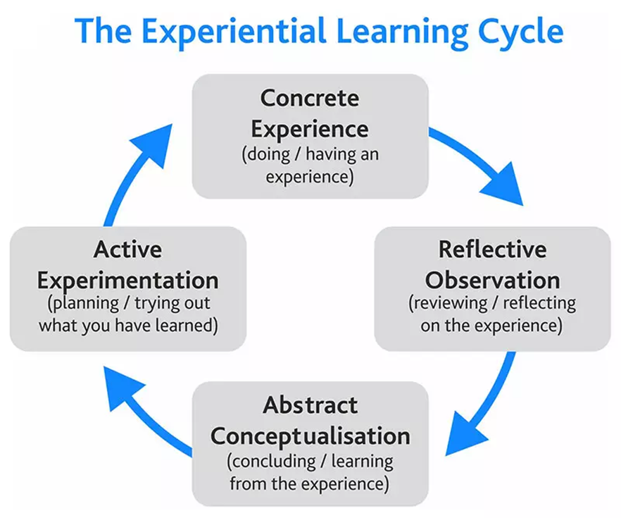 | 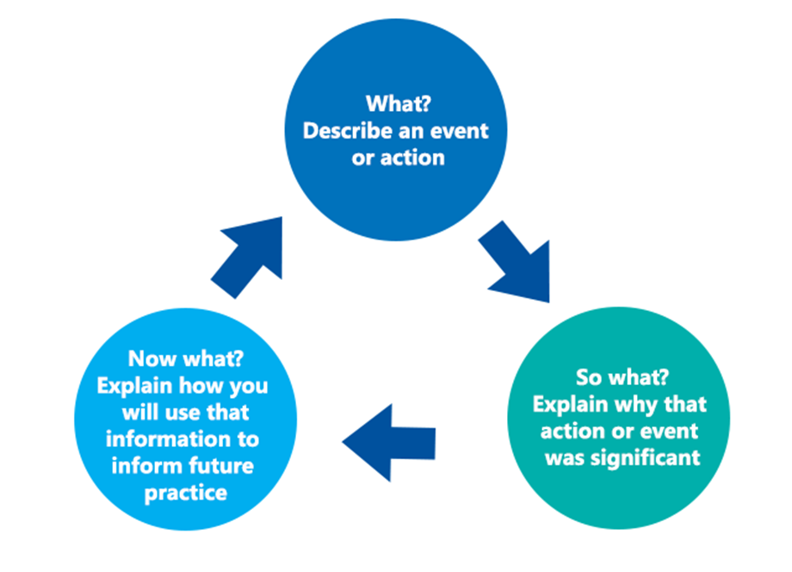  Driscoll’s model
Comparing the two models above I think Kolb’s model expresses his experiential learning cycle remains the most widely influential and cited model or clearest expression of experiential learning theory which you can reflect by using the four ways to be effective in your learning. According to Morris (2020) Learners, if they are to be effective, need four different kinds of abilities—concrete experience abilities (CE), reflective observation abilities (RO), abstract conceptualization abilities (AC), and active experimentation (AE) abilities. That is, they must be able to involve themselves fully, openly, and without bias in new experiences (CE). They must be able to reflect on and observe their experiences from many perspectives (RO). They must be able to create concepts that integrate their observations into logically sound theories (AC), and they must be able to use these theories to make decisions and solve problems (AE). Kolb’s explains you need to have four abilities to be successful by making lots of observations and involve yourself fully and be open and except changes to be effective.
Driscoll’s model expresses that you are not just finding out what happened. We are using our experience and identifying what was significant about it, and then deciding what we should do next by using the three methods- what, so what and now what. This will help us work through our thoughts and feelings about the experience. And you will identify what needs to be done differently next time by bringing it all together.
To become successful in a professional practitioner it will be great to reflect on your own practice by using different models to help reflect so you will be effective in your learning as you will find out different ways to learn and achieve, which will support yourself, students, staff, and parents along the way as they will be seeing process.

A professional is an individual who chooses to work as a certain profession and requires special training to do their job role that they have chosen to have a career in. In schools you will need to have experience in working with children and complete the right course that suits the job role, over time there will be other training to complete so you will put your Professional Practice in place and it will help you apply your knowledge to your job role by using day-day Planning and Preparation, and assessing The Classroom Environment making sure it’s safe, so students are able to learn and follow Instruction, by completing Professional Responsibilities you are being effective in your job role. According to Johston (2020, p.8) Instruments of architectural practice such as contracts and change orders, shop drawings and specifications did not just spring forth from nowhere; rather, they developed over time as functional equivalents on the social plane of the material-specific tools that mediate any craft or trade. They rationalized and formalized the social and material interactions bred by increasingly complex building tasks. As such, they served as structuring mechanisms both shaped by and shaping practice, both enabling and constraining human agency. Such tools were forged in response to indigenous needs to mediate differentiated local building cultures. He is saying your profession will develop over time by improving your practice as things change, so you will need to change.
By following Values in your setting, as they are important to a professional practitioner as you need to be respected and supported in your role this helps you to build confidence in your learning while delivering your practice, we should be treated fairly and listened to where needed so we understand acceptable practice which makes the organization more reliable, by us role modeling appropriate behaviour, we can build a friendly and respectful work environment. Which will help the professional practitioner build on their career path by developing and growing in the future. The main values which is important is loyalty because if you can trust you are able to make the right actions when working in a group this will give you a sense of belonging and you will be able to be an effective worker, by showing you can all work together as a team or work alone with surrounding support. according to Natale (1995, p135) Definitionally, loyalty is an affection that develops in a person, bonding the person to the object of his or her affection with the result that the person makes choices and takes actions on the basis of the experienced bond. The object of the loyalty can be a person (e.g., a boss or supervisor) or a group or team, an enterprise or a place, a cause or an ideal embodied by the object. Loyalty enlarges the sense of self.
In your professional practice communication plays a big role as this will help you build relationships with the staff and children, this will help you meet the needs of the children as they will trust you, that will make the children want to learn and trust you. The staff will also have trust in you too by developing effective relationships within your setting allowing all the staff to work together, which will help to meet the needs of children, parents, and carers. It is important to role model good behavior so the children can pick up on the way you behave then the children will model by being polite, good manners and know how to show respect to others as that’s how we should be in our setting. Good communication skills help with effective interaction, which involves listening, understanding, and responding to people in the right way which again children will pick up on this. According to Roffey (2012, p.vii) The past decade has seen a seismic shift within psychology and allied sciences towards an increasing emphasis on what makes life go well. Positive Psychology has played a central role in rebalancing the previous obsession with problems, pathology and dysfunction. The happiness and wellbeing of individuals has been at the core of this new science, and we have learned much about the value of positive emotions, the characteristics of happy people, and ways to promote individual happiness and wellbeing. However, the foundation of what makes lives go well is not the individual, but the quality of our relationships – the development of trust, the giving and receiving of love and support, and the myriad ways in which relationships can be life enhancing. Our relationships play a big part for everyone, by reinforcing positive relationships this allows children and staff to trust you, which will improve learning development.
By having an in-depth knowledge and understanding of safeguarding protects you, staff, and the students around you. It is very important to maintain your training and keep up to date on all the policies available, so you are always keeping the children safe. According to Tunstill (2010, p.2) between the tasks (as defined in Children Act 1989 terminology) of promoting and safeguarding the welfare of children. The former can be thought of as those services whose delivery and largely voluntary usage is focused on addressing the needs of a child within the setting of her/his family. By promoting safeguarding and the welfare of the children in schools this helps the needs of the children by us getting to know them so they can trust us and are open to talk to us when they need to, it is our duty to report any neglect or concerns to keep the children safe by promoting this in school.
Working in partnership with multi-agency is important as they can investigate concerns more, by putting the relevant support in place to help the children and families. Working together in our setting will allow each agency to have a clear understanding of our role in supporting the child. Not using these working relationships, communication could break down, which would reduce the quality of support the child receives. All of us working together will help the child learn and grow.
By us planning and using observations this will all connect with protecting the children, so we know if there are any changes in their learning or social activities in and out of the setting, they may change during play with will indicate they may need help, or not be on track with their learning, by us doing these observations on the children this will also help with the planning so we know what to do next time to help the children get back on track with their learning and even if they need support from the multi-agencies. This will all help with us meeting the children’s needs. According to Cleaver (2009, p.2) Training should be available at a number of levels to address the learning needs of both managers and practitioners. The following table provides suggested learning outcomes for these target groups. This table can also be found at www.everychildmatters.gov.uk/workingtogether. The training resource Safeguarding Children – A Shared Responsibility to which this book relates was commissioned by the government to support the implementation of its guidance on managing individual cases. This guidance is set out in Chapter 5 of Working Together (HM Government, 2006). It provides advice on what should happen if somebody has concerns about the welfare of a child (including those living away from home) and in particular concerns that a child may be suffering, or may be at risk of suffering, significant harm. In your setting training should be always available, which will help you meet the children’s needs, you will get the right advice by keeping up to date with the training, so you know what do if you have a concern and how to bring other agencies in by following the guidance. This is all to protect the children, so they have a chance to learn and grow, by doing all of this we are being professional practitioners.
The principle of UNCRC (The United Nations Convention on the Rights of the Child) is important in your setting as all children have rights so they should have access to play while learning and most children learn while playing, children should be treated fairly and listened to. The UNCRC states that all children should be respected and protected, by doing this we are meeting their needs ensuring that our children grow up in a dignity, tolerance, freedom, and equality setting.
By using all these techniques in your role this will help protect and meet the needs of the children and you will see progress in their learning, and this helps you be effective in your job role by protecting the children by keeping up to date with training and knowing all the guidelines to keep them safe. You will need to meet the individual and inclusive needs of the children in your setting to be successful.

References -
‌Brock (Ed.). (2015). The early years reflective practice handbook. Routledge.
Cawson. (2009). Safeguarding children: a shared responsibility. Wiley.

Cattaneo, A.A.P. and Motta, E. (2020). ‘I Reflect, Therefore I Am… a Good Professional’. On the Relationship between Reflection-on-Action, Reflection-in-Action, and Professional Performance in Vocational Education. Vocations and Learning, pp.185–204.
George Barnett Johnston (2020). Assembling the Architect. Bloomsbury Publishing.
Morris. (2020). Experiential learning - a systematic review and revision of Kolb’s model. Interactive Learning Environments, 1064–1077.
Natale, Rothschild, B. M., Sora, J. W., & Madden, T. M. (Eds.). (1995). Work values: education, organization, and religious concerns.

Roffey (Ed.). (2012). Positive Relationships: Evidence Based Practice across the World (1st ed. 2012.). Springer Netherlands.
Tunstill, J., Aldgate, J. and Thoburn, J. (2010). Promoting and safeguarding the welfare of children: a bridge too far? Journal of Children’s Services, pp.14–24.

