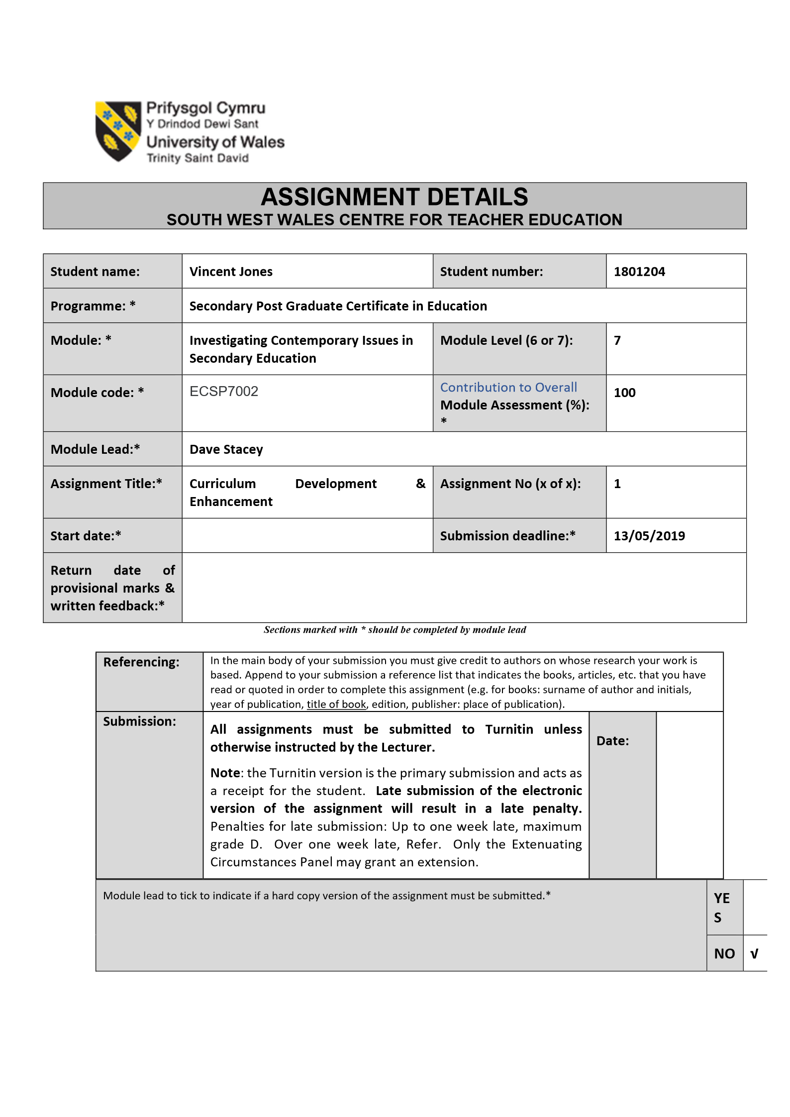

Curriculum Development and Enhancement
ECSP7002

Through the introduction of bilingual key words in presentations and handouts, do participants increase their vocabulary and use of the Welsh language in a history lesson?

Introduction

This research was undertaken in School X, a large mixed 11-18 secondary comprehensive of over 1800 pupils including sixth form. School X is an English-medium school, with the school’s provision for the Welsh language described as ‘sector leading’ (Estyn, 2016, P. 6). A mixed ability Year Seven class was targeted for the research. The research was in response to a speech in August 2016 by Carwyn Jones, First Minister in the Welsh Assembly Government, who introduced an ambitious target of having one million Welsh speakers by 2050 (Welsh Assembly Government (WAG), 2016). The target was a culmination of proposals which saw the Future Generations Act (2015) set out the vision of the ‘Wales we want to see’ in 2050, with the Welsh language key to the goal of maintaining and promoting a vibrant Welsh culture and heritage (www.legislation.gov.uk; Estyn, 2018). Cymraeg 2050 stated that in order to achieve the set target, an environment in which Welsh could be confidently used needed to be created at home and in the workplace (WAG, 2016). Key to this target was the growth of Welsh-medium schools, with 40% of pupils to be educated through the Welsh-medium by 2050 (WAG, 2016). However, the majority of learners in Wales are still being taught in the English medium, and it is the growth of Welsh second language which will prove crucial to reaching one million Welsh speakers by 2050. Every teacher, whether primary or secondary, in every subject or Area of Learning (AOL) is required to speak some Welsh, with all new teachers required to learn conversational Welsh whilst training (CAAGCC). In School X, it was apparent that only a basic use of Welsh was being used or attempted outside of bilingual classes for More Able and Talented (MAaT) pupils. Within School X’s History department, the use of Welsh varied greatly, but in no case was an environment for the use of Welsh being observed by the researcher. ‘The Basics’ of introduction, date and exit were in Welsh, as School X policy demanded, within which stood a history lesson taught in the English language. This was not in conjunction with Jones et. al. (2013), which stated the importance of the Welsh language and culture in the History curriculum. After consultation with the Head of Department, it was decided to introduce Welsh key words into the scheme of work through bilingual PowerPoint presentations and worksheets, with the aim of increasing both learner and teacher confidence and Welsh vocabulary.

Literature Review
Welsh Assembly Government Policy and Welsh in the New Curriculum
2022 will herald the introduction of a new Curriculum for Wales, based on recommendations by Prof. Graham Donaldson in Successful Futures (2015). Successful Futures (2015) stated that one of the key strengths of education in Wales was the teaching of the Welsh language and culture (Donaldson, 2015; WAG 2016), and that future education in Wales should ‘embrace the value the young people of Wales attach to their language…by strengthening the focus on its commercial value for the jobs market’ and procure ‘the suggested cognitive benefits of bilingualism’ (Donaldson. 2015, P. 60). Cwricwlwm Cymreig, History and the story of Wales (2013) stated that the Welsh language and culture should be at the very heart of the new curriculum (Jones et. al., 2013), and that the growth of the Welsh language, along with an increase in bilingualism, specifically those people for whom Welsh is a second language, will benefit Wales through the growth and preservation of Welsh culture and heritage (Jones et. al., 2013). Bilingual learning, and the creation of a post-education environment in which bilingualism is valued, it is hoped will encourage Welsh learners by providing a purpose for Welsh second language beyond the initial statutory phase of education in Wales (Estyn, 2018; Donaldson, 2015). The emphasis on cultural and economic benefits of promoting the Welsh language is at the forefront of government policy and the new Curriculum for Wales. The Welsh Language (Wales) Measure Act (2011) saw equality for Welsh and English languages in the workplace give real purpose to the teaching and learning of Welsh for future generations (www.legislation.gov.uk). By promoting bilingualism and its benefits, and providing an economic value to bilingualism after education, WAG aims to create an environment and purpose for the learning of Welsh, reaching one million culturally enriched Welsh speakers by 2050 (WAG, 2017).
In order to achieve its target of one million Welsh speakers, WAG sets out three themes under which areas of development are placed and targeted for action. They are;
- Increasing the number of Welsh speakers
- Increasing the use of Welsh
- Creating favourable conditions – infrastructure and context
Favourable conditions in which the Welsh language can thrive are essential in creating the environment that supports language acquisition and use (WAG, 2017). To support this aim, WAG aims to double the number of Welsh teachers in secondary education and Welsh-medium teachers by 2050 (WAG, 2017). Whilst WAG (2007) defines bilingualism relative to the number of subjects offered by the school in the Welsh-medium, there is no condition set with regards to the number of pupils taking subjects bilingually. In secondary education, these targets are only going to be met by the teaching of all subjects through the medium of Welsh (Lewis, 2010). This reliance on non-specialist teaching does raise questions as to the quality of teaching Welsh second language. In ‘One Language for All – Review of Welsh Second Language at Key Stages 3 and 4’ (WAG, 2013), Jones states problems with the quality of teaching Welsh as a second language. They are:
- Lack of confidence in spoken Welsh amongst teachers, especially in Key Stage 2
- Most secondary schools (as with School X) do not provide an environment for spoken Welsh outside of Welsh lessons;
- The reliance on non-specialist teachers to promote bilingualism in schools, who lack an understanding and methodology to create such an environment for second language Welsh to flourish. (WAG, 2013)
Estyn (2018) also calls into question the value of non-specialist teaching of the Welsh language, stating that errors in grammar and syntax are an issue in both primary and secondary teaching. Whilst in any subject the reliance on non-specialist teachers would have a limited effect on learners, a specialist-only approach would severely limit the required environment for growth needed to achieve one million Welsh speakers by 2050. Crucially for this research, WAG (2017) set two targets based on spoken Welsh, one being the target for one million Welsh speakers, the other to increase the percentage of the population that speak Welsh daily and can speak more than just a few words of Welsh from 10 per cent (in 2013–15) to 20 per cent by 2050’ (WAG, 2017, P. 11). Through the introduction of bilingual presentations and worksheets, it is this second target which mostly identifies with this research.

Welsh Within the Context of a History Lesson
So why promote the Welsh language in a history lesson? What are the benefits to the learner, especially if the environment for the growth of the Welsh language is not being met in other areas? Baker (2006) lists five reasons why people may acquire a second language; ideological, international, individual, language value and language survival and revitalisation. Ideologically and internationally, society and the economy benefit from bilingualism (Baker, 2006), the ‘ethically informed citizens’ and ‘enterprising, creative contributors’ called for in all Areas of Learning in Successful Futures (2015). Individual reasons include cultural awareness along with intercultural sensitivity and awareness, along with an increased awareness of social and ethical values within that culture (Baker, 2006), all of which underpin Successful Futures (2015) and the New Curriculum for Wales. Baker (2003) also sees cognitive development as an individual benefit of acquiring a second language, the skills needed to do so sharpen the mind and allow for greater intellectual stimulation. Baker (2006) and Jones et. al. (2013) agree that language is a way of not only seeing the world today objectively, but also a living link to the past that cannot be lost, central to the study of history, in particular, Welsh history. By embracing the language of their ancestors within a History lesson, learners are closer to understanding the history of the world around them, with a better understanding of that world today as a consequence (Jones et. al., 2013; Baker, 2003; Baker 2006).
Research also shows that ‘learners are more successful in acquiring a language if they do more than merely learn the language as a subject and use it as a medium for learning other topics or subjects’ (WAG, 2009, P. 17). There are benefits to ensuring Welsh is not just taught in the vacuum of a Welsh lesson, benefits which transfer to the acquisition of other languages and skills within the curriculum (Donaldson, 2015; Estyn, 2009; Lewis, 2010). With so much value given to the Welsh language in education, and the focus on a curriculum rich in Welsh culture and heritage, History would seem a natural place for the use and amalgamation of language and learning (Jones et.al., 2013). With the cross-curricular focus in Successful Futures (2015), the Welsh language can be a foundation to the success of the curriculum, permeating all subjects. Ensuring Welsh is heard and used every day is the responsibility of all teachers, regardless of subject, as ‘all teachers should attempt to introduce Welsh visually in their classes. When learners hear and see Welsh across the curriculum, this will contribute to strengthening the bilingual ethos in school’ (Bangor, P. 5). Estyn stated that ‘not enough English-medium schools encourage pupils to practice using their Welsh in subjects other than Welsh’ (Estyn, 2009, P.11; Estyn, 2008; Estyn, 2007). If, over a period of an academic year, learners could access key words and sentences in the Welsh language through presentations and worksheets in a History lesson, the ability to speak more than ‘just a few words of Welsh’ would be met by both learner and teacher. The new curriculum aims to create an environment for the growth of Welsh language, culture and heritage, with WAG, through legislation, creating a purpose for Welsh post-education. Within Wales there is a drive to ensure the preservation of the Welsh language, and with it, Welsh culture and heritage. While these outcomes are valid from a cultural perspective, and valid certainly if one is looking at Wales from a historical perspective, are the benefits of bilingualism real and measurable?
The Benefits of Bilingualism?
Whereas there is an increasing amount of literature available on the benefits and advantages of a bilingual education, there has been little in the way of classroom strategies for learning bilingually. Currently, in Welsh-medium secondary schools, monolingualism is encouraged, with a Welsh-only approach (). While this clearly supports the goal of a Wales ‘rich in language’, it does little to promote bilingualism in a bilingual country. There are perceived benefits to bilingualism, both cognitive and economic, but researchers still debate the effect bilingualism has on other areas of learning. Rhieni dros Addysg Gymraeg (RhAG) (Parents for Welsh-medium Education) ‘believes firmly that bilingualism is a real benefit and that it supports the learning of further languages and opens doors to children and young people as they move into the workplace’ (Donaldson, 2015, P. 59). The Millennium Cohort Study (2017) studied 19,000 British children, and found that children who spoke more than one language, whilst behind until five years old, then excelled academically compared to their monolingual equals on reaching the age of seven. However, Bialystok et. al. (2005) found no advantage or disadvantage in being a bilingual learner, as long as the levels of vocabulary were similar to monolingual equals. Monolingual and bilingual learners were found to have no differences in their ability to learn, aside from bilingual learners having an advantage in the area of languages, which Bialystok et. al. (2005) concluded was due to an increased vocabulary if two languages had been studied. This increased vocabulary enabled a bilingual learner to read a second language easier. Lewis (2010) shows that the positive effects of bilingualism, however they are measured, do not stand up to the pressures faced by schools and learners in KS4. Learners by KS4 disengage from bilingualism, with exam pressures, all of which unless specifically chosen will be taken in the English-medium, reducing the use of Welsh within the wider curriculum to nothing more than an irritation (Lewis, 2010). In a sample taken by the National Assembly for Wales in 2010, only 3% of schools offered any subject other than Welsh through the medium of Welsh or bilingually at KS4. Also, 75% of pupils would decline the offer of a subject taught through the Welsh-medium if it were offered (Baker, 2006; Lewis, 2010).
It is long recognised that the teaching and learning experience of Welsh through the English-medium is ineffective due to time constraints the quality of the teaching (Baker, 1993; Lewis, 2010). WAG (2009) suggests developing the teaching of Welsh second language so pupils not being taught through the Welsh-medium have the same benefits of learning and living in a bilingual country (WAG, 2009; Lewis, 2010). Estyn stated even before the current targets for Welsh speakers were set, that the quality of Welsh second language teaching would curtail the growth in Welsh speakers (Estyn, 2007). Meilyr Rowlands, Chief Inspector of Estyn, states ‘Improving the teaching and learning of Welsh for all learners is at the heart of developing Wales as a bilingual nation’ (Estyn, 2018). Iaith Pawb identified the issues surrounding Welsh taught as a second language as far back as 2002 (WAG, 2002). Nor is the suggestion that more resources are needed to encourage Welsh speaking throughout education new. The Qualifications, Curriculum and Assessment Authority for Wales (ACCAC) aimed to develop ‘classroom resources to support the teaching of Welsh and of all subjects through the medium of Welsh and bilingual resources to support the Curriculum Cymreig’ as far back as 2003 (ACCAC, 2003, P. 2). The attempt to improve the quality and amount of Welsh spoken outside a Welsh lesson is nothing new and has thus far been ineffective (Lewis, 2010; Estyn, 2007).
Poor Welsh second language resources were considered very challenging for non-specialist teachers, with 60% of headteachers stating a lack of trained staff limited their development of bilingualism (Baker, 2006). Baker (2003; 2006) and Estyn (2007) both state that contact time, and guidance and methodology support for non-specialist teachers is needed if the growth of bilingual teaching is to grow apace with WAG policy. Having compulsory Welsh lessons and GCSE examinations shows commitment to ensuring the revitalisation and survival of the Welsh language, but a lack of resources and use of Welsh in other lessons means the opportunity throughout the rest of the curriculum is then lost. Interdependency is critical. Use in school and not at home, or vice versa, will have a negative effect, similarly in home/work or social/home etc (Lewis, 2010). This clearly relates to the curriculum. Welsh in one part of the curriculum, will not see Welsh thrive throughout the curriculum. Any benefits of bilingualism are lost (Jones, 2010; Baker, 2006). WAG (2016) states that the environment in which the Welsh language can grow is as important as the teaching and learning. One cannot exist without the other (CAAGCC). In the context of acquiring, using and sharing Welsh with others, this entails purposeful planning in order to ensure that the best possible conditions are in place to:
- support speakers as they begin to develop their linguistic skills – at home, through the education system or later in life
- facilitating their ability and their readiness to continue to use Welsh, with their families, in their communities and social networks, with their colleagues and in accessing services
- identifying the circumstances and factors most likely to weaken their contact with the language or diminish their readiness to use it
- equip speakers to make decisions that will support their use of Welsh in future. (WAG, 2017, P. 19)
In supporting, facilitating and encouraging the use of Welsh in a History lesson, both learner and lesson can be enriched. Achieving one million Welsh speakers would reverse 100 years of decline in the next 30 years. This research aims to provide an insight as to how accepting learners are of a bilingual lesson, and whether an environment can be created within a History lesson which encourages the use of the Welsh language, with Welsh culture and heritage at the heart of learning.

School Policy and Practice
School X prospectus states that its promotion of bilingual learning as one of its key strengths (Appendix B). School X’s provision for the Welsh language has been described as sector leading (Estyn, 2016). School X claims to provide opportunities for all pupils at all levels to choose an English of Welsh medium route to qualifications. School X uses its ‘Cwrs Carlam’ provision to ensure the more able and talented pupils are fast-tracked, in their development of Welsh language skills. School X also promotes its use of extra-curricular activities and residential courses as bilingual opportunities and holds a bilingual eisteddfod every year. School X additionally ‘promotes pupils’ understanding of the culture, customs and traditions of Wales well’ (Appendix A), and ‘has a wide and varied programme of activities at lunchtime and after school to broaden learners’ experiences, including sporting, cultural and linguistic opportunities’. While School X endeavours to include the Welsh language within all lessons in KS3, in conjunction with WAG’s early years provision for the Welsh language from the foundation phase onwards (WAG, 2017; Jones, 2013), at KS4, no provision for Welsh was observed, with time constraints the reason given for the decline in bilingual lessons.
The researcher witnessed a MAaT class in several subjects being taught bilingually at KS3, though in most of these lessons, the use of English was not encouraged, essentially making it a Welsh-medium lesson and not a bilingual lesson. However, there was no provision for bilingual learning aside from ‘the basics’ in mixed ability or less able classes. School X enforced the Welsh language through ‘the Basics’. ‘The Basics’ were the minimum expected from teachers in all subjects and Areas of Learning. Entry and exit, date and instructions were all in spoken Welsh, and could be found on signage within the classroom, as per School X policy. Praise was also in Welsh. However, this varied from teacher to teacher due to varying capabilities of the teacher. In juxtaposition with this research, only ‘lesson objectives’ and ‘class work’ were expected to be in Welsh in all presentations, and even then, strictly in Welsh and not bilingually. School X’s last Estyn report (2016) identified ninety-eight per cent of pupils were from a white British background. Additionally, it identified that ten percent of pupils were fluent in Welsh, with thirty-nine percent of pupils spoke some Welsh, but were not fluent (Estyn, 2016). Only 8% of pupils speak Welsh at home. Over ninety-nine percent of pupils have list English first language, suggesting little second language within the community.

Methodology
Action Research in Education
Action research in education is a process used to identify a problem or issue, improve the teaching and learning experience through intervention, before finally evaluating and implementing the change (Cohen & Manion 1994; Taber, 2007). ‘Action research is a cyclic process that requires interventions to be implemented, evaluated, modified, implemented in their new form’ (Taber, 2007). For a teacher-researcher to make use of an empirical enquiry, the correct question, focus and methodology is essential. The right methodology can help provide sound evidence to ensure a confident outcome in a short base of time (Taber, 2007). The methodology chosen is also important in evaluating whether the research is valid and trustworthy. Almost all literature supports a simple model of research as being;
- Framing the research around a question
- Deciding the form of the data needed to provide an answer
- Collecting and analysing the data
- Answering the question with the analysed data
Action research is at its most beneficial when used to improve an observed part of one’s own professional work (Taber, 2007). ‘Even if a study is being undertaken as part of course requirements (e.g. for a PGCE or master’s course), it makes sense to identify an area where there are clear grounds for believing that research could potentially inform improvements for the teacher(s) and learners involved’ (Taber, 2007, P 120). ‘Built into action research is the proviso that, if as a teacher I am dissatisfied with what is already going on, I will have the confidence and resolution to attempt to change it. I will not be content with the status quo’ (McNiff, 1988, P. 50).

Intervention Method
An intervention should form from the principle of what works. Altrichter & Posch (1989) states that ‘what’s good for the practice is good for research’ (P. 29). The decision to use a pre and post-test was identified as easy to implement alongside the research question. Kumar (2011) regards pre and post-testing an appropriate method for testing the success of a short intervention. Participants take a pre-test, which is then followed by an intervention. The same test, or at least as similar a test as possible in the case of Punch (2009), is then taken, the post-test. Cranmer (2017) sees the wide use of such tests growing due to the growth of inexperienced teacher-researcher, such as a PGCE or master’s student, and the tests ease of use. Limitations to the study often form the basis for the methodology chosen for the research (McNiff & Whitehead, 2009). There are drawbacks to the use of pre and post-testing. Brown & Dowling (1998) see the school context as causing unreliability, as most of the time between pre and post-tests is spent outside of the classroom, where learning cannot be controlled by the intervention. Maturation, the act of learning or developing regardless of intervention, this making the success of the intervention difficult to measure, is an issue in any learning environment. Whilst this cannot be controlled, the period between pre and post-tests can be limited to reduce its impact on the study.
Pre and post-tests nullify certain ethical concerns, such as influence or bias, due to the test conditions. However, the ‘test’ itself can increase stress on the participants (Cohen & Manion, 1994). Whilst every effort is made to reduce this stress, it is impossible to predict how testing affects the participant. This can be both offset and increased by an increased sample size. Pre and post-tests were considered more suitable to a small-scale intervention than other methods, such as Grounded Theory. Taber (2007) states that Grounded Theory cannot be used if a result is required within a limited amount of time, which makes it unsuitable for the teacher-researcher. However, if a teacher-researcher is exploring an issue of professional interest which they intend to pursue throughout their career, GT can be used to further this research beyond this paper (Taber, 2007). This approach also sees the limitation of stand-alone action research negated somewhat through the reinvention of the research as a process later in a teacher-researchers career. The test and re-test, or pre and post-test were conducted at the same time of day, in the shortest period that the timetable would allow, in order to maintain a reliability and stability (Punch, 2009). Punch (2009) states that a long period between any test and retest can lead to validity issues due to lack of consistency. While learners are developing in the research stage, it is important that the researcher stays consistent. To this end, the period of research should not be prolonged to allow for a false development of the results.

Research Question
Punch (2009) and Cohen & Manion (2000) both state that methodology should flow from questions. ‘For the teacher-researcher, the focus often seems to suggest itself’ (Taber, 2007, P. 119). Taber (2007) and Punch (2009) state that research questions cannot be set until research begins. This is not possible in post-graduate research, as a question is submitted for ethical clearance long before research begins. Punch (2009) states that questions which form from paradigms somewhat compensates for this issue. By developing a question from what the teacher-researcher is observing, the question becomes a pragmatic response to an issue, providing focus to the research question, and also helps identify the data required to answer the question (Punch, 2009). Punch (2009) states that neither quantitative or qualitative data are more valuable, if fact, combined appropriately they make for stronger research. This ‘mixed method’ research was the approach chosen by this researcher. The research question would provide quantitative data. The questions posed in the questionnaire would assess the environmental chances for development, producing qualitative data, which in turn could be used to better understand the quantitative data collected in the post test. While quantitative data is mostly used mainly as theory verification, qualitative data mainly used for theory generation, a mix of the two is necessary as the aim of this research was to see if bilingual presentations positively affected learners (Punch, 2009). Therefore, in proving that the lack of environmental factors for the growth of bilingualism were there, theory verification, it was hoped to prove that small changes in that environment could provide the opportunity for bilingualism to develop and then prosper, theory generation. While Punch (2009) states that a research question may change as work proceeds, personal experiences prior to the research beginning actually reinforced the question planned. However, it was decided to include a questionnaire to look at underlying barriers to bilingualism that might exist. The questionnaire links to the environmental conditions as defined in Cymraeg 2050 (WAG, 2016), questioning personal and home conditions for bilingualism, while the research question is built around the prospects for growth in education.

Ethics
Labaree (2003) proposes several shifts that teachers must undergo in their transition to researcher, he describes the transition from teacher to researcher as involving a shift from the normative to the analytical. Researchers genuinely concerned for well-being can be too narrow if they do not appreciate the complexity of well-being and its pursuit (Hosteller, 1995). Therefore, ethically, the researcher needs to ask whether the intervention benefits the participants. Taber (2007) states that the risk of ethical infringements should be set against other standard procedures often used in the classroom. Whilst this research does not wish to risk unwanted stress on participants, enforcing a seating plan and discouraging fluid intake within a lesson are regularly witnessed and both have negative impacts on learning (Taber, 2007). In some cases, the researcher needs to balance the benefits to the teaching and learning experience of the research with the risks involved in the research itself (Taber, 2007). Punch (2002) states that pupils must be treated as such, and any adverse stress noted and reduced. The British Educational Research Association (BERA), who regulate research in post-graduate and master’s courses, state that all participants must therefore be made aware of the research. They can withdraw at any time, and also responsibly withdrawn if concerns appear to the teacher-researcher. This research was conducted within BERA guidelines.

Evaluation
The Intervention
The research was completed within the theme of ‘Heroes and Villains’. The theme was chosen due to its Welsh perspective and skills focus for Cwricwlwm Cymreig (Jones et. al., 2013). This allowed for incorporation of Welsh key words with relative ease. It also reduced the difference it made to the originally planned lesson, negating any stress the participants may have experienced if resources were unrecognisable from previous lessons (Kumar, 2011). Three lesson were used, with four words in focus for each lesson, in line with CAAGCC guidelines which state that ‘vocabulary and sentences need to be varied every week’ (CAAGCC, 2017) so learners are not seeing a predictable lesson. It was decided that participants would not be prompted to speak the Welsh words unless they themselves asked for help reading them. This was based on CAAGCC guidelines which state that each learner will attempt different strategies to learn bilingually, and the focus for bilingual learning should be inclusion and not the needs of the study (CAAGCC, 2017). The class numbered twenty-seven learners. On the day of the pre-test, twenty-four pupils attended, of which twenty-three took the pre-test. Therefore, the initial sample size was twenty-three participants. This was reduced to twenty, due to three absentees when conducting the post-test. The period between pre- and post-test was seventeen days. This allowed the test and re-test to be done in the same period, in order to achieve an environment that was as close to the original as possible. The pre-test (Appendix C) was followed by three lessons in which twelve key words were repeated visually, either in worksheets or PowerPoint presentations three times. Four words were taken from participants books, words they are repeating on a daily basis. Four words were instructions used by teachers daily and could be found on posters around every classroom. Four words were subject specific and used bilingually in the research segment only.
Three PowerPoint presentations were used over the three lessons. Each had its own design though each was recognisable as being part of a series. Lessons one and two had additional worksheets with the Welsh key words repeated to comply with the multi-media approach to a lesson required by School X. School X History Department also requested other conditions on the intervention. Whilst not used in the test sample, it was agreed that the two other Year Seven classes taught by the teacher-researcher would receive the same presentation, thus not to disadvantage them from the research sample group. In addition to the twelve Welsh key words within the pre- and post-test, participants were asked three questions regarding their own provisions outside the classroom. They were;
- What is your considered level of the Welsh language?
- Does anyone in your family speak Welsh?
- Do you hear Welsh being spoken at home?
The environment for the growth of second language Welsh is key to the success of WAG targets (WAG, 2017; Lewis, 2010), and by collecting data regarding each participants environment, the research could evaluate whether any positive outcomes might prosper outside of the study.

Resources and Conditions
The questionnaire and pre- and post-test method used allowed for limited interruption to the lesson (Kumar, 2011). Pupils were tested before the first lesson. The test had already been explained, and any stress minimised. There was still a small amount of stress observed on receipt of the pre-test. Participants were told they would receive the same test at the end of the study, but no explanation of the bilingual resources was given. During the intervention, participants very quickly recognised the increase in the use of Welsh key words, even though both format and subject matter had been maintained to avoid confusion or stress. Cranmer (2017) sees this as causing additional learning which clouds the research. While this is valid, maturation can be seen as a result of the need to reduce ethical concerns, as the introduction of the intervention reduces stress (Kumar, 2011). Participants were keen to ‘highlight’ Welsh key words on bilingual worksheets provided. Punch (2002) states this desire of the participants to give the researcher the correct answer to be damaging both ethically, and for the validity of the study. However, Taber (2007) sees this as part of the enhanced teaching and learning experience. If participants are adapting to the study resources, with each participant learning in their own different way, then the teaching and learning experience issue which the teacher-researcher is studying is partly answered. I have collected qualitative data in the form of a questionnaire and collected quantitative data that can be measured and represented in numbers. However, all the quantifiable data has been interpreted qualitatively.

Findings
Firstly, the results of the questionnaire were assessed. The first question, ‘What is your considered level of the Welsh language?’ gave contradictory findings. Two participants (10%) stated their level of Welsh as ‘none’. Two participants (10%) assessed themselves as ‘fluent’, both of which had come from a Welsh-medium primary school. Therefore, 80% of the sample stated their level as ‘a little Welsh’. This closely matched the school’s own analysis of 9% fluency, but the 80% of pupils who knew a little Welsh was more than double the 39% measured by Estyn (2016). This was considered promising, as most pupils, even if they are not of a good standard, are aware that they know ‘more than a little Welsh’ (WAG, 2017). When asked ‘Does anyone in your family speak Welsh?’, six participants (33.33%) said that someone in their family spoke Welsh, more in line with School X’s own findings (39%). Results from the third question were disappointing when assessed. When asked ‘Do you hear Welsh being spoken at home?’, only four participants answered yes (20%). Therefore, despite 90% of the sample stating they know at least ‘a little Welsh’, on 20% of participants have an environment at home in which they can confidently use Welsh. This contradicted the school’s own findings and comments about the use of Welsh within the community. It also cast doubt on whether a positive outcome within the study could transfer to the home and workplace, as suggested by Donaldson (2015).
The results of the post-test showed an overall improvement in the use and knowledge of Welsh key words. Of the twenty participants who sat both pre and post-tests, 14 improved on their pre-test, while 6 showed no improvement. No-one achieved a lower score. Therefore, 70% of participants increased the amount of Welsh key words they could recall, while 30% of participants had the same score. The average participant answered 2.4 out of the 12 key words correctly in the pre-test. This was disappointing, as it was agreed with the mentor to use four everyday Welsh words in the pre- and post-tests. It was suggested to the researcher that a score of four should be the ‘entry level’. However, this increased to 5.2 out of 12 in the post-test. The class was a mixed ability class, with both targets and current levels ranging from Level 3 to Level 6. While some pupils in the post-test scored one, one pupil (Appendix E) scored twelve out of twelve (Pupil A’s pre-test is Appendix D). Improvement was shown in pupils of every target level. This again contradicts School X’s policy (Appendix B), where they promote the teaching of only Welsh-medium primary and MAaT pupils bilingually, as improvement was shown even in less able pupils. Whilst the two pupils who stated themselves to be ‘fluent’ had the highest scores, equal improvement was recorded across pupils who considered themselves knowing ‘none’ or ‘a little Welsh’.

Other Findings and Considerations
The results suggest that pupils do increase their knowledge and use of Welsh key words when those words are presented bilingually in a History lesson. However, it is possible to dismiss or exaggerate statistical improvements. Taber (2007) points out that a statistically significant result can be the result of chance or be of minimal importance, while a result which is not statistically significant can still be important. This can lead to a ‘reading’ of results which are flawed or biased to suit the researcher. With this in mind, the qualitative data recorded does suggest that even though quantitative data showed an improvement in pupil’s levels of Welsh, the lack of environment for growth outside of school can be seen as an overall negative result. However, it is valid to state that the study did show an improvement in the educational environment in the period of the study.
That Welsh forms most of the administrative language, which can often be negative, and forms a large percentage of teacher-learner interactions within a lesson, can be a barrier to the use of Welsh second language throughout the lesson (Taber, 1992). Two Welsh key words chosen for the test were deliberately administrative. If School X’s policy is enforced in every lesson, pupils should be hearing these two words at least twelve times per day. Interestingly. Only seven participants (35%) of pupils were able to identify both words in the pre-test, with the same result in the post-test. Whilst no link can be proven, this would suggest Taber (1992) is correct, and that pupils have a barrier to bilingualism which comes from adverse use of Welsh to inform and chastise them. In fact, almost all improvement in the tests came from new subject specific Welsh key words. This suggests that throughout the curriculum, there is an opportunity for bilingualism being lost (WAG, 2016; Lewis, 2010).

Conclusion
While the above quantitative data showed a positive outcome, observations made during the research proved mixed. Both pupils who identified as ‘fluent’ were confidently reading the Welsh key words – School X has an ‘every child reads in class’ (ERIC) policy where pupils read to the class at random. However, a significant proportion of usually confident readers were reluctant to read. There was a clear decline in pupils volunteering to read where Welsh key words appeared, a sign that even with an increase in environmental factors, confidence remained low. While this research cannot prove a link between increased bilingualism and academic achievement, it can claim that bilingual presentations increase the use of a second language, which other research has claimed improves academic performance. Additionally, it can be concluded that while bilingual presentations can increase the amount of historical key words known and used in a history lesson, beyond the classroom, the environmental factors needed for the confident use of a second-language are not in place. There are several factors which restrict the impact of this research. Jones (2016) states that teacher confidence cannot be improved without training and support, with pedagogical knowledge in languages and bilingualism. Hosteller (2005) sees ‘no link between the theory and practice that would support teachers in developing ﬂexible pedagogical language knowledge (Hosteller, 2005, P. 119). Therefore, ‘it is becoming increasingly common for university-based teacher education programs to require foundational and methods courses in second-language acquisition and instruction’ (Hosteller, 2005, P.119). However, this researcher found that poor resources and lack of training had less of an impact than the presence of an ‘English-only’ attitude within the History department of School X. CAAGCC (2017) sees ‘developing the [PGCE] trainees’ understanding of the importance of bilingualism and the Cwricwlwm Cymreig in schools in Wales’ as fundamental to a better bilingual teaching and learning experience. The research question within this study was chosen purposefully, as the researcher saw this as a weakness in School X, despite its own claims.
Therefore, despite the positive results in terms of use and knowledge of Welsh key words, and albeit limited success of the bilingual presentations, this research concludes that even a considered and inclusive bilingual presentation does little to combat the effects low confidence in bilingualism in teachers. CAAGCC (2017) states that;
‘All teachers should create an atmosphere where they support the use of Everyday Welsh rather than forcing it upon learners. All teachers should attempt to introduce Welsh visually in their classes. When learners hear and see Welsh across the curriculum, this will contribute to strengthening the bilingual ethos in school.’
However, this cannot be achieved if the majority of teachers are either uncomfortable with or ignorant of bilingual learning. Estyn’s (2018) statement that poor syntax and grammar restrict bilingualism, along with the poor methodology and lack of resources which Estyn (2007) held responsible, both point to a poor teaching experience. The lack of experience, use, or interest in bilingualism was witnessed in School X, and research points to this issue being key to a better bilingual learning experience. This research does point to an improvement in the future well-being of bilingualism in Wales. CAAGCC (2017) ensures new trainees use ‘Welsh as a second or additional language within the curriculum and how to do so effectively in accordance with requirements S1.1, S2.2 and S33.5 of the Welsh Assembly Government’s Qualified Teacher Status Standards (2009) (CAAGCC, 2017, P. 3). With every new trainee teacher, not forgetting every new trainee teacher-researcher, being given a sound pedagogical start in bilingualism, there is a point in the future where lack of training, and confidence will diminish.
‘There are limits to what can be done in any one project’ (Punch, 2009, P. 42). However, many well developed small-scale studies can provide a better understanding of issues than one cumbersome large-scale project (Punch, 2009). This research, whilst improving the knowledge and use of Welsh within a History lesson on a small scale, has larger implications for further research. Cohen et. al. (2003) observe ‘the value of any resource… depends how it is used in planning and teaching. (Cohen et. al., 2003, P. 115), while Bell (1999) states ‘a review should provide the reader with a picture…of the state of knowledge and of major questions in the subject area being investigated’ (Taylor et. al., 2006, P. 17). Therefore, the value of this research is in its further use, and, as in all scientific research, as much in the questions it raises as the questions answered. This research will inform new issues, as is the cyclic nature of action research, and ensure that the teacher-researcher is active in improving the teaching and learning experience of their learners.

Limitations
The process that the researcher goes through to achieve understanding is a spiral of action research cycles consisting of four major phrases: ‘planning, acting, observing and reflecting’ (Zuber-Skerrit, 1991, P. 2). This cyclic process alternates between action and critical reflection (Dick, 2002), the answer leading to another question. ‘As the cycles progress a greater understanding is developed through the continuous refining of methods, data and interpretation’ (Dick, 2002, P, 15). Limits to any intervention or study will therefore weaken its reliability, validity and impact. The main limitation of this research is that the cycle ends after one revolution. The outcomes are never improved on. Whilst identifying an area of weakness, there was no opportunity to implement any improvement. A research programme implies an ongoing cyclic approach which this action research cannot be (Taber, 2007). Other limitations also originate from this research being conducted in a Professional Teaching Experience. The limitations of this research are set by the process being educational and not professional. Also, the short period of time to complete this study, did not provide the researcher with ample time to access a wide variety of literature prior to the choice of research question (Koshy, 2010). The research is therefore too narrow in its aims.
If, as is the case, this research follows Taber’s (2007) suggestion that action research is an attempt to improve a weakness professionally observed, then the limitations of this research can be mitigated through further development of the strategy beyond this phase of research. If the research has professional value to the researcher, there is more likely to be an opportunity to apply the results to future use (Taber, 2007). By linking a professional need to the research, it is more likely to have value with future classes (Taber, 2007). Therefore, this research, in forming part of the researcher’s professional development, enables better practice and further targets for the use of Welsh and bilingualism in PTE2 and a professional teaching career. Other limitations were the quality of the resources and pedagogical methodology in bilingualism. Baker (2006) states that poor resources and lack of confidence in teachers to create them, sees teachers reduce, not increase, the use of bilingual presentations. While the resources used were verified and improved by Welsh first language teachers, the teacher-researcher confidence in spoken Welsh did further limit the creation of the environmental factors crucial to the research. The lack of a bilingual pedagogy was evident in the editing of presentations for use. While this teacher-researcher had qualified help, this is clearly a risk for Welsh basic second language teachers. Incorporating bilingualism into an assessment would require a better understanding of the Welsh language than most teachers possess (Baker, 2006). Bilingual presentations should assist the teaching and learning experience. In doing so, they have provided a window into how that teaching and learning experience can be further improved, and shown the limitations that exist currently which are a barrier to bilingualism and one million Welsh speakers by 2050.

Bibliography

Online Resources

Welsh Assembly Government (2017) Cymraeg 2050 Cardiff: Welsh Government Access online 13/05/2019 at; https://gov.wales/docs/dcells/publications/170711-welsh-language-strategy-eng.pdf

Welsh Assembly Government (2010) Welsh Medium Education Strategy Cardiff: Welsh Government Access online 13/05/2019 at; https://gweddill.gov.wales/docs/dcells/publications/100420welshmediumstrategyen.pdf

Welsh Assembly Government (2013) One language for all - Review of Welsh second language at Key Stages 3 and 4 Cardiff: Welsh Government Access online 13/05/2019 at; https://gweddill.gov.wales/docs/dcells/publications/130926-review-of-welsh-second-lan-en.pdf

Welsh Assembly Government (2014) A living language: a language for living Welsh Language Strategy 2012–17 Cardiff: Welsh Government Access online 13/05/2019 at; https://gov.wales/sites/default/files/publications/2018-12/cymraeg-2050-welsh-language-strategy.pdf

Welsh Assembly Government (2016) Taking Wales Forward 2016–2021 Cardiff: Welsh Government Access online 13/05/2019 at; https://gweddill.gov.wales/docs/strategies/160920-taking-wales-forward-en.pdf

Welsh Assembly Government (2015) Well-being of Future Generations (Wales) Act 2015 Cardiff: Welsh Assembly Government Access online 13/05/2019 at; https://gweddill.gov.wales/docs/dsjlg/publications/150623-guide-to-the-fg-act-en.pdf

Welsh Assembly Government (2007) Defining schools according to Welsh medium provision Cardiff: Welsh Government Access online 13/05/2019 at; https://gweddill.gov.wales/docs/dcells/publications/150203-defining-schools-welsh-medium-en.pdf

Welsh Assembly Government (2002) Iaith Pawb: A National Action Plan for a Bilingual Wales. Cardiff: Welsh Assembly Government

Welsh Assembly Government (2002) A Bilingual Future: Policy Statement by the Welsh Assembly Government. Cardiff: Welsh Assembly Government

Welsh Government (2008) History in the National Curriculum for Wales. Cardiff: Welsh Government

Donaldson, G (2015) Successful Futures Cardiff: Welsh Assembly Government Access online 13/05/2019 at; https://gov.wales/docs/dcells/publications/150225-successful-futures-en.pdf

CAAGCC Literacy Skills Guidance – Everyday Welsh – ITET Booklet Access online 13/05/2019 at; https://www.bangor.ac.uk/education-and-human-development/reportforms/forms/Guidebook%20Everyday%20Welsh.pdf

Jones, E. et.al. (2013) The Cwricwlwm Cymreig, history and the story of Wales. Cardiff: Welsh Government at; http://learning.gov.wales/docs/learningwales/news/130424-cwricwlwm-cymreig-report-en.pdf Access online 13/05/2019

ACCAC (2003) Developing the Curriculum Cymreig. Cardiff. ACCAC Access online 13/05/2019 at; http://learning.gov.wales/docs/learningwales/publications/130424-developing-the-curriculum-cymreig-en.pdf

Lewis W. G. Welsh Second Language in the National Curriculum - the case of teaching Welsh in English-medium schools Cardiff: National Assembly for Wales Access online 13/05/2019 at;
http://www.assembly.wales/NAfW%20Documents/paper_3_-_dr_w_gwyn_lewis.pdf%20-%2002092010/paper_3_-_dr_w_gwyn_lewis-English.pdf

Estyn (2007) The Annual Report of Her Majesty’s Chief Inspector of Education and Training in Wales 2005-2006. Cardiff: Estyn

Estyn (2008) The Annual Report of Her Majesty’s Chief Inspector of Education and Training in Wales 2006-2007. Cardiff: Estyn

Estyn (2009) The Annual Report of Her Majesty’s Chief Inspector of Education and Training in Wales 2007-2008. Cardiff: Estyn

Estyn (2014) English in Key Stages 2 and 3 Cardiff: Estyn Access online 13/05/2019 at; https://www.estyn.gov.wales/sites/default/files/documents/English%20in%20key%20stages%202%20and%203%20-%20June%202014.pdf

Estyn (2005) Y Cwricwlwm Cymreig - Progress made by schools in implementation of ACCAC guidance issued in 2003. Cardiff: Estyn Access online 13/05/2019 at;
https://dera.ioe.ac.uk/5753/1/Remit_6_April_05.pdf

Estyn (2018) Welsh in key stage 2 and key stage 3 in Welsh-medium or bilingual schools: Cardiff Access online 13/05/2019 at; https://www.estyn.gov.wales/sites/default/files/documents/Welsh%20in%20key%20stage%202%20and%20key%20stage%203%20in%20Welsh-medium%20or%20bilingual%20schools%20En.pdf

Jones M. (2016) Research Briefing Welsh-medium education and Welsh as a subject Cardiff: National Assembly for wales Access online 13/05/2019 at; http://www.assembly.wales/research%20documents/rs16-048/16-048-english-web.pdf

WJEC (2011) Developing Welsh in English Medium Secondary Schools. http://resource.download.wjec.co.uk.s3.amazonaws.com/vtc/2013-14/wjec-cpd/dev-welsh/developing-welsh.pdf

Websites

www.legislation.gov.uk

http://www.assembly.wales/Committee%20Documents/ELL%2003-02(p.1)%20RHAG%20paper-07022002-28935/3c5aa387000b55b40000457500000000-English.pdf

https://gov.wales/statistics-and-research

http://actionresearch.net/living/rawalpdf/Chapter2.pdf

https://cls.ucl.ac.uk/cls-studies/millennium-cohort-study/

https://www.carmarthenshire.gov.wales/home/council-services/education-schools/bilingual-education/advantages-of-being-bilingual/#.XNmUo_ZFxjp

Books

Baker C. (1993) Foundations of Bilingual Education and Bilingualism Clevedon: Multilingual Matters

Baker (2006) Foundations of Bilingual Education and Bilingualism (4th Edition) Clevedon: Multilingual Matters

BERA (British Educational Research Association) (2018) Ethical Guidelines for Educational Research (4th edition) London

Cranmer, G. (2017) ‘One Group Pretest-Posttest Design’ The SAGE Encyclopaedia of Communication Research Methods London: Sage

Koshy, V. (2010) Action Research for Improving Educational Practice: A step-by-step guide (2nd edition) London: Sage

Kumar, R. (2011) Research methodology: a step-by-step guide for beginners (3rd edition) London: Sage

Phillips, R. (2005) Reflective Teaching of History 11-18: Continuum Studies in Reflective Practice and Theory London

Punch K. F. (2009) Research Methods in Education London: Sage

Taber K. S. (2007) Classroom-based Research and Evidence-based Practice – A Guide for Teachers London: Sage

Brown, A. & Dowling, P. (1998) Doing Research/Reading Research: A Mode of Interrogation for Education London: Falmer Press

Cohen L., & Manion L. (1994) Research Methods in Education (4th Edition) London: Routledge

Lassonde C. A., & Israel S. E. (2007) Teachers Taking Action Newark

McNiff J., & Whitehead J. (2009) Doing and Writing Action Research London: Sage

Cohen, L., Manion, L. & Morrison, K.R.B. (2011) Research methods in education (7th edition) London: Routledge

Taylor C., Wilkie M., Baser J. (2006) Doing Action Research London: Sage

Zuber-Skerrit, O. (1991) Action Research for Change and Development. Aldershot: Avebury.

Journals

Altrichter, H. and Posch, P. (1989) Does ‘grounded theory’ approach offer a guiding paradigm for teacher research? Cambridge Journal of Education 19(1): 21-31.

Bialystok, E., McBride-Chang, C. and Luk, G. (2005) Bilingualism, Language Proficiency, and Learning to Read in Two Writing Systems. Journal of Educational Psychology, 97(4), 580-590.

Dick, B. (2002) Action research: action and research.

Hosteller Hostetler, Karl. Educational Researcher; Washington Vol. 34, Issue 6, (Aug/Sep 2005): 16-21.

Marsden, E. & Torgerson, C.J. (2012) Single group, pre- and post-test research designs: Some methodological concerns’ Oxford Review of Education: Vol. 38(5), pp.583-616

Punch, S. (2002) ‘Research with children: the same or different from research with adults?’ In: Childhood, Vol. 9(3): pp.321-341

Zuber-Skerritt, O. and Perry, C. (2002) Action research within organizations and university thesis writing. The Learning Organisation 9(4): 171-179

Appendices

Appendix A - School X Policy
We are proud of our Welsh heritage and promote the Welsh language alongside the learning of English in the following ways:
• Certain subjects are taught bilingually at Key Stage 3 for a group of pupils
• Certain subjects are taught through the medium of Welsh for a group of pupils
• Specialist peripatetic Welsh Teachers serve our cluster primary schools
• Welsh is taught to all pupils Years 7-11.
• An annual Eisteddfod
• A wide range of extra-curricular activities including ‘Clwb Siarad’
• Students are encouraged to use their Welsh language skills outside the classroom
• All signs are bilingual

Appendix B – School X Prospectus
This academic session (2018/19) pupils who are identified in Year 6 as able pupils in Welsh will enter the school and study four subjects; History, Geography, Physical Education and Religious Education bilingually, and this will continue throughout Key Stage 3.

Appendix C – Pre- and Post-test
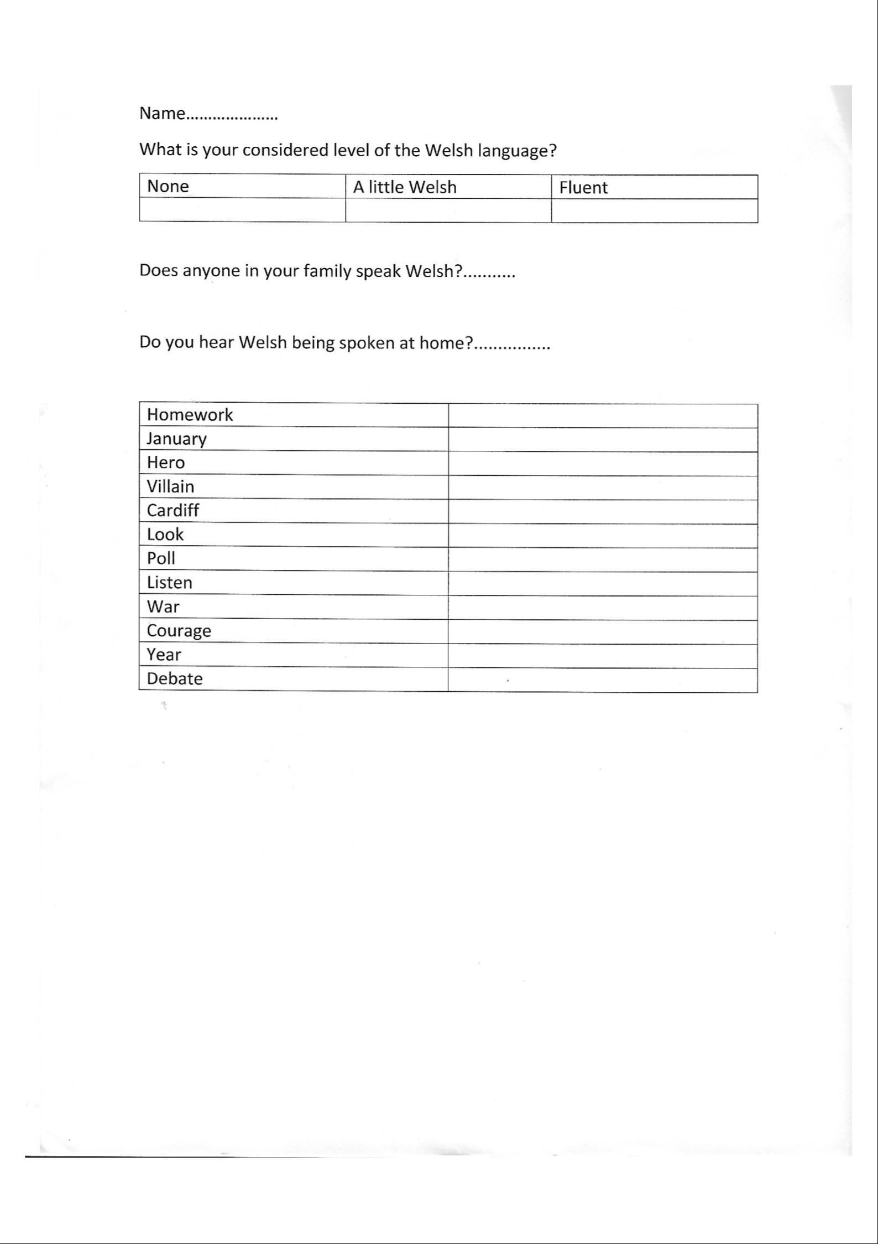

Appendix D – Pre-test of Pupil A
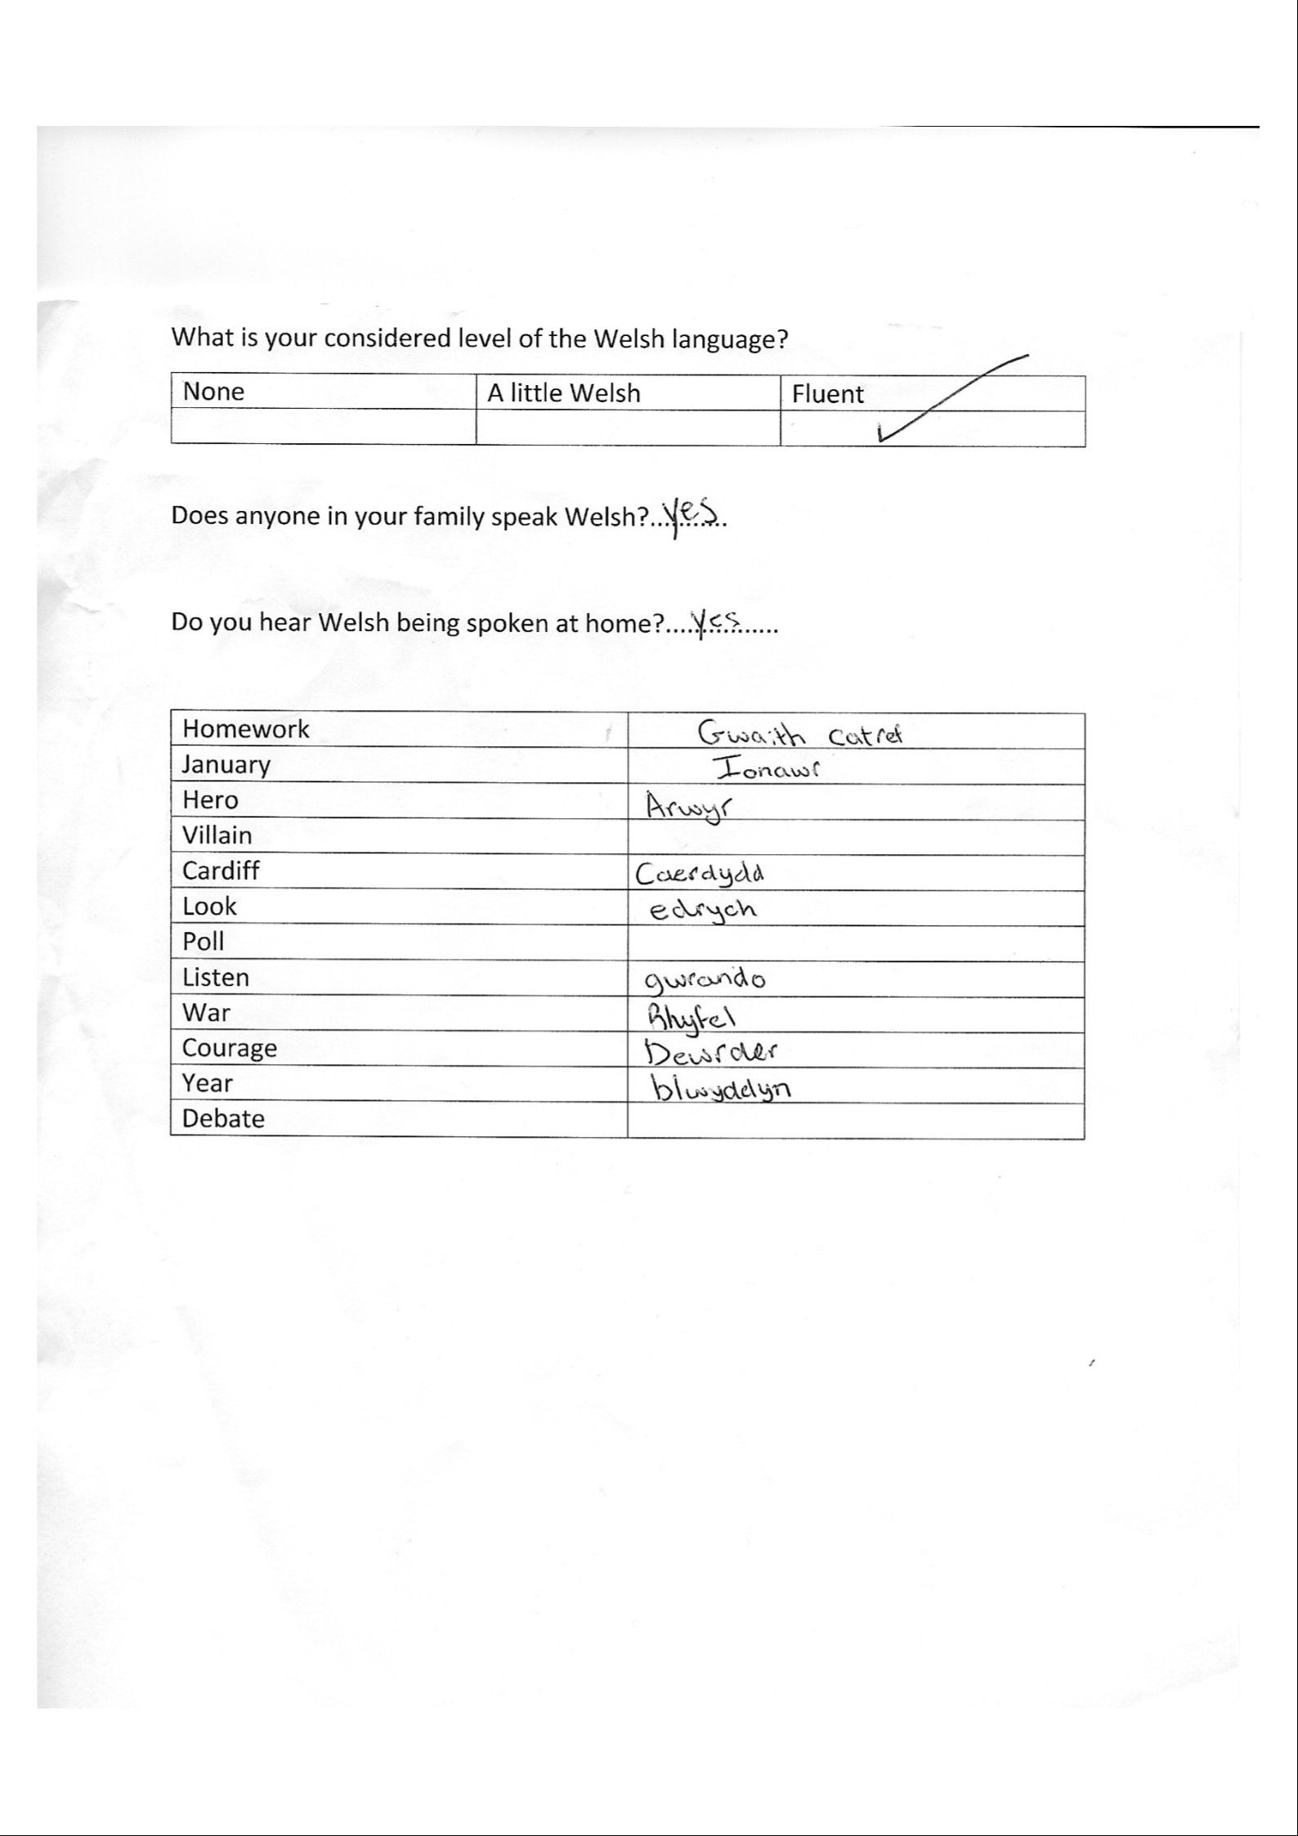

Appendix E – Post-test of Pupil B
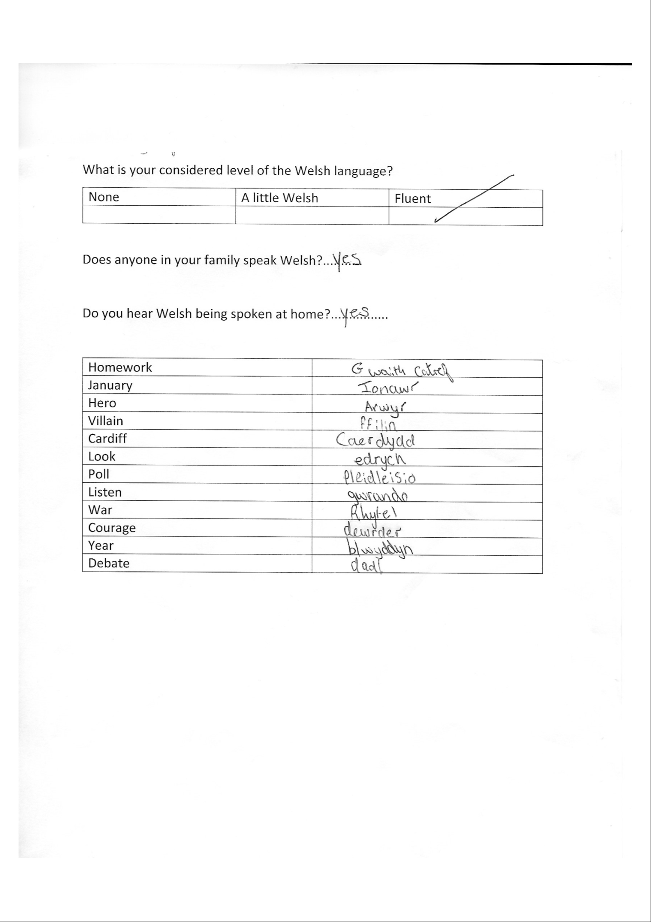

Appendix F – Sample of PowerPoint intervention



