MENU ENGINEERING

MODULE CODE: BMIH4002

LEVEL: 4

STUDENT NAME: PETRU PIRON
STUDENT ID: 2233575

Table of Contents
Part 1: Restaurant Concept 3
Theme 3
Target Audience 3
Justification of the Menu Selection 4
Pricing Strategy 4
References 5
Restaurant Concept 5
Picture Sources 5
Appendices 8
Appendix 1: Types of Allergens 8
Appendix 2: Menu 9

Part 1: Restaurant Concept

Theme
Trinity Hotel Chain intends to open a new restaurant concept. The new restaurant will be named as “The Saffron Crocus.” The idea of this new restaurant is to celebrate the vibrancy and strong flavours of Asian and Middle-Eastern cuisines. The menu at “The Saffron Crocus” will include a fusion menu with a variety of Indian, Persian and Arabic cuisines. An emphasis on the ambience and interior will be made to ensure that customers are able to enjoy an outstanding gastronomic experience.

Target Audience
"The Saffron Crocus" serves refined people with unusual tastes. Because they appreciate the depth and richness of Asian and Middle Eastern cuisines, these clients should be drawn to dining experiences that highlight vivid tastes and unusual culinary cultures. Foodies should be open-minded and appreciate authenticity in flavour and presentation (Tuorila and Hartmann, 2020). Fusion meals should appeal to the target audience. Customer targeting factors are listed below.
Factor | Description
Democratic | Age: 18 to 64 years  Gender: Everyone, irrespective of their gender  Income: 20,000 GBP annual income and above
Behavioural | Customers interested in café exploration activities are mostly targeted by this restaurant.
Psychographic | The targeted customers are likely to respect the culture and have an open mind in terms of exploring new fusion foods and cuisines.
Table 1: Targeted Customers for The Saffron Crocus

Justification of the Menu Selection
"The Saffron Crocus" intentionally mixes Arabic, Persian, and Indian cuisines. It serves numerous customers seeking unique dining experiences by capitalising on the worldwide fusion food trend. The restaurant uses unique flavours and culinary methods to stand out in a competitive restaurant market (Ellis et al., 2018). Herbs and spices loved for their flavour are abundant in the selected cuisines. Indian food has strong spices and many vegetarian options, while Persian and Arabic cuisines emphasise grilled meats and aromatic rice dishes (Sattarzadeh et al., 2023). This diversity ensures broad appeal to diverse preferences. The name and idea of the restaurant reference saffron, a rare and expensive spice, demonstrating its commitment to high-quality food and a sophisticated dining experience. Saffron is known for its rich flavour; saffron adds elegance and quality (Spence, 2023). Asian and Middle Eastern meals reflect modern culinary trends and meet the growing demand for robust, international flavours (Fan et al., 2021). It positions "The Saffron Crocus" as a rising star in this field, promising a memorable meal.

Pricing Strategy
"The Saffron Crocus" intends to become a popular 4-star Restaurant through the application of competitive cost. Maintaining competitive prices allows the restaurant to reach more customers, and manage customer loyalty (Pal and Aradhya, 2020). The restaurant also examines the COGS for each item before setting pricing to maintain at least a 60% gross profit margin.

References
Ellis, A., Park, E., Kim, S. and Yeoman, I., (2018). What is food tourism? Tourism management, 68, pp.250-263.
Fan, S., Teng, P., Chew, P., Smith, G. and Copeland, L., (2021). Food system resilience and COVID-19–Lessons from the Asian experience. Global Food Security, 28, p.100501.
Pal, S. and Aradhya, G.B., (2020). A Study on Challenges Faced by Restaurants to Maintain Quality Food with Competitive Pricing. Available at SSRN 3643790.
Sattarzadeh, N., Tsiami, A., Maxim, C. and Iordanova, E., (2023). Awareness and perceptions of ethnic restaurant managers towards authenticity and sensory strategies–A case study of Persian ethnic restaurants in London. International Journal of Gastronomy and Food Science, p.100679.
Spence, C., (2023). Saffron: The colourful spice. International Journal of Gastronomy and Food Science, p.100821.
Tuorila, H. and Hartmann, C., (2020). Consumer responses to novel and unfamiliar foods. Current Opinion in Food Science, 33, pp.1-8.
Valenta, R., Hochwallner, H., Linhart, B. and Pahr, S., (2015). Food allergies: the basics. Gastroenterology, 148(6), pp.1120-1131.
Arora (2023) Available at: https://shwetainthekitchen.com/mango-lassi/ (Accessed on: 10/11/2023)
Aysegul (2023) Available at: https://foolproofliving.com/grilled-shrimp-kabobs/ (Accessed on: 10/11/2023)
Glebe Kitchen (2023) Available at: https://glebekitchen.com/nihari-gosht-indian-beef-stew/ (Accessed on: 10/11/2023)
Thomas (2023) Available at: https://indiaphile.info/gulab-jamun-cheesecake/ (Accessed on: 10/11/2023)
Turkish Food Chef (2023) Available at: https://turkishfoodchef.com/hummus-humus/ (Accessed on: 10/11/2023)

Appendices

Appendix 1: Types of Allergens
Food allergens are certain proteins found in some specific food items, which might trigger the immune system, causing allergies. When these food items (allergens) are consumed, they might lead to allergic reactions, ranging from mild symptoms such as hives to life-threatening reactions, also called anaphylaxis.
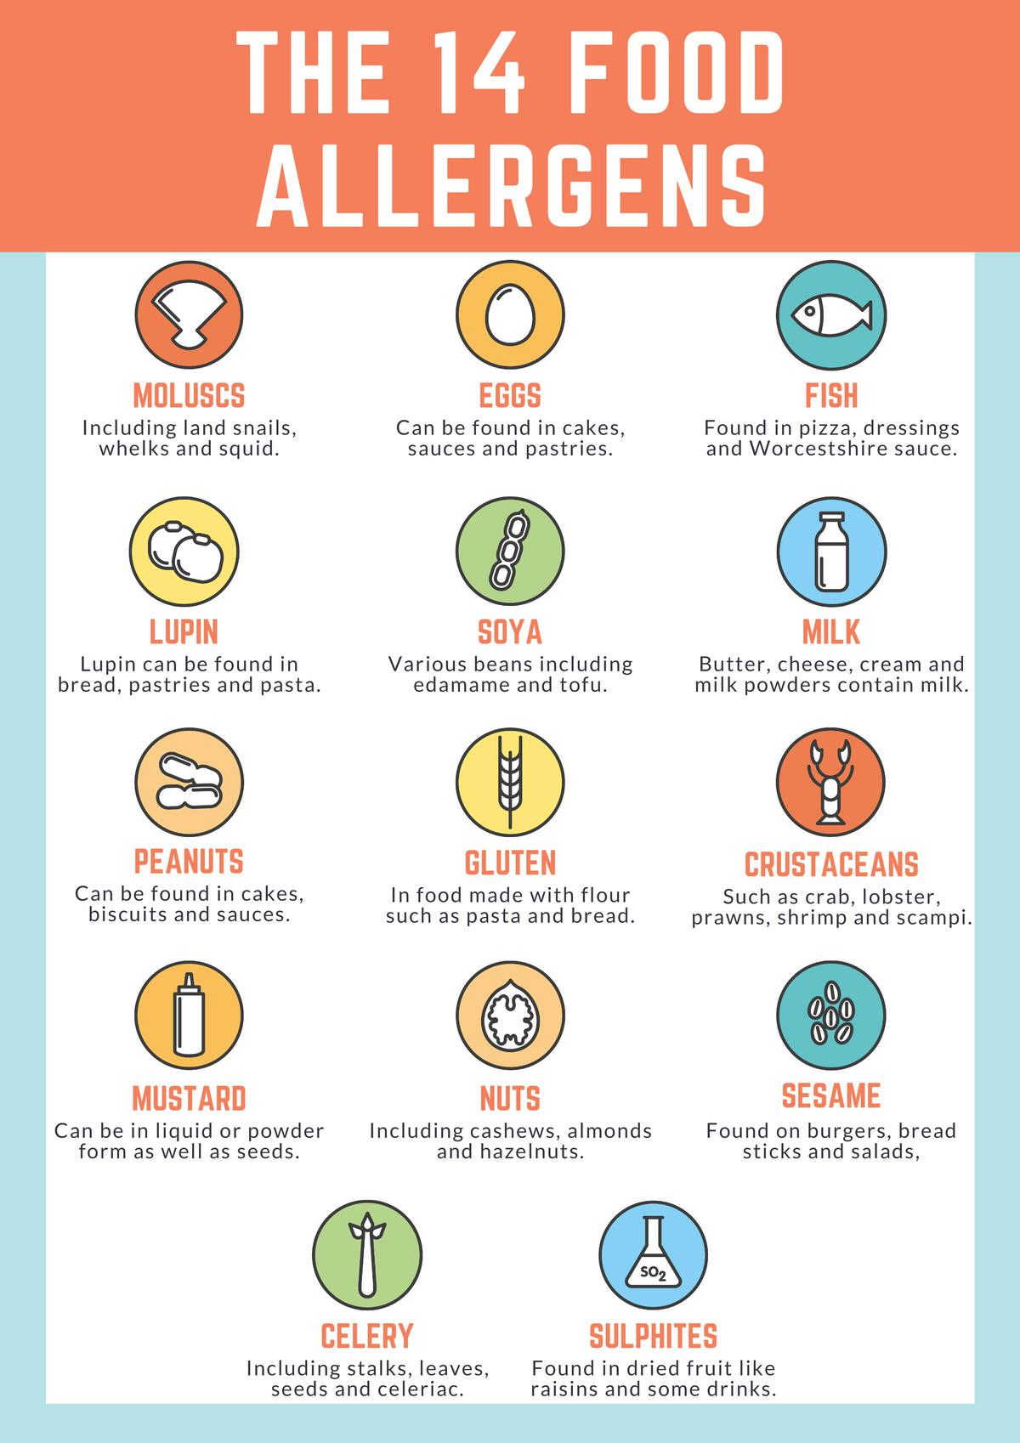
Figure 1: 14 Common Types of Allergens
(Source: Valenta et al., 2015)

Appendix 2: Menu


