
Caitlyn Moore
2318510
Abstract
Approved Document Z – Embodied and Whole Life Carbon: A proposed regulation for achieving Net Zero in the UK.
Embodied & Whole Life Carbon
The Building Regulations 2010
Approved Document Z
Volume 1
Table of Contents
Summary 1
1. Introduction 2
2 Frameworks 3
2.1 Existing Frameworks 3
2.2 Lessons for Regulation 3
3 Existing Regulations 4
3.1 Review of Existing Building Regulations 4
3.2 Introducing Part Z – Embodied Carbon 5
4 Approved Document Part Z Proposal 5
4.1 Title and Scope 5
4.2 Key Components 5
5 Implementation 6
.1 Pilot Phase (2025-2030) 6
5.2 Mandatory Reporting (2030-2035) 6
5.3 Full Compliance (from 2035) 6
5.4 Supporting Actions 7
6 How the Proposed Regulation Achieves Net Zero 7
7 Reporting 8
8 Requirements for Building Control Sign-off 9
9 Conclusion 9
References 10

Summary
The UK construction industry must achieve Net Zero by 2050 under national climate policy. Existing regulations especially Parts L and A address operational carbon but leave embodied and whole life carbon unregulated. This gap has gained significance as embodied emissions now represent a substantial proportion of a building’s lifetime footprint.
This document outlines a proposal for a new Building Regulation, Part Z focused on embodied carbon and whole life performance. The proposal touches on established frameworks such as BREEAM, Passivhaus, LETI, the AECB Standard and UKGBC guidance. Part Z introduces whole life carbon assessments, low carbon material requirements and staged reporting aligned with the UKs Net Zero 2050 Pathway.

Introduction

Context
The UKs commitment to Net Zero by 2050 is embedded in the climate change act 2008 reinforced by successive carbon budgets and international agreements. As of 2025, the construction industry is responsible for approximately one quarter of the national greenhouse gas emissions which rises to 42% if transport associated with construction is included. This makes the sector a critical focus for decarbonisation.
While operational carbon has gradually decreased due tp grid decarbonisation and improved energy standards embodied carbon from the manufacture, transport, installation, replacement, and disposal of building materials has become more significant. Current Welsh Building regulations do not yet provide requirements or limits for embodied carbon, resulting in inconsistent practice across the industry. the purpose of this proposal is to introduce regulatory mechanisms to address those emissions. (Business in the Community , 2025)

1.2 Defining Net Zero
Net Zero refers to achieving a balance between greenhouse gas emissions produced and those removed from the atmosphere. In practice this requires rapid emissions reductions across all sectors, including buildings along with limited carbon removals to offset residual emissions. Because embodied emissions occur before a building is occupied and cannot be offset through improved energy performance later, regulatory intervention is required to ensure buildings constructed today are aligned with long term carbon targets. (Mark Poynting, 2025)

1.3 Construction Sector Response
The construction industry is working towards achieving Net Zero emissions by 2050, the main focus on decarbonisation in the industry has been on operational emissions and energy efficiency in buildings. Embodied carbon is extremely challenging in the construction industry which is becoming a focus point for policy.
The industry is trying to move towards using recyclable materials, modern methods of construction such as off-site manufacturing to reduce waste. The industry is also incorporating digital technologies such as BIM, carbon modelling and passive design approaches.
However, despite progress the UK building regulations remain focused on operational performance and do not yet cover whole-life or embodied carbon assessment. To address this gap this report proposes the development of a new regulatory framework Part Z to embed whole life carbon regulation across the whole construction industry. (Business in the Community , 2025)

Frameworks
2.1 Existing Frameworks
BREEAM (Building Research Establishment Environmental Assessment Method) is a widely used sustainability assessment. Its holistic scope covers energy, water efficiency, materials, waste, ecology and health and wellbeing. BREEAM has pushed to normalize environmental performance assessments and encourages designers to consider whole-building sustainability at early deign stages. (BREEAM, N/D)
Passivehaus originated in Germany, but it has widely spread across the UK. It is very focused on achieving very low operational energy demand, it sets limits on space heating requirements, airtightness and thermal performance which results in buildings that use up to 75-90% less heating energy compared to UK new builds. Passive Haus proves that what is achievable when design is driven by energy performance rather than regulatory requirements. (Passivehaus Trust, 2025)
LETI (The London Energy Transformation Initiative) is a network made up of over 1000 voluntary construction professionals who work together to put the UK on the road to a zero-carbon future. LETI has influenced industry expectations in relation to carbon reductions and they also provide Whole Life Carbon Assessments. (LETI, 2017)
The UK Green Building Council (UKGCB) is a membership led network that plans to transform the sustainability of the construction industry by transforming the way things are planned, designed, constructed, maintained, repurposed, and operated. (UKGBC, N/D)
Association for Environment Conscious Building (AECB) is the largest and oldest network for sustainable building that has been running since the 1980s. the network provides practical and evidence-based criteria for construction projects. (AECB , N/D)

2.2 Lessons for Regulation
All the above frameworks demonstrate levels of precision and transparency that exceed current building regulations. While part L sets minimum energy efficiency requirements, frameworks such as Passivhaus and AECB provide stricter performance targets that are supported by measurable outcomes such as airtightness testing. BREEAM and UKGBC place strict emphasis on materials, embodied carbon, and lifecycle analysis whilst Building Regulations currently offer limited guidance. LETI sets a clear embodied carbon target which fills a gap that has been missed by mandatory regulations.

Existing Regulations
The current Building Regulations ensure safety, structural stability, and energy efficiency. However, when they are compared against Zet Zero requirements numerous gaps come to surface, particularly around whole-life and embodied carbon. A thorough review of relevant Welsh Building Regulations highlight the need for more comprehensive and future proof approved documents.

Review of Existing Building Regulations

Part A – Structure
Part A provides information on the structural requirements needed to ensure that buildings can safely withstand applied loads such as gravity, wind and imposed use. Although these standards are informative from a structural point of view the regulation currently does not cover the environmental implications associated material choices. High carbon structural materials such as steel and concrete significantly contribute to embodied carbon in new builds and refurbishments.
Part A requires a shift towards low carbon structural solutions to align with Net Zero and they could potentially include:
- Mandatory embodied carbon reporting for primary structural materials which will benefit design.
- Prioritizing low carbon alternatives such as timber, low carbon concrete and reused steel.
- Ensure that structural systems support future disassembly to allow the materials to be reused.
Integrating the above measures would allow Part A to align with Net Zero to continue providing guidance on structural integrity whilst taking into consideration the carbon reductions. (Welsh Government, 2017)

Part L – Conservation of Fuel and Power
The Welsh Government updated Part L (2022) to improve energy and carbon performance in new and existing buildings, which include improved fabric standards, lower carbon emissions, and mandatory air tightness testing. The changes show progress however Part L is still focused on operational energy which leaves embodied carbon unregulated. Operational emissions continue to decline due to grid decarbonization, embodied carbon becomes a large proportion of total lifetime emissions. (Welsh Government , 2025)

To align Part L with Net Zero, further information should include:
- Mandatory whole life carbon assessments covering both upfront and in use carbon.
- Updated u-values consistent with best practice standards such as Passivehaus and the AECB energy standard.
- Tighter airtightness testing to reduce heat loss and requirements for ventilation strategies.
- Fabric performance to ensure building envelopes achieve high thermal performance before renewable technologies are considered.
- Material efficiency and circularity considerations reducing waste and promoting low carbon construction methods.
Adding further information to Part L would ensure that operational and embodied emissions are addressed to support Wales’s transition to a low-energy and low carbon-built environment. (Welsh Government , 2025)

Introducing Part Z – Embodied Carbon
Embodied carbon represents 20-50% of building life cycle emissions and contributes a major gap in regulations. Both LETI and UKGBC recommend mandatory embodied carbon reporting across the UK by 2028. Introducing a specific Part Z would provide a clear regulatory mechanism for addressing these emissions.

Approved Document Part Z Proposal

4.1 Title and Scope
Approved Document Part Z – Embodied Carbon and Whole Life Performance
(To be read alongside Parts L and A of the Building Regulations)
Approved Document Z proposes a new regulatory mechanism to address the currently unregulated but increasingly significant issue of embodied carbon and whole life environmental impacts in Wales. It applies to new buildings and major refurbishments, with mandatory requirements for developments. The document aims to create a regulatory framework aligned with Net Zero commitment by 2050.

4.2 Key Components
Part Z introduces requirements across design, construction, and operational phases to ensure robust and transparent carbon assessment.

Design Stage – Digital Carbon Tools
Development teams must use approved WLCA tools during RIBA stages 2-4 to calculate upfront and whole life impacts. Early modelling informs decisions on materials, and energy system.

Material Selection – Low Carbon Procurement
A new Embodied Carbon Product register will catalogue compliant low carbon materials suitable for Welsh construction. Products must demonstrate verified environmental data, prioritizing FSC certified timber, low cement concrete, recycled steel, biogenic materials, and reclaimed components.

Construction Stage – Monitoring and Reporting
Contractors must record site energy consumption, fuel use, transport logistics and waste. This data informs the final WLCA submitted at completion and expands accountability across the supply chain.

Post Occupancy Verification
Within two years of completion buildings must undergo a performance evaluation to assess operational energy, indoor environment quality and maintenance impacts. This addresses the performance gap common in UK buildings.

Implementation
Introducing Part Z requires a phased approach to ensure industry readiness, supply chain capacity and meaningful carbon reduction outcomes. The proposed implementation strategy consists of three stages.

Pilot Phase (2025-2030)
During this initial voluntary phase, Part Z would be adopted by major developers operating in Wales – such as Landsec, British Land and Welsh public-sector regeneration bodies. Local authorities would be encouraged to request WLCA submissions for major planning applications, providing early evidence on feasibility, cost impacts and baseline performance across different building types. This period would support capacity building within design teams and contractors, enabling them to become familiar with carbon modelling tools and low-carbon procurement processes.

5.2 Mandatory Reporting (2030-2035)
From 2030 WLCA becomes mandatory requirements as planning submissions for all buildings over 1000m2 GIA. Although carbons caps would not yet be f=enforced, full lifecycle reporting ensures the Welsh government can collect robust market data to refine future carbon limits. Digital submission platforms – integrated with EPC database would allow transparent verification and reduce administrative burdens.

Full Compliance (from 2035)
By 2035 legally blinding carbon intensity caps would apply to all relevant developments supported by enforcement mechanisms like those used in Part L compliance. Developers must demonstrate that projects meet embodied and whole-life carbon limits before completion certificates are issued.

Supporting Actions
- Nationwide training programmed for architects, engineers and contractors.
- Government incentive to accelerate uptake of low carbon materials and MMC.
- Investment in digital verification systems enabling automated WLCA checking and real-time carbon benching.
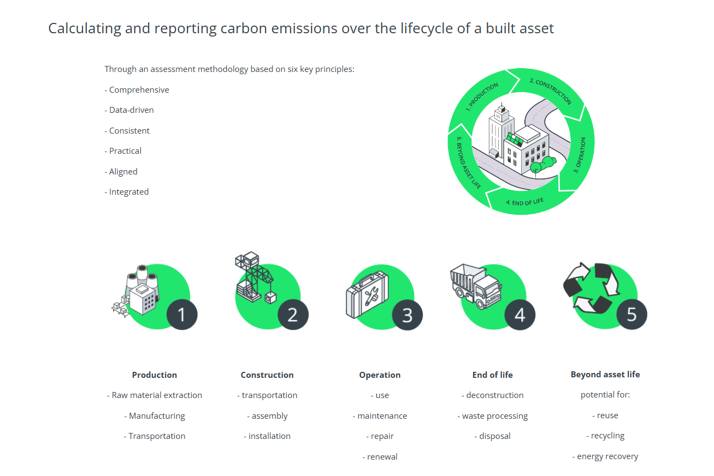 (RICS, N/D)

6 How the Proposed Regulation Achieves Net Zero
The introduction of Approved Document Part Z directly targets the emissions currently unaccounted for under Welsh Building Regulations mainly embodied and whole life carbon emissions. By addressing whole life carbon assessments in line with UKGBC and LETI guidance the regulation ensures that both upfront carbon A1-A5 and operational carbon B1-B7 are calculated and progressively reduced. Aligning operational threshold with Passive Haus standards reduces energy demand which enables buildings to achieve Net Zero Ready status when paired with onsite renewable generation as recommended in the future Wales strategy and the UK Net Zero Strategy.
By integrating circular construction, recycled requirements, renewable integration, low carbon material procurement the regulations reduce lifecycle emissions sufficiently for Welsh buildings to align with Net Zero by 2050.

Calculation
To accurately quantify embodied carbon a standardized calculation process must be followed. The first step is to determine the quantity of each material used within the building. This requires establishing the material volume which is calculated by multiplying the thickness by the area it covers. Once the total material volume is known it is combined with verified carbon factors. These carbon factors represent the emissions associated with stages A1-A3 of the lifecycle Raw material extraction, processing, and manufacturing.
This process should be repeated for all materials within a building to generate the total upfront embodied carbon.
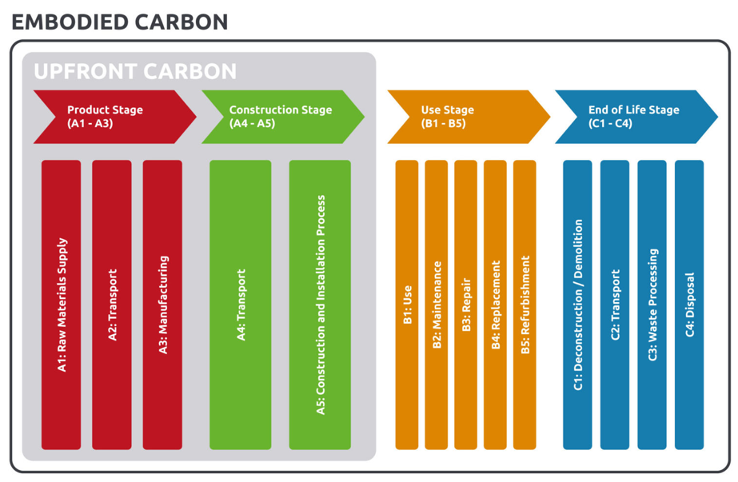

7 Reporting

Design Stage RIBA 2-4
- WLCA submitted using tools such as one click.
- Embodied carbon values benchmarked against mandatory limits.
- Submissions of low carbon material schedules and recycled content declarations.
- Energy modelling via SBEM or DSM to demonstrate compliance with Part L.

Construction Stage RIBA 5
- Contractors submit verified site energy logs, transport distances and waste audits.
- Updated WLCA including A4-A5 emissions.
- Photographic evidence and digital material passports uploaded to a national Part Z database.

Completion Stage RIBA 6
- Final WLCA
- EPC, airtightness tests and ventilation commissioning.
- Post occupancy evaluation plan.
The above aligns with the report-verify-publish model used in the London Plan 2021 and UKGBC reporting guidelines. (Lilly Lewarne Architects, 2025)

8 Requirements for Building Control Sign-off
Building control sign off will only be granted when the below documentation is provided:

8.1 Mandatory Documents
- Final whole life carbon assessments demonstrating compliance with Part Z carbon caps.
- Material procurement evidence to show FSC certification, EPDs and recycled content declarations.
- Construction Stage emissions report t includes site fuel use, transport logs and waste management summary.
- Operational performance documentation such as EPC, SBEM outputs.
- Airtightness test certificates
- Renewable energy verification showing regulated energy is met by low carbon.

8.2 Post completion Requirements
Post occupancy evaluation at year 2 must be scheduled and funded though signoff occurs before POE delivery.
The structure mirrors existing compliance mechanisms for Part L and the London Energy Transformation initiative but with whole life carbon accountability embedded.

Conclusion
Current Building Regulations remain insufficient although they have been progressed over the years, they still do not directly address the issue to meet the Net Zero 2050 target. There is no set regulation in place that addresses embodied carbon and current regulations briefly touch whole life performance which means a vast number of emissions are left unaddressed. The introduction of Part Z combined with enhanced requirements to Part L, F, O and V will provide a comprehensive framework to manage both operational and embodied carbon. The integrated approach ensures that buildings are designed and constructed in a consistent manner with all principles considered such as energy efficiency and long-term resilience. The proposed framework will ensure that sustainability is embedded into the built environment and ultimately these measures will ensure that all new buildings contribute to the Net Zero Pathway.

References
AECB , N/D. AECB Building Knowledge. [Online]
Available at: https://aecb.net/
[Accessed 24 November 2025].
BREEAM, N/D. A Guide to how BREEAM Works. [Online]
Available at: https://breeam.com/about/how-breeam-works
[Accessed 24 November 2025].
Business in the Community , 2025. The Construction Sector and Net Zero , N/A: Business in the Community .
Environment Accounts Team, 2025. Greenhouse Gas Emissions, UK: provisional estimates 2024. [Online]
Available at: https://www.ons.gov.uk/economy/environmentalaccounts/bulletins/greenhousegasintensityprovisionalestimatesuk/latest
[Accessed 24 November 2025].
LETI, 2017. About LETI. [Online]
Available at: https://www.leti.uk/about
[Accessed 24 November 2025].
Lilly Lewarne Architects, 2025. RIBA Stages Explained. [Online]
Available at: https://lillylewarne.co.uk/riba-stages-explained/
[Accessed 06 December 2025].
Mark Poynting, 2025. What is Net Zero and is the UK on track to achieve it?, s.l.: BBC.
Mark Poynting, n.d. What is Net Zero and is the UK on track to achieve it?, s.l.: s.n.
Passivehaus Trust, 2025. What is Passivehaus?. [Online]
Available at: https://www.passivhaustrust.org.uk/what_is_passivhaus.php
[Accessed 24 November 2025].
RICS, N/D. Whole Life Carbon Assessment (WLCA) for the built environment, s.l.: RICS.
UKGBC, N/D. About UKGBC. [Online]
Available at: https://ukgbc.org/about/
[Accessed 24 November 2025].
Welsh Government , 2025. Building Regulations Part F. [Online]
Available at: https://www.gov.wales/sites/default/files/consultations/2025-08/approved-document-f-vol-1-consultation-version.pdf
[Accessed 24 November 2025].
Welsh Government , 2025. Building Regulations Part L. [Online]
Available at: https://www.gov.wales/building-regulations-part-l-2025-review
[Accessed 24 November 2025].
Welsh Government, 2025. Building Regulations - Approved Document F. [Online]
Available at: https://www.gov.wales/building-regulations-part-l-2025-review
[Accessed 24 November 2025].

