A Comparative Study of Myth in Horror Cinema
GuanYu Chen
2502779

Research-Led Practice
2026.5.11

Declaration
I declare that this work is my own and has not been submitted in substantially the same form for the award of a higher degree elsewhere. All sources of information used in this dissertation have been acknowledged in accordance with academic conventions.

I confirm that this work has not been copied, in whole or in part, from any other source except where properly referenced. Any ideas, quotations, or data taken from other authors have been clearly cited and referenced.

I understand that plagiarism and other forms of academic misconduct are treated seriously by the University and may result in disciplinary action.

Certificate of Authenticity
I certify that this submission is entirely my own work and that I have not engaged in any form of academic misconduct, including plagiarism or collusion.

All sources of information, including ideas, data, and quotations from other authors, have been fully acknowledged and referenced in accordance with the required academic conventions.

I confirm that any use of artificial intelligence (AI) tools in the development of this work has been carried out in accordance with University guidelines and has been appropriately acknowledged where applicable.

I understand that any breach of academic integrity regulations may result in disciplinary action in accordance with University policies.

Abstract
This study explores the role of myth in shaping horror cinema through a comparative analysis of Silent Hill (2006) and the Chinese film Zhong Xie (2016). While both films draw upon mythological frameworks, they emerge from distinct cultural contexts and employ different strategies to construct fear.

The research examines how Western religious mythology, particularly themes of judgment, sin, and hell, informs the psychological and symbolic horror in Silent Hill. In contrast, Zhong Xie draws upon Chinese rural folk beliefs, ritual practices, and spirit possession to create a form of horror grounded in realism and lived cultural experience.

Through analysis of mythological symbolism, psychological horror theory, ritual studies, and socio-cultural context, this study identifies key differences in how fear is generated across cultures. It argues that Silent Hill externalises internal guilt through symbolic and abstract systems, whereas Zhong Xie presents myth as an active and socially embedded belief system.

Ultimately, this research demonstrates how myth functions not only as a narrative device, but as a culturally specific framework for expressing fear, belief, and human psychology in horror cinema.

CONTENTS PAGE

Introduction
Myth has long played a central role in the construction of horror narratives, providing symbolic frameworks through which fear, belief, and the unknown can be explored. In cinema, myth is frequently adapted and reinterpreted to reflect cultural values, psychological anxieties, and social structures. Horror films often use myth not only as narrative material, but also as a way of shaping atmosphere, symbolism, and audience perception.
This study presents a comparative analysis of Silent Hill (2006) and Zhong Xie (2016), two horror films that approach myth and fear through different cultural traditions. Silent Hill draws heavily upon Christian symbolism, guilt, and psychological horror, while Zhong Xie is grounded in Chinese folk belief, ritual practice, and rural supernatural traditions. Although both films engage with mythological structures, they differ significantly in their representations of fear, narrative strategies, and cultural foundations.^{【1】}
In addition to textual analysis, this research also informs the development of an original creative practice project titled Beyond the Veil. Inspired by the comparative study of Silent Hill and Zhong Xie, the project combines psychological horror with Chinese ritual horror to explore themes of trauma, memory, and inherited belief through visual storytelling.

2. Research Framework
The aim of this research is to examine how myth operates across different cultural contexts and how these differences influence cinematic constructions of horror. Through the analysis of themes including ritual, psychological fear, religion, and socio-cultural belief systems, the study explores how audiences experience fear in relation to mythology and cultural identity.^{【2】}
In addition to textual analysis, this research adopts a research-led creative practice approach through the development of an original horror project titled Beyond the Veil. The project functions as a practical exploration of myth, ritual, and psychological horror informed by the comparative analysis of Silent Hill and Zhong Xie.

3. Theoretical Framework

3.1 Myth and Narrative
Myth provides a foundational structure for storytelling, often expressed through archetypes, symbolic imagery, and transformation. As discussed by Joseph Campbell, mythic narratives follow recurring patterns that continue to influence contemporary film.^{【3】}

3.2 Psychological Horror and the Uncanny
Psychological horror focuses on internal fear and uncertainty. Sigmund Freud introduces the concept of the “uncanny”, describing the discomfort caused by something that is both familiar and unfamiliar. This concept is central to understanding how horror operates in Silent Hill.^{【4】}

3.3 Ritual and Cultural Belief
Ritual plays a crucial role in reinforcing belief systems. In many cultural contexts, ritual acts as a bridge between the human and supernatural world, making myth tangible and experiential. This is particularly relevant in analysing Zhong Xie.

4. Case Studies: Myth and Horror in Silent Hill (2006) and Zhong Xie (2016)
4.1 Mythological Frameworks
Both Silent Hill (2006) and Zhong Xie (2016) construct their horror through mythological systems, yet the nature of these systems differs significantly.
In "Silent Hill", the imagery of the church and the industrialized scenes visually reinforce the Christian concepts of punishment and moral corruption. The pyramid head is not only a monster but also symbolically represents evil and violence.^{【5】}
In contrast, Zhong Xie draws upon Chinese folk beliefs, where myth exists as part of everyday life. The presence of spirits, possession, and supernatural forces is not purely symbolic, but culturally embedded and treated as a plausible reality within the narrative.
Element | Silent Hill | Zhong Xie
Source of Fear | Psychological guilt | Ritual belief
Myth Type | Fictional | Lived folk mythology
Setting | Fragmented fictional town | The rural environment of China
Horror Mechanism | Uncanny creatures | Spirit possession
Visual Style | Decayed town | Documentary realism

Whereas Silent Hill externalises fear through symbolic creatures and psychological fragmentation, Zhong Xie generates horror through culturally familiar rituals and realistic environments. This contrast demonstrates how Western horror often internalises fear, while Chinese horror situates fear within collective belief systems.
4.2 Construction of Fear
The two films employ different mechanisms to generate fear.
Silent Hill primarily relies on psychological horror. Fear emerges from internal guilt and the confrontation with one’s own moral failings. The use of distorted, semi-human creatures creates an uncanny effect, destabilising the viewer’s perception of reality.
By contrast, Zhong Xie constructs fear through realism and cultural familiarity. The horror is grounded in everyday settings, where ritual practices and belief in spirits create a sense of immediacy. Rather than abstract fear, the audience experiences a form of terror that feels socially and culturally tangible.
These two completely different approaches to dealing with fear directly influenced the sources of inspiration during the creation of the work. The psychological atmosphere and symbolic creature designs created in "Silent Hill" provided a basis for the project to adopt distorted visual images, while Zhong Xie inspired the incorporation of ritualistic activities and supernatural elements with cultural background.
4.3 Body, Ritual, and Representation
"Silent Hill" creates a terrifying world through a grotesque and religious visual style. In terms of imagery, it features triangular heads, nurse monsters, and burned bodies to form a hellish body image; photography extensively uses wide-angle lenses, fog, and special effects spaces to create a sense of a maze; scene choreography often includes religious gatherings, monster chases, and multi-level space transitions, intensifying the sense of oppression; colors are mainly gray, dark red, and rust tones, representing decay and evil; lighting uses high-contrast light and flickering lights to create a creepy atmosphere; costumes are predominantly gothic and religious, highlighting the sense of alienation; camera movements extensively use tracking shots, rapid advances, and surround shots to enhance the gaming experience; the sound uses industrial noises, alarm sounds, and sharp music to create a continuous sense of tension. The core of the entire film is to present visualized hellish horror in the context of religious judgment and body alienation.^{【6】}
"Believing in Evil Spirits" presents the terrifying events in rural Chinese villages in a documentary-style of authenticity. In terms of imagery, the subjects are mostly ordinary villagers, patients, and witch doctors, without any monster-like designs. However, the authenticity makes it even more depressing. The photography adopts a handheld DV style and low-cost documentary shots, enhancing the sense of reality. The scene arrangement mainly focuses on the narrow rural spaces and the process of exorcism rituals, featuring a life-like characteristic. The colors are mainly earthy yellow, gray-green, and dark tones, presenting the atmosphere of a dilapidated village. The lighting mostly uses natural light, bulb light, and flashlight light, creating a realistic night texture. The costumes are very ordinary, mainly consisting of rural clothes and traditional robes, strengthening the documentary feel. The camera movement is slow and has a shaky effect, resembling a real filming of events. The sound largely retains wind sounds, insect chirping, incantations, and environmental noises, creating psychological horror through silence and pauses. The film showcases the superstition and spiritual fear in the real society through folk rituals and the actual physical state.^{【7】}
4.4 Space and Reality
Spatial construction further differentiates the two films.
Silent Hill creates a fictional, fragmented world that reflects psychological states. The environment is unstable and constantly shifting, reinforcing the idea of internalised fear.
In contrast, Zhong Xie is set within a recognisable rural environment. The use of real locations and documentary-style filming reduces the distance between fiction and reality, making the horror more believable and immersive.^{【8】}
4.5 Summary
While both films utilise myth as a foundation for horror, their approaches differ fundamentally. Silent Hill operates through abstraction, symbolism, and psychological projection, whereas Zhong Xie presents myth as a lived and culturally embedded reality.
These comparative findings informed the visual and thematic development of Beyond the Veil, particularly in relation to ritual imagery, environmental storytelling, and psychological symbolism. The project combines elements of symbolic horror inspired by Silent Hill with culturally grounded ritual practices influenced by Zhong Xie to create a hybrid form of horror representation.

5. Discussion
Western and Chinese horror films reflect different cultures' understanding of fear. Western horror films emphasize religion, monsters, and physical alienation, while Chinese horror films focus more on folk superstitions, family ethics, and psychological repression. Horror films are not just entertainment; they are also a form of cultural expression. Mythology can influence the audience because it originates from long-term cultural memories and collective imagination. Whether it's demons, hell, ghosts, or exorcism, these familiar myths make it easier for the audience to experience real fear and emotional resonance. Globalization has allowed horror films from different countries to blend together. Eastern films have influenced the psychological horror style of Western films, and Western films' special effects and visual styles have also influenced Asian horror films, forming cross-cultural horror expressions. In the future, horror films will become increasingly integrated, combining Eastern folk customs, Western special effects, and global narratives. However, truly successful horror films still need to retain their local cultural characteristics to allow the audience to have a real emotional connection.^{【9】}
These insights are particularly relevant for projects exploring myth, transformation, and the unknown, supporting the development of layered and culturally informed storytelling.

Creative Practice: Beyond the Veil
6.1Narrative and Myth
"Beyond the Veil" is an original horror short film that combines psychological horror with elements of Chinese folk rituals. It tells the story of Lin Ran, an art college student who has been avoiding her family and childhood memories for a long time. After her grandmother's death, she returns to the remote old house in the countryside to deal with the belongings, but gradually gets involved in an ancient ritual about the "boundary between the living and the dead". Her grandmother was the person in charge of the "Crossing the Veil" ritual in the village, and people believed that this ritual could help the souls of the deceased cross the "veil" between the two worlds during the first seven days. After returning to the old house, Lin Ran discovers hidden talismans behind the mirror, burned family photos, and incomplete ritual masks, and begins to experience a series of inexplicable phenomena: the reflections in the mirror move out of sync, footsteps can be heard from the empty building, the space of the house keeps twisting, and even the reality and dreams gradually become indistinguishable. As the investigation deepens, she gradually recovers her forgotten childhood memories and learns that she participated in the "Crossing the Veil" ritual when she was a child. In that ritual, a part of her consciousness seemed to remain "behind the veil". In the end, on the ritual space of the seventh-day ceremony, Lin Ran must make a choice: completely close the veil that connects the real world and the spiritual world, at the cost of losing all memories of her family and the past; or cross the veil and stay in another world forever. The film combines the psychological oppression style of "Silent Hill" with the folk ritual horror in "Zhong Xie" to explore how grief, trauma, memory, and inherited beliefs together constitute fear, and transforms the myth from an abstract symbol into a "living cultural experience".
Explanation：In Chinese culture, it is believed that the deceased will return to the world after death on the seventh day to complete the unfinished tasks they had before their death.
6.2 Visual Development
The visual style influence of "Silent Hill" on "Beyond the Veil" mainly lies in the psychological horror and oppressive atmosphere. The work incorporates elements such as fog, enclosed spaces, industrial rust, distorted human bodies, and low lighting. Through cold tones, shadowy spaces, and slow camera movements, it portrays the inner fears and mental collapse of the characters.^{【10】}
The influence of the supernatural theme mainly stems from Chinese folk horror and realistic styles. The work incorporates elements such as incense, talismans, exorcism rituals, rural old houses, and handheld cameras, making the supernatural phenomena more relatable to daily life, enhancing the sense of ritual and reality, and creating a documentary-style psychological horror atmosphere.
The core visual symbols of "Beyond the Veil" include mirrors, curtains, ritual masks, ashes and talismans. The mirror symbolizes the fragmentation of identity and psychological disintegration; the curtain represents the boundary between the real world and the spiritual realm; the ritual mask embodies ancestral beliefs and repressed spiritual memories; the ashes and talismans enhance the cultural authenticity and mystery of ritual horror.
6.3 Prototype / Storyboard
Scene One: Returning to the Old House
The protagonist entered the abandoned old house for the first time.
Visual Design:Narrow corridor Dim lighting Mold stains on the walls Dust particles in the air
Objective: Establish a realistic and restrained atmosphere.
The picture was generated by AI.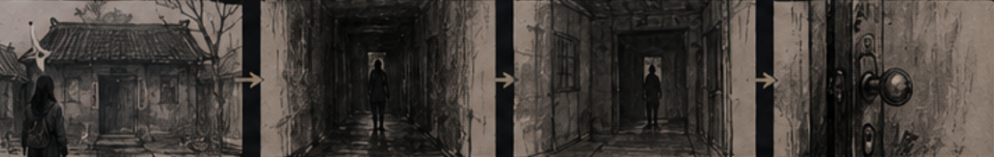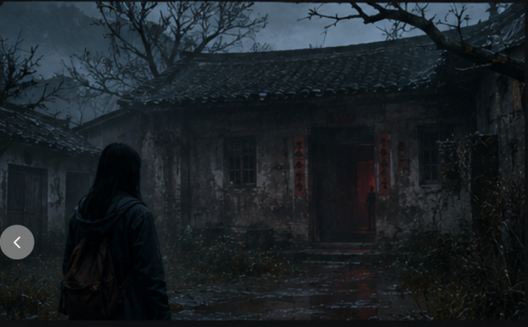
Scene Two: Mirror Displacement
The protagonist noticed that the movements in the mirror image were not synchronized.
Visual Design:Fixed Shot Slow Delayed Action Abnormal Breathing Sound Dark Background
Purpose: Create the "uncanny effect" as described by Freud.
The picture was generated by AI.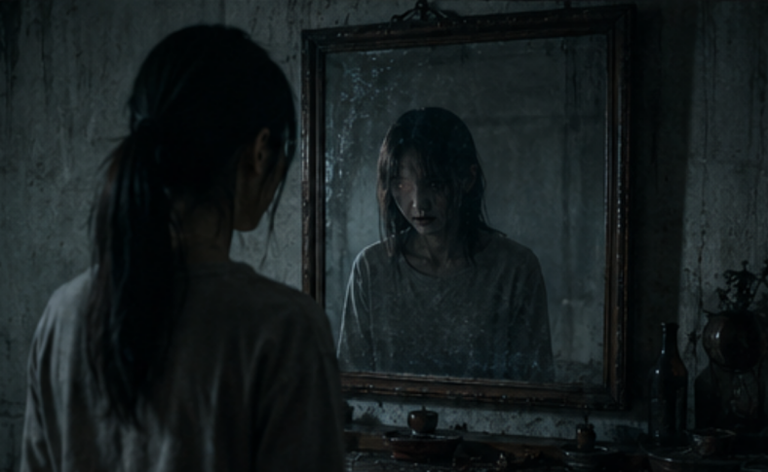
Scene Three: Ritual Space
The protagonist discovers the hidden ritual room.
Inclusions:Spell charm Ash from incense Sacrificial photos Red curtain Ritual mask
Purpose:
Strengthen the imagery of Chinese folk horror.
The picture was generated by AI.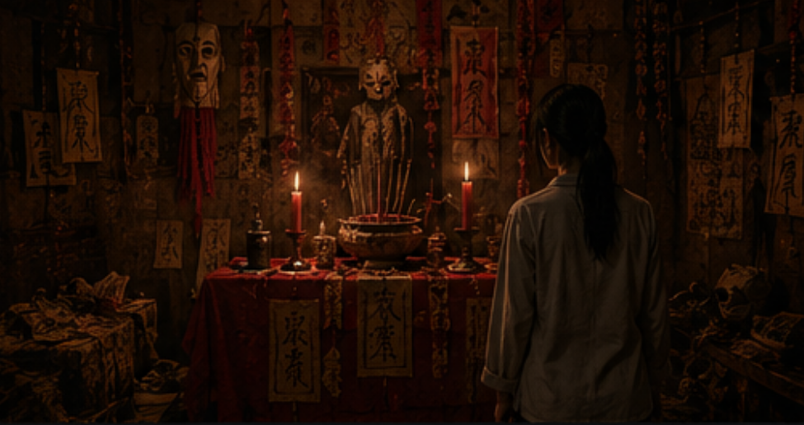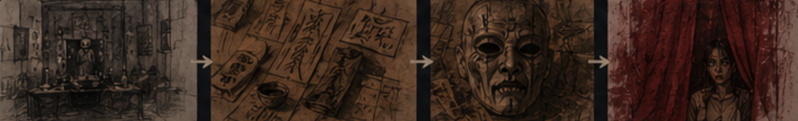
Scene Four: Crossing the Veil
The final ritual sequence (the climax of the ceremony).
Visual Design: Red lights Smoke Distorted space Fast editing chanting sound
Objective: Integrating psychological horror and ritual horror.
The picture was generated by AI.
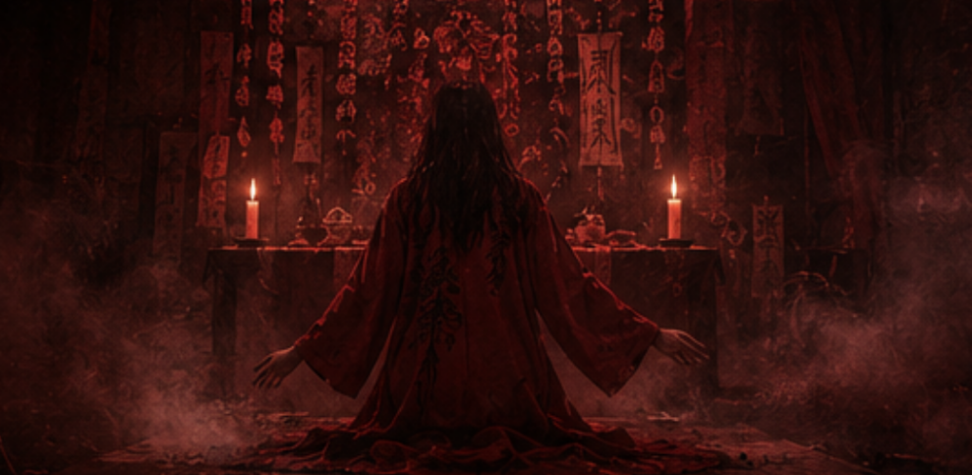

6.3 Reflection
Through the creation and research of "Beyond the Veil", I have gained a deeper understanding of the differences between Chinese and Western horror films in terms of myth, ritual, and psychological horror. "Silent Hill" emphasizes internal psychology and symbolic space, while "Zhong Xie" pays more attention to folk beliefs and ritual realism. In practice, I attempted to integrate the two styles to create a terrifying atmosphere that combines psychological oppression and cultural authenticity. This project not only helped me transform theoretical research into visual narratives, but also significantly enhanced my creative abilities in terms of atmosphere, space, and symbolic imagery.

Cite the literature
- Campbell, J. (2008) The Hero with a Thousand Faces. 3rd edn. Novato, CA: New World Library.
- Smith, H. and Dean, R.T. (eds.) (2009) Practice-led Research, Research-led Practice in the Creative Arts. Edinburgh: Edinburgh University Press.
- Campbell, J. (2008) The Hero with a Thousand Faces. 3rd edn. Novato, CA: New World Library.
- Freud, S. (2003) The Uncanny. Translated by D. McLintock. London: Penguin Books.
- Perron, B. (2012) Silent Hill: The Terror Engine. Ann Arbor: University of Michigan Press.
- Hantke, S. (2010) American Horror Film: The Genre at the Turn of the Millennium. Jackson: University Press of Mississippi.
- Plate, S.B. (ed.) (2009) Ritual and Religious Belief: A Reader. Oxford: Oxford University Press.
- Reyes, X.A. (ed.) (2016) The Horror Sensorium: Media and the Senses. Jefferson, NC: McFarland.
- Choi, J. and Wada-Marciano, M. (eds.) (2009) Horror to the Extreme: Changing Boundaries in Asian Cinema. Hong Kong: Hong Kong University Press.
- Sullivan, G. (2010) Art Practice as Research: Inquiry in Visual Arts. 2nd edn. Thousand Oaks: Sage.

