Marian Raducanu
The Humanities – Mind Map

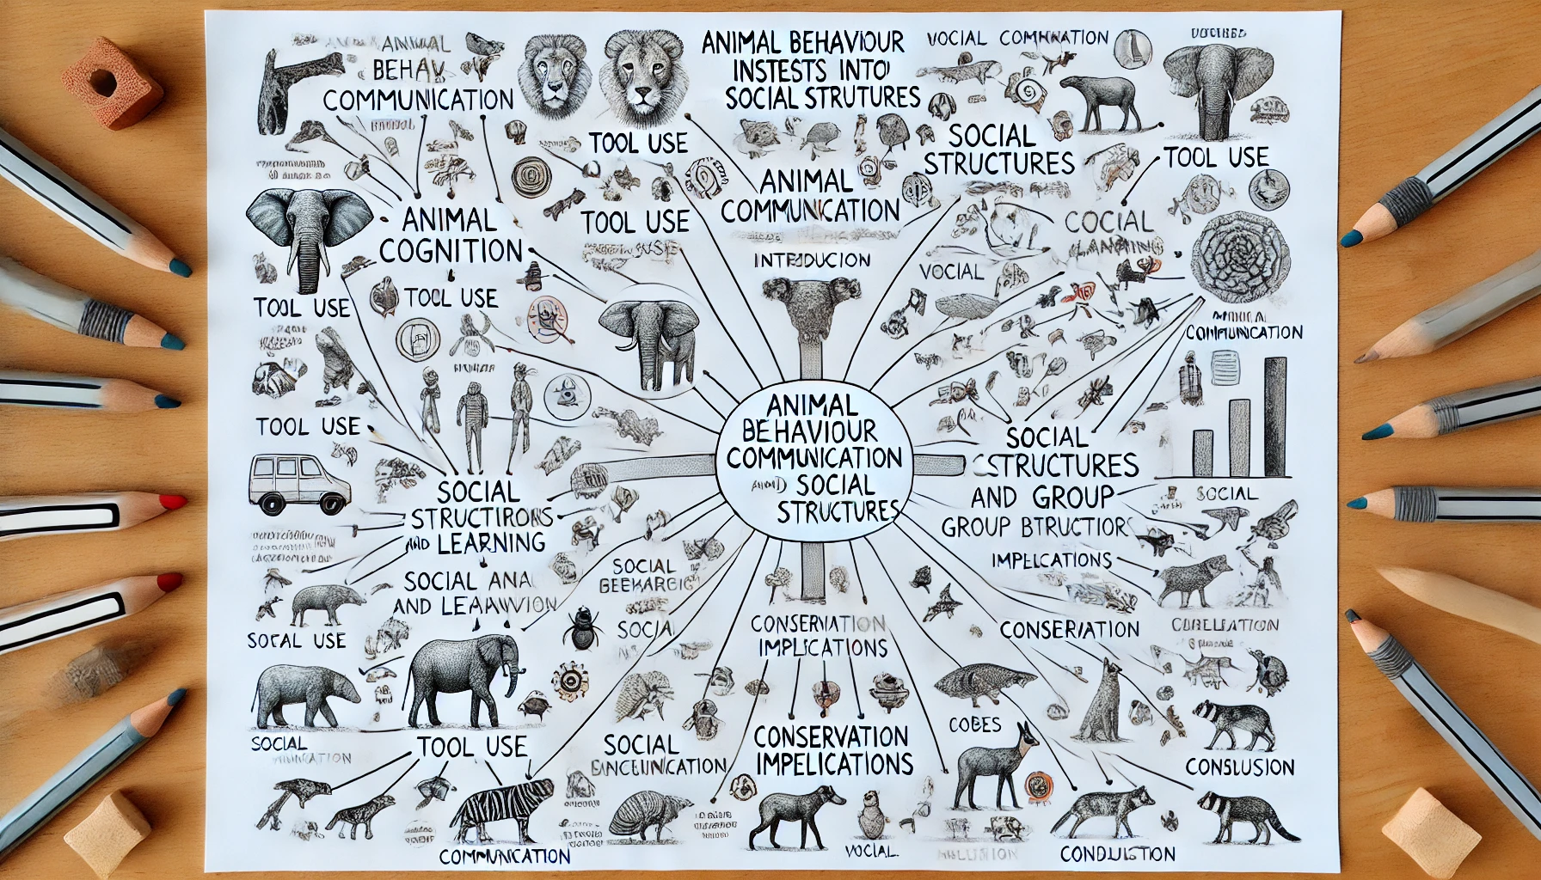

Below is a mind map to plan different themes, subthemes, and types of evidence to include in an essay on Animal Behaviour and Communication: Insights into Cognition and Social Structures. This process organizes your thoughts so that you can write a full-saturated and interesting essay; it is easier because you have organized your ideas before writing.
FIELD: Animal Behaviour and Communication; Applying Lessons about Cognition and Social Structure
Introduction
Animal Cognition and Social Behaviour: Fundamentals of Intelligence, Social Organization, and Communication
Thesis: State the main point or research question, for example: Why animal behavior is important to study animal behaviour to gain insight into cognition and social complexity.
Background Context: Why do animals behave as they do? This question boils down to evolutionary advantages, with brief examples varying across species.
Animal Cognition
A: Tool Use and Problem-Solving
Tool use (e.g., crows) and sponging behaviour in dolphins
Fact: Animal tool use; studies of animal intelligence
B. Memory and Learning Skills
Such activities include the long memory of elephants and watching-order learning in octopuses.
Scientific articles on memory studies; learning experiments images
C. Self-awareness and emotion
Examples include mirror tests in primates and empathy-displaying dogs.
Evidence: Self-acknowledgment tests; mirror test pictures
Animal Communication
A. Vocal Communication
Examples would be songs from birds, echolocation from dolphins, and rumbling from elephants.
Proof: Audio waveforms, audio recordings and spectrograms; vocal learning studies.
B. Communication via chemicals and scents
Illustrative examples: Ant pheromone trailing and marking in mammals
Research on how chemical signalling works; images of chemical-based communication
Visual Indicators and Nonverbal Cues.
Some Examples – — Bee waggle dance, dog body language, lizard displays.
Examples: Images or video recordings of communicating bees, dogs, or lizards showing body signals; visual comes charts.
Human Nature, Nurture, and culture
A. Social Structure and Function
For instance: wolf packs and primate social hierarchies
Directions in pack biology and analysis time (visually if possible, from visual pamphlets); Direct validation.
B. Coordination and Prosocial Action
Ex: Sentries in meerkats and alliances in dolphins
For instance, Support: Images/Videos of cooperation; science behind unselfishness in animals
C. Reproductive systems and mating behaviours
Birds are an example, with their monogamous pairs and courtship displays.
Proves: Photographs of mating displays; literature written on reproductive strategies.
Animal Behaviours Explain Cognition and Social Dynamics
A. Related to how we think as humans
Examples: The significance of chimpanzee problem-solving in understanding human cognition.
Example: Comparative studies of the same behaviour in other species; pictures doing the same behaviour).
B. Implications for Conservation and Animal Welfare
Type used: Research into coculture tourism and its conservation implications, e.g., the group dynamics of endangered species
Proof: Articles related to their preservation; Images from a sanctuary or study area.
Conclusion
What We Learned: summarizes what we discovered about animal intelligence, language, and family life.
Implications for future research: We suggest that nonbehavioral—and and a nesting token theory of cognition—might lead investigations.
Last Reflections on the Similarities Between Humans and Other Animals: Do animals think like us?
This method of gathering evidence for each theme allows one to create a mind map with supporting material, such as photos (animal behaviour), diagrams, and graphs. This method provides a background for a wide range of studies on animal behaviour and communication, both cognitive and social.

