Academic Discipline of Hospitality and Tourism Management BA International Hotel Management

ESSAY: Discuss how the evolution of Human Resources Management (HRM) facilitates the strategic development of an international hotel brand through workforce planning, recruitment, and selection

Student: Olga Brinza 2242685
Module Lead: Scott James

Wordcount:1869
The hospitality industry is one of the most important businesses referring to its economic contribution and is one that mostly depends on human resources (Ashton, 2018; Liu and Wall, 2006). I strongly agree with this as hospitality is vulnerable to labour shortages and high turnover and needs effective human resource management systems for the best flow of employees and their retention within a business. It cannot be neglected that Human Resources Management within a hotel covers a large range of activities targeted at delivering extraordinary guest experiences, ensuring at the same time operational competence and efficiency within hospitality businesses. In this essay, I will discuss how the changing roles of HRM influence the strategic development of Hilton Hotels through the planning, recruitment, and selection process.
It is important to note that recruiting, personnel selection, and strategic planning are essential mechanisms of successful hospitality management. Besides these, Human Resources Management should provide opportunities for nourishing work, given the variety of hire options in the different types of business, the rich social connection, and the reward involved in providing give-and-take open hospitality (Poulston, 2015). Working in the hospitality industry typically means below-subsistence-level pay, unacceptable working conditions, exploitation, abuse, and even modern slavery. This statement emphasizes the significant importance of professional Human Resources Management in the hotel industry as a tool for improving this situation.
From my perspective, one of the best examples of effective Human resources management is Hilton Hotels known also as Hilton Worldwide. This hotel company is one of the best examples of Human Resources implication and development for business success and employee satisfaction. The evolution of HRM in Hilton Hotels reflects broader industry trends toward strategic workforce management.
As it is well known in the mid-20th century, Hilton experienced rapid growth locally and internationally. This period shifted the HRM practices across Hilton properties, with a need for the development of employee training programs, performance review systems, and standardized job roles. Additionally, Hilton started to prioritize employee dedication and satisfaction, appreciating the critical role of motivated and well-trained staff in delivering exceptional guest experiences.
Initially, Human Resources Management in Hilton hotels was largely administrative, focusing mostly on tasks such as payroll and compliance. However, as competition with other brands intensified and customer expectations rose, Hilton recognized the need to align HRM practices with strategic business objectives. This shift towards strategic HRM involved a greater emphasis on talent management, employee development, and organizational culture. Later, in the early 21st century, Hilton Hotels underwent significant technological advancements that revolutionized HRM practices. Hilton also implemented talent management programs to select, develop, and retain top talent across their global workforce.
It is a fact that Hilton Worldwide Hilton has a vast collection of hotels operating in 94 countries worldwide. The company owns eleven well-known hotel brands, which are divided into five segments, namely, luxury, upper upscale, upper midscale, upscale, and timeshare. It has over 6000 hotels worldwide with around 1.4 million employees across the globe. At a glance on their website, I could see their vision and values which promote the approach to ensure the best experiences for guests and expressive prospects for team members with an accent on the values of ‘integrity, cooperation, leadership, and partnership. These are the result of Human Resources Management and their continuous efforts and dedication.
Based on this, I consider that a hotel’s success is directly proportional to the employee's well-being and motivation. As a result of this change of strategies, Hilton has been declared one of the best places to work for several years. They acknowledged the importance and necessity of Strategic human resources management (SHRM) in the hotel operation.
Additionally, Hilton's Human Resources Management has focused on educating internally, especially its HRM systems, by continuously working to develop a sense of belonging. In my opinion, this was possible because they have created a comprehensive work environment and prioritized training and programs for employees that accelerate them in succeeding in their career goals. These processes help manage performance, deliver excellent customer service, and cultivate an environment that fosters talent growth.
Another key element that has changed over decades is workforce planning at Hilton Hotels. This helps Human Resources management to ensure it has the right people in the right roles at the right time. This method implies predicting future staffing demands based on business ideas and market tendencies. An example is the fact that Hilton's HR department cooperates closely with senior management to detect strategic priorities and convert them into workforce needs. By projecting future demand, Hilton can immediately rectify talent gaps and develop strategies to attract and retain top talent. For example, when integrating into new markets, Hilton conducts detailed analyses to reveal the skills and expertise required to succeed in those regions.
Technological innovations have influenced the hospitality industry, changing how Hilton plans, recruits, and selects its workforce. For example, digital recruitment platforms and artificial intelligence tools assist Hilton's Human Resources management in reaching a broader number of candidates and streamlining the selection process. Moreover, innovations in workforce management software enhance operational efficiency and facilitate real-time performance monitoring, enabling Hilton to optimize staffing levels and improve service delivery.
Interestingly, Hilton has effectively implemented a digital interview platform called HireVue. This platform allows them to examine video interviews of multiple candidates at once, without the need for a recruiter to be present. Hilton uses this video evaluation at the first stage of their hiring process, which helps them determine if the candidate would be a good fit or not from the start. Using HireVue has reduced Hilton's time-to- hire process from 45 days to only five days, which I find very useful and money and time-saving.
It is my belief that in order to improve its hiring process, the Human Resources Management has performed comprehensive research on various hiring methods over the activity years. The objective of this exploration was to find ways to expand the group of applicants and ensure that the hiring process is adapted to meet the needs of each candidate. The company is focused on providing an honest and comprehensive hiring experience to all potential candidates, and this element is just one of the many steps it is taking to achieve this goal. Hilton has pushed up same-day job fairs, where candidates are interviewed on-site, get an immediate job offer, and can begin working the next day. This strategy has been a considerable success at most of the largest hotels. Hilton has also invested in “second chance” hiring and has looked at how to hire and support refugees, how to reintegrate previously retired workers, and how to bring in disadvantaged youth.
Beyond hiring, Hilton focuses on employees’ involvement in the first 90 days of work, when turnover is usually the highest. I found it interesting that Hilton delegates training buddies, who work directly with new employees to help them learn the necessary skills and to help them get into the company’s culture. From my own experience, this is a useful tool and helps candidates understand the company’s level of expectations from new starters.
It is of significant importance to mention that recruitment is another critical component of HRM that directly impacts the quality of Hilton's workforce and guest experiences. Hilton employs a variety of recruitment strategies to attract a diverse pool of candidates, including online job postings, career fairs, and employee referrals. Additionally, Hilton leverages its employer brand to highlight its commitment to employee development and career advancement opportunities. By positioning itself as an employer of choice, Hilton can attract top talent who align with its values and culture. Moreover, Hilton's recruitment process is designed to assess not only candidates' skills and qualifications but also their fit with the organization's culture and the focus on customer satisfaction.
An incredibly significant element of Human Resources Management is the investment in the staff’s learning programs. In this aspect, Hilton has its learning strategy at Hilton University. The university provides millions of classes worldwide, teaching basic hospitality skills and job-specific expertise to foster leadership development. Hilton Human Resources Management offers leadership development programs called "talent accelerators" to their employees at all stages of their careers. These programs are suggested to teach distinct characteristics of leadership, including wellness, sustainability, and inclusion. Both internal company executives and external providers present the courses. In addition to this, Hilton has joined Guild Education, which helps employees extend their own educational goals.
I strongly agree that Hilton's formidable reputation as an employer is due to such individualized approaches to recruiting and development. Some employees have flexibility, and they can do their jobs when suitable for them. I consider that freedom increases employee’s well-being and satisfaction, and as a result, it boosts the company’s success.
Other benefits that I would like to mention are underlined on the Hilton website. It states, “Come for the job, thrive in your career, and enjoy the journey of Making the Stay.” The company offers benefits that empower you to defy expectations and seek excellence. Thrive at Hilton is a Team Member Value Proposition. It is aimed to support the well-being and performance of the Team Members with industry-leading benefits, recognition, and support to meet professional needs. Besides this, Hilton has a variety of events that are aimed to thank and reward its members. Hilton offers its employees discounts for its hotels worldwide.
Hilton Worldwide has been acknowledged for its efforts in supporting diversity and inclusivity in the hiring, development, and retention of employees. The company has been registered in the top fifty companies offering diversity for seven years in a row. In this direction, the company has begun a strategy to advance gender and ethnic diversity in recruitment. Furthermore, this strategy helps to reach the organisational mission, which is to positively impact the local community and achieve the global expansion strategy of Hilton Worldwide.
I was pleasantly surprised to learn that Hilton Hotels not only focuses on their company's needs but also promotes a family-friendly work environment. The company offers several programs such as 'Parental Leave', 'Parenthood Journey', 'Milk Stork', and 'Adoption Assistance' to support its employees. These programs could indirectly or directly enhance employees' personal and professional growth by improving job flexibility and satisfaction. For example, on a survey sourced by Great Place To Work® 2021 Global Employee Engagement Study, 95% of employees at Hilton say it is a great place to work compared to 57% of employees at a typical U.S.-based company. This is undoubtedly a result of the hard work of Human Resources Management and everyone within the company.
Considering the above-mentioned Hilton Worldwide strategic approach to HR planning, recruitment, and selection which plays a fundamental role in the development of the business worldwide, I can conclude that over its existence as a business, Hilton Worldwide proved its development and competitiveness in the industry that goes hand in hand with new technologies and trends. By aligning its workforce with organisational goals, attracting the best talent, and selecting individuals who represent Hilton's values, the company ensures that its company is offering exceptional guest experiences and achieves long-term success in the competitive hospitality industry. The employees feel appreciated and motivated to grow on their career and personal paths, promoting the brand and its values and principles.
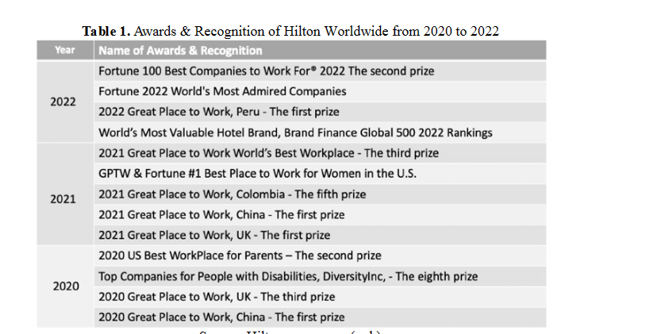
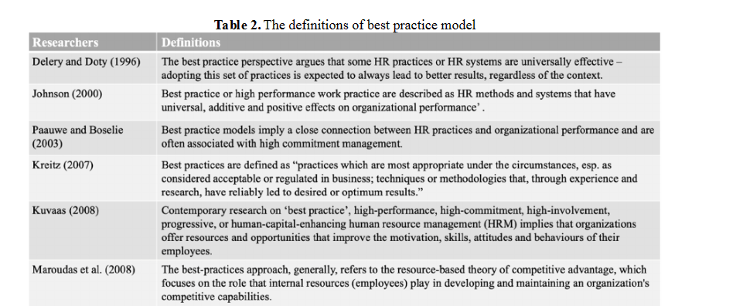
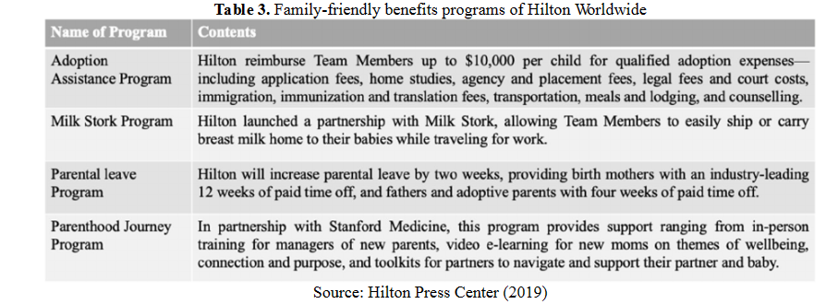

References:
- Armstrong, M. and Brown, D., 2019. Strategic Human Resource Management: back to the future. Institute for Employment Studies reports, pp.1-36.
- Padhi, N. (2010). Michal Armstrong, Armstrong’s Handbook of Human Resource Management Practice (11th Edition). United Kingdom: Kagan Publishing, 2009 (ISBN 9780742952421). Global Business Review, 11(2), 312-314. https://doiorg.ezproxy.uwtsd.ac.uk/10.1177/097215091001100213
- PETAKOVIĆ, E., 2023. Quality Service Management: A Guide to Improving Business Processes. Tourism and Hospitality Management, 29(2), pp. 315-316.
- Walker, J 2021, Introduction to Hospitality, Global Edition, Pearson Education, Limited, Harlow. Available from: ProQuest Ebook Central. [10 May 2024].
- Baum, T. (2019) ‘Hospitality employment 2033: A backcasting perspective (invited paper for “luminaries” special issue of International Journal of Hospitality Management)’, International journal of Hospitality Management, 76, pp. 45–52. Available at: https://doi.org/10.1016/j.ijhm.2018.06.027.
- Zhang, Jinlan. (2023). Analysis of Strategic Human Resource Management Practices: A Case Study of Hilton Worldwide. Frontiers in Business, Economics and Management. 8. 215-222. 10.54097/fbem.v8i3.7872.
- Heidi Lynne Kurter, Sep 19, 2019, How Hilton Reduced Their Time To Hire From 43 Days Down To 5, Available at: How Hilton Reduced Their Time To Hire From 43 Days Down To 5 (forbes.com), (Accessed:10 May 2024).
- Maxwell, G.A. and Watson, S. (2006) ‘Perspectives on line managers in human resource management: Hilton International’s UK hotels’, International journal of human resource management, 17(6), pp. 1152–1170. Available at: https://doi.org/10.1080/09585190600697638.
- Tom Baum,Hospitality employment 2033: A backcasting perspective (invited paper for ‘luminaries’ special issue of International Journal of Hospitality Management), International Journal of Hospitality Management,Volume 76, Part B,2019,Pages 45-52,ISSN 0278-4319,https://doi.org/10.1016/j.ijhm.2018.06.027.
- Zhuravska, N. (2019) ‘The Employee Resourcing of Human Resources Management: A Comparative Aspect’, Comparative professional pedagogy, 9(3), pp. 1–7. Available at: https://doi.org/10.2478/rpp-2019-0022.
- ARGENTI, P.A., 1998. STRATEGIC EMPLOYEE COMMUNICATIONS. Human Resource Management (1986-1998), 37(3-4), pp. 199.
- KAPUR, R., 2021. STRATEGIC RESOURCING AS KEY ASPECT OF STRATEGIC HUMAN RESOURCE MANAGEMENT. International Journal of Information, Business and Management, 13(4), pp. 47-56.
- Dainty, A. R. J., Raidén, A. B., & Neale, R. H. (2009). Incorporating Employee Resourcing Requirements into Deployment Decision Making. Project Management Journal, 40(2), 7-18. https://doi-org.ezproxy.uwtsd.ac.uk/10.1002/pmj.20119
- Tuzunkan, D. (2018) Contemporary human resources management in the tourism industry. Edited by D. Tuzunkan and V. Altintas. Hershey, PA: Business Science Reference. Available at: https://doi.org/10.4018/978-1-5225-5760-9.
- Parry, Emma, Michael J. Morley, and Chris Brewster (eds), The Oxford Handbook of Contextual Approaches to Human Resource Management (2021; online edt. Oxford Academic, 14 Apr. 2021), https://doi.org/10.1093/oxfordhb/9780190861162.001.0001, accessed 12 May 2024.
- Hilton Worldwide Holdings Inc. SWOT Analysis (no date). MarketLine, a Data monitor business. (UWTSD online library).
- Yong Joong Kim, Woo Gon Kim, Hyung-Min Choi, Kullada Phetvaroon, The effect of green human resource management on hotel employees’ eco-friendly behavior and environmental performance, International Journal of Hospitality Management, Volume 76, Part A,2019, Pages 83-93, ISSN 0278-4319, https://doi.org/10.1016/j.ijhm.2018.04.007.
- Vorakarn Chalermchaikit, Metin Kozak, Sirichai Preudhikulpradab, Gender inclusion: The practices of organizational development and human resource management, International Journal of Hospitality Management, Volume 120,2024,103773, ISSN 0278-4319 https://doi.org/10.1016/j.ijhm.2024.103773.
- https://jobs.hilton.com/us/en
- Great place to work, 2023, Available at: https://www.greatplacetowork.com/certified-company/1000367

