DS 1 Template

My Screenshots/Photos
- Please add 4–6 screenshots or photos of your digital life.
- You can use your phone or laptop.
- For each screenshot, write one or two sentences explaining what it shows.

Screenshot/Photo 1
[Insert Photo/Screenshot below]
This photo shows part of my daily routine, as I enjoy starting my morning with a caramel latte. This represents how I use my phone to capture and share everyday moments from my day to day life.

[Write what this shows of your digital life]

Screenshot/Photo 2
[Insert Photo/Screenshot below]
This photo shows how I use my laptop for studying and compleating university assignments. Technology is an important part of my digital life as it helps me research information, helps me to stay organised and too communicate with others
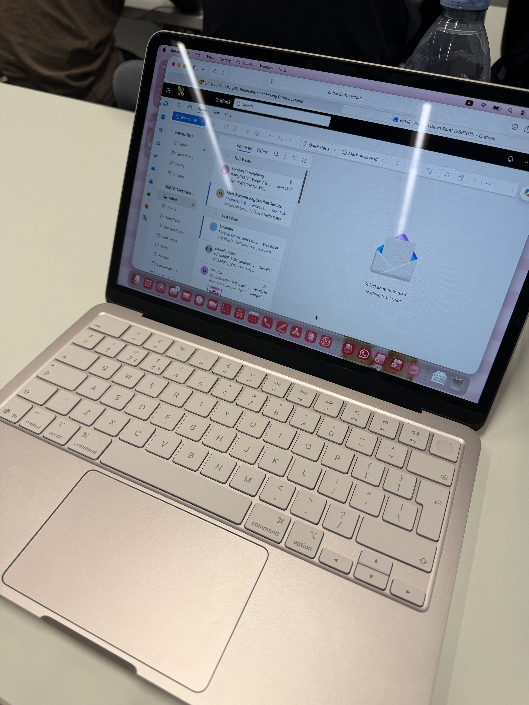
[Write what this shows of your digital life]

Screenshot/Photo 3
[Insert Photo/Screenshot below]
My planners is apart of my digital life because it helps me to write everything down to help me stay organised with my daily life, it helps me to stay track and focused on upcoming events.
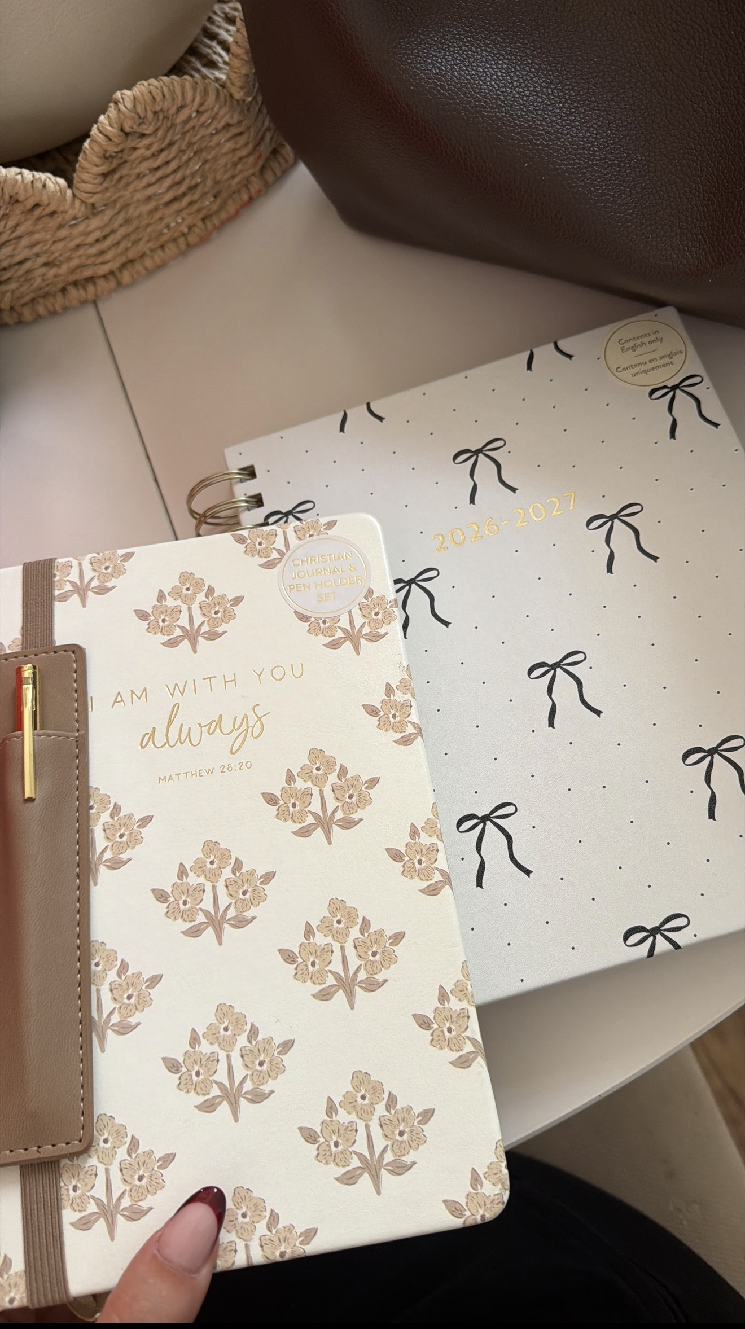
[Write what this shows of your digital life]

Screenshot/Photo 4
[Insert Photo/Screenshot below]
My calender is apart of my digital life because I get too put upcoming events into my calander and it also allows me to set reminders to help me remember, keeping track of important dates, appointments, and university deadlines.
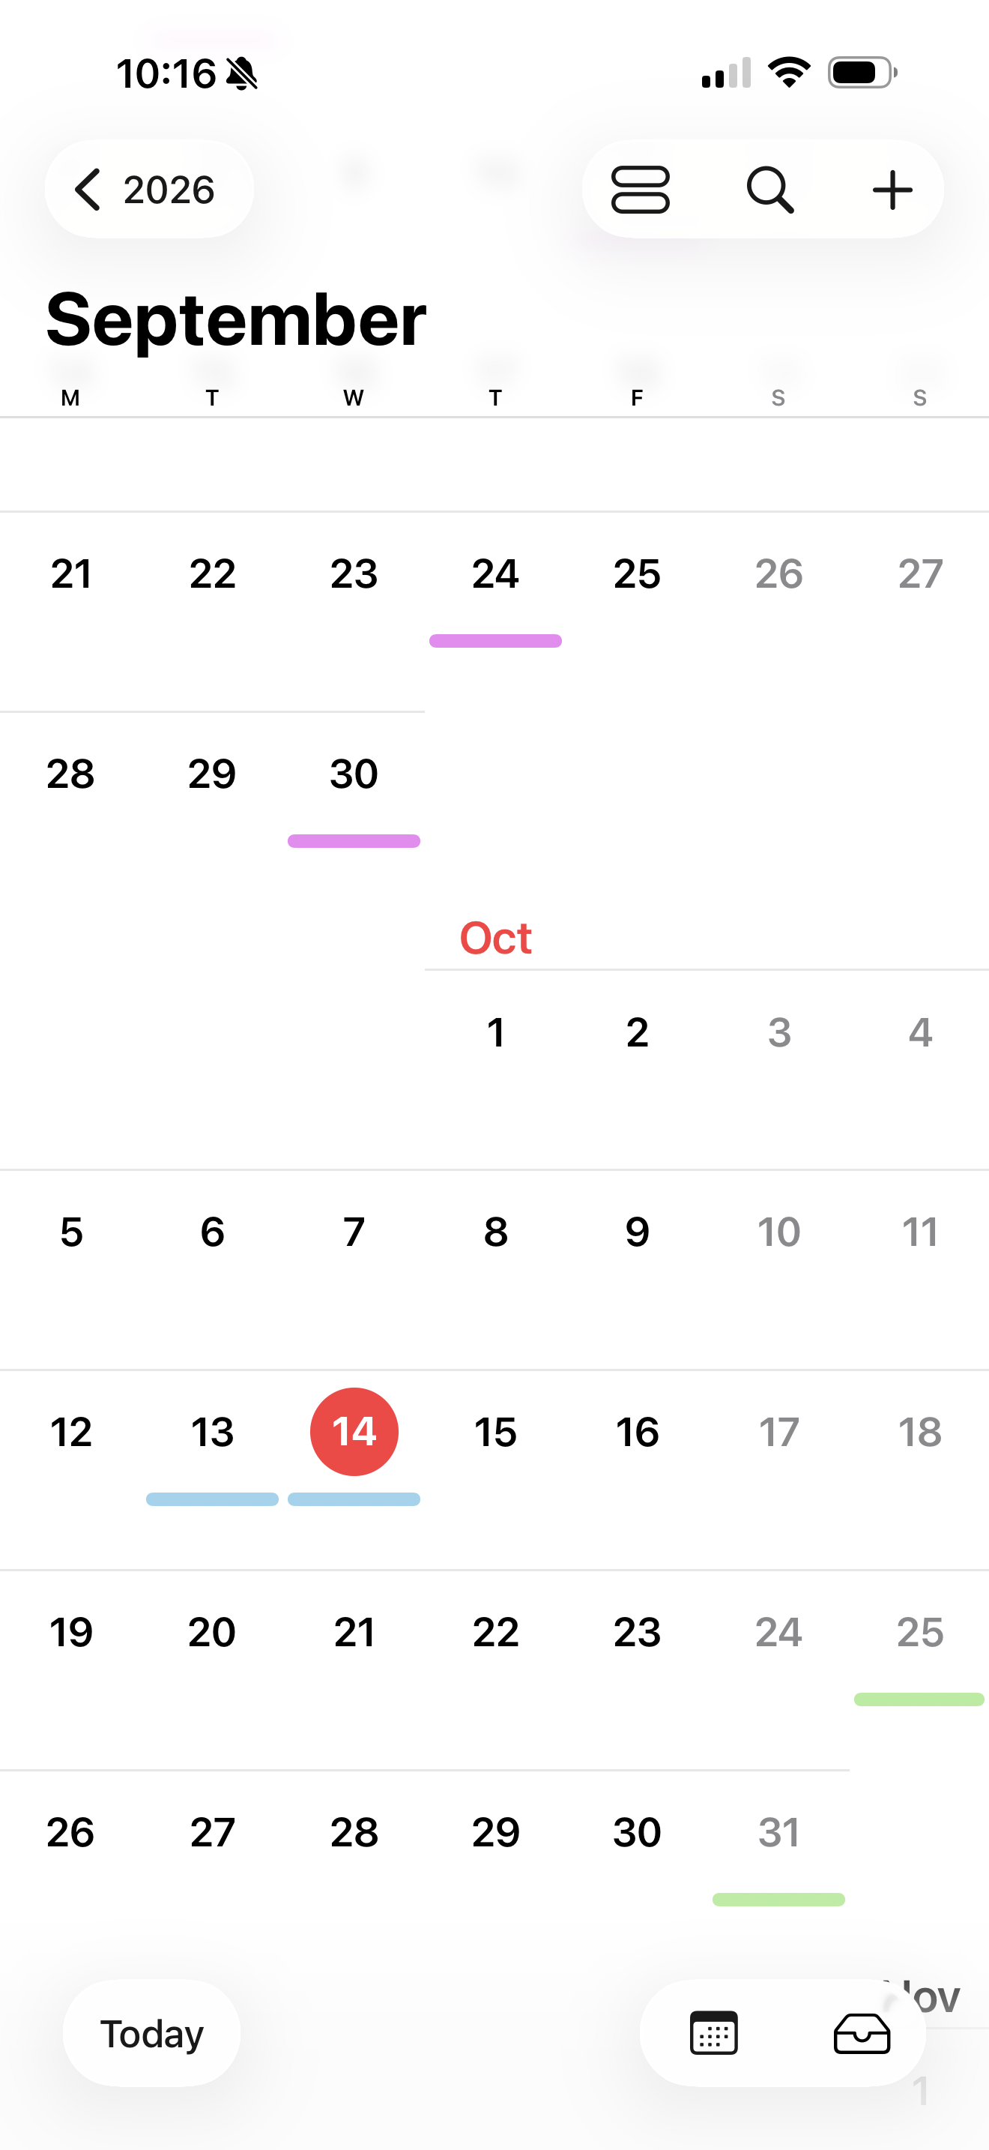
[Write what this shows of your digital life]

Screenshot/Photo 5
[Insert Photo/Screenshot below]
My apple pay is apart of my digital life because it allows me to make quick and secure payments, using my phone or apple watch. It makes everyday more convinent for me because I don’t have to carry around my everyday card with me.
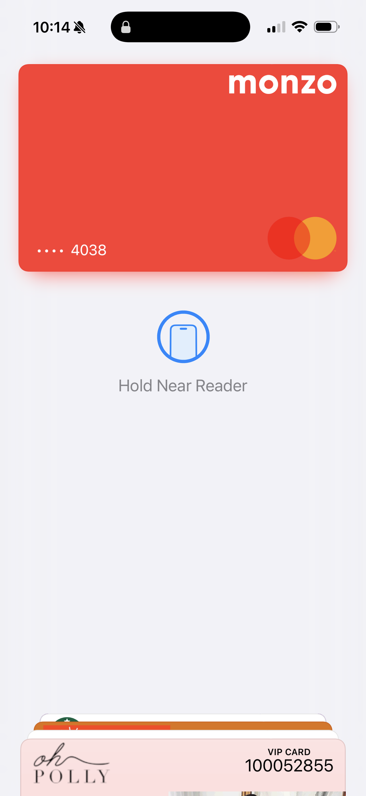
[Write what this shows of your digital life]

Screenshot/Photo 6
[Insert Photo/Screenshot below]

[Write what this shows of your digital life]

My Short Reflection
- Write 5–8 simple sentences about your digital life.
- You can use the sentence starters below if helpful.

Sentence starters
- I use digital tools to …
- I feel confident when I …
- I want to improve …
- I often use these tools: …
- I sometimes feel nervous about …
- I hope this module will help me …
- Digital skills are important for me because …
You can write more if you want.

Submission Checklist
Before you submit, please check:
​​​ ☐ I added 4–6 screenshots
☐ I wrote short sentences for each screenshot
☐ I wrote my short reflection
☐ My work is my own
☐ My file opens correctly
​​☐ My file opens correctly

