

Student name: Osman Kamara
Student ID: 2324742

Module name: Empowering the Older Person
Module code: BMHP6027_LON
Lecturer’s name: Laila Surani

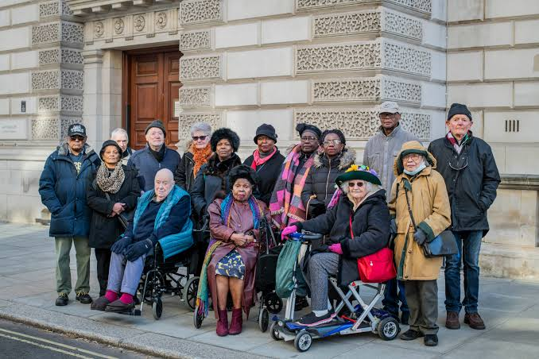 |  | Critically evaluate the care, empowerment and support needs for older people  Freedom and Choice: Care empowerment fundamentally encompasses the dimensions of freedom and choice ( Nordhaug,2021).  Cognitive needs: The cognitive needs of older adults involve the preservation and enhancement of cognitive function ( Studer,. et al.2021).  Physical needs: It comprise a broad set of requirements aimed at sustaining physiological function ( Mahrs, 2017).  Dignity: Within nursing home contexts, dignity is constituted through self esteem, and a sense of social worth ( Liu,. et al. 2025).  Social and emotional needs: They are tightly interwoven with social determinants such as loneliness ( Ruiz,. et al. 2026 |  | 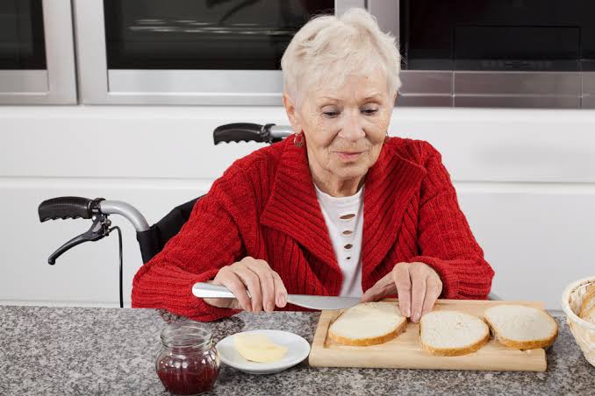
Introduction  The Uk is undergoing significant demographic change marked by a rising share of older adults, bringing a wide array of policy and societal challenges. As in other advanced economies, population ageing in the UK has far- reaching implications for health expenditure, pension and retirement frameworks, the provision and financing of long- term care, the structure and productivity of the labour force, and the distribution of income ( Anderson,. et al.2000).  England’s 50+ population is projected to rise from 23.1 million in 2025 to 24.0 million in 2040. Frailty prevalence within this group is expected to increase from 70.2% to 76.1%. Health service use and costs are projected to rise by 10 billion pounds ( Walsh,. et al. 2026). |  |  |  | Challenges in Maintaining Independence and Functional ability  Independence in older adults is multifaceted, shaped by personal values and context, standard assessments may miss dimensions of independence ( Taylor,. Et al. 2024).  Community- dwelling of older adults follow distinct independence path ( Bimou,. et al. 2021).  Recommendations  Community- embedded empowerment programs correlate with improved physical, psychological, social, and economic welfare ( Harahap,. et al. 2026).  Expansion is warranted ( Harahap,. et al. 2026).  Empowerment works best via staged steps ( Malik,. et al 2020).  Conclusion  Enhancing empowerment for older people in the UK requires integrated digital education and community engagement ( Motorga, 2024).  Structured health- empowerment programs requires preparation, assessment and planning ( Malik,. et al. 2020).
Effectiveness and benefit approaches and interventions.
UK approaches emphasise personalised, home- based, coolaborative care to sustain independence ( Heaven,.et al. 2024).
Prosper: 12 week personalised care ( Heaven,. et al.2024).
Theories
Two UK approaches emphasise behaviour change ( Stathi,. et al. 2023).
Active connected engaged is a peer- volunteer( Stathi,. et al. 2023)
HomeHealth is a home- based, behaviour- change intervention for older adults ( Walters,. et al. 2017)

References
Anderson, G. F., & Hussey, P. S. (2000). Population aging: a comparison among industrialized countries. Health Affairs (Millwood, Va.), 19(3), 191–203.
https://doi.org/10.1377/hlthaff.19.3.191

Bimou, C., Harel, M., Laubarie-Mouret, C., Cardinaud, N., Charenton-Blavignac, M., Toumi, N., Trimouillas, J., Gayot, C., Boyer, S., Hebert, R., Dantoine, T., & Tchalla, A. (2021). Patterns and predictive factors of loss of the independence trajectory among community-dwelling older adults. BMC Geriatrics, 21(1), Article 142. https://doi.org/10.1186/s12877-
021-02063-7

Harahap, F. I. N., Kamil, M., Alvi, R. R., Hendrawijaya, A. T., Pradikto, B., Winarti, H. T., Arnady, M. A., Syahid, A., & Rosilawati, R. (2026). Empowerment Model for The Elderly and Community to Improve the Welfare of the Elderly [version 2; peer review: 1 approved with reservations, 1 not approved]. F1000 Research, 15. https://doi.org/10.12688/f1000research.176617.2

Heaven, A., Bower, P., Day, F., Farrin, A., Fernadez, C., Foster, M., Foy, R., Hawkins, R., Hulme, C., Humphrey, S., Lawton, R., Parker, C., Thompson, E., West, R., & Clegg, A. (2024). PeRsOnaliSed care Planning for oldER people with frailty (PROSPER): protocol for a randomised controlled trial. Current Controlled Trials in Cardiovascular Medicine, 25(1), Article 8. https://doi.org/10.1186/s13063-023-07857-1
Liu, Y., Wang, Y., Li, X., Ma, L., & Li, X. (2025). Dignity in nursing homes: A qualitative descriptive study of older adults’ experiences. Nursing Ethics, 32(4), 1060–1072. https://doi.org/10.1177/09697330241305554
Mahrs Träff, A., Cedersund, E., & Nord, C. (2017). Perceptions of physical activity among elderly residents and professionals in assisted living facilities. European Review of Aging and Physical Activity, 14(1), Article 2. https://doi.org/10.1186/s11556-017-0171-9
Malik, A., Widhanarto, G. P., & Vitriani, A. M. (2020). Participants in the Elderly Empowerment Program Posyandu Ngudi Utomo: Study in Indonesia. Journal of Nonformal Education, 6(1), 19–28. https://doi.org/10.15294/jne.v6i1.22592
Malik, A., Widhanarto, G. P., & Vitriani, A. M. (2020). Participants in the Elderly Empowerment Program Posyandu Ngudi Utomo: Study in Indonesia. Journal of Nonformal Education, 6(1), 19–28. https://doi.org/10.15294/jne.v6i1.22592
Motorga, M. E. (2024). Bridging marginalization: the political imperative of inclusive digital futures in elderly empowerment. Polis (Bucharest, Romania), XII(2(44)), 149–165.
Nordhaug, M. (2021). Quandaries of Autonomy and Empowerment in Evidence-Based Nursing Care. Professions and Professionalism, 11(1). https://doi.org/10.7577/pp.3711
Stathi, A., Withall, J., Crone, D., Hawley-Hague, H., Playle, R., Frew, E., Fenton, S., Hillsdon, M., Pugh, C., Todd, C., Jolly, K., Cavill, N., Western, M., Roche, S., Kirby, N., Boulton, E., Thompson, J., Chatwin, K., Davies, A., … Greaves, C. (2023). A peer-volunteer led active ageing programme to prevent decline in physical function in older people at risk of mobility disability (Active, Connected, Engaged [ACE]): study protocol for a randomized
Studer-Luethi, B., Brasser, M., Lusti, S., & Schaerli, R. (2021). A cross-sectional survey of a public, evidence-based multimodal program for cognitive health in older adults. Archives of Public Health = Archives Belges de Santé Publique, 79(1), Article 165. https://doi.org/10.1186/s13690-021-00670-9
Taylor, E., Goodwin, V. A., Ball, S., Clegg, A., Brown, L., & Frost, J. (2024). Older Adults’ Perspectives of Independence Through Time: Results of a Longitudinal Interview Study. The Gerontologist, 64(2), 1. https://doi.org/10.1093/geront/gnad073
Walters, K., Frost, R., Kharicha, K., Avgerinou, C., Gardner, B., Ricciardi, F., Hunter, R., Liljas, A., Manthorpe, J., Drennan, V., Wood, J., Goodman, C., Jovicic, A., & Iliffe, S. (2017). Home-based health promotion for older people with mild frailty: the HomeHealth intervention development and feasibility RCT. Health Technology Assessment (Winchester, England), 21(73), 1–128. https://doi.org/10.3310/hta21730
Walsh, B., England, T., Brailsford, S., Fogg, C., Fraser, S., Roderick, P. J., de Lusignan, S., Harris, S., & Clegg, A. (2026). Projected trends in frailty prevalence and associated health service use and costs in the over-50s in England, 2025 to 2040: a simulation modelling study. Age and Ageing, 55(4). https://doi.org/10.1093/ageing/afag109

