A GUIDE FOR CHILDCARE PROFESSIONALS – THE VALUE OF EFFECTIVE COMMUNICATION IN THE LEARNING AND DEVELOPMENT OF YOUNG CHILDREN DURING TRANSITIONS

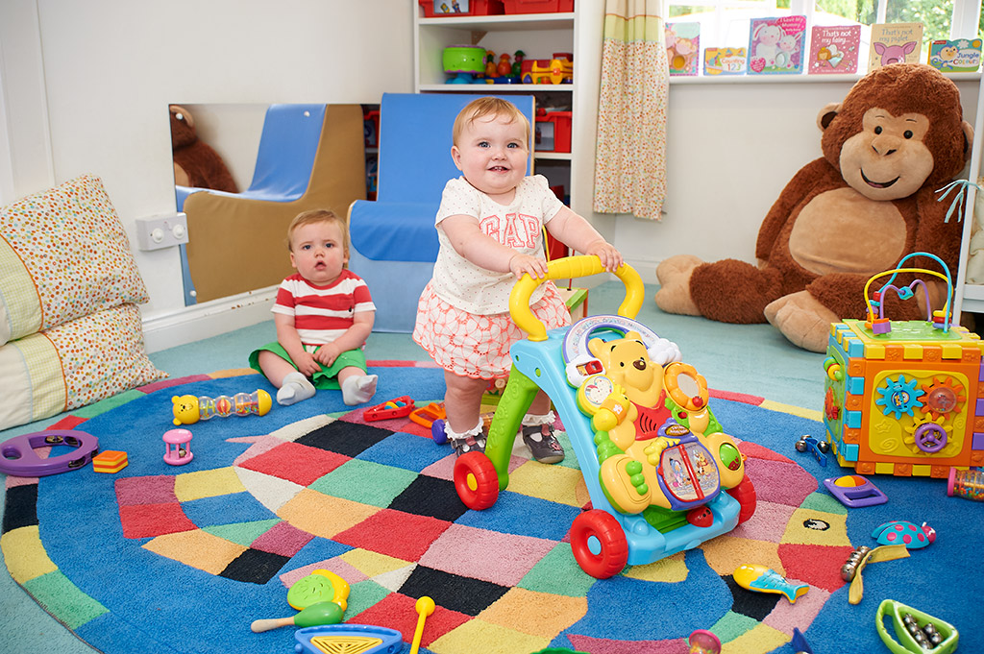
(Waltonpps.co.uk, 2021)

A TRANSITIONS HANDBOOK FOR EARLY CHILDHOOD PROFESSIONALS

CONTENTS
An Introduction and rationale Page 3
Transitions Page 5
The Needs of the Child Page 7
The Role of the Adult Page 10
Partnership Page 13
Interventions Page 15
Proposed Outcomes Page 18
Reference List Page 19

INTRODUCTION AND RATIONALE
Newborns and young children are face with changes in their lives on a frequent basis. In the life of young children, there are several transitional periods. These include the transition from home to a childminder or a pre-school setting, entering in a reception class, and advancing through the Foundation Stage into Key Stage.
There is a growing interest in educational transitions since children's social and academic performance throughout the transition to school or between stages of education can be a significant component in determining their future progress and development. Ghaye and Pascal (1989 cited in Dunlop and Fabian, 2007)
This guide is for key practitioners who deal with children aged 1-2 years who are transitioning from home to nursery settings.
This transition handbook main goal will be to help the child and family adjust to their new environment in a nursery setting. As a result, the child will feel more secure, confident, and equipped to deal with the challenges that lie ahead.
The main goal of this handbook is to provide support and guidance to all early childhood practitioners working with children aged 1 to 2 years old in order to help them develop successful transitional practices that will benefit children and their families during this time, particularly those transitioning from home to nursery.
This guide will help practitioners understand how transitions work and how to handle them, ensuring a smooth transition. Practitioners will need to form relationships and partnerships with both the child and the parents. This will allow the practitioner to obtain critical information to make the transition go smoothly.
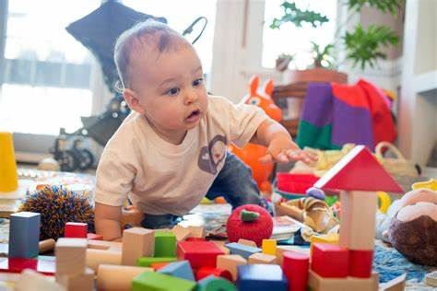 (Source: Bing.com, 2021)

TRANSITIONS
Transition- This is the process of changing from one condition or form to another (Oxford Student’s Dictionary, 2007 p 1122).
It is often said that taking a child from home to a nursery may be a difficult transition. At this age, most children enter an early years program, such as a nursery, but it is also the child's first time away from the family and interacting with other toddlers. The capacity to form intimate bonds with adults and other children is essential for a child's healthy transition. (Supporting transitions: Using Child Development as a Guide Transitions Are Part of Life, n.d.)
Understanding child development and personal, family background experiences that influence children's school adjustment is important to the transition to school process. Rimm-Kauffman et al. (2000 cited in Dunlop and Fabian, 2007) Practitioners that have a good grasp of the child and family will be able to give the finest resources for a smooth transition for the child. Most children feel better at ease in a familiar environment with familiar people, therefore this would be the perfect location for the practitioner to get the necessary information and get to know the child for a smooth transition for both the child and the parents.
Transitions are co-constructed by children, parents, and teachers in the context of their intersecting experiences and the cultures in which they live Dunlop (2003 cited in (Dunlop and Fabian, 2007) Children who transition smoothly from home to nursery were more likely to succeed in the future. Both children and their families should be viewed holistically. Bronfenbrenner (1989 cited in Dunlop and Fabian, 2007)

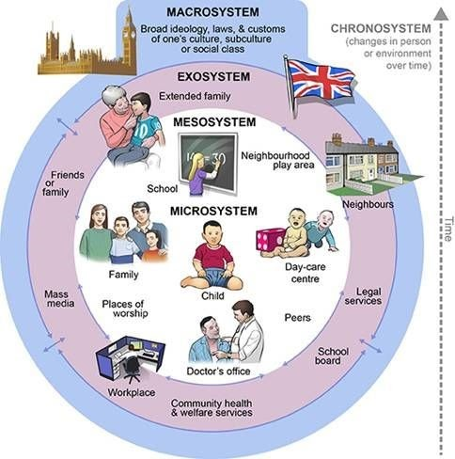(Source: Pinterest, n.d.)
Bronfenbrenner’s Ecological Model of the Human Development view that each setting in which a child interacts, such as home, nursery, or the house of grandparents, is referred to as a micro system, and each of them plays an important part in the development of the child. (Brooker, 2008)

THE NEEDS OF THE CHILD
Children must be included and cared for in a caring and safe setting. They will need to build strong bonds with their key workers because this will be their first time away from their parents. To ensure a smooth transition, key practitioners should emphasize what the child currently knows and understands.
If a child has a healthy attachment, he or she may trust that the adults will respond to his or her needs. For example, if the child is hungry, sleepy, or scared, the adult will respond to satisfy those needs. This provides the child the courage to explore his surroundings and build self-esteem. This will aid in child development. As shown by attachment theory, for optimal socioemotional development, all children require a stable and secure bond with at least one caregiver. Bowlby (1969 cited in Scharer, 2018)

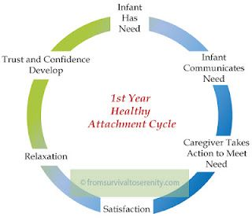 (Source: Pinterest, n.d.)

Play can be used to satisfy a need, solve an issue, or express a feeling, depending on the individual.' Smidt (2010) Play is an essential element of the transition process; according to the United Nations Convention on the Rights of the Child, children have the right to play, rest, and participate in cultural activities. Children's brains expand, their muscles strengthen, and they acquire important social and life skills such as sharing, taking turns, making decisions, and understanding others' feelings while they play. Play is a form of emotional release, but it also has an educational purpose. Isaacs (1930 cited in Lindon, 2012)
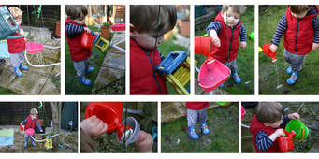 (Source: Nortonsafe.search.ask.com, n.d.)

Maslow’s Hierarchy of Needs (1943 cite in Mcleod, 2018)) practitioners are encouraged to recognize and support the individual needs of children at all times. The needs at the bottom of the hierarchy must be fulfill before those at the top. This is one of the most crucial aspects of transition because children need to feel loved, safe, and secure, as well as have access to basic necessities like food, drink, clothes, and shelter. When these needs are met, relationships and a healthy child development emerge.
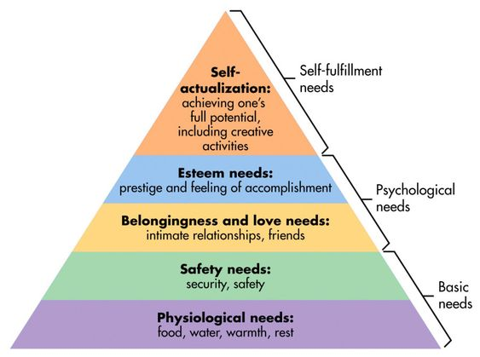(Source: Pinterest, n.d.)

The Foundation Phase Framework states that an early childhood curriculum should be well-structured in order to be effective. There should be three strands in that structure:
- provision for various starting points from which children develop their learning, building on what they already know.
- relevant and appropriate content that matches the various levels of young children's needs.
- planned and purposeful activity that provides opportunities for teaching and learning, both indoors and outdoors.
There should be chances for children to participate in adult-planned activities as well as activities that they design or begin themselves. Children do not distinguish between "play" and "work," and practitioners should not either. Children require time to become absorbed in their task, to work in detail, and to complete activities.

Statutory framework for the early years foundation stage suggest that providers must support children in four areas: (Department for education, 2021)
- literacy
- mathematics
- understanding the world
- expressive arts and design
Three areas are very crucial for stimulating children's interest and excitement for learning, creating relationships, and flourishing are:
- communication and language
- physical development
- personal, social and emotional development

THE ROLE OF THE ADULT
During transitions, Early Childhood Practitioners must ensure that each child's needs are met. Only when parents and practitioners work together to provide a smooth transition can effective transitions be achieved. Only if both parties are committed and communicate properly can this be accomplished. Setting a uniform learning strategy is crucial, as is ensuring that children's expectations are not contradicted. It is also critical to maintain regular communication with parents and caregivers in order to guarantee a smooth transition.
As children begin attending an early childhood program, they face both exciting opportunities and challenges, and this transition must be handled carefully and efficiently. For the entire family, its first time the child tends to leave the home setting can be an anxious and stressful moment. (Croner-i, 2019)
PARENTS and CAREGIVERS
Parent – A father or mother (Oxford Student’s Dictionary, 2007 p 740).
Parents play a key role in ensuring their child's wellbeing during the transition. Children and parents should be given the chance to become acquainted with the school environment so that they may begin to establish relationships with keyworkers. Parents must understand exactly what will occur and how they will participate in the process. During transitions, parents' essential duty is to maintain strong contact with key personnel and provide the required information for a smooth transition. The influence of parents is significant throughout childhood and adolescence. DFES (2007 cited in Wilson, 2016)

(Source: Pinterest, n.d.)
Tips for caregivers: (education.gov.vc, n.d.)
- Assist children in communications without use of oral language - Play pantomi
- me games, in which you play out stories or scenarios without saying anything. Act out what words imply.
- Improve children listening ability - Play games where you make "mistakes" for the child to notice. "Simple Simon" is a good example.
- Read to children (in groups and one- on- one) - Every day reading assists to develop a baby's brain
- Use music, chants and rhythms - Make up melodies and sing them over and over again. Words that rhyme
- Children should be listened to - Encourage them to use words to communicate. Remember that learning a new language may be enjoyable.

KEY WORKER
The role of the key person is to help ensure that every child’s care is tailored to meet their individual needs (in accordance with paragraph 1.16), to help the child become familiar with the setting, offer a settled relationship for the child and build a relationship with their parents. (Department for education, 2021)
Attachment is intrinsically linked to the concept of the internal working model and the construction of self-concept. A baby with a strong attachment to a primary caregiver has a secure base from which to explore and return, knowing that they will always be there. As a result, the newborn develops a sense of well-being, which influences their internal working model of their value in interpersonal relationships. Babies and very young children can form attachments to a constant caregiver or a limited group of caregivers. This link serves as an emotional safety net, and it must be strong enough to catch the child if their parents are not around. Bowlby (1969 cited in Dunlop and Fabian, 2007)
Key workers should pay a visit to the child before the start of their program to ensure a smooth transition. It allows parents to ask questions and practitioners to introduce themselves to the child and family in a familiar setting, while giving child the opportunity to meet their key worker. The key worker will be able to learn about the child's needs and weaknesses during this period. Greenfield (2012 cited in Wilson, 2016)
The following are some of the key activities that should be done to help children transition: (Flying Start -Annex Transition Guidance, 2017)
- Make contact with families and set up visits for the child and his or her family.
- Give children the chance to participate in a variety of activities when they come to visit.
- Tell the child when the parent will return by referring to a familiar occasion, such as snack time.
- Encourage the child to bring in a familiar thing from home, such as a toy or blanket,
- To ensure that the child has access to their familiar item from home anytime they need it.
- Encourage flexibility by allowing a settling-in time based on the child's needs.
- Support, watch, and get to know the children by being welcoming and open

Parents are their children's first educators, sharing information with them through everyday activities and play, and continuing to assist their children's learning until they attend education systems such as nurseries. Children's interactions with other people grow when they attend these institutions, which is why parents should be involved in the transition process from the start.
PARTNERSHIPS
A solid channel of communication between parents and key workers is essential. They must provide information that is critical to the transition process on a regular basis. Communication is a key component in fostering excellent parental involvement. Jordan et al 1998 and Keyes (2002 cited in Fitzgerald 2004 p 13)
At the outset of the transition process, key workers must ensure that parents have a significant role to play. It is critical to provide a variety of opportunities for parents and caregivers to participate in their children's education. This will assist in overcoming any obstacles that may arise, such as religious and cultural barriers. Daily diaries may assist both parents and practitioners better understand a child's pace of growth, and parents' evenings can let both parties address any queries they may have about their child's development.
The Early Years Foundation Stage (EYFS) places a high value on partnership with parents and caregivers. Parents, families, and practitioners working together to help children is what a partnership entail. A successful partnership requires trust, honesty, and transparency from all parties involved. The earlier each family forms a partnership, the longer it will last throughout the child's education and the more significant the grain will be. Eldridge (2001 cited in Fitzgerald, 2004 p 13)
Parent-practitioner partnerships are vital for a successful transition, but they are not the only important partnerships. During this process, partnerships with other childcare centers, family support workers, the community, physicians, and other government employees are critical.
The Reggio Emilia approach is based on the belief that we learn through making connections between things, concepts and experiences. We make these connections through interaction with others and the environment we are in. The participation of parents and the community is one of the most distinctive features of the Reggio approach. Parents should always be invited to play an active part in their child’s learning process to create a link to the community. Creating a connection between the early years setting, the home and the community promotes continuity in the children’s lives and creates a strong sense of common identity for all participants. (lesley.edu, n.d.)

INTERVENTIONS
Transitioning to a nursery environment may be a challenging process for children, especially those who are separated from their mother or a mother figure for the first time. As a result of this long and difficult process, various inventions have been developed to aid in a smooth transition for both the child and the parents. The following activities can be done to make the transition from a home to a child care setting go smoothly: (Flying Start -Annex Transition Guidance, 2017)

- Distributing a brochure to parents - This brochure will include information on the transition process, the nursery's mission statement, and all of the activities that take place in the nursery. It could also contain images of the setting (including areas such as the toilet and the outdoor play area). This will provide parents a clearer understanding of what to expect throughout the transition period and the environment their child would be involved in.
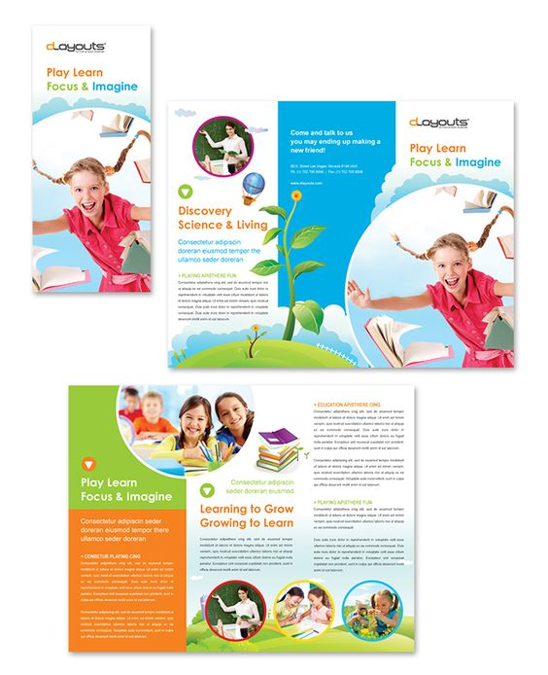 (Source: Pinterest, n.d.)
- Home visit - The nursery may have a policy requiring practitioners to visit the child and their family at home prior to the beginning of the nursery program. This will allow both the parent and the child to feel at ease in a familiar setting, as well as the practitioner to ask questions and get to know the child and parents better, establishing a strong bond and line of communication.
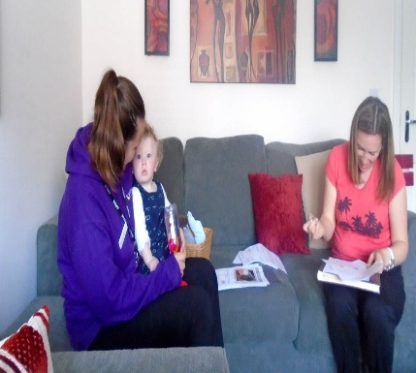 (Source: Village Nursery, 2016)
- Visit to nursery/open day - The nursery may invite the child and parent to visit at a specified time to become acquainted with the nursery setting and meet the key workers. This will allow the child to connect with other toddlers while becoming familiar with the setting, while the parents become acquainted with the environment and establish a channel of communication with key workers.
 (Source: Guest, 2017)
- Invite parents to stay with the child as they adjust to the new environment - The nursery may request that parents stay with their children for at least 30 minutes at the start of the program until they have become acquainted to the nursery environment.
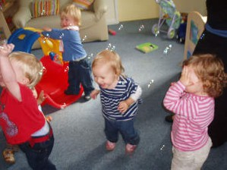 (Source: Nortonsafe.search.ask.com, n.d.)
- Provide parents with a written daily journal of their child's activities - this will help them to stay informed about their child's activities while also allowing them to participate in some of the activities at home.
 (Source: Nortonsafe.search.ask.com, n.d.)

PROPOSED OUTCOMES

Finally, key workers can examine the children to see if their strategies were successful. They may see the child socializing with other toddlers and becoming self-sufficient rather than being completely dependent on the key worker, leaving the parent without crying, or enthusiastically entering the room and greeting the caregiver. While they are successful, key workers must remember that each child is unique and will transition in a different way and require a different amount of time.
Parents who are more comfortable leaving their child in a nursery environment for a longer amount of time have a more successful transition. They feel safer and develop a trusting bond with one another along with relationships. Lillian made me very comfortable, she made me feel, your child is safe here, we do this and this, trying to explain things they’re doing every day, so obviously when you come back and children are happy, you start to trust them. (Parent Interview, Babies cited in Brooker, 2008)
Day cares, nurseries, and pre-schools can reduce the stress of transitions between phases, whether from home to nursery, nursery to school, or within the school system, by implementing their own transition plans furthermore transitions will be smooth and successful as a result of this.
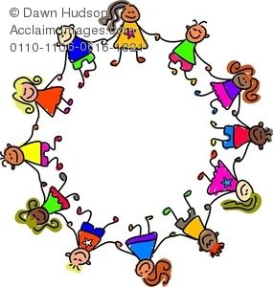 (Source: Pinterest, n.d.)
Reference List
Aline-Wendy Dunlop and Hilary Fabian (2007) Informing Transitions in the Early Years. Maidenhead: Open University Press. Available at: https://search-ebscohost com.ezproxy.uwtsd.ac.uk/login.aspx?direct=true&db=nlebk&AN=234198&site=ehost-live (Accessed: 23 November 2021).
Bing.com. (2021). [online] Available at: https://th.bing.com/th/id/OIP.fC2k5K2xp_jEXzs5vw-KsgHaE8?pid=ImgDet&rs=1 [Accessed 22 Nov. 2021].
Brooker, L 2008, Supporting Transitions in the Early Years, McGraw-Hill Education, Berkshire. Available from: ProQuest Ebook Central. [25 November 2021].
Croner-i (2019). Managing Transitions in Early Years Provisions | Croner-i. [online] Croneri.co.uk. Available at: https://app.croneri.co.uk/feature-articles/managing-transitions-early-years-provisions.
Damien Fitzgerald (2004) Parent Partnerships in the Early Years. London: Continuum (Classmates). Available at: https://search-ebscohost-com.ezproxy.uwtsd.ac.uk/login.aspx?direct=true&db=nlebk&AN=329272&site=ehost-live (Accessed: 30 November 2021).
Dunlop, A. and Fabian, H. (2007) “Informing Transitions In The Early Years”, Open
University Press
Department for education (2021). Statutory framework for the early years foundation stage Setting the standards for learning, development and care for children from birth to five. [online] Gov.uk. Available at: https://assets.publishing.service.gov.uk/government/uploads/system/uploads/attachment_data/file/974907/EYFS_framework_-_March_2021.pdf.
education.gov.vc. (n.d.). Tips for Caregivers. [online] Available at: http://education.gov.vc/education/index.php/tips-for-caregivers [Accessed 29 Nov. 2021].
Edwards, C.P., Gandini, L. and Forman, G.E. (1998). The hundred languages of children: the Reggio Emilia approach--advanced reflections. Greenwich, Conn.: Ablex Pub. Corp.
Flying Start -Annex Transition Guidance. (2017). [online] Available at: https://gov.wales/sites/default/files/publications/2019-07/flying-start-transition-guidance-for-professionals.pdf.
Giddens, A. and Bowlby, J. (1970). Attachment and Loss, Volume I: Attachment. The British Journal of Sociology, [online] 21(1), p.111. Available at: https://www.abebe.org.br/files/John-Bowlby-Attachment-Second-Edition-Attachment-and-Loss-Series-Vol-1-1983.pdf.
GOV.WALES. (n.d.). Children and families | Topic. [online] Available at: https://gov.wales/children-families.
Guest (2017). How to Help Young Children Settle Into a New Nursery. [online] First Discoverers. Available at: https://www.firstdiscoverers.co.uk/new-nursery-settle/.
Hostettler Schärer, J. (2018). How educators define their role: building “professional” relationships with children and parents during transition to childcare: a case study. European Early Childhood Education Research Journal, 26(2), pp.246–257.
lesley.edu. (n.d.). Reggio Emilia Approach to Early Childhood Education | Lesley University. [online] Available at: https://lesley.edu/academics/college-of-liberal-arts-sciences/reggio-emilia-program [Accessed 30 Nov. 2021].
Lindon, J. (2012). Understanding child development: 0-8 years. 3rd ed. ed. HODDER.
Mcleod, S. (2018). Maslow’s Hierarchy of Needs. [online] Simply Psychology. Available at: https://canadacollege.edu/dreamers/docs/Maslows-Hierarchy-of-Needs.pdf.
Nortonsafe.search.ask.com. (n.d.). daily journal, Norton Safe Search. [online] Available at: https://nortonsafe.search.ask.com/search?q=daily+journal&page=1&ctype=pictures&doi=2021-08-25&cmpgn=jul21&o=APN12178&p2=%5EEQ%5Ejul21%5E&qo=navTop [Accessed 1 Dec. 2021].
Nortonsafe.search.ask.com. (n.d.). Importance of Play, Norton Safe Search. [online] Available at: https://nortonsafe.search.ask.com/search?q=Importance+of+Play&page=1&ctype=pictures&doi=2021-08-25&cmpgn=jul21&o=APN12178&p2=%5EEQ%5Ejul21%5E&qo=navTop [Accessed 23 Nov. 2021].
Nortonsafe.search.ask.com. (n.d.). Nursery Babies, Norton Safe Search. [online] Available at: https://nortonsafe.search.ask.com/search?q=Nursery+Babies&qo=relatedSearchNarrow&o=APN12178&l=dir&doi=2021-08-25&cmpgn=jul21&p2=%5EEQ%5Ejul21%5E&ctype=pictures [Accessed 30 Nov. 2021].
Pinterest. (n.d.). dLayouts Professional templates for designer. | Brochure design template, School brochure, Trifold brochure template. [online] Available at: https://www.pinterest.ca/pin/45458277475412106/ [Accessed 30 Nov. 2021].
Pinterest. (n.d.). 25 IDEAS for Your Newborn Family Photos | Annie Baby Monitor in 2021 | Mother baby photography, Newborn baby photoshoot, Newborn baby photography. [online] Available at: https://www.pinterest.ca/pin/16536723622231379/ [Accessed 23 Nov. 2021].
Pinterest. (n.d.). In For the Long Haul: Factors Contributing to the Marriage Crisis | Child development theories, Ecological systems theory, social work theories. [online] Available at: https://www.pinterest.ca/pin/368521182010011685/ [Accessed 23 Nov. 2021].
Pinterest. (n.d.). kids in a circle clipart - Google Search | Children holding hands, Girls holding hands, Toddler art. [online] Available at: https://www.pinterest.ca/pin/487725834645383736/ [Accessed 1 Dec. 2021].
Sas.upenn.edu. 2021. [online] Available at: <https://www.sas.upenn.edu/~cavitch/pdf-library/Bowlby_Nature.pdf> [Accessed 22 November 2021].
Smidt, S. (2010) Playing to learn: the role of play in the early years. London: Routledge.
Social and Emotional Aspects of Development Guidance for practitioners working in the Early Years Foundation Stage. (n.d.). [online] Available at: https://www.foundationyears.org.uk/wp-content/uploads/2011/10/SEAD_Guidance_For_Practioners.pdf.
Supporting transitions: Using Child Development as a Guide Transitions Are Part of Life. (n.d.). [online] Available at: https://web.partnership.vcu.edu/projectseedva/downloadables/supporting-transitions-brief-one.pdf.
Teresa Wilson (2016) Working with Parents, Carers and Families in the Early Years: The Essential Guide. London: Routledge. Available at: https://search-ebscohost-com.ezproxy.uwtsd.ac.uk/login.aspx?direct=true&db=nlebk&AN=1036396&site=ehost-live (Accessed: 24 November 2021).
Village Nursery. (2016). Home Visits. [online] Available at: https://village-nursery.co.uk/2016/10/13/home-visits/.
Waltonpps.co.uk. (2021). [online] Available at: https://www.waltonpps.co.uk/wp-content/uploads/sites/4/walton-nursery-babies-milton-keynes.jpg.

