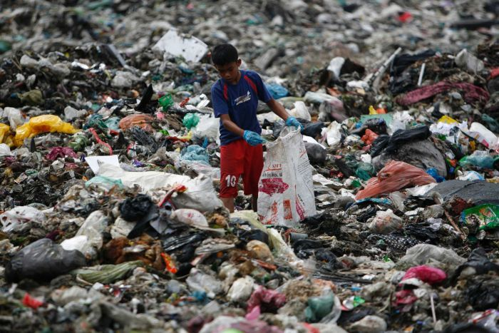
Rural Poverty: Think globally, act locally

Lesson Plan
Rural Poverty: Think globally, act locally
Subject – Education for sustainable development and global youth work  (ESDGYW) | In attendance – Natasha Oliver  Recommended- 12 + young people | Date – 11th May 2020

INTRODUCTION/BACKGROUND
The rationale for using poverty as the subject for this lesson plan was due my professional practice being solely carried out within in a youth centre in a rural community whose members have firsthand experience of poverty. By focusing on a topic which is relatable to the young people’s lives allows them to make a difference to their own actions and their communities (Welton, 2020).
Poverty is on the increase on a global scale, but research discussed in a report by Suttie (2019) estimates that in rural community’s poverty affects seventy nine percent of those who reside in these locations.
In the western world, we live in a vast growing society which promotes equality, a society which provides access to education and amenities which provide us with a high standard of living. Unfortunately we live in an extremely unequal and divided world, a world which can be divided in two, the developed world which includes the United Kingdom, Australia, and the United States and then the developing world which includes countries such as Asia, Africa and Latin America. Almost a quarter of the developing world’s population live in such terrible poverty they simply struggle to exist (Christian aid, 2017).

Objectives of the lesson
- To look at how actions or lack of action in regards to ESDGC from various countries can cause a ripple effect on other countries globally
- To actively participate in a variety of activities which provide informal learning on ESDGC and sustainability
- Provide enjoyable activities which allow choice and decision making and to work as part of a team
- Provide a feedback station which allows those involved to have their voices heard and make recommendations for change

Aims of the lesson
- Develop knowledge and understanding of the basics of ESDGC and sustainability
- Illustrate that our actions can cause damage on a global scale
- Generate discussions on poverty and the different affects it has on the population
- Develop team work skills
- Encourage action which brings change (Welton, 2020).

THE TOPIC
As outlined in the lesson overview, the key topic of this lesson plan will be poverty. This theme links to the seven key themes of ESDGC as discussed in the document ‘Education for sustainable development: A common understanding for the youth work sector’ (Welsh Assembly Government (WAG), 2008).
All of the activities which are delivered throughout this lesson plan will focus on being inclusive, participative, educative, expressive and empowering (CWYVS, 2018). They will also be directly linked to the ten principles of ESDGYW (WAG, 2008).

THE ICEBREAKER:
Bottle basher

Equipment:  - Masking tape  - two pairs of tights  - Two tennis balls  - Plastic bottles filled with water (Where possible reuse single use plastic bottles which may have been placed in recycling) | How to:  - Set up bottles in two lines, eight in each  - Split the group into teams  - Each group to line up behind line marked with tape  - Place a tennis ball in one foot of each pair of tights  - One person from each group to begin by placing the tights on their head  - On the count of three these group members try to knock the bottles down using only the tennis ball in the tights  - Once they have knocked all eight down they are to give the tights to the next team member  - The staff member will stand bottles back up as quickly as possible  - This is a race
Time:  15 minutes | Learning outcomes  - Build upon team work skills  - Each of those involved to feel at ease  - Heighten communication skills  - To promote equality of opportunity

MAIN ACTIVITY
Think globally, act locally

Equipment  - Masking tape  - Black bin bag  - Plastics and recyclables  - Pre made cards explaining which country they come from and the scene the group will act  - Paper money  - Coco beans  - Chocolate | How to  - Separate the room into four sections using masking tape  - Split the group into four smaller groups and ask each to go to one of the four sections of the room  - Ask each group to read the card in their section and then introduce their country to the other groups by acting out their scene  - Each group to then guess what was happening in each ‘country’  - Discussions on what is happening between developed and developing countries and what we can do to generate change
Learning outcomes  - To work in teams and build upon communication skills  - To understand the impact actions on a local level impact other countries across the globe  - Encourage discussion which allow the young people’s opinions and voices to be heard  - Introduce the understanding of the inequalities caused by globalisation  - Encourage action which brings change | Time  45 minutes

FEEDBACK SESSION
Message in a bottle

Equipment  - Paper  - Pens  - Recycling bags  - Plastic bottles from the main session | How to  - Each person to be given a piece of paper, pen and bottle  - Each person to put one thing they enjoyed about the lesson, one thing they didn’t enjoy, one thing they would change and one idea how we can become more sustainable on the paper  - Each person puts their feedback paper inside  - The youth worker walks round with the recycling bag and the young people try to get their feedback bottle in the bag
Learning outcomes  - Each person able to have their views and opinions heard  - Identify ways in which a change in actions can have a positive effect on our planet  - Evaluate how they feel the session delivery went  - Analyze their roles in society | Time  20 minutes

Reference list
Christian aid. (2017) The Poverty Challenge. Available at: https://www.christianaid.org.uk/sites/default/files/2017-08/the-poverty-challenge-game-schools.pdf (Accessed: 10th May 2020).
Suttie.D.(2019) Overview: Rural poverty in developing countries:issues, policies and challenges. Available at: https://www.un.org/development/desa/dspd/wp-content/uploads/sites/22/2019/03/Rural-poverty-EGM_IFAD-overview.pdf (Accessed: 10th May 2020).
Welsh Assembly Government. (2008) Education for sustainable development and global citizenship: A common understanding for the youth work sector. Available at: https://moodle.uwtsd.ac.uk/pluginfile.php/81612/mod_resource/content/1/CommonUnderstandingofESDGCinYouthWork-eng.pdf (Accessed: 10th May 2020).
Welton.N. (2020) SJYW5012. Global youth work. Lecture 7. 9th March 2020.
Image reference list
https://www.worldofbuzz.com/wp-content/uploads/2019/06/canada-says-it-wont-be-accepting-plastic-waste-sent-back-from-malaysia-world-of-buzz-2.jpg (Accessed: 10th May 2020).

