ASSIGNMENT 1
MOBILE APPLICATION ALONG WITH AR/VR TECHNOLOGY IN HOTEL AND HOSPITALITY SECTOR THAT AIDS IN HOTEL BOOKING AND SOLVING CUSTOMER QUERIES

Table of Contents
1.0 Introduction 3
2.0 Overview of literature: 4
3.0 Application of technology in the hotel and hospitality sector 7
4.0 Future policy and management options for incorporating AR/VR-based hotel booking mobile applications 10
5.0 Conclusion 11
Reference 12

1.0 Introduction
The selected theme and its importance
It is to state that in the present times, the usage of technology is done in the hotel and hospitality industry in a proficient manner. In the present case, the considerations of the Mobile app technology are done along with the incorporation of the AR and VR technology for the booking as well as customer query solving in the hotel as well as the hospitality industry. A report by Medium (2018) has highlighted that about 85% of the time is spent on mobile apps by the end users. Mobile apps are able to help the hotel and hospitality companies in their user engagement, customer loyalty as well as their communication medium.
The details of the hotel as well as the hospitality industry and its relevance
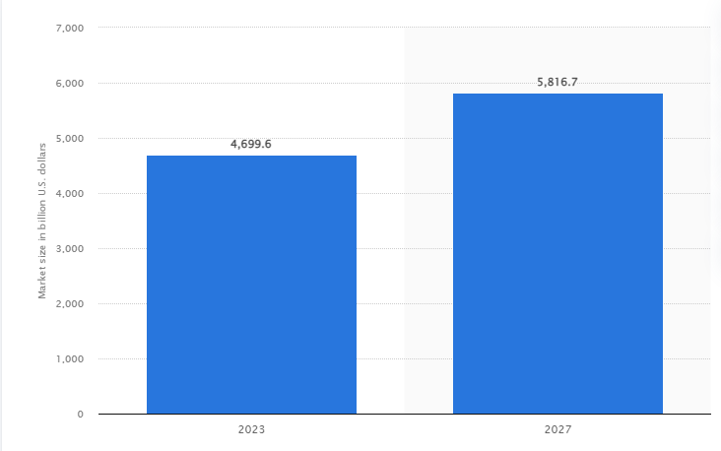
Figure 1: Market size of the hotel and hospitality industry
(Source: Statista, 2023),
A report by Statista (2023), is able to present the fact that 4.699 billion US dollars and it is expected to reach the figure of 5,816 billion by the end of 2027. It is able to highlight the fact that this industry is one of the essential industries in the world as it is able to highlight the revenue that is contributed by the industry in the global economy.
Prevalence of technology in the hotels as well as hospitality sector
Tomislav and STIFANICH (2020), highlight that the use of technology is becoming prevalent in the hotel as well as hospitality sector. 74% of the travellers prefer to use mobile apps for their booking and other works. Further, hotel apps are used by 70% of travellers to make their booking decisions (Tomislav and STIFANICH, 2020). It is able to gives an insight on the prevalence of the technology in the hotel as well as hospital sector. Cooper and Hall (2019), state that technological incorporation is significant in hospitality sector.

2.0 Overview of literature:
SWOT analysis

Strengths  - Mobile apps are helping in the increment of the customer engagement (Abdelmoaty and Soliman, 2020).  - It is able to help in the addressal of queries as well as questions of the customers (Anand et al., 2023).  - It is helping in hotel booking for the customers.  - AR and VR technology usage is increasing customer satisfaction | Weakness  - The use of AR and VR can increase the cost of the customers (Thelen, 2022).  - Limitation of technology is one of the main hurdles in reference to AR and VR technology.
Opportunities  - It can help the hotel industry to give exclusive experiences to customers (Anand et al., 2023).  - It can increase the trust of the customers regarding the hospitality sector. | Threats  - Taxation of VR technology applications can enhance the cost of the hotel and hospitality firms (Thelen, 2022).  - The use of the technologies can bring legal issues.

Impact of the mobile app in the hotel as well as hospitality industry for the booking as well as customer queries
Kamboj and Gupta (2020), in their study, are able to highlight the fact that service providing firms have been using M-commerce as the platform that is allowing them to reach to their customer in an effective manner. The features of mobile apps happen to include ubiquity, portability as well as personalisation. The engagement of the users is increased through such measures.
On the other hand, Abdelmoaty and Soliman (2020), in their study, have highlighted that the usage of mobile apps can be done in innovative ways. Many of the employees of the customers of the hospitality sector have been opting to do the usage of mobile phones for paying the bills. It can be said that the usage of the mobile phones is done for the booking of the hotels. Apart from that it can be said that the usage of the mobile apps is to be done for the consideration for addressing the queries of the consumers in a proficient manner.
Impact of AR and VR technology along with the Mobile apps in the hospitality as well as the hotel industry
According to Anand et al. (2023), the use of AR-based apps has been able to focus on three essential quality determinants. This includes the service quality, information quality as well as system. It is to state that the consolidation of customer satisfaction can be achieved with AR-based apps. Optimisation of the customer queries can be done with the help of such technology.
On the other hand, Thelen (2022), in their study has highlighted that use of the AR and VR technology is done in the pre-booking stage. It is able to help in the resolve of the questions as well as insecurities that the customers have regarding the facilities as well as accommodation in the hotels. Thelen (2022), in their study, is able to further highlight that weakness in relation to technology includes technology limitation, increasing the cost of customers as well as creation of a distance in respect to the real experience. The threats of the element include taxation in reference to the VR technology and it can create legal issues in respect to the technology.
Theoretical perspective of the study
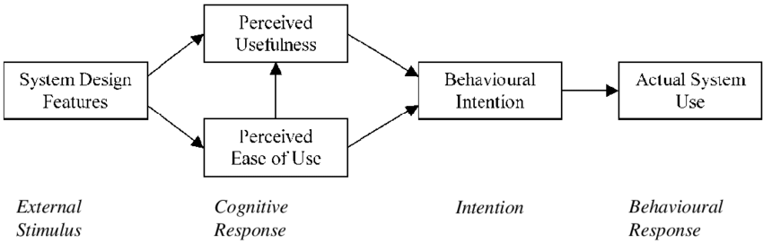
Figure 1: Technology Acceptance Model
(Source: Goh and Wen, 2021)
Incorporation of the different theories is to be done. Goh and Wen (2021), highlight that the technology acceptance model gives the notion that the ease of use as well as the usefulness happens to be an important element in the acceptance of a technology. Ford and Sturman (2020), in their study, are able to imply the fact that the tourism industry is able to highlight the fact in the tourism, the customer interaction plays a pivotal part. It is to state that the mobile apps as well as AR and VR are useful as an opportunity for customer engagement. However, perceived usefulness can be questioned. A better understanding of it can be done with the help of diffusion of innovation theory.
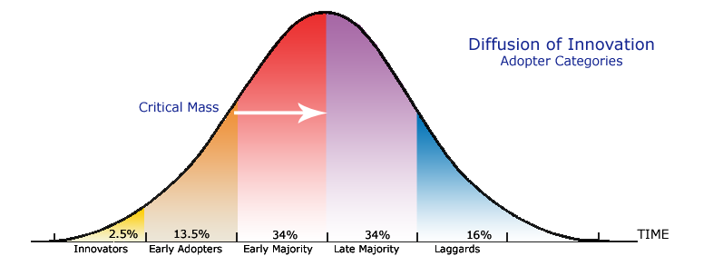
Figure 2: Diffusion of innovation theory
(Source: Al Mansoori et al., 2016)
As per the observation of the study of Min et al. (2021), the diffusion of innovation theory is able to imply that most of the individuals as well as entities take a considerable amount of time to get accustomed to new technologies. Even in the case of the technologies such as the AR, VR and mobile apps, it is to state that a certain time will be needed.

3.0 Application of technology in the hotel and hospitality sector
In the modern context of any industry, technology has started to play an important role in raising the capacity of the business to perform and raise overall operational efficiency of organisations. Contemporary systems have had an impact that contributes to the development of the hospitality industry (Cooper and Hall, 2019). Moreover, in the modern world, the tourism and hospitality industry is shifting to address the changing technology scope (Lemelin et al., 2013). This is the consideration that will be key to conducting this study, especially in the context of the hotel and hospitality industry. As opined by Jayawardena et al. (2023), digital transformation has been an evolutionary process which can leverage the digital infrastructure in any geographical location and the available technologies to develop operational competencies and customer service capabilities in the hotel and hospitality industry. This level of technological acceptance has been an instrumental step in the innovative capacity of the hotel and hospitality industry (Brotherton, 2015). More specifically, mobile technology has become a significant tool in the industry in discussion to develop technological acceptance to enhance customer relationship management and service quality. As per Law et al. (2018), Information and Communication Technologies, commonly referred to as ICTs have significantly impacted the hospitality industries for a long time. In the modern era of the smartphone and smartphone applications, this technology has provided positive reinforcements towards effective data transmission, accumulation and analysis. Therefore, from this discussion, it can be clearly presented that the goal of this report will be focusing on the assistance of smartphone applications in the technology acceptance capacity of the customer service aspect of the hotel and hospitality industry.
Furthermore, extended acceptance of mobile phone technology, such as smartphone applications has been a critical upgrade in developing the capacity of the hospitality sector in developing improved communication with customers, therefore, enhancing its capacity to serve the customers in the most effective manner. As defined by Huang et al. (2019), technical innovations have been among the most relevant undertakings benefitting the service capacity of the hotel and hospitality industry. Many hospitality businesses have developed smartphone applications for enhanced communication with customers to develop overall guest satisfaction and generate an avenue for enhancing customer loyalty. Technologies such as mobile applications can also add certain drawbacks for customers, such as vulnerability to data theft and other cybersecurity issues. According to Veleva and Tsvetanova (2018), limitations such as technological barriers can have a negative impact on the application of smartphone technologies on the hospitality industry. More importantly, lack of consumer trust, lack of security of personal data and difficulty in building customer relationships are the other issues faced by the industry in this factor as well, especially, when considering mobile applications for digital marketing. The American hotel chain, Marriott, developed the Marriott Bonvoy app, which has used augmented reality (AR) technology to use the mobile phone of a guest as the room key (Marriott, 2024). While this technology has been there in one form or another in the hotel chain since 2010, in the post-pandemic era, this technology has been critical to addressing social distancing norms while not harming the operational capacities of the hospitality organisation.
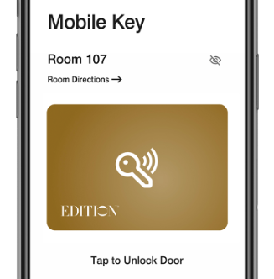.
Figure 3: The Marriott Bonvoy mobile room key feature
(Source: Marriott, 2024)
In this case, it has been observed that technological innovation has afforded the organisation the opportunity to facilitate simplifications in human life, creating a technological revolution. This scenario can be considered a significant example of an effective incorporation of the technology acceptance model (TAM) (Aburbeian et al., 2022). Another major hotel chain, Radisson hotels has considered the utility of mobile applications for online checking in and checking out. The mobile application for the hotel chain can be utilised by organisations to express their own tastes and preferences and making the checking in and checking out processes simplified for the customers (Raddisson-hotels, 2024). As observed in the aftermath of the global pandemic, the application of mobile technologies, such as mobile check-in has created a positive guest experience, guests’ control over services, room quality and creating a general enhanced experience. As observed by Chan et al. (2021), the applications of these technologies have also benefited by aiding control and prevention measures for the COVID-19 virus. It is also important to note that the technology considered for the development of these mobile applications is the Internet-of-Things concept, which enhances the capacity of an organisation to utilise technology to effectively render any service to the customers when necessary (Car et al., 2019). Also as per Car et al. (2019), the concept of automatic check-ins in hotels has been an IoT-enabled technology factor, which has also presented certain weaknesses, such as privacy and security issues, as well as a challenge to data management due to generation of complex software systems.
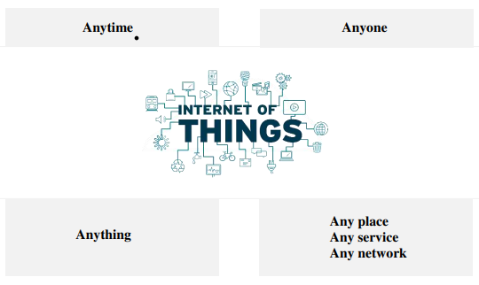
Figure 4: The concept of IoT
(Source: Car et al., 2019)
However, the application of mobile technologies in the hotel industry has primarily aided the industry to deliver improved customer service aspects. An observed case has been that of the automated booking app of Premier Inn, which has driven up the revenues of the hotel chain by 1.6 million USD (Butcher, 2023). Thus, the considered technology aspect of using AR and VR technology to aid an improved automated hotel booking experience in the hotel and hospitality industry can be beneficial to the industry.

4.0 Future policy and management options for incorporating AR/VR-based hotel booking mobile applications
In this section of the study, there will be two types of recommendations presented. The first type of recommendation will be focusing on general application of technological tools in the hotel and hospitality industry, especially when considering the incorporation of smartphone applications. The second type of recommendation will aid the understanding of the industry leaders in the application of augmented reality and virtual reality-based technology incorporation in automated hotel booking for mobile applications.
- The first recommendation that can be feasible for the given subject of the study will be enhanced cyber risk management strategies. Cyber risk mitigation systems can include technologies such as benefits of digital risk reductions, using measures such as end-to-end encryption for mobile communication, the reduction of entry points, management of bugs and glitches and hardware issues (Paté‐Cornell et al., 2018). These risk management actions can be effective as cybersecurity measures in the case of mobile applications. End-to-end encryption can be specifically effective as it creates a wall around any form of conversation between the hospitality institution and the customers, protecting sensitive information.
- Another recommendation in this case can be placing a focus on the utility of mobile phones as communication tools (O’connor and Andrews, 2018). The task of a smartphone as a communication device can be the management of data and information sources. This can aid the management of customer data such as specific tastes and preferences. This can enhance the process of generating augmented reality or virtual reality imaging for serving the customers.
- Digital technology can also improve the aspect of inclusivity and diversity in the operations of the hospitality industry. Mobile applications can have the significant attribute of allowing enhanced capacity to people with disabilities such as autism, creating more inclusive hospitality experiences in the post-pandemic era (Rehman et al., 2021). For example, specific tools can be presented by the digital application that can aid people with disabilities be able to use the online booking and checking-in functions. Augmented reality can also benefit by assisting these inclusive practices.
The application of artificial intelligence (AI) and machine learning (ML)
AI and ML can aid the developers of the mobile applications in providing the opportunity to machines to emulate human intelligence and learn by gathering additional information from ‘experiences’ (Castanyer et al., 2024). Therefore, a learning mobile application can be developed. This learning mobile application can gather information on the basis of customer preferences, therefore, creating an enhanced customer experience with every learning experience.

5.0 Conclusion
In the conclusion of the study, it is to imply that the usage of the mobile apps is being done in the hospitality sector in a proficient manner. The reason for this is that it is able to help in the conductance of a certain number of applications of the industry such as the booking of the hotels as well as the resolving the customer queries that the consumers have regarding the accommodation that they are willing to take. The use of AR and VR technology is also helping in this cause as all the answers or queries of the customers can be addressed with the help of the AR and VR technology. The use of the technologies is done in hotels such as the Premiere Inn as well as the Marriott. However, a certain number of hurdles in respect to the technology are to be considered. For example, the incorporation of the technology can make an increment in the overall cost of the customers in an efficient manner. Apart from that there is a possibility that legal issues can arise with the use of the technology.

Reference
Abdelmoaty, G.A. and Soliman, S.A.E.M., (2020). Smart Technology Applications in Tourism and Hospitality Industry of The New Administrative Capital, Egypt. Journal of Association of Arab Universities for Tourism and Hospitality, 19(2), pp.102-129.
Aburbeian, A.M., Owda, A.Y. and Owda, M. (2022) A technology acceptance model survey of the metaverse prospects. Ai, 3(2), pp.285-302.
Al Mansoori, H., Ali, A.B. and al Hassan, M.K., (2016). Nature and Quality of Smart Government Services: The Case of the UAE. International Journal of Enhanced Research in Science, Technology & Engineering, 5(1), pp.53-64.
Anand, K., Arya, V., Suresh, S. and Sharma, A., (2023). Quality dimensions of augmented reality-based mobile apps for smart-tourism and its impact on customer satisfaction & reuse intention. Tourism Planning & Development, 20(2), pp.236-259.
Brotherton. B (2015) Researching Hospitality & Tourism 2nd Edn. Sage. London
Butcher, D. (2023) Don’t miss Tomorrow’s Retail Industry News, Retail Dive. Available at: https://www.retaildive.com/ex/mobilecommercedaily/premier-inn-app-drives-more-than-1-6m-in-revenues (Accessed: 29 January 2024).
Car, T., Stifanich, L.P. and Šimunić, M. (2019) Internet of things (iot) in tourism and hospitality: Opportunities and challenges. Tourism in South East Europe, 5, pp.163-175.
Castanyer, R.C., Martínez-Fernández, S. and Franch, X. (2024) Which design decisions in AI-enabled mobile applications contribute to greener AI?. Empirical Software Engineering, 29(1), pp.1-34.
Chan, I.C.C., Ma, J., Ye, H. and Law, R. (2021) A comparison of hotel guest experience before and during pandemic: evidence from online reviews. In Information and Communication Technologies in Tourism 2021: Proceedings of the ENTER 2021 eTourism Conference, January 19–22, 2021, pp.549-556. Springer International Publishing.
Cooper, C. and Hall, C.M. (2019) Contemporary Tourism: An International Approach, 4th Edn. Goodfellows, Oxford.
Ford.R.C, Sturman.M.C (2020) Managing Hospitality Organizations 2nd Edn. Sage, London.
Goh, E. and Wen, J., (2021). Applying the technology acceptance model to understand hospitality management students’ intentions to use electronic discussion boards as a learning tool. Journal of Teaching in Travel & Tourism, 21(2), pp.142-154.
Huang, Y.C., Chang, L.L., Yu, C.P. and Chen, J. (2019) Examining an extended technology acceptance model with experience construct on hotel consumers’ adoption of mobile applications. Journal of Hospitality Marketing & Management, 28(8), pp.957-980.
Jayawardena, C., Ahmad, A., Valeri, M. and Jaharadak, A.A. (2023) Technology acceptance antecedents in digital transformation in hospitality industry. International Journal of Hospitality Management, 108, p.103350.
Kamboj, S. and Gupta, S., (2020). Use of smart phone apps in co-creative hotel service innovation: an evidence from India. Current Issues in Tourism, 23(3), pp.323-344.
Law, R., Chan, I.C.C. and Wang, L. (2018) A comprehensive review of mobile technology use in hospitality and tourism. Journal of Hospitality Marketing & Management, 27(6), pp.626-648.
Lemelin, H., Dawson, J. and Stewart, E.J., (2013) Last chance tourism: Adapting tourism opportunities in a changing world. Routledge.
Marriot (2024) Access more, Marriott Bonvoy App. Available at: https://mobile-app.marriott.com/en-us (Accessed: 29 January 2024).
Medium. (2018). How Mobile Apps and Technologies are Supporting Hotel Industry. Available at <https://medium.com/@dailywebtips/how-mobile-apps-and-technologies-are-supporting-hotel-industry-64af531902b8 > [Accessed 29 January 2024]
Min, S., So, K.K.F. and Jeong, M., (2021). Consumer adoption of the Uber mobile application: Insights from diffusion of innovation theory and technology acceptance model. In Future of tourism marketing (pp. 2-15). Routledge.
O'connor, S. and Andrews, T. (2018) Smartphones and mobile applications (apps) in clinical nursing education: A student perspective. Nurse education today, 69, pp.172-178.
Paté‐Cornell, M.E., Kuypers, M., Smith, M. and Keller, P. (2018) Cyber risk management for critical infrastructure: a risk analysis model and three case studies. Risk Analysis, 38(2), pp.226-241.
Radissonhotels (2024) Explore our hotels offering online check-in | radisson hotels. Available at: https://www.radissonhotels.com/en-us/radisson-plus/online-check-in (Accessed: 29 January 2024).
Rehman, I.U., Sobnath, D., Nasralla, M.M., Winnett, M., Anwar, A., Asif, W. and Sherazi, H.H.R. (2021) Features of mobile apps for people with autism in a post COVID-19 scenario: Current status and recommendations for apps using AI. Diagnostics, 11(10), p.1923.
Statista. (2023). Market size of the hospitality industry worldwide in 2023, with a forecast for 2027. Available at <https://www.statista.com/statistics/1247012/global-market-size-of-the-hospitality-industry/ > [Accessed 29 January 2024]
Thelen, A.E., (2022). The Challenges and Benefits of Implementing Virtual Reality and Augmented Reality in the Hotel Industry.
Tomislav, C.A.R. and STIFANICH, L.P., (2020). Mobile technology: a tool to increase hotel sales and revenue. Economics Business and Organization Research, pp.454-465.

