INTROUDCING THE MODERN WORKPLACE (LCBB4003)
Group Report
by:
Georgian Alexandru Gogoase(2026827)
Ana Gurduz (2029605)
Elena Nicoleta Oprea (2024786)
Mihail Pasat (2028167)

Lecturer: Uju Ugochukwu

University of Wales Trinity Saint David

Contents
Introduction and Company Overview 3
Background of Tim Cook 5
Leadership Style of Tim Cook 7
Extrinsic and Intrinsic Motivations Used by Tim Cook 9
Extrinsic Motivations in Apple Used by Tim Cook 9
Intrinsic Motivations Used by Tim Cook 11
Leadership, Personality and Motivational Theories to Substantiate the Tim Cook’s Strategies 13
Democratic Leadership 13
Transformational Leadership 14
Maslow’s Hierarchy of Needs 15
Goal-Setting Theory 16
Reinforcement Theory 17
The Ways in Which Employee’s Performance Can be Increased Through Extrinsic and Intrinsic Motivations 19
Other Conclusions Which Can be Drawn from the Leadership of Tim Cook 21
References 22

Introduction and Company Overview

Leaders play a prominent role in case of organising business by allocating resources efficiently as well as motivating employees to attain organisational goals and objectives (Daft and Lane, 2015). CEOs or leaders of successful multinational companies’ direct employees toward an organisational goal by using various internal and external motivational aspects. In this group report the ins and outs regarding the CEO of Apple, Tim Cook’s leadership style along with the strategies that he used and using since 2011 after the departure of Steve Jobs are going to be discussed.
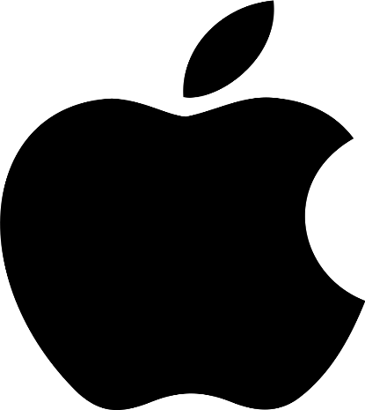
Figure 01: Apple’s Logo (www.designrush.com)
Apple is recognised as the most innovative company by Boston Consultancy Group in 2020 (Markander, 2021). Apple, the most prominent and influential tech company of this generation, was founded back on 1st April 1976 in California (Los Altos) in the United States which operates over 500 retail stores across 25 nations. Although it is headquartered in California, United States, it has established dominance in other regions in which they operate. Broadly, it has three product divisions, these are consumer electronics, computer software, and online services. It has earned $274.5 billion in 2020 even amidst the global pandemic. Currently, it has approximately 147,000 employees all over the globe who work relentlessly to innovate for ensuring a better future. It has a number of subsidiaries which include Braeburn Capital, Beats Electronics, Claris, Apple Energy, LLC Apple Sales, International Apple Services and Apple Worldwide Video. Apple is singlehandedly bringing numerous innovations in versatile fields within the tech industry. Some of the prominent brands of Apple are iPhone, iPad, Apple Watch, Apple TV, iPod and HomePod. Apple entered the on-demand streaming service industry on 1st November 2019 with the introduction of Apple TV+. This way, Apple not only brings innovation by manufacturing creative products but also provides quality and innovative services through their Apple TV+. The company which started its journey by manufacturing Mackintosh now contains 15.5 per cent of the market share in terms of sells units to end-users within the smartphone industry in the first quarter of 2021 (Apple, 2021).

Background of Tim Cook

Timothy D. Cook, current CEO of Apple, born on 1st November 1960 in Alabama in the US. He graduated from Robertsdale High School and got his MBA from Duke University and then earned a degree from Auburn Industry in Industrial Engineering. His working career started as a newspaper delivery boy in his hometown. Before joining IBM, he also worked at a paper mill and an aluminium plant (Apple Leadership - Tim Cook, 2021).

Figure 02: Timothy D. Cook, current CEO of Apple (www.twitter.com)
Tim worked with IBM for almost 12 years where he successfully handled manufacturing and distribution functions. After that, he shifted to Compaq in which he worked as a vice president responsible for procuring and managing all of Compaq’s product inventory (Apple Leadership - Tim Cook, 2021).
He joined Apple back in as senior vice president of worldwide operations, after one year of re-joining of a legendary figure, Steve Jobs. Tim Cook was also served as CPO (Chief Operating Officer) of Apple before taking the mantle of the CEO after the departure of Steve Jobs. As Amazon was going through severe financial trouble which made them nearly bankrupt during the time of Steve’s departure, many thoughts Tim Cook will not be the right person for the job. But Tim’s hard-working mentality along with his sheer intelligence he came up with a number of organisational changes and innovations which helped Apple to reinvigorate and revamp its strategies to stay competitive and ensure future sustainability. He motivates employees through the right type of incentives and Cook has introduced new product lines for Apple focusing more on services like Apple Music and Apple TV+ and rather than products. Currently, with a market cap of 2 billion, it is considered the most valuable company in the world which refers to the fact that Tim Cook is an exceptional leader and CEO of the organisation (Tim Cook took the helm at Apple 9 years ago. Here's how he got his start and built Apple into the world's most valuable company., 2021).

Leadership Style of Tim Cook

Unlike Steve Jobs, who is pinpointed as an autocratic yet successful leader by many of the industry experts, Tim cook is an improvised democratic leader as he has all the favourable traits of a democratic leader (Kim, 2020). For example, even with his immense experience and industry knowledge, he always welcomes different opinions as he keeps the platform open for everyone. By saying “everyone” it does not indicate employees and managers of the organisation exclusively but also refers to other stakeholders like customers. Under the management of Tim Cook, Apple introduced a community section within the discussion forum of the official website of Apple in which literally anyone can share his/her ideas, feelings, thoughts about Apple and its products (Contacting apple with a new product idea - Apple Community, 2021). A prominent trait of a democratic leader is they listen to their surroundings meticulously as they welcome feedback based two-way communication. But the term “improvised” applies to Tim Cook because not all the traits of a democratic leader are presented in Tim. For example, in the case of making an informed decision, he does not depend on what the majority says, rather he focuses on the needs and the demands of the market which is tagged with the potential new external trends (Kim, 2020). In other words, from some perspectives, he has a quality of a transformative leader and adaptive leader too.
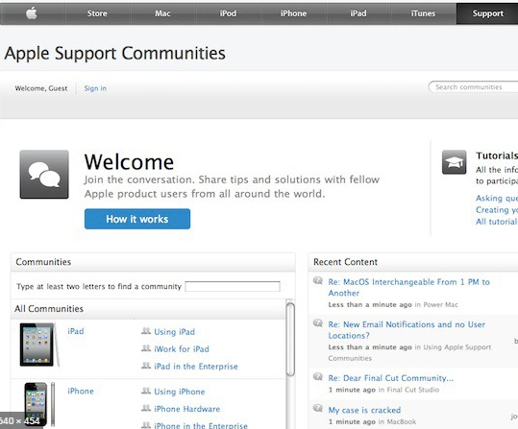

Figure 03: Community Forum of Apple (www.discussions.apple.com)
For example, during the time of Apple Watch’s development, some of the key members of top management were cynical as it was requiring a vast number of resources to implement. But Tim convinced them with his charismatic attitude and influencing words that vast resources will only be needed in the development process, after that due to the economies of scale, Apple will be able to reduce its manufacturing costs significantly (Kim, 2020). After the introduction of the Apple Watch, it turned out a critical success for the organisation, thanks to Tim Cook’s transformative leadership traits.
In the same way, Cook was able to oversee the trend of on-demand services and invested heavily on Apple TV+ in 2015, which provides them with a revenue of $14.5 billion whereas the total revenue was 274.52 billion U.S. dollars in 2020 amidst the time of COVID-19 when many successful organisations forced to cut off employees due to shortage of revenue (Goldsmith and Goldsmith, 2021). This indicates Cook has the ability to predict the trend and changes strategies according to the alteration within the external environment, which is a trait of adaptive leadership.

Extrinsic and Intrinsic Motivations Used by Tim Cook

Extrinsic motivation is one kind of encouragement that is given to an individual by an outside party with the help of financial or non-financial incentives as a reward to attain something particular whereas intrinsic motivation is all about personal satisfaction which comes from inside of an individual without the influence of external rewards.

Extrinsic Motivations in Apple Used by Tim Cook

At the time of Steve Jobs departure, the company was needed to reform as tensions and miscommunications raised between management and employees which lessened the employee relations within Apple. After taking the mantle, Cook utilised some of the strategic motivational ways to resolve the severe problem temporarily.
Providing Products Instead of Raising Salary: Due to the departure of Steve Jobs lower-level management and employees started to think it would impact them negatively because although Steve was an autocratic leader, he knew how to incentivise employees to get the job done. To eradicate this type of negative thought, Cook provided free iPod Shuffle to the employees. Besides, he has started a scheme known as “recognition bonus” for the management who are not able to implement any idea due to less viability or resource limitation but give tremendous effort to bring innovation. This way, Cook was successfully able to encourage top management to be brave and fearless in case of trying new things which is the lifeblood of a tech-based innovative company.
Widening Opportunities for Customised Skills Development Programme: Even before Tim Cook, Apple spent a considerable number of resources behind arranging training sessions as it directly improves the work efficiency of employees. But Tim cook focused on existing employees rather than the ones who are newly recruited because the implementation of an innovative idea is the responsibility of existing employees who have experience and the organisation’s culture-related knowledge. That is why he increased development sessions rather than training sessions which motivated employees to work better as they attained a more in-depth practical understanding of various topics and subjects. Besides cook reduced the length of the development sessions and widened the array of subjects. For example, he curtailed development sessions like macOS Support Essentials 11 and App Development with Swift, 6-months to 3-months which motivated employees because it is psychologically proved that short-term learning processes are less boring and completed by more individuals than the lengthy ones. But the reduced timeframe did not sacrifice the quality because he introduced versatile development sessions on different topics even which were trendy but not related to the existing product line of Apple. That is how Apple was able to start their own streaming channel through Apple TV+. Employees were motivated and encouraged by the customised development opportunity as they practised with flexibility without the company pressure using self-paced training in the training-apple app. Remote working opportunities and flexible timing opportunities were tagged with the development sessions which also motivated employees as freedom and motivation are positively connected.
Various Perks and Benefits: Perks and benefits are important to motivate employees in a workplace. 21st-century employees do not always prefer monetary benefits, especially the employees who are creative and innovative. Tim cook, as very good at understanding trends and individuals’ preferences, introduced gym credit opportunities as the ongoing trends of health awareness are increasing at an exponential rate. In their Cupertino California office, Apple offers 300 dollars for the sole purpose of enhancing employees’ fitness (8 Amazing Employee Perks At Apple, 2021). As part of the health and wellbeing package, they also provide generous health and dental insurance package. Besides, employees who work in night shift and at weekends get free access to the on-site apple cafeteria’s foods. To offer commute support Apple offers cycles to employees as well as offers discounts to the local public. To remain highly competitive amidst Silicon Valley’s other tech giants, Cook started to provide an annual 25% discount to the apple employees when they purchase an iPod computer or iPad, every three years workers can get 250 dollars discount on an iPad or a 500-dollar discount on a mac (8 Amazing Employee Perks At Apple, 2021). Depending on the product they also provide discounts for the family and friends of the employees. Finally, offering discounted stock purchase options motivates talented employees to loyal Apple employees (8 Amazing Employee Perks At Apple, 2021).

Intrinsic Motivations Used by Tim Cook

Creating a Culture of Belongingness: Cook, being an improvised democratic leader, created an atmosphere of sharing emotions, thoughts and ideas. For example, Apple largely depends on team efforts as they constantly create, diverge and reshuffling team members to get the best out of them (Apple employees reveal the 19 best things about working for the world's most valuable company, 2021). This way, the whole organisation works as a family at the same time keeping the professionalism intact. Unlike many other tech companies, Cook ensures creating a work-friendly indicates a “balanced” culture in which everyone demonstrates love and respect toward others but upholding professionalism at the top. This way employees feel they are working in a family where positive emotions spread which positively associated with motivation.
Practising Gratitude: Almost all successful leaders and CEOs show gratitude toward their employees from time to time. The exception for Tim Cook is, he shows his gratitude publicly as well as privately (How Tim Cook Motivates His Team in Under a Minute, 2021). He shows gratitude through e-mail as even many low-level workers get direct mail from the CEO which inspires them to do better. He also utilises various social media to show constant support toward his employees.
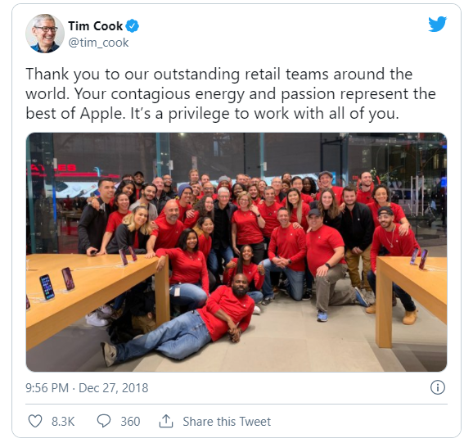
Figure 04: Demonstration of Gratitude Publicly (www.twitter.com)
Acknowledging Accomplishment: Tim Cook gives gift cards to acknowledge their accomplishment. Not only that but also, he created Apple’s considerate paid-time-off reward for a global workforce. For example, at the time of the holiday season, Apple surprised its employees with an extended holiday so that the entire workforce could take a week’s break. More interestingly, Tim Cook singlehandedly decided to provide paid holidays for three days in a row Instead of just one day off on Thanksgiving. Besides, Apple always consider employees’ locations and job roles while tailoring reward scheme so that workers in a remote region of the world would get paid time off during an equivalent holiday (Apple employees reveal the 19 best things about working for the world's most valuable company, 2021).

Leadership, Personality and Motivational Theories to Substantiate the Tim Cook’s Strategies

Democratic Leadership

The main essence of democratic leadership is associated with the fact that whether leader appreciates feedback from employees or his/her subordinate. Unlike autocratic leaders, democratic ones welcome individuals to share their thoughts, emotions and ideas. At the same time share their ideas with the subordinates, unlike the laissez-faire leadership where leaders put all the responsibility to the employees (Davis, 2018). As Steve Jobs followed autocratic leadership it does not mean it is superior leadership. Because Steve Jobs was a prodigy level genius, so instead of discussing with the employees, he ordered directly to implement the plan, but for the other leaders, this approach may reduce employees’ company loyalty and increase the turnover ratio. Cook represents democratic leadership because unlike autocratic or laissez-faire he thrives for fruitful discussion with his employees where ideas are mutually shared between employees and leadership.

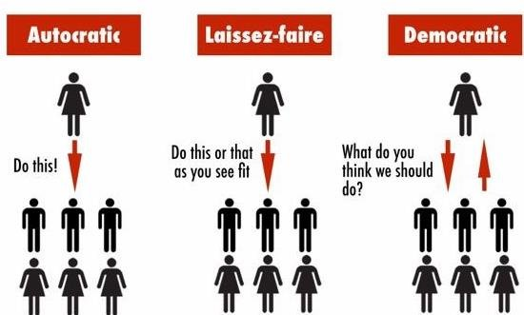
Figure 05: Comparison between Democratic, Laissez-Faire and Autocratic (www.medium.com)

Transformational Leadership
Transformational leadership is all about charismatic leadership in which leaders influence employees to attain the goals and objectives that leaders want to attain for organisational success (Davis, 2018). There are four components of transformational leadership (Safire and Safir, 2016). The first one is inspirational motivation which indicates the leader articulates a vision and inspires and motivates employees. Tim cook follows this in the case of developing the Apple Watch as he convinced TMTs (top management team) to implement this idea.
Secondly, idealised influence indicates transformational leader inspires respect and trust through high ethical standards which have been ensured by Tim Cook as he thrives for a “balanced” work-friendly environment discussed previously.
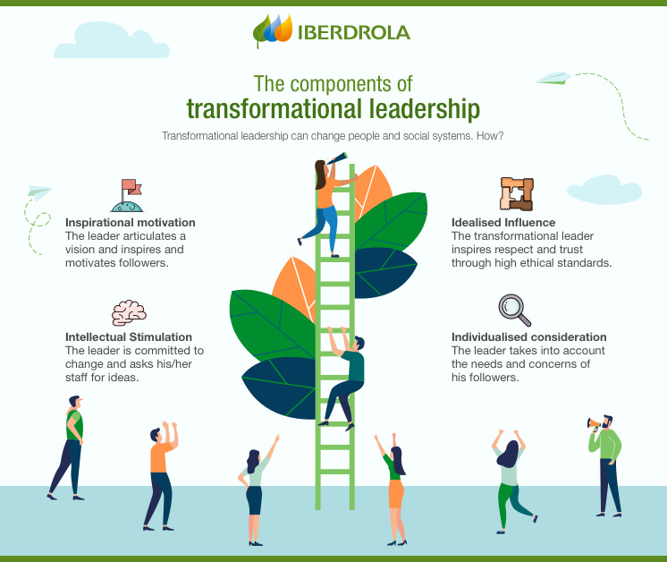
Figure 06: The Components of Transformational Leadership (www.iberdrola.com)
Then intellectual stimulation indicates the leader is committed to change and asks his/her staff for ideas (Davis, 2018). Tim cook started the community forum which works as the innovation funnel for Apple for a couple of years.
Fourthly, individualised consideration indicates the leader takes into account the needs and concerns of followers which can also be pinpointed within Tim Cook as he ensures to provide paid holidays for three days in a row Instead of just one day off on Thanksgiving which was discussed previously.

Maslow’s Hierarchy of Needs

This motivational theory demonstrates both extrinsic as well as intrinsic motivational approaches through five states. Physiological needs are the extrinsic approaches as foods, shelter, accommodation etc. which are provided to employees. In the 21st-century demands of employees have been evolved and they prefer to have a superior way to practise these rights, meaning apart from providing launch time, job safety or basic bonuses they need to provide unique ways to cater for these basic human needs more conveniently (Safire and Safir, 2016). Tim cook’s decision to provide cycle service for commute or free access to the apple food cafeteria for night shift and weekend workers are some of the implementations of modern-day physiological needs. Same way, by creating a culture of the shared-belongingness company ensures 3rd needs which are known as “love and friendship needs.” It is an example of intrinsic motivation’s implementation using Maslow’s hierarchy of needs.
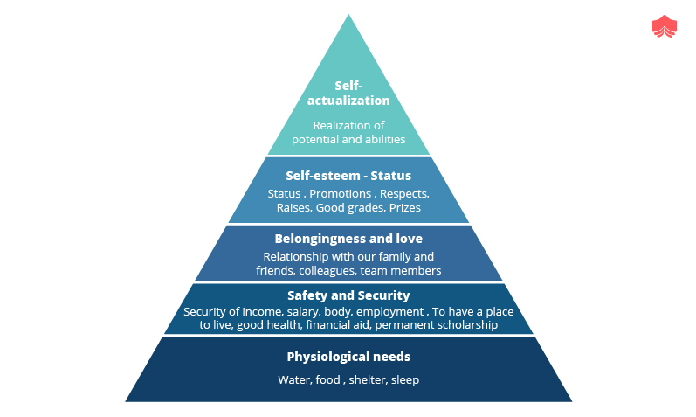
Figure 07: Maslow’s Hierarchy of Needs (www.corporatefinnaceinstitute.com)

Goal-Setting Theory

According to goal-setting theory, short, challenging yet attainable goals are most effective because employees get inherently motivated by these types of goals as they feel they are valued by the organisation (Locke and Latham, 2018). According to this motivational theory, leaders set goals that are short in length but challenging to inspire employees to attain the goals. When they are provided with challenging tasks, employees think the company puts enormous belief in them, so they need to ensure quality achieving it effectively (Locke and Latham, 2018). This theory is utilised by Tim Cook in the case of formulating the development programme as he reduced the 6-month courses to 3-month courses but introduced more array of varieties in the case of development programmes that assist employees to thrive for more complex skills and capabilities than the basic ones provided before.

Reinforcement Theory

This theory composed of four components which are positive reinforcement, negative reinforcement, punishment and extinction (Safire and Safir, 2016). Steve Jobs believed in negative reinforcement which suggests if employees are able to demonstrate positive behaviour negative consequences will not going to happen. For example, if the creative manager was able to produce 2 incremental ideas and 1 radical innovation he will not be fired from the organisation, in other words, the negative consequences will not be applied to him /her due to his/her success. On the other hand, Tim Cook strongly believes in positive reinforcement rather than negative reinforcement, let alone punishment.

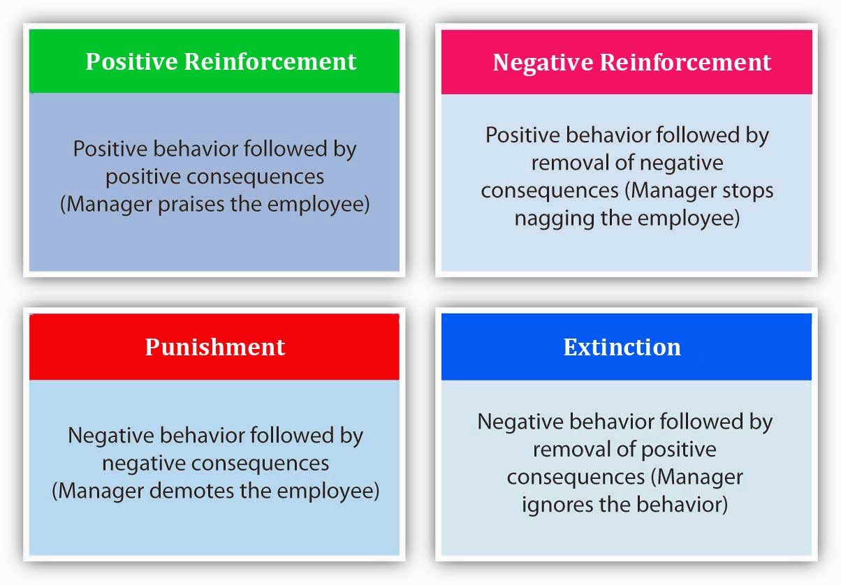
Figure 08: Reinforcement Theory (www.lumenlearning.com)
According to positive reinforcement, positive behaviour will be rewarded promptly so that particular employees motivated to repeat this type of positive behaviour and other employees also motivate to imitate his/her success (Davis, 2018). By constantly acknowledging employees’ achievements and contributions, both publicly and privately, Tim cook utilises the positive reinforcement strategy. Besides, in his reign, Apple started to publish employee achievement in their community forum as well as blogs. Thanksgiving notes along with three paid days off strategies are inspired by the concept of positive reinforcement strategy which is a prominent aspect of reinforcement motivational theory.

The Ways in Which Employee’s Performance Can be Increased Through Extrinsic and Intrinsic Motivations
First of all, it is tough to suggest Apple, as Apple is doing exactly right while treating its employees. Therefore, in this part, the author does not suggest any new extrinsic or intrinsic ways to increase Apple’s employees’ productivity rather discusses what should be done to offer these extrinsic and intrinsic motivations without facing any risks as there are ways that Apple can do better by tweaking these intrinsic and extrinsic motivational factors.
Under the mantle of Tim Cook, Apple focusing more on the service industry and also provides more benefits and perks to the employees who work in the branch of Apple music or Apple TV+. Although it is not a wrong way to treat its customers a significant gap between treating employees may generate biases which in turn spoils the current atmosphere of Apple. Therefore, Apple can arrange a different motivational scheme for the employees who work in a less profitable product line branch than that of the employees who work in a more profitable product line branch.
While giving various perks and benefits Tim Cook should consider whether these will be advantageous or not for all the employees; not just some of them, although the cycle service introduced by Cook looks promising in the truest sense it may not enhance all the employees’ productivity which could create performance gap among the employees. Employees who are not able to drive a cycle do not get motivated by these perks which ultimately does not increase their productivity at all.
Speaking of perks and benefits, Tim Cook should be aware of the problem of generalisation. Publishing employee’s achievements in the weekly blog is a great way to acknowledge one’s effort/achievement. But psychology does not work the same way for all individuals. Extremely introvert individuals may not like this type of gratitude. So, top management can consult or ask for the permission of the employees before publishing anything as it is related to the employees’ mindset which is again related to the employees’ productivity directly.
The way Tim Cook is handling the COVID-19 situation is praiseworthy but in case of providing the extrinsic as well as intrinsic motivations, Cook can customise its perks and benefits. For example, in times of the rough lockdown restrictions period, employees no longer utilise the discount offers as these are expensive products. So instead of providing discounts on products or giving other non-financial remuneration, financial remunerations can be chosen to enhance employees’ productivity or at least retaining the current productivity of the employees in time of COVID-19.
Finally, the problem regarding remote working opportunities is creating severe problems in Apple as employees wrote letters to the CEO Tim Cook regarding their discomfort with the decision of returning to offices from September for three days a week. This problem becomes more chronic day by day as according to a report by Verge, 80 employees of Apple voiced against the remote work policy of Tim Cook during the time of COVID-19 and more shockingly, according to Blumberg news, approximately 40 per cent of employees remarked they would consider quitting their jobs if they were not provided with full-fledged remote work flexibility (Kelly, 2021). This can be solved by using the right type of extrinsic and intrinsic motivational factors. For example, Tim Cook can ensure a convenient vaccination programme through which employees along with their families can get the vaccines in remote places as well. Considering the fact that Apple is a trillion-dollar worth organisation measures like this would not be impractical to implement. By ensuring employees along with their loved ones are fully vaccinated, Apple can dissolve the ongoing self-intrigued demotivation of employees which will ultimately impact the mindset of the employees positively as they will think they are a valuable asset to the organisation. This way their productivity will be increased.

Other Conclusions Which Can be Drawn from the Leadership of Tim Cook
Cook’s leadership style is very dynamic and stylish which goes perfectly with a company like Apple. Although both Steve Jobs and Cook are very successful their way of dealing with issues and coming up with constant innovations vastly differ. It is true that the ongoing emergence of radical innovations are not coming at the same pace when Steve Jobs was the CEO but from the humane perspective, the overall work conditions have been improved dramatically. Employees jobs are more secured than ever, and they are rightfully acknowledged for their achievements.
According to Leander Kahney, a prominent writer and author in the field of technology, Cook’s is a highly underrated leader as he is a way better leader than Steve Jobs. According to him, considering all the qualities of a successful CEO, Cook’s leadership is more appropriate in this era of the 21st century where stakeholders from all fronts have different needs and demands (Tim Cook Is a Better CEO Than Steve Jobs Was, Says Biography Author, 2021).
In this group assignment, the authors have discussed ins and outs of Tim Cook’s way of motivating its employees along with its relation to the theoretical perspectives. Apart from discussing his leadership styles and prominent way of motivating employees, some of the ways that these can be implemented more effectively are also discussed.

References
Apple. 2021. Apple Leadership - Tim Cook. [online] Available at: <https://www.apple.com/leadership/tim-cook/> [Accessed 12 July 2021].
Apple. 2021. Apple. [online] Available at: <https://www.apple.com/> [Accessed 12 July 2021].
Business Insider. 2021. Apple employees reveal the 19 best things about working for the world's most valuable company. [online] Available at: <https://www.businessinsider.com/best-things-about-working-at-apple-2016-1> [Accessed 12 July 2021].
Business Insider. 2021. Tim Cook took the helm at Apple 9 years ago. Here's how he got his start and built Apple into the world's most valuable company.. [online] Available at: <https://www.businessinsider.com/the-rise-of-apple-ceo-tim-cook-2016-1> [Accessed 12 July 2021].
Daft, R. and Lane, P., 2015. Leadership. 5th ed. Stamford: Cengage Learning, p.46.
Davis, K., 2018. Marketing management. 7th ed. New York: Wiley, pp.212-224.
Discussions.apple.com. 2021. Contacting apple with new product idea - Apple Community. [online] Available at: <https://discussions.apple.com/thread/2485354> [Accessed 12 July 2021].
Goldsmith, J. and Goldsmith, J., 2021. Apple Q4 2020: Revenue Hits $64 Billion, iPhone Sales Soft; No Forward Guidance – Deadline. [online] Deadline.com. Available at: <https://deadline.com/2020/10/apple-quarterly-revenue-64-billion-iphone-sales-soft-co-declines-to-give-forward-guidance-as-pandemic-spikes-1234606087/> [Accessed 12 July 2021].
Inc.com. 2021. How Tim Cook Motivates His Team in Under a Minute. [online] Available at: <https://www.inc.com/tommy-mello/how-tim-cook-motivates-his-team-in-under-a-minute.html> [Accessed 12 July 2021].
Inc.com. 2021. Tim Cook Is a Better CEO Than Steve Jobs Was, Says Biography Author. [online] Available at: <https://www.inc.com/minda-zetlin/tim-cook-apple-better-ceo-than-jobs.html> [Accessed 12 July 2021].
Kelly, J., 2021. Apple Employees Wrote A Letter To CEO Tim Cook Saying Why They Don’t Want To Return To The Office. [online] Forbes. Available at: <https://www.forbes.com/sites/jackkelly/2021/06/05/apple-employees-wrote-a-letter-to-ceo-tim-cook-saying-why-they-dont-want-to-return-to-the-office/?sh=41aaf1136418> [Accessed 12 July 2021].
Kim, H., 2020. Comparison of Strategic Leadership: Steve Jobs and Tim Cook. Business and Management Studies, 6(3), p.17.
Locke, E. and Latham, G., 2018. A theory of goal setting and task performance. 13th ed. Englewood Cliffs: Prentice-Hall, pp.122-129.
Markander, M., 2021. Apple named world's most innovative company. [online] Macworld UK. Available at: <https://www.macworld.co.uk/news/apple-worlds-most-innovative-company-3793438/> [Accessed 12 July 2021].
Safire, W. and Safir, L., 2016. Leadership. 8th ed. New York: Galahad Books, pp.232-259.
Youtube.com. 2021. 8 Amazing Employee Perks At Apple. [online] Available at: <https://www.youtube.com/watch?v=phWeICatn98> [Accessed 12 July 2021].

