Monday | 21st April, 2025 |  |  |  | Issue 1
The EcoSphere
 | THE DIGITAL NEWSPAPER
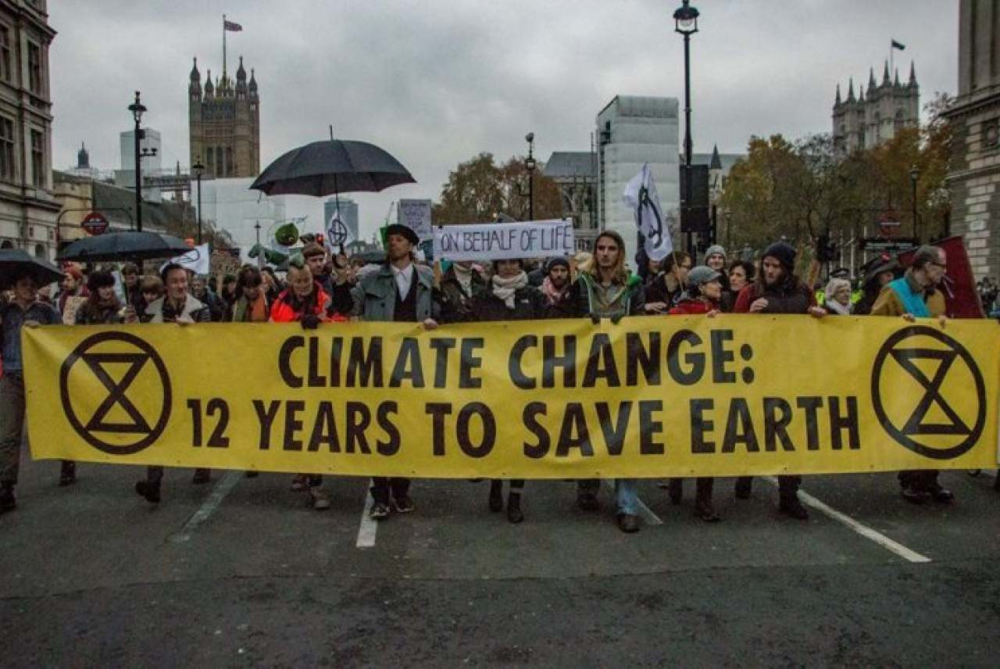 |  |  |  | Top 10 Headlines  The Latest News  -------------- Harriet Ross  - Extinction Rebellion: Are they a friend of the planet or a foe of the people?  - Deeds not Words: Is this the way we should raise awareness of climate change?  - How can we as individuals reduce our carbon footprint?  - What does net zero really mean, and is it achievable?  - Is more extreme weather on the rise?  - What does net zero really mean, and is it achievable?  - Raw Sewage in our waters: why haven’t people learnt their lesson from the Cholera Epidemic?  - LA Fires: What went so wrong?  - Is no snow going to be a future concern for the Winter Olympics?  - Will Trump manage to undo years of work on climate change?
Picture taken from an Extinction Rebellion protest in April 2019. This was one of their first official protests in the UK after being created in 2018.
Extinction Rebellion:
Are they a friend of the planet or foe of the people?
-------------- Harriet Ross |  | On my initial observation of their mission, they appear as a very determined group of individuals who are willing to go the extra mile to make change. They seemed to have been enlightened or perhaps even inspired by the Suffragette Movement in the early 20th Century who used similar and sometimes extreme tactics to raise awareness of their plight for women’s suffrage and were successful.  Although it is highly interesting that they have most likely looked to history for ways to make awareness, it is important to note that the movement wasn’t the sole reason why women gained the right to vote; their key contribution to the war effort during WW1, alongside the introduction of female MPs in 1918 which used their insider links in Parliament to aid in the creation of fairer suffrage for all.  What I am trying to say here is that women had to be clever to get what they wanted, publicity stunts are somewhat important to create change amongst the people, but it is important to note that, politicians are the key people to create (cont…)
Since the 1980s, climate change has dominated the headlines, and many groups, states, organisations etc, have attempted to come together as a collective to tackle the issue head on.

The approaches and tactics used have varied over time, however one of the most prominent groups in recent times, Extinction Rebellion has resorted to more extreme methods of protest and raising awareness. This has varied from road blockades, protests outside key events, such as London Fashion Week, hunger strikes, mass arrest, gluing themselves to objects, defacing public property, and the list goes on and on.

All these methods of protest are key examples of one of their pledges, which is ‘Deeds not Words’, however the question arises, are these methods a reliable and useful way of holding the government to account and encouraging change, or are they just viewed as idiotic hippies who have no life, so would rather go about creating chaos and anarchy to the general public.

Monday 21st April, 2025
(cont…) change, thus they are the ones that need to be convinced more than anyone, but their militaristic and extreme tactics are not the way to go unless you want to appear uncivilised and an anarchist group.  Therefore in my intial observation, I argue that Extinction Rebellion are on the right tracks but also need to create the key links with leaders and politicians to create the change they want.  One undeniable strength of Extinction Rebellion is their ability to raise awareness of climate change, and spark debate and change on the topic. Apart from staging major road blockages they have taken part in major stunts, to raise awareness of climate change. One of their most famous stunts was on 3rd October 2019, where according to BBC News, protesters used a fire engine to spray fake blood onto the HM Treasury building, however the stunt slightly backfired when they lost control of the hose. The protesters stated that they are “highlighting the inconsistency between the UK government’s insistence that the UK is a world leader in tackling climate change, and the vast sums it pours into fossil fuel exploration”.  The Met Police said that five men and three women have been arrested on suspicion of criminal damage.  These methods of protest are most certainly a clever way to gain attention especially as they act as physical metaphors to how they believe the government and some companies are acting, for example in this instance, they are saying that the government has blood on their hands. As well as acting as physical metaphors they are also sparking the general public interest in their movement and raising awareness of climate change. I must admit that before 2019 I didn’t really know much about climate change, I knew it was a thing, but didn’t understand the significance of it and that action must be done. Although I have no intention of joining XR, they have most certainly aided in my education of climate change. They have also encouraged many high-profile celebrities to do the same, such as Emma Thompson, and they have also used their social media platforms too, thus creating a trickle-down effect, and putting greater pressure onto our leaders.  However, I do believe that the way Extinction Rebellion carries out its protests is highly problematic, for a variety of different reasons. Firstly, their extreme tactics are alienating key high-profile supporters. Although it is great that they have managed to get some celebrities, such as Emma Thompson, support for the cause, people like her do not have the ability or power to lobby key politicians to make change, and if XR carry on using disruptive tactics, politicians will never support them as they will be deemed and unruly and anarchists.  Their tactics are also problematic because they can cost the taxpayers millions in repairing damages etc, and in 2021 The Telegraph newspaper estimated that they had cost the taxpayers more than £50 million in the last two years alone, and I dread to even think how much they have cost us since then. Alongside this you could also argue that the way they deface public property is contradictory to their message, as it is highly likely that the ‘clean up crews’ have had to use toxic chemicals to remove paint, glue etc from our streets and buildings, thus creating further unnecessary damage to the environment.  In addition to this, the posters that XR use are most likely made of plastic, the marker pens used to write on the signs most likely contain harmful chemicals, and on occasion when XR have worn hi vis jackets, which are made from synthetic materials and also harmful for the environment. What I am trying to say here, is even the basic methods of protest they are using is highly counter intuitive to their message of protecting and saving the environment.  Overall, I do believe that Extinction Rebellion, is most certainly on the right tracks to create change and a better environment for all, however for them to be a true and proper success, they must change their methods of raising awareness, because without this, they will never gain the support of the necessary leaders to make change. |  | However, I do believe Extinction Rebellion has the chance to become an even bigger pressure for change if they look at the methods of other climate change groups. For example, The Wildlife Trusts (which was formed by Charles Rothschild in 1912), use educational activities and a variety of different campaigns to raise awareness about climate change, and most importantly what we can do about it, without causing chaos to our streets. Although they are not the most well-known pressure group, I do most certainly remember hearing about their campaign over what we, as individuals, can do about climate change. The link to view this is here: https://www.wildlifetrusts.org/things-you-can-do-climate-change  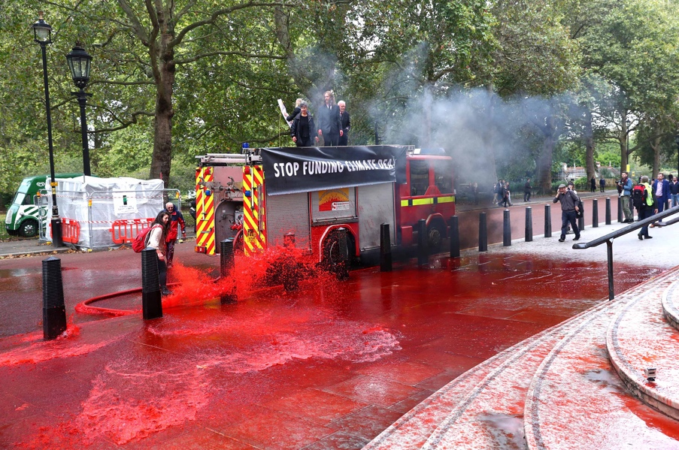  Picture taken from the 2019 XR protest at the HM Treasury. As you can see, the hose has now become uncontrollable and is spraying the paths and bypassers as well as the building.
I believe this campaign, that is encouraging to make people make small, but significant changes to our lifestyle is a valuable tool to raising awareness of climate but also encourages people to be more conscious of their own individual impact, thus achieving an almost immediate response of reduced carbon footprint, resource conservation, environmental protection and also thus create a ripple effect as it may inspire others to do the same. And yes, although making small changes, will not grab the attention of politicians or key leader straight away, they will eventually catch wind of it and who knows, they may even put some of these changes into law. One of their most famous examples of this was around 2019 when a video went viral on YouTube of a plastic straw being stuck in a turtle’s nose. Although this video was incredibly sad, it encouraged many people and eventually key institutions such as McDonalds and Marriott to ban the use of plastic straws in their establishments, and later on in 2020 the government decided to ban the use of them altogether.

Extinction Rebellion has always been a controversial topic when it comes to discussing a solution to climate change, and many people are understandably undecided as to whether they are a friend of the world or foe of the people, but from my understanding they are both. They have undoubtedly been a friend of the world by raising awareness of climate change, in a way their predecessors would have done, and understood, which is an extremely important and valuable thing. However, at the same time I do also question the validity in their extreme and anarchical actions, and whether this is truly necessary, which I am sure many people and politicians charge the same question. However, I do believe that they are on the right tracks, but they must look to the future, and not the past of the extremeness of some of other pressure groups for change. They should strive for a more liberal and democratic approach by lobbying MPs respectfully but also like The Wildlife Trust, encourage people to make small changes to their lifestyle to reduce our individual impact on climate change, and encourage a trickle-down effect.

2 |  |  | Issue 1

