Research, design and implement a data capture system to improve efficiency of machinery and increase production levels

- Research Methods – ACDA5012

Project Proposal

Scott Thomas

Supervisors: Dr Steve Mosey/Dr Gary Jones

Contents
- Introduction
- Research
- Aims & objectives
- Project design
- Gantt chart
- Reference list

Figures
Figure 1 – Flow chart
Figure 2 – Gantt Chart

1. Introduction

For this work-based project I will research, design, and implement a data capture system to improve the efficiency of the production equipment and increase production levels. This in turn will increase profit.
I work in the Commemorative Coin department of The Royal Mint. Due to the Coronavirus pandemic, many people were looking to invest in gold and silver bullion and commemorative coins. This has caused an increase in received orders which have continued beyond the pandemic. Our production department has struggled to keep up with the demands and now we, engineering, are looking to increase production levels without buying new equipment due to limited space and to save on costs. To do this I will install a data capture system so that we can see what issues cause downtime or quality issues so that we can modify the machines to increase production levels and to produce a better-quality product. This project will also identify bottlenecks in the production pipeline again leading to improved Overall Equipment Efficiency and increased production levels.
To gain a better understanding of data capture systems and the affect that they have on production I will conduct research into different data capture systems in use today and how they streamline production and improve efficiency.
I will then design a system capable of logging the different faults that occur on our equipment and is able to feed these issues back to our server where we can study the issues and implement the necessary changes required to increase production efficiency.

2. Research

Research has been carried out to identify the data capture systems that are in use and how they are used to increase Overall Equipment Effectiveness (OEE) and to emphasise why I want to design and install this type of system in my workplace, The Royal Mint.
The pinnacle of this type of the system and what every company should be striving towards is Industry 4.0. Industry 4.0 is defined as the forth industrial revolution.
The first industrial revolution started in the late 18th century in Britain and helped enable mass production using steam power instead of purely human and animal power, producing finished goods with machines instead of producing them by hand. [1]
The second industrial revolution arrived a century later and was powered by the use of gas, oil and electric. The use of these power sources coincided with the use of more advanced communications via telephone and telegraph allowed mass production with the introduction of automation to the manufacturing processes. [1]
The third industrial revolution began midway through the 20th century. The third industrial revolution saw the introduction of programmable logic controllers to control machinery to automate manufacturing processes. The addition of advanced telecommunications and data analysis to the manufacturing process allowed the collection of data to improve manufacturing techniques. [1]
Finally the forth industrial revolution (industry 4.0) is defined as the increase in automation and the introduction of smart machines and smart factories. Collecting data has allowed manufacturers to produce more goods efficiently due. This is due to more data being received by engineers. The less down time in the machinery the higher the production levels. It has also allowed them to find bottlenecks in the production process. By collecting more data and combining it with other enterprise data, a smart factory can make better decisions and improve Overall Equipment effectiveness. [1]
Through this research it can be seen how important and relevant industry 4.0 is and the benefits that it will have on the manufacturing sector. This also shows how relevant my project will be to improve the Overall Equipment Effectiveness of the production equipment in The Royal Mint commemorative coin department.
In Todays manufacturing environments it is vital for companies to obtain complete, accurate and accessible data to achieve cost-effective production.
‘Meta Smart Factory’ is a great example of this and is the type of system that I believe every manufacturing company should strive towards including The Royal Mint. The main goal of Meta Smart Factory is to ensure effective manufacturing operations and improve production outputs using software architecture based on the internet of things. Meta Smart factory increases productivity, improves quality, lowers costs and also improves the working environment for employees by implementing a continuous improvement environment. [2]
Upgrading to Smart Factory Process takes several elements to be successful. These include:
- Real-time data collection – data such as machine running, overload, waiting, maintenance etc.
- Advanced production planning & scheduling – Optimising workloads in the production and manufacturing process
- Production management – Production orders can be delivered to the operators and the equipment in real-time without the need to use paper as the system is fully automated. This again optimises the production process
- Line management and finding bottlenecks – Identifying areas which effect the efficiency of the production process. Identifying the reasons why machines are down. This could be down to a number of reasons including waiting for product, waiting for tooling or lack of operator. By tracking this, solutions can be found to improve the Overall Equipment Effectiveness
- Inventory management – Product can be ordered before the machines go on stop
- Maintenance management – Predictive, preventative, breakdown and corrective maintenance is continuously tracked and managed. Therefore, maintenance teams can respond to machine downtime immediately. All other maintenance can be scheduled to be completed at times in which they will least effect production rates.
- Labour management – Able to monitor labour costs, productivity, scheduling and overtime allowing the employer to identify issues with manning levels before they occur
- Analytics & reporting – All data from the manufacturing process is collected and analysed and evaluated to find the Overall Equipment Effectiveness for the production process.
- Full automation – Eventually striving towards full automation of the complete production process which is the future of the manufacturing environment [2]
I believe that The Royal Mint should be striving towards these goals, and I think that this data capture system will be a good start and will help us identify the issues with the machines and bottlenecks in our production process.
I have researched common reasons that downtime occurs in the production process. These are:
- No blanks
- No tooling
- Tooling change
- No blank in feed table
- No blank in feed tube
- Lack of operator
- Mechanical breakdown
- Electrical issues
- Feed bowl issues
- Die fault
- Quality issues
- Packaging issues
- Break time
These will all need to be included in my design. As the project progresses, I may need to add more faults in to further optimise the OEE of the production process.

3. Aims & Objectives

The main aim of my project
Research, design and implement a data capture system to log the reasons why production equipment is not running.
Objectives
- Increase Overall Equipment Efficiency of production.

- Implement the data capture system on more than one machine

- Programme the data capture system to record the rate at which the machines are running in order to see how much product they are producing

- Introduce a real time screen in the managers or maintenance workshop to view the OEE figures and the production rates

4.Project Design

I have produced a flowchart to show the basic design of the system I am going to implement:
Figure 1.
PC

Press PLC
HMI
Data capture PLC
Network Switch
Server
Flow chart explained
I am going to base my project on one of the presses that produce our silver bullion coin. I have decided to instal the data capture system on this press as we are quite far behind on our silver bullion coin and can’t make enough of it. This is the piece of equipment that will most benefit from the installation of a data capture system to increase its OEE.
I will purchase and program a PLC (programmable Logic Controller) to capture the data from the press and a HMI (Human Machine Integration). The press PLC, network switch, server and PC are already on site and in full working order.
I will program the data capture PLC to log the reasons that that the press has stopped. This will be done by taking outputs off the press PLC for the auto stoppages. These outputs will be the reason for the press stoppage.
Reasons for stoppages in production occurring
Some examples of reasons for auto-stoppages are:
- No blanks on feed table
- No blanks in feed tube
- Feed bowl tripped
- Die fault
The HMI will be needed to input data that is not present on the PLC. When the press is stopped manually, the reason will need to be inputted manually by the operator. A few examples of this are:
- Break times
- No blanks
- Tooling change
- Quality issue with blanks
The HMI will also be needed to further explain the reason of an auto-stoppage. For example, if the press stops for a die fault then the reason the die fault occurs will be required. An example of this would be that there was a foreign blank in the press or that the blanks double up causing two blanks to be struck at the same time.
All this data will then be fed to the server via ethernet. The ethernet cable will be firstly connected to the network switch and then to the server. This data will then be available to the PC with anyone with the correct access being able to view it.
I will also programme the system to read machine speeds so that the production rates will be viewable and therefore we can determine if the changes that we are making are increasing production rates.
With all this data being collected I believe that I will be able to find the most common reasons for downtime and therefore increase the Overall Equipment Effectiveness of the press.

Standards and regulations
There are several standards, acts and regulations that will need to be adhered to, to ensure that the installed product complies with health and safety requirements to ensure that the data capture system is safe to use. These include:
- BS7671 18th edition wiring regulations [3]:
The installation must comply with these regulations in order to ensure that the installation is safe to use. All cables used must be fit for purpose, be protected by the correct circuit breaker to ensure there will be no fire risk in the event of a fault, all cables must be clearly identified using the correct coloured cable etc.

- Electricity at work act 1989 [4]:
This regulation covers what must be done to keep people safe while working with or near electrical equipment.

- Health and Safety at Work act 1974 [5]
The Health and Safety at Work act is the primary piece of legislation covering health and safety in Great Britain. The act sets out the general duties that employers have towards employees, employees have to themselves and to each other. This act must be complied with at all stages during this project.

- Personal Protective Equipment regulations 1992 [6]
This regulation states that Personal Protective Equipment must be used when no other solution can be implemented. Ideally the hazard should be eliminated. If not, the hazard should be replaced. If the hazard can not be replaced then engineering controls should be put in place to isolate employees from the hazard. Administrative controls should be put in place next to change the way people work. Only if none of the above are possible should Personal Protective Equipment be put in place. An example of where I will need to use PPE is when drilling to fit the required parts.
Risk assessments will be carried out before any work takes place.

Resources required
In my engineering department we have a couple of spare Allen Bradley 1100 MicroLogix PLCs. After doing some research I have found that this PLC fits all the requirements to fulfil my project. It requires a 240V AC power supply which means that I will not have to install a separate power supply; has 10 inputs which will be ample for my project and has ethernet connectivity meaning that I can connect it straight to the server via a network switch [7]
I will require RSLogix500 to programme this PLC which is already installed on our PC’s in work. I will be programming the PLC using ladder logic.
I will also use an Allen Bradley panel view for my HMI as they are small and compact. They are quite commonly used in our company, and we have all necessary software required to programme them.

Gantt chart

Figure 2.
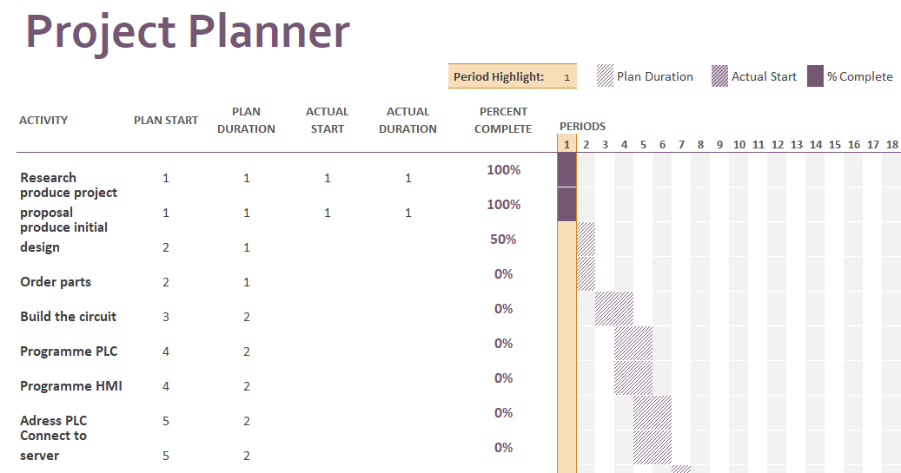
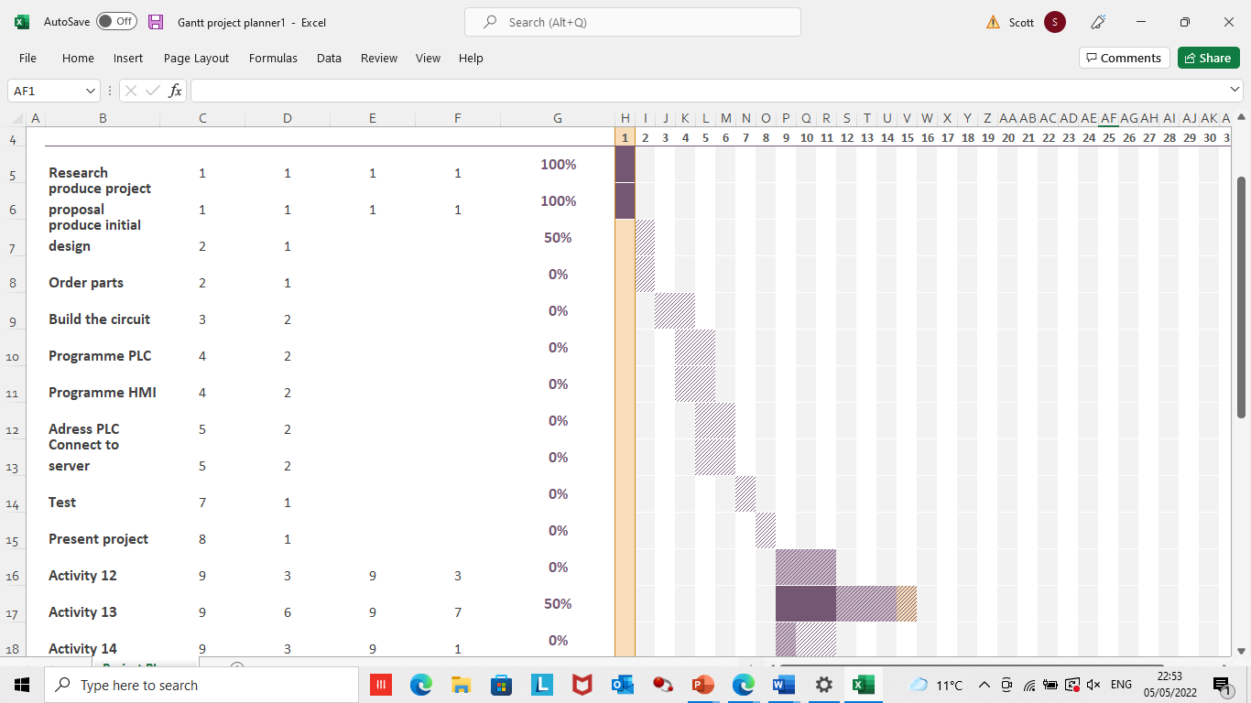

6. Reference List

[1] What is Industry 4.0 and how does it work? | IBM Accessed 01/05/22
[2] Meta Smart Factory - Industry 4.0 - Smart Manufacturing - IIoT - MES - Meta Smart Factory Accessed 02/05/22
[3] BS 7671 - 18th Edition - IET Wiring Regulations (theiet.org) Accessed 03/05/22
[4] The Electricity at Work Regulations 1989 - HSR25 (hse.gov.uk) Accessed 03/05/22
[5] Health and Safety at Work etc Act 1974 – legislation explained (hse.gov.uk) Accessed 03/05/22
[6] Personal protective equipment (PPE) at work regulations from 6 April 2022 (hse.gov.uk) Accessed 03/05/22
[7] Allen-Bradley MicroLogix 1100 PLCs - Latest information, tips, hints. Accessed 05/05/22
[8] Allen Bradley's PLC Programming Handbook | PLCdev Accessed 05/05/22

8. Bibliography

