
Event Experience



Steffan Treharne
October 24, 2017

1705128
The Events Industry
M4X02104

Executive Summary

This report will be looking at the impacts of consumer experience at Judgement Day in Cardiff. It will also be looking at what contributes to the experience such as suitability and accessibility, economic impacts, environmental impacts, food and beverage and health and safety. All these will determine whether the event is successful or a failure in eyes of the consumer. This report also be looking at things such as price of food to price of parking and revenue of the event, if there are any other options for consumers other than food or parking at the stadium. This report has significant information to determine the events outcome also the potential consumers in question, whether to go?

Introduction

The purpose of this report is to observe and analyse the event industry specifically in the sport sector. This report will specifically be looking at an event that happens every year in Cardiff which is ‘Judgement day’. The report will observe and analyse consumers (fans) experience at the event, whilst looking at the positive and negative impacts the consumer has on the local community. Such as suitability and accessibility, but also how well the event is organised and if it meets the needs such as price of attendance, food and beverage, security, health and safety. These needs of the consumer will impact the outcome of this report whether it is positive or negative. Judgement day is an event that advertises the welsh love for the sport of rugby and brings the four regions together, the four clubs are The Scarlets, The Ospreys, Cardiff Blues and The Newport Gwent Dragons. The four clubs contest one another to get the maximum points for the Pro 14 league. The Pro 14 league is the rugby union league held between 14 clubs across the UK and Italy, this usually consists of four welsh clubs, four Scottish, four Irish and two Italian clubs.

Table of Contents
Executive Summary 1
Introduction 2
Suitability and Accessibility of venue 4
Suitability 4
Accessibility 4
Economic 6
Food and Beverage 7
Environmental & Transport 8
Environmental 8
Transport 8
Health and safety 9
Conclusion 10
Referencing 11
Bibliography 12
Appendix 15
Appendix 1 15
Appendix 1.1 seating plan 15
Appendix 2 16
Appendix 2.1 16
Appendix 3 16
Appendix 4 16
Appendix 5 17

Suitability and Accessibility of venue

Suitability

This part of the report will be focusing on the suitability and Accessibility of place for event in question which is ‘Judgement day’, Principality Stadium in Cardiff. Suitability of the venue in eyes of the consumer is where place of event is situated. referencing Bowdin (2006, p.214) “event ‘place’ refers to both the site where the event takes place (the venue) and the place at which consumers can purchase their tickets”. Referring previously by Bowdin, this does meet the suitability of the consumer. Also, suitability has many other key factors such as seating quantity, facilities, maintenance and location. With an expected attendance record of over 74,500 the venue can meet the demands of the event.
Looking at growth of attendance from 2016 judgement day of 62,000 to 2017 of estimated 74,500 there is 20.16% increase of attendance, looking at the increase of one year there could be a concern and negative impact on the venue soon if figures still raise every year.
Referencing Bowdin (2006, p.37) “it is the task of the event manager to identify and predict these impacts and then to manage them to achieve the best balance for all parties, so that on balance the overall impact of the event is positive. To achieve this, all foreseeable positive impacts must be developed and maximized, and negative impacts countered”.
Referring to what Bowdin has said in this context above, by identifying the positive or negative impacts such as the increase of growth, can result in a slower growth of attendance.

Accessibility

Accessibility ranges from wheelchair access, prams and visual problems, this is a concern as this could have a negative impact on attendance and financial profit. In this instance the venue has improved on some aspects, such as designated seating for wheelchairs, screens for impaired vision but no storage for prams. The impact of no storage for prams could potentially have the impact to stop some families to attend the event. To resolve this, the venue could insert lockers or designated areas for prams, as this will bring back those who couldn’t store prams.

Economic

Sales of tickets are one of the biggest revenues for the event, the reason for this is that each ticket costs £10 for this event, this also is one of the main attractions for consumers as tickets are at a low price. There is evidence Li, S. & Jago, L, (2013, p. 591) say that “Early studies tended to focus purely on net ﬁnancial impact, which is the difference between event revenue largely from ticket sales”. Looking at information previously mentioned in section of “suitability and accessibility” of’ 74,500 attendances’ this would make the event £745,000 revenue in one day this is mainly where the revenue would come from. There are other beneficial economic impacts not only for the event but also for local business and authorities and communities, such as revenue going on food and beverage in local restaurants before or after the event. Also, revenue going to local authorities such as paying for parking which is £6 in St David’s car park for 5 hours. As the event is on from 2:30pm until 7pm, If 2% of attendance park here that would be £8940 revenue which in time will go back into the local economy. This is without mentioning other parking areas within the city. Also looking at food and beverage within the venue. The cost of alcohol is around £5, this is a big revenue with price of burgers which are around £4 a burger, food and beverage will be discussed under the heading of food and beverage later in this report.

Food and Beverage

Food and beverage is one of main sources of revenue of a big event such as the one in this report, also revenue for the local economy. this is part of the experience for the consumer on a whole. As mentioned previously in the report in the economic section. Food was priced at £4 for a burger and an alcoholic beverage would cost £5, soft drinks £2 a bottle. In turn for a normal consumer individually for food and an alcoholic beverage would cost £9 and with soft drink £7. This is an expensive event for families, this is where local restaurants will play a key element with food and drink for children a little less expensive and for adults would be around the same price. Families will look at this as a ‘more for your money’ idea.
Not only is food itself a big revenue for the event but the advertising of certain brands within the event will produce a lot of revenue. Advertising is one of the key factors from big food and beverage companies.as referenced by Danylchuk, K, E. and Macintosh, E (2009)
“alcohol industries, like other sponsors, see value in associating themselves with sporting events for a multitude of reasons, such as their huge potential media exposure, potential for increased sales, brand awareness through signage and logo usage, brand positioning, and corporate responsibility”.
This changes the experience for the consumer as they will be persuaded by the advertising of big scale companies to buy the brand, this in turn will be more expensive. Also, big brands effect the experience for consumers such as the experience from the point of view of food and beverage this can determine the wants of consumer but also profit of the section.

Environmental & Transport

Environmental

In this section of the report will be looking at the environmental negative and positive impacts that consumers have on the event in question. There are several key impacts on the environment when going to event such as this one, the main impacts are CO2 pollution consumption in the city from travelling consumers whether it’s from cars, trains and buses. This also impacts fields to where a lot of pop up car parks are for events like this in Cardiff, this will in time destroy the nature life around the pop up car parks as more demand for car park spaces the more trees and plants will need to be removed. In turn this will lower numbers of animals which is a negative impact on the environment as you need insects such as bees to pollinize flowers. There are several ways of reducing this problem such as using the park and ride facilities which local authorities need to create these services and using other local stadiums parking as an option.
Other environmental impacts are waste from the event such as wrappers and bottles. As 74,500 consumers (fans) eat and drink there will be a high demand for bins for this waste. In this event there are bins scattered around the stadium but not enough to deal with consumption. There are a few options such as bins on every row of the stadium, placing stewards at the entrance and exit of each stand ready with bags for waste and placing bins by each exit of the stadium. This in turn lower consumption of waste, also reduce the risk of consumers throwing waste into the local river as it runs past the stadium. This also has effect on the wildlife such as fish and other wildlife in the river as they can consume plastic.

Transport

This part of the report is looking at transport and how is impacts on consumers. There are several options of transport such as cars, buses and trains, these are the main options of transport for consumers. There are negative impacts such as queues on main roads or on train tracks. Also, there are certain amount of car parks and train schedules that will be off putting for the consumer just because of the wait and demand on these requirements which in turn will reduce the number of attendants. The event management working with local authorities and transport companies can reduce all this simply by planning and advertising about the services of park and rides I have mentioned previously in the section of environmental. Also making the consumer aware of the delays and give advice such as leaving earlier to attend or plan an earlier train service. All these will in turn make consumers happier which means more potential profit in the future and more recognition of the event.

Health and safety

In this part of the report will be focusing on health and safety, and what are the main focuses whilst attending an event as a consumer such as fire exits ad signs. Referencing from Bladen, C (2012).
“The route out of the venue should be clearly recognisable and accessible no matter where the fire breaks out. When fire breaks out, people often try to leave the way they entered. Where this is not possible (perhaps because the fire has broken out there or smoke is causing visibility issues), people should be able to find an alternative route to safety (HSE 1999: 22). Stewards and staff must be trained to usher people to safety. There is often resistance from guests who have underestimated the risk and do not want to use another exit”.
As this suggests that having procedures and specific fire exits in place with specific routes is always safer, but in some cases, this is not always true as fires can block entrances or exits. Using members of staff as guidance will lower the risk of accidents which in whole provides a safer environment for consumers. There several other key factors involved in health and safety, as quoted previously on page 5 ‘that it is up to the events management’, to avoid these impacts such as poor health and safety. All aspects of health and safety are covered in this event and that comes down to the management team.

Conclusion

Looking at the whole experience for the consumer and whether it is positive or negative, on a whole it is a positive experience as it caters to what consumers want even though there are factors such as price of food, parking also absence pram space. These impacts have different effect on everyone. It is up to the consumer whether they want food in the event or if they want to park in expensive car parks or use park and ride. these are provisions and extras that either they do or don’t want. The focus of the consumer is on the event and if the consumer enjoyed the experience of the two rugby games that took place. As this is held every year and attracts more consumers then people are experiencing a good event and through sharing the personal experience they had, the event will continue to grow as price for tickets are low. Referencing to Lesjak, M. et Al (2017, p,75) “People having more time for leisure activities, disposable income” this will continue to have a positive impact. As mentioned previously that due to more income the event will continue to grow.

Referencing

Bladen, C (2012), Events Management an Introduction, Hoboken: Taylor and Francis.
Bowdin, G. (2006), Events Management, (2nd edition) Oxford: Butterworth-Heinemann
Danylchuk, K, E. and Macintosh, E (2009), Food and Non-Alcoholic Beverage Sponsorship of Sporting Events: The Link to the Obesity Issue, 18:2, pp. 69
Lesjak, M. Axelsson, E.P. and Mekinc, J., (2017). Sports Spectators Tourism Reason When Attending Major Sporting Events: Euro Basket 2013, Koper, Slovenia. European Journal of Tourism Research, 16, pp. 74-91.
Li, S and Jago, L. (2013), economic impacts of major sports events – a meta analysis of the key trends, Current Issues in Tourism, 2013, Vol.16 (6), pp. 591

Bibliography

Ntloko, N, J. (2008). SPORT TOURISM EVENT IMPACTS ON THE HOST COMMUNITY: A CASE STUDY OF RED BULL BIG WAVE AFRICA. South African Journal for Research in Sport, Physical Education & Recreation, 30:2, pp. 79-94.
Collins, A. (2007). Assessing the Environmental Consequences of Major Sporting Events: The 2003/04 FA Cup Final. Urban Studies (Routledge), 44:3, pp. 457-477.
Funk, D. (2008). Consumer behaviour in sport and events: Marketing action (Sports marketing series). Amsterdam: Butterworth-Heinemann.
Beard, C. (2017). EVENT EVALUATION AND DESIGN: HUMAN EXPERIENCE MAPPING. Event Management, 21:3, pp. 365-375.
Wei L. (2017). EVENT EXPERIENCES THROUGH THE LENS OF ATTENDEES. Event Management, 21:4, pp. 463-480.
Close, Angeline G. (2006). Engaging the Consumer through Event Marketing: Linking Attendees with the Sponsor, Community, and Brand. Journal of Advertising Research, 46:4, pp. 420-434
Parkes, L & Bogle, (2016). Defining a quantitative framework for evaluation and optimisation of the environmental impacts of mega-event projects. Journal of Environmental Management, 167, pp.236–245.
Getz, D., (2012). Event studies: theory, research and policy for planned events (2nd edition), Abingdon: Routledge.
Conway, D., (2009). The event manager's bible: the complete guide to planning and organising a voluntary or public event (3rd edition), Oxford: How To Books.

Event satisfaction | Notes / comments
Suitability of venue | Location very good for the event for the consumers to travel to.
Accessibility of venue | Wheelchairs access good for consumer no storage for prams for family consumers
Parking | Different locations with different prices for consumers to choose from.
Public transport | Bus and train services very regular from different locations for consumers and not far from event.
Access for emergency vehicles | Access for emergency vehicles every corner of each stand for emergency.
Location, size and type of entries and exits | Location good for consumer as stadium 80,000 seats each stand has an entry and exit.
Spectator flow through the venue | Flow in and out of stadium for consumer is one way up and down stairs.
Crowd management | Filling each stand from bottom to top best way for consumer.
Lighting | Too bright for the stadium to view the event. Need, more for stands stairs.
Merchandise for sale | Good range of merchandise but very expensive.
Lost and found | Lost and found positioned at main gates.
Catering | Plenty of food stalls although expensive.
Toilets | Need to clean more frequent.
Waste management | Need to empty a lot sooner and more bins in general.
General condition and maintenance of facility | Good general condition of stadium up to standards for event.
Seating isles | Positioned close together not much leg room.
Sound systems for audience | There is a presenter for sound who plays music also when a team scores.
Visual (screens) | There are two main screens also screens for visual impaired consumers.
Security | Stewards at every entrance and police outside just in case of emergency also checks before going into stadium.  On a whole good crowd management by filling stadium block by block.
Safety | Checks into stadium due to glass bottles and cans also paramedics and ambulance available.  Access for emergency vehicles on the 4 main entrances of the

Appendix

Appendix 1

You will find this in section suitability and accessibility for location of event also seat planning. Also figures of growth.
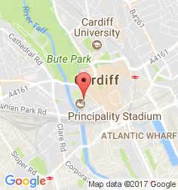 this is for location of stadium.

Appendix 1.1 seating plan

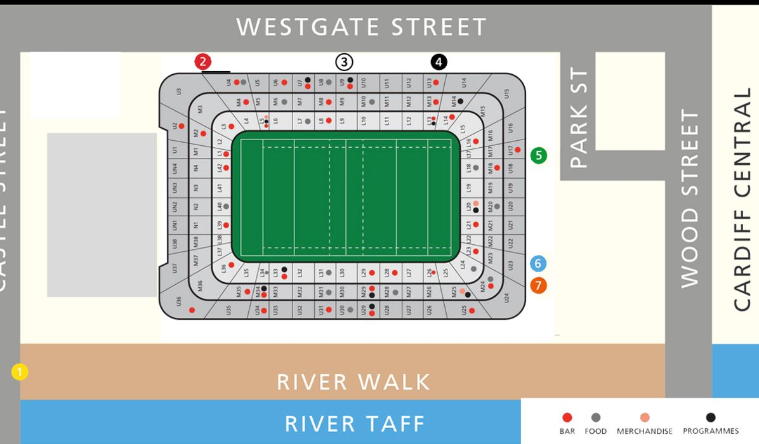

Appendix 1.2

http://www.cardiffblues.com/mobile/news/8239.php
http://www.scarlets.co.uk/eng/news/11147.php#.WgCHxoXXLIV

Appendix 2

This appendix will be found in the economic section.

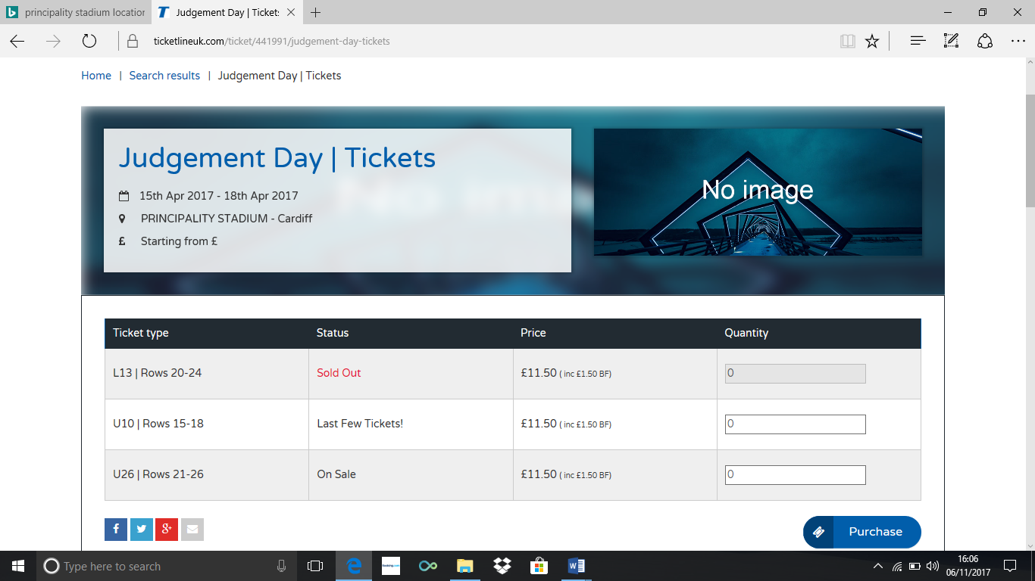 this shows price of tickets.

Appendix 2.1

These are the prices for parking for different car parks around Cardiff on event day.
http://www.walesonline.co.uk/whats-on/whats-on-news/everything-you-need-know-judgement-11260521

Appendix 3

This will be found in food and beverage section.
https://www.tripadvisor.co.uk/RestaurantsNear-g186460-d3345922-Cardiff_City_Stadium-Cardiff_South_Wales_Wales.html

Appendix 4

This will be part of the environmental and transport section.

https://www.cardiff.ac.uk/__data/assets/pdf_file/0010/348661/The-environmental-impacts-of-sport.pdf

Appendix 5

this information will be relevant for health and safety.

http://www.principalitystadium.wales/information/safety-information.php#.WgCTd4XXLIU

