University of Wales Trinity Saint David
School of Engineering
PLC Control – Developments and Functional Specifications
Michael Corish
2115171
Advanced Manufacturing Operations
22/09/2024
L6 – Control Technology ACMA6001



Table of Contents

1 Task 1 – Programmable Logic Control Milestones 1
1.1 Historical Context of Programmable Logic Controllers 1
1.2 Technological Advancements 2
1.2.1 Hardware 2
1.2.2 Software 3
1.3 Impact on Industrial Practice 4
2 Task 2 – Functional Design Specification 5
2.1 Functional Design Specification Stages 5
2.1.1 System Overview 5
2.1.2 Codes and Standards 6
2.1.3 Control System Architecture 6
2.1.4 Process Description 7
2.1.5 Control Philosophy 8
2.1.6 PLC Functionality 9
2.1.7 Testing 10

Table of Figures

Figure 1 - Initial PLC design concept desired characteristics (Jones, 1998). 1
Figure 2 - The very first commercially used PLC in history - Modicon 084 (Mohamed, et al., 2023) 2
Figure 3 - PLC block diagram of the basic operation and components (Polytechnic Hub, 2017) 3
Figure 4 - Compatibility from relay ladder logic to PLC ladder logic (Lander, 2019). 3
Figure 5 - IEC 6113-3 standardising industrial PLC programming languages (Kumar, 2023). 4
Figure 6 - Functional Design flow chart identifying the requirement of high-level to detailed information (Asana, 2024). 6
Figure 7 - A typical Industrial Control System displaying the complete architecture. 7
Figure 8 - Profibus communication protocol used in a DC to AC conversion for induction motors (Vadi, et al., 2022). 7
Figure 9 - Example of a process flow chart in chemical manufacturing (Visual Paradigm Online, 2024) 8
Figure 10 - Typical response of an On-Off controller (Ali, 2023). 9
Figure 11 - Typical responses of the PID controller. 9
Figure 12 - Overview of the process used to generate PLC code in adaptive manufacturing systems (Mo, et al., 2023). 10
Figure 13 - HMI feedback from workplace PLC control system displaying control mode selection. 11
Figure 14 - Virtual commissioning technological pyramid (Korpai, et al., 2024). 12

Task 1 – Programmable Logic Control Milestones

Programmable logic controllers (PLC) are computer-based, solid-state, single processor devices with the ability to control industrial equipment and an entire automated system (Alphonsus & Abdullah, 2016). Programmable Logic Controllers are a special form of microprocessor-based controller. It includes a programmable memory to store instructions and to implement functions such as logic, sequencing, timing, counting and arithmetic (Lashin, 2014). Many factories use programmable logic controllers to cut production costs and/or increase quality (Erickson, 2002). Also, (Levenson, et al., 2017), (Amin & Mridha, 2020) and (Frey, 2014) all agree that benefits of PLC control systems include robustness, reliability and cost effectiveness. This report will review key areas of PLC development through research of Historical and Technological advancements, while also documenting the impact on Industry practices.

Historical Context of Programmable Logic Controllers

The initial design concept of programmable logic control was introduced by the Hydramatic Division within General Motors Corporation in 1968 (Jones, 1998)(Figure 1). Although, (Olsson, 2005) highlights that the company Bedford Associates presented the Modular Digital Controller to General Motors, which began the evolution of PLCs. During this time, automotive manufacturing lines were generally controlled by components such as relays and timers. These electromechanical systems obviated the use of switches for power on and power off actions (Netto & Bagri, 2013). The application of hard-wired relay systems in manufacturing industry was associated with complex wiring systems and large storage facilities for control system components. Troubleshooting failures could lead to multiple hours of downtime. The malfunctioning of one relay in the control system would cease all operations of the equipment, creating increased complexity in fault finding.
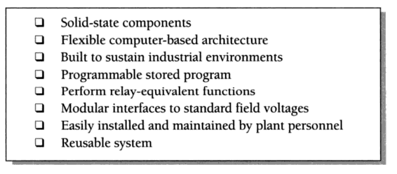

Figure 1 - Initial PLC design concept desired characteristics (Jones, 1998).
The first fully operational PLC model was called the Modicon 084 (Figure 2), this name derived from Bedford Associates 84th project. The specifications of the Modicon 084 consisted of 16 inputs, 16 outputs and 1 kilobyte of memory space, these capabilities are minimal compared to the modern day PLC (Peterson, 2022). The PLC was designed to contain certain properties such as robustness, with the ability to withstand extreme conditions including heat, cold, moisture and dirty air (Radwell International, 2018). When comparing the widely used hard-wired relay control system against the innovative Modicon 084 PLC, there are clear indicators as to why the manufacturing industry widely converted to programmed logic. Firstly, reducing equipment downtime leads to increased productivity, while also creating greater flexibility of automated production lines through stored program memory. Also, removing complex relay systems created larger amounts of space for manufacturing companies.
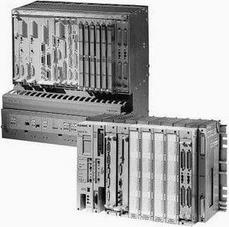

Figure 2 - The very first commercially used PLC in history - Modicon 084 (Mohamed, et al., 2023)

Technological Advancements

Hardware

Originally, PLC hardware consisted of a power supply, processor, inputs/outputs modules and programming device (Figure 3). The Modicon 084, had a programming interface that was coded by rotary thumbwheel and simple on/off switches and a display comprising of lamps and numeric digit displays (Walker, et al., 2010). During the 1980’s, the introduction of computers were influential in programming advancements. Circuit boards, processors, and other electronic components are rapidly shrinking in size, while input/output modules and memory storage size are increasing. These improvements are influencing how PLCs are being designed. However, some things are affecting the acceptance of these changes, these include the need for ruggedness, reliability, and stability (c3controls, 2024). The modular design of PLC hardware coincides with the rack configuration, this allows individual components to be removed and replaced instead of full unit replacement. The PLC rack serves several functions. It physically holds the modules in place, and it also provides electrical connections between the modules by using a printed circuit board at the back of the rack assembly (Alphonsus & Abdullah, 2016).
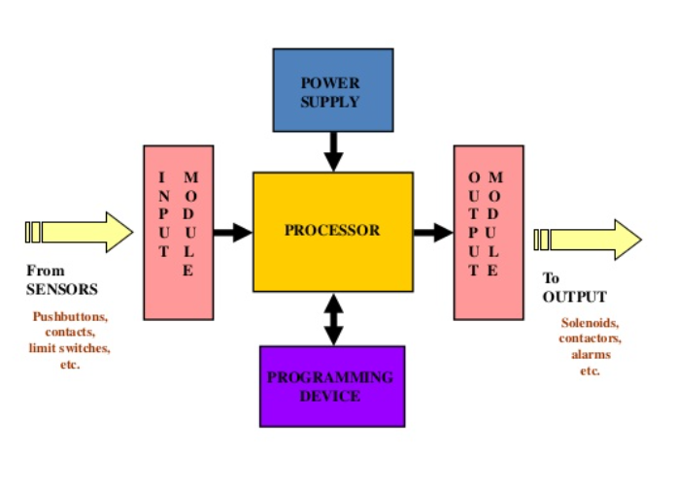

Figure 3 - PLC block diagram of the basic operation and components (Polytechnic Hub, 2017)

Software

Ladder diagrams represented relay-based wiring in a form already familiar to electrical engineers, enabling a smoother transition between control system change (Figure 4). This simplified interpretation of PLC software and allowed staff to make modification with greater ease (Walker, et al., 2010). The ladder diagram interface is still currently used within modern day PLC technology, along with others such as Structured Text, Function Block Diagram, Instruction List and Sequential Function Charts. Software developments in PLC communication technology has continued to advance over the years, firstly field I/O, such as AB Remote I/O is introduced. This greatly reduced wiring costs, increasing the rate of growth in PLC advancement (EECO , 2024). Further development in network communications such as ethernet and wireless, led to intelligent I/O capabilities. The introduction of Human-Machine-Interface (HMI) technology, changed how PLCs interacted with plant employees and workplace machinery. (Koshti & Joshi, 2007) summaries HMI operations as a PLC based automation system that allows the operator to interact through the HMI with the logic stored in the PLC to control the real world process in the real time.
Ladder diagrams represented relay-based wiring in a form
already familiar to electrical engineers and technicians, so, without extensive training, they
could easily interpret and implement new designs and modifications.
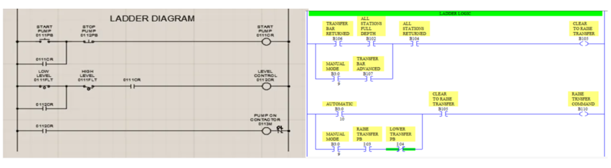
Figure 4 - Compatibility from relay ladder logic to PLC ladder logic (Lander, 2019).

Impact on Industrial Practice

The enhancement in PLC technology has created a positive impact on industry through flexibility, stability and improved productivity. Fixed automation was the common form of automation used with relay control system application in manufacturing. However, through advancements in PLC components, flexible automation allowed manufacturing companies to expand product ranges instead of single product batch production. The popularity of PLC application in industry, created requirements for industry standards, known as IEC 1131. (Ohman, et al., 1997) summarises the IEC 1131-3 standard as defining different language paradigms, Sequential Function Charts, and some program organization units (Figure 5). The standard also specifies their representation, and rules of evaluation. The implementation of an industry standard produced compatibility between opposing PLC manufacturers. Previously mentioned PLC characteristics such as robustness and reliability have enhanced productivity outputs due to the reduction in manufacturing line downtime. To summarise, Programmable Logic Controllers provide an ecosystem of relatively simple software logic, robust and rugged hardware, networks with controllable real-time behaviours, and extensive availability of interoperable components such as sensors and actuators (Sehr, et al., 2020). The PLC control system has continued to develop to the modern day Industry 4.0 through hardware component development and emerging technologies such as the Internet of Things (IoT). Combining all these aspects of PLC development, highlights the positive impact made on industry through decades of advancing manufacturing demands.
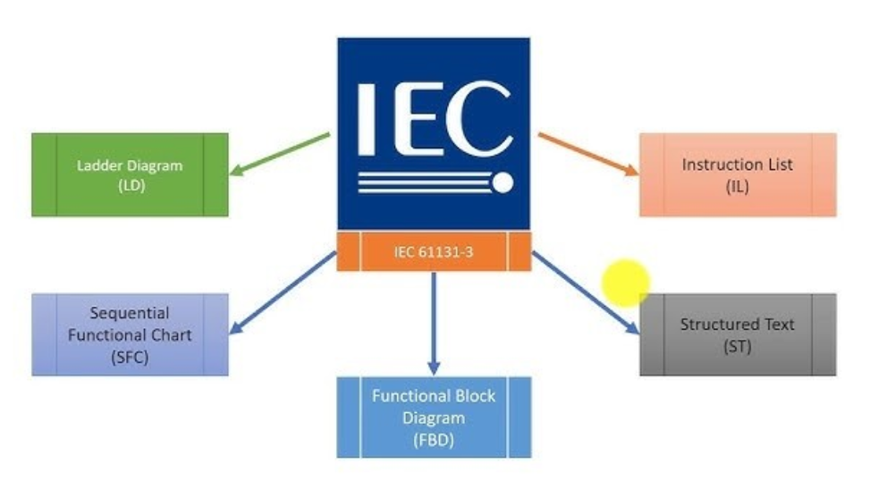
Figure 5 - IEC 6113-3 standardising industrial PLC programming languages (Kumar, 2023).

Task 2 – Functional Design Specification

The purpose of the Functional Design Specification (FDS) in Programmable Logic Control (PLC) systems is to outline the design requirements for functional needs. Creating FDS documentation is crucial to managing system construction and meeting customer requirements of system performance. (Li, et al., 2022) regards functional design as a process that involves decomposing an overall function into sub-functions, searching for suitable solution principles for the sub-functions, and combining the solutions of the sub-functions into a complete technical solution to achieve the desired function. The advantages of using an FDS document include the clear message outlined for manufacturers, system integrators, quality control and customers. (IDC Technologies, 2012) suggest the implementation of a complete and coherent FDS has numerous benefits which include time savings of approximately 50% of total time and a saving of resources and money of approximately 25%.
This report will use literature review to understand the essential stages required for the development of a Functional Design Specification of Programmable Logic Controller control systems. While also, describing the critical factors that are required during the FDS documentation process.

Functional Design Specification Stages

The outlined structure of a FDS document are broken down in to stages, allowing key highlighted areas to be captured. Therefore, ensuring the final product meets the desired capabilities requested by the customer. The stages to this document are as follows:
- System Overview
- Codes and Standards
- Control System Architecture
- Process Description
- Control Philosophy
- PLC Functionality
- Testing

System Overview

The purpose of this stage of the functional design process of a PLC control system, is to produce a high level description of an entire control system (Figure 6). The key areas highlighted within this section include project scope, functionality requirements, stakeholders and project purpose. Similar to a project charter, which are widely used in all industries undertaking projects. (Wong, et al., 2022) describe the Project Charter as the most important document which officially kick-starts a project. The signed project charter formally authorizes the existence of the project. Also, (IACS Engineering, 2024) reveal that this area of FDS can include a brief description of the controlled process and the interaction between the control system.

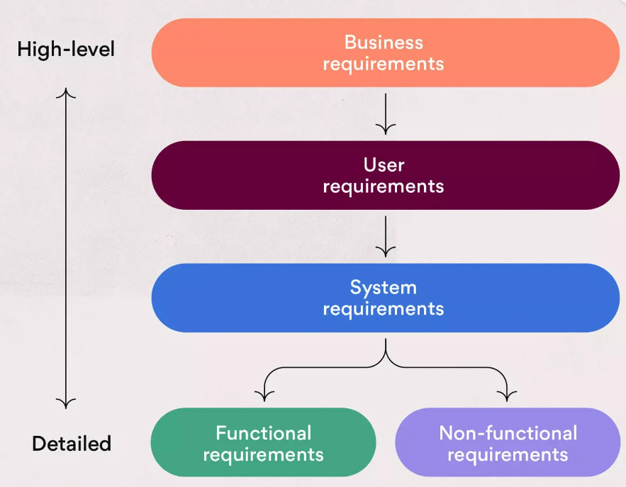

Figure 6 - Functional Design flow chart identifying the requirement of high-level to detailed information (Asana, 2024).

Codes and Standards

There is a requirement to understand international industry codes and standards, as these may influence the documentation of a Functional Specification. (IACS Engineering, 2024) explain that, while the core elements of PLC Functional Specifications remain consistent, international industrial automation and control system standards can influence specific details within the document. As previously mentioned, the industrial standard for PLC programming language (IEC 61131-3), should be documented and specifications adhered to within the documentation. This ensures ease of maintenance, code understanding and compatibility with various PLC platforms. When designing a control system, safety is a critical area of documentation to understand and must conform to the industry standard IEC 61508. (Charnock, 2001) identifies IEC 61508 as an international standard for managing Functional Safety with regard to Electrical / Electronic / Programmable Electronic Safety Related Systems. When applying to PLC FDS, documentation is required to illustrate the Safety Integrity Level (SIL) of the required process for the PLC program. Lastly, depending on industrial context, certain areas of manufacturing require specific industry standards that may apply, for example chemical processing.

Control System Architecture

This section of the FDS identifies the hardware components used within the control system. The hardware of a PLC control system comprises of CPU, Memory and Circuits for input/output data. Each of the hardware components require certain specifications to ensure controlled process compatibility, such as memory storage capabilities depending on the number of commands required in program logic (Greeff & Ghoshal, 2004). Also, other components of the control system are outlined, these include sensors, actuators, HMI/SCADA software and communication networks. Profibus is an example of communication used, (Tapia, 2023) summarises this as an open field digital network standard used to interconnect process automation components such as field sensors, actuators, and PLCs in industrial environments. The architecture of Profibus is built upon a client/server model. These documented components create an overview of how the control system operates and the flow of data between each, illustrating the architecture of the whole system (Figure 7).
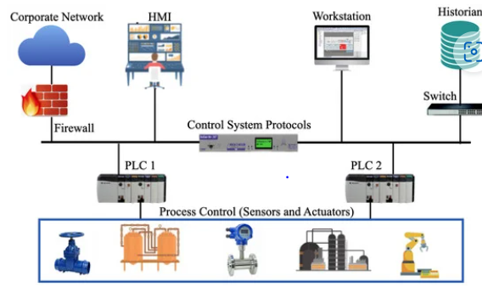

Figure 7 - A typical Industrial Control System displaying the complete architecture.
A real world case study using Profibus as its communication protocol to convert a Direct Current (DC) power supply into an Alternating Current (AC) power supply for industrial induction motors (Figure 8). (Vadi, et al., 2022) explains that the Profibus network communication was preferred to Modbus due to its secure and stable nature in factory conditions. Also, thanks to its fast and reliable structure, it provides communication over longer distances compared to the Modbus protocol (Mahmood, et al., 2013). Other benefits include integration with new generation products such as Profinet, which has known real-time capabilities, high data rates and minimal latency (Vieira, et al., 2024). Therefore, leading to no additional costs (Zhang, et al., 2017).
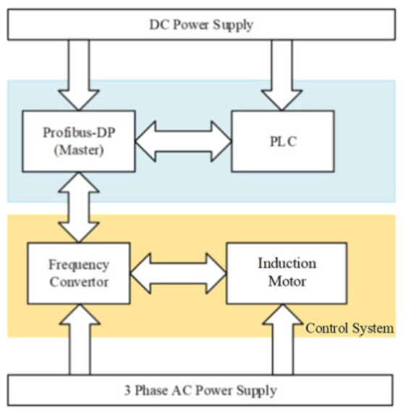

Figure 8 - Profibus communication protocol used in a DC to AC conversion for induction motors (Vadi, et al., 2022).

Process Description

During this stage of the FDS, detail begins to increase when documenting the process as a whole. The use of process diagrams are essential to creating an understanding of how the process interacts and each component within that process. Process Diagrams used during this section include Flow Charts and Piping & Instrumentation Diagrams (P&ID). Flow Charts have the ability to help visualise and improve workflow. (Mainville, 2023) explains that by mapping out each step of the process, identifying areas that are repetitive and time consuming, creates opportunity for process automation (Figure 9). For PLC design, recognising certain elements of the process such as process inputs and outputs are important. These will have a direct effect on the number of input/output ports required on the newly designed PLC. Also, understanding the process environment will coincide with the robustness requirement of the given PLC. Environmental conditions that can affect PLC design include temperature, humidity, vibration, explosive atmospheres and dust. By identifying the working conditions of the considered PLC, will create longer lifespans after implementation due to environmental condition research (Serhane, et al., 2019).
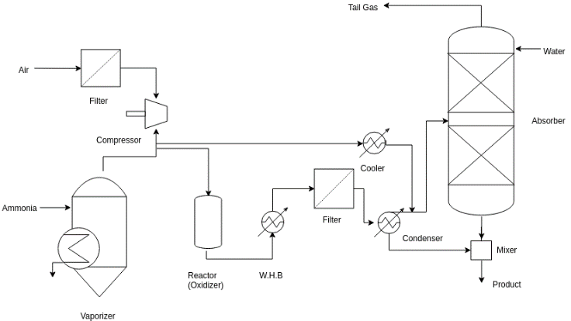

Figure 9 - Example of a process flow chart in chemical manufacturing (Visual Paradigm Online, 2024)

Control Philosophy

Selecting the methodology for control of the PLC control system involves identifying a philosophy depending on process conditions. Popular control philosophy’s used in industry include Proportional Integral Derivative (PID), Sequential and On/Off control. The On/Off control has a two-step switch that corrects the error signal based off control system feedback (Figure 10). While, the PID controller is more finely tuned to rectify error within the control system. Proportional control simply produces a control action proportional to the error signal, Integral control produces a control action proportional to the integral of error over time and Derivative control creates a control action proportional to the rate of error change (Alphonsus & Abdullah, 2016). Combining these control modes together produces a highly controlled closed loop system when tuned correctly (Figure 11). Depending on the process in question, this section of the FDS is crucial to identifying the correct control philosophy for the operational targets set by stakeholders.
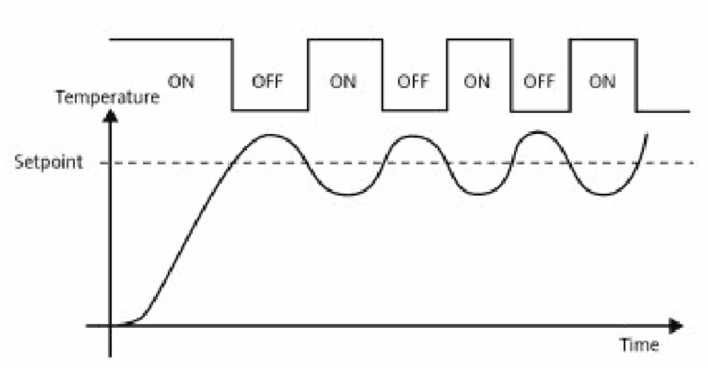

Figure 10 - Typical response of an On-Off controller (Ali, 2023).
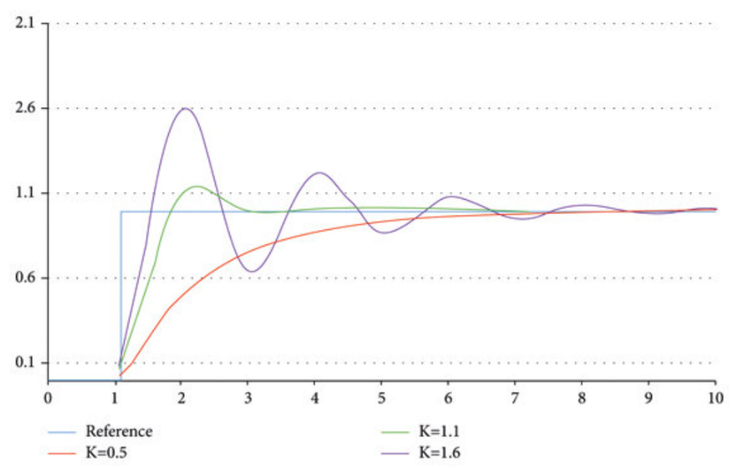

Figure 11 - Typical responses of the PID controller.

PLC Functionality

This area of the FDS captures the fine details of PLC control system setup and the functions required to produce compatible commands that coincide with the selected process. Multiple areas of PLC functionality are included during this stage of the documentation process. Several of these areas are included below:

Technical Aspects

(Antonsen, 2022) highlights the most important rule to variable naming by indicating that most companies or PLC programmers have their own guidelines or conventions for variable naming. However, the most important rule is to create meaningful variable names. An example of a variable name with meaning would be TankLevelSensor. This creates simplicity for all users of the PLC program and provides greater ease of access when searching areas of the program. Mapping inputs and outputs in a control system means converting the raw I/O values into usable data. The data is then used in the station-level control logic to perform actions or display statuses (Dietrich, 2024). This technique corresponds with naming conventions, by physically assigning process inputs and outputs to the PLC memory and allows correct selection and communication between devices.
Control Logic is a major aspect of the PLC functionality section of the FDS, through defining the logic required by selected programming language. When selecting programming languages, (Ohman, et al., 1997) explains that depending on graphical or text representation preference. Functional Block or Ladder Logic diagrams fall into the graphical displays, while programming languages such as Instruction List and Structured Text are visually similar to code. The control logic defines how the PLC will react to various sensor inputs, perform calculations, and generate control signals for the connected actuators based on the pre-defined program (IACS Engineering, 2024). The process of creating PLC programming in an adaptive manufacturing system is displayed in (Figure 12).
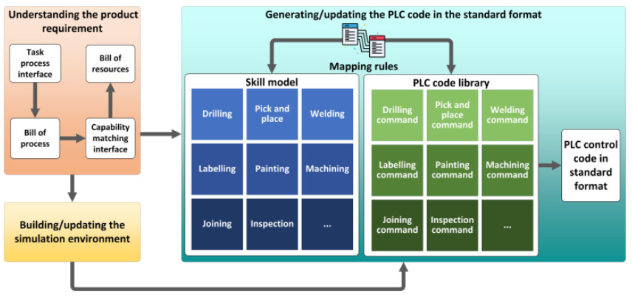
Figure 12 - Overview of the process used to generate PLC code in adaptive manufacturing systems (Mo, et al., 2023).
For sequenced or high precision processes, this section documents the steps and control action timings within the PLC program. These are pre-planned actions to ensure the controlled process reaches desired capabilities. Setting control system fault handling parameters, ensures that corrective actions can be automatically overcome if required. Also, displaying process alarms and fault identification are designed into the PLC program.

Safety Aspects

The safety of plant operators and engineers is critical when designing an industrial control system, preventing injury and reducing risk are of the highest importance. (Pattimore, 2016) identifies the fundamental difference between interlock and permissive signals, explaining that when an event occurs an interlock will provide an unhealthy feedback and the process will stop. However, permissive requires actions to be met before process start up. Together they provide protection of plant employees and equipment with closed loop control system feedback. Also, documented are the emergency stops of the control system process that are triggered during emergencies, resulting in safe shutdowns of plant machinery. When encountering plant failures there is an importance to shutting down equipment in a controlled manner, otherwise known as Fail-safe Logic (Lowe, 1984). Also, (Saric, 2019) explains that if a safety critical system detects a failure in hardware or software components, it automatically goes into a safe-state by de-energising control system outputs. Ensuring these aspects of PLC specification are included within the FDS documentation are crucial for employee and process safety.

Control System Modes

When selecting control system modes, all modes detailed within the FDS. As an example, Auto mode for fully automated operation, Semi-auto mode for single cycle of operation and Manual for operator intervention. These modes must be integrated with the PLC control system, so program commands correspond with system requests. (Figure 13) displays control mode selection on HMI from PLC control system within the Hot Mill department of Tata Steel.
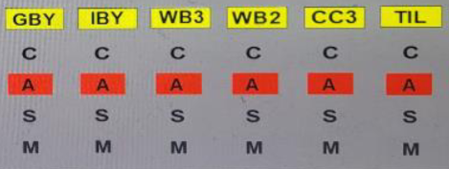

Figure 13 - HMI feedback from workplace PLC control system displaying control mode selection.

Testing

The final stage of FDS includes testing and acceptance of the newly developed PLC control system. (Querejeta, 2023) believes that traditional commissioning can be error-prone and lead to unwanted delays. However, with Virtual Commissioning (Figure 14) the ultimate goal is to perform partial validations and engineering designs in a virtual environment early in the development process, without the need for a physical version of the system. This significantly improves the design and overall quality of new systems, minimising errors and costs. There are also other options such as partial traditional commissioning combined with virtual commissioning for either PLC hardware or software depending on area developments.
(Thonnessen, et al., 2018) states a Hardware-in-the-Loop (HiL) simulator replaces the plant. The simulator models the sensors of the plant and in return, samples the outputs of the PLC in order to analyse them. Otherwise, in the Software-in-the-Loop (SiL) approach, a virtual PLC is instantiated to test the automation code associated with the behaviour models in the simulation layer (Rothhaupt, et al., 2024). (Muresan & Pitica, 2012) believes that the SiL approach is up to 60 times more cost effective than HiL. While also, providing greater flexibility for different scenarios and control algorithms. Although, during literature review, PLC simulator selection are highly compatible depending on PLC manufacturer selection. For example, the RSLogix emulator is compatible with Allen-Bradley PLCs.
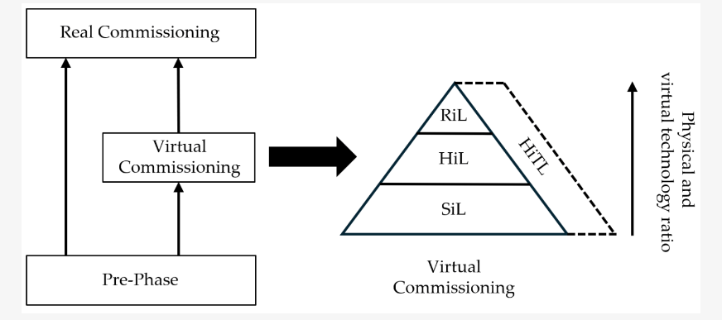
Figure 14 - Virtual commissioning technological pyramid (Korpai, et al., 2024).

References
Ali, H., 2023. Real Time Temperature Control Using LabVIEW Based on PID Algorithm and Power Electronics. African Journal of Advanced Pure and Applied Sciences, 2(4), p. 341.
Alphonsus, E. R. & Abdullah, M. O., 2016. A review on the applications of programmable logic controllers (PLCs). Renewable and Sustainable Energy Reviews, Volume 60, pp. 1185-1205.
Amin, A. & Mridha, M., 2020. A mini view of PLC. International Journal of Research in Engineering and Technology, 6(2), pp. 23-25.
Antonsen, T. M., 2022. PLC Controls with Ladder Diagram (LD). 1st ed. Copenhagen: Books On Demand.
Asana, 2024. What is the difference between business requirements and functional requirements?. [Online]
Available at: https://asana.com/resources/business-requirements-document-template
[Accessed 11 09 2024].
c3controls, 2024. The History of Programmable Logic Controllers: From Then to Now. [Online]
Available at: https://www.c3controls.com/white-paper/history-of-programmable-logic-controllers/
[Accessed 05 09 2024].
Charnock, C., 2001. IEC 61508 – A PRACTICAL APPROACH TO ITS APPLICATION IN THE PROCESS INDUSTRY. SYMPOSIUM SERIES , 148(52), pp. 667-682.
Dietrich, S., 2024. Techniques for I/O Mapping in PLC Programs. [Online]
Available at: https://control.com/technical-articles/techniques-for-i-o-mapping-in-plc-programs/
[Accessed 15 09 2024].
EECO , 2024. Evolution of the PLC. [Online]
Available at: https://media.eecoonline.com/asset/oro/Evolution_of_the_PLC_Infographic
[Accessed 06 09 2024].
Erickson, K. T., 2002. Programmable logic controllers. IEEE Potentials, 15(1), pp. 14-17.
Frey, G., 2014. Programmable Logic Controllers. 1st ed. London: Springer.
Greeff, G. & Ghoshal, R., 2004. Practical E-Manufacturing and Supply Chain Management. 1st ed. s.l.:Elsevier.
IACS Engineering, 2024. Functional Design Specifications (FDS). [Online]
Available at: https://www.iacsengineering.com/functional-specifications/
[Accessed 11 09 2024].
IDC Technologies, 2012. Design of Industrial Automation Functional Specifications for PLCs, DCSs and SCADA Systems, Perth: IDC Technologies.
Jones, C. T., 1998. Programmable Logic Controllers: The Complete Guide to the Technology. 1st ed. s.l.:Brilliant-Training.
Korpai, R., Szanto, N. & Csapo, A. B., 2024. A Framework for Effective Virtual Commissioning: Guiding Principles for Seamless System Integration. Journal of Manufacturing and Materials Processing, 8(4), p. 165.
Koshti, V. M. & Joshi, S. M., 2007. Design of Human Machine Interface for PLC based Automation System. IFAC Proceedings Volumes, 40(18), pp. 343-346.
Kumar, D., 2023. IEC 61131 is the international standard for programmable logic controllers.. [Online]
Available at: https://www.linkedin.com/pulse/iec-61131-international-standard-programmable-logic-dilip-kumar
[Accessed 06 09 2024].
Lander, A., 2019. Programmable Logic Controllers: The Evolution of a Disruptive Technology. [Online]
Available at: https://www.engineering.com/story/programmable-logic-controllers-the-evolution-of-a-disruptive-technology
[Accessed 09 04 2024].
Lashin, M. M., 2014. Different Applications of Programmable Logic Controllers (PLC). International Journal of Computer Science, Engineering and Information Technology (IJCSEIT), 4(1), pp. 27-34.
Levenson, R. M., Nelson, Z. E. & Adegbege, A. A., 2017. Programmable Logic Controller for Embedded Implementation of Input-Constrained Systems. IFAC-PapersOnLine, 50(1), pp. 14412-14417.
Li, S., Li, W. & Li, Y., 2022. An Extended Functional Design Approach Based on Working Principle and Property and Its Application. Applied Sciences, 12(12), pp. 62-84.
Lowe, D. R. T., 1984. Reliability aspects of programmbale logic controllers. Measurement and Control, 17(8), p. 310.
Mahmood, R., Shah, T. & Rehman, H., 2013. High speed control of induction machines. Doha, IEEE.
Mainville, D., 2023. Process Diagrams: Why they are important & examples to get you started. [Online]
Available at: https://navvia.com/blog/how-to-create-process-diagrams-why-they-are-important-and-examples-to-get-you-started
[Accessed 13 09 2024].
Mo, F. et al., 2023. PLC orchestration automation to enhance human–machine integration in adaptive manufacturing systems. Journal of Manufacturing systems, Volume 71, pp. 172-187.
Mohamed, A., Galgal, K. & Mogili, U., 2023. Programmbale Logic Controllers in Flexible Manufacturing System (FMS). AIP Conference Proceedings, 29(17), p. 2.
Muresan, M. & Pitica, D., 2012. Software in the Loop environment reliability for testing embedded code. Alba Iulia, IEEE, pp. 325-328.
Netto, R. & Bagri, A., 2013. Programmable Logic Controllers. International Journal of Computer Applications, 77(11), p. 27.
Ohman, M., Johansson, S. & Arzen, K. E., 1997. Implementation Aspects of the PLC Standard IEC 1131-3. IFAC Proceedings Volumes, 30(4), pp. 27-32.
Olsson, G., 2005. Handbook of Networked and Embedded Control Systems. 1st ed. Boston: Birkhauser.
Pattimore, B., 2016. Mine site Commissioning with Programmable Logic , Murdoch: Murdoch University.
Peterson, D., 2022. The Origin Story of the PLC. [Online]
Available at: https://control.com/technical-articles/the-origin-story-of-the-plc/
[Accessed 04 09 2024].
Polytechnic Hub, 2017. Block diagram of programmable logic controller (PLC). [Online]
Available at: https://www.polytechnichub.com/block-diagram-programmable-logic-controller-plc/
[Accessed 2024 09 2024].
Querejeta, M. U., 2023. Methodology and Toolset for Testing Highly Reconfigurable Programmable Logic Controllers, Arrasate: Mondragon Unibertsitatea.
Radwell International, 2018. The Father of PLC's: How Richard Morley Revolutionised the Automation Industry. [Online]
Available at: https://blog.radwell.co.uk/the-father-of-plcshow-richard-morley-revolutionised-the-automation-industry
[Accessed 04 09 2024].
Rothhaupt, M., Vogt, L. & Urbas, L., 2024. Strategies for Software and Hardware Compatibility Testing in Industrial Controllers. Processes, 12(3), p. 580.
Saric, M., 2019. Simulation-based Testing of Failsafe Industrial Peripheral Modules, Vienna: Institute of Computer Technology.
Sehr, M. A. et al., 2020. Programmable Logic Controllers in the Context of Industry 4.0. IEEE Transactions on Industrial Informatics , 1(1), p. 99.
Serhane, A., Raad, M., Raad, R. & Susilo, W., 2019. Programmable logic controllers based systems (PLC-BS): vulnerabilities and threats. SN Applied Sciences, 1(924).
Tapia, E., 2023. Assessing Industrial Communication Protocols to Bridge the Gap between Machine Tools and Software Monitoring. Sensors (Basel), 23(12), pp. 56-94.
Thonnessen, D., Rakel, S., Reinker, N. & Kowalewski, S., 2018. Matching Discrete Signals for Hardware-in-the-Loop Testing of PLCs. IFAC-PapersOnLine, 51(10), pp. 229-234.
Vadi, S., Bayindir, R., Toplar, Y. & Colak, I., 2022. Induction motor control system with a Programmable Logic Controller (PLC) and Profibus communication for industrial plants — An experimental setup. ISA Transactions , Volume 122, pp. 459-471.
Vieira, R. et al., 2024. Performance Evaluation of Computer Vision Algorithms in a Programmable Logic Controller: An Industrial Case Study. Sensors, 24(3), p. 843.
Visual Paradigm Online, 2024. Chemicals Manufacturing. [Online]
Available at: https://online.visual-paradigm.com/diagrams/templates/process-flow-diagram/chemicals-manufacturing/;VPSESSIONID=80CD800C4B05B415BA6F7F128C29B4D0
[Accessed 13 09 2024].
Walker, M., Bissell, C. & Monk, J., 2010. The PLC: a logical development. Institute of Measurement and Control, 43(9), pp. 280-284.
Wong, W. Y., Sam, T. H., Too, C. W. & Pok, W. F., 2022. Software Quality Assurance Plan: Setting Quality Assurance Checkpoints within the Project Life Cycle and System Development Life Cycle. IEEE 18th International Colloquium on Signal Processing & Applications, 1(1), pp. 214-219.
Zhang, Z., Liu, Y. & Bazzi, A. M., 2017. An improved high-performance open-loop V/f control method for induction machines. Tampa , IEEE.

