

Title: Programs in C and Documentation

Author: Michael Andrew Elliott

Student No.: 1809306

Module: Software Development (ACCA4017)

Date: Monday February 25th, 2019

Table of Contents
1. Introduction 3
2. Part A - Understanding 3
2.1. A1 - Explanation of a Variable 3
2.2. A2 - Explanation of a For-Loop 4
2.3. A3 - Explanation of an Array 4
3. Part B - Implementation 5
3.1. Exercise 1 – Showing different variables 5
3.1.1 Identifying the problem 5
3.1.2 Annotated Code 5
3.1.3 Testing 6
3.2. Exercise 2 – Calculation shaded surface area 8
3.2.1 Identifying the problem 8
3.2.2 Annotated Code 8
3.2.3 Testing 9
3.3. Exercise 3 – Calculating price with VAT for 5 products 10
3.3.1 Identifying the problem 10
3.3.2 Annotated Code 11
3.3.3 Testing 12
3.4. Exercise 4 – Fruit machine game 13
3.4.1 Identifying the problem 13
3.4.2 Annotated Code 14
3.4.3 Testing 15
4. Conclusion 17
5. Bibliography 18
6. Appendices 20

Introduction
The following report will demonstrate the author’s understanding of the syntax and semantics of a high-level programming language. This will be evidenced by the author deploying basic software constructs using simple algorithms in the development of solutions to 4 programming problems.

Part A - Understanding
For this section of the report the author will provide an explanation on the following:
- What is a variable and why they are important to writing programs.
- Why the ‘for’ loop can also be referred to as a counting loop.
- The explanation of an array and what their features are.

A1 - Explanation of a Variable
To help understand what is a variable is it is useful to know how computer programs use data types to organise various types of data in a program.
A variable is one of those data types and is a data value which can be changed by either the user or the program. Data values can be stored in the computer’s memory, which can then be later called upon when using its identifiable name.
Variables can be used to ask a user a question such as what is your favourite number? In addition, variables can change during a program execution. There are four distinct types of variable data types, see figure 1 below.
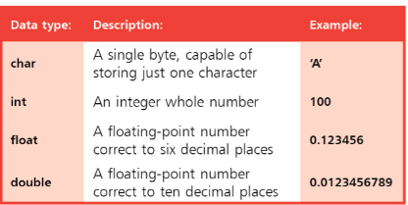
Figure 1 McGrath, Mike
To use variables in a program they must be declared prior to any executable code. If a value is assigned to a variable it is said to have been initialized. The examples below show how different variables are declared and initialized.
Variable | Declared | Initialized
Character | char letter; | letter = ‘C’;
Integer | int number; | number = 22;
Float | float currency; | currency = 2.50;
Double | double number; | number = 3.2348975

Variables are important in writing programs as they enable programmers to create flexible programs and allow them to use them to represent the data.

A2 - Explanation of a For-Loop
To fully explain the ‘for’ loop it is first necessary to explain what a loop is in terms of programming. Basically, where a piece of code in a program automatically repeats, this can be termed a loop. Once all the statements have been completed within a loop this is called an iteration. Loop lengths are controlled by ‘conditional tests. If the tested condition remains true, the loop will continue but will halt if it is found to be false.
The ‘for’ loop is often referred to as a counting loop as the expression can control the number of complete executions of a loop or loops, which is dependant that the test expression remains true. Every time an iteration is completed the counter specified in the program is incremented and any statements are executed.
The syntax for an array is the initializer, test expression, incrementer, and the statements e.g. for (i=0; i<=5; ++ i) {the statement}.
The for loop can be used to make the program code look neater and more organized. The for loop ensures that the program author can shorten their code to make it more efficient.
An example where a for loop could be used is automating a list of incremental values. To print a list numbering one to three without a for loop would be:
Printf (“Value is 1”)
Printf (“Value is 2”)
Printf (“Value is 3”)
With a for loop the above can be automated to print the same statements on the screen.
Int i;
for(i=1; i <4; i=i++)
{
Printf(“Value is: %d\n”, i);
}
The for loop would print out the statements on the screen but in a more efficient way.

A3 - Explanation of an Array
Unlike a standard variable an array enables the program to store multiple data items. This is done by the array being a series of locations in memory each holding a single item of data but using the same name.
When items are stored in an array they are done so consecutively, in what is called the array element, which typically starts with zero rather than the number one. Therefore, when specifying 3 elements in an array [3] this would represent the following:

element one [0]
element two [1]
element three [2]
The syntax for an array is the data type, name of the array, and the number of elements e.g. int array[3].
An example of where an array would be useful is displaying several variables to record a list of prices. Without an array this would be specified by using a separate variable for each one e.g.
float = price1, float = price2, float = price3, and so on
Using an array, it would be one expression e.g.
float price [3[

Part B - Implementation
For this section of the report the author will demonstrate his understanding of the syntax and semantics of a high-level programming language. This will be evidenced by the author deploying basic software constructs using simple algorithms in the development of solutions to the following programming problems

Exercise 1 – Showing different variables

3.1.1 Identifying the problem
This exercise requires a program to show how variables can contain different types of values. To demonstrate this, the program is to declare three variables which contain a name, height and an age. These variables should be inputted in to the program and the results displayed on the screen.
The individual stages for the program are as follows:
- User enters 3 variables (name (string), height (float), age (integer).
- Print the entries entered by the user on the screen.

3.1.2 Annotated Code
#include <stdio.h>

void main()
{
char name[12]; //varialbe to hold user input (12 character maximum)
float height; // varialbe to hold user input
int age; //varialbe to hold user input

printf("Please enter your name: ");
scanf("%s", name); //user enters their name

printf("\nPlease enter your height in metres/centimeters: ");
scanf("%f", &height); //user enters their height

printf("\nPlease enter your age in years: ");
scanf("%d", &age); //user enters their age

printf("\n\nHello your name is %s, your height is %.2f, and your age is %d\n\n", name,height,age); //prints out user's name, height and age
}

3.1.3 Testing
Normal Values
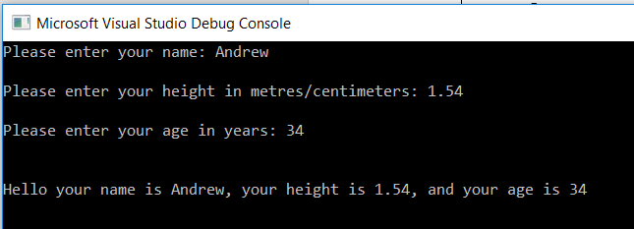
Result: Program ran as expected, input values displayed on screen.
Normal Values - floats
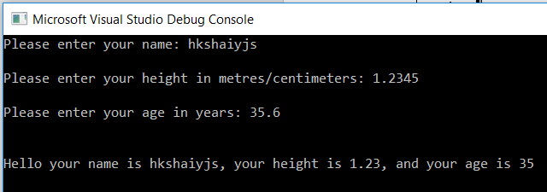
Result: Program ran as expected, input values displayed on screen.
Boundary Values – name maximum characters with height and age the same
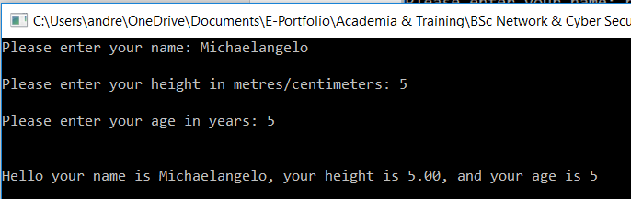
Result: Program ran as expected, input values displayed on screen.

Boundary values – name longer than string value
Although program ran there was an exception error.
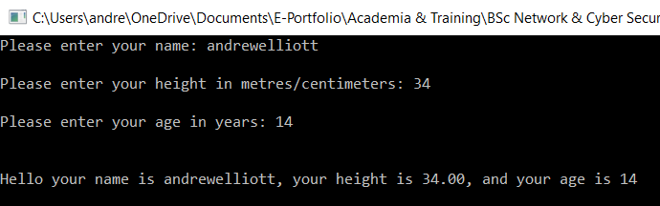
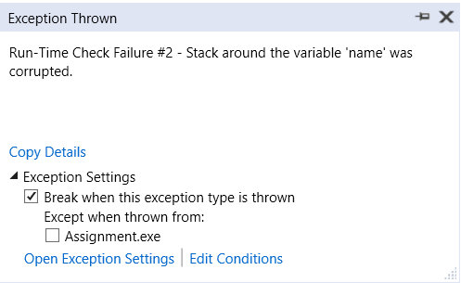
Result: Program ran but with errors.
Boundary values – name includes a space
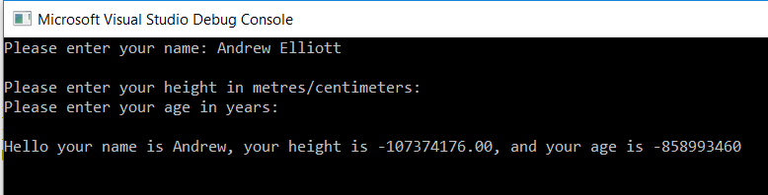
Result: Program failed.
Impossible values – number entered as name and letters entered in height and age
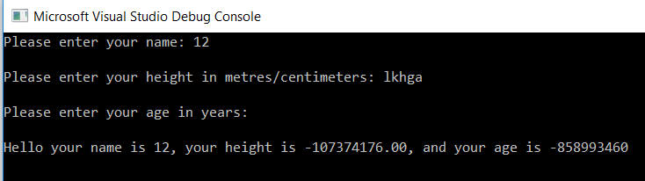
Result: Program failed.

Exercise 2 – Calculation shaded surface area

3.2.1 Identifying the problem
This exercise requires a program to find the surface area of a shaded area identified in the exercise. The shaded area is within a circle that contains a triangle. The program requires the user to enter the dimensions of both the circle and the triangle so that the shaded surface area can be calculated.
A couple of things to note is that the triangle’s surface area can be larger that the circle’s, and all of the triangle does not have to be inside the circle for the shaded area to be calculated correctly.
The program must be broken down as follows:
- The surface area of the circle must be calculated.
- The surface area of the triangle must be calculated.
- The surface area of the triangle has then to be deducted from the surface area of the circle to give the surface area of the shaded area.
The individual stages for the program are as follows:
- User enters the radius of the circle.
- Calculate the surface area of the circle.
- Store the result (float).
- Print the result on the screen.
- Users enters the height and base dimensions of the triangle.
- Calculate the surface area of the triangle.
- Store the result (float).
- Print the result on the screen.
- Deduct the surface area of the triangle from the surface area of the circle.
- Store the result (float).
- Print the result on the screen.

3.2.2 Annotated Code
The following program uses functions to calculate the answer to the exercise. Under Appendix 1 the program is written without using functions.
#include <stdio.h>

#define PI 3.142 //declaring PI as a constant

float enterfloat(void); //prototype to entering values
float calculatecircle(float radius); //prototype to calculate area of the circle
float calculaterectangle(float height, float base); //prototype to calculate area of the triangle
float calculateshadedarea(float area, float area2); //prototype to calculate shaded area of the shape

void main()
{
float radius, base, height; //variables to hold user input
float area, area2, shadedarea; //variables to hold float calculation
printf("\n\nPlease enter radius of the circle: ");
radius = enterfloat(); //user enters raduis
area = calculatecircle(radius); //using a function to calculate area of circle
printf("The surface area of the circle is %.2f\n\n", area); //print area
printf("Please enter height of the triangle: ");
height = enterfloat(); //user enters height of triangle
printf("Please enter base of the triangle: ");
base = enterfloat(); //user enters base of the triangle
area2 = calculaterectangle(height, base); //using a function to calculate area of the triangle
printf("The surface area of the triangle is %.2f\n\n", area2); //print area
shadedarea = calculateshadedarea(area, area2); //using a function to calculate shaded area
printf("The shaded area of the overall shape is %.2f", shadedarea); //print of shaded area
}

float calculatecircle(float radius) //function to calculate area of circle
{
float result; //variable to hold user input
result = PI * radius * radius; //calculating the result
return result; //storing the variable
}

float calculaterectangle(float height, float base) //function to calculate area of triangle
{
float result; //variable to hold user input
result = base*height / 2; //calculating the result
return result; //storing the variable
}

float calculateshadedarea(float area, float area2) //function to calculate shaded area
{
float shadedarea; //variable to hold user input
shadedarea = area - area2; / calculating the result
return shadedarea; //storing the variable
}

float enterfloat() // function used for user to enter data in program
{
float thevalue; //variable to hold user input
printf("Please enter your value: ");
scanf("%f", &thevalue); //user enters the value
return thevalue; //storing the value
}

3.2.3 Testing
Normal Values
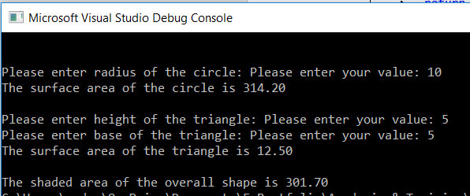
Result: Program ran as expected, correct answer calculated.
Normal Values - negative
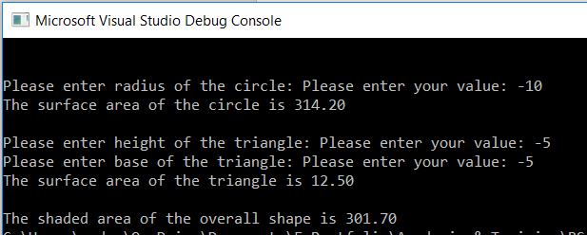
Result: Program ran as expected, correct answer calculated.
Boundary values – all values the same
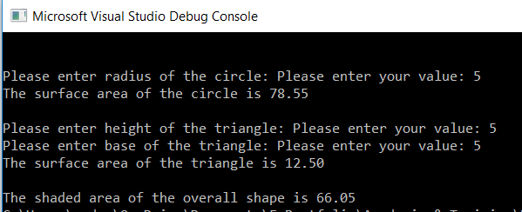
Result: Program ran as expected, correct answer calculated.

Impossible values – letters entered
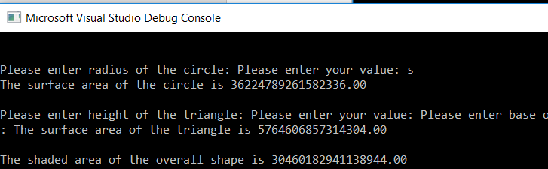
Result: Program failed.

Exercise 3 – Calculating price with VAT for 5 products

3.3.1 Identifying the problem
This exercise requires a program to enable a user to enter the prices of 5 products into an array. Once all the prices have been entered the total price is calculated, the VAT on this price is calculated and then added to the total.
The individual stages for the program are as follows:
- User enters the prices for 5 products.
- Add the prices.
- Store the result (float).
- Print the result on the screen.
- Calculate the VAT at 20%.
- Store the result (float).
- Print the result on the screen.

Annotated Code
The following program uses an array to calculate the answer to the exercise. Under Appendix 2 the program is written without using an array.
#include <stdio.h>

void main()

{
float products[5]; //set up the array and variables
float subtotal, totalprice; //storing the varialbe

printf("Please enter the price of 5 products in Sterling\n");

printf("\nPlease enter the price of the product 1: ");
scanf("%f", &products[0]); //user enters the product value
printf("\nPlease enter the price of the product 2: ");
scanf("%f", &products[1]); //user enters the product value
printf("\nPlease enter the price of the product 3: ");
scanf("%f", &products[2]); //user enters the product value
printf("\nPlease enter the price of the product 4: ");
scanf("%f", &products[3]); //user enters the product value
printf("\nPlease enter the price of the product 5: ");
scanf("%f", &products[4]); //user enters the product value

subtotal = products[0]+ products[1]+ products[2]+ products[3]+ products[4]; // calculating the subtotal
printf("\nThe total price excluding VAT is %.2f\n", subtotal); //print out the subtotal

totalprice = subtotal + ((subtotal * 20) / 100); //calculating the VAT on the subtotal
printf("\nThe total price including VAT is %.2f\n", totalprice); //print out the total

}

3.3.3 Testing
Normal Values
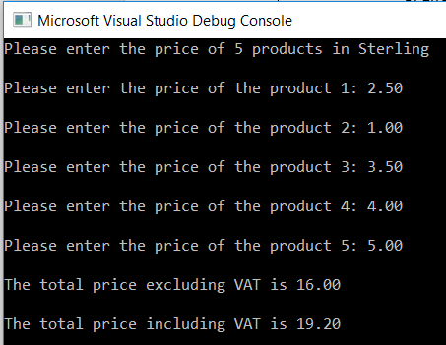
Result: Program ran as expected, correct answer calculated.

Normal Values - negative
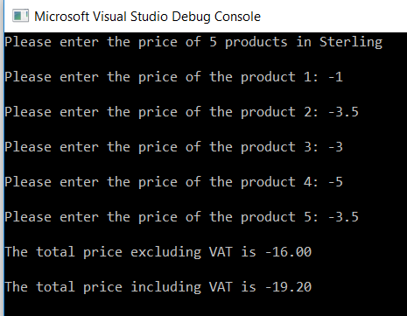
Result: Program ran as expected, correct answer calculated.
Boundary values – all values the same
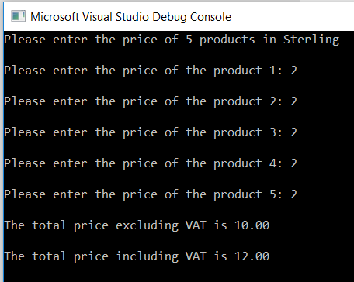
Result: Program ran as expected, correct answer calculated.

Impossible values – letters entered
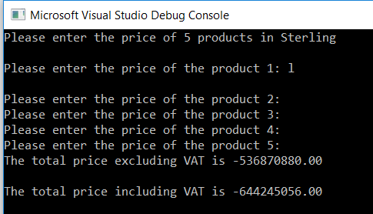
Result: Program failed.

Exercise 4 – Fruit machine game

3.4.1 Identifying the problem
This exercise requires a program to represent 3 reels of a fruit machine with numbers ranging from 1 to 5 representing symbols. The numbers are chosen randomly, and the user can have as man goes as they wish. There is a scoring system, where there is three of the same numbers scores 20 points, any combination of two fives scores 100 points, and three fives scores 2000 points. After each spin the user is asked if they wish to spin again.
The individual stages for the program are as follows:
- User indicates whether they wish to make a spin.
- If the user has indicated yes, make a spin (go to stage 4).
- If the user has indicated no, end the game.
- Check whether the user has won or lost.
- Print the result on the screen.
- If the user has indicated yes, make a spin (go back to stage 4).
- If the user has indicated no, end the game.

3.4.2 Annotated Code
The following program uses an array to calculate the answer to the exercise. Under Appendix 2 the program is written without using an array.
#include <stdio.h>
#include <stdlib.h>
#include <time.h>

void main()
{
int myarray[3]; //array variable
int low = 1; //lowest of range
int high = 5; //highest of range
char choice; //variable to hold user input
srand(time(NULL)); //seed randomness
int i; //variable for holding input
int score1 = 2000, score2 = 100, score3 = 20, score4=0;

printf("Do you wish to spin? (Y/N) ");
scanf(" %c", &choice); //user enters input

while (choice == 'y') //while choice
{
for (i = 0; i < 3; i++) //the number of columns in the array
{
myarray[i] = rand() % (high - low + 1) + low; //indicating random selection
printf("%d ", myarray[i]);
}

if ((myarray[0] == 5) && (myarray[1] == 5) && (myarray[2] == 5)) //checking where each column is 5
{
printf("\nYou win, and your points are %d", score1);
}

else if (((myarray[0] == 5) && (myarray[1] == 5)) || ((myarray[0] == 5) && (myarray[2] == 5)) || ((myarray[1] == 5) && (myarray[2] == 5))) //checking where two columns have the number 5
{
printf("\nYou win, and your points are %d", score2);
}

else if ((myarray[0] == myarray[1]) && (myarray[1] == myarray[2])) //checking that each column has the same number
{
printf("\nYou win, and your points are %d", score3);
}

else
{
printf("\nYou lose, and your points are %d", score4);
}

printf("\nDo you wish to spin? (Y/N) ");
scanf(" %c", &choice); //user enters input
}
printf("\nOK, thank you for playing, see you next time\n\n");
}

3.4.3 Testing
Normal Values
- The accumulation of scoring of two fives anywhere in the reel to give 100 points, as well as zero points for no score.
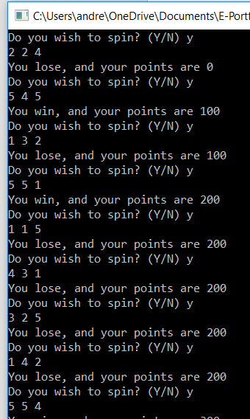
Result: Program ran as expected, correct scores calculated.

- The accumulation of all numbers being the same to give 20 points.
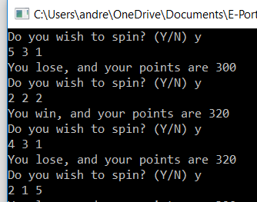
Result: Program ran as expected, correct scores calculated.
- The accumulation of all numbers being five to give 2000 points, plus the user stating ‘n’ for no when asked to spin again.
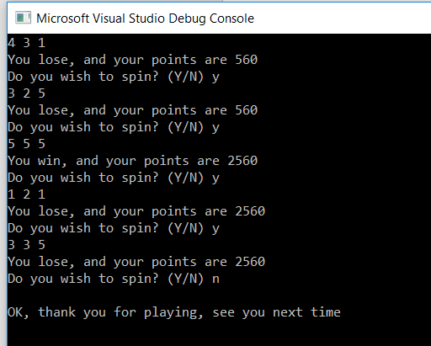
Result: Program ran as expected, correct scores calculated.

- When the user states ‘n’ for no at the start of the program.
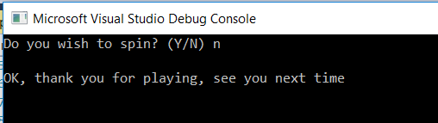
Result: Program ran as expected, game ended.
Boundary values – other letters other than ‘y’ or ‘n’
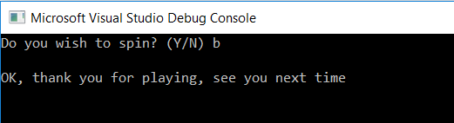
Result: Program did not run, as expected, game ended.
Impossible values – numbers entered both positive and negative
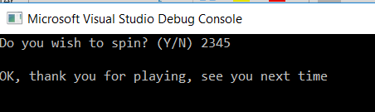
Result: Program did not run, as expected, game ended.
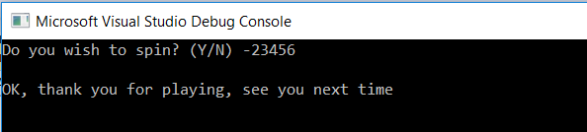
Result: Program did not run, as expected, game ended.

Conclusion
The report has demonstrated the author’s understanding of the syntax and semantics of a high-level programming language. This has been evidenced by the author deploying basic software constructs using simple algorithms in the development of solutions to 4 programming problems.

Bibliography
1. Mike McGrath, C Programming in easy steps, 4th ed. Easy Steps Ltd, 2014.
2. “BBC Bitesize - GCSE Computer Science - Constants, variables and data types - Revision 5.” [Online]. Available: https://www.bbc.com/bitesize/guides/zc6s4wx/revision/5. [Accessed: 19-Jan-2019].
3. “Arrays and lists - Revision 1 - KS3 Computer Science - BBC Bitesize.” [Online]. Available: https://www.bbc.com/bitesize/guides/zy9thyc/revision/1. [Accessed: 23-Feb-2019].

Appendices
Appendix 1
#include <stdio.h>

#define PI 3.142

void main()
{
float radius, height, base, area, area2, area3;

printf("\nPlease enter radius of the circle: ");
scanf("%f", &radius);

area = PI * radius * radius;
printf("\nThe surface area of the circle is: %.2f", area);

printf("\nPlease enter height of the triangle: ");
scanf("%f", &height);
printf("\nPlease enter base of the triangle: ");
scanf("%f", &base);

area2 = (height * base) / 2;
printf("\nThe surface area of the triangle is: %.2f", area2);

area3 = area - area2;
printf("\nThe surface area of the shaded is: %.2f", area3);

}

Appendix 2
#include <stdio.h>
#include <stdlib.h>
#include <time.h>

void main()
{
int rand1, rand2, rand3;
int low = 1; //lowest of range
int high = 5; //highest of range
char choice;
srand(time(NULL)); //seed randomness
int score1 = 2000, score2 = 100, score3 = 20, score4 = 0;

printf("Do you wish to spin? (Y/N) ");
scanf(" %c", &choice);

while (choice == 'y')
{

rand1 = rand() % (high - low + 1) + low;
rand2 = rand() % (high - low + 1) + low;
rand3 = rand() % (high - low + 1) + low;
printf("%d %d %d ", rand1, rand2, rand3);

if ((rand1 == 5) && (rand2 == 5) && (rand3 == 5))
{
printf("You win, and your points are %d", score1);
}

else if ((rand1 == 5) && (rand2 == 5) || (rand1 == 5) && (rand3 == 5) || (rand2 == 5) && (rand3 == 5))
{
printf("\nYou win, and your points are %d", score2);
}

else if ((rand1 == rand2) && (rand2 == rand3))
{
printf("\nYou win, and your points are %d", score3);
}

else
{
printf("You lose, and your points are %d", score4);
}

printf("\nDo you wish to spin? (Y/N) ");
scanf(" %c", &choice);
}
printf("\nOK, thank you for playing, see you next time\n\n");
}

