Research Project Proposal: Impact of Current Challenges on the Human Resource Department

Name: Naila Lipika
Student No: 2107176
Module title: Personnel Resourcing and Development
Module number: BMIH5005
Lecturer’s name: Kathryn Roberts

Contents
Introduction 4
Background 4
Scope of the Study 5
Discussion/Literature Review 5
Employee Retention 5
Importance of retaining adept staff 6
PESTEL Analysis 6
SWOT Analysis 8
Employee Lifecycle 9
Recommendation 10
Conclusion 10
References 12

Executive Summary
The industry which has been most sufferer due to the recent events is the tourism industry as people spend their extra money on wandering. When Covid-19 hit the world, the industry got a shock. Everyone has to restrict themselves in their rooms, which was too much frustrating. Next came the Russia-Ukraine war further depressing the business. This has forced the industry to cut off employees to save extra cost. Political turmoil in the UK also contributed negatively to the hotel industry. Despite being famous worldwide as a luxury accommodation service provider, Four Season Hotel had to go through this; even now it is going through these things. The hotel has got strength in recruiting quality employees but has been bad in keeping them. The leadership style is not aligned with organizational goal. Employees morale is low. These things must be improved by training, contractual employment, and proper organizational and HR policies, which are supposed to solve the current issues.

Introduction
British Hotel Industry has been suffering huge shocks from the onset of talks of BREXIT, for the COVID pandemic and for the Russia-Ukraine War (Rae, 2022). There has been inflation in the economy; people are immuring themselves because of lack of money and imminent global economic crisis. They are stinting their expenditure on tours and amusement, which has made a huge buffet on the face of the hotel business. Moreover, for the hotel industry it has been costlier to rent space and land than that of previous days and as there is lack of visitors in the hotel, they are often to lay the employees off (Rijal, 2022). This has been made a crisis in the hotel industry sector. Employees are always dreadful of being laid off. This has made a negative impact on employee engagement and productivity and the economic and market condition have made it difficult for the hotels to retain the employees giving them salaries every month without having to work for the hotel as enough impacting the profit margin.

Background
Four Season Hotel is one of the best luxurious hotel chains in the world based in Canada operating in almost every continent including the Europe and now having almost 100 hotels and resorts around the globe. It was founded in 1961 and has been being expanded since the time. It has a glorious story of giving high quality customer service and it is now within 100 companies to work for. The HR statement of the hotel is that “treat visitors like you want to be treated”. There are glorious annals of building engaged employees and retaining them of this hotel. The company has employed 45000 employees in its hotels and resorts. It has a great internal culture, and it pays very well to its valuable employees. It has been known that one of its competitive advantages is having the best staff to serve the visitors. However, the recent challenges of the economic crisis have made low customer inflow to the hotel and thereby attenuating the profit margin if not making it a losing concern. Therefore, it has been a challenge for the hotel chain to retain employees and assure them of employment, which is making them less engaged thereby reducing the hotel’s productivity. Again, the hotel has recently cut the compensation of the employees making it difficult to retain the talented ones. Therefore, a predicament has been created in the hotel. The research proposal is about suggesting solutions to the problems.

Scope of the Study
As the economy is changing, the hotel industry is facing severe problems like slashing off employees, cutting down the operating expense, reducing land lease, giving up additional facilities to other enterprises. Therefore, on the broad line, scope of the study includes:
- Finding out the impacts of current political turmoil in the UK on employee retention of Four-Season Hotel
- Discovering the effect of Russia-Ukraine war on the hotel’s HR management.
- Unearthing how COVID has made a change in the hotel industry’s retention policy on the perspective of Four-Season Hotel.
- Discovering possible solutions to the problems.

Discussion/Literature Review

Employee Retention
Employee Retention is defined as refraining the employees from going out of the organization and joining another one for better policies, salaries, environment or else (Noe, 2023). An organization should have ability to retain the employees for minimizing the cost of HR as human resources are recruited, trained, and maintained in exchange of huge cost. If they don’t remain in the organization, it would a great loss for the organization.
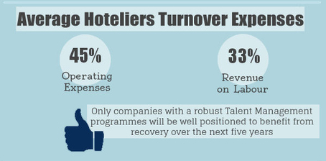
Figure 1: Expense of Employee Turnover
Source: (Noe, 2023)
Average turnover in the hotel industry in UK is 30% whereas in the USA, it is 31% (Milovanović, 2021). Though the percentage is slightly less than that in the USA, it has great expense like operating cost of 45% and revenue cost is 33%.

Importance of retaining adept staff
Organizations are built up with employees (Adler & Lazarus, 2012). The Four-Season Hotel has reached this too far only with the help of its talented employees. It is their competitive advantage. Their recruit the best employees and train them in a world class way. Therefore, they become able to satisfy the hotel visitors. Good employees make a brand of the hotel by giving best service to the visitors and the visitors by word of mouth spread the hotel’s name (Agarwal, 2012). This is how a brand is created without much significant cost. Moreover, it should be mentioned that Word-of-Mouth is one of the most credible ways of promotion. The second importance is employee engagement. If adept employees can be retained, they are engaged in the organization and work wholeheartedly thinking the organization as their own. Doing so increases productivity thereby profit of the organization. Four season hotel is one of the most profit-making hotels in the UK. It provides the best service and earns well. It is a win-win situation, which has only been possible through their efficient and talented workforce. Employee retention saves time in frequent hiring and training of the staff. High employee retention creates a competitive advantage for the organization and builds up a positive working environment thus further reducing employee retention costs.

PESTEL Analysis
PESTEL analysis is a widely used tool for evaluating the external environment (Davern, 2021). Here, there will be some analysis of the impact of different external forces on hotel and tourism industry as well as on employee retention of Four-Season Hotel.
Political Environment
First comes political environment which is defined as political and government actions that affect the business organization. Here in the UK, there have been political turmoil throughout the year and during BREXIT as well (Halim, 2021). These kinds of political turmoil have made an apprehension in the economy. The economic policies of Liz Truss had made a shock in the economy of the UK. Pound value against the US dollar got lowest in the history. She had cut down budget and heralded a mini budget. This dropdown has crunched the employment market of the hotel industry including the Four Season.
Economic Environment
The economy is passing through a hard time because of the Ukraine and Russia war. The world-wide supply chains of the food and energy have been restricted. Though UK is not much dependent on Russian gas and oil, 40% supply of Europe’s gas comes from Russia. Therefore, price of everything have been increased. People have restricted their spending on aspects other than food and medication. This has made the hotel industry fall into a critical situation. Four seasons’ profit margin has been shrunk for this economic issue.
Social Environment
The social environment is also being hampered because of the immigrants from Ukraine as the war is running there (Noe, 2023). Another aspect is that Covid-19 has been hampering social life. It has been restricting life by not allowing people to come out and gather together.
Technological Environment
Technology is changing every day. It is considered the most dynamic environment of business. As technology changes, everything changes. Employees are now able to compare employment salary and can easily get access to job circular. Therefore, recruiting quality employees with lower cost has been difficult for the hotel industry.
Environmental Factors
Environmental aspects are too important today. Last COP-26 has been observed in Glasgow, Scotland which has asserted that our environment must be protected to save the world (Noe, 2023). Due to concerns about environmental pollution, the usage of many things and carbon emissions have been limited, which has impelled the hotel industry to search for alternatives way of doing things making additional pressure on Four Season Hotel.
Legal Environment
Legal requirements have been stronger than those of before as different right groups have raised their voice which has compelled the law makers in the parliament to enact laws in favor of those groups (Rae, 2022). Food hygiene and fire regulations are strict in the UK; therefore, a hotelier must obligate the rules strictly. Insincerity about these things would make retain employees and bring customers in the hotels. However, Four Season Hotel is very careful about this matter.

SWOT Analysis
SWOT Analysis is done to evaluate the internal and external environment of the organization consisting of four aspects like strength, weakness, opportunity, and threat.
Strength
Four Season Hotel is within 100 companies to work for, which is a great thing for the company (Chong & Lobo Marques, 2021). Again, it has a great internal/corporate culture that teaches the employees to treat the customer in best way.
Weakness
The great weakness in HR of the Four-Season Hotel is its lack of employee commitment and high employee turnover (Davern, 2021). It has higher job stress than in other hotels and employees have low morale. It has inconsistency between organization’s leadership style and organizational goals.
Opportunities
There is much opportunity to train its employees online which is now available and can make their purchases and avail of the learning of those courses. It can also recruit trained employees from different staff-providing firms.
Threats
Now employees want huge compensation, huge benefits and the like. In this era of technology, it is hard to retain employees who are talented and hard working.

Employee Lifecycle
Employee lifecycle is a theory that denotes to the way employees are gone through (Chong & Lobo Marques, 2021). Human Resource manager at Four Season Hotel emphasizes on attraction of quality employees. However, Four Season has lack of caring about keeping the talented employees that is why the employee turnover is high.

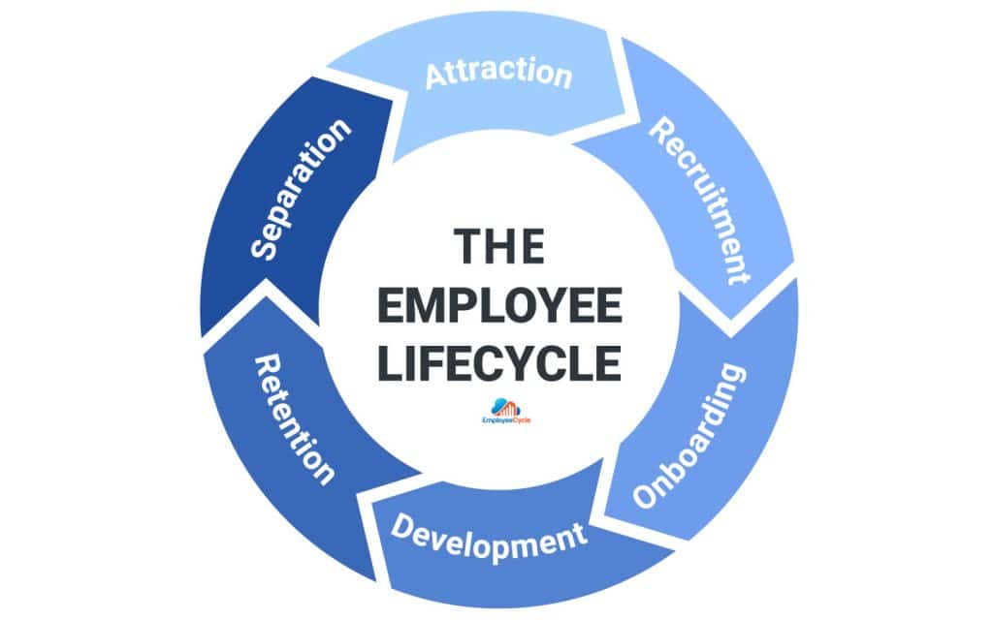
Source: (Chong & Lobo Marques, 2021)
Figure 2: Employee Lifecycle
Again, because of the war slashing of the bad employees have been important as demand is not good enough. However, the hotel should keep a sharp eye about the risk of apprehension among the employees about their job security. Therefore, the employee lifecycle should be maintained carefully by the HR managers of the Four-Season Hotel.

Recommendation
As the economic condition is not good around the world specially in Europe, the tourism industry is in shock (Chong & Lobo Marques, 2021). Therefore, Four Season Hotel would search for strategies to resolve the issues of employee retention and other issues being suffered in the business. As there are two sides of the employee retention problem, which are keeping the employees through making business and the other is preventing the employees from leaving the organization. On both ends, Four-Season Hotel should work.
- The hotel should build package on their services and give discount so that more sales are generated, and they can make profit not by premium price but by selling a larger volume. Doing so will compensate for employee retention as retaining more employees rather than required when there is less demand and an economic crisis is a loss project for a business.
- The second thing is to increase employee commitment through a favorable and contractual retention culture.
- The hotel should increase productivity by relieving the job stress of the employee and thereby increasing employees’ morale.
- Leadership style should be matched with the organizational goals.
- The hotel should look for low-cost suppliers of inputs to suspense the higher cost of inflation.
- Four Seasons should avail of technology to train employees and provide them with international online courses to learn and be better.

Conclusion
The economic crisis has created a pressure on employee retention as demand of tourism has fallen and as the revenue has been lower and demand has been less, there has been a need for laying off some employees. On the other hand, talented employees always look for better compensation, opportunity, and employment. Therefore, a balance must be maintained. In recent years, BREXIT, the recent political turmoil in the UK, inflation due to War—everything is contributing to challenges in the tourism industry. Therefore, the human resource manager at Four Season Hotel must make careful decisions about employee retention and profit making. They have to play on the hard line but being careful at least for this time.

References
Adler, H. and Lazarus, B.I. (2012) “Use of employee assistance programs by the hotel-motel industry,” Employee Assistance Quarterly, 7(4), pp. 51–58. Available at: https://doi.org/10.1300/j022v07n04_04.
Agarwal, A.K. (2012) “Employee perspective: A key to retention in IT industry,” International Journal of Scientific Research, 1(6), pp. 98–100. Available at: https://doi.org/10.15373/22778179/nov2012/37.
Ahmad, A. (2021) “Employee stress and turnover intentions of employees in Hotel Organizations,” Webology, pp. 23–39. Available at: https://doi.org/10.14704/web/v18si05/web18211.
Aslan, A.H. and Wood, R.C. (2013) “Trade Unions in the hotel and catering industry: The views of Hotel Managers,” Employee Relations, 15(2), pp. 61–70. Available at: https://doi.org/10.1108/01425459310031831.
Chong, K.Y. and Lobo Marques, J.A. (2021) “A prospective analysis about employee retention strategies for Macao Hotel Industry,” The 2021 12th International Conference on E-business, Management and Economics [Preprint]. Available at: https://doi.org/10.1145/3481127.3481251.
Davern, D. (2021) “Talent management, the employer brand, and employee retention: Evidence from the Irish Hotel Sector,” Talent Management Innovations in the International Hospitality Industry, pp. 79–98. Available at: https://doi.org/10.1108/978-1-80071-306-220211005.
Dessler, G. (2020) Human Resource Management. New York: Pearson.
Four Season Hotel (2022) Four Seasons Hotels and resorts. Available at: https://www.fourseasons.com/ (Accessed: November 27, 2022).
Gaikwad, S.K. and Shende, K. (2015) “An analysis of effectiveness and challenges in implementation of employee Retention Management System (ERMS) in hotel industry of Pune City,” ATITHYA: A Journal of Hospitality, 1(2). Available at: https://doi.org/10.21863/atithya/2015.1.2.013.
Halim, H. (2021) “Hotel employee retention: Do workplace environment, leader communication and job satisfaction matter?,” European Proceedings of Social and Behavioural Sciences [Preprint]. Available at: https://doi.org/10.15405/epsbs.2021.06.02.39.
Hesford, J.W., Malina, M.A. and Pizzini, M. (2012) “Is there an optimal level of employee turnover? an empirical examination of the performance effects of turnover in the hotel industry,” SSRN Electronic Journal [Preprint]. Available at: https://doi.org/10.2139/ssrn.2132979.
“Influences on HRM in the Hotel Industry” (2022) Human Resource Management in the Hotel Industry, pp. 77–104. Available at: https://doi.org/10.4324/9780203020869-11.
Kashif, D.M. (2022) “Impact of employee turnover in the hotel industry an empirical study of select hotels in Uttar pradesh,” SSRN Electronic Journal [Preprint]. Available at: https://doi.org/10.2139/ssrn.4185594.
Milovanović, V. (2021) “The COVID-19 pandemic effects on the hotel industry,” TOURISM CHALLENGES AMID COVID-19 [Preprint]. Available at: https://doi.org/10.52370/tisc21570vm.
Noe, R.A. (2023) Human Resource Management: Gaining a competitive advantage. New York, NY: McGraw Hill Education.
Pratomo, A. and Zulkarnain, A. (2018) “Leadership style toward employee performance evaluation in Hotel Industry,” Proceedings of the 3rd International Conference on Social Sciences, Laws, Arts and Humanities [Preprint]. Available at: https://doi.org/10.5220/0010011104770481.
Rae, M. (2022) “The economic impact of the Ukraine–russia war.” Available at: https://doi.org/10.4135/9781529609059.
Rijal, R. (2022) “Factors influencing employee retention in the Nepalese Hotel Industry: The Pathways to Future Research,” Quest Journal of Management and Social Sciences, 4(1), pp. 112–127. Available at: https://doi.org/10.3126/qjmss.v4i1.45873.
“Strategic Human Resource Development” (2021) Human Resource Development, pp. 77–101. Available at: https://doi.org/10.4324/9780080455389-5.
Singh, D. and Amandeep (2017) “Impact of employee turnover on hotel industry- a study of Selected Hotels of New Delhi,” International Journal of Research -GRANTHAALAYAH, 5(4), pp. 153–158. Available at: https://doi.org/10.29121/granthaalayah.v5.i4.2017.1807.
Werner, J.M. (2014) “Human resource development ≠ human resource management: So what is it?,” Human Resource Development Quarterly, 25(2), pp. 127–139. Available at: https://doi.org/10.1002/hrdq.21188.

