LCBB4003
Introducing the Modern Workplace

Table of Contents
Introduction 3
Organisational structure 4
Geographical structure 4
Functional structure 5
Product structure 6
Organisational culture 7
Organisational performance 9
The relationship among structure, culture and organisational performance 15
Conclusion 17
References 18

Introduction
The modern workplaces around the world is a structure based upon unique culture influenced by the business environment and the country culture which ultimately leads to better organisational performance aligning with the goals and objectives (Chión, 2019). There is a relationship among the organisational structure, culture and organisational performance. The leadership roles and the management responsibilities can bring a better balance for an organisation. Controlling the behaviour of the people within the organisation with the behavioural approaches to management can create a culture and structure that increase the chance of being successful for a company (Armstrong, 2017).
The Coca-Cola Company is the largest beverage and soft drinks producer in the world owning four of the worlds five most popular and the biggest soft drink brands. The company has more than 4,300 products under more than 500 brands. Though the company is a global company, it operates by customising is operational strategies based on the country requirements and the consumer behaviour of a particular region (Brondoni, 2020). The culture, organisational structure, people and the organisational performance of the company has been described in the paper.

Organisational structure
Organisational structure brings the different parts of the organisation altogether and explains the ways the functions should be coordinated, delegated and supervised. As the Coca-Cola Company is a multinational company, the structure should also include various global and regional factors. The corporate segment of the company provides overall direction to the regional segments of the company (Lange, 2016). Organisational structures design to meet the aims and objectives. Though the company is providing guidelines and directions to the regional segments, the company focuses on teamwork and the employees enjoy flexibility in decision making. The employees are encouraged to share their ideas that can improve the decision making within the organisational boundary which means that the company follows and has built a flexible organisational structure (Huczynski, 2013). The company is structured in such a way so that the teams are formed with the specialist from the various functional and regional background.
The company has structured its organisation following some factors: function, product, geography and process.

Geographical structure
The company provides goods and services to its regional markets by considering their local demand and culture. Hence their primary organisational structure has been formed based on the geographical locations. The company currently has over 500 brands operating in more than 200 countries. The company does not follow a single strategy in each of their locations worldwide and as a result, they need to follow a structure by dividing the overall operation of the organisation into different regions (Xu, 2018). The company has different geographic operating segments which are referred to as strategic business units. The country-wise operations are run from those regional headquarters and their respective head of operations. The operations of Great Britain Coca-Cola falls under North West Europe division.
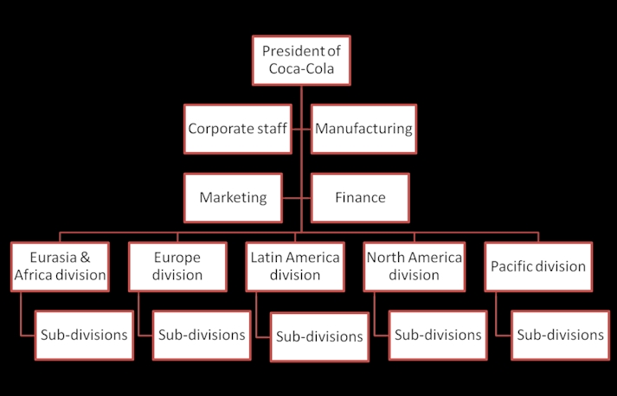
Figure1: Regional structure of The Coca Cola Company
Source: (Zammit, 2019)
The structure has been prepared based on the tastes and lifestyles of the residents of those countries and regions. The income and consumption behaviours of those regions have also been taken into consideration (Zammit, 2019). And won the most important reasons the company has followed geographical structure is that the markets in those regions are at their different stages of product and industry life cycle.

Functional structure
Along with the operational structure, the company also follows a functional structure at a more local level to become specialised in those markets. The company also follows the matrix structure in its operation at local and regional level (Animashaun, 2017). For example, the director of marketing needs to report to the Division head and also to the divisional deputy director of customer relations.
Moreover, the company has chief executives in all of the major functional areas. And they have also chief executives at a sub-division level to customise their operations according to the local demand, income level and culture.
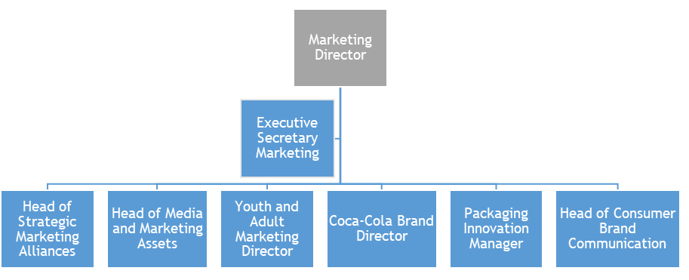
Figure2: Structure of marketing functions in Great Britain Coca-Cola
Source: (Taylor, 2017)
The marketing function of the company, for example, is operated by a hierarchical structure but with the network structure in hand, the employees can maintain smooth communication with their subordinates and co-workers (Taylor, 2017). Thus they form a team where every employee are encouraged to provide their opinion if they think that may improve the decisions being taken.

Product structure
Inside the company, the company focuses on individual products meeting the local and regional requirements demanded by the consumers. The Coca-Cola Company is a global business with the accumulation of all of its regional and divisional segments. Its divisional segments are segregated into various teams concentrating on given products and those teams are solely focused on the production, operation, sales and promotion based on their knowledge and competences on those particular brands (Odukah, 2016.

Figure3: Product structure of GB Coca-Cola
Source: (Sodhi, 2017)
For example, Great Britain Coca-Cola has various teams focusing on carbonated beverages, fruit juices, drinking water, energy drinks, sports drinks and squashes.

Organisational culture
The structure of the company is mostly built upon its organisational culture. Organisational culture is the set of values and behaviours that creates a distinctive psychological and social environment in an organisation (Huczynski, 2013). The organisational culture focuses on two distinctive elements of the business world include the business environment and the culture of the region where it does business (Omari, 2017). The business environment is believed to be the most influential factor that shapes the culture of the company. According to Hofstede's cultural dimension, the cultural dimensions are of four types with a fifth one included later. This dimension has also been applied in coca-cola.
Cultural dimension | Score of Coca-Cola | Country score | Comments
Power distance | 26/100 | 35/100 | The company has a culture of teamwork, cooperation and flexibility. And as a result despite being a hierarchical organisation, the company has a less level of power distance most of the businesses in the UK.
Uncertainty avoidance | 47/100 | 35/100 | The company follows a network structure alongside the other organisational structures which helps them to maintain stable communication within and outside the organisation. Maintaining good communication has helped them to avoid uncertainty (Armstrong, 2017). They hold team meetings where the members are from different background and with proper communication of the risks and uncertainties in various functional areas, the company can take necessary precautionary steps.
Individualism/ collectivism | 23/100 | 89/100 | The company believes in collectivism and hence in the parameter of individualism, they have scored very low. The company motivate their employees to work in teams to develop team spirits and engagement with the organisation.
Masculinity/femininity | 44/100 | 66/100 | The company believes in fluids general rules that the task should not have any gender preferences. And hence on the skill of masculinity, there was scored lower than the country score in the United Kingdom.
Short term / long term | 13/100 | 25/100 | The company looks for the achievement of long term goals and objectives. They focus on accountability and self-discipline of the employees and the teams. They prefer to stay focused more on the future market position of the brands and services of the company.
Table1: Hofstede’s Cultural Dimension in GB Coca-Cola
Source: Self-Creation
Another model of cultural dimension, namely GLOBE Cultural Dimensions, as also provided some additional dimensions of cultural variation. The Coca-Cola Company also follow some of those cultural dimensions in their organisational culture establishment (Chión, 2019). The company tends to also be focused on humane oriented, assertive and performance-oriented.

Organisational performance
The company is the world's largest beverage and soft drinks producer and distributor owning four out of the five largest beverage brands across the globe. The company has been maintaining a disciplined growth which the current net operating revenues as of 2018 is $31.9 billion Hans current market capitalisation as of 2018 is $202.1 billion. The company has more than 4,300 products under more than 500 brand names; 600 of their new products has been launched in 2018 we have increased there performance in most of the parameters in 2018 and the later years (The Coca-Cola Company, 2020).
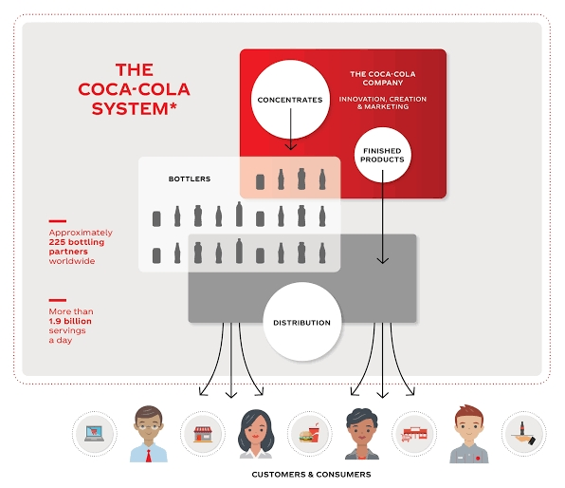
Figure4: The Coca-Cola system
Source: (The Coca-Cola Company, 2020)
With the establishment of The Coca-Cola system, the company has been generating more values without complicating its organisational structure and reducing the number of risks. With the help of the approximately 225 bottling partners, the local packaging, bottling, distributing and market understanding has been transferred to the bottling partners who understand the local markets very well. But the manufacturing, marketing and other key operations like research and development have been kept under the supervision of The Coca-Cola Company (The Coca-Cola Company, 2020). Thus the company is enjoying a reduced level of organisational structure complexity and uncertainty.
The company is also doing better in many other financial and environmental parameters.
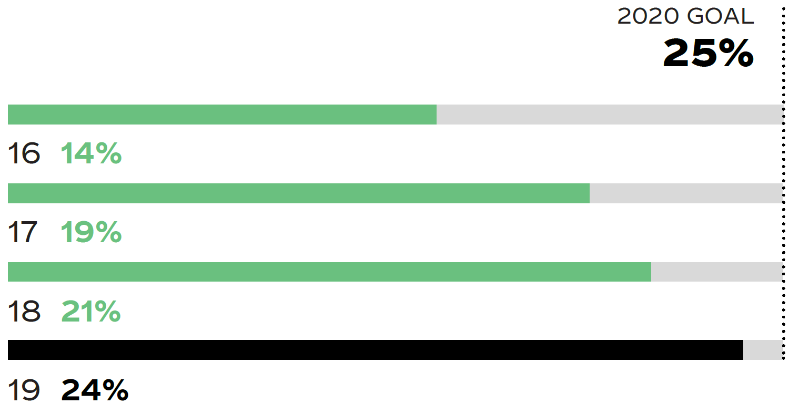
Figure5: Reduction of carbon footprints
Source: (The Coca-Cola Company, 2020)
The company has reduced their carbon footprints significantly in the last 5 years under their program named “drink in your hands”. The last four years the company has reduced its carbon footprints by 10%.
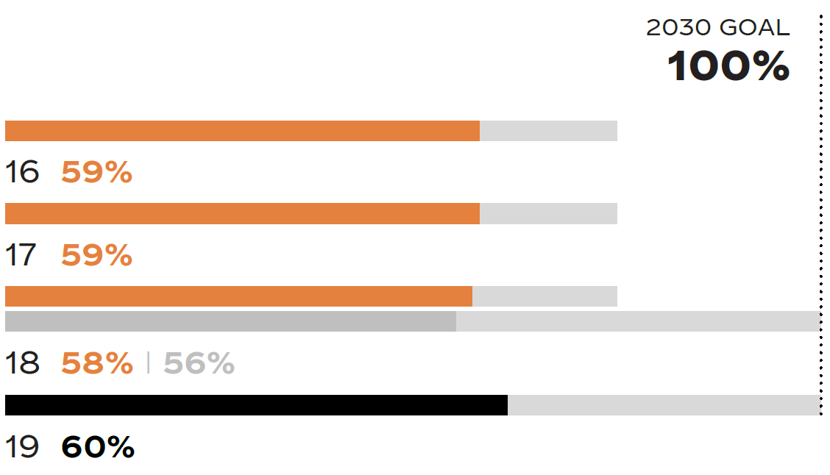
Figure6: Percentage of bottles or cans refilled or recycled
Source: (The Coca-Cola Company, 2020)
Worldwide the company recycles more than 60% of their bottles and cans to protect the environment from plastic pollution. The company is targeting that they will recycle all of their produced bottles and cans within 2030. This is one of the most courageous goes saved by the company to protect the environment.
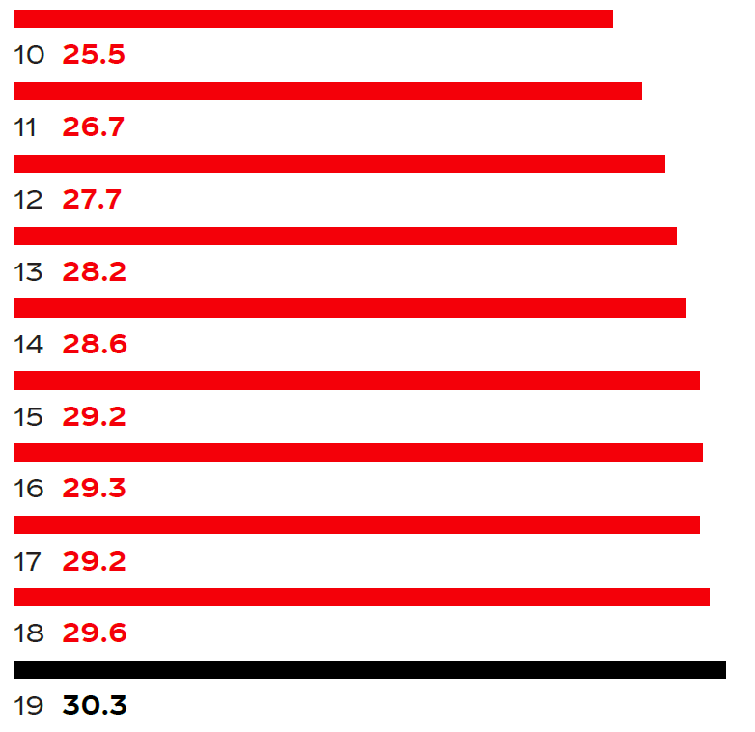
[Total Company Unit Cases in Billion]
Figure7: Volume Growth
Source: (The Coca-Cola Company, 2020)
Over the last 10 years, the company has increased its volume of production in terms of units buy nearly 5 billion. In recent years, the company has experienced is the biggest leap in terms of volume growth in 2019 because the company has launched more than 600 products globally in different countries across the globe.
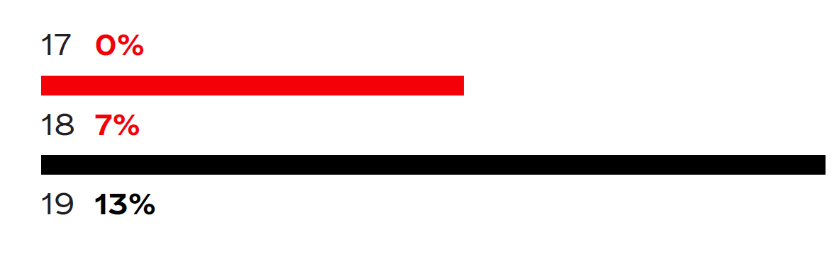
Figure8: Operating Income Growth
Source: (The Coca-Cola Company, 2020)

Operating income growth of the company has interest over the last three years. Operating income growth of the company has increased drastically after 2018 because in that year the company has launched more than 600 products across the globe.
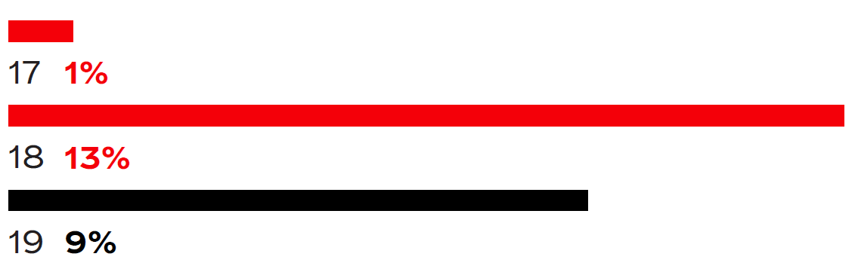
Figure9: Diluted net income per share growth
Source: (The Coca-Cola Company, 2020)

the partial net income growth of the company has also increased over the years but in 2019 the growth was lower than that of the previous year. Though the growth was lower, the company is still expensive positive growth in terms of net income per share.

The relationship among structure, culture and organisational performance
The organisational culture, structure and performance are interconnected and relevant to one another (Mullins, 2016). All of the things revolve around the people in the organisation. People means the employees and the managers of the organisation who are responsible for the achievement of the goals and objectives of the organisation. The people in the organisation are assigned with respective roles and responsibilities both in teams and individually (Taylor, 2017). Their roles and responsibilities include building the organisational structure based on the cultivable culture to yield in the best performance.
The company has a culture of teamwork, flexibility and interpersonal relationships. The company focuses to build a cultural base of the organisation where every employee will be heard. The company considers its employees as the best resource in the organisation. The employees have good relationships with their co-workers and hence they feel like they are in a family which increases employee engagement (Zammit, 2019).
Such a culture helps the organisation have a flexible structure where various teams are formed by taking employees with various skills and competencies in different functional areas. With the network structure in hands, the company ensures good communication of the knowledge and information while they make a decision. Though the company has structural flexibility, the hierarchy of the organisation ensures that the managers and the employees are accountable to their senior management ensuring that the key goals and objectives are being met (Lange, 2016). The company follows a mixture of the centralised and decentralized structure of organisation alongside the other factors of structuring the organisation including geographical structure, product structure and functional structure.
Such a structure of the organisation based upon a unique culture has helped the organisation to achieve the best organisational performance in the beverage and soft drinks industries globally. The company is doing better in almost all of the parameters of performance measurement.

Conclusion
The Coca-Cola Company is successfully managing its organisational structure based on the organisational structure that fosters business performance. The organisational culture, structure and performance are interconnected and relevant to one another. The company is structured in such a way so that the teams are formed with the specialist from the various functional and regional background (Brondoni, 2020). The company has different geographic operating segments which are referred to as strategic business units. The country-wise operations are run from those regional headquarters and their respective head of operations. The business environment is believed to be the most influential factor that shapes the culture of the company (Mullins, 2016).

References
Animashaun, A.O., 2017. An investigation of controlling management of the enterprise on the example of the Coca Cola (Doctoral dissertation).
Armstrong, M., Taylor, S., 2017. Armstrong's Handbook of Human Resource Management Practice, 14th Edition, Kogan Page
Brondoni, S.M., 2020. Shareowners, Stakeholders & the Global Oversize Economy. The Coca-Cola Company Case. Symphonya. Emerging Issues in Management, (1), pp.16-27.
Busk, D., 2016. How Coca-Cola Journey transformed corporate communications. Journal of Digital & Social Media Marketing, 4(1), pp.6-16.
Chión, S.J., Charles, V. and Morales, J., 2019. The impact of organisational culture, organisational structure and technological infrastructure on process improvement through knowledge sharing. Business Process Management Journal.
Coca-colacompany.com. 2020. The Coca-Cola Company: Refresh The World. Make A Difference. [online] Available at: <https://www.coca-colacompany.com/> [Accessed 5 August 2020].
Huczynski, A., Buchanan, D, 2013. Organisational Behaviour (8th edition) Harlow: Pearson
Ibrahim, A.U. and Daniel, C.O., Impact of leadership on organisational performance.
Lange, S., Tachiciu, L., Pirnea, I.C. and Maier, A., 2016. A case study on effectiveness of organisational structures under the effect of globalization.
Malik, T.A., Khan, H.U., Shah, A. and Gul, S., 2017. Performance measurement using distributed performance knowledge management system: Empirical case study of Coca Cola Enterprises. International Review of Business Research Papers, 6(1), pp.250-282.
Mullins, L, 2016. Management and Organisational Behaviour 11th Edition, Pearson.
Odukah, M.E., 2016. Factors Influencing Staff Motivation among Employees: A Case Study of Equator Bottlers (Coca Cola) Kenya. Journal of Human Resource and Sustainability Studies, 4(02), p.68.
Omari, S.M., Ateka, R.M. and Nyaboga, B., 2017. The influence of Strategic Change Management Practices on Organizations Performance: A case of the Operations of soft drink Industries in Western Kenya. International Journal of Social Sciences and Entrepreneurship, 1(4), pp.557-567.
Sodhi, M.S. and Son, B.G., 2017. Supply-chain partnership performance. Transportation Research Part E: Logistics and Transportation Review, 45(6), pp.937-945.
Taylor, M., 2017. Cultural variance as a challenge to global public relations: A case study of the Coca-Cola scare in Europe. Public Relations Review, 26(3), pp.277-293.
Xu, V., 2018. Introducing Coca-Cola: One of the Most Iconic Brands in the World.
Zammit, T., 2019. Organisational culture and attitudes towards financial statements: an analysis (Master's thesis, University of Malta).

