Privative water company’s social responsibility

---Chinese national water company whether transfer to privative water company

Student : Chen Wei
Student number: 1702098

- Introduction

In China, water enterprises are related to the people's livelihood, and the state is in the hands of enterprises that relate to the people's livelihood. In the UK, as early as 1980 's, Britain has sold a group of government water companies to private businesses in order to promote the economy and has achieved good results. China Water Group is the next group of China's Ministry of water resources. It is the largest Water Service Company in China, with a population of about 20 million people. It has commissioned more than 4000 kilometers of operation drainage network. According to the 2016 annual report of China Water Group, the total income of water group is almost the same as their expenditure. Therefore, the transformation to private enterprises may be a way to change their current situation. This report will analyze the private water enterprises in the UK and the us from the perspective of corporate social responsibility and discuss whether China's water enterprises can refer to the UK and the us to transform state-owned enterprises into private businesses.

2.0 Main body

2.1 What is Corporate Social Responsibility(CSR)?

Corporate social responsibility (CSR) is the commitment by organizations to behave ethically and contribute to economic development while improving the quality of live of the workforce and their families as well as the local community and society at large (Johnson, et al.,2014 p.127). In the competition of contemporary enterprises, corporate social responsibility has become a major factor in helping enterprises to gain competitive advantage.

2.1.1 Freeman vs Friedman – Stakeholder and Shareholder theory

Stakeholder theory: Stakeholder theory refers to the management activities of the company's business managers to balance the interests of various stakeholders. Compared with traditional shareholder theory, this theory holds that the development of any company is inseparable from the input or participation of various stakeholders. The company pursues the interests of stakeholders as a whole, not just the interests of shareholders. （Freeman 2010）.
At the same time, the stakeholder theory will bring some advantages and disadvantages to the company. Because of the use of stakeholder theories, companies will pay more attention to long-term investment rather than short-term interests and try to avoid high-risk decisions. And using stakeholder theories, there will be better corporate governance within and outside the company because they will consider that more factors may affect the company. Just like a coin has two sides, this theory will also bring some problems for the company. For example, the decision-making of the company will be too conservative, and it will not be able to create innovations and entrepreneurship efficiently. Sometimes companies also make uneconomic investments because of stakeholder theory. (Johnson, et al.,2014 p.118)
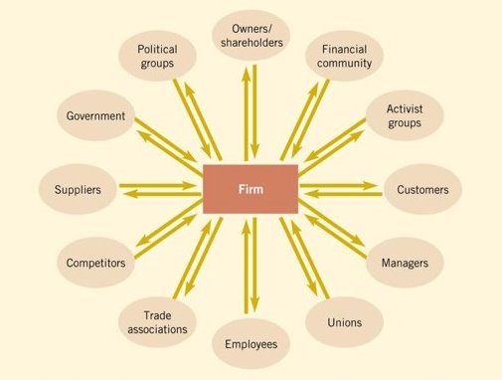
According to R.E. Freeman’s Stakeholder theory(1984), there are some stakeholder for a firm-owners. Financial community, activity groups, customers, managers, unions, employees, trade associations, competitors, suppliers, government and political group.
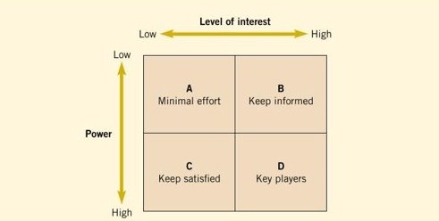
In order to better analyze the impact of the company's stakeholders on the company, people proposed the concept of stakeholder mapping. This concept is identified stakeholder interest and power and in reading political priorities（D. Walker, I,, Bourne and A, Shelley 2008, P645）.

Shareholder theory: The company's business goal is to maximize the interests of shareholders, and the only way for managers to exercise control rights in accordance with the interests of shareholders is an effective guarantee for corporate governance. The basic idea is that the manager serves the shareholders, the shareholders are the bearers of the company's residual risks, and the shareholders have the power to use, dispose, and transfer their property rights. The manager's goal is to maximize the interests of shareholders (Friedman 1963). At the same time, shareholders are the core of the company. How to safeguard their interests is the goal of the company.
At the same time, when safeguarding shareholders' rights, they also consider some stakeholders, such as customers.

2.1.2 Carroll’s Pyramid of Corporate Social Responsibility(CSR)

Pyramid of Corporate Social Responsibility was proposed by Archie Carroll in 1983. He regards corporate social responsibility as a structural component and relates to four different levels of corporate-social relations. That is, “corporate society is included in a specific period of time. The social, economic, legal, ethical, and charitable expectations of economic organizations" (Archie B Carroll 1991). And the responsibilities that companies need at every level are gradually reduced from the bottom up.
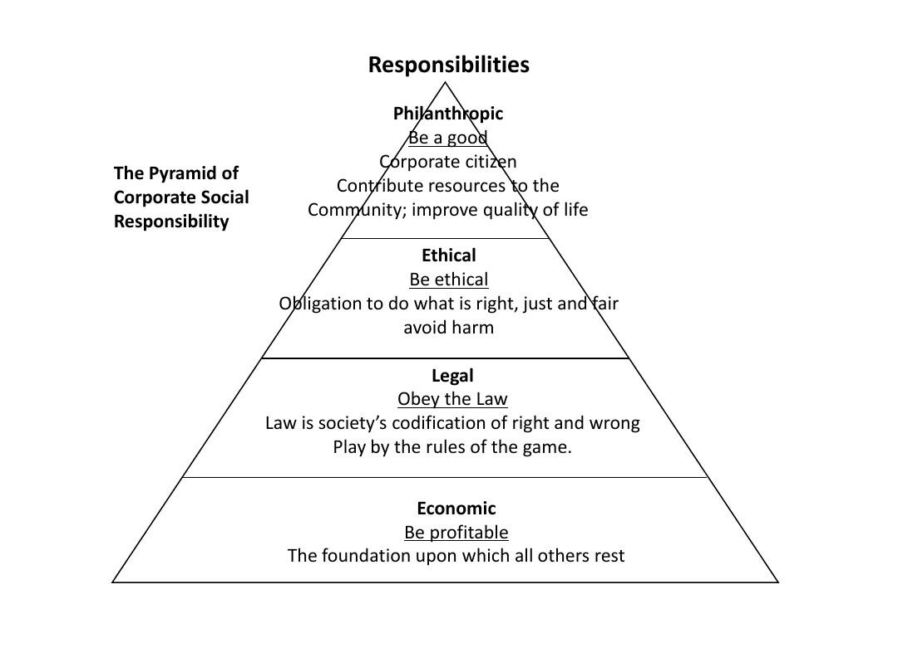
Next, we will discuss Pyramid's corporate social responsibility of private water companies, and analyze from economic, legal, ethical and philanthropic 4 parts.
2.1.2.1 Economic Responsibilities

In Pyramid of Corporate Social Responsibility, economic responsibility is the first need to consider the social responsibility of the enterprise. The first demand of an enterprise is to ensure the normal operation of the enterprise and make a profit for the enterprise（WINDSOR, D., 2001.）.

The York Water Company provides water and wastewater services to an estimated population of 196,000 through approximately 69,000 connections in South Central Pennsylvania（York Water 2015）. The figure below is the York Income Water sheet
from 2011 to 2015. Through the chart, you can intuitively discover that York Water’s profits have been increasing during these 5 years, and between 2013 and 2014, York Water did not Expanding their range of services and their target customers have no apparent growth (York Water 2014), therefore, the rise in price of drinking water has been the main reason for their net income growth.
Through the analysis of the above information, the first responsibility of private water companies is their economic responsibility and increase their profits.

2.1.2.2 Legal Responsibilities

As an integral part of the society, the enterprise gives and supports the enterprises to assume productive tasks and provide the society with the power to provide products and services. It also requires the enterprises to achieve economic goals within the legal framework. Therefore, companies have the necessary legal responsibility（LIPINSKY, D.A. and IVANOVA, T.N., 2017.）。

Because water resources are related to the people's livelihood, each country will have a special department to manage and supervise the behavior of the water company, whether it is a state-owned enterprise or a private company. In the UK, there will be The Drinking Water Inspectorate (DWI), and the Ministry of Water Resources in China.
The Drinking Water Inspectorate (DWI) was formed in 1990 to provide independent reassurance that water supplies in England and Wales are safe and drinking water quality is acceptable to consumers（gov.Uk）When there is a problem with the quality of water in the UK, DWI will investigate the first time. For example, on June 7, 2017, the affected areas included the towns of Working ton and Whitehaven and surrounding areas, where people reported odor odors in drinking water. DWI conducted investigations at the first time and conducted interviews with related companies, and The results of the survey were presented to the public on December 5, 2017 in the form of reports (gov.uk).

From this case, it can be concluded that any company must follow the law, which is the legal responsibility of the company. And the people and the government will supervise the company. This is the social responsibility that companies must fulfill.

2.1.2.3 Ethical Responsibilities

Ethical responsibility refers to the need for companies to comply with the ethical requirements of some public societies that expect companies to follow those who have not yet become law.（FOLEY, R.W., BENNETT, I. and WETMORE, J.M., 2012.）。

According to the BBC's November 30, 2017, water company information cannot be trusted . There are four private water companies that have missing data in the annual report, which will cause customers to lose trust in the company. They are Southern Water, Bristol Water, Dee Valley Water and Thames Water. According to Ofwat-company monitoring report, they were unable to confirm the sources of tap water provided by these four companies. The behavior of the four companies did not violate the law, but it affected the right of the customers and the public to know. This kind of behavior is a violation of the enterprise's ethical responsibility, does not provide accurate data on the company's behavior, and does not explain the public's own sources of water.

2.1.2.4 Philanthropic Responsibilities

Philanthropic responsibility is the responsibility of the implementation of corporate resources. In general, the society also places some expectations on companies that they do not or cannot clearly express. It is entirely up to the individual or the enterprise to judge and choose whether or not to bear the responsibilities. This is a completely voluntary act, such as a charitable donation. Provide housing or provide daycare centers, etc（YAKOVLEVA, N. and VAZQUEZ-BRUST, D., 2012）.

According to the Thames water official website, they participated in WaterAid in 1981 and made efforts for everyone around the world to obtain safe drinking water and sanitation facilities. They have donated more than 35 million pounds in total. Thames Water completed a four-year project in Bangladesh, raising 2.14 million pounds, helping more than 50,000 people to get clean water, and 53,000 access to safe toilets（Thames water）. It can be seen from the case that private companies will want to participate in charitable activities and will give back to society. These behaviors can help them win the favor of some stakeholders, such as customers. At the same time, this time makes the company employees more willing to join this group.
2.2 Sustainability

2.2.1.what is sustainability?
Sustainable refers to the coordinated development of economy, society, resources, and environmental protection. They are an inseparable system that not only achieves the purpose of economic development, but also protects the atmosphere, fresh water, oceans, land, and forests that human beings rely on to survive. Resources and environment to enable companies to develop
(LEE, S.H., 2011.)。

2.2.2. Sustainability and Privatized Water Companies

When talking about the sustainable development of private water companies, they first need to consider how to ensure that resources are acquired in nature and do not damage the local environment and establish a long-term mining plan to ensure that their mining is in the scope of the recovery of the environment Inside and able to provide fresh and clean water to customers. One example is Thames Water. They presented their sustainability plan in 2012 as follows:
Water a precious resource. -manage the water cycle in the most sustainable way by taking less, losing less, and planning for resilient water resources for the long-term.
Providing sustainable drainage. - ensure sewerage network is as resilient as possible and will take advantage of opportunities to deliver more sustainable drainage solutions.
Mitigating climate change. - minimize our carbon footprint associated with energy and fuel use, reduce consumption of resources and their associated carbon or cutting the lower carbon alternatives.
Enhancing customer inclusion. - customers are at the center of what they do and they will active seek to make our services affordable, engage them on what they want and provide fair and transparent charging.
Delivering efficient operations. -seek to reduce the use of natural resources, minimize waste, deliver efficient and effective operations for both today and the future and work with our supply chain to improve our resilience.
Long-term sustainable investment. - take a longer-term view of managing the finance ability of our business ensuring we attractive to investors of both equity and debt（Thames water ）.
2.2.3The quality of water

According to the report of the China Water Quality Monitoring Bureau (2018), among the 148 water quality monitoring sites in China, there are 8 first-class water points, 74 second-class water points, 39 third-grade water points, 12 fourth-grade water points, and 5 fifth-level waters points, and 9 poor quality water spots, the failure rate was 6.2%. Comparing with the quality of water in the United Kingdom, According to Drinking Water Inspectorate (2015), the unqualified water quality rate in the United Kingdom during the year was only 0.04%, and the sample size was 3. 80000.The reflection of this gap is, I think, in the nature of the enterprise. Private companies must use good water resources to attract customers and avoid being punished by the regulatory authorities. They also face the threat of competitors. For state-owned enterprises, their competitive pressures are small. Moreover, customers have fewer choices and they have a large and stable market to support their own business survival. Therefore, from the perspective of water quality, the conversion of Chinese water companies into private enterprises is a situation that is beneficial to people.

2.2.4The future of water supply

According to the World Health Organization (2018) report, 844 million people did not even have basic drinking water services, including 159 million people who depended on surface water. Globally, at least 2 billion people use potable water sources. By 2025, half of the world's population will live in areas affected by water. In low- and middle-income countries, 38% of health-care facilities lack improved water, 19% do not have a good sanitation environment, and lack of water and soap wash hands 35%.
Therefore, in the future water supply, we need to reduce the use of fresh water and collect available water in the natural environment in China, that is, learn to collect rainwater and reuse domestic water for many times. For example, the washed water can be used to clean the toilet and not use it. Bathing in a shower with a rain shower will save 2/3 of the domestic water.

2.3 advantage and disadvantage of a private water industry

2.3.1 advantage

When water companies were transformed into private companies, these companies moved from a comfortable and comfortable environment into a competitive environment. At this time, in order to be able to develop in the competition, they must constantly improve themselves, whether in the quality of water or the efficiency of the service. From the data, we can see that in China, water companies are state-owned enterprises, but the rate of disqualification of water sources is 6.2%, while in the UK, this is only 0.04%. Meanwhile, in private companies, earning profits is their A goal, this will also improve the company's profitability, making the company a better development. And in order to gain revenue, they have no choice but to increase their own efficiency to enhance their competitiveness. This will also stimulate the company's ability to innovate.

2.3.2 disadvantage

When water companies are transformed into private companies, they will also have some shortcomings. For example, investors will mainly consider their own interests. Investors are businessmen and not philanthropists. What they need to consider is how to obtain benefits as soon as possible, instead of thinking about how to make customers get high-quality and reasonable-price water. These issues are the government needs to consider. Therefore, when companies make decisions, they will only make the best choice for themselves under the law

2.3.3 is the water industry better of being public or private?

Chinese water companies are national industries. They can provide consumers with water at a reasonable price because their main concern is to ensure that their water quality is within the national regulations and that profitability is not their main purpose. However, the quality of water and the efficiency of business services cannot be guaranteed.
In contrast, British water companies are private companies. Their water prices are relatively high, but they are within the reach of British residents. However, the service efficiency of companies and the quality of their companies are much higher than those of China. Moreover, in order to ensure the trust of the winning customers, the British company will test its own water conditions and publish it to the public.
By contrasting the water industry in the UK and China, I believe that when Chinese water companies are transformed into private companies, they will obtain greater benefits for the public and will also promote the development of the company.

2.4 Corporate Citizenship

Corporate citizenship involves the social responsibility of businesses and the extent to which they meet legal, ethical and economic responsibilities, as established by shareholders. The goal is to produce higher standards of living and quality of life for the communities that surround them and still maintain profitability for stakeholders. The demand for socially responsible corporations continues to grow, encouraging investors, consumers and employees to use their individual power to negatively affect companies that do not share their values.

2.4.1 Water companies and the extended view of Corporate Citizenship

There is an example that Anglian Water. According to Anglian water education provision encompasses all Key Stages and A-Level. There are a range of topics covered such as water efficiency, pollution, climate change and sustainability. Sessions are fun, interactive and include challenges and self-directed projects. All of the Anglian Water Community Education team are qualified, experienced teachers with current DBS checks. And all of these sessions are at no cost(Anglian Water 2017).

3.0 Conclusion
This report discusses the social responsibility of British private water companies and the quality of British water resources, and compares them with Chinese national water companies. It concludes that Chinese water companies should turn to privatization and need to be as rigorous as Britain. Private companies are supervised while giving a standard pricing. This will promote the progress and development of Chinese water companies.
At the same time, through research on water resources, water companies should properly develop water resources and make full use of domestic water.

Reference

Anglian Water Education center
Available at: http://www.anglianwater.co.uk/community/education/education-centres/
[Accessed 24 March 2018]

Archie B Carroll, 1991. The Pyramid of Corporate Social Responsibility: Toward the Moral Management of Organizational Stakeholders

BBC News, 2017, water company information cannot be trusted
Available at :http://www.bbc.co.uk/news/uk-england-42184416
【Accessed 20 March 2018】

China Environmental Inspection Station 11 weekly reports in 2018
Available at :http://www.cnemc.cn/showReport.do?cateId=2093030&contentId=210005580&siteId=2002
[Accessed 27 March 2018]

D. Walker, I,, Bourne and A, Shelley, “Influence, stakeholder mapping and visualization”, Construction Management and Economic 2008, P645

DWI, 2017. Water problem research
http://www.dwi.gov.uk/pressmedia/pressreleases/2017_12_05_Copeland-%20EAL.pdf
[Accessed 22 March 2018]

FOLEY, R.W., BENNETT, I. and WETMORE, J.M., 2012. Practitioners' Views on Responsibility: Applying Nanoethics. Nanoethics, 6(3), pp. 231-241.

Freeman, R. E. Strategic Management: A stakeholder approach, 1984.London: Pitman

Freeman, R.E., 2010. Strategy Management: A Stakeholder Approach. Cambridge: Cambridge University Press

Friedman, M., 1963. Capitalism and Freedom. Chicago: University of Chicago Press and Phoenix Book.

Johnson, G., Scholes, K.&Whittington, R., 2014. Exploring Corporate Strategy :The strategic Position

LEE, S.H., 2011. Exploring sustainability VALS: Sustainability value, lifestyle-practices and stewardship, University of North Texas.

LIPINSKY, D.A. and IVANOVA, T.N., 2017. Social Foundation and Sociological Substantiation of Positive Legal Responsibility. Journal of Advanced Research in Law and Economics, 8(3), pp. 878-886.

Thames Water, 2018, Sustainability
Available at: https://corporate.thameswater.co.uk/-/media/Site-Content/Thames-Water/Corporate/AboutUs/CRS/2017/Sustainability-policy.pdf
[Accessed 26 March 2018]

Thames Water, Water Aid
Available at:https://corporate.thameswater.co.uk/About-us/Community/Supporting-WaterAid
[Accessed 27 March 2018]

WINDSOR, D., 2001. The future of corporate social responsibility. International Journal of Organizational Analysis, 9(3), pp. 225-256.

WHO Drinking Water
Available at :http://www.who.int/mediacentre/factsheets/fs391/en/
[Accessed 27 March 2018]

YAKOVLEVA, N. and VAZQUEZ-BRUST, D., 2012. Stakeholder Perspectives on CSR of Mining MNCs in Argentina. Journal of Business Ethics, 106(2), pp. 191-211.

