
School of Hospitality and Tourism
Assignment Submission
Student Name: | Kaysar Ahmed
Student Number: | 2211257
Module | Food and Beverage Operations
Module Code | BMIH4002
Tutor Name | Tristan Hawkins

Table of Contents

INTRODUCTION 2
Application of Gibbs model: Reflection from on learning. 3
PERSONAL REFLECTION 3
REFERENCES 5

INTRODUCTION
The food and beverage business services industry covers several food-based hospitality enterprises (Maitland, 2015). Different kinds of food and drink services are covered in this article. It also details the required knowledge and abilities for staff members to provide each kind of service. It also includes an introspective evaluation of past events and a look forward at how lessons learned may influence future achievements.

Application of Gibbs model: Reflection from on learning.
Gibbs learning cycle help to reflect on what has been learnt as well as guide for the future learning through taking corrective action. Gibbs learning also include different kinds of steps while wide range of learning and reflection help to get an idea for future learning and action items to be learned.

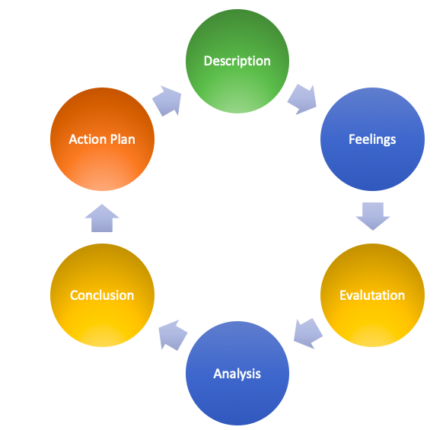
Gibbs' Reflective Cycle (Kotschevar, Withrow and Kotschevar, 2018)

PERSONAL REFLECTION
There are several service models used by the food and beverage industry (Kotschevar, Withrow and Kotschevar, 2018). Some of the most frequent service categories are described below. Using Gibbs learning cycle, I will try to explain some of my experience from past.
Description: I am working one of the biggest restaurants in London where I am service the customers and offering different kinds of foods. As a server, I came across different kinds of issues which has given me strong experience and supporting me in my career. With offering the foods, communication, connection, customer satisfaction, technical and management skills helped to add strong value to my professional career.
Previous work experience has taught me that the most crucial part of the hospitality industry is offering first-rate service to visitors. The satisfaction of guests is the priority. When I first began working in this field, I ran across some challenges, but my supervisor helped me work through them. It was at work that I picked up useful skills like napkin folding and cutlery stacking. Since effective communication is essential in my line of work, I should always strive to become better at it.
Evaluation: It was at work that I picked up useful skills like napkin folding and cutlery stacking. During the service, I have learnt that different kinds of skills that is important for a person who is planning to work in hospital and service industry. Some of the things are discussed in the following:
- Communication skills: One of the important things that an individual is required to learn is communication skills. It helps to connect with the customers, offering them good comfort and connecting while offering service.
- Management skills: Another significant skill that I have reraised people in the service industry is required to have been management skills. Skills of planning, resource allocation, management, leading people and taking corrective action while needed is significant that helps to manage the workplace and handle issues relating to customer service.
Analysis: I was able to analyze the situation and make proper use of my learnings. Some of other issues that I have found which needs to be taken care of while being part of service industry. These include:
- About safety and sanitary standards as table service since food is often portioned and served there.
- The server's plate-swapping abilities must be top-notch.
- The server must be aware of how the tables are supposed to be configured.
- They need strong verbal and written communication abilities. One of the advantages of learning a new language is the opportunities it may open for you.
- Staff members need to be able to operate well under pressure, since many customers may come all at once.
Conclusion: Previous work experience has taught me that the most crucial part of the hospitality industry is offering first-rate service to visitors. It has been established that the many facets of the food and beverage industry need various kinds of skills, both hard and soft (Steen, 2016). Regular interactions between employees and consumers are crucial to the success of any business. Therefore, it is essential that workers develop in all aspects of their lives.
Action plan: Since effective communication is essential in my line of work, I should always strive to become better at it. During the reflection, I have realized that some of the issues that I need to improve and learn for betterment in my professional career. One of the issues that I have found is knowledge about my wine and beverage that needs to developed if I want to work in bigger hotel and restaurant. With knowledge of the wine, I will able to impress the customers and push sell of the business.

REFERENCES
Freedman, P., 2017. French cuisine is no longer the king of fine dining. UK Business Insider, [online] Available at: <http://uk.businessinsider.com/why-french-cuisine-is-no-longer-the-king-of-fine-dining-2016-10>
Kotschevar, L., Withrow, D. and Kotschevar, L., 2018. Study guide to accompany Management by menu, fourth edition. Hoboken, N.J.: John Wiley.
Maitland, O., 2015. Ethnic Foods. [online] Keynote.co.uk. Available at: <https://www.keynote.co.uk/media-centre/in-the-news/display/ethnic-foods/?articleId=18>
Romeo, P., 2015. 7 restaurant trends every FSD should know. FoodService Director, [online] Available at: <http://www.foodservicedirector.com/ideas-innovation/emerging-trends/articles/7-restaurant-trends-every-fsd-should-know>
Steen, J., 2016. Is Fine Dining on The Way Out? [online] Huffington Post Australia. Available at: <http://www.huffingtonpost.com.au/2016/06/22/is-fine-dining-on-the-way-out_a_21399738/>
Witts, S., 2016. UK diners to spend £54.7bn on eating out by 2017. Big Hospitality, [online] Available at: <http://www.bighospitality.co.uk/Trends-Reports/UK-diners-to-spend-54.7bn-on-eating-out-by-2017>

