

Principles and Concepts of Finance
BMSW5012
LEVEL 5
Budgeting Principles and Approaches – Edwards

Student Name: Vlad Constantin Timpau
ID: 2208334
Lecturer : Marie Pitson

15th April 2024

Executive Summary
The main goal of this report is to totally look into how well Edwards, a store chain that deals in camping gear, did financially during a very important six-month period, from June to November. The primary goal of this study is to evaluate how well the organization's current budgeting methods, inventory and cash flow management, and general financial situation are working. In response to the demands of its banking partners, the company is taking steps to fix a substantial overdraft.
It was during this time that a full Profit & Loss statement was made and that the cash and inventory amounts were carefully looked over. According to the research results, the company is having a lot of financial and operational problems. These results have helped identify key areas that need strategic changes.
Important findings from the probe point to a worrying trend in the company's cash management strategy. In fact, the cash amount slowly goes down over the course of six months, reaching a deficit of £108,600 by November. It's clear that effective cash flow management and a reevaluation of payment and sales policies are needed to improve financial availability after the big drop in available funds.
Furthermore, looking at the stock budget reveals possible ways to improve inventory management. Inventory levels have reached an all-time high by the end of the allotted time frame, indicating a discrepancy between the amount of stock bought and the real desire for sales. Inequality like the one described above makes it harder to allocate capital that could be used to pay down debt or make smart investments, which hurts cash flows.
The Profit & Loss statement for the given time period shows a net profit, even though the profit rates aren't very high. Despite making a lot of money, the smaller net profit margins stayed the same because of the high operational costs and interest costs. To do this, a full analysis of the organization's cost structures and operational efficiencies is needed.
Considering the information given, a just-in-time (JIT) inventory system is suggested as the best way to move forward. For lower inventory management costs, this technology would make the link between inventory amounts and real-time sales patterns more accurate. In order to speed up the process of adapting to economic and market fluctuations, it is also recommended that dynamic budgeting and financial forecasting methods, such as continuous forecasts, be used.
The report also stresses how important it is to improve cost management in all areas of the business. According to the suggestion, different ways of financing or reorganising debts should be looked into in order to better manage financial obligations and boost profits.
The report is a full analysis of Edwards' finances, pointing out important issues and practical ways for the company to improve its financial situation. Using this approach will help the company get back on its feet quickly and stay in business in a very competitive market. The financial situation of the group could be significantly altered if the suggestions are put into action correctly. The results of this would be better operational efficiency and a stronger financial base.

Table of Contents
Executive Summary 1
1 Introduction 5
2 Main Findings 6
3 Financial Challenges for Edwards in the Next Six Months 7
3.1 Deteriorating Cash Position 8
3.2 Overstocking and Inventory Mismanagement 9
3.3 High Operating Costs Impacting Profitability 10
3.4 Dependency on Credit Sales 11
4 Conditions for Successful Budgeting and Budgetary Control 13
4.1 Behavioral Considerations in Budgeting 14
5 Critical Evaluation of Traditional Budgeting Methods 16
5.1 Inherent Flaws in Traditional Budgeting 17
5.2 Evolution and Beyond Budgeting 18
5.3 Implications and Strategic Insights 19
6 Conclusion 20
7 Bibliography 21

List of Figures
Figure 1 Management Actions against Deteriorating of Cash Position 6
Figure 2 Management Actions against Overstocking and Inventory Mismanagement 7
Figure 3 Management Actions against High Operating Costs Impacting Profitability 7
Figure 4 Management Actions against Dependency on Credit Sales 8
Figure 5 Conditions for Successful Budgeting and Budgetary Controls 9
Figure 6 Behavioral Considerations in Budgeting 11
Figure 7 Flaws in Traditional Budgeting 13

Introduction
In the fast-paced retail industry, effective financial management is crucial, particularly in consumer goods segments such as camping equipment (Kumar, Gupta and Bapat, 2024; Li, Frederick and Gereffi, 2019). Budgeting plays a vital role in financial management, impacting both immediate business choices and long-term operations (Bennett, Wirth and Parry, 2021; Atrill and McLaney, 2021; Deo, 2021).
The traditional approach to budgeting has evolved into more sophisticated methods that effectively address the complex challenges encountered by modern businesses (ACCA global, 2024; Coombs and Jenkins, 2006). One commonly used approach is incremental budgeting, where adjustments are made to the budget based on changing financial goals and market conditions.
Alternative budgeting techniques such as rolling forecasts and zero-based budgeting aim to address the limitations of traditional budgeting (Ursu and Georgescuii, 2022; Nikodijević, Novićević and Rogan, 2020; Cardoş, 2014; Campos and Rodrigues, 2016). By implementing these tactics, managers can improve operational efficiency and responsiveness by proactively assessing expenses and aligning them strategically with goals (Liyanage and Gooneratne, 2021; Dlamini and Schutte, 2021; Hansen, 2011).
Edwards, the retailer of camping gear, is the focus of the budgeting research. The task Edwards encountered in supervising fifteen sites and meeting a deadline for settling an overdraft exemplifies the challenges associated with retail budget management. This report delves into financial statistics and strategies, exploring industry trends and budgeting studies. This study offers a comprehensive examination of how modern organisations can navigate financial challenges in an uncertain economic climate. It compares Edwards' theories with current budgeting practices to provide insights and recommendations.
Readers will explore the implementation of both modern and traditional budgeting strategies as they delve into the study. In addition, they will understand how these strategies impact the flexibility and financial results of businesses.

Main Findings
- The stock budget for the six months to 30 November is:
Month | June £000 | July £000 | August £000 | September £000 | October £000 | November £000
Opening Balance | 125 | 123 | 104 | 118 | 164 | 197
Stock Purchased | 180 | 170 | 203 | 200 | 180 | 195
Cost of Stock Sold | 182 | 189 | 189 | 154 | 147 | 133
Closing Stock | 123 | 104 | 118 | 164 | 197 | 259
- The cash budget for the period to 30 November is:
Month | June £000 | July £000 | August £000 | September £000 | October £000 | November £000
Cash Receipts | 260 | 270 | 270 | 220 | 210 | 190
Cash Payments:
Administration | 21 | 20 | 18 | 19 | 19 | 17
Credit Card Payment | 5 | 5 | 5 | 4 | 4 | 3
Stock Purchased | 205 | 180 | 170 | 203 | 200 | 180
Repayments of Loan | 7 | 7 | 7 | 7 | 7 | 7
Selling Expenses | 9 | 8 | 7 | 6 | 6 | 6
Taxation Paid | 0 | 0 | 0 | 20 | 0 | 0
Interest Payments | 1 | 1 | 1 | 1 | 1 | 1
Shop Refurbishment | 34 | 26 | 18 | 0 | 0 | 0
Total Payments | (282) | (247) | (226) | (260) | (237) | (214)
Opening Balance | (25) | (47) | (24) | 21 | (19) | (46)
Receipts - Payments | (22) | 23 | 44 | (40) | (27) | (24)
Closing Balance | (47) | (24) | 21 | (19) | (46) | (71)

- The (accruals-based) budgeted Profit & Loss Account for the six months ending 30 November is:
Account | £000 | Calculation
Sales | 1420 | Total from sales income
Cost of Goods Sold | -994 | Sum of monthly COGS
Gross Profit | 426 | Sales - COGS
Selling Expenses | -41 | Sum of monthly expenses
Admin Expenses | -144 | Sum of monthly admin costs
Credit Card Charges | -26 | 3% of sales income
Refurbishments | -78
Operating Profit | 137 | Gross Profit - Expenses
Interest Expense | -14 | Sum of monthly interest
Profit for the Period | 123 | Operating Profit - Interest
Taxation | -20
Net profit | 103 | Profit - Taxation

Financial Challenges for Edwards in the Next Six Months
A thorough examination of the financial data and projections reveal several significant obstacles that Edwards is expected to encounter in the coming months. Edwards is likely to face these challenges. To effectively address these difficulties, it will be crucial to implement strategic management strategies, which will be discussed in greater detail below.

Deteriorating Cash Position
After analysing the cash budget, it becomes clear that the cash situation is declining. The deficit keeps increasing month after month, reaching its peak in November at £108,600. This suggests a notable liquidity risk that may jeopardise the organization's capacity to fulfil its financial obligations and sustain operational effectiveness. The figure below illustrates the management actions that can be undertaken to resolve the challenge.
Figure 1 Management Actions against Deteriorating of Cash Position
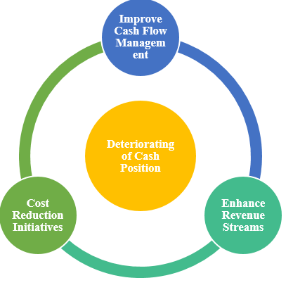
Source: Self-Developed
As illustrated in the Figure 1 they should consider the following:
- A more stringent credit control and cash management system should be implemented in order to guarantee that receivables are recovered in a brief amount of time (Cangoz and Secunho, 2020; Mayer et al. 2023).
- Consider other revenue streams, such as internet sales channels or one-of-a-kind promotions, in order to increase the amount of cash that is coming in.
- The comprehensive assessment of all expenses is required in order to identify areas in which costs could be reduced without compromising the quality of the product or the level of service provided to customers.
In addition to implement stringent credit control system Edward can explore alternate financing options like lines of credit or short-term loans to overcome gaps in cash flow at the time of deficit period. Edward can also negotiate on extended payment terms with its suppliers to alleviate cash pressure and maintain relationships.

Overstocking and Inventory Mismanagement
The stock budget reveals an excessive amount of stock, indicating a significant increase in inventory levels towards the end of the quarter in relation to sales. It seems that there is not enough stock available. Idle inventory can have a negative impact on cash flow and lead to increased storage costs (Lyu et al. 2020; Khan and Siddiqui, 2019). The figure below illustrates the management actions that can be undertaken to resolve the challenge.
Figure 2 Management Actions against Overstocking and Inventory Mismanagement
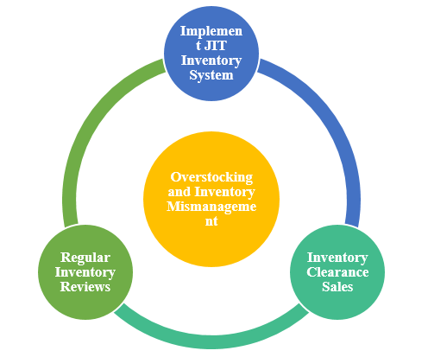
Source: Self-Developed
As illustrated in the Figure 2 they should consider the following:
- Implementing a just-in-time inventory system can greatly enhance the business's ability to efficiently manage stock and minimise storage costs (Stojkanović, Petković, and Ivanov, 2021; Iwasokun, Ogunseye and Adeleye, 2023; Ufua et al. 2022; Lyu et al. 2020; Milewski, 2022; Harcourt and Ali, 2021). By implementing this approach, the correlation between customer demand and inventory levels will be enhanced (Nugroho et al. 2022; Lyu et al. 2020; Hussein and Zayed, 2021; Tirkolaee, Goli and Weber, 2021).
- One can generate immediate revenue by capitalising on clearance sales, which offer a chance to dispose of surplus inventory.
- Regularly evaluating inventory turnover rates is crucial to align procurement strategies with sales projections.
Edward can prioritize regular demand forecasting and analyse trends apart from just-in-time inventory system. It helps in aligning stock levels according to customer needs. Company can also use inventory management system to provide real-time updates about stock movement and help in making effective decisions related to stock and purchase level.

High Operating Costs Impacting Profitability
Despite the substantial revenue generated, the analysis of the Profit & Loss account reveals a remarkably low net profit, indicating that elevated operating expenses are severely impacting profitability. The figure below illustrates the management actions that can be undertaken to resolve the challenge.

Figure 3 Management Actions against High Operating Costs Impacting Profitability
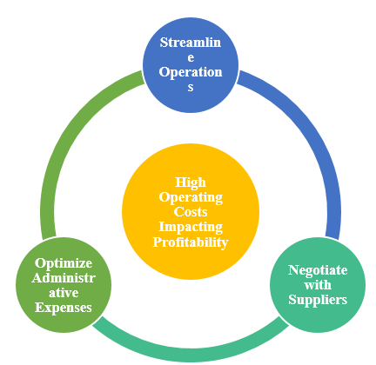
Source: Self-Developed
As illustrated in the Figure 3 they should consider the following:
- Conducting a thorough evaluation of every operational process is crucial to pinpoint any areas that may benefit from improvement and increased efficiency. Streamlining processes can lead to cost savings and improved productivity (Palange and Dhatrak, 2021; Xu et al. 2020; Rathore, 2023).
- Genuinely want to lower the cost of the items one sell and boost your profit margins, it would be wise to engage in negotiations with the suppliers to secure better prices or more favorable payment terms.
- Consider investing in technology that can streamline operations and reduce expenses related to labor and administrative fees.
Edward should also explore outsourcing non-core functions to get specialization in its core operations which will reduce overhead costs that is associated with in-house operations. Edward can also invest in training employees with the aim to enhance their productivity to develop efficient culture in the organization.

Dependency on Credit Sales
A significant portion of retail sales is conducted through credit, which, although common, puts a significant strain on cash flows. This is particularly evident when one takes into account the high expenses linked to credit card transactions (Wade, Wade and Srinivas, 2023).
The figure below illustrates the management actions that can be undertaken to resolve the challenge.
Figure 4 Management Actions against Dependency on Credit Sales
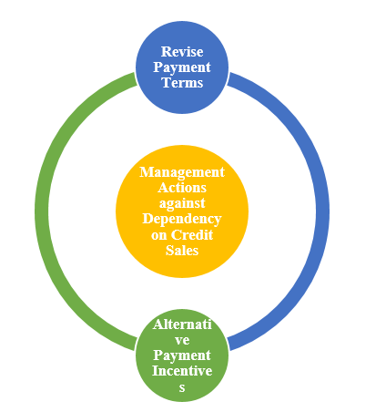
Source: Self-Developed
As illustrated in the Figure 4 they should consider the following:
- To minimize dependence on credit sales, it could be beneficial to adjust payment terms or implement incentives to promote prompt payments (Wang et al. 2022).
- Lowering transaction costs can be achieved by providing incentives, such as cash discounts or the option of direct debit, for payments made through alternative methods to credit cards (Simatele and Mbedzi, 2021; Klein, 2020; Świecka, Terefenko and Paprotny, 2021; Ho et al. 2022).
Along with adjusting payment terms Edward can provide cash transactions incentives in the form of loyalty programs and discounts. It encourage customers to choose non-credit payment option. Edward can explore partnership with Fintech companies to include digital payment solution to expand payment options and lower the dependency on traditional credit cards.

Given the concerns raised by Edwards' financial analysis, it is imperative to perform a thorough strategic analysis of financial management methods. By implementing the recommended management steps, Edwards can effectively tackle these critical challenges, enhancing its financial stability and laying the foundation for sustained growth in the highly competitive retail market.

Conditions for Successful Budgeting and Budgetary Control
In order to ensure the smooth functioning and effective implementation of a budgeting and budgetary management system, it is essential for a company to establish the following key prerequisites:
Figure 5 Conditions for Successful Budgeting and Budgetary Controls
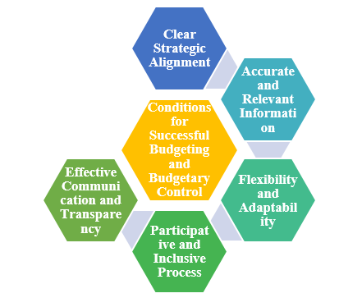
Source: Self-Developed
Ensuring that the organizational budgeting process aligns with the strategic goals and objectives of the organization is crucial (Dairo et al. 2021; Gavrikova, Volkova and Burda, 2020). By breaking down broad objectives into specific and achievable financial metrics, budgets should accurately reflect the strategic plan. Every financial decision and action made by the company is carefully aligned with the overall strategic goals of the organization, ensuring that they are in sync (Pearlson, Saunders and Galletta, 2024; Gray, Helper and Osborn, 2020; Ghonim et al. 2022; Mitropoulos, 2021).
In order to ensure the success of budgeting, it is of utmost importance to possess accurate and relevant data (Bergmann et al. 2020; Campos and Rodrigues, 2016; Nikodijević et al. 2020). When designing the budget, it is vital to take into consideration historical data, benchmarks from the industry, and predictions that are reasonable (Pan and Zhang, 2021; Ursu and Georgescuii, 2022; Bergmann et al. 2020). These are necessary elements that should all be taken into the account. The fact that operational indicators and financial matters are interrelated, in turn, means that such interplay affects the financial health of the organization. This is an inference that can be made considering the details presented here.
Contrary to mainly static budget scenarios, flexible budgets is an essential attribute to fulfill the dynamic needs of the company (Fried et al. 2020). Two things that contribute to the effectiveness of a great budgeting system are continuous overhaul and increased flexibility. Through this composition, the company is able to respond to variables in the market and improvements in its operations.
As shown by Kunzl and Messner (2021), the entire process of budgeting that requires active participation of different departments and management levels is what creates a deep sense of responsibility and ownership among the members of the organization. Through the participation of all members of the organization, starting from the senior levels to the workforce, a budget that is faultlessly precise and more effective as match the requirements and limitations of each department should be put in place.
Communication is a no-brainer when it comes to effectively and efficiently depicting financial plans, limitations, and goals. Muthomi and Thurmaier (2021) argued that the atmosphere of trust and understanding among team members should be improved to ensure transparency of the budgeting and decision-making process. These two aspects are absolutely necessary for the budgeting system to function effectively and to be positively appreciated by the public.

Behavioral Considerations in Budgeting
The efficiency of a budgeting and budgetary management system is significantly impacted by the activities of the personnel who are responsible for putting the system into action during its implementation. The management should thoroughly investigate the following behavioral aspects:

Figure 6 Behavioral Considerations in Budgeting
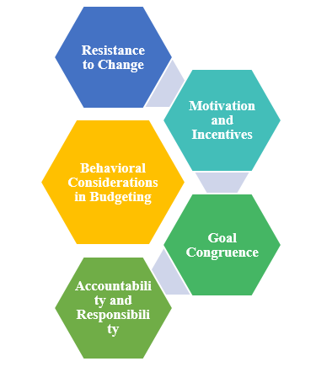
Some individuals within an organization may exhibit resistance to change, especially when new systems challenge established routines. During the period of transition, it is crucial to provide management with proper training and support, ensuring that they fully understand and appreciate the advantages of the new budgeting method.
When putting together the budgeting system, it is essential to give careful consideration to the potential impact that it could have on the motivation of the employees. It is possible to serve as a potent motivator for managers and staff by providing them with performance rewards that are related to budget targets. This incentive can help them reach their budget goals. In order to effectively protect the organization's long-term interests, it is of the utmost importance to exercise extreme caution with regard to the potential adverse effects that these incentives may have. This involves avoiding excessive cost-cutting or inadequate investment, both of which have the potential to put the organization's stability at risk (Simatele and Mbedzi, 2021; Datar and Rajan, 2021; Drury, 2021; Grey et al. 2020).
At the individual or departmental level, it is of the utmost importance that the objectives that are established during the process of budgeting are in accordance with the goals that each participant has set for themselves. It is possible for the effectiveness of the budgeting system to be badly impacted, and it may also lead to conflicts, when personal aspirations do not line with the fiscal goals of the organisation.
It is vital, within the scope of budgeting systems, to have a mission of responsibilities that is explicit with regard to particular budgetary items. The establishment of protocols is absolutely necessary in order to guarantee that individuals and departments are held accountable in the appropriate manner for their financial performance. Not only is it essential to keep a record of accomplishments, but it is also essential to provide constructive comments and criticism in order to encourage continuous progress. The reason for this is that the subject matter is of such utmost significance.
By taking into account the behavioural features of an organisation, it is possible to considerably improve the efficiency of the budgeting and budgetary control mechanisms that are in place inside that business. The firm will not have any trouble achieving this objective without any difficulty. This results in an increase in the allocation of resources, an improvement in the management of financial resources, and ultimately, a stronger alignment with strategic objectives. All of these outcomes are a consequence of this.
Considering behavioural aspects along with organization it is essential to enhance the budget efficiency for budget and budget control mechanism. It helps better resource allocation, enhance financial management and align its objectives for organizational success.

Critical Evaluation of Traditional Budgeting Methods
Over the course of human history, traditional budgeting has continually been a vital component of financial planning in a wide variety of industries, including both the public and private sectors. This is true for both public and private sectors together. Traditional budgeting methods assist organisations in effectively managing their finances by enabling them to forecast revenue, allocate resources, and monitor low financial progress in accordance with the goals that they have defined (Wanna et al. 2020; Eneanya, 2018). Businesses become skillful in a safe custody of their money as a result of this low The regular practice of using this group to govern is a method that is generally accepted as a control. Nevertheless, typewriters are still the most commonly used thing in organisational structures. They, however, possess the quality of providing certain extent of security; but there are drawbacks too. This is specifically with a reference to circumstances where it is used in businesses characterized by a high state of activity and quick variations in the environment.

Inherent Flaws in Traditional Budgeting
Concerning the budget, the normal method for allocating funds seems to require too much time and too many resources in general. It is possible that the process of budgeting which comprises of preparation, review, and approval might take a lot of time which could be instead used for strategic decision-making and operational development.
Traditional budgeting, conducted annually, may hinder progress. The conventional budgeting approach used by corporations often hinders their ability to quickly adapt to market fluctuations and capitalise on new opportunities or challenges. Due to the inflexibility of this approach, it becomes challenging to efficiently distribute resources in response to both internal and external changes.
Cost management is often considered a top priority in traditional budgeting (Drury, 2021; Datar and Rajan, 2017). Overemphasising cost reduction can hinder the progress of growth and innovation initiatives that require a long-term dedication and may yield greater advantages - in terms of expenses. It is undeniable that cost management is crucial, regardless of the circumstances.
Traditional budgets can be prone to inaccuracies as they heavily depend on forecasts and historical data (Liyanage and Gooneratne, 2021; Horner, 2020). Mistakes in data entry are a frequent occurrence in the operation, and if left unchecked, they can lead to significant discrepancies.
Conventional budgets have empowered higher management with greater decision-making authority (Alhalawi and Dammak, 2024). Due to the centralised nature of financial planning and decision-making, individuals who are unhappy with their jobs may find their motivation decreasing.

Figure 7 Flaws in Traditional Budgeting
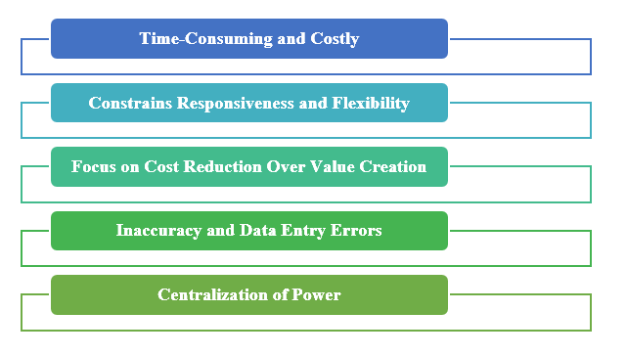

Evolution and Beyond Budgeting
Budgeting has evolved over time to incorporate a range of approaches, considering the inherent limitations. There are various methodologies that can be utilised, such as value proposition budgeting, incremental budgeting, zero-based budgeting, and activity-based budgeting. Every option tackles a different aspect of the deficiencies in the conventional approach. Zero-based budgeting, for example, necessitates a thorough reevaluation of every expense, promoting more strategic allocation of resources (Campos and Rodrigues, 2016; Lyu et al. 2020). This holds true regardless of the financial history.
The concept of Beyond Budgeting takes the evolutionary trajectory to new heights. It is recommended that the company consider eliminating traditional budgeting procedures to enhance management control and increase the corporation's agility (Alhalawi and Dammak, 2024; Hansen, 2011). Beyond Budgeting was created to promote a decentralised environment that fosters creativity and adaptability. The establishment is built upon the principles of transparency, autonomy, and value.
The framework called Beyond Budgeting consists of six leadership principles and six management process principles, all aimed at improving the agility of businesses. In the process of transitioning from hierarchical control to a framework that values shared values, empowers teams, and supports a flexible approach to performance management, these notions provide corporate organisations with a significant amount of assistance.
In conclusion, although traditional budgeting procedures have been depended upon for a considerable amount of time for the purpose of financial management, their applicability in the modern-day business world is being called into question. It is possible for businesses to improve their capacity to negotiate the complexities and uncertainties of modern business by putting into place budgeting systems that are flexible, centred on value, and responsive. The conventional methods that have been used in the past are not the same as this strategy. To align financial planning and operation performance of Edward strategic adjustments is crucial. The company can implement just-in-time inventory system to improve its cash flow and reduce risk of overstocking. Edward can adopt flexible budgeting options like forecast rotation that help company to adapt according to market requirements to enhance sales. These conditions are important for safeguarding financial stability and increase sales.

Implications and Strategic Insights
It is abundantly obvious, on the basis of the findings of the study investigation, that there is an immediate and pressing requirement for significant measures to improve cash flows and inventory management. If Edwards does not take fast action to address the rising inventory levels and the diminishing cash reserve, the company may be put in a position where it faces serious financial issues. A just-in-time (JIT) inventory system can be used to improve cash flows by lowering holding costs and minimising the risk of overstocking. This can be accomplished by reducing the amount of inventory that is held. It is essential for Edwards to immediately implement upgrades to its cost management procedures and, if necessary, reevaluate its pricing and client payment policies in order for the firm to produce a profit since it is essential for the company to generate a profit.
It may be possible for the company to quickly adjust to changes in the market if it were to implement budgeting approaches that are more flexible, such as forecast rotation. In order to ensure the financial stability of the company and improve sales performance, Edwards needs to solve operational financial difficulties in a timely manner. These concerns include cash flow and inventory management. It is imperative that this be done in order to protect and enhance the sales performance of the organisation. On the basis of these findings, it appears that strategic adjustments are required in order to bring the organization's operational performance and financial planning into alignment with its long-term objectives.

Conclusion
Extensive financial research was carried out for the camping goods retail chain Edwards over the course of a period of six months. This study provides an in-depth review of the existing budgeting procedures utilised by the organisation as well as the impact those procedures have on the organization's overall financial health. Initially, the stock budget analysis reveals that there is a potential problem with inventory levels, which suggests that there may be a scenario of overstocking despite the fact that there are indications of preparedness. The study of the cash budget revealed that the cash balance declined with time, ultimately revealing a shortage of £108,600 in November. The loss in cash flow bring to light operational inefficiencies and put company's solvency in jeopardy. In conclusion, despite the fact that Edwards has taken advantage of successful sales techniques, the data unequivocally indicates that there is a want for enhanced financial management practices. Edwards possesses the knowledge necessary to not just do rid of the bank's forced overdraft, but also to achieve long-term stability and sustainable growth in the retail market, which is notoriously cutthroat.

Bibliography
ACCA global (2024). Beyond budgeting | ACCA Qualification | Students | ACCA Global. [online] www.accaglobal.com. Available at: https://accaglobal.com/gb/en/student/exam-support-resources/professional-exams-study-resources/p5/technical-articles/beyond-budgeting.html [Accessed 12 Apr. 2024].
Alhalawi, N.S. and Dammak, S., 2024. Breaking the budget chains: Empowering Iraqi small-and medium-sized enterprises through Beyond Budgeting. South African Journal of Economic and Management Sciences, 27(1), p.11.
Atrill, P. and McLaney, E. (2021), Management Accounting for Decision Makers, (Tenth Edition), Harlow: Pearson Education Limited
Bennett, A., Wirth, C. and Parry, J., 2021. Fundamentals of finance: Financial institutions and markets, personal finance, financial management. Massey University Press.
Bergmann, M., Brück, C., Knauer, T. and Schwering, A., 2020. Digitization of the budgeting process: determinants of the use of business analytics and its effect on satisfaction with the budgeting process. Journal of Management Control, 31(1), pp.25-54.
Campos, C.M.P. and Rodrigues, L.L., 2016. Budgeting techniques: incremental based, performance based, activity based, zero based, and priority based. Global Encyclopedia of Public Administration, Public Policy, and Governance, Springer, Cham, doi, 10, pp.978-3.
Cangoz, M.C. and Secunho, L., 2020. Cash Management: How Do Countries Perform Sound Practices?.
Cardoş, I.R., 2014. New trends in budgeting–a literature review. SEA–Practical Application of Science, 2(04), pp.483-489.
Coombs, H.M. and Jenkins, D.E. (2006). Public sector financial management. London: Thomson Learning.
Dairo, M., Adekola, J., Apostolopoulos, C. and Tsaramirsis, G., 2021. Benchmarking strategic alignment of business and IT strategies: opportunities, risks, challenges and solutions. International Journal of Information Technology, 13(6), pp.2191-2197.
Datar, S.M and Rajan, M.V. 2017. Horgren’s Cost Accounting, A Managerial Emphasis – Global Edition, (Eleventh Edition), London: Pearson
Deo, P., 2021. Fixed Asset Management-Revisited. Journal of Accounting and Finance, 21(1), pp.10-22.
Dlamini, B. and Schutte, D.P., 2021. An exploratory study on the usage of Management Accounting Practices among Small and Medium Enterprises in Zimbabwe. The Journal of Accounting and Management, 11(2).
Drury, C. 2021. Management and Cost Accounting, (Eleventh Edition), London: Prentice Hall.
Eneanya, A.N., 2018. Performance management system and public service delivery in Nigeria: Impacts, problems, challenges and prospects. Africa’s Public Service Delivery and Performance Review, 6(1), pp.1-9.
Fried, J.E., Liebers, D.T. and Roberts, E.T., 2020. Sustaining rural hospitals after COVID-19: the case for global budgets. Jama, 324(2), pp.137-138.
Gavrikova, E., Volkova, I. and Burda, Y., 2020. Strategic aspects of asset management: An overview of current research. Sustainability, 12(15), p.5955.
Ghonim, M.A., Khashaba, N.M., Al-Najaar, H.M. and Khashan, M.A., 2022. Strategic alignment and its impact on decision effectiveness: a comprehensive model. International Journal of Emerging Markets, 17(1), pp.198-218.
Gray, J.V., Helper, S. and Osborn, B., 2020. Value first, cost later: Total value contribution as a new approach to sourcing decisions. Journal of Operations Management, 66(6), pp.735-750.
Hansen, S.C., 2011. A theoretical analysis of the impact of adopting rolling budgets, activity-based budgeting and beyond budgeting. European Accounting Review, 20(2), pp.289-319.
Harcourt, H. and Ali, F.O., 2021. Just-in-time inventory management imports on sales performance of paint manufacturing firms in rivers state, Nigeria. Nigerian Journal of Management Sciences Vol, 22(2).
Ho, C.Y., Kim, N., Rong, Y. and Tian, X., 2022. Promoting mobile payment with price incentives. Management Science, 68(10), pp.7614-7630.
Horner, D. (2020), Accounting for Non Accountants, (Twelfth Edition), London; Kogan Press
Hussein, M. and Zayed, T., 2021. Critical factors for successful implementation of just-in-time concept in modular integrated construction: A systematic review and meta-analysis. Journal of cleaner production, 284, p.124716.
Iwasokun, G.B., Ogunseye, M.O. and Adeleye, S.A., 2023. Development of a Stock Control and Management System based on Just-in-Time Technique. International Journal of Innovative Computing, 13(2), pp.65-74.
Khan, F. and Siddiqui, D.A., 2019. Impact of inventory management on firm’s efficiency–A quantitative research study on departmental stores operating in Karachi. Khan, F. and Siddiqui, DA (2019). Impact of Inventory Management on Firm’s Efficiency–A Quantitative Research Study on Departmental Stores Operating in Karachi. Social Science and Humanities Journal, 3(4), pp.964-980.
Klein, A., 2020. China’s digital payments revolution. Brookings Institution, Washington.
Kumar, A., Gupta, N. and Bapat, G., 2024. Who is making the decisions? How retail managers can use the power of ChatGPT. Journal of Business Strategy, 45(3), pp.161-169.
Kunzl, F. and Messner, M., 2023. Temporal Structuring as Self-Discipline: Managing time in the budgeting process. Organization Studies, 44(9), pp.1439-1464.
Li, F., Frederick, S. and Gereffi, G., 2019. E-commerce and industrial upgrading in the Chinese apparel value chain. Journal of Contemporary Asia, 49(1), pp.24-53.
Liyanage, T. and Gooneratne, T., 2021. From'Traditional'Budgeting to'Better'Budgeting: Navigating through'Stability'and'Change'. Management Accounting Frontiers, 4, pp.27-50.
Lyu, Z., Lin, P., Guo, D. and Huang, G.Q., 2020. Towards zero-warehousing smart manufacturing from zero-inventory just-in-time production. Robotics and Computer-Integrated Manufacturing, 64, p.101932.
Mayer, J.H., Lischke, L., Quick, R. and Kalden, F., 2023. When Cash Is King—An Accounts Receivables App Accommodating Different Use Situations. Journal of Information Systems, 37(2), pp.101-122.
Milewski, D., 2022. Managerial and economical aspects of the just-in-time system “lean management in the time of pandemic”. Sustainability, 14(3), p.1204.
Mitropoulos, S., 2021. An integrated model for formulation, alignment, execution and evaluation of business and IT strategies. International Journal of Business and Systems Research, 15(1), pp.90-111.
Muthomi, F. and Thurmaier, K., 2021. Participatory transparency in Kenya: Toward an engaged budgeting model of local governance. Public administration review, 81(3), pp.519-531.
Nikodijević, M., Novićević, B. and Rogan, M., 2020. Empirical Study of the Implementation of Certain Budgeting Concepts in Manufacturing Companies in Serbia. Economic Themes, 59(1), pp.61-76.
Nugroho, A., Christiananta, B., Wulani, F. and Pratama, I., 2022. Exploring the association among just in time, total quality and supply chain management influence on firm performance: evidence from Indonesia.
Palange, A. and Dhatrak, P., 2021. Lean manufacturing a vital tool to enhance productivity in manufacturing. Materials Today: Proceedings, 46, pp.729-736.
Pan, Y. and Zhang, L., 2021. Roles of artificial intelligence in construction engineering and management: A critical review and future trends. Automation in Construction, 122, p.103517.
Pearlson, K.E., Saunders, C.S. and Galletta, D.F., 2024. Managing and using information systems: A strategic approach. John Wiley & Sons.
Rathore, B., 2023. Digital transformation 4.0: integration of artificial intelligence & metaverse in marketing. Eduzone: International Peer Reviewed/Refereed Multidisciplinary Journal, 12(1), pp.42-48.
Rosid, A., Judijanto, L., Stiadi, M., Rostini, R. and Mohamad, M.T., 2023. Contemporary marketing management strategies: navigating complexity and challenges in the dynamic industry era. International Journal of Economic Literature, 1(3), pp.271-284.
Simatele, M. and Mbedzi, E., 2021. Consumer payment choices, costs, and risks: Evidence from Zimbabwe. Cogent Economics & Finance, 9(1), p.1875564.
Świecka, B., Terefenko, P. and Paprotny, D., 2021. Transaction factors’ influence on the choice of payment by Polish consumers. Journal of Retailing and Consumer Services, 58, p.102264.
Stojkanović, D., Petković, Z. and Ivanov, L., 2021. Just in Time as a Modern Principle of Inventory Management. KNOWLEDGE-International Journal, 45(1), pp.193-197.
Tirkolaee, E.B., Goli, A. and Weber, G.W., 2020. Fuzzy mathematical programming and self-adaptive artificial fish swarm algorithm for just-in-time energy-aware flow shop scheduling problem with outsourcing option. IEEE transactions on fuzzy systems, 28(11), pp.2772-2783.
Ufua, D.E., Ibidunni, A.S., Papadopoulos, T., Matthew, O.A., Khatoon, R. and Agboola, M.G., 2022. Implementing just-in-time inventory management to address contextual operational issues: a case study of a commercial livestock farm in southern Nigeria. The TQM Journal, 34(6), pp.1752-1771.
Ursu, I. and Georgescuii, I.U.L.I.A.N.A., 2022. PLANNING WITH OR WITHOUT BUDGETS? THE “NEW CONTROLLING” APPROACH. Review of Economic and Business Studies, p.105.
Wade, M., Tomlinson, N. and Srinivas, V. (2023). 2024 banking and capital markets outlook. [online] Deloitte Insights. Available at: https://www2.deloitte.com/us/en/insights/industry/financial-services/financial-services-industry-outlooks/banking-industry-outlook.html [Accessed 12 Apr. 2024].
Wang, L., Wang, Z., Tian, L. and Li, C., 2022. Evolutionary game and numerical simulation of enterprises’ green technology innovation: based on the credit sales financing service of supply chain. Sustainability, 15(1), p.702.
Wanna, J., Kelly, J. and Forster, J., 2020. Managing public expenditure in Australia. Routledge.
Xu, J., Xu, X., Huang, C., Angelo, J., Oliveira, C.L., Xu, M., Xu, X., Temel, D., Ding, J., Ghose, S. and Borys, M.C., 2020, January. Biomanufacturing evolution from conventional to intensified processes for productivity improvement: a case study. In MAbs (Vol. 12, No. 1, p. 1770669). Taylor & Francis.

